Skill – 14

- To Parse Append Operator, Open Files in Append Mode, Redirect Streams, Preserve Existing Data, Validate Appends, Test Scenarios.

To Parse stderr Redirection, Redirect Error Streams, Capture Error Output, Verify File Contents, Handle Failures, Test Error Cases

Code(14A) :

#include <stdio.h>
#include <stdlib.h>
#include <string.h>
#include <unistd.h>
#include <fcntl.h>
#include <sys/wait.h>

#define INPUT_SIZE 500
#define ARG_SIZE 50

int main()
{
char input[INPUT_SIZE];
char *args[ARG_SIZE];
char *filename;
int argc;

printf("Append Redirection Program\n");
printf("--------------------------\n");
printf("Example: echo Hello >> output.txt\n");
printf("Type exit to quit.\n\n");

while (1)
{
printf("shell> ");
fflush(stdout);

if (fgets(input, sizeof(input), stdin) == NULL)
break;

input[strcspn(input, "\n")] = '\0';

if (strcmp(input, "exit") == 0)
break;

if (strlen(input) == 0)
continue;

/* Find >> operator */
char *redirect = strstr(input, ">>");

if (redirect == NULL)
{
printf("Error: Use >> for append redirection.\n");
continue;
}

/* Separate command and filename */
*redirect = '\0';
filename = redirect + 2;

/* Skip spaces */
while (*filename == ' ')
filename++;

if (*filename == '\0')
{
printf("Error: Output file not specified.\n");
continue;
}

/* Parse command */
argc = 0;

char *token = strtok(input, " \t");

while (token != NULL && argc < ARG_SIZE - 1)
{
args[argc++] = token;
token = strtok(NULL, " \t");
}

args[argc] = NULL;

if (argc == 0)
{
printf("Error: Command not specified.\n");
continue;
}

/* Create child process */
pid_t pid = fork();

if (pid < 0)
{
perror("fork");
continue;
}

if (pid == 0)
{
/*
* O_APPEND ensures new data is added
* at the end of the existing file.
*/
int fd = open(filename,
O_WRONLY | O_CREAT | O_APPEND,
0644);

if (fd == -1)
{
perror("open");
exit(1);
}

/* Redirect stdout to file */
if (dup2(fd, STDOUT_FILENO) == -1)
{
perror("dup2");
close(fd);
exit(1);
}

close(fd);

/* Execute command */
execvp(args[0], args);

perror("execvp");
exit(1);
}
else
{
int status;

waitpid(pid, &status, 0);

if (WIFEXITED(status) &&
WEXITSTATUS(status) == 0)
{
printf("Data appended successfully to %s\n",
filename);
}
else
{
printf("Append operation failed.\n");
}
}
}

return 0;
}

OUTPUT :
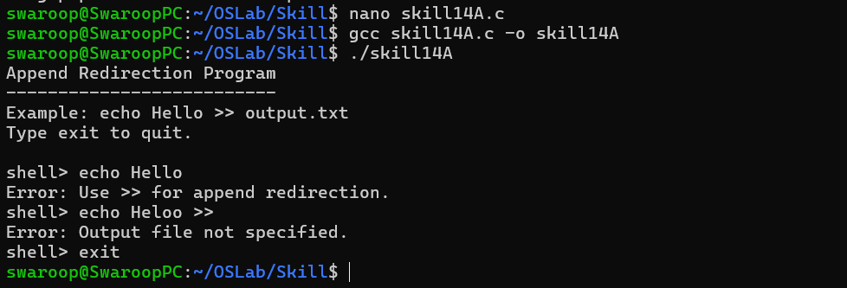

Part-B :

Code (14B) :

#include <stdio.h>
#include <stdlib.h>
#include <string.h>
#include <unistd.h>
#include <fcntl.h>
#include <sys/wait.h>

#define INPUT_SIZE 500
#define ARG_SIZE 50

int main()
{
char input[INPUT_SIZE];
char *args[ARG_SIZE];
char *filename;
int argc;

printf("stderr Redirection Program\n");
printf("--------------------------\n");
printf("Example: ls /wrong/path 2> error.txt\n");
printf("Type exit to quit.\n\n");

while (1)
{
printf("shell> ");
fflush(stdout);

if (fgets(input, sizeof(input), stdin) == NULL)
break;

input[strcspn(input, "\n")] = '\0';

if (strcmp(input, "exit") == 0)
break;

if (strlen(input) == 0)
continue;

/* Find stderr redirection operator */
char *redirect = strstr(input, "2>");

if (redirect == NULL)
{
printf("Error: Use 2> for stderr redirection.\n");
continue;
}

/* Separate command and error file */
*redirect = '\0';
filename = redirect + 2;

/* Skip spaces */
while (*filename == ' ')
filename++;

if (*filename == '\0')
{
printf("Error: Error output file not specified.\n");
continue;
}

/* Parse command */
argc = 0;

char *token = strtok(input, " \t");

while (token != NULL && argc < ARG_SIZE - 1)
{
args[argc++] = token;
token = strtok(NULL, " \t");
}

args[argc] = NULL;

if (argc == 0)
{
printf("Error: Command not specified.\n");
continue;
}

/* Create child */
pid_t pid = fork();

if (pid < 0)
{
perror("fork");
continue;
}

if (pid == 0)
{
/*
* Open error output file.
* O_TRUNC clears old contents.
*/
int fd = open(filename,
O_WRONLY | O_CREAT | O_TRUNC,
0644);

if (fd == -1)
{
perror("open");
exit(1);
}

/* Redirect stderr to file */
if (dup2(fd, STDERR_FILENO) == -1)
{
perror("dup2");
close(fd);
exit(1);
}

close(fd);

/* Execute command */
execvp(args[0], args);

/* execvp error also goes to redirected stderr */
perror("execvp");
exit(1);
}
else
{
int status;

waitpid(pid, &status, 0);

if (WIFEXITED(status))
{
printf("Command finished with exit status: %d\n",
WEXITSTATUS(status));

printf("Check error output using:\n");
printf("cat %s\n", filename);
}
}
}

return 0;
}

Output :

