Skill – 17

- To Implement how to List Active Jobs, Display Status Information, Retrieve Job IDs, Format Output, Update State Information, Test Job Listings.

To design how to Identify Target Job, Transfer Terminal Control, Resume Processes, Wait for Completion, Update Job State, Test Foreground Switching

Code(17A) :

#include <stdio.h>
#include <stdlib.h>
#include <string.h>
#include <unistd.h>
#include <sys/types.h>
#include <sys/wait.h>

#define MAX_JOBS 20
#define INPUT_SIZE 256
#define CMD_SIZE 128

typedef enum
{
RUNNING,
DONE
} JobState;

typedef struct
{
int job_id;
pid_t pid;
pid_t pgid;
char command[CMD_SIZE];
JobState state;
} Job;

Job jobs[MAX_JOBS];
int job_count = 0;
int next_job_id = 1;

/* Convert state to text */
const char *get_state(JobState state)
{
if (state == RUNNING)
return "Running";

return "Done";
}

/* Add a background job */
void add_job(pid_t pid, pid_t pgid, const char *command)
{
if (job_count >= MAX_JOBS)
{
printf("Job table full.\n");
return;
}

jobs[job_count].job_id = next_job_id++;
jobs[job_count].pid = pid;
jobs[job_count].pgid = pgid;
jobs[job_count].state = RUNNING;

strncpy(jobs[job_count].command,
command,
CMD_SIZE - 1);

jobs[job_count].command[CMD_SIZE - 1] = '\0';

job_count++;
}

/* Update job states */
void update_states(void)
{
for (int i = 0; i < job_count; i++)
{
if (jobs[i].state == RUNNING)
{
int status;

pid_t result = waitpid(
jobs[i].pid,
&status,
WNOHANG
);

if (result == jobs[i].pid)
{
jobs[i].state = DONE;
}
}
}
}

/* List all jobs */
void list_jobs(void)
{
update_states();

printf("\n========== JOB LIST ==========\n");

if (job_count == 0)
{
printf("No jobs found.\n");
printf("==============================\n");
return;
}

printf("%-5s %-8s %-8s %-12s %s\n",
"JOB", "PID", "PGID", "STATE", "COMMAND");

printf("----------------------------------------------\n");

for (int i = 0; i < job_count; i++)
{
printf("%-5d %-8d %-8d %-12s %s\n",
jobs[i].job_id,
jobs[i].pid,
jobs[i].pgid,
get_state(jobs[i].state),
jobs[i].command);
}

printf("==============================================\n");
}

/* Find job using job ID */
int find_job(int job_id)
{
for (int i = 0; i < job_count; i++)
{
if (jobs[i].job_id == job_id)
return i;
}

return -1;
}

/* Start background process */
void start_background(char *command)
{
pid_t pid = fork();

if (pid < 0)
{
perror("fork");
return;
}

if (pid == 0)
{
setpgid(0, 0);

char *args[64];
int argc = 0;

char *token = strtok(command, " ");

while (token != NULL && argc < 63)
{
args[argc++] = token;
token = strtok(NULL, " ");
}

args[argc] = NULL;

if (argc == 0)
exit(EXIT_SUCCESS);

execvp(args[0], args);

perror("execvp");
exit(EXIT_FAILURE);
}

setpgid(pid, pid);

add_job(pid, pid, command);

printf("[%d] %d started\n",
next_job_id - 1,
pid);
}

int main(void)
{
char input[INPUT_SIZE];

printf("JOB LIST MANAGER\n");
printf("----------------\n");
printf("Commands:\n");
printf(" command & Start background job\n");
printf(" jobs List active jobs\n");
printf(" id N Retrieve job information\n");
printf(" exit Exit\n\n");

while (1)
{
update_states();

printf("myshell> ");
fflush(stdout);

if (fgets(input, sizeof(input), stdin) == NULL)
break;

input[strcspn(input, "\n")] = '\0';

if (strcmp(input, "exit") == 0)
break;

if (strcmp(input, "jobs") == 0)
{
list_jobs();
continue;
}

/* Retrieve job ID */
if (strncmp(input, "id ", 3) == 0)
{
int id = atoi(input + 3);

int index = find_job(id);

if (index == -1)
{
printf("Job %d not found.\n", id);
}
else
{
printf("\nJob ID : %d\n",
jobs[index].job_id);

printf("PID : %d\n",
jobs[index].pid);

printf("PGID : %d\n",
jobs[index].pgid);

printf("State : %s\n",
get_state(jobs[index].state));

printf("Command: %s\n\n",
jobs[index].command);
}

continue;
}

if (strlen(input) == 0)
continue;

size_t len = strlen(input);

if (input[len - 1] == '&')
{
input[len - 1] = '\0';

while (strlen(input) > 0 &&
input[strlen(input) - 1] == ' ')
{
input[strlen(input) - 1] = '\0';
}

char command_copy[CMD_SIZE];

strncpy(command_copy,
input,
CMD_SIZE - 1);

command_copy[CMD_SIZE - 1] = '\0';

start_background(command_copy);
}
else
{
printf("Use '&' for background jobs.\n");
}
}

return 0;
}

OUTPUT :
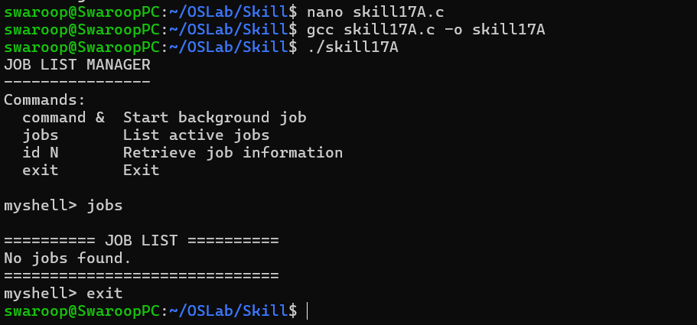

Part-B :

Code (17B) :

#include <stdio.h>
#include <stdlib.h>
#include <string.h>
#include <unistd.h>
#include <signal.h>
#include <sys/types.h>
#include <sys/wait.h>
#include <termios.h>

#define MAX_JOBS 20
#define INPUT_SIZE 256
#define CMD_SIZE 128

typedef enum
{
JOB_RUNNING,
JOB_STOPPED,
JOB_DONE
} JobState;

typedef struct
{
int job_id;
pid_t pid;
pid_t pgid;
char command[CMD_SIZE];
JobState state;
} Job;

Job jobs[MAX_JOBS];
int job_count = 0;
int next_job_id = 1;

/* Convert state to string */
const char *state_name(JobState state)
{
switch (state)
{
case JOB_RUNNING:
return "Running";

case JOB_STOPPED:
return "Stopped";

case JOB_DONE:
return "Done";

default:
return "Unknown";
}
}

/* Add job */
void add_job(pid_t pid, pid_t pgid, const char *command)
{
if (job_count >= MAX_JOBS)
{
printf("Job table full.\n");
return;
}

jobs[job_count].job_id = next_job_id++;
jobs[job_count].pid = pid;
jobs[job_count].pgid = pgid;
jobs[job_count].state = JOB_RUNNING;

strncpy(jobs[job_count].command,
command,
CMD_SIZE - 1);

jobs[job_count].command[CMD_SIZE - 1] = '\0';

job_count++;
}

/* Find job by ID */
int find_job(int id)
{
for (int i = 0; i < job_count; i++)
{
if (jobs[i].job_id == id)
return i;
}

return -1;
}

/* Display jobs */
void list_jobs(void)
{
printf("\n------ JOBS ------\n");

for (int i = 0; i < job_count; i++)
{
printf("[%d] PID=%d PGID=%d %-8s %s\n",
jobs[i].job_id,
jobs[i].pid,
jobs[i].pgid,
state_name(jobs[i].state),
jobs[i].command);
}

printf("------------------\n");
}

/* Start background job */
void start_job(char *command)
{
pid_t pid = fork();

if (pid < 0)
{
perror("fork");
return;
}

if (pid == 0)
{
/*
* Child creates its own process group.
*/
setpgid(0, 0);

/*
* Restore default signal handling.
*/
signal(SIGINT, SIG_DFL);
signal(SIGTSTP, SIG_DFL);
signal(SIGTTIN, SIG_DFL);
signal(SIGTTOU, SIG_DFL);

char *args[64];
int argc = 0;

char *token = strtok(command, " ");

while (token != NULL && argc < 63)
{
args[argc++] = token;
token = strtok(NULL, " ");
}

args[argc] = NULL;

if (argc == 0)
exit(EXIT_SUCCESS);

execvp(args[0], args);

perror("execvp");
exit(EXIT_FAILURE);
}

/*
* Parent places child into its own process group.
*/
setpgid(pid, pid);

add_job(pid, pid, command);

printf("[%d] %d started in background\n",
next_job_id - 1,
pid);
}

/* Bring job to foreground */
void foreground_job(int job_id)
{
int index = find_job(job_id);

if (index == -1)
{
printf("Job %d not found.\n", job_id);
return;
}

Job *job = &jobs[index];

printf("Bringing job [%d] to foreground...\n",
job->job_id);

/*
* Give terminal control to the job's
* process group.
*/
if (tcsetpgrp(STDIN_FILENO, job->pgid) == -1)
{
perror("tcsetpgrp");
return;
}

/*
* If the process was stopped,
* resume it using SIGCONT.
*/
if (job->state == JOB_STOPPED)
{
if (kill(-job->pgid, SIGCONT) == -1)
{
perror("SIGCONT");
}
else
{
job->state = JOB_RUNNING;
}
}

/*
* Wait until the process exits or stops.
*/
int status;

if (waitpid(job->pid,
&status,
WUNTRACED | WCONTINUED) == -1)
{
perror("waitpid");
}
else
{
if (WIFEXITED(status))
{
printf("Job [%d] exited normally.\n",
job->job_id);

job->state = JOB_DONE;
}
else if (WIFSIGNALED(status))
{
printf("Job [%d] terminated by signal.\n",
job->job_id);

job->state = JOB_DONE;
}
else if (WIFSTOPPED(status))
{
printf("Job [%d] stopped.\n",
job->job_id);

job->state = JOB_STOPPED;
}
else if (WIFCONTINUED(status))
{
printf("Job [%d] continued.\n",
job->job_id);

job->state = JOB_RUNNING;
}
}

/*
* Give terminal control back to shell.
*/
if (tcsetpgrp(STDIN_FILENO, getpgrp()) == -1)
{
perror("tcsetpgrp");
}

printf("Terminal control returned to shell.\n");
}

int main(void)
{
char input[INPUT_SIZE];

printf("FOREGROUND JOB CONTROL\n");
printf("----------------------\n");

printf("Commands:\n");
printf(" command & Start background job\n");
printf(" jobs List jobs\n");
printf(" fg N Bring job N to foreground\n");
printf(" exit Exit\n\n");

/*
* Make shell its own process group.
*/
setpgid(0, 0);

while (1)
{
printf("myshell> ");
fflush(stdout);

if (fgets(input,
sizeof(input),
stdin) == NULL)
{
break;
}

input[strcspn(input, "\n")] = '\0';

if (strcmp(input, "exit") == 0)
break;

if (strcmp(input, "jobs") == 0)
{
list_jobs();
continue;
}

/*
* fg command
*/
if (strncmp(input, "fg ", 3) == 0)
{
int job_id = atoi(input + 3);

foreground_job(job_id);

continue;
}

if (strlen(input) == 0)
continue;

size_t len = strlen(input);

/*
* Background command
*/
if (input[len - 1] == '&')
{
input[len - 1] = '\0';

while (strlen(input) > 0 &&
input[strlen(input) - 1] == ' ')
{
input[strlen(input) - 1] = '\0';
}

char command_copy[CMD_SIZE];

strncpy(command_copy,
input,
CMD_SIZE - 1);

command_copy[CMD_SIZE - 1] = '\0';

start_job(command_copy);
}
else
{
printf("Use '&' to start a background job.\n");
}
}

return 0;
}

Output :

