Skill – 18

- To Analyze Signal Delivery, Understand Signal Masks, Review Process Groups, Explore Terminal Signals, Test Signal Behavior.

To implement how to resume Stopped Jobs, Send Continue Signals, Update Job Status, Maintain Job Table, Verify Execution, Test Background Recovery

Code(18A) :

#include <stdio.h>
#include <stdlib.h>
#include <unistd.h>
#include <signal.h>
#include <sys/types.h>
#include <sys/wait.h>

volatile sig_atomic_t signal_received = 0;

/* Signal handler */
void handle_signal(int sig)
{
signal_received = sig;

if (sig == SIGINT)
printf("\nChild: SIGINT received\n");

else if (sig == SIGTERM)
printf("Child: SIGTERM received\n");

else if (sig == SIGUSR1)
printf("Child: SIGUSR1 received\n");

fflush(stdout);
}

int main(void)
{
pid_t pid;

printf("Signal Delivery and Process Group Demo\n");
printf("---------------------------------------\n");

pid = fork();

if (pid < 0)
{
perror("fork");
return 1;
}

if (pid == 0)
{
/* Child process */

printf("Child PID : %d\n", getpid());
printf("Parent PID : %d\n", getppid());
printf("Child PGID : %d\n", getpgrp());

/* Install signal handlers */
signal(SIGINT, handle_signal);
signal(SIGTERM, handle_signal);
signal(SIGUSR1, handle_signal);

/*
* Create a signal mask.
* SIGUSR1 will temporarily be blocked.
*/
sigset_t mask;

sigemptyset(&mask);
sigaddset(&mask, SIGUSR1);

if (sigprocmask(SIG_BLOCK, &mask, NULL) == -1)
{
perror("sigprocmask");
exit(EXIT_FAILURE);
}

printf("\nChild: SIGUSR1 is now BLOCKED.\n");
printf("Child: Waiting for signals...\n");

for (int i = 0; i < 10; i++)
{
printf("Child running... %d\n", i + 1);
sleep(1);
}

/*
* Unblock SIGUSR1.
* If SIGUSR1 was sent while blocked,
* it can now be delivered.
*/
printf("\nChild: Unblocking SIGUSR1...\n");

if (sigprocmask(SIG_UNBLOCK, &mask, NULL) == -1)
{
perror("sigprocmask");
exit(EXIT_FAILURE);
}

sleep(2);

printf("Child: Finished.\n");
exit(EXIT_SUCCESS);
}
else
{
/* Parent process */

printf("Parent PID : %d\n", getpid());
printf("Child PID : %d\n", pid);

sleep(2);

printf("\nParent: Sending SIGUSR1...\n");

if (kill(pid, SIGUSR1) == -1)
perror("kill");

sleep(2);

printf("Parent: Sending SIGINT...\n");

if (kill(pid, SIGINT) == -1)
perror("kill");

sleep(2);

printf("Parent: Sending SIGTERM...\n");

if (kill(pid, SIGTERM) == -1)
perror("kill");

waitpid(pid, NULL, 0);

printf("\nParent: Child completed.\n");
}

return 0;
}

OUTPUT :
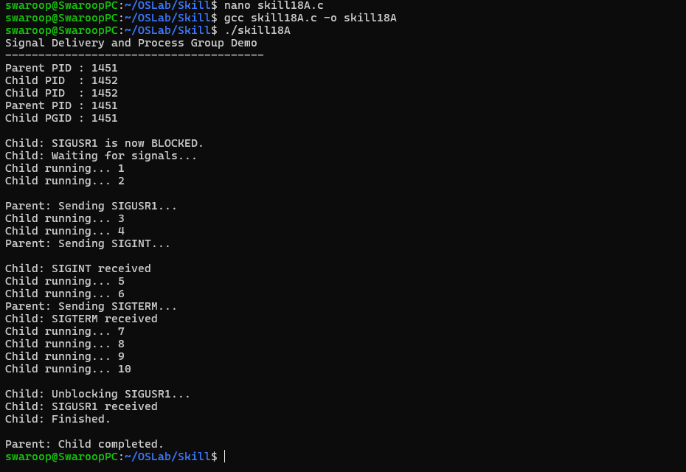

Part-B :

Code (18B) :

#include <stdio.h>
#include <stdlib.h>
#include <string.h>
#include <unistd.h>
#include <signal.h>
#include <sys/types.h>
#include <sys/wait.h>

#define MAX_JOBS 20
#define INPUT_SIZE 256
#define CMD_SIZE 128

typedef enum
{
JOB_RUNNING,
JOB_STOPPED,
JOB_DONE
} JobState;

typedef struct
{
int job_id;
pid_t pid;
pid_t pgid;
char command[CMD_SIZE];
JobState state;
} Job;

Job jobs[MAX_JOBS];
int job_count = 0;
int next_job_id = 1;

/* Convert job state to text */
const char *state_name(JobState state)
{
switch (state)
{
case JOB_RUNNING:
return "Running";

case JOB_STOPPED:
return "Stopped";

case JOB_DONE:
return "Done";

default:
return "Unknown";
}
}

/* Find job using job ID */
int find_job(int job_id)
{
for (int i = 0; i < job_count; i++)
{
if (jobs[i].job_id == job_id)
return i;
}

return -1;
}

/* Add a new job */
void add_job(pid_t pid, pid_t pgid, const char *command)
{
if (job_count >= MAX_JOBS)
{
printf("Job table is full.\n");
return;
}

jobs[job_count].job_id = next_job_id++;
jobs[job_count].pid = pid;
jobs[job_count].pgid = pgid;
jobs[job_count].state = JOB_RUNNING;

strncpy(jobs[job_count].command,
command,
CMD_SIZE - 1);

jobs[job_count].command[CMD_SIZE - 1] = '\0';

printf("[%d] PID=%d started\n",
jobs[job_count].job_id,
pid);

job_count++;
}

/* Display job table */
void list_jobs(void)
{
printf("\n========== JOB TABLE ==========\n");

if (job_count == 0)
{
printf("No jobs.\n");
printf("===============================\n");
return;
}

printf("%-5s %-8s %-8s %-10s %s\n",
"JOB",
"PID",
"PGID",
"STATE",
"COMMAND");

printf("-----------------------------------------------\n");

for (int i = 0; i < job_count; i++)
{
printf("%-5d %-8d %-8d %-10s %s\n",
jobs[i].job_id,
jobs[i].pid,
jobs[i].pgid,
state_name(jobs[i].state),
jobs[i].command);
}

printf("===============================================\n");
}

/* Check and update job states */
void update_jobs(void)
{
for (int i = 0; i < job_count; i++)
{
int status;

pid_t result = waitpid(
jobs[i].pid,
&status,
WNOHANG | WUNTRACED | WCONTINUED
);

if (result == jobs[i].pid)
{
if (WIFSTOPPED(status))
{
jobs[i].state = JOB_STOPPED;

printf("\n[%d] Stopped - %s\n",
jobs[i].job_id,
jobs[i].command);
}
else if (WIFCONTINUED(status))
{
jobs[i].state = JOB_RUNNING;

printf("\n[%d] Continued - %s\n",
jobs[i].job_id,
jobs[i].command);
}
else if (WIFEXITED(status))
{
jobs[i].state = JOB_DONE;

printf("\n[%d] Done - %s\n",
jobs[i].job_id,
jobs[i].command);
}
else if (WIFSIGNALED(status))
{
jobs[i].state = JOB_DONE;

printf("\n[%d] Terminated - %s\n",
jobs[i].job_id,
jobs[i].command);
}
}
}
}

/* Stop a running job */
void stop_job(int job_id)
{
int index = find_job(job_id);

if (index == -1)
{
printf("Job %d not found.\n", job_id);
return;
}

if (jobs[index].state != JOB_RUNNING)
{
printf("Job %d is not running.\n", job_id);
return;
}

/*
* Negative PGID sends the signal to the
* complete process group.
*/
if (kill(-jobs[index].pgid, SIGSTOP) == -1)
{
perror("SIGSTOP");
return;
}

jobs[index].state = JOB_STOPPED;

printf("[%d] Job stopped.\n", job_id);
}

/* Resume a stopped job */
void resume_job(int job_id)
{
int index = find_job(job_id);

if (index == -1)
{
printf("Job %d not found.\n", job_id);
return;
}

if (jobs[index].state != JOB_STOPPED)
{
printf("Job %d is not stopped.\n", job_id);
return;
}

printf("Sending SIGCONT to job [%d]...\n",
job_id);

/*
* Send SIGCONT to the entire process group.
*/
if (kill(-jobs[index].pgid, SIGCONT) == -1)
{
perror("SIGCONT");
return;
}

jobs[index].state = JOB_RUNNING;

printf("[%d] Job resumed.\n", job_id);
}

/* Start a background command */
void start_background(char *command)
{
pid_t pid = fork();

if (pid < 0)
{
perror("fork");
return;
}

if (pid == 0)
{
/*
* Create a new process group.
*/
setpgid(0, 0);

/*
* Restore default signal behavior.
*/
signal(SIGINT, SIG_DFL);
signal(SIGTSTP, SIG_DFL);
signal(SIGCONT, SIG_DFL);

char *args[64];
int argc = 0;

char *token = strtok(command, " ");

while (token != NULL && argc < 63)
{
args[argc++] = token;
token = strtok(NULL, " ");
}

args[argc] = NULL;

if (argc == 0)
exit(EXIT_SUCCESS);

execvp(args[0], args);

perror("execvp");
exit(EXIT_FAILURE);
}

/*
* Parent places child in its own process group.
*/
setpgid(pid, pid);

add_job(pid, pid, command);
}

int main(void)
{
char input[INPUT_SIZE];

printf("BACKGROUND JOB RECOVERY SYSTEM\n");
printf("--------------------------------\n");

printf("Commands:\n");
printf(" command & Start background job\n");
printf(" jobs Display job table\n");
printf(" stop N Stop job N\n");
printf(" resume N Resume stopped job N\n");
printf(" exit Exit\n\n");

while (1)
{
/*
* Check whether any job changed state.
*/
update_jobs();

printf("myshell> ");
fflush(stdout);

if (fgets(input,
sizeof(input),
stdin) == NULL)
{
break;
}

input[strcspn(input, "\n")] = '\0';

if (strcmp(input, "exit") == 0)
break;

if (strcmp(input, "jobs") == 0)
{
list_jobs();
continue;
}

/* stop N */
if (strncmp(input, "stop ", 5) == 0)
{
int job_id = atoi(input + 5);

stop_job(job_id);

continue;
}

/* resume N */
if (strncmp(input, "resume ", 7) == 0)
{
int job_id = atoi(input + 7);

resume_job(job_id);

continue;
}

if (strlen(input) == 0)
continue;

size_t len = strlen(input);

/*
* Check for background command.
*/
if (input[len - 1] == '&')
{
input[len - 1] = '\0';

while (strlen(input) > 0 &&
input[strlen(input) - 1] == ' ')
{
input[strlen(input) - 1] = '\0';
}

char command_copy[CMD_SIZE];

strncpy(command_copy,
input,
CMD_SIZE - 1);

command_copy[CMD_SIZE - 1] = '\0';

start_background(command_copy);
}
else
{
printf("Use '&' to start a background job.\n");
}
}

return 0;
}

Output :

