Skill – 19

- To Register Handlers, Configure Signal Actions, Handle Interrupts, Manage Signal Context, Verify Stability, Test Signal Events.
To Capture SIGINT, Forward Signals, Protect Shell Process, Terminate Foreground Jobs, Update Job States, Test Interrupt Handling

Code(19A) :

#include <stdio.h>
#include <stdlib.h>
#include <unistd.h>
#include <signal.h>
#include <string.h>

volatile sig_atomic_t sigint_count = 0;
volatile sig_atomic_t sigusr1_count = 0;

/* SIGINT handler */
void handle_sigint(int sig)
{
(void)sig;

sigint_count++;

write(STDOUT_FILENO,
"\nSIGINT received!\n",
18);
}

/* SIGUSR1 handler */
void handle_sigusr1(int sig)
{
(void)sig;

sigusr1_count++;

write(STDOUT_FILENO,
"SIGUSR1 received!\n",
19);
}

int main(void)
{
struct sigaction sa_int;
struct sigaction sa_usr1;

printf("SIGNAL HANDLER DEMO\n");
printf("-------------------\n");

/*
* Configure SIGINT handler.
*/
memset(&sa_int, 0, sizeof(sa_int));

sa_int.sa_handler = handle_sigint;

sigemptyset(&sa_int.sa_mask);

sa_int.sa_flags = SA_RESTART;

if (sigaction(SIGINT, &sa_int, NULL) == -1)
{
perror("sigaction SIGINT");
return 1;
}

/*
* Configure SIGUSR1 handler.
*/
memset(&sa_usr1, 0, sizeof(sa_usr1));

sa_usr1.sa_handler = handle_sigusr1;

sigemptyset(&sa_usr1.sa_mask);

sa_usr1.sa_flags = SA_RESTART;

if (sigaction(SIGUSR1, &sa_usr1, NULL) == -1)
{
perror("sigaction SIGUSR1");
return 1;
}

printf("Process PID: %d\n", getpid());

printf("\nHandlers registered successfully.\n");

printf("Press Ctrl+C to generate SIGINT.\n");
printf("From another terminal use:\n");
printf("kill -SIGUSR1 %d\n", getpid());
printf("\nPress Ctrl+Z to stop the program.\n\n");

while (1)
{
printf("Program is running...\n");
sleep(2);
}

return 0;
}

OUTPUT :
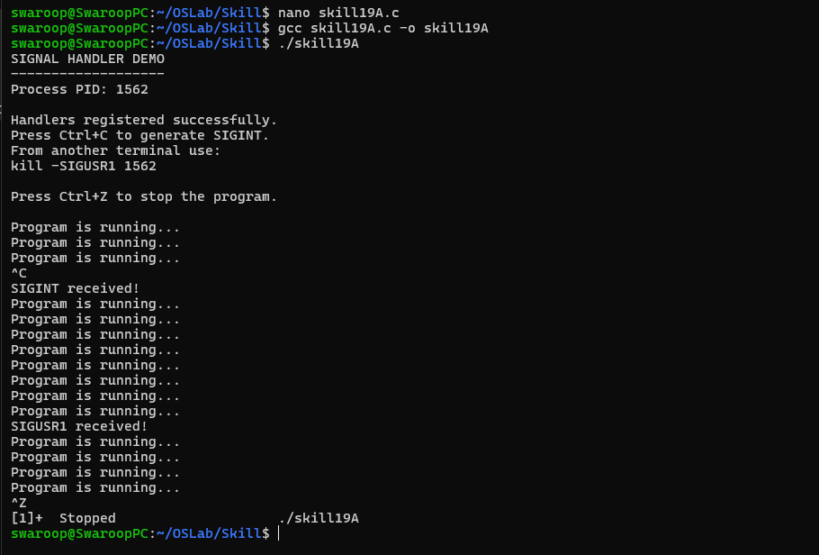

Part-B :

Code (19B) :

#include <stdio.h>
#include <stdlib.h>
#include <string.h>
#include <unistd.h>
#include <signal.h>
#include <sys/types.h>
#include <sys/wait.h>
#include <errno.h>

#define INPUT_SIZE 256
#define CMD_SIZE 128

volatile sig_atomic_t foreground_pgid = 0;

/*
* SIGINT handler for the shell.
*
* The shell itself is protected.
* SIGINT is forwarded to the foreground
* process group.
*/
void handle_sigint(int sig)
{
(void)sig;

if (foreground_pgid > 0)
{
/*
* Negative PGID sends the signal
* to the complete process group.
*/
kill(-foreground_pgid, SIGINT);
}
else
{
write(STDOUT_FILENO,
"\nShell: SIGINT ignored.\nmyshell> ",
31);
}
}

/*
* Start foreground command.
*/
void run_foreground(char *command)
{
pid_t pid;
int status;

pid = fork();

if (pid < 0)
{
perror("fork");
return;
}

if (pid == 0)
{
/*
* Child creates its own process group.
*/
setpgid(0, 0);

/*
* Child uses default SIGINT behavior.
*/
signal(SIGINT, SIG_DFL);

signal(SIGTSTP, SIG_DFL);

char *args[64];
int argc = 0;

char *token = strtok(command, " ");

while (token != NULL && argc < 63)
{
args[argc++] = token;
token = strtok(NULL, " ");
}

args[argc] = NULL;

if (argc == 0)
exit(EXIT_SUCCESS);

execvp(args[0], args);

perror("execvp");
exit(EXIT_FAILURE);
}

/*
* Parent also assigns child to its
* own process group.
*/
setpgid(pid, pid);

foreground_pgid = pid;

printf("Foreground job started.\n");
printf("PID : %d\n", pid);
printf("PGID: %d\n", pid);
printf("Press Ctrl+C to terminate it.\n");

/*
* Wait for foreground job.
*/
while (1)
{
pid_t result = waitpid(
pid,
&status,
WUNTRACED
);

if (result == -1)
{
if (errno == EINTR)
continue;

perror("waitpid");
break;
}

if (WIFEXITED(status))
{
printf("\nJob completed normally.\n");
printf("Exit status: %d\n",
WEXITSTATUS(status));

break;
}

if (WIFSIGNALED(status))
{
printf("\nForeground job terminated.\n");
printf("Signal: %d\n",
WTERMSIG(status));

break;
}

if (WIFSTOPPED(status))
{
printf("\nForeground job stopped.\n");

break;
}
}

/*
* Foreground job is no longer active.
*/
foreground_pgid = 0;

printf("Job state updated: DONE/STOPPED\n");
}

/*
* Install shell signal handler.
*/
void setup_signal_handler(void)
{
struct sigaction sa;

memset(&sa, 0, sizeof(sa));

sa.sa_handler = handle_sigint;

sigemptyset(&sa.sa_mask);

sa.sa_flags = SA_RESTART;

if (sigaction(SIGINT, &sa, NULL) == -1)
{
perror("sigaction");
exit(EXIT_FAILURE);
}
}

int main(void)
{
char input[INPUT_SIZE];

printf("SIMPLE SIGNAL-AWARE SHELL\n");
printf("-------------------------\n");

/*
* Configure SIGINT handler for shell.
*/
setup_signal_handler();

printf("Shell PID: %d\n", getpid());

printf("\nThe shell will survive Ctrl+C.\n");
printf("Ctrl+C is forwarded to foreground jobs.\n\n");

while (1)
{
printf("myshell> ");
fflush(stdout);

if (fgets(input,
sizeof(input),
stdin) == NULL)
{
break;
}

input[strcspn(input, "\n")] = '\0';

if (strcmp(input, "exit") == 0)
{
printf("Shell exiting.\n");
break;
}

if (strlen(input) == 0)
continue;

/*
* Run command in foreground.
*/
char command_copy[CMD_SIZE];

strncpy(command_copy,
input,
CMD_SIZE - 1);

command_copy[CMD_SIZE - 1] = '\0';

run_foreground(command_copy);
}

return 0;
}

Output :

