Skill – 21

- To Connect Modules, Validate Interfaces, Test End-to-End Execution, Handle Errors, Improve Reliability, Refactor Components.
To Detect Runtime Errors, Generate Messages, Log Failures, Handle Invalid Syntax, Recover Gracefully, Test Error Scenarios

Code(21A) :

#include <stdio.h>
#include <stdlib.h>
#include <string.h>
#include <unistd.h>
#include <sys/types.h>
#include <sys/wait.h>

#define INPUT_SIZE 256
#define MAX_ARGS 32

/* ---------- Module 1: Command Parser ---------- */

int parse_command(char *input, char *args[])
{
int count = 0;

char *token = strtok(input, " ");

while (token != NULL && count < MAX_ARGS - 1)
{
args[count++] = token;
token = strtok(NULL, " ");
}

args[count] = NULL;

return count;
}

/* ---------- Module 2: Interface Validation ---------- */

int validate_command(char *args[], int count)
{
if (count == 0)
{
printf("Error: Empty command.\n");
return 0;
}

if (args[0] == NULL)
{
printf("Error: Invalid command interface.\n");
return 0;
}

return 1;
}

/* ---------- Module 3: Process Execution ---------- */

int execute_command(char *args[])
{
pid_t pid;
int status;

pid = fork();

if (pid < 0)
{
perror("fork");
return -1;
}

if (pid == 0)
{
execvp(args[0], args);

perror("execvp");
exit(EXIT_FAILURE);
}

if (waitpid(pid, &status, 0) == -1)
{
perror("waitpid");
return -1;
}

if (WIFEXITED(status))
{
return WEXITSTATUS(status);
}

if (WIFSIGNALED(status))
{
printf("Process terminated by signal %d\n",
WTERMSIG(status));

return -1;
}

return -1;
}

/* ---------- Module 4: Error Handling ---------- */

void handle_result(int result)
{
if (result == 0)
{
printf("Command completed successfully.\n");
}
else
{
printf("Command failed with status %d.\n",
result);
}
}

/* ---------- Main Integration Module ---------- */

int main(void)
{
char input[INPUT_SIZE];

printf("MODULE INTEGRATION SHELL\n");
printf("------------------------\n");
printf("Type commands such as: ls, pwd, date\n");
printf("Type 'exit' to quit.\n\n");

while (1)
{
char *args[MAX_ARGS];

printf("myshell> ");
fflush(stdout);

if (fgets(input,
sizeof(input),
stdin) == NULL)
{
printf("\nInput error or EOF.\n");
break;
}

input[strcspn(input, "\n")] = '\0';

/* Exit */
if (strcmp(input, "exit") == 0)
{
printf("Shell terminated.\n");
break;
}

/* Parse */
int count = parse_command(input, args);

/* Validate */
if (!validate_command(args, count))
{
continue;
}

/* Execute */
int result = execute_command(args);

/* Handle result */
handle_result(result);
}

return 0;
}

OUTPUT :
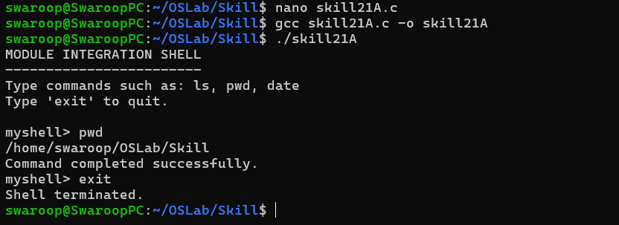

Part-B :

Code (21B) :

#include <stdio.h>
#include <stdlib.h>
#include <string.h>
#include <unistd.h>
#include <sys/types.h>
#include <sys/wait.h>
#include <errno.h>
#include <time.h>

#define INPUT_SIZE 256
#define MAX_ARGS 32
#define LOG_FILE "shell_errors.log"

/* Write error information to log file */
void log_error(const char *message)
{
FILE *file = fopen(LOG_FILE, "a");

if (file == NULL)
{
perror("Cannot open log file");
return;
}

time_t now = time(NULL);

fprintf(file,
"[%s] %s\n",
ctime(&now),
message);

fclose(file);
}

/* Display and log error */
void report_error(const char *message)
{
fprintf(stderr, "Error: %s\n", message);

log_error(message);
}

/* Check command syntax */
int validate_syntax(char *input)
{
if (input == NULL || strlen(input) == 0)
{
report_error("Empty command.");
return 0;
}

/* Command cannot start with pipe */
if (input[0] == '|')
{
report_error("Invalid syntax: command starts with '|'.");
return 0;
}

/* Command cannot end with pipe */
size_t len = strlen(input);

if (len > 0 && input[len - 1] == '|')
{
report_error("Invalid syntax: command ends with '|'.");
return 0;
}

/* Detect consecutive pipes */
if (strstr(input, "||") != NULL)
{
report_error("Invalid syntax: consecutive pipes.");
return 0;
}

return 1;
}

/* Parse command */
int parse_command(char *input, char *args[])
{
int count = 0;

char *token = strtok(input, " ");

while (token != NULL && count < MAX_ARGS - 1)
{
args[count++] = token;
token = strtok(NULL, " ");
}

args[count] = NULL;

if (count == 0)
{
report_error("No command found.");
return -1;
}

return count;
}

/* Execute command */
int execute_command(char *args[])
{
pid_t pid = fork();

if (pid < 0)
{
report_error("Unable to create process.");
return -1;
}

if (pid == 0)
{
execvp(args[0], args);

/*
* execvp failed.
*/
fprintf(stderr,
"Runtime error: cannot execute '%s': %s\n",
args[0],
strerror(errno));

exit(127);
}

int status;

if (waitpid(pid, &status, 0) == -1)
{
report_error("waitpid() failed.");
return -1;
}

if (WIFEXITED(status))
{
int exit_code = WEXITSTATUS(status);

if (exit_code != 0)
{
char message[INPUT_SIZE];

snprintf(message,
sizeof(message),
"Command '%s' exited with status %d.",
args[0],
exit_code);

log_error(message);
}

return exit_code;
}

if (WIFSIGNALED(status))
{
char message[INPUT_SIZE];

snprintf(message,
sizeof(message),
"Command '%s' terminated by signal %d.",
args[0],
WTERMSIG(status));

report_error(message);

return -1;
}

return -1;
}

int main(void)
{
char input[INPUT_SIZE];

printf("ERROR HANDLING SHELL\n");
printf("--------------------\n");

printf("Commands:\n");
printf(" Normal command -> execute\n");
printf(" Invalid command -> display and log error\n");
printf(" exit -> terminate shell\n\n");

while (1)
{
char *args[MAX_ARGS];

printf("myshell> ");
fflush(stdout);

if (fgets(input,
sizeof(input),
stdin) == NULL)
{
printf("\nInput closed. Exiting safely.\n");
break;
}

input[strcspn(input, "\n")] = '\0';

/* Exit */
if (strcmp(input, "exit") == 0)
{
printf("Shell terminated safely.\n");
break;
}

/* Validate syntax */
if (!validate_syntax(input))
{
printf("Recovering... Enter another command.\n");
continue;
}

/* Parse */
int count = parse_command(input, args);

if (count < 0)
{
printf("Recovering... Enter another command.\n");
continue;
}

/* Execute */
int result = execute_command(args);

if (result == 0)
{
printf("Command executed successfully.\n");
}
else
{
printf("Command failed, but shell continues.\n");
}
}

return 0;
}

Output :

