Skill – 22

- To Run Valgrind, Identify Leaks, Fix Memory Errors, Release Resources, Verify Cleanup, Document Findings.
To Design Test Cases, Create Test Scripts, Automate Execution, Verify Outputs, Compare Results, Generate Reports.

Code(22A) :

#include <stdio.h>
#include <stdlib.h>
#include <string.h>

#define BUFFER_SIZE 100

/* Allocate memory */
char *create_message(const char *text)
{
size_t length = strlen(text) + 1;

char *buffer = malloc(length);

if (buffer == NULL)
{
perror("malloc");
return NULL;
}

strcpy(buffer, text);

return buffer;
}

/* Process allocated memory */
void process_message(char *message)
{
if (message == NULL)
return;

printf("Message: %s\n", message);
}

/* Release memory */
void cleanup(char *message)
{
if (message != NULL)
{
free(message);
message = NULL;
}
}

int main(void)
{
char *message;
char *second_buffer;

printf("VALGRIND MEMORY TEST\n");
printf("--------------------\n");

/* Allocate memory */
message = create_message(
"Operating Systems Memory Test"
);

if (message == NULL)
{
return EXIT_FAILURE;
}

/* Use allocated memory */
process_message(message);

/*
* Allocate another block.
* This block will also be released.
*/
second_buffer = malloc(BUFFER_SIZE);

if (second_buffer == NULL)
{
perror("malloc");

cleanup(message);

return EXIT_FAILURE;
}

strcpy(second_buffer,
"Temporary buffer");

printf("%s\n", second_buffer);

/*
* Release all allocated memory.
*/
free(second_buffer);
second_buffer = NULL;

cleanup(message);

printf("\nMemory cleanup completed.\n");

return EXIT_SUCCESS;
}

OUTPUT :
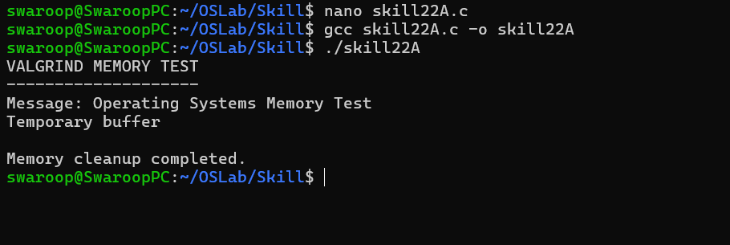

Part-B :

Code (22B) :

#include <stdio.h>
#include <stdlib.h>
#include <string.h>

#define MAX_TESTS 10
#define OUTPUT_SIZE 1024

typedef struct
{
char name[50];
char command[200];
char expected[200];
} TestCase;

/* Execute command and capture output */
int run_test(TestCase *test)
{
char command[300];
char output[OUTPUT_SIZE];

/*
* Redirect command output to temporary file.
*/
snprintf(command,
sizeof(command),
"%s > test_output.txt 2>&1",
test->command);

int status = system(command);

if (status == -1)
{
return 0;
}

FILE *file = fopen("test_output.txt", "r");

if (file == NULL)
{
return 0;
}

size_t bytes_read = fread(
output,
1,
sizeof(output) - 1,
file
);

output[bytes_read] = '\0';

fclose(file);

/*
* Compare expected text with actual output.
*/
if (strstr(output, test->expected) != NULL)
{
return 1;
}

return 0;
}

/* Generate test report */
void generate_report(TestCase tests[],
int results[],
int count)
{
FILE *report = fopen("test_report.txt", "w");

if (report == NULL)
{
perror("report");
return;
}

int passed = 0;

fprintf(report,
"OPERATING SYSTEM TEST REPORT\n");

fprintf(report,
"============================\n\n");

for (int i = 0; i < count; i++)
{
fprintf(report,
"Test %d: %s\n",
i + 1,
tests[i].name);

fprintf(report,
"Command : %s\n",
tests[i].command);

fprintf(report,
"Expected: %s\n",
tests[i].expected);

if (results[i])
{
fprintf(report,
"Result : PASS\n\n");

passed++;
}
else
{
fprintf(report,
"Result : FAIL\n\n");
}
}

fprintf(report,
"============================\n");

fprintf(report,
"Total Tests : %d\n",
count);

fprintf(report,
"Passed : %d\n",
passed);

fprintf(report,
"Failed : %d\n",
count - passed);

fprintf(report,
"============================\n");

fclose(report);
}

int main(void)
{
TestCase tests[MAX_TESTS] =
{
{
"Print working directory",
"pwd",
"/"
},

{
"Display date",
"date",
"202"
},

{
"Display current user",
"whoami",
""
},

{
"Echo test",
"echo OS_TEST",
"OS_TEST"
},

{
"List directory",
"ls",
""
}
};

int test_count = 5;
int results[MAX_TESTS];

printf("AUTOMATED TEST RUNNER\n");
printf("=====================\n\n");

for (int i = 0; i < test_count; i++)
{
printf("Running Test %d: %s\n",
i + 1,
tests[i].name);

results[i] = run_test(&tests[i]);

if (results[i])
{
printf("Result: PASS\n\n");
}
else
{
printf("Result: FAIL\n\n");
}
}

generate_report(
tests,
results,
test_count
);

printf("Test execution completed.\n");
printf("Report generated: test_report.txt\n");

return 0;
}

Output :

