Skill – 23

- To Execute Large Pipelines, Launch Multiple Jobs, Measure Stability, Monitor Resources, Detect Failures, Analyze Performance.
To Document Architecture, Create Flow Diagrams, Explain Execution Paths, Describe Syscalls, Record Design Decisions, Review Documentation.

Code(23A) :

#include <stdio.h>
#include <stdlib.h>
#include <unistd.h>
#include <sys/types.h>
#include <sys/wait.h>
#include <sys/resource.h>
#include <string.h>
#include <time.h>
#include <errno.h>

#define PIPE_COUNT 4
#define BUFFER_SIZE 256

/*
* Execute:
*
* ls -l
* |
* v
* grep ".c"
* |
* v
* sort
* |
* v
* wc -l
* |
* v
* cat
*
* This demonstrates a multi-stage pipeline.
*/

int main(void)
{
int pipes[PIPE_COUNT - 1][2];
pid_t pids[PIPE_COUNT];

char *commands[PIPE_COUNT][4] =
{
{"ls", "-l", NULL, NULL},
{"grep", ".c", NULL, NULL},
{"sort", NULL, NULL, NULL},
{"wc", "-l", NULL, NULL}
};

struct timespec start, end;

printf("LARGE PIPELINE EXECUTION\n");
printf("=========================\n");

/*
* Start performance timer.
*/
if (clock_gettime(CLOCK_MONOTONIC, &start) == -1)
{
perror("clock_gettime");
return EXIT_FAILURE;
}

/*
* Create pipes.
*/
for (int i = 0; i < PIPE_COUNT - 1; i++)
{
if (pipe(pipes[i]) == -1)
{
perror("pipe");
return EXIT_FAILURE;
}
}

/*
* Create processes.
*/
for (int i = 0; i < PIPE_COUNT; i++)
{
pids[i] = fork();

if (pids[i] < 0)
{
perror("fork");
return EXIT_FAILURE;
}

if (pids[i] == 0)
{
/*
* Connect input from previous pipe.
*/
if (i > 0)
{
if (dup2(pipes[i - 1][0],
STDIN_FILENO) == -1)
{
perror("dup2 stdin");
exit(EXIT_FAILURE);
}
}

/*
* Connect output to next pipe.
*/
if (i < PIPE_COUNT - 1)
{
if (dup2(pipes[i][1],
STDOUT_FILENO) == -1)
{
perror("dup2 stdout");
exit(EXIT_FAILURE);
}
}

/*
* Close all pipe descriptors in child.
*/
for (int j = 0; j < PIPE_COUNT - 1; j++)
{
close(pipes[j][0]);
close(pipes[j][1]);
}

/*
* Execute command.
*/
execvp(commands[i][0], commands[i]);

/*
* execvp failed.
*/
perror(commands[i][0]);
exit(127);
}
}

/*
* Parent closes all pipe descriptors.
*/
for (int i = 0; i < PIPE_COUNT - 1; i++)
{
close(pipes[i][0]);
close(pipes[i][1]);
}

/*
* Wait for all pipeline processes.
*/
int failures = 0;

for (int i = 0; i < PIPE_COUNT; i++)
{
int status;

pid_t result;

do
{
result = waitpid(
pids[i],
&status,
0
);
}
while (result == -1 && errno == EINTR);

if (result == -1)
{
perror("waitpid");
failures++;
continue;
}

if (WIFEXITED(status))
{
int exit_code = WEXITSTATUS(status);

printf("Process PID %d completed: exit=%d\n",
pids[i],
exit_code);

if (exit_code != 0)
failures++;
}
else if (WIFSIGNALED(status))
{
printf("Process PID %d terminated by signal %d\n",
pids[i],
WTERMSIG(status));

failures++;
}
}

/*
* Stop performance timer.
*/
if (clock_gettime(CLOCK_MONOTONIC, &end) == -1)
{
perror("clock_gettime");
return EXIT_FAILURE;
}

double elapsed =
(end.tv_sec - start.tv_sec) +
(end.tv_nsec - start.tv_nsec) / 1000000000.0;

/*
* Resource usage.
*/
struct rusage usage;

if (getrusage(RUSAGE_CHILDREN, &usage) == -1)
{
perror("getrusage");
}
else
{
printf("\nResource Usage\n");
printf("--------------\n");
printf("User CPU time : %ld.%06ld sec\n",
usage.ru_utime.tv_sec,
usage.ru_utime.tv_usec);

printf("System CPU time : %ld.%06ld sec\n",
usage.ru_stime.tv_sec,
usage.ru_stime.tv_usec);

printf("Maximum memory : %ld KB\n",
usage.ru_maxrss);
}

printf("\nPerformance\n");
printf("-----------\n");
printf("Execution time : %.6f seconds\n",
elapsed);

printf("Pipeline stages : %d\n",
PIPE_COUNT);

printf("Failures : %d\n",
failures);

if (failures == 0)
{
printf("Status : STABLE\n");
}
else
{
printf("Status : FAILURE DETECTED\n");
}

return failures == 0
? EXIT_SUCCESS
: EXIT_FAILURE;
}

OUTPUT :
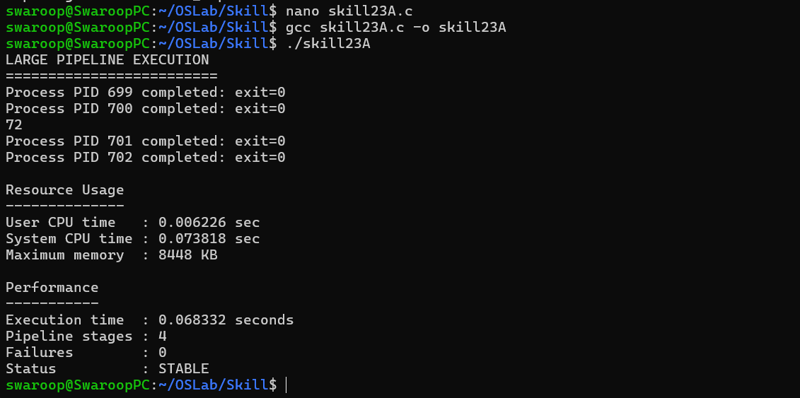

Part-B :

Code (23B) :

#include <stdio.h>
#include <stdlib.h>

#define REPORT_FILE "architecture_report.txt"

/* Write section heading */
void write_heading(FILE *file, const char *heading)
{
fprintf(file, "\n");
fprintf(file, "========================================\n");
fprintf(file, "%s\n", heading);
fprintf(file, "========================================\n");
}

/* Write architecture */
void document_architecture(FILE *file)
{
write_heading(file, "1. SYSTEM ARCHITECTURE");

fprintf(file,
"The system follows a shell-based process execution model.\n\n");

fprintf(file,
"Main Components:\n");

fprintf(file,
"1. Command Input Module\n");
fprintf(file,
"2. Command Parser\n");
fprintf(file,
"3. Process Creation Module\n");
fprintf(file,
"4. Pipeline / IPC Module\n");
fprintf(file,
"5. Process Execution Module\n");
fprintf(file,
"6. Process Monitoring Module\n");
fprintf(file,
"7. Error Handling Module\n");
}

/* Write flow diagram */
void document_flow(FILE *file)
{
write_heading(file, "2. EXECUTION FLOW DIAGRAM");

fprintf(file,
" +----------------+\n");
fprintf(file,
" | User Command |\n");
fprintf(file,
" +-------+--------+\n");
fprintf(file,
" |\n");
fprintf(file,
" v\n");
fprintf(file,
" +----------------+\n");
fprintf(file,
" | Command Parser |\n");
fprintf(file,
" +-------+--------+\n");
fprintf(file,
" |\n");
fprintf(file,
" v\n");
fprintf(file,
" +----------------+\n");
fprintf(file,
" | fork() |\n");
fprintf(file,
" +-------+--------+\n");
fprintf(file,
" |\n");
fprintf(file,
" v\n");
fprintf(file,
" +----------------+\n");
fprintf(file,
" | execvp() |\n");
fprintf(file,
" +-------+--------+\n");
fprintf(file,
" |\n");
fprintf(file,
" v\n");
fprintf(file,
" +----------------+\n");
fprintf(file,
" | waitpid() |\n");
fprintf(file,
" +-------+--------+\n");
fprintf(file,
" |\n");
fprintf(file,
" v\n");
fprintf(file,
" +----------------+\n");
fprintf(file,
" | Status Check |\n");
fprintf(file,
" +----------------+\n");
}

/* Document execution path */
void document_execution(FILE *file)
{
write_heading(file, "3. EXECUTION PATH");

fprintf(file,
"Step 1: User enters a command.\n");

fprintf(file,
"Step 2: Command is parsed into arguments.\n");

fprintf(file,
"Step 3: Parent creates a child using fork().\n");

fprintf(file,
"Step 4: Child executes the requested program using execvp().\n");

fprintf(file,
"Step 5: Parent waits using waitpid().\n");

fprintf(file,
"Step 6: Parent checks the exit status.\n");

fprintf(file,
"Step 7: Errors are reported if execution fails.\n");
}

/* Document system calls */
void document_syscalls(FILE *file)
{
write_heading(file, "4. SYSTEM CALLS USED");

fprintf(file,
"fork()\n");
fprintf(file,
" Creates a new child process.\n\n");

fprintf(file,
"execvp()\n");
fprintf(file,
" Replaces the child process with a new program.\n\n");

fprintf(file,
"waitpid()\n");
fprintf(file,
" Allows the parent to wait for a specific child.\n\n");

fprintf(file,
"pipe()\n");
fprintf(file,
" Creates an IPC communication channel.\n\n");

fprintf(file,
"dup2()\n");
fprintf(file,
" Duplicates file descriptors for redirection/pipelines.\n\n");

fprintf(file,
"getrusage()\n");
fprintf(file,
" Retrieves resource usage information.\n\n");

fprintf(file,
"kill()\n");
fprintf(file,
" Sends signals to processes or process groups.\n");
}

/* Document design decisions */
void document_design(FILE *file)
{
write_heading(file, "5. DESIGN DECISIONS");

fprintf(file,
"1. POSIX system calls are used for process management.\n");

fprintf(file,
"2. fork() and execvp() are separated to provide clear process control.\n");

fprintf(file,
"3. Pipes are used for communication between pipeline stages.\n");

fprintf(file,
"4. waitpid() is used to avoid zombie processes.\n");

fprintf(file,
"5. Return values are checked after important system calls.\n");

fprintf(file,
"6. Errors are reported using perror() or explicit messages.\n");

fprintf(file,
"7. Components are separated into logical modules.\n");
}

/* Review documentation */
void document_review(FILE *file)
{
write_heading(file, "6. DOCUMENTATION REVIEW");

fprintf(file,
"Architecture documented : YES\n");

fprintf(file,
"Execution path documented : YES\n");

fprintf(file,
"Flow diagram documented : YES\n");

fprintf(file,
"System calls documented : YES\n");

fprintf(file,
"Design decisions documented : YES\n");

fprintf(file,
"Error handling documented : YES\n");

fprintf(file,
"Resource monitoring documented: YES\n");

fprintf(file,
"\nDocumentation status: COMPLETE\n");
}

int main(void)
{
FILE *file;

printf("ARCHITECTURE DOCUMENTATION GENERATOR\n");
printf("=====================================\n");

file = fopen(REPORT_FILE, "w");

if (file == NULL)
{
perror("fopen");
return EXIT_FAILURE;
}

document_architecture(file);
document_flow(file);
document_execution(file);
document_syscalls(file);
document_design(file);
document_review(file);

fclose(file);

printf("\nDocumentation generated successfully.\n");
printf("File: %s\n", REPORT_FILE);

return EXIT_SUCCESS;
}

Output :

