Skill – 8

- To Detect Variable References, Expand Values, Handle Undefined Variables, Update Tokens, Support Nested Variables, Test Expansion Logic.

To Identify Built-ins, Create Dispatch Table, Execute In-Process Commands, Handle Invalid Commands, Maintain State, Test Dispatch Logic

Code(8A) :

#include <stdio.h>
#include <stdlib.h>
#include <string.h>
#include <ctype.h>

#define MAX_INPUT 500
#define MAX_OUTPUT 1000

// Expand variables in a string
void expand_variables(char *input, char *output)
{
int i = 0;
int j = 0;

while (input[i] != '\0')
{
// Detect variable reference
if (input[i] == '$')
{
i++;

char var_name[100];
int k = 0;

// Handle ${VARIABLE}
if (input[i] == '{')
{
i++;

while (input[i] != '\0' &&
input[i] != '}' &&
k < 99)
{
var_name[k++] = input[i++];
}

if (input[i] == '}')
i++;
}
else
{
// Handle $VARIABLE
while (input[i] != '\0' &&
(isalnum(input[i]) || input[i] == '_') &&
k < 99)
{
var_name[k++] = input[i++];
}
}

var_name[k] = '\0';

// Undefined variable
if (k == 0)
{
output[j++] = '$';
continue;
}

char *value = getenv(var_name);

if (value != NULL)
{
strcpy(&output[j], value);
j += strlen(value);
}
else
{
printf("Variable '%s' is undefined.\n", var_name);
}
}
else
{
output[j++] = input[i++];
}
}

output[j] = '\0';
}

int main()
{
char input[MAX_INPUT];
char output[MAX_OUTPUT];

printf("Variable Expansion Test\n");
printf("-----------------------\n");

printf("Enter a string: ");
fgets(input, sizeof(input), stdin);

// Remove newline
input[strcspn(input, "\n")] = '\0';

expand_variables(input, output);

printf("\nOriginal: %s\n", input);
printf("Expanded: %s\n", output);

return 0;
}

OUTPUT :
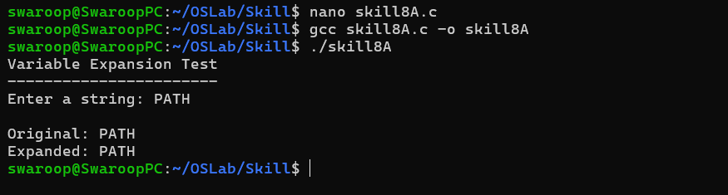

Part-B :

Code (8B) :
#include <stdio.h>
#include <stdlib.h>
#include <string.h>
#include <unistd.h>

#define MAX_INPUT 200
#define MAX_ARGS 20

// Function declarations
void builtin_cd(char **args);
void builtin_pwd(char **args);
void builtin_echo(char **args);
void builtin_help(char **args);
void builtin_exit(char **args);

// Structure for dispatch table
typedef struct
{
char *name;
void (*function)(char **args);
} Builtin;

// Dispatch table
Builtin builtins[] =
{
{"cd", builtin_cd},
{"pwd", builtin_pwd},
{"echo", builtin_echo},
{"help", builtin_help},
{"exit", builtin_exit}
};

int builtin_count = sizeof(builtins) / sizeof(builtins[0]);

// cd command
void builtin_cd(char **args)
{
if (args[1] == NULL)
{
printf("cd: missing directory\n");
return;
}

if (chdir(args[1]) != 0)
{
perror("cd");
}
}

// pwd command
void builtin_pwd(char **args)
{
char cwd[500];

if (getcwd(cwd, sizeof(cwd)) != NULL)
{
printf("%s\n", cwd);
}
else
{
perror("pwd");
}
}

// echo command
void builtin_echo(char **args)
{
for (int i = 1; args[i] != NULL; i++)
{
printf("%s ", args[i]);
}

printf("\n");
}

// help command
void builtin_help(char **args)
{
printf("\nBuilt-in commands:\n");
printf(" cd <directory> - Change directory\n");
printf(" pwd - Display current directory\n");
printf(" echo <text> - Display text\n");
printf(" help - Display help\n");
printf(" exit - Exit shell\n\n");
}

// exit command
void builtin_exit(char **args)
{
printf("Exiting shell...\n");
exit(0);
}

// Find command in dispatch table
int find_builtin(char *command)
{
for (int i = 0; i < builtin_count; i++)
{
if (strcmp(command, builtins[i].name) == 0)
{
return i;
}
}

return -1;
}

// Parse input
int parse_input(char *input, char **args)
{
int count = 0;

char *token = strtok(input, " \t");

while (token != NULL && count < MAX_ARGS - 1)
{
args[count++] = token;
token = strtok(NULL, " \t");
}

args[count] = NULL;

return count;
}

int main()
{
char input[MAX_INPUT];
char *args[MAX_ARGS];

printf("Simple Built-in Shell\n");
printf("Type 'help' for available commands.\n");

while (1)
{
printf("myshell> ");
fflush(stdout);

if (fgets(input, sizeof(input), stdin) == NULL)
{
break;
}

input[strcspn(input, "\n")] = '\0';

if (strlen(input) == 0)
{
continue;
}

int argc = parse_input(input, args);

if (argc == 0)
{
continue;
}

// Find command in dispatch table
int index = find_builtin(args[0]);

if (index != -1)
{
// Execute built-in command
builtins[index].function(args);
}
else
{
printf("myshell: command not found: %s\n", args[0]);
}
}

return 0;
}

Output :

