Skill – 9

- To Change Directories, Validate Paths, Update Working Directory, Handle Errors, Maintain Previous Directory, Test Navigation.

To Identify Built-ins, Create Dispatch Table, Execute In-Process Commands, Handle Invalid Commands, Maintain State, Test Dispatch Logic

Code(9A) :

#include <stdio.h>
#include <stdlib.h>
#include <string.h>
#include <unistd.h>
#include <limits.h>
#include <errno.h>

#define MAX_INPUT 500

int main()
{
char input[MAX_INPUT];
char current_dir[PATH_MAX];
char previous_dir[PATH_MAX];

// Store initial directory
if (getcwd(current_dir, sizeof(current_dir)) == NULL)
{
perror("getcwd");
return 1;
}

strcpy(previous_dir, current_dir);

printf("Directory Navigation Program\n");
printf("Commands: cd <path>, cd -, pwd, exit\n\n");

while (1)
{
// Display current directory
if (getcwd(current_dir, sizeof(current_dir)) != NULL)
{
printf("%s> ", current_dir);
}
else
{
printf("myshell> ");
}

fflush(stdout);

if (fgets(input, sizeof(input), stdin) == NULL)
{
break;
}

input[strcspn(input, "\n")] = '\0';

// Exit
if (strcmp(input, "exit") == 0)
{
printf("Exiting...\n");
break;
}

// pwd command
if (strcmp(input, "pwd") == 0)
{
if (getcwd(current_dir, sizeof(current_dir)) != NULL)
{
printf("%s\n", current_dir);
}
else
{
perror("pwd");
}

continue;
}

// cd command
if (strncmp(input, "cd", 2) == 0 &&
(input[2] == ' ' || input[2] == '\0'))
{
char *path = input + 2;

// Skip spaces
while (*path == ' ')
{
path++;
}

// cd without argument -> HOME
if (*path == '\0')
{
path = getenv("HOME");

if (path == NULL)
{
printf("cd: HOME is not set\n");
continue;
}
}

// cd - -> previous directory
if (strcmp(path, "-") == 0)
{
char temp[PATH_MAX];

if (chdir(previous_dir) != 0)
{
perror("cd");
continue;
}

strcpy(temp, current_dir);
strcpy(current_dir, previous_dir);
strcpy(previous_dir, temp);

printf("%s\n", current_dir);
continue;
}

// Save current directory before changing
char old_dir[PATH_MAX];

if (getcwd(old_dir, sizeof(old_dir)) == NULL)
{
perror("getcwd");
continue;
}

// Change directory
if (chdir(path) != 0)
{
printf("cd: cannot access '%s': %s\n",
path, strerror(errno));
continue;
}

// Update previous directory
strcpy(previous_dir, old_dir);

// Get new directory
if (getcwd(current_dir, sizeof(current_dir)) != NULL)
{
printf("Changed directory to: %s\n", current_dir);
}
}
else
{
printf("Unknown command: %s\n", input);
}
}

return 0;
}

OUTPUT :
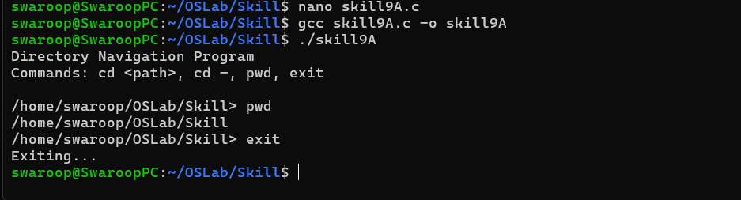

Part-B :

Code (8B) :
#include <stdio.h>
#include <stdlib.h>
#include <string.h>
#include <unistd.h>

#define MAX_INPUT 500
#define MAX_ARGS 20

// Function declarations
void builtin_cd(char **args);
void builtin_pwd(char **args);
void builtin_echo(char **args);
void builtin_help(char **args);
void builtin_exit(char **args);

// Dispatch table structure
typedef struct
{
char *name;
void (*function)(char **args);
} Builtin;

// Dispatch table
Builtin builtins[] =
{
{"cd", builtin_cd},
{"pwd", builtin_pwd},
{"echo", builtin_echo},
{"help", builtin_help},
{"exit", builtin_exit}
};

int builtin_count = sizeof(builtins) / sizeof(builtins[0]);

// cd command
void builtin_cd(char **args)
{
if (args[1] == NULL)
{
char *home = getenv("HOME");

if (home != NULL)
{
if (chdir(home) != 0)
perror("cd");
}

return;
}

if (chdir(args[1]) != 0)
{
perror("cd");
}
}

// pwd command
void builtin_pwd(char **args)
{
char cwd[1000];

if (getcwd(cwd, sizeof(cwd)) != NULL)
{
printf("%s\n", cwd);
}
else
{
perror("pwd");
}
}

// echo command
void builtin_echo(char **args)
{
for (int i = 1; args[i] != NULL; i++)
{
printf("%s", args[i]);

if (args[i + 1] != NULL)
printf(" ");
}

printf("\n");
}

// help command
void builtin_help(char **args)
{
printf("\nAvailable built-in commands:\n");
printf(" cd <directory> - Change directory\n");
printf(" pwd - Show current directory\n");
printf(" echo <text> - Display text\n");
printf(" help - Show help\n");
printf(" exit - Exit shell\n\n");
}

// exit command
void builtin_exit(char **args)
{
printf("Exiting shell...\n");
exit(0);
}

// Search dispatch table
int find_builtin(char *command)
{
for (int i = 0; i < builtin_count; i++)
{
if (strcmp(command, builtins[i].name) == 0)
{
return i;
}
}

return -1;
}

// Parse input into arguments
int parse_input(char *input, char **args)
{
int count = 0;

char *token = strtok(input, " \t");

while (token != NULL && count < MAX_ARGS - 1)
{
args[count] = token;
count++;

token = strtok(NULL, " \t");
}

args[count] = NULL;

return count;
}

int main()
{
char input[MAX_INPUT];
char *args[MAX_ARGS];

printf("Simple Built-in Shell\n");
printf("Type 'help' to see available commands.\n\n");

while (1)
{
printf("myshell> ");
fflush(stdout);

if (fgets(input, sizeof(input), stdin) == NULL)
{
break;
}

input[strcspn(input, "\n")] = '\0';

if (strlen(input) == 0)
{
continue;
}

int argc = parse_input(input, args);

if (argc == 0)
{
continue;
}

// Find command in dispatch table
int index = find_builtin(args[0]);

if (index != -1)
{
// Execute built-in in current process
builtins[index].function(args);
}
else
{
printf("myshell: command not found: %s\n",
args[0]);
}
}

return 0;
}
Output :

