PRACTICAL – 4

- Write a C program where a parent process creates multiple child processes and synchronizes their completion using wait() and waitpid(). Compare the behavior of both functions.

Create a scenario where a child process becomes a zombie process. Investigate the process table and then modify the program to eliminate zombie processes using proper synchronization techniques.

Code: (4A)

#include <stdio.h>
#include <stdlib.h>
#include <unistd.h>
#include <sys/wait.h>

int main() {
pid_t pid1, pid2;

// Create first child
pid1 = fork();

if (pid1 == 0) {
printf("Child 1\n");
printf("PID : %d\n", getpid());
sleep(3);
printf("Child 1 Finished\n");
exit(0);
}

// Create second child
pid2 = fork();

if (pid2 == 0) {
printf("Child 2\n");
printf("PID : %d\n", getpid());
sleep(5);
printf("Child 2 Finished\n");
exit(0);
}

printf("\nParent PID : %d\n", getpid());

// Wait for any child
wait(NULL);
printf("One child has finished.\n");

// Wait for the second child
waitpid(pid2, NULL, 0);
printf("Child 2 has finished.\n");

printf("All child processes completed.\n");

return 0;
}

Output:
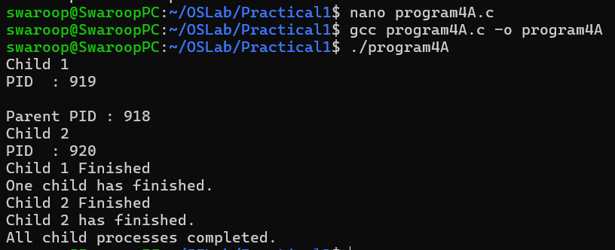

PART_B :- Zombie Process

Code: (4B):
#include <stdio.h>
#include <stdlib.h>
#include <unistd.h>

int main() {

pid_t pid = fork();

if (pid == 0) {
printf("Child Process\n");
printf("PID : %d\n", getpid());

printf("Child exiting...\n");
exit(0);
}

else {
printf("Parent PID : %d\n", getpid());

printf("Parent sleeping...\n");

sleep(20);

printf("Parent finished.\n");
}

return 0;
}

Output:

