PRACTICAL – 10

1. Investigate inode structures using commands such as ls -i, stat, and find. Create hard links and symbolic links and explain their impact on inode allocation.

Design a program using mmap() to perform file reading and writing. Compare memory-mapped I/O with traditional read/write operations in terms of efficiency and implementation complexity.

10A

Output:
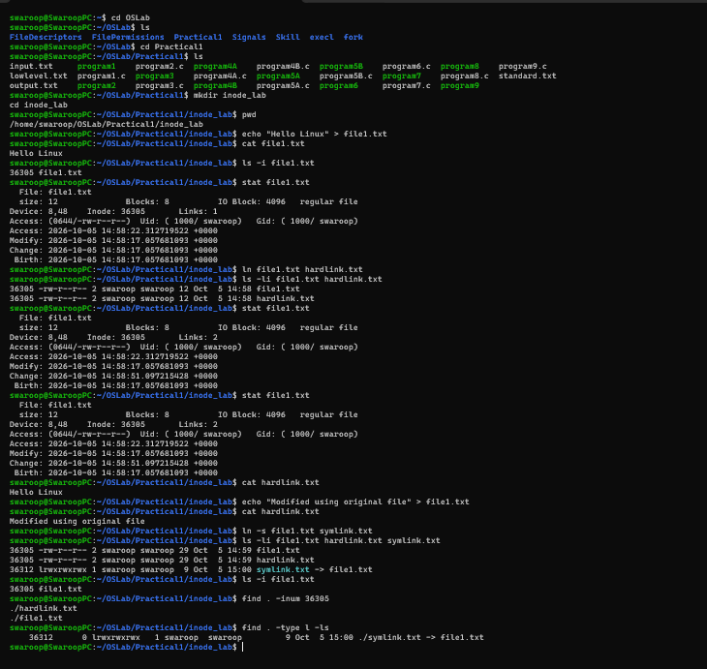

PART_B :

Code: (10B):
#include <stdio.h>
#include <stdlib.h>
#include <fcntl.h>
#include <unistd.h>
#include <sys/mman.h>
#include <string.h>

int main()
{
const char *filename = "mmap_file.txt";

int fd = open(filename, O_RDWR | O_CREAT, 0644);

if (fd == -1)
{
perror("open");
return 1;
}

const char *data = "Hello from mmap()!\n";
size_t size = strlen(data);

if (ftruncate(fd, size) == -1)
{
perror("ftruncate");
close(fd);
return 1;
}

char *ptr = mmap(NULL, size,
PROT_READ | PROT_WRITE,
MAP_SHARED, fd, 0);

if (ptr == MAP_FAILED)
{
perror("mmap");
close(fd);
return 1;
}

memcpy(ptr, data, size);

printf("File contents: %s", ptr);

if (msync(ptr, size, MS_SYNC) == -1)
{
perror("msync");
}

munmap(ptr, size);
close(fd);

return 0;
}

Output:

