OS -Lab

Program 1: execl() – Execute with List:
Output:
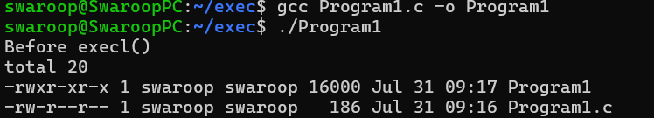

Program 2: Execute with List + PATH:
Output:
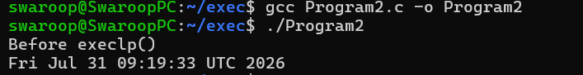

Program 3: execv() – Execute with Vector:
Output:
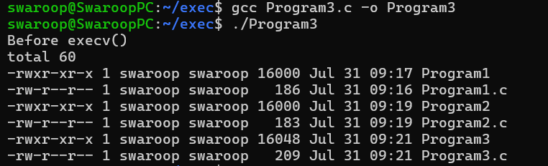

Program 4: execvp() – Execute with Vector + PATH1:
Output:
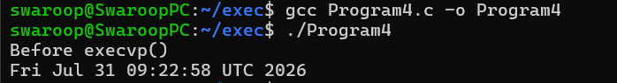

Program 5: execve() – Execute with Vector + Environment:
Output:
