PRACTICAL – 5

1. Implement a producer-consumer communication system using anonymous pipes
where the parent process generates data and the child process consumes it.
Measure the communication efficiency.
Develop a program that executes the equivalent of the shell command:
Ls -l | grep ".c" using fork(), pipe(), dup2(), and exec() system calls.

Code: (5A)

#include <stdio.h>
#include <stdlib.h>
#include <unistd.h>
#include <string.h>
#include <sys/wait.h>
#include <time.h>

#define BUFFER_SIZE 100

int main()
{
int fd[2];
pid_t pid;
char write_msg[] = "Hello from Producer!";
char read_msg[BUFFER_SIZE];

struct timespec start, end;
double time_taken;

// Create pipe
if (pipe(fd) == -1)
{
perror("Pipe failed");
return 1;
}

// Create child process
pid = fork();

if (pid < 0)
{
perror("Fork failed");
return 1;
}

if (pid > 0)
{
// Parent Process - Producer

close(fd[0]); // Close read end

clock_gettime(CLOCK_MONOTONIC, &start);

write(fd[1], write_msg, strlen(write_msg) + 1);

close(fd[1]);

wait(NULL);

clock_gettime(CLOCK_MONOTONIC, &end);

time_taken =
(end.tv_sec - start.tv_sec) +
(end.tv_nsec - start.tv_nsec) / 1000000000.0;

printf("Producer: Data sent successfully.\n");
printf("Communication time: %.9f seconds\n", time_taken);
}
else
{
// Child Process - Consumer

close(fd[1]); // Close write end

read(fd[0], read_msg, BUFFER_SIZE);

printf("Consumer received: %s\n", read_msg);

close(fd[0]);

exit(0);
}

return 0;
}

Output:
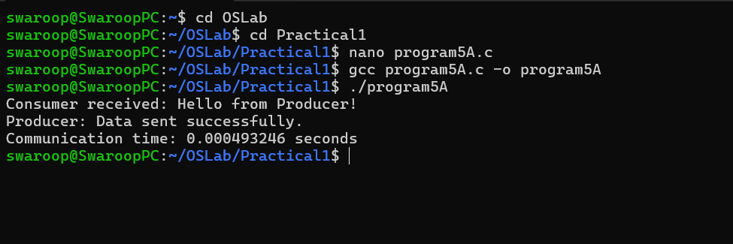

Code: (5B):

#include <stdio.h>
#include <stdlib.h>
#include <unistd.h>
#include <sys/wait.h>

int main()
{
int fd[2];
pid_t pid1, pid2;

// Create pipe
if (pipe(fd) == -1)
{
perror("Pipe failed");
return 1;
}

// First child for ls -l
pid1 = fork();

if (pid1 < 0)
{
perror("Fork failed");
return 1;
}

if (pid1 == 0)
{
// Redirect stdout to pipe write end
dup2(fd[1], STDOUT_FILENO);

close(fd[0]);
close(fd[1]);

// Execute ls -l
execlp("ls", "ls", "-l", NULL);

perror("execlp ls failed");
exit(1);
}

// Second child for grep ".c"
pid2 = fork();

if (pid2 < 0)
{
perror("Fork failed");
return 1;
}

if (pid2 == 0)
{
// Redirect stdin to pipe read end
dup2(fd[0], STDIN_FILENO);

close(fd[0]);
close(fd[1]);

// Execute grep ".c"
execlp("grep", "grep", ".c", NULL);

perror("execlp grep failed");
exit(1);
}

// Parent process
close(fd[0]);
close(fd[1]);

// Wait for both children
waitpid(pid1, NULL, 0);
waitpid(pid2, NULL, 0);

return 0;
}

Output:

