PRACTICAL RECORD

Spring Boot Student Management REST API

Roll Number: 2520090224
Name: Ch. Shanthi Swaroop

Aim:
To develop a Spring Boot REST API for Student Management system with MySQL database integration, demonstrating CRUD operations (Create, Read, Update, Delete) using HTTP methods.

Student Entity
The Student entity class contains id, name, department, and email attributes with automatic ID generation using GenerationType.IDENTITY.
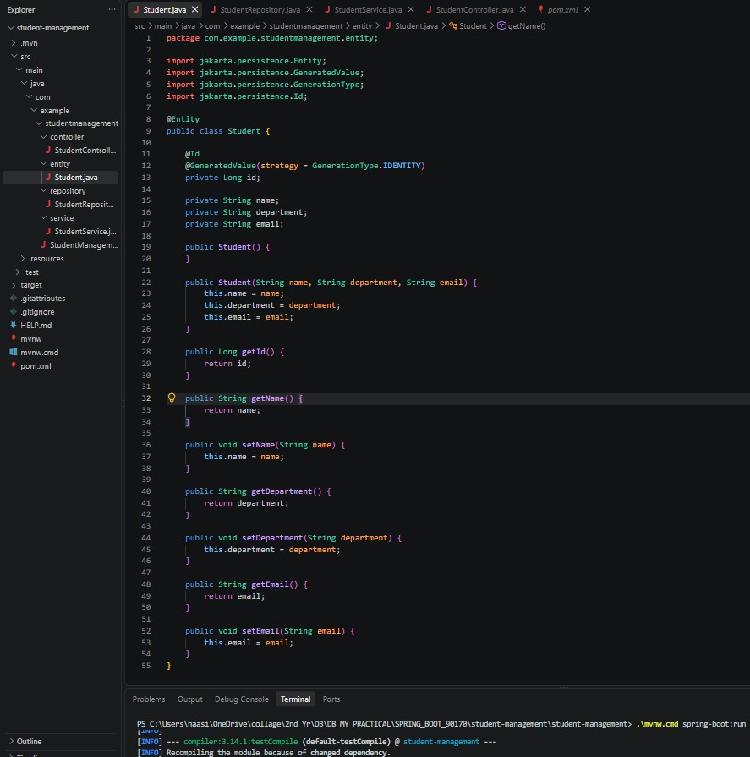

Figure 1: Student.java - Entity Class

Student Repository
The StudentRepository interface extends JpaRepository to provide database operations such as save(), findAll(), findById(), and deleteById().
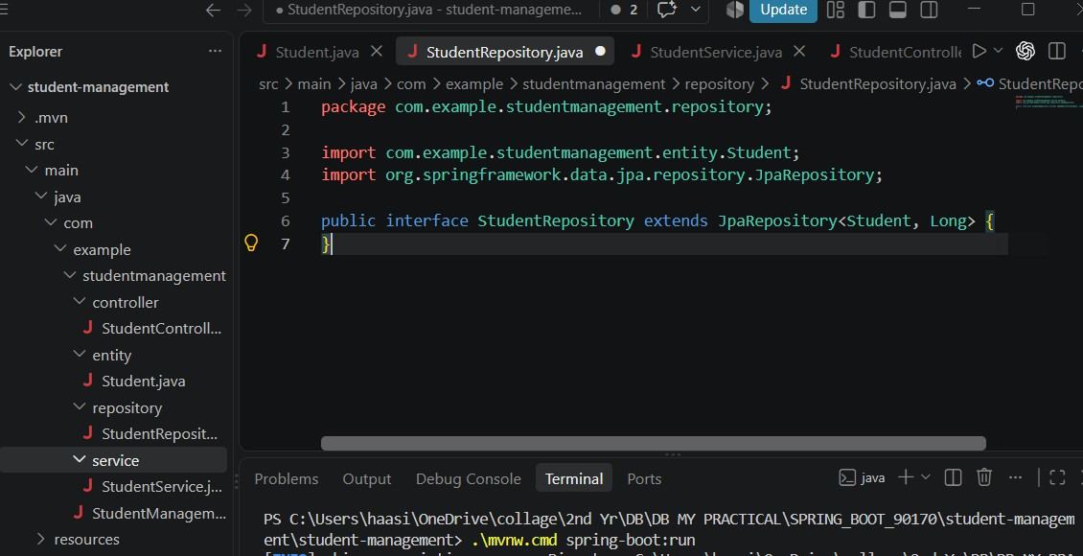
Figure 2: StudentRepository.java - Repository Interface

Student Service
The StudentService class contains business logic for creating, retrieving, updating, and deleting student records through the repository.

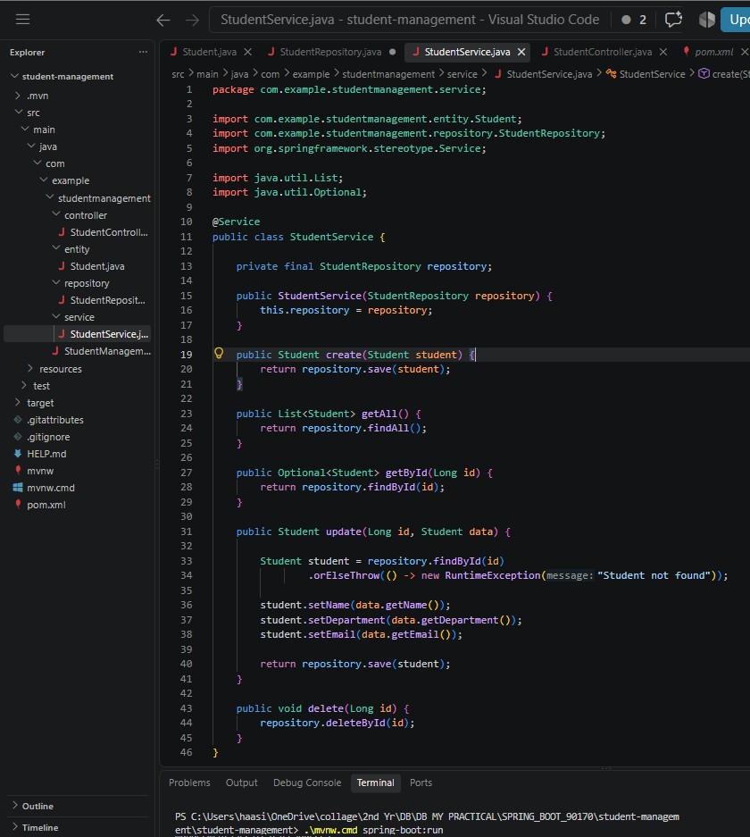
Figure 3: StudentService.java - Service Layer

Student REST Controller
The StudentController provides REST endpoints for POST, GET, PUT, and DELETE operations on the /api/students path.

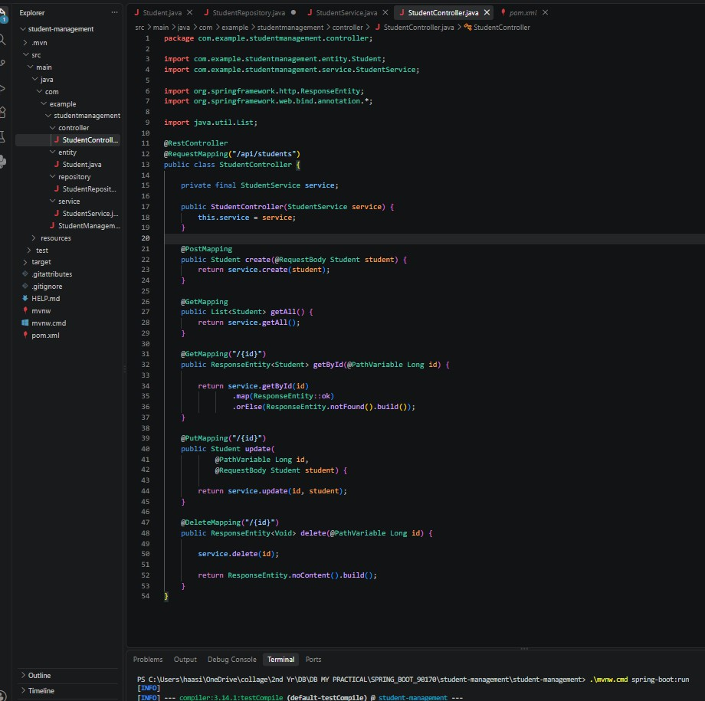

Figure 4: StudentController.java - REST Controller

MySQL Configuration
The application.properties file contains MySQL database URL, credentials, Hibernate configuration with ddl-auto=update, and server port 8080.

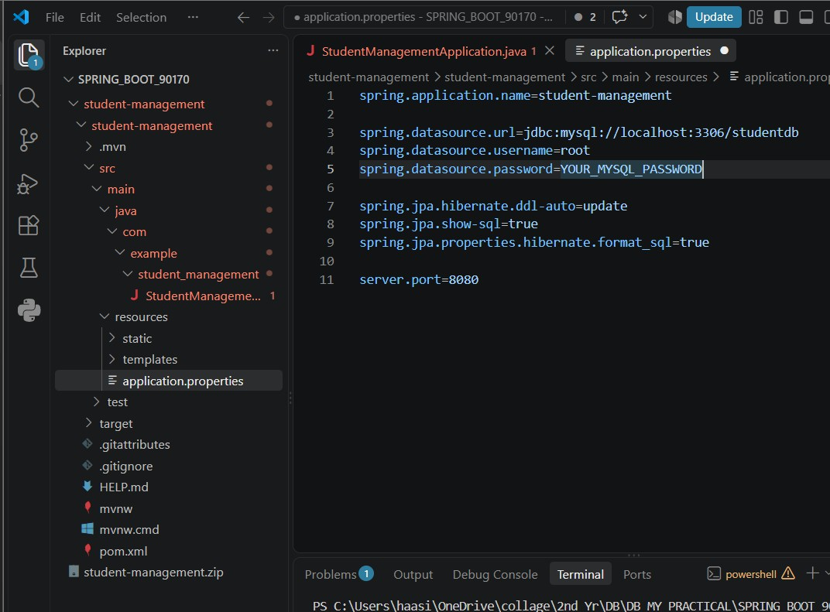

Figure 5: application.properties - Database Configuration

POST – Create Student
The POST request creates a new student record with name, department, and email and stores it in the MySQL database.
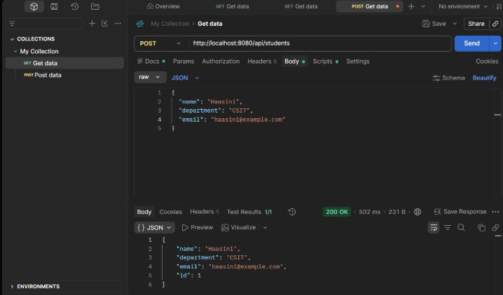

Figure 6: POST Request – Create Student

GET – Read Students
The GET request retrieves all student records stored in the database through the Spring Boot REST API.
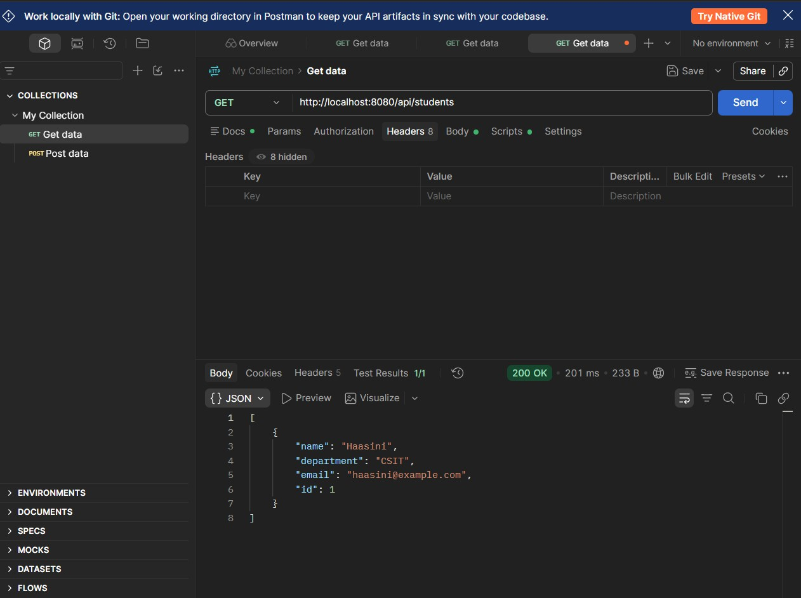
Figure 7: GET Request – View Students

PUT – Update Student
The PUT request updates the existing student record with new name, department, and email information.

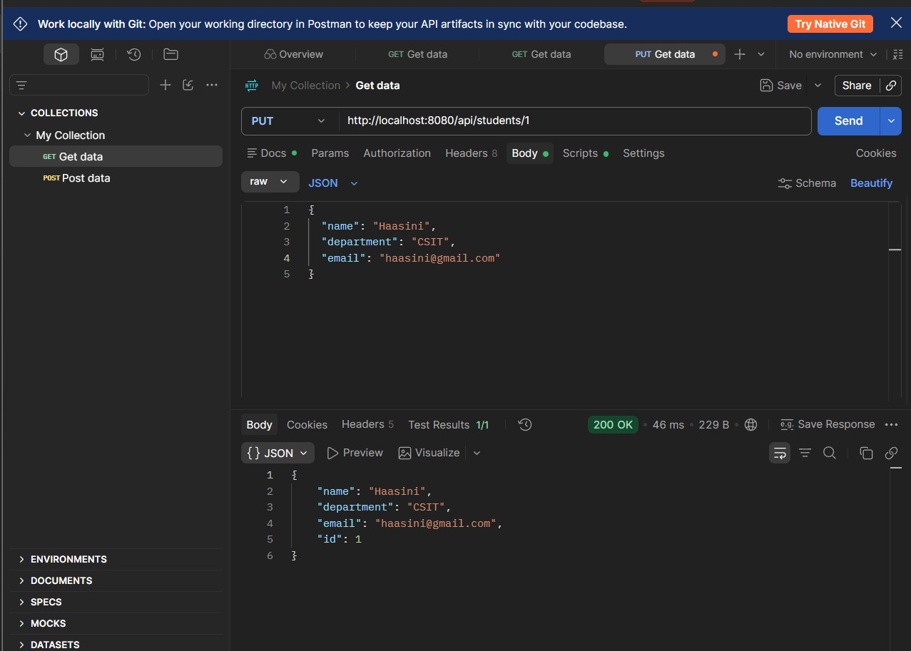

Figure 8: PUT Request – Update Student

Verify Data in MySQL
The student data sent through the Spring Boot REST API is verified in MySQL Workbench using SELECT * FROM student query on the studentdb database.

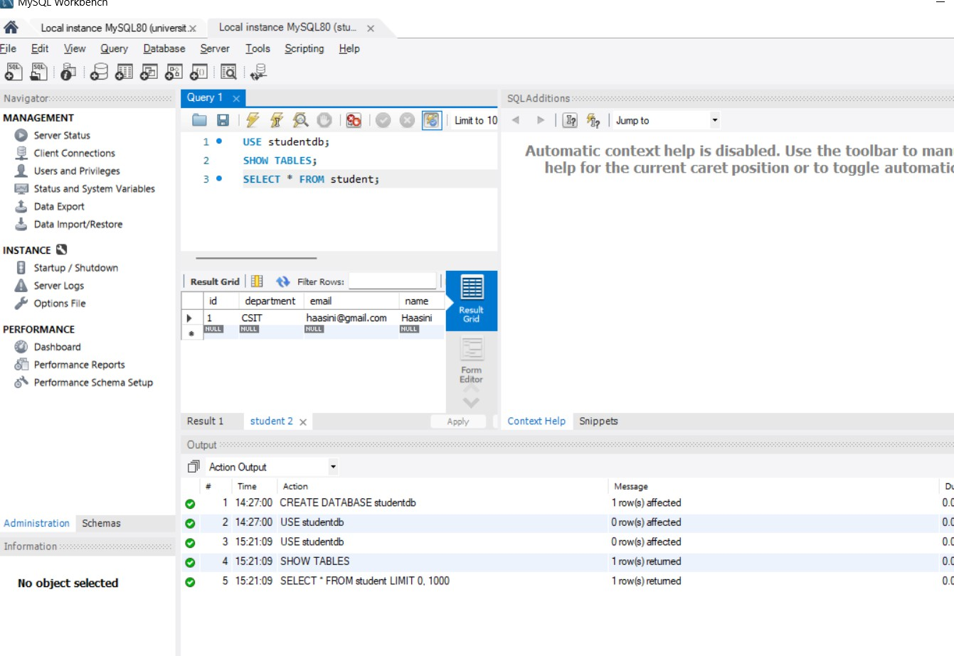

Figure 9: Student Data Stored in MySQL

DELETE – Delete Student
The DELETE request removes the selected student record from the database and returns a 204 No Content response.

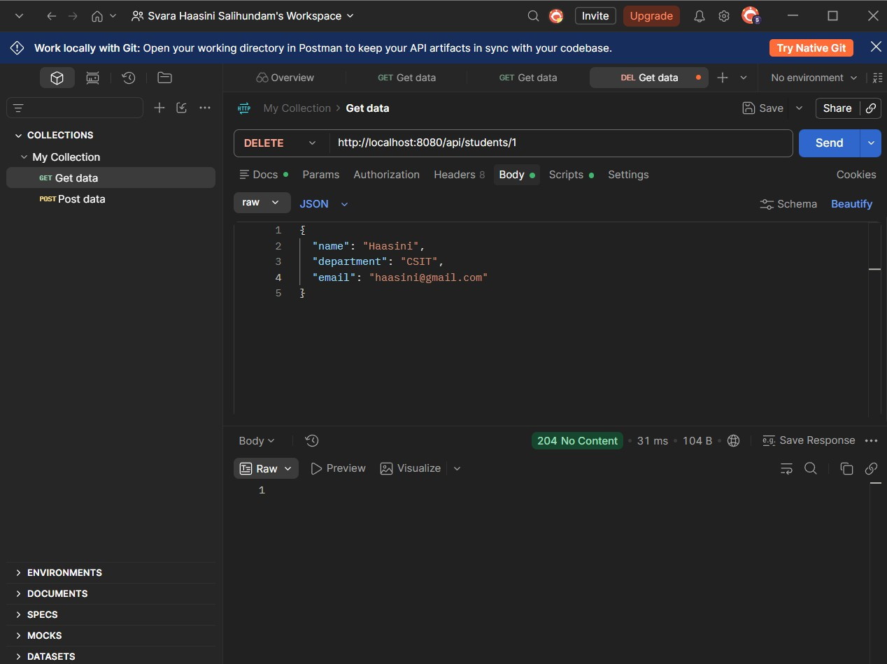
Figure 10: DELETE Request – Delete Student

Verify Data After Deletion
The MySQL database is queried again to verify that the deleted student record has been removed successfully.
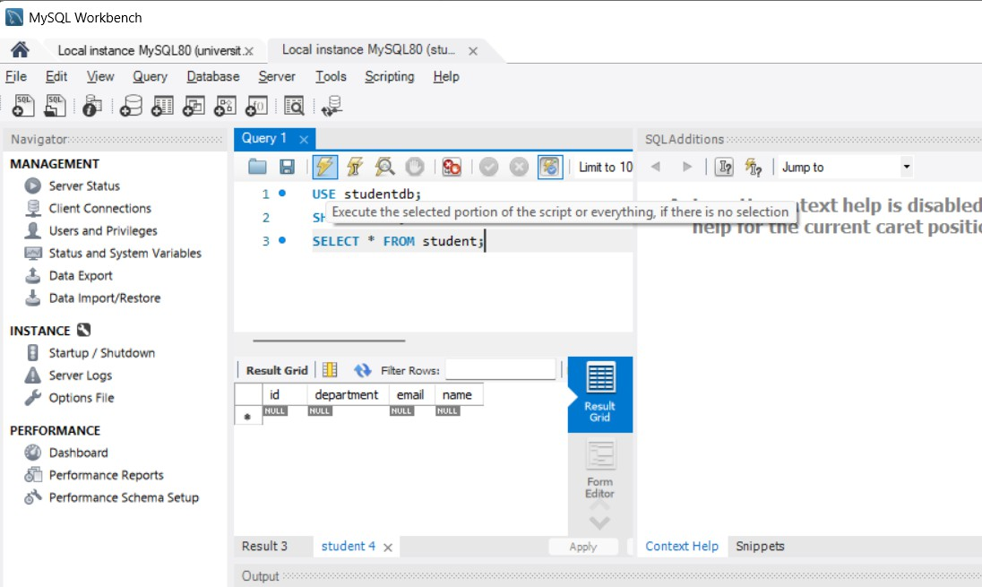

Figure 11: Database Verification After Deletion

Result:
The Spring Boot Student Management REST API was successfully created and tested using POST, GET, PUT, and DELETE operations, and the data was successfully integrated with the MySQL database.

