DATABASE SYSTEMS ENGINEERING AND DISTRIBUTED BACKEND DEVELOPMENT

SECTION 1 : DDL (DATA DEFINITION LANGUAGE)

QUESTION 1 - CREATE TABLE
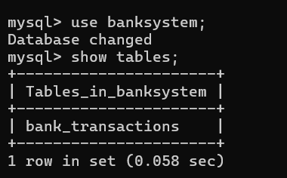
QUESTION 2 - ALTER TABLE ADD COLUMN
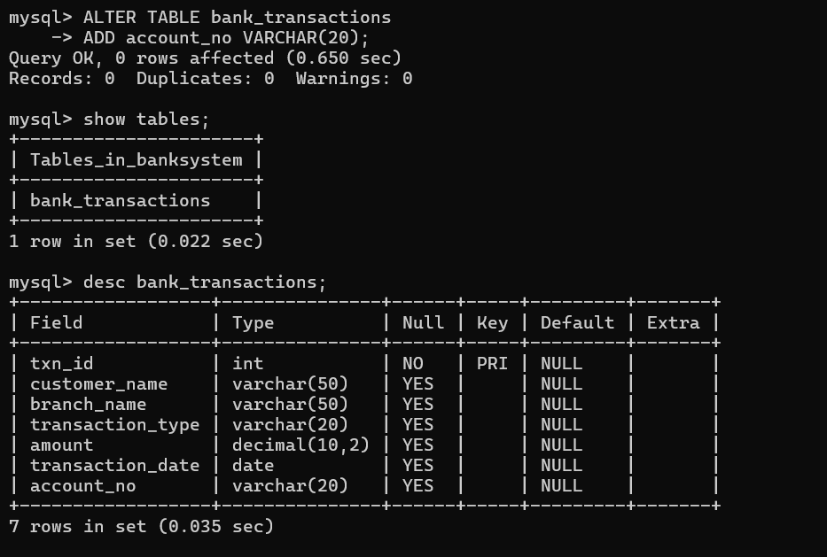

QUESTION 3 - ALTER TABLE MODIFY COLUMN
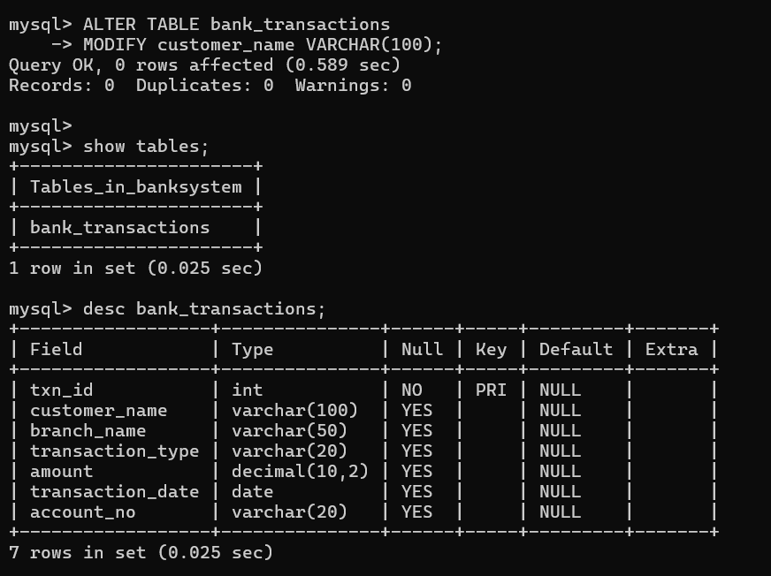
QUESTION 4 - RENAME TABLE
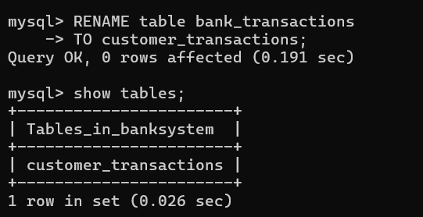

SECTION 2 : DML (DATA MANIPULATION LANGUAGE)

STEP 1 : INSERT SAMPLE DATA
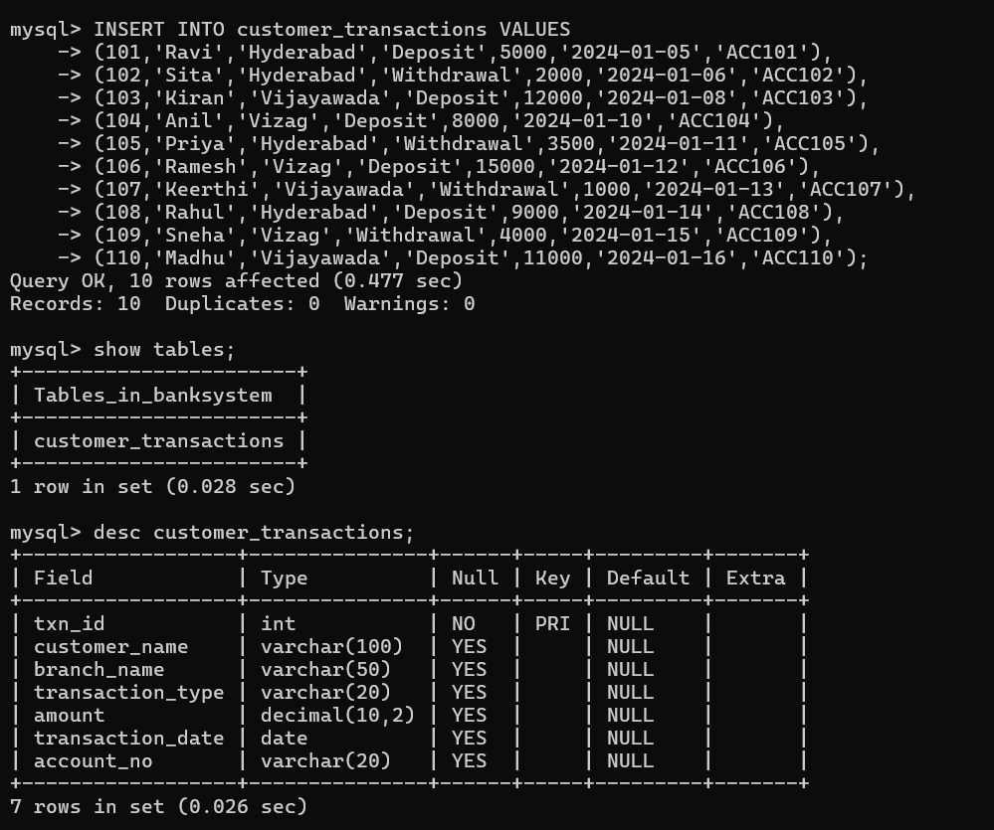

QUESTION 7 – INSERT
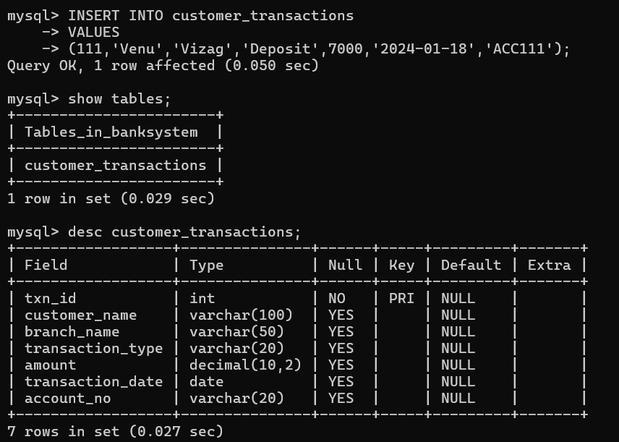

QUESTION 8 – UPDATE
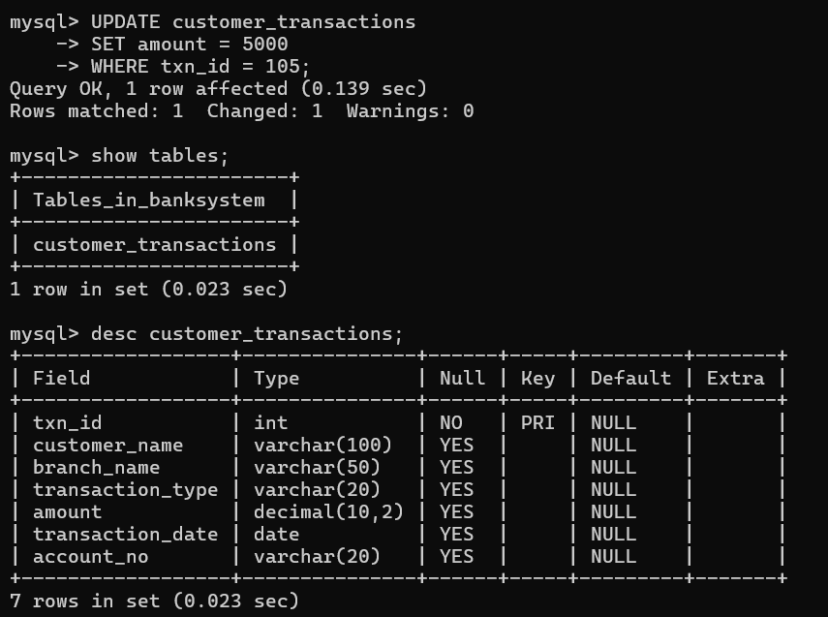

QUESTION 9 – DELETE
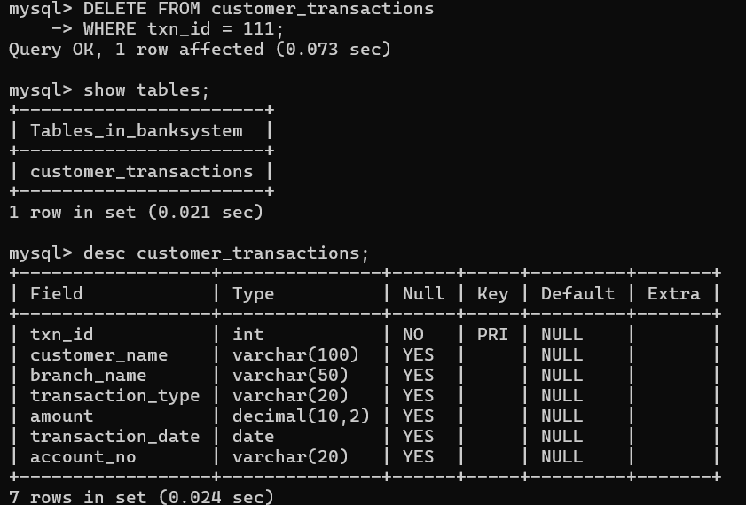
QUESTION 10 – SELECT
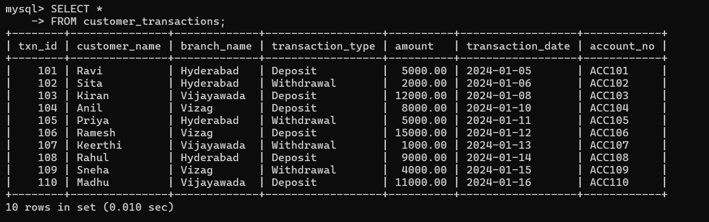
QUESTION 11 - SELECT WITH WHERE
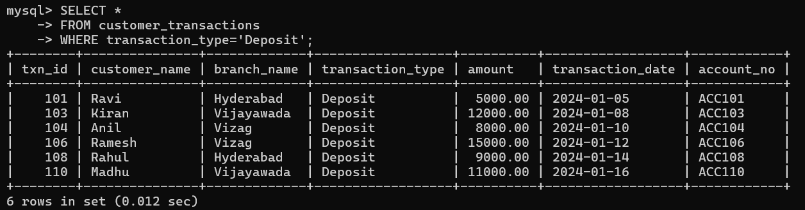

QUESTION 12 - SELECT WITH ORDER BY
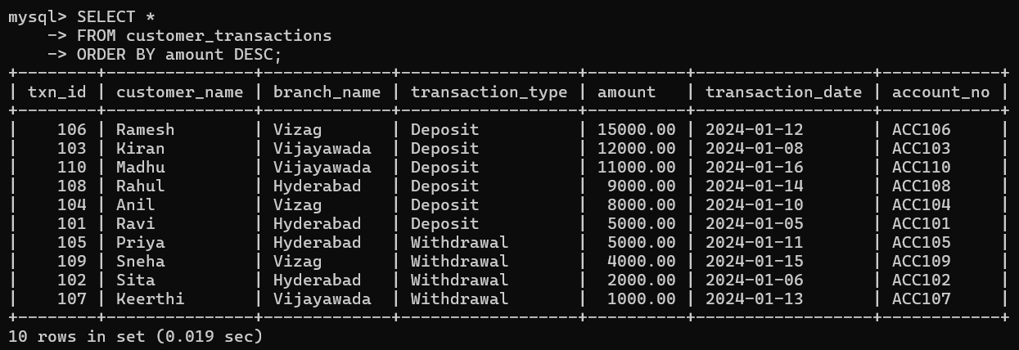

SECTION 3 : DCL (DATA CONTROL LANGUAGE)

QUESTION 13 - GRANT SELECT
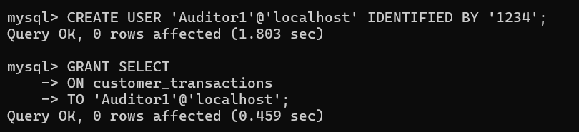

QUESTION 14 - GRANT ALL PRIVILEGES
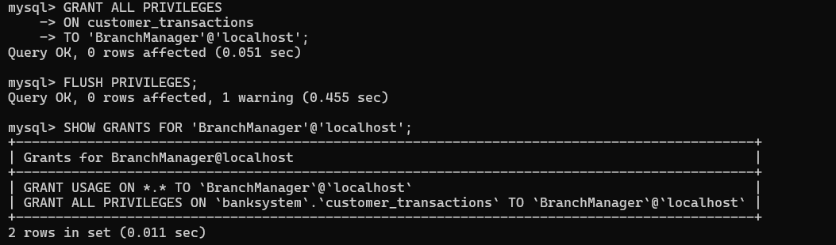

QUESTION 15 - REVOKE SELECT
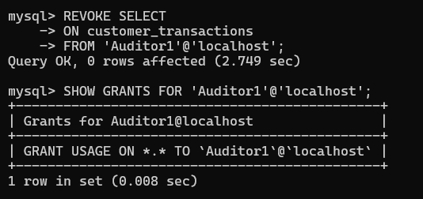
QUESTION 16 - REVOKE ALL
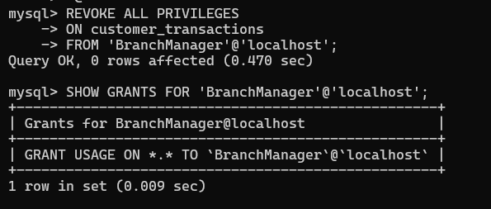

SECTION 4 : TCL (TRANSACTION CONTROL LANGUAGE)
QUESTION 17 - COMMIT

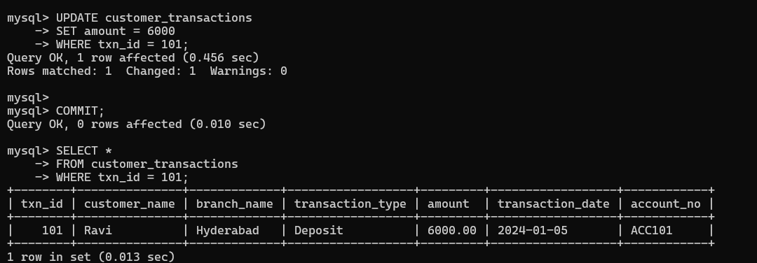
QUESTION 18 - SAVEPOINT
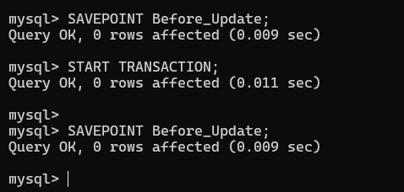
QUESTION 19 - ROLLBACK TO SAVEPOINT
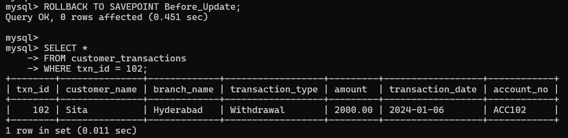

QUESTION 20 - FULL TCL EXAMPLE
