PRACTICAL RECORD

Python Flask Web Application

Name: Ch. Shanthi Swaroop
Roll Number: 2520090224

Aim:
To develop Flask web applications demonstrating basic routing, variable URL routing, dynamic URL building with url_for(), and GET and POST methods for form submission.

First Flask Application
A simple Flask application is created with a basic route to display a welcome message.

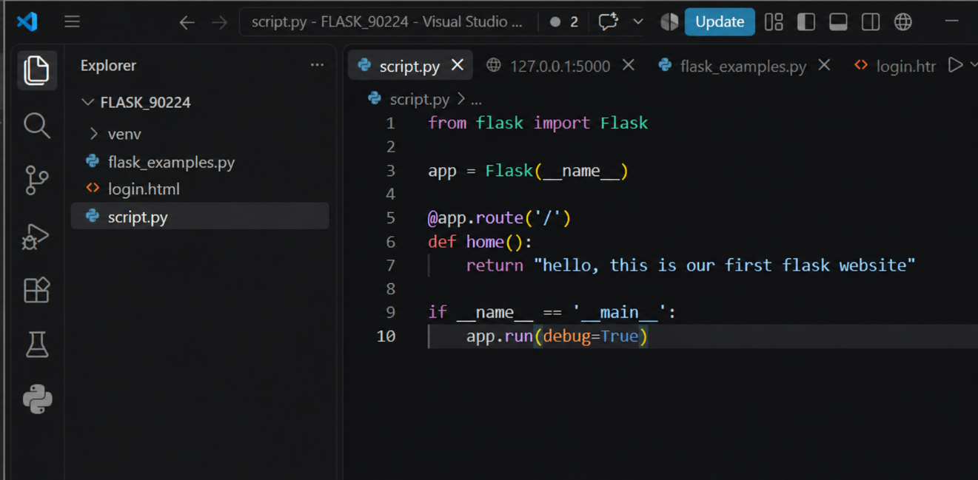

Figure 1: script.py - First Flask Application Code
The Flask app runs on localhost:5000 and displays "hello, this is our first flask website".

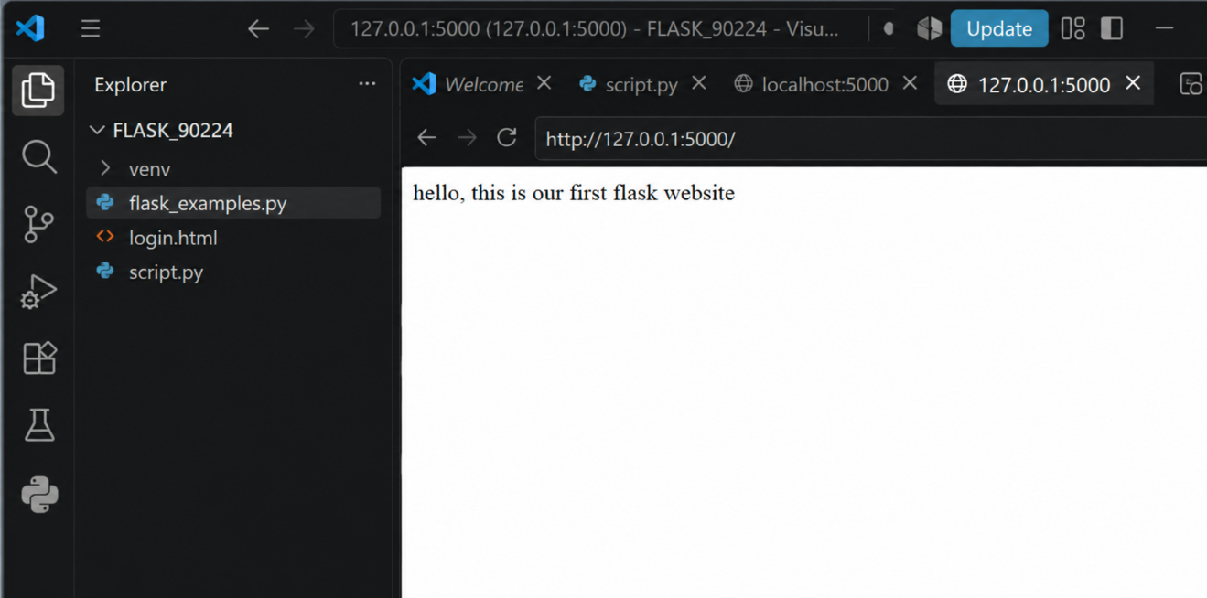

Figure 2: First Flask Application Output

Basic Flask Routing
Basic routing is used to map URLs to functions that return responses.

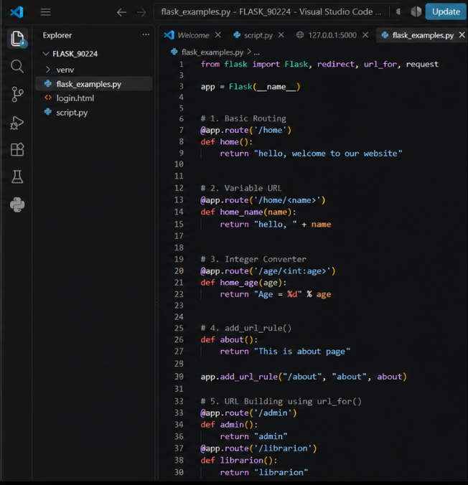
Figure 3: flask_examples.py - Basic Routing (/home route)
When accessing /home, the application returns "hello, welcome to our website".

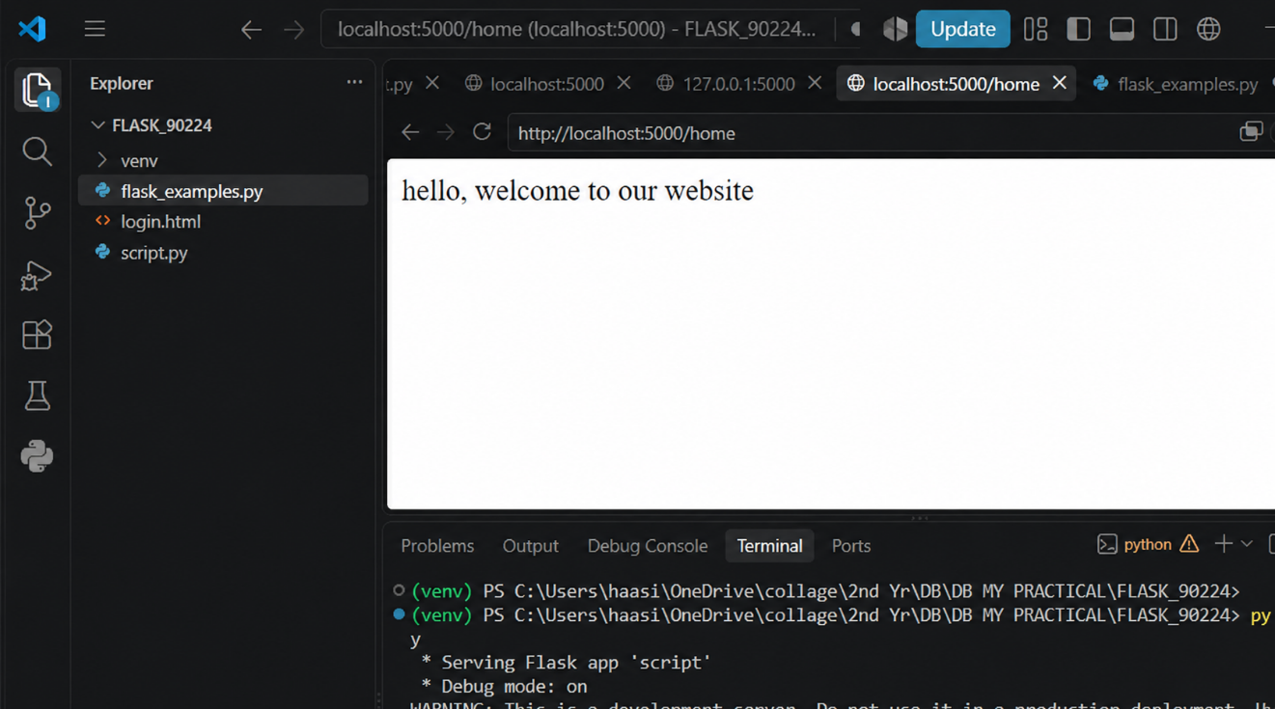

Figure 4: Basic Routing Output

Variable URL Routing
Variable URL routing allows dynamic URLs with parameters extracted from the URL path.

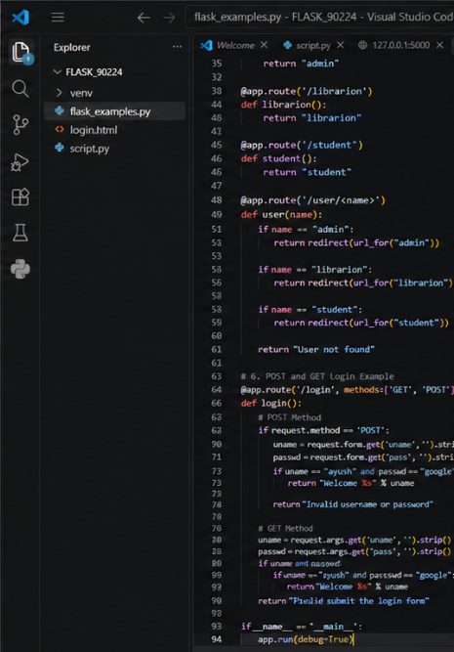

Figure 5: flask_examples.py - Variable URL Routing (/home/<name> route)

Accessing /home/Haasini returns "hello, Swaroop" by extracting the name parameter from the URL.

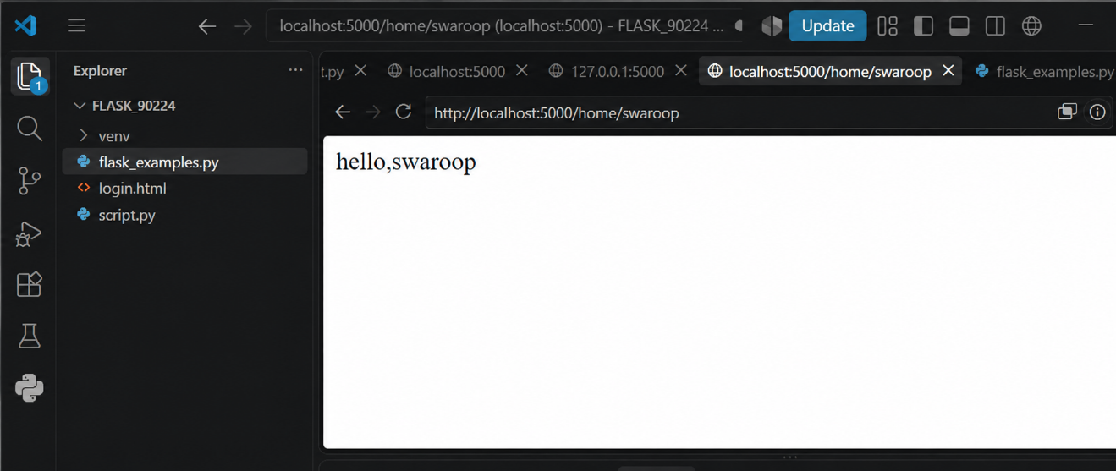

Figure 6: Variable URL Routing Output
- Dynamic URL Building using url_for()
The url_for() function is used to dynamically build URLs and perform redirects to different routes.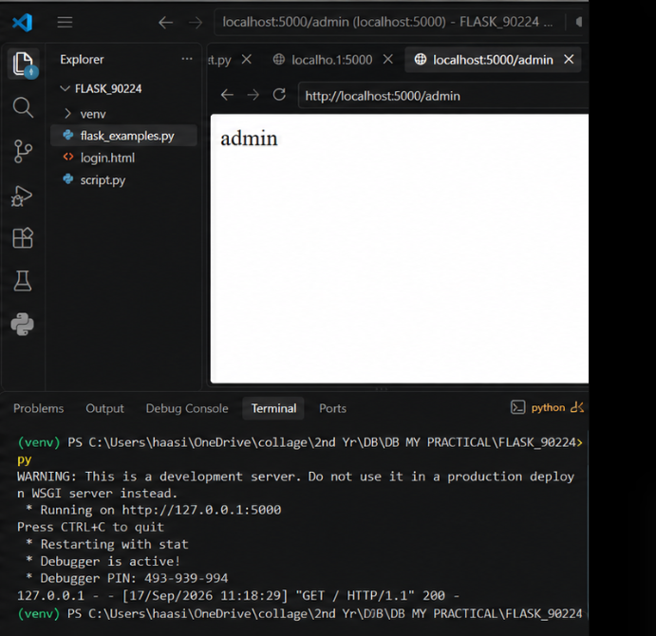
Figure 7: Dynamic URL Building Output (/user/admin route)

Flask Login Form
An HTML login form is created with POST and GET methods for form submission and credential validation.
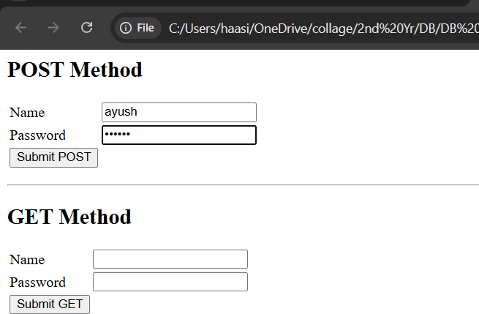

Figure 8: login.html - Login Form with POST and GET Methods

POST Method
The POST method submits form data securely to the server without exposing credentials in the URL.


Figure 9: POST Method - Login Success Response

GET Method
The GET method passes form data through the URL query string as parameters.
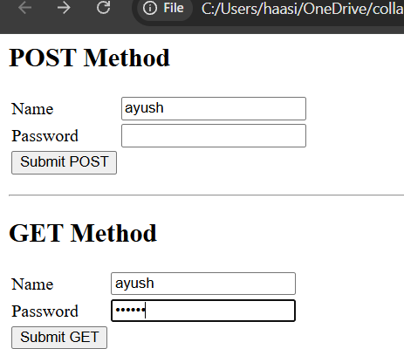

Figure 10: GET Method - Form with Query Parameters



Figure 11: GET Method - Login Success with URL Query String

Result:
The Flask programs were executed successfully, demonstrating basic routing, variable routing, dynamic URL building, and GET and POST methods.

