Open the Git URL – http:// 172.18.2.18 in Chrome

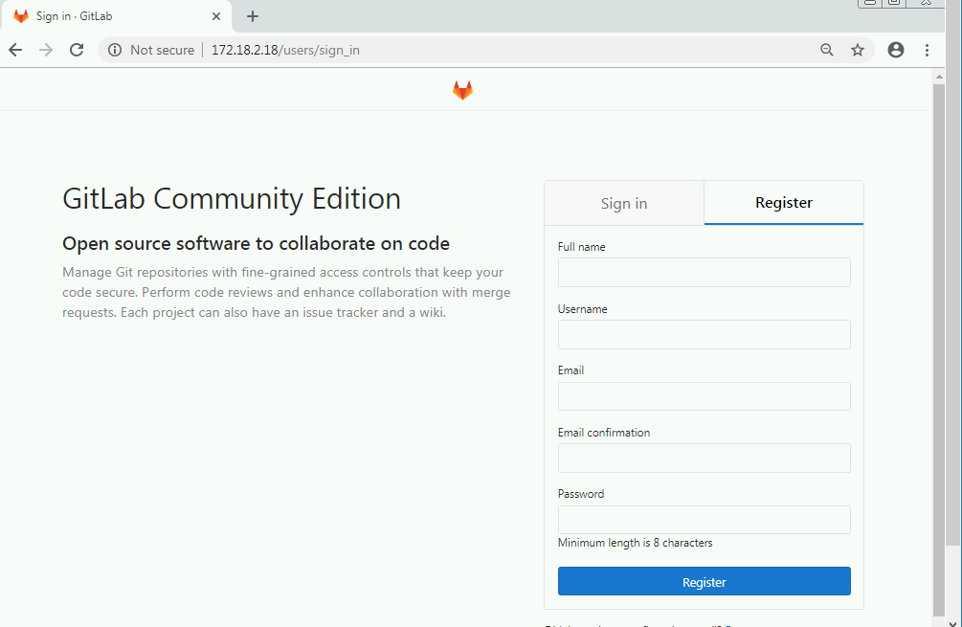

Register using your cognizant email id.

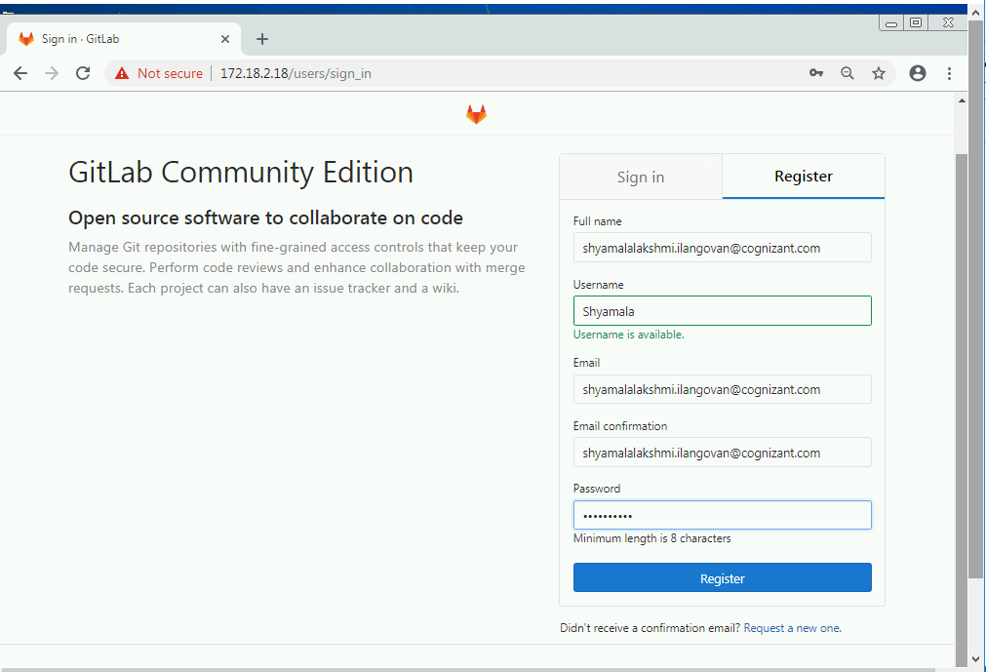

Once register you can create the project in GIT.

