Name:-Sahil Kumar

Mobile:-9162231102

Email: sahilkumar.118969@marwadiuiversity.ac.in

Collage: Marwadi University

Degree: B.Tech(CE)

Start: 3:11pm

**Question: Write a program to generate the following pattern**

Sol.

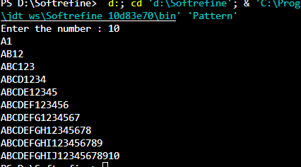

**Code snippet:**

import java.util.*;

public class Pattern{

public static void main(String[] args) {

Scanner sc = new Scanner(System.in);

System.out.print("Enter the number : ");

int number = sc.nextInt();

for(int i=0; i<number; i++){

int Alphabet = 65;

for(int j=0; j<=i; j++){

System.out.print((char) Alphabet++);

}

for(int j=0; j<=i; j++){

System.out.print(j+1);

}

System.out.println();

}

sc.close();

}

}

End: 3:31pm

Start: 3:43pm

**Question**: **Given A square matrix, write a program to rotate it in place by 90 degree**.

Sol.

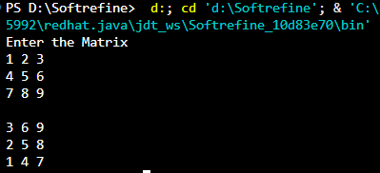

**Code snippet:**

import java.util.*;

public class Matrix {

public static void main(String[] args) {

Scanner sc = new Scanner(System.in);

int n = 3;

System.out.println("Enter the Matrix ");

int[][] Matrix = new int[n][n];

for (int i = 0; i < n; i++) {

for (int j = 0; j < n; j++) {

Matrix[i][j] = sc.nextInt();

}

}

for (int j = n - 1; j >= 0; j--) {

for (int i = 0; i < n; i++) {

System.out.print(Matrix[i][j]+" ");

}

System.out.println();

}

sc.close();

}

}

End: 3:58pm

Start: 4:12pm

Question: Find longest Balanced String

Sol.

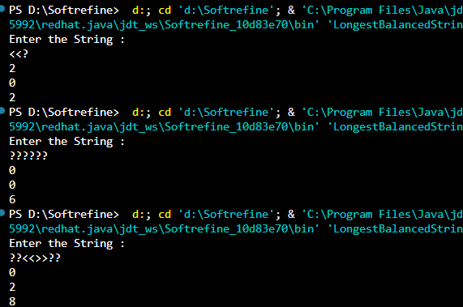

Code snippet:

import java.util.*;

public class LongestBalancedString {

public static void main(String[] args) {

Scanner sc = new Scanner(System.in);

System.out.println("Enter the String : ");

String s = sc.nextLine();

int length = s.length();

Stack<Character> stack = new Stack<>();

int number = 0;

int count = 0;

for (int i = 0; i < length; i++) {

if (s.charAt(i) == '?') {

count++;

}

}

for (int i = 0; i < length; i++) {

if (s.charAt(i) == '<') {

number++;

stack.push(s.charAt(i));

}

if (stack.peek() == '<' && s.charAt(i) == '>') {

stack.pop();

number--;

}

if (stack.isEmpty() && s.charAt(i) == '?') {

stack.push('<');

number++;

count--;

}

if (stack.peek() == '<' && s.charAt(i) == '?') {

if (i < count) {

stack.push('>');

number++;

count--;

}

}

}

System.out.println(number);

sc.close();

}

}

Incomplete

Start: 5:45pm

Question: Longest Common Subsequence

Sol.

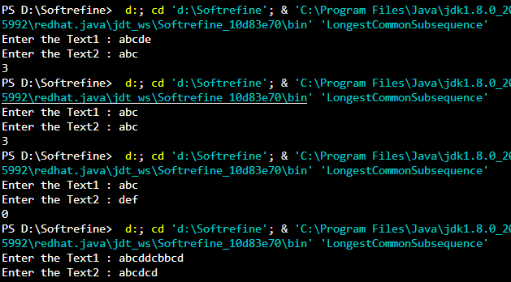

Code snippet:

import java.util.*;

public class LongestCommonSubsequence {

public static void main(String[] args) {

Scanner sc = new Scanner(System.in);

System.out.print("Enter the Text1 : ");

String text1 = sc.nextLine();

int length1 = text1.length();

System.out.print("Enter the Text2 : ");

String text2 = sc.nextLine();

int length2 = text2.length();

int[][] dp = new int[length1 + 1][length2 + 1];

for (int i = 1; i <= length1; i++) {

for (int j = 1; j <= length2; j++) {

if (text1.charAt(i - 1) == text2.charAt(j - 1)) {

dp[i][j] = dp[i - 1][j - 1] + 1;

} else {

dp[i][j] = Math.max(dp[i - 1][j], dp[i][j - 1]);

}

}

}

System.out.println(dp[length1][length2]);

}

}

End: 6:03pm