**OOP with OS Theory Assignment**



**Name :-** Swarup Moulik

**Class :-** BCA2G

**Section :-** 2G

**Semester :-** 3rd

**Student ID :-** 231001102215

**Subject :-** OS theory assignment

**Assignment 1**

Question

Make directories under directories using bash terminal.

Commands Used

To go to Desktop :-

tiu@tiu-matha-mota:~$ cd Desktop

To make a folder/directory :-

tiu@tiu-matha-mota:~/Desktop$ mkdir BCA2A

To change to directory :-

tiu@tiu-matha-mota:~/Desktop$ cd BCA2A

To make directories under directories :-

tiu@tiu-matha-mota:~/Desktop/BCA2A$ mkdir 1st 3rd 5th 7th

tiu@tiu-matha-mota:~/Desktop/BCA2A$ cd 3rd

tiu@tiu-matha-mota:~/Desktop/BCA2A/3rd$ mkdir Java WebTech OS CASD

tiu@tiu-matha-mota:~/Desktop/BCA2A/3rd$ cd CASD

tiu@tiu-matha-mota:~/Desktop/BCA2A/3rd/CASD$ mkdir French SAPABAP PHP

To go to the previous folder :-

tiu@tiu-matha-mota:~/Desktop/BCA2A/3rd/CASD$ cd ..

tiu@tiu-matha-mota:~/Desktop/BCA2A/3rd$ cd ..

tiu@tiu-matha-mota:~/Desktop/BCA2A$ cd ..

Output

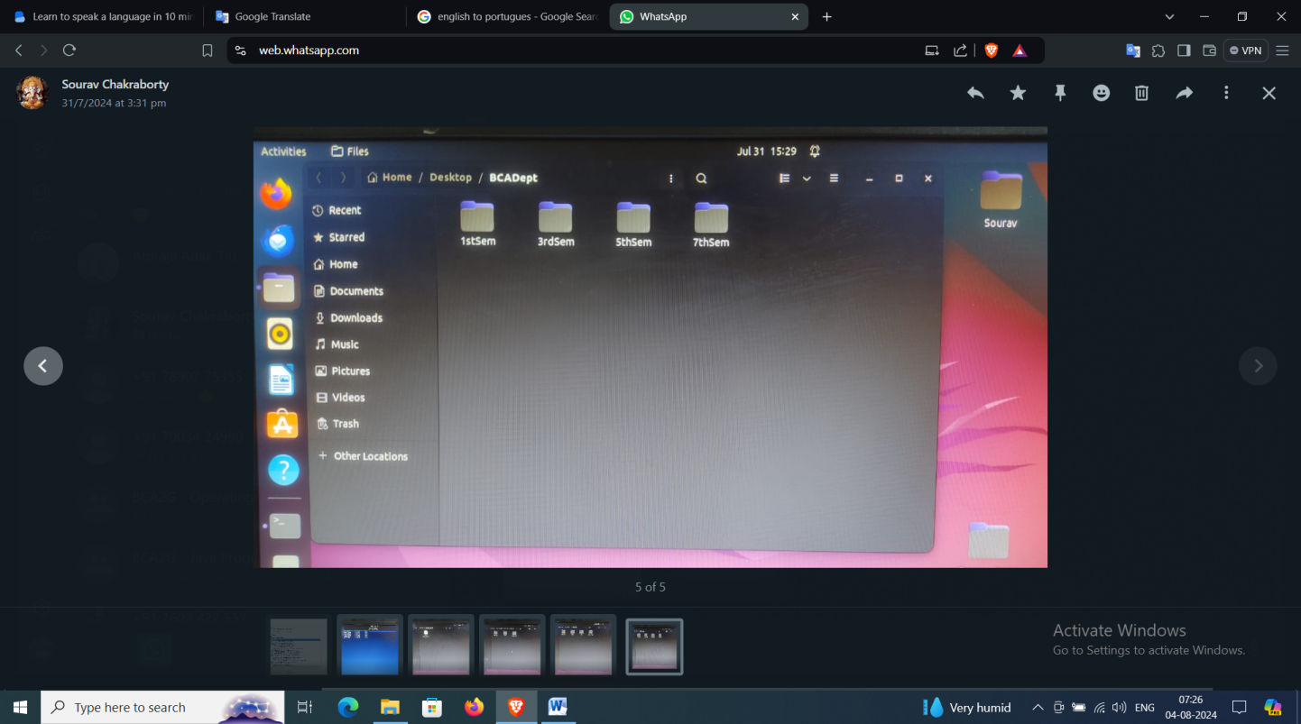

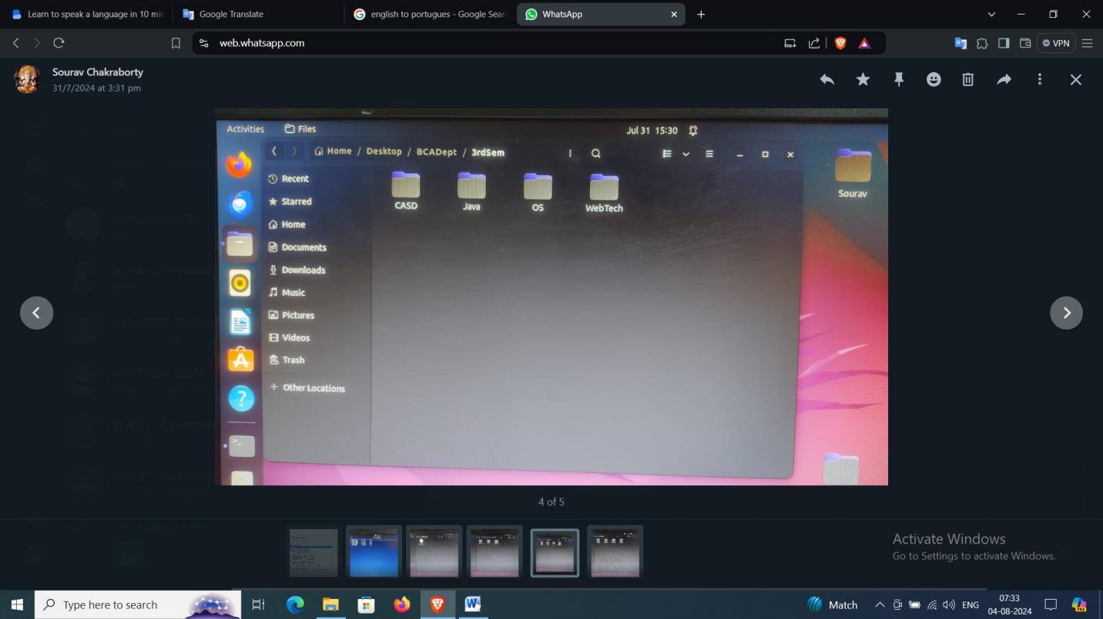

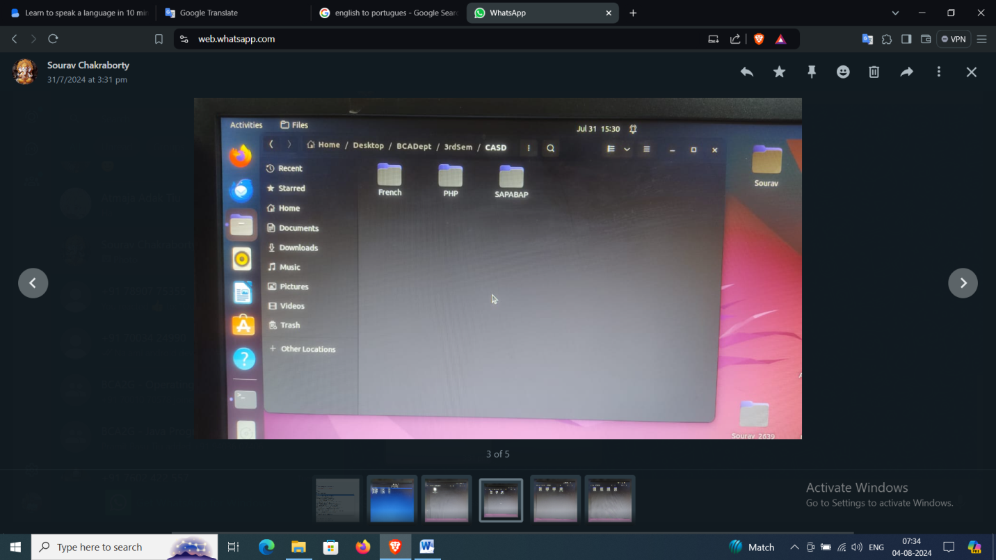

**Assignment 2**

**Question**

Create a directory in desktop, rename it and create a database

**Commands Used**

To create the directory :-

tiu@tiu-matha-mota:~/Desktop$ mkdir OS_Worksheet1

To rename the directory :-

tiu@tiu-matha-mota:~/Desktop$ mv OS_Worksheet1 Swarup_2215

**To create a file :-**

tiu@tiu-matha-mota:~/Desktop/Swarup_2215$ gedit OS_Worksheet1

**Output**

2233 A.K Shukla g.m. sales 12/12/52 6000

5678 SumitDas d.g.m mktg 19/12/43 6000

1006 C.Saxena direc sales 03/09/38 6700

1265 S.N.Sahoo mngr sales 12/03/63 5600

2476 AnilGupta mngr sales 01/05/59 8200

6521 V.K.Gupta g.m. mktg 31/12/40 9000

**Assignment 3**

**Question**

Display some sections of the created database

**Commands Used**

To print the 2nd column of the database :-

tiu@tiu-matha-mota:~/Desktop/Swarup_2215$ cut -f2 OS_Worksheet1

To print the 4th column of the database :-

tiu@tiu-matha-mota:~/Desktop/Swarup_2215$ cut -f4 OS_Worksheet1

To print the 3rd and 4th column of the database :-

tiu@tiu-matha-mota:~/Desktop/Swarup_2215$ cut -f3,4 OS_Worksheet1

To print the first 4 rows :-

iu@tiu-matha-mota:~/Desktop/Swarup_2215$ head -4 OS_Worksheet1

To print the last 2 rows :-

tiu@tiu-matha-mota:~/Desktop/Swarup_2215$ tail -2 OS_Worksheet1

**Output**

**tiu@tiu-matha-mota:~/Desktop/Swarup_2215$ cut -f2 OS_Worksheet1**

A.K Shukla

SumitDas

C.Saxena

S.N.Sahoo

AnilGupta

V.K.Gupta

**tiu@tiu-matha-mota:~/Desktop/Swarup_2215$ cut -f4 OS_Worksheet1**

sales

mktg

sales

sales

sales

mktg

**tiu@tiu-matha-mota:~/Desktop/Swarup_2215$ cut -f3,4 OS_Worksheet1**

g.m. sales

d.g.m mktg

direc sales

mngr sales

mngr sales

g.m. mktg

**tiu@tiu-matha-mota:~/Desktop/Swarup_2215$ head -4 OS_Worksheet1**

2233 A.K Shukla g.m. sales 12/12/52 6000

5678 SumitDas d.g.m mktg 19/12/43 6000

1006 C.Saxena direc sales 03/09/38 6700

1265 S.N.Sahoo mngr sales 12/03/63 5600

**tiu@tiu-matha-mota:~/Desktop/Swarup_2215$ tail -3 OS_Worksheet1**

2476 AnilGupta mngr sales 01/05/59 8200

6521 V.K.Gupta g.m. mktg 31/12/40 9000