SWARUP SONAWANE(A231) EXP.1 70012200126

1.to perform addition, WAP subtraction, multiplication, and division of 2 numbers.

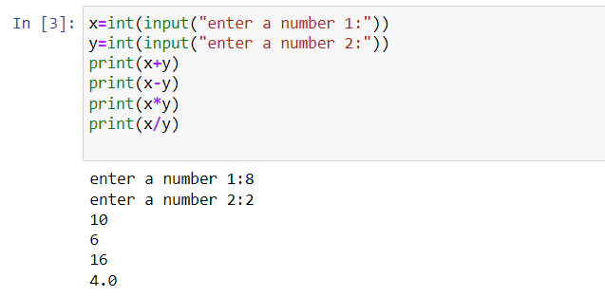

2.Write a program to enter a number and print its square, cube and square root. 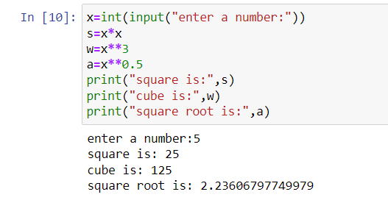 3.WAP to calculate the average of 3 numbers.

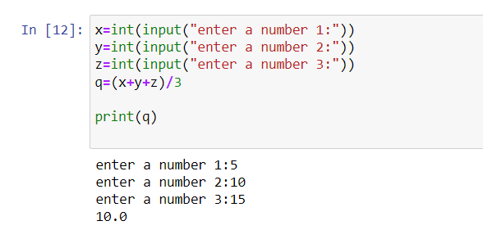

4.Write a program to calculate the area of a right-angle triangle.

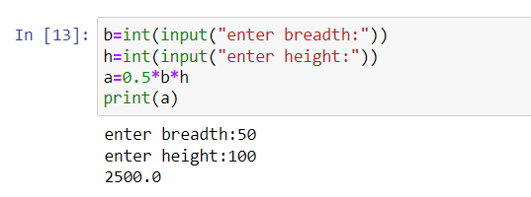 5.Write a program to calculate the volume of a cylinder/sphere.

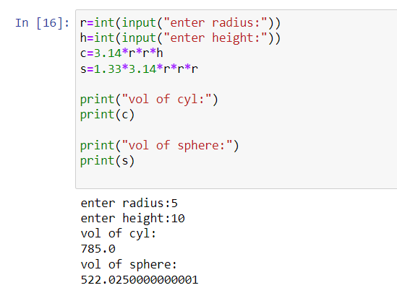

6.WAP to calculate simple interest.

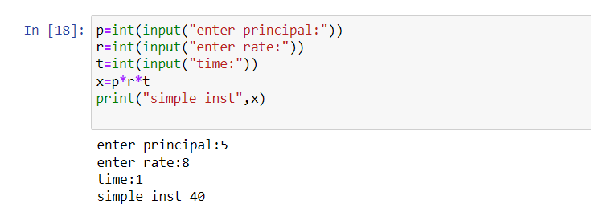

7.WAP to convert temperature in Celsius into Fahrenheit.

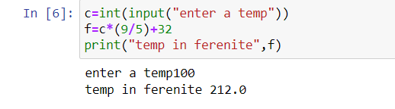

8.WAP to convert a length from meters to Feet and Inches.

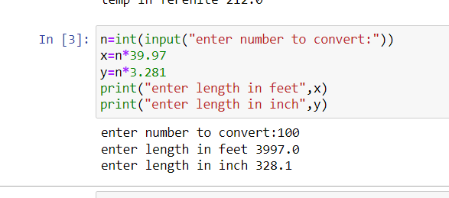 9.WAP to calculate the area of circle/rectangle/square.

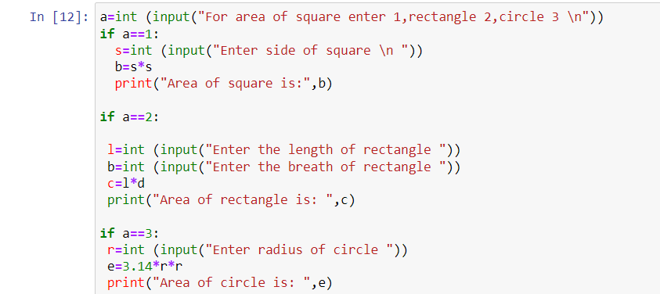

10.WAP to find Euclidean distance between two points on a plane.

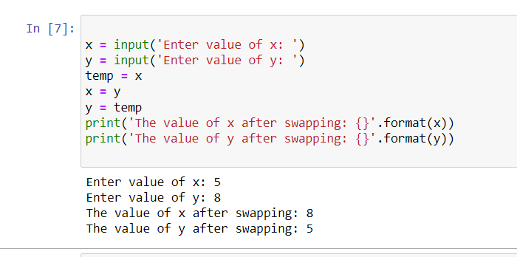

11.WAP to swap the values of two variables.



12.WAP to demonstrate the use of relational operators.

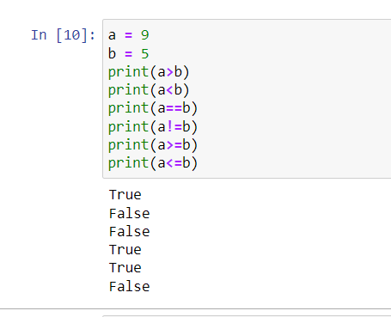

13.WAP to demonstrate the use of logical operators.

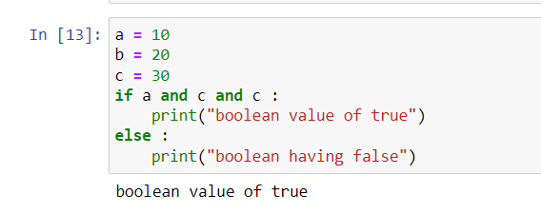

14.WAP to demonstrate the use of bitwise operators.

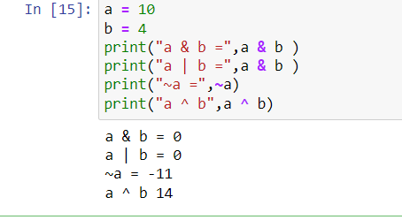

15.WAP to double the value of a variable using bitwise operator.

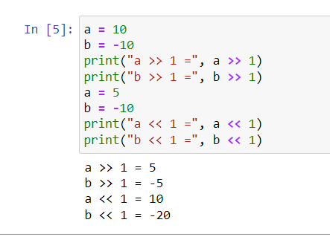……………END…………………………….