Data Visualization & Reporting Strategy
Turning Raw Data Into Decisions with Python-Based Visual Analytics
Week 3 — Business Intelligence & Analytics Track

1. Overview: Why Visual Analytics Matters
Every business generates far more data than any spreadsheet can meaningfully explain on its own. Rows and columns hide patterns; a well-built chart reveals them in seconds. Visual analytics is the discipline of turning raw numbers into images that a manager, an investor, or a frontline team can understand at a glance, and it's become one of the most valuable skills in modern business intelligence because it shortens the distance between "we collected the data" and "we made a decision because of the data."
Python has become the backbone of this work for a simple reason: it treats visualization as part of the same workflow as data cleaning and analysis, not a separate step you hand off to another tool. A single script can pull data from a database, clean it, run the numbers, and produce a polished chart, all without leaving the pipeline. That means fewer manual exports, fewer version-control headaches with screenshots pasted into slide decks, and dashboards that can be regenerated automatically every time new data lands.
Throughout this document, we'll ground every concept in a real example: a dataset of used-car listings from Pakistan (spanning general listings and a BMW-specific subset), covering price, mileage, fuel type, engine capacity, transmission, and model year across more than 78,000 vehicles. It's a good stand-in for the kind of messy, real-world commercial data most businesses actually have to work with.

2. Visualization Techniques and When to Use Them
Not every chart type suits every question. Picking the right one is less about aesthetics and more about matching the shape of the data to the shape of the question you're asking. Below is a practical breakdown of the charts that come up most often in business analytics.
Chart Type | Best For | Business Example
Bar / Column Chart | Comparing totals or averages across a small number of categories | Average resale price by fuel type (Electric vs. Petrol vs. Diesel)
Line Chart | Showing a trend over a continuous sequence, usually time | Average listing price by model year, to see how depreciation trends
Scatter Plot | Examining the relationship between two numeric variables | Mileage vs. price, to see how driven distance affects resale value
Box Plot | Comparing the spread and outliers of a metric across groups | Price distribution and outlier listings within each transmission type
Heatmap | Visualizing correlation or density across many variables at once | Correlation matrix of price, mileage, engine capacity, and model year
Histogram | Understanding the distribution of a single variable | How listing prices are distributed across the whole used-car market
Stacked/100% Bar | Showing how a whole breaks down into parts, and how that mix shifts | Share of listings by fuel type across different price bands
A rule of thumb that holds up well in practice: use bar charts to compare, line charts to track change, scatter plots to find relationships, and box plots or histograms when you need to talk about spread and outliers rather than just averages. Averages alone can be dangerously misleading — a market with a handful of ultra-luxury outliers can post a high "average price" while most real listings sell far below it, which is exactly why distribution-aware charts matter alongside simple comparisons.

3. Python Libraries: Strengths and Best Use Cases
Python's visualization ecosystem isn't one tool but a layered stack, and knowing which layer to reach for saves a lot of wasted effort.

Matplotlib — the foundation
Matplotlib is the low-level engine almost everything else in Python plotting is built on. It gives full control over every pixel of a chart — tick marks, fonts, colors, annotations — which makes it the right choice for polished, print-ready static figures such as the ones embedded later in this document. The trade-off is verbosity: producing a clean chart often takes more lines of code than in higher-level libraries.

Seaborn — statistical clarity, fast
Seaborn sits on top of Matplotlib and is built specifically for statistical visualization. It handles the fiddly parts of grouped comparisons, distributions, and correlation heatmaps with one or two lines of code, and its default styling looks presentation-ready out of the box. It's the natural choice when the question is "how does this metric vary across groups" or "how are these variables related."

Plotly — interactivity for stakeholders
Plotly trades some of Matplotlib's fine-grained control for built-in interactivity: zooming, hovering for exact values, and toggling series on and off. That makes it especially useful for dashboards and reports meant to be explored by non-technical stakeholders in a browser, rather than printed as a static image. It also integrates cleanly with Dash for building full interactive web dashboards.
Library | Strength | When to Reach For It
Matplotlib | Total control, publication-quality static output | Formal reports, printed decks, custom-styled figures
Seaborn | Fast, attractive statistical plots with sensible defaults | Exploratory analysis, correlation and distribution charts
Plotly | Interactive, web-friendly, stakeholder-facing | Live dashboards, executive reports viewed on-screen

4. Interpretation Guidelines
A chart is only useful if the person looking at it reads it correctly, and misreading visualizations is one of the most common — and costly — mistakes in business reporting. A few habits help avoid that:
- Start with scale, not shape: Always check the axes before the shape of the data.
- Two lines that look like they're converging can just be sitting on different scales. Reading the numbers on the axis first prevents that mistake before it happens.
- Watch for truncated or non-zero baselines. A jump from 40% to 42% looks dramatic on a chart whose y-axis starts at 39%, and barely visible on one that starts at 0%. Always note where the axis begins.
- Outliers deserve investigation, not deletion.
- A handful of extreme points — like a handful of ultra-rare, ultra-expensive listings — can be a data-entry error, or they can be the most important story in the dataset. Box plots and scatter plots make these visible; the next step is always to ask why they're there before deciding whether to exclude them.
- Correlation is not causation. Correlation on a scatter plot or heatmap shows that two variables move together, not that one causes the other. A negative relationship between mileage and price is intuitive, but confirming causation needs more than a single chart.
- Cross-check trends against distributions. A single chart rarely tells the whole story. Cross-reference a price trend by year with a distribution chart to check whether that trend is being driven by the whole market or just a shrinking pool of high-end listings.

5. Narrative Example: The Pakistan Used-Car Market
To make the guidance above concrete, here is a short narrative built from the dataset we referenced earlier — 78,630 used-car listings across the general Pakistani market, alongside a focused subset of BMW listings and a separate global used-car reference file. This is the kind of write-up that should accompany a chart in a real business report: it doesn't just describe the picture, it explains why it matters.
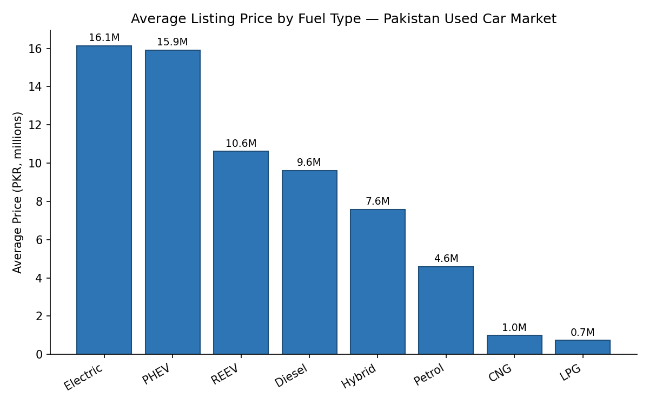
Figure 1 — Average listing price by fuel type across the Pakistani used-car market.
The first chart compares average asking price across fuel types. Electric and plug-in hybrid vehicles command the highest average prices — both above PKR 15 million — while conventional petrol vehicles, which make up the overwhelming majority of the market at roughly 85% of listings, average closer to PKR 4.6 million. For a dealership or marketplace deciding where to invest inventory or marketing budget, this single chart makes a clear case: electrified vehicles are a small but disproportionately high-value segment, and a business that ignores them is leaving margin on the table even if volume stays concentrated in petrol.
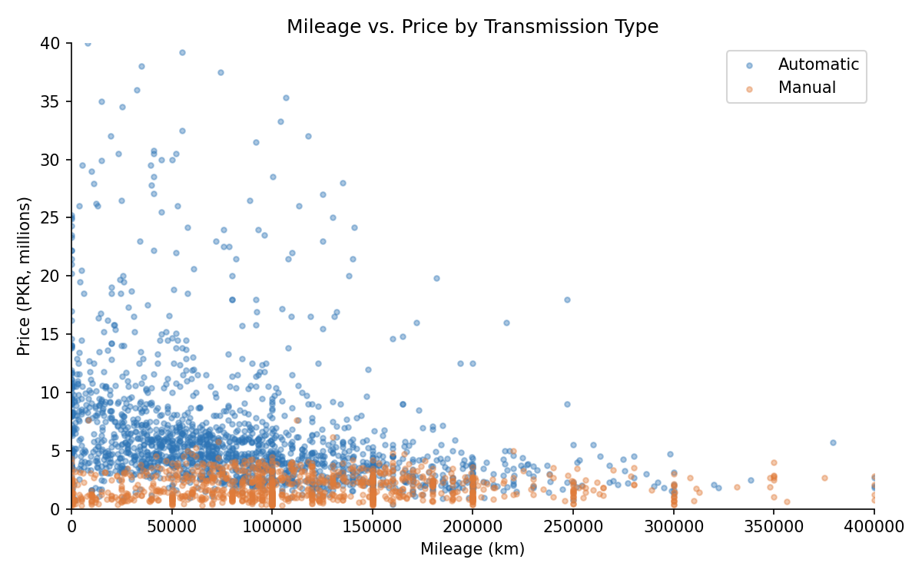
Figure 2 — Relationship between mileage and price, split by transmission type.
The second chart plots mileage against price for a representative sample of listings, split by transmission. Two things stand out immediately. First, the expected negative relationship holds: higher-mileage vehicles cluster toward lower prices, consistent with a broader dataset-wide correlation of about -0.21 between mileage and price. Second, automatic-transmission vehicles (in blue) sit visibly higher on the price axis than manual vehicles (in orange) at almost every mileage level — automatics average roughly PKR 7.2 million against about PKR 1.9 million for manuals, a gap far larger than mileage alone explains.
Put together, the narrative for a business stakeholder would read something like this: "Transmission type is a stronger price signal in this market than mileage is. A pricing or inventory-sourcing strategy that treats manual and automatic vehicles as one pool will systematically misprice a large share of listings. We recommend segmenting valuation models by transmission first, then adjusting within each segment for mileage and model year, rather than applying a single blended depreciation curve across the whole inventory." That single paragraph, backed by two charts, does more to move a pricing decision than a page of raw summary statistics would on its own — which is the entire point of visual analytics in a business setting.

Closing Note
Good data visualization isn't about making charts prettier — it's about making the right decision easier to see. Choosing the correct chart type, picking the right Python tool for the job, reading axes and distributions carefully, and pairing every chart with a clear written narrative are the habits that turn a data team's output into something the rest of the business actually acts on.

