Facial Expression Detection using Webcam

In this project we have designed two separate application such as Person Registration and Facial Expression Detection

1. Person Registration: using this application we can add person details such as person ID, person Name and his face
2. Facial Expression Detection: using this application we can predict facial expression and then we predict the person in the image with expression

To run project first double click on ‘run_register_person.bat’ file to get below screen

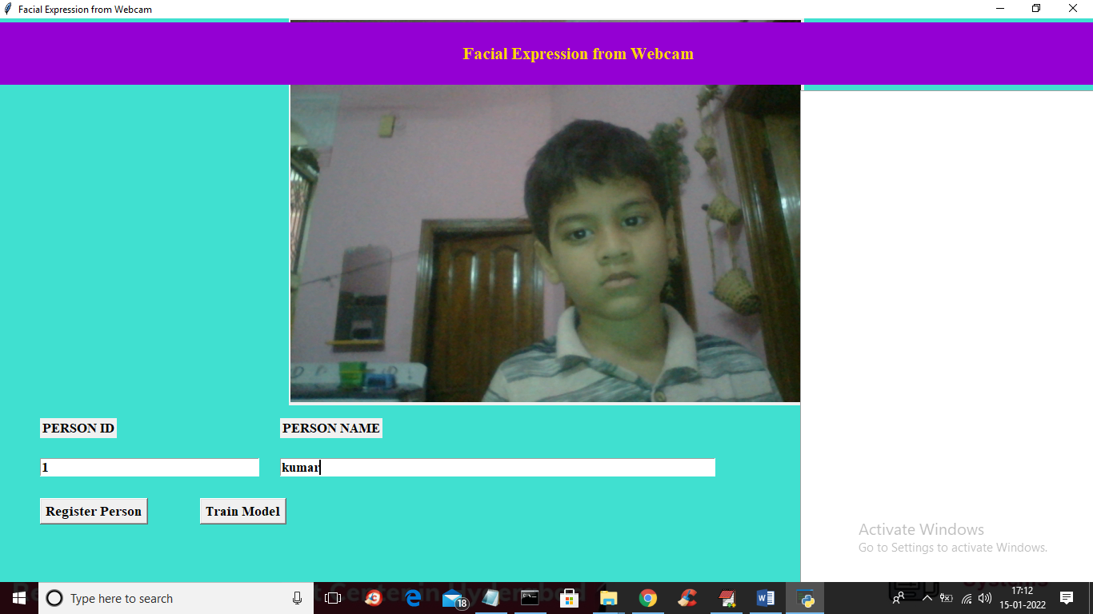

In above screen enter person ID and person name and then click on ‘Register Person’ button to capture person face and to get below screen

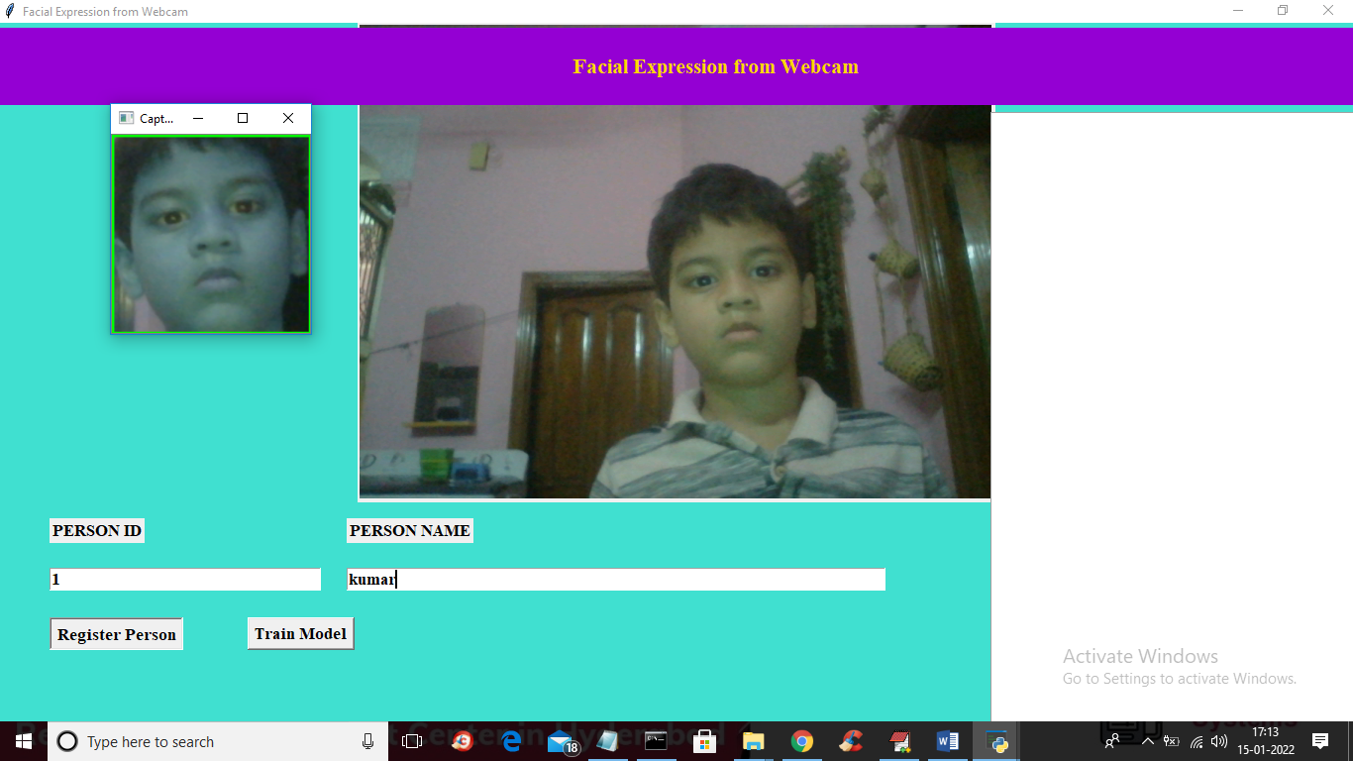

In above screen person face captured and now click on ‘Train Model’ button to add this person to training model so while detecting expression person name can be identified. In above screen person registered as kumar

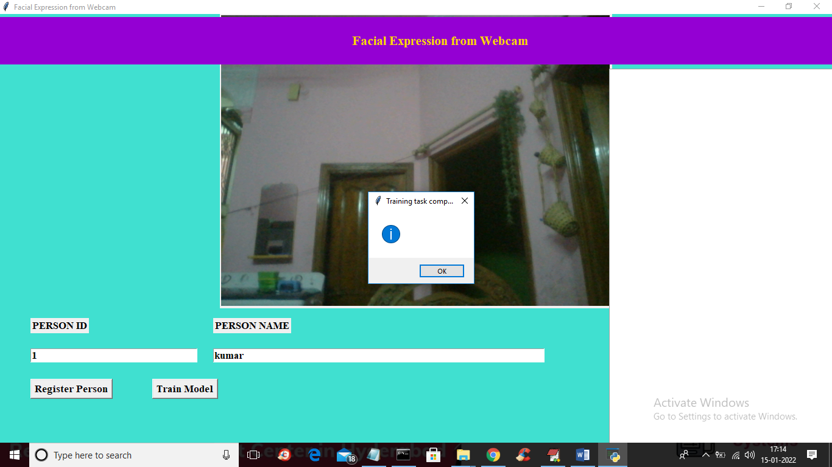

In below screen training task completed and now click OK and similarly you can use above application to signup news users. Now close this application and then double click on ‘run.bat’ file to start facial expression detection application and to get below screen

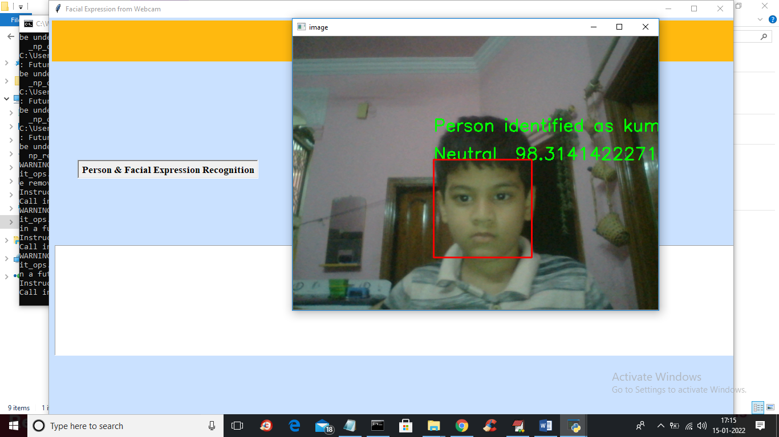

In above screen we can see application predicting person name as well as his facial expressions. To start webcam u need to click on ‘Person Facial Expression Recognition’ button

