**Skin Disease Detection and Classification Using Deep Learning Algorithms**

**Software requirements**

**• Programming Language : Python, Colab**

**• Packages : Numpy,Matplotlib, Tensorflow, Pandas, Flask Framework,Keras**

**• Tool : Python 3.7**

**Framework**

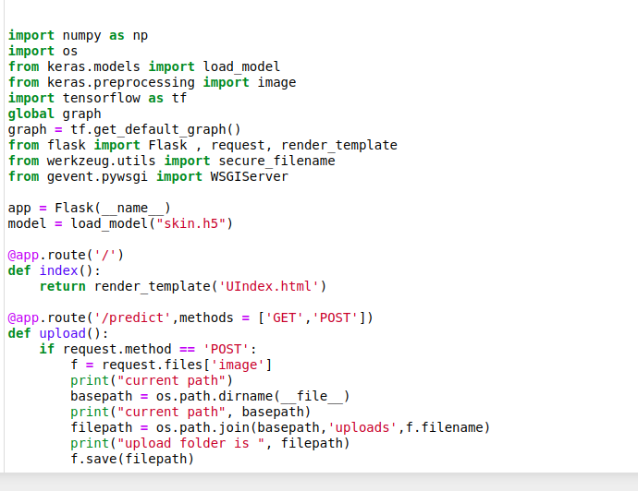

**Localhost**

**In cmd - python app.py**

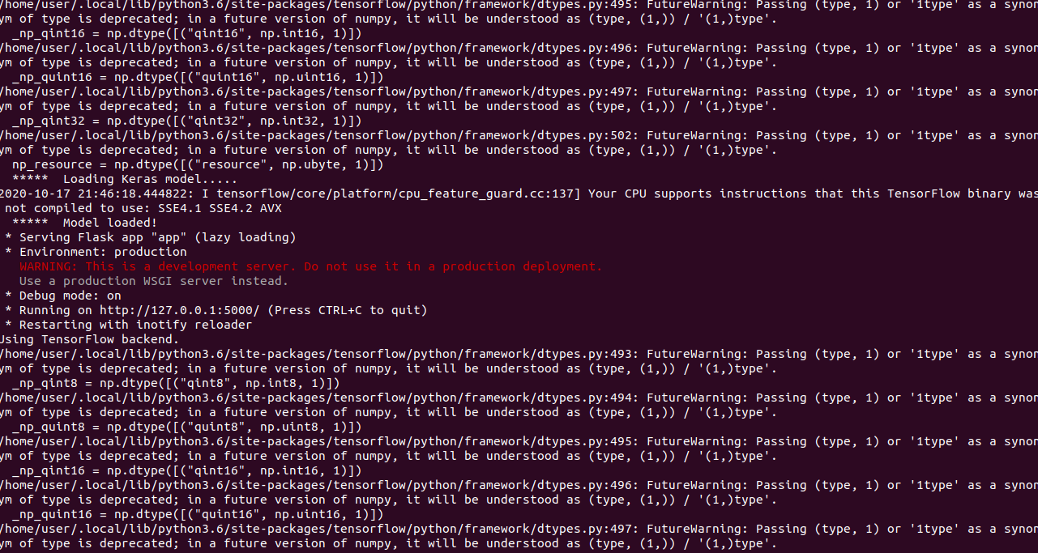

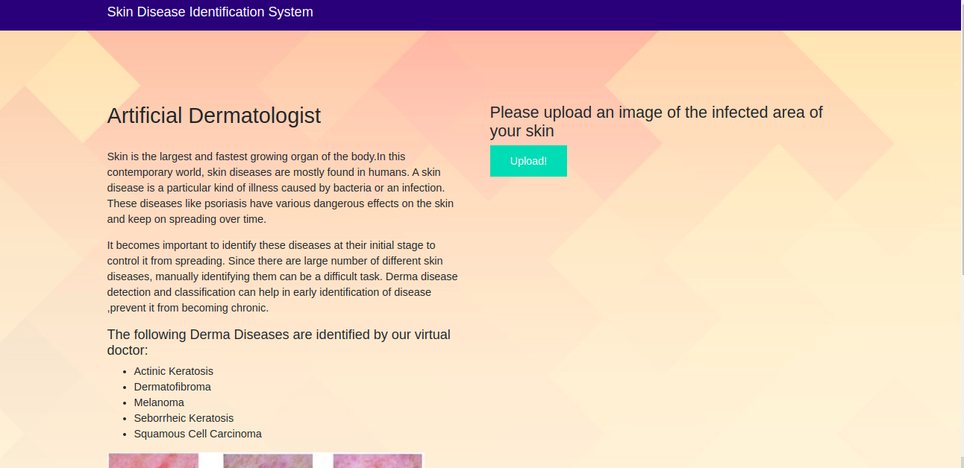

### 

### 

## Artificial Dermatologist

**Skin is the largest and fastest growing organ of the body.In this contemporary world, skin diseases are mostly found in humans. A skin disease is a particular kind of illness caused by bacteria or an infection. These diseases like psoriasis have various dangerous effects on the skin and keep on spreading over time.**

**It becomes important to identify these diseases at their initial stage to control it from spreading. Since there are large number of different skin diseases, manually identifying them can be a difficult task. Derma disease detection and classification can help in early identification of disease ,prevent it from becoming chronic.**

**we are collect 5 images it contains img1-actinic keratosis, img2-dermatofibroma, img3-melanoma, img4-seborrheic keratosis, img5-squamous cell carcinoma**

##### The following Derma Diseases are identified by our virtual doctor:

* **Actinic Keratosis**
* **Dermatofibroma**
* **Melanoma**
* **Seborrheic Keratosis**
* **Squamous Cell Carcinoma**

**Upload an image using upload button**

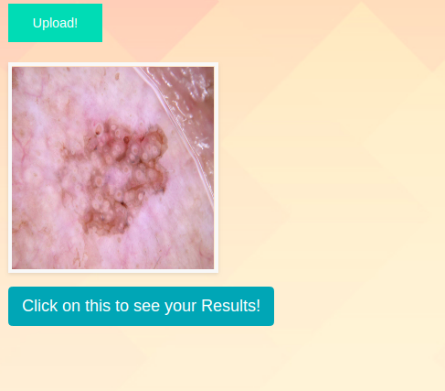

**Click for results**

