A First Project Report on

**Multi-Featured Calculator**

Submitted in Partial Fulfillment of the Requirements for

the Degree of **BCA**

under Pokhara University

Submitted by:

**Swarup Lamsal, 222041**

Under the supervision of

**Er. Nirdosh Adhikari**

Date: 08-28-2023



**Department of BCA**

**NEPAL COLLEGE OF**

**INFORMATION TECHNOLOGY**

Balkumari, Lalitpur

# ACKNOWLEDGMENT

I would like to express my deep appreciation and gratitude to my subject teacher and lecturer Er. Nirdosh Adhikari Sir for his contagious support, advise, information and encouragement in this project.

I feel immense pleasure to present my project after a considerable time. Besides my effort, the support and guidelines given by the others have not been unnoticed. I express my gratitude to all the people for the support on me doing this project.

I express my thanks to Nepal College of Information Technology for it has been a source of this project and support, valuable information, resources and guidance given to me to carryout this project.

I am also grateful and indebted to my beloved friends for their immense help, support and encouragement throughout the completion of the project without which the completion of the project would not have been possible.

Last but not the least, I would like to thank my lecturer, parents, friends, this college and others who helped me for their guidance and support.

# TABLE OF CONTENTS

ACKNOWLEDGMENT I

TABLE OF CONTENTS II

INTRODUCTION III

OBJECTIVES III

METHODOLOGY IV

1. Model Study V

2. Requirement Analysis VI

3. System Design VI

4. Coding VI

5. Testing VII

6. Maintenance VII

DESIGN VII

1. DFD Level 0 VIII

2. System Flowchart IX

CONCLUSION X

# INTRODUCTION

This project is about creating a Multi-featured Calculator using C language. This Calculator can perform basic arithmetic calculations along with performing on other values like square root, cube root, square, and cube of a number.

Also, the feature to calculate the percentage obtained by a student with respect to the total number of subjects and marks obtained in each subject is also present in this multi-featured calculator. The feature to calculate the values of different trigonometric functions is also provided in this calculator.

Along with the above mentioned feature, the calculator also has an in-build conversion system that can convert different quantities like Currency, Length, Mass, Temperature and Time. Inside these different quantities, the units of these quantities can be converted to one another.

This project utilizes the different topics related to C-programming such as loops, switch-case, comparison statements like if-else and also utilizes the concept of local and global functions in C. It also consists of different header files and different data types are used for different calculations.

# 

# OBJECTIVES

Some of the objectives of the project is mentioned below :-

1. To be familiar with different concepts of C-programming such as Global/Local functions, conditional statements, different types of loops, pointers, switch-case statements, etc.
2. To provide the user with an interface to interact with the calculator and operate on different arithmetic calculations.
3. To make the user be able to work on conversion among different units of quantities like Currency, Mass, Length, Temperature and Time.
4. To generate a Basic Calculator System that also consists of additional additional features using a Mid-Level Programming Language i.e. C-Language.

# METHODOLOGY

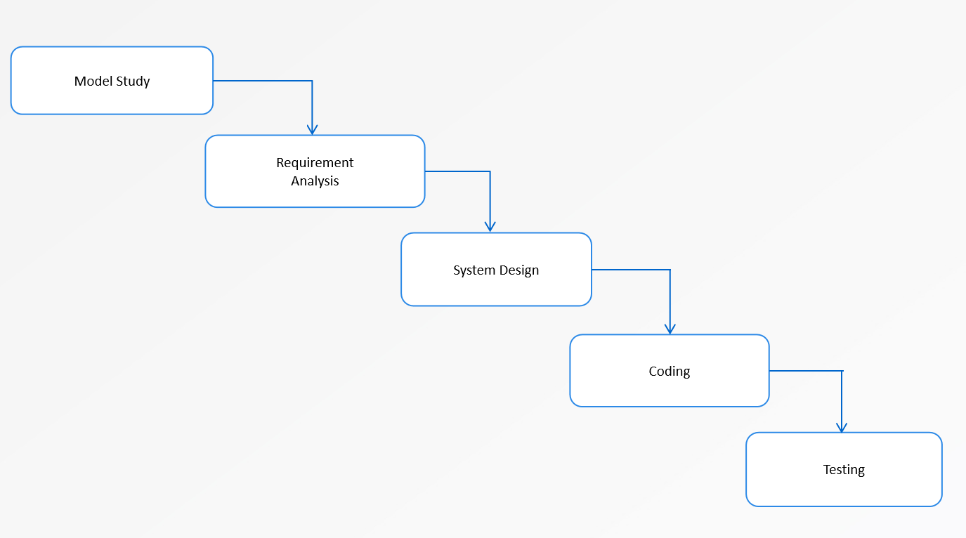

Fig-: Waterfall Model

Steps of the Waterfall Model:-

## Model Study

First of all, the model of a scientific calculator, which is capable of performing a wide range of arithmetic calculations along with conversions of standard units, was studied to find inspiration for the project. By studying the model, a list of features that are performed by the calculator and need to be implemented in the Multi-featured Calculator using the C language was compiled.

## Requirement Analysis

The list that could be formulated after studying the model helped me understand the requirements for the creation of the Multi-featured Calculator project. In addition to the fundamental arithmetic calculations, the necessity for one or more menus to enhance user-program interaction became apparent. Alongside these menus, it was also recognized that dividing the code into multiple functions would facilitate both comprehension and debugging during the program's development. In conjunction with the initial requisites, adaptations to the Waterfall model were made to enhance its compatibility with my needs. This adjustment allowed for the formulation of additional requirements as the code development progressed.

## System Design

After the system's requirements were documented, the recognition of the importance of maximizing interactivity emerged as a crucial factor in establishing a seamless and error-resistant system. In pursuit of this objective, a menu-based system was conceived, encompassing sub-menus for various conversions, and was implemented using functions containing distinct switch-case structures. While this system ensures a remarkably smooth user-program interaction, the design was intentionally oriented towards simplicity and functionality rather than flashiness or aesthetic appeal.

## Coding

After formulating the fundamental system design through brainstorming, I proceeded to code the preliminary menu segment for the calculator. Once the menu sections were finalized using switch-case structures to handle diverse user inputs, I subsequently developed distinct calculation segments to address various conditions such as addition, subtraction, multiplication, and division of two numbers.

## Testing

Following the coding phase, I initiated the testing process by examining different scenarios corresponding to the menu options. I meticulously tested each case, scrutinizing the program's behavior to identify any potential errors arising during input provision and subsequent output reception.

## Maintenance

The errors identified during the testing phase were gradually addressed through a debugging process. Additionally, I enlisted the assistance of my friends and teacher to conduct further testing and error identification. Continuously gathering their feedback, I have been actively debugging the code in response to any issues highlighted, with the aim of enhancing the program's user-friendliness to the greatest extent possible.

# DESIGN

Data-flow-diagram(DFD)

1. DFD Level 0

Enter numbers for calculations

Outputs for calculations

User

Calculator System

Enter choices from menu

Fig:- 0 Level Data-Flow-Diagram

0 Level Data-Flow-Diagram is the most simplified version of a Data-Flow-Diagram. In the 0 Level DFD, There is one process (being circle shaped which is the Calculator System), one external entity (being rectangular shaped which is User), and arrows that shows the data flow in the system.

As the system contains different Menu-based Interfaces, the users are required give choice from the menus shown in the menu interfaces. Also, after selecting a specific choice, the users needs to enter numbers to operate on the selected operation. After the users give the number/s to operate, the system provides the output after operating on the values.

## System Flowchart

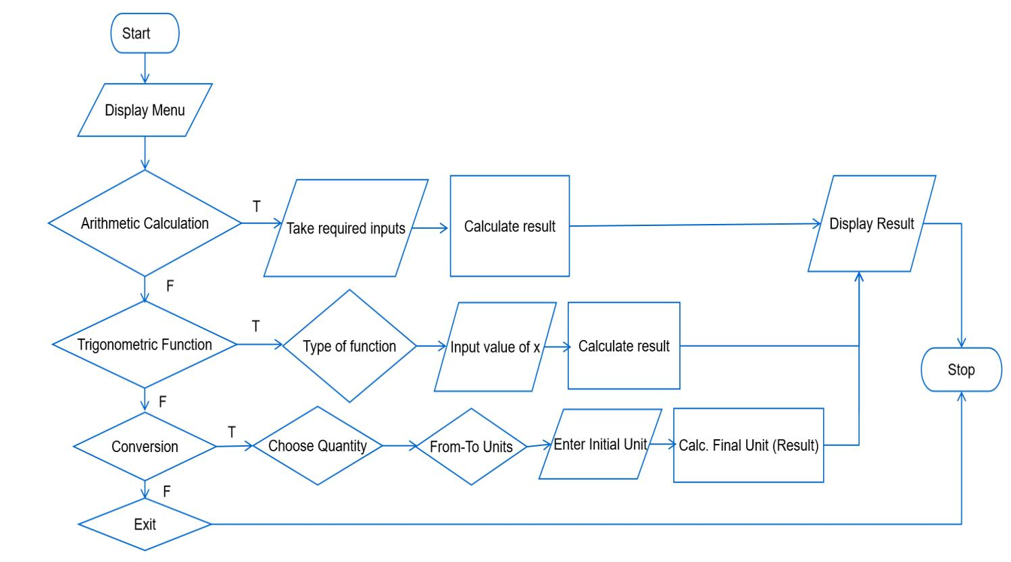

Fig:- System Flowchart of Calculator System

# CONCLUSION

In conclusion, this project of creating a Multi-featured Calculator familiarized myself of different features in C like basic inputs and outputs, loops, switch-case statements, pointer, functions, and many more. The development of this project also allowed myself to learn the techniques though which connecting these different features in C allowed to make the program run smoothly without any complications.

This Multi-featured Calculator can be used by different people to carryout similar operations to that of a normal calculator along with carryout conversions of different Units within a Standard Quantity. The units included in a Standard Quantity as well as the Standard Quantities itself is multiple in number due to which users will be able to convert wide variety of units.

Although the scale of this project is quite low, I will be continuously looking to find and debug any issues that may arise in the future. Along with debugging, I will also work on enhancing the scale at which I am able to complete this project.

Lastly, I would again like to thank all of the people including my Course Subject Teacher and all of my friends that have helped me to accomplish this project and I hope I can continue creating such similar projects in the near future using different Programming Languages like C.