**MOBILE COMPUTING LAB**

**A Lab Manual Submitted in Fulfilment**

**of the Degree of**

**MASTER**

**In**

**COMPUTER APPLICATION**

**Year 2022-2023**

**By**

**Ms. MANJAREKAR SWARUPA SATYAVAN GEETA**

**(Seat No.:- 806075)**

**(Application Id:- 170714)**

**Under the Guidance of**

**Asst. Prof. Mr. Dnyaneshwar Deore.**



**Institute of Distance and Open Learning**

**Vidya Nagari, Kalina, Santacruz East – 400098.**

**University of Mumbai**

**PCP Center**

**Satish Pradhan Dnyanasadhana College,**

**Thane.**



**Institute of Distance and Open Learning**

**Vidya Nagari, Kalina, Santacruz East – 400098.**

***CERTIFICATE***

This is to certify that, this Lab Manual entitled “**Mobile Computing Lab**” is a record of work carried out by **Ms. Manjarekar Swarupa Satyavan Geeta (Seat no:- 806075),** student of MCA Semester-III class and is submitted to University of Mumbai, in partial fulfilment of the requirement for the award of the degree of Master in Computer Application. The Lab Manual has been approved.

**___________ ____________ ____________**

**Guide External Examiner Coordinator –M.C.A**

**Approval of Lab Manual**

This is to certify that the Lab Manual entitled “**Mobile Computing Lab**”, for Master in Computer Application submitted to University of Mumbai by **Ms. Manjarekar Swarupa Satyavan Geeta (Seat no:- 806075)** a bonafide student of Institute of Distance and Open Learning, Vidyanagari, Kalina, Santacruz East has been approved for the award of Master in Computer Application.

**Examiner**

**1.**

**2.**

**Date:**

**Place:**

**Declaration**

I declare that this written submission represents my ideas in my own words and where other's ideas or words have been included, I have adequately cited and referenced the original sources. I also declare that I have adhered to all principles of academic honesty and integrity and have not misrepresented or fabricated or falsified any idea/data/fact/source in my submission. I understand that any violation of the above will be cause for disciplinary action by the Institute and can also evoke penal action from the sources which have thus not been properly cited or from whom proper permission has not been taken when needed.

-----------------------------------------

(Signature)

Ms. Manjarekar Swarupa Satyavan Geeta

Seat No: 806075

Date:

Place:

**Index**

|  |  |
| --- | --- |
| **Practical No** | **Details** |
| 1 | Introduction To Android  A. Create a simple Hello World application  B. Creating android application for generating user interface for student registration and feedback form by using all basic UI Controls. |
| 2 | Basic Controls And UI Component   1. Program to demonstrate use of spinner, autocompleteTextView, multiline text and TextView Control by creating feedback form 2. create a basic calculator app using android studio. |
| 3 | Data base connectivity  A. Creating android program to demonstrate the use of internal storage  B. Creating android program to demonstrate the use of shared preferences |
| 4 | Introduction To Graphics, Animation And Multimedia  A. Write a program to draw basic graphic construction like listenerCancelled,circle,arc,ellipse and rectangle.  B. Write a program to draw animation using increasing circles filled with different colors and patterns. |
| 5 | Location Based Services  A. Write a program to find your location in the map |
| 6. | Socket Programming in C/C++ |

# **Practical 1: Introduction To Android**

1. **Create a simple Hello World application.**

**Code:**

**MainActivity.java**

package com.example.myapplication;

import androidx.appcompat.app.AppCompatActivity;

import android.os.Bundle;

import android.widget.*;

import android.view.View;

public class MainActivity extends AppCompatActivity {

Button b1;

@Override

protected void onCreate(Bundle savedInstanceState) {

super.onCreate(savedInstanceState);

setContentView(R.layout.activity_main);

b1 =(Button) findViewById(R.id.btnClick);

b1.setOnClickListener(new View.OnClickListener(){

@Override

public void onClick(View v) {

Toast.makeText(getApplicationContext(), "Yes I am clicking on the button", Toast.LENGTH_SHORT).show();

}

});

}

}

ActivityMain.xml

Code:

<?xml version="1.0" encoding="utf-8"?>

<androidx.constraintlayout.widget.ConstraintLayout xmlns:android="http://schemas.android.com/apk/res/android"

xmlns:app="http://schemas.android.com/apk/res-auto"

xmlns:tools="http://schemas.android.com/tools"

android:layout_width="match_parent"

android:layout_height="match_parent"

tools:context=".MainActivity">

<TextView

android:layout_width="331dp"

android:layout_height="76dp"

android:layout_alignParentTop="true"

android:layout_alignParentEnd="true"

android:layout_marginTop="160dp"

android:layout_marginEnd="16dp"

android:text="Hello Android Application!"

android:textColor="@android:color/holo_green_dark"

android:textSize="25dp"

app:layout_constraintBottom_toBottomOf="parent"

app:layout_constraintEnd_toEndOf="parent"

app:layout_constraintHorizontal_bias="0.8"

app:layout_constraintLeft_toLeftOf="parent"

app:layout_constraintRight_toRightOf="parent"

app:layout_constraintTop_toTopOf="parent"

app:layout_constraintVertical_bias="0.0" />

<Button

android:id="@+id/btnClick"

android:layout_width="wrap_content"

android:layout_height="wrap_content"

android:text="Click on me"

app:layout_constraintEnd_toEndOf="parent"

app:layout_constraintStart_toStartOf="parent"

tools:ignore="MissingConstraints"

tools:layout_editor_absoluteY="248dp" />

</androidx.constraintlayout.widget.ConstraintLayout>

**Design:**

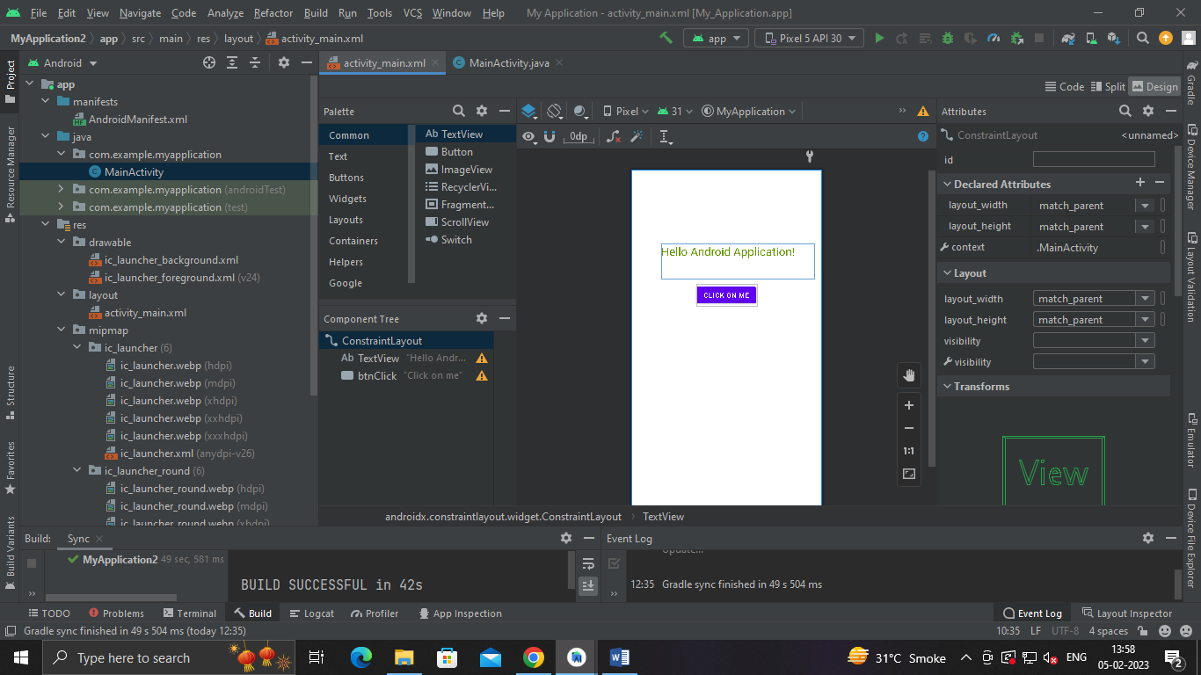

**Output:**

1. **TITLE: Creating android application for generating user interface for student Registration and feedback form by using all basic UI controls.**

**Code:**

**activity_main.xml**

<?xml version="1.0" encoding="utf-8"?>

<android.support.constraint.ConstraintLayout

xmlns:android="http://schemas.android.com/apk/res/android"

xmlns:tools="http://schemas.android.com/tools"

xmlns:app="http://schemas.android.com/apk/res-auto"

android:layout_width="match_parent"

android:layout_height="match_parent"

tools:context=".MainActivity">

<LinearLayout

android:layout_width="wrap_content"

android:layout_height="wrap_content"

android:orientation="vertical"

app:layout_constraintBottom_toBottomOf="parent"

app:layout_constraintEnd_toEndOf="parent"

app:layout_constraintStart_toStartOf="parent"

app:layout_constraintTop_toTopOf="parent">

<ImageButton

android:id="@+id/imageButton"

android:layout_width="320dp"

android:layout_height="147dp"

android:scaleType="fitCenter"

app:srcCompat="@drawable/College1" />

<EditText

android:id="@+id/editTextTextPersonName"

android:layout_width="match_parent"

android:layout_height="match_parent"

android:ems="20"

android:inputType="textPersonName"

android:layout_marginBottom="20dp"

android:hint="Enter your Name" />

<EditText

android:id="@+id/editTextTextEmailAddress"

android:layout_width="265dp"

android:layout_height="wrap_content"

android:hint="Enter your Email Address"

android:ems="10"

android:layout_marginBottom="20dp"

android:inputType="textEmailAddress" />

<EditText

android:id="@+id/editTextPhone"

android:layout_width="match_parent"

android:layout_height="wrap_content"

android:layout_marginBottom="20dp"

android:ems="10"

android:hint="Enter your Phone No"

android:inputType="phone" />

<EditText

android:id="@+id/editTextTextPostalAddress"

android:layout_width="match_parent"

android:layout_height="wrap_content"

android:ems="10"

android:layout_marginBottom="20dp"

android:hint="Enter your Postal Address"

android:inputType="textPostalAddress" />

<CheckBox

android:id="@+id/checkBox2"

android:layout_width="match_parent"

android:layout_height="wrap_content"

android:layout_marginBottom="20dp"

android:text="Please Tick if you want to have Hostel facility" />

<RadioGroup

android:layout_width="match_parent"

android:layout_height="match_parent" >

<RadioButton

android:id="@+id/radioButton4"

android:layout_width="match_parent"

android:layout_height="wrap_content"

android:layout_marginBottom="20dp"

android:text="Male" />

<RadioButton

android:id="@+id/radioButton3"

android:layout_width="match_parent"

android:layout_height="wrap_content"

android:layout_marginBottom="20dp"

android:text="Female" />

</RadioGroup>

<Button

android:id="@+id/button"

android:layout_width="match_parent"

android:layout_height="wrap_content"

android:background="#F1A7A7"

android:text="Register" />

</LinearLayout>

</android.support.constraint.ConstraintLayout>

**MainActivity.java:**

package com.example.registration

import android.support.v7.app.AppCompatActivity

import android.os.Bundle

class MainActivity : AppCompatActivity() {

override fun onCreate(savedInstanceState: Bundle?) {

super.onCreate(savedInstanceState)

setContentView(R.layout.activity_main)

}

}

**Output:**

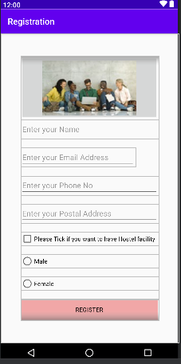

# **Practical 2: BASIC CONTROLS AND UI COMPONENT**

1. **For the functioning of the spinner and AutoComplete Text View control, Code has to be written in mainActivity.java.**

**Code:**

**MainActivity.java**

package com.example.customerfeedbackform;

import android.support.v7.app.AppCompatActivity;

import android.os.Bundle;

import android.view.View;

import android.widget.AdapterView;

import android.widget.AdapterView.OnItemSelectedListener;

import android.widget.ArrayAdapter;

import android.widget.Spinner;

import android.widget.Toast;

import android.widget.AutoCompleteTextView;

public class MainActivity extends AppCompatActivity implements

OnItemSelectedListener{

String[] Country={"India","Nepal","China","Srilanka","Australia"};

String[] feedback = { "suggestion", "compliment", "complaint",

"other"};

@Override

protected void onCreate(Bundle savedInstanceState) {

super.onCreate(savedInstanceState);

setContentView(R.layout.activity_main);

Spinner spin = (Spinner) findViewById(R.id.spinner);

spin.setOnItemSelectedListener(this);

ArrayAdapter aa = new

ArrayAdapter(this,android.R.layout.simple_spinner_item,Country);

ArrayAdapter<String> adapter = new ArrayAdapter<String>(this,

android.R.layout.simple_dropdown_item_1line, feedback);

AutoCompleteTextView actv =

(AutoCompleteTextView)findViewById(R.id.autoCompleteTextView);

actv.setThreshold(1);

actv.setAdapter(adapter);

aa.setDropDownViewResource(android.R.layout.simple_spinner_dropdo

wn_item);

//Setting the ArrayAdapter data on the Spinner

spin.setAdapter(aa);

}

@Override

public void onItemSelected(AdapterView<?> adapterView, View view,

int i, long l) {

}

@Override

public void onNothingSelected(AdapterView<?> adapterView) {

}

}

**Output:**

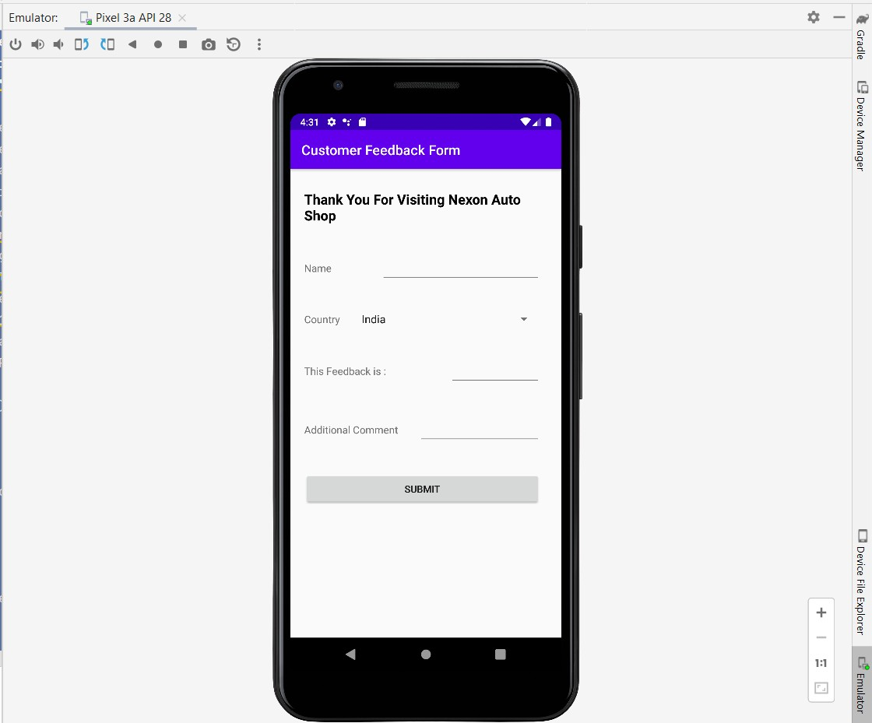

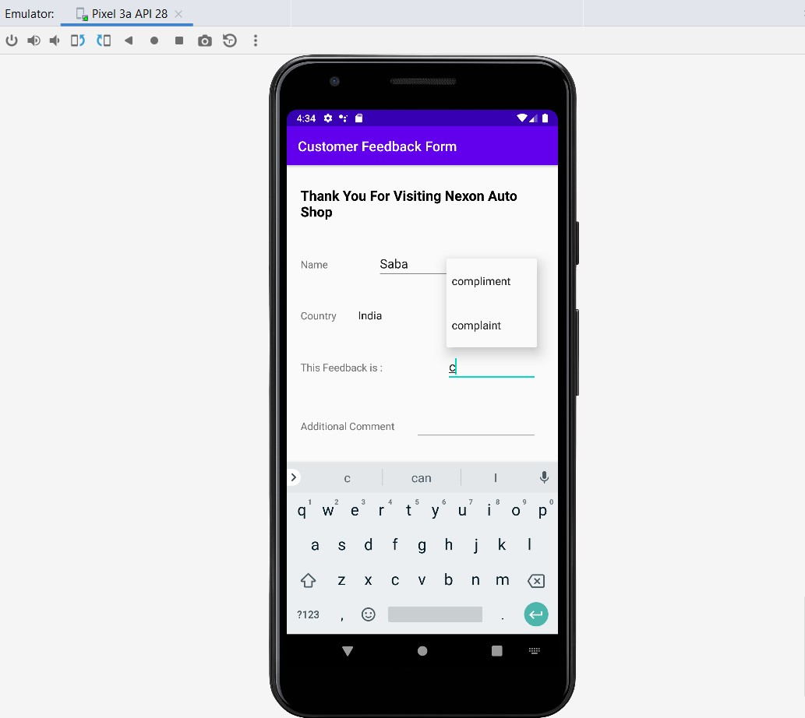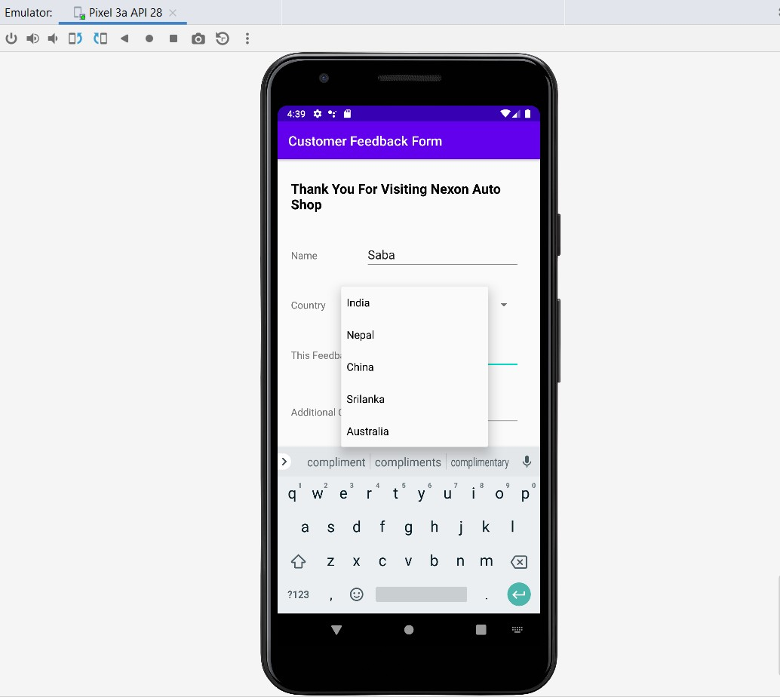 **Spinner Control: for Country Selection AutoComplete TextView Control:**

1. **Create a basic calculator app using android studio.**

**activity_prac22.xml**

<?xml version="1.0" encoding="utf-8"?>

<RelativeLayout xmlns:android="http://schemas.android.com/apk/res/android"

xmlns:app="http://schemas.android.com/apk/res-auto"

xmlns:tools=http://schemas.android.com/tools

android:layout_height="match_parent"

tools:context=".Prac_2_2">

<LinearLayout

android:layout_margin="20dp"

android:orientation="vertical"

android:layout_width="match_parent"

android:layout_height="wrap_content">

<EditText

android:id="@+id/caltxt"

android:editable="false"

android:clickable="false"

android:textSize="35dp"

android:cursorVisible="true"

android:layout_width="match_parent"

android:layout_height="80dp"

android:layout_margin="30dp"

/>

<LinearLayout

android:orientation="horizontal"

android:layout_width="match_parent"

android:layout_height="wrap_content">

<Button

android:id="@+id/cal7"

android:layout_width="70dp"

android:layout_height="70dp"

android:layout_margin="10dp"

android:background="@drawable/border_button"

android:text="7"

android:textColor="@color/black"

android:textSize="35dp"

app:backgroundTint="@null" />

<Button

android:layout_width="70dp"

android:layout_height="70dp"

android:layout_margin="10dp"

android:background="@drawable/border_button"

android:text="8"

android:textColor="@color/black"

android:textSize="35dp"

app:backgroundTint="@null" />

<Button

android:id="@+id/cal9"

android:layout_width="70dp"

android:layout_height="70dp"

android:layout_margin="10dp"

android:background="@drawable/border_button"

android:text="9"

android:textColor="@color/black"

android:textSize="35dp"

app:backgroundTint="@null" />

<Button

android:id="@+id/caldiv"

android:layout_width="70dp"

android:layout_height="70dp"

android:layout_margin="10dp"

android:background="@drawable/border_button"

android:text="/"

android:textColor="@color/black"

android:textSize="35dp"

app:backgroundTint="@null" />

</LinearLayout>

<GridLayout

android:layout_width="match_parent"

android:layout_height="wrap_content">

<Button

android:id="@+id/cal4"

android:layout_margin="10dp"

android:text="4"

android:textSize="35dp"

android:layout_width="70dp"

android:layout_height="70dp"

android:textColor="@color/black"

app:backgroundTint="@null"

android:background="@drawable/border_button"/>

<Button

android:id="@+id/cal5"

android:layout_margin="10dp"

android:text="5"

android:textSize="35dp"

android:layout_width="70dp"

android:layout_height="70dp"

android:textColor="@color/black"

app:backgroundTint="@null"

android:background="@drawable/border_button"/>

<Button

android:id="@+id/cal6"

android:layout_margin="10dp"

android:text="6"

android:textSize="35dp"

android:layout_width="70dp"

android:layout_height="70dp"

android:textColor="@color/black"

app:backgroundTint="@null"

android:background="@drawable/border_button"/>

<Button

android:id="@+id/calmul"

android:layout_margin="10dp"

android:text="x"

android:textSize="35dp"

android:layout_width="70dp"

android:layout_height="70dp"

android:textColor="@color/black"

app:backgroundTint="@null"

android:background="@drawable/border_button"/>

</GridLayout>

<GridLayout

android:layout_width="match_parent"

android:layout_height="wrap_content">

<Button

android:id="@+id/cal1"

android:layout_margin="10dp"

android:text="1"

android:textSize="35dp"

android:layout_width="70dp"

android:layout_height="70dp"

android:textColor="@color/black"

app:backgroundTint="@null"

android:background="@drawable/border_button"/>

<Button

android:id="@+id/cal2"

android:layout_margin="10dp"

android:text="2"

android:textSize="35dp"

android:layout_width="70dp"

android:layout_height="70dp"

android:textColor="@color/black"

app:backgroundTint="@null"

android:background="@drawable/border_button"/>

<Button

android:id="@+id/cal3"

android:layout_margin="10dp"

android:text="3"

android:layout_width="70dp"

android:layout_height="70dp"

android:textColor="@color/black"

app:backgroundTint="@null"

android:background="@drawable/border_button"/>

<Button

android:id="@+id/calsub"

android:layout_margin="10dp"

android:text="-"

android:textSize="35dp"

android:layout_width="70dp"

android:layout_height="70dp"

android:textColor="@color/black"

app:backgroundTint="@null"

android:background="@drawable/border_button"/>

</GridLayout>

<GridLayout

android:layout_width="match_parent"

android:layout_height="wrap_content">

<Button

android:id="@+id/cal0"

android:layout_margin="10dp"

android:text="0"

android:textSize="35dp"

android:layout_width="70dp"

android:layout_height="70dp"

android:textColor="@color/black"

app:backgroundTint="@null"

android:background="@drawable/border_button"/>

<Button

android:id="@+id/calpo"

android:layout_margin="10dp"

android:textSize="35dp"

android:layout_width="70dp"

android:layout_height="70dp"

android:textColor="@color/black"

app:backgroundTint="@null"

android:background="@drawable/border_button"/>

<Button

android:id="@+id/caladd"

android:layout_margin="10dp"

android:text="+"

android:textSize="35dp"

android:layout_width="70dp"

android:layout_height="70dp"

android:textColor="@color/black"

app:backgroundTint="@null"

android:background="@drawable/border_button"/>

<Button

android:id="@+id/calequal"

android:layout_margin="10dp"

android:text="="

android:textSize="35dp"

android:layout_width="70dp"

android:layout_height="70dp"

android:textColor="@color/black"

app:backgroundTint="@null"

android:background="@drawable/border_button"/>

</GridLayout>

</LinearLayout>

</RelativeLayout>

**Prac_2_2.java**

package com.example.mobilepracticals;

import androidx.appcompat.app.AppCompatActivity;

import android.os.Bundle;

import android.view.View;

import android.widget.Button;

import android.widget.EditText;

import com.sdsmdg.tastytoast.TastyToast;

import net.objecthunter.exp4j.Expression;

import net.objecthunter.exp4j.ExpressionBuilder;

import java.nio.charset.StandardCharsets;

public class Prac_2_2 extends AppCompatActivity implements View.OnClickListener {

Button

btn1,btn2,btn3,btn4,btn5,btn6,btn7,btn8,btn9,btn0,btnadd,btnsub,btndiv,btnmul,btnequal,bt

npoint;

EditText txtinput;

String txtIP ="";

int c=0;

@Override

protected void onCreate(Bundle savedInstanceState)

{super.onCreate(savedInstanceState);

setContentView(R.layout.activity_prac22);

txtinput=findViewById(R.id.caltxt);

btn0=findViewById(R.id.cal0);

btn1=findViewById(R.id.cal1);

btn2=findViewById(R.id.cal2);

btn3=findViewById(R.id.cal3);

btn4=findViewById(R.id.cal4);

btn5=findViewById(R.id.cal5);

btn6=findViewById(R.id.cal6);

btn8=findViewById(R.id.cal8);

btn9=findViewById(R.id.cal9);

btnequal=findViewById(R.id.calequal);

btnadd=findViewById(R.id.caladd);

btnsub=findViewById(R.id.calsub);

btndiv=findViewById(R.id.caldiv);

btnmul=findViewById(R.id.calmul);

btnpoint=findViewById(R.id.calpo);

btn0.setOnClickListener(this);

btn1.setOnClickListener(this);

btn2.setOnClickListener(this);

btn3.setOnClickListener(this);

btn4.setOnClickListener(this);

btn5.setOnClickListener(this);

btn6.setOnClickListener(this);

btn7.setOnClickListener(this);

btn8.setOnClickListener(this);

btn9.setOnClickListener(this);

btnpoint.setOnClickListener(this);

btnmul.setOnClickListener(this);

btndiv.setOnClickListener(this);

btnsub.setOnClickListener(this);

btnadd.setOnClickListener(this);

btnequal.setOnClickListener(this);

}

@Override

public void onClick(View v) {

switch

(v.getId()){case

R.id.cal0:

txtinput.setText(txtinput.getText()+"0");

break;

case R.id.cal1:

break;

case R.id.cal2:

txtinput.setText(txtinput.getText()+"2");

break;

case R.id.cal3:

txtinput.setText(txtinput.getText()+"3");

break;

case R.id.cal4:

txtinput.setText(txtinput.getText()+"4");

break;

case R.id.cal5:

txtinput.setText(txtinput.getText()+"5");

break;

case R.id.cal6:

txtinput.setText(txtinput.getText()+"6");

break;

case R.id.cal7:

txtinput.setText(txtinput.getText()+"7");

break;

case R.id.cal8:

txtinput.setText(txtinput.getText()+"8");

break;

case R.id.cal9:

txtinput.setText(txtinput.getText()+"9");

break;

case R.id.calpo:

if(c==1)

{

TastyToast.makeText(getApplicationContext(),"Cant

add",TastyToast.LENGTH_SHORT,TastyToast.ERROR);

}e

lse

{

txtinput.setText(txtinput.getText()+".");

c++;

}

break;

case R.id.calequal:

// txtinput.setText(txtinput.getText()+"=");

Expression expression=new

ExpressionBuilder(txtinput.getText().toString()).build();

double op=expression.evaluate();

txtinput.setText(op+" ");

break;

case R.id.caladd:

c=0;

txtinput.setText(txtinput.getText()+"+");

break;

case R.id.calsub:

c=0;

txtinput.setText(txtinput.getText()+"-");

break;

case R.id.caldiv:

c=0;

txtinput.setText(txtinput.getText()+"/");

break;

case R.id.calmul:

c=0;

txtinput.setText(txtinput.getText()+"*");

break;

}

} }

**Output**





# **Practical 3: DATA BASE CONNECTIVITY**

1. **Creating android program to demonstrate the use of Internal Storage.**

**Code:**

**Activity_main.xml**

<?xml version="1.0" encoding="utf-8"?>

<android.support.constraint.ConstraintLayout

xmlns:android="http://schemas.android.com/apk/res/android"

xmlns:app="http://schemas.android.com/apk/res-auto"

xmlns:tools="http://schemas.android.com/tools"

android:layout_width="match_parent"

android:layout_height="match_parent"

tools:context=".MainActivity">

<LinearLayout

android:layout_width="match_parent"

android:layout_height="match_parent"

android:orientation="vertical"

android:layout_marginRight="20sp"

android:layout_marginLeft="20sp">

<TextView

android:id="@+id/textView"

android:layout_width="match_parent"

android:layout_height="wrap_content"

android:text="Internal Storage"

android:layout_marginTop="20sp"

android:layout_marginBottom="20sp"

android:textSize="40sp"

android:textColor="@color/black"

android:textStyle="bold"

/>

<EditText

android:id="@+id/editTextTextPersonName"

android:layout_width="match_parent"

android:layout_height="wrap_content"

android:ems="10"

android:inputType="textPersonName"

android:hint="Enter Text"

android:layout_marginTop="20sp"

android:layout_marginBottom="20sp"

android:textSize="30sp"/>

<TextView

android:id="@+id/textView2"

android:layout_width="match_parent"

android:layout_height="wrap_content"

android:hint="Read"

android:layout_marginTop="20sp"

android:layout_marginBottom="20sp"

android:textSize="30sp"/>

<LinearLayout

android:layout_width="match_parent"

android:layout_height="match_parent"

android:orientation="horizontal">

<Button

android:id="@+id/button"

android:layout_width="wrap_content"

android:layout_height="wrap_content"

android:layout_weight="1"

android:text="Save" />

<Button

android:id="@+id/button2"

android:layout_width="wrap_content"

android:layout_height="wrap_content"

android:layout_weight="1"

android:text="Load" />

</LinearLayout>

</LinearLayout>

</android.support.constraint.ConstraintLayout>

**MainActivity.java**

package com.example.internalstorage;

import android.support.v7.app.AppCompatActivity;

import android.os.Bundle;

import android.view.View;

import android.widget.Button;

import android.widget.EditText;

import android.widget.TextView;

import android.widget.Toast;

import java.io.FileInputStream;

import java.io.FileOutputStream;

public class MainActivity extends AppCompatActivity {

Button b1,b2;

TextView tv;

EditText ed1;

String data;

private String file = "mydata";

@Override

protected void onCreate(Bundle savedInstanceState) {

super.onCreate(savedInstanceState);

setContentView(R.layout.activity_main);

b1=(Button)findViewById(R.id.button);

b2=(Button)findViewById(R.id.button2);

ed1=(EditText)findViewById(R.id.editTextTextPersonName);

tv=(TextView)findViewById(R.id.textView2);

b1.setOnClickListener(new View.OnClickListener() {

@Override

public void onClick(View v) {

data=ed1.getText().toString();

try {

FileOutputStream fOut =

openFileOutput(file,MODE_APPEND);

fOut.write(data.getBytes());

fOut.close();

Toast.makeText(getBaseContext(),"file

saved",Toast.LENGTH_SHORT).show();

}

catch (Exception e) {

// TODO Auto-generated catch block

e.printStackTrace();

}

}

});

b2.setOnClickListener(new View.OnClickListener() {

@Override

public void onClick(View v) {

try {

FileInputStream fin = openFileInput(file);

int c = 0;

String t="";

while( (c= fin.read()) != -1) t += Character.toString((char) c);

tv.setText(t);

Toast.makeText(getBaseContext(),"file

read",Toast.LENGTH_SHORT).show();

}

catch(Exception e){

}

}

}); }

}

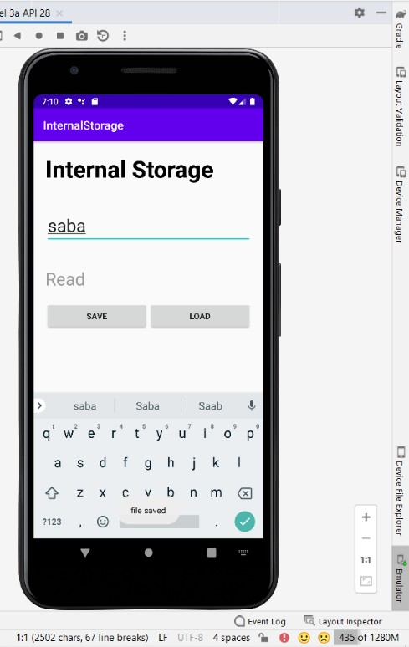**Output:**

Once we click on load button, all the data saved in internal strorage file will be displayed, As we are using Append mode ,it is showing previous data also.

>Data->Data->com.example.internalstorage->files->myData

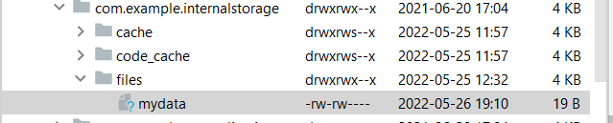

1. **Creating android program to demonstrate the use of Shared preferences.**

**Activity_main.xml:**

<?xml version="1.0" encoding="utf-8"?>

<androidx.constraintlayout.widget.ConstraintLayout xmlns:android="http://schemas.android.com/apk/res/android"

xmlns:app="http://schemas.android.com/apk/res-auto"

xmlns:tools="http://schemas.android.com/tools"

android:layout_width="match_parent"

android:layout_height="match_parent"

tools:context=".MainActivity">

<LinearLayout

android:layout_width="match_parent"

android:layout_height="match_parent"

android:orientation="vertical"

android:layout_marginLeft="30sp"

android:layout_marginRight="30sp">

<TextView

android:id="@+id/textView"

android:layout_width="match_parent"

android:layout_height="wrap_content"

android:text="Shared Preferences"

android:textSize="40sp"

android:textStyle="bold"

android:textColor="@color/black"/>

<EditText

android:id="@+id/editTextTextPersonName"

android:layout_width="match_parent"

android:layout_height="wrap_content"

android:layout_marginTop="20dp"

android:layout_marginBottom="20dp"

android:ems="10"

android:hint="Enter your Name"

android:inputType="textPersonName" />

<EditText

android:id="@+id/editTextTextPersonName2"

android:layout_width="match_parent"

android:layout_height="wrap_content"

android:ems="10"

android:inputType="textPersonName"

android:hint="Enter your Age"

android:layout_marginTop="20dp"

android:layout_marginBottom="20dp"/>

<EditText

android:id="@+id/editTextTextEmailAddress"

android:layout_width="match_parent"

android:layout_height="wrap_content"

android:ems="10"

android:inputType="textEmailAddress"

android:hint="Enter Your Email"

android:layout_marginTop="20dp"

android:layout_marginBottom="20dp"/>

<Button

android:id="@+id/button"

android:layout_width="match_parent"

android:layout_height="wrap_content"

android:text="Save"

android:layout_marginTop="20dp"

android:layout_marginBottom="20dp"/>

</LinearLayout>

</androidx.constraintlayout.widget.ConstraintLayout>

**MainActivity.java:**

package com.example.sharedpreferences;

import androidx.appcompat.app.AppCompatActivity;

import android.content.Context;

import android.os.Bundle;

import android.content.SharedPreferences;

import android.view.View;

import android.widget.Button;

import android.widget.EditText;

import android.widget.Toast;

public class MainActivity extends AppCompatActivity {

private EditText name, age,email;

Button b1;

public static final String MyPREFERENCES = "MyPrefsData" ;

public static final String Name = "nameKey";

public static final String Age = "ageKey";

public static final String Email = "emailKey";

SharedPreferences sharedpreferences;

@Override

protected void onCreate(Bundle savedInstanceState) {

super.onCreate(savedInstanceState);

setContentView(R.layout.activity_main);

name =(EditText) findViewById(R.id.editTextTextPersonName);

age = (EditText)findViewById(R.id.editTextTextPersonName2);

email=(EditText) findViewById(R.id.editTextTextEmailAddress);

b1=(Button) findViewById(R.id.button);

sharedpreferences = getSharedPreferences(MyPREFERENCES, Context.MODE_PRIVATE);

b1.setOnClickListener(new View.OnClickListener() {

@Override

public void onClick(View v) {

String n = name.getText().toString();

String a = age.getText().toString();

String e = email.getText().toString();

SharedPreferences.Editor editor = sharedpreferences.edit();

editor.putString(Name, n);

editor.putString(Age, a);

editor.putString(Email, e);

editor.commit();

Toast.makeText(MainActivity.this,"Thanks",Toast.LENGTH_LONG).show();

}

});

}

}

**Output:**

User Enters data in text field



Now when you press save button, the text will be saved in the shared preferences. Now press back button and exit the application.

To Check Shared preferences, click on



# **Practical 4: INTRODUCTION TO GRAPHICS, ANIMATION AND MULTIMEDIA**

1. **Write a Program to draw basic graphics construction like line, circle, arc, ellipse and rectangle.**

#include<graphics.h>

#include<conio.h>

**void** main()

{

intgd=DETECT,gm;

initgraph (&gd,&gm,"c:\\tc\\bgi");

setbkcolor(GREEN);

printf("\t\t\t\n\nLINE");

line(50,40,190,40);

printf("\t\t\n\n\n\nRECTANGLE");

rectangle(125,115,215,165);

printf("\t\t\t\n\n\n\n\n\n\nARC");

arc(120,200,180,0,30);

printf("\t\n\n\n\nCIRCLE");

circle(120,270,30);

printf("\t\n\n\n\nECLIPSE");

ellipse(120,350,0,360,30,20);

getch(); }

**output:**



1. **Write a Program to draw animation using increasing circles filled with different colours and patterns**

#include<graphics.h>

#include<conio.h>

void main()

{

intgd=DETECT, gm, i, x, y;

initgraph(&gd, &gm, "C:\\TC\\BGI");

x=getmaxx()/3;

y=getmaxx()/3;

setbkcolor(WHITE);

setcolor(BLUE);

for(i=1;i<=8;i++)

{

setfillstyle(i,i);

delay(20);

circle(x, y, i*20);

floodfill(x-2+i*20,y,BLUE);

}

getch();

closegraph();

}

**Practical 5:- LOCATION-BASED SERVICES**

1. **Write a program to find your location in the Map**

package com.abhiandroid.GoogleMaps.googlemaps;

import android.Manifest;

import android.content.Context;

import android.content.pm.PackageManager;

import android.location.Address;

import android.location.Criteria;

import android.location.Geocoder;

import android.location.Location;

import android.location.LocationManager;

import android.os.Build;

import android.os.Bundle;

import android.support.v4.app.ActivityCompat;

import android.support.v4.app.FragmentActivity;

import android.support.v4.content.ContextCompat;

import android.widget.Toast;

import com.google.android.gms.common.ConnectionResult;

import com.google.android.gms.common.api.GoogleApiClient;

import com.google.android.gms.location.LocationListener;

import com.google.android.gms.location.LocationRequest;

import com.google.android.gms.location.LocationServices;

import com.google.android.gms.maps.CameraUpdateFactory;

import com.google.android.gms.maps.GoogleMap;

import com.google.android.gms.maps.OnMapReadyCallback;

import com.google.android.gms.maps.SupportMapFragment;

import com.google.android.gms.maps.model.BitmapDescriptorFactory;

import com.google.android.gms.maps.model.LatLng;

import com.google.android.gms.maps.model.Marker;

import com.google.android.gms.maps.model.MarkerOptions;

import com.abhiandroid.GoogleMaps.googlemaps.R;

import java.io.IOException;

import java.util.List;

import java.util.Locale;

public class MapsActivity extends FragmentActivity implements

OnMapReadyCallback,

GoogleApiClient.ConnectionCallbacks,

GoogleApiClient.OnConnectionFailedListener,

LocationListener {

public static final int MY_PERMISSIONS_REQUEST_LOCATION =

99;

GoogleApiClient mGoogleApiClient;

Location mLastLocation;

Marker mCurrLocationMarker;

LocationRequest mLocationRequest;

private GoogleMap mMap;

@Override

protected void onCreate(Bundle savedInstanceState) {

super.onCreate(savedInstanceState);

setContentView(R.layout.activity_maps);

if (android.os.Build.VERSION.SDK_INT >=

Build.VERSION_CODES.M) {

checkLocationPermission();

}

SupportMapFragment mapFragment = (SupportMapFragment)

getSupportFragmentManager()

.findFragmentById(R.id.map);

mapFragment.getMapAsync(this);

}

@Override

public void onMapReady(GoogleMap googleMap) {

mMap = googleMap;

mMap.setMapType(GoogleMap.MAP_TYPE_NORMAL);

mMap.getUiSettings().setZoomControlsEnabled(true);

mMap.getUiSettings().setZoomGesturesEnabled(true);

mMap.getUiSettings().setCompassEnabled(true);

//Initialize Google Play Services

if (android.os.Build.VERSION.SDK_INT >=

Build.VERSION_CODES.M) {

if (ContextCompat.checkSelfPermission(this,

Manifest.permission.ACCESS_FINE_LOCATION)

== PackageManager.PERMISSION_GRANTED) {

buildGoogleApiClient();

mMap.setMyLocationEnabled(true);

}

} else {

buildGoogleApiClient();

mMap.setMyLocationEnabled(true);

}

}

protected synchronized void buildGoogleApiClient() {

mGoogleApiClient = new GoogleApiClient.Builder(this)

.addConnectionCallbacks(this)

.addOnConnectionFailedListener(this)

.addApi(LocationServices.API)

.build();

mGoogleApiClient.connect();

}

@Override

public void onConnected(Bundle bundle) {

mLocationRequest = new LocationRequest();

mLocationRequest.setInterval(1000);

mLocationRequest.setFastestInterval(1000);

mLocationRequest.setPriority(LocationRequest.PRIORITY_BALANCED

_POWER_ACCURACY);

if (ContextCompat.checkSelfPermission(this,

Manifest.permission.ACCESS_FINE_LOCATION)

== PackageManager.PERMISSION_GRANTED) {

LocationServices.FusedLocationApi.requestLocationUpdates(mGoogleAp

iClient,

mLocationRequest, this);

}

}

@Override

public void onConnectionSuspended(int i) {

}

@Override

public void onLocationChanged(Location location) {

mLastLocation = location;

if (mCurrLocationMarker != null) {

mCurrLocationMarker.remove();

}

//Showing Current Location Marker on Map

LatLng latLng = new LatLng(location.getLatitude(),

location.getLongitude());

MarkerOptions markerOptions = new MarkerOptions();

markerOptions.position(latLng);

LocationManager locationManager = (LocationManager)

getSystemService(Context.LOCATION_SERVICE);

String provider = locationManager.getBestProvider(new Criteria(),

true);

if (ActivityCompat.checkSelfPermission(this,

Manifest.permission.ACCESS_FINE_LOCATION) !=

PackageManager.PERMISSION_GRANTED &&

ActivityCompat.checkSelfPermission(this,

Manifest.permission.ACCESS_COARSE_LOCATION)

!= PackageManager.PERMISSION_GRANTED) {

return;

}

Location locations =

locationManager.getLastKnownLocation(provider);

List<String> providerList = locationManager.getAllProviders();

if (null != locations && null != providerList && providerList.size() >

0) {

double longitude = locations.getLongitude();

double latitude = locations.getLatitude();

Geocoder geocoder = new Geocoder(getApplicationContext(),

Locale.getDefault());

try {

List<Address> listAddresses =

geocoder.getFromLocation(latitude,

longitude, 1);

if (null != listAddresses && listAddresses.size() > 0) {

String state = listAddresses.get(0).getAdminArea();

String country = listAddresses.get(0).getCountryName();

String subLocality = listAddresses.get(0).getSubLocality();

markerOptions.title("" + latLng + "," + subLocality + "," +

state

+ "," + country);

}

} catch (IOException e) {

e.printStackTrace();

}

}

markerOptions.icon(BitmapDescriptorFactory.defaultMarker(BitmapDesc

riptorFactory.HUE_BLUE));

mCurrLocationMarker = mMap.addMarker(markerOptions);

mMap.moveCamera(CameraUpdateFactory.newLatLng(latLng));

mMap.animateCamera(CameraUpdateFactory.zoomTo(11));

if (mGoogleApiClient != null) {

LocationServices.FusedLocationApi.removeLocationUpdates(mGoogleAp

iClient,

this);

}

}

@Override

public void onConnectionFailed(ConnectionResult connectionResult) {

}

public boolean checkLocationPermission() {

if (ContextCompat.checkSelfPermission(this,

Manifest.permission.ACCESS_FINE_LOCATION)

!= PackageManager.PERMISSION_GRANTED) {

if (ActivityCompat.shouldShowRequestPermissionRationale(this,

Manifest.permission.ACCESS_FINE_LOCATION)) {

ActivityCompat.requestPermissions(this,

new

String[]{Manifest.permission.ACCESS_FINE_LOCATION},

MY_PERMISSIONS_REQUEST_LOCATION);

} else {

ActivityCompat.requestPermissions(this,

new

String[]{Manifest.permission.ACCESS_FINE_LOCATION},

MY_PERMISSIONS_REQUEST_LOCATION);

}

return false;

} else {

return true;

}

}

@Override

public void onRequestPermissionsResult(int requestCode,

String permissions[], int[] grantResults) {

switch (requestCode) {

case MY_PERMISSIONS_REQUEST_LOCATION: {

if (grantResults.length > 0

&& grantResults[0] ==

PackageManager.PERMISSION_GRANTED) {

if (ContextCompat.checkSelfPermission(this,

Manifest.permission.ACCESS_FINE_LOCATION)

== PackageManager.PERMISSION_GRANTED) {

if (mGoogleApiClient == null) {

buildGoogleApiClient();

}

mMap.setMyLocationEnabled(true);

}

} else {

Toast.makeText(this, "permission denied",

Toast.LENGTH_LONG).show();

}

return;

}

}

}

}

**Output**:

Now run the App. If you are connected to internet and provide access to

your location then in Map you will see your current location.

**Practical 6:- SOCKET PROGRAMMING IN C/C++**

1. **we are exchanging one hello message between server and client to**

**demonstrate the client/server model.**

**Server.c**

**C**

// Server side C/C++ program to demonstrate Socket

// programming

#include <netinet/in.h>

#include <stdio.h>

#include <stdlib.h>

#include <string.h>

#include <sys/socket.h>

#include <unistd.h>

#define PORT 8080

int main(int argc, char const* argv[])

{

int server_fd, new_socket, valread;

struct sockaddr_in address;

int opt = 1;

int addrlen = sizeof(address);

char buffer[1024] = { 0 };

char* hello = "Hello from server";

// Creating socket file descriptor

if ((server_fd = socket(AF_INET, SOCK_STREAM, 0))

== 0) {

perror("socket failed");

exit(EXIT_FAILURE);

}

// Forcefully attaching socket to the port 8080

if (setsockopt(server_fd, SOL_SOCKET,

SO_REUSEADDR | SO_REUSEPORT, &opt,

sizeof(opt))) {

perror("setsockopt");

exit(EXIT_FAILURE);

}

address.sin_family = AF_INET;

address.sin_addr.s_addr = INADDR_ANY;

address.sin_port = htons(PORT);

// Forcefully attaching socket to the port 8080

if (bind(server_fd, (struct sockaddr*)&address,

sizeof(address))

< 0) {

perror("bind failed");

exit(EXIT_FAILURE);

}

if (listen(server_fd, 3) < 0) {

perror("listen");

exit(EXIT_FAILURE);

}

if ((new_socket

= accept(server_fd, (struct sockaddr*)&address,

(socklen_t*)&addrlen))

< 0) {

perror("accept");

exit(EXIT_FAILURE);

}

valread = read(new_socket, buffer, 1024);

printf("%s\n", buffer);

send(new_socket, hello, strlen(hello), 0);

printf("Hello message sent\n");

// closing the connected socket

close(new_socket);

// closing the listening socket

shutdown(server_fd, SHUT_RDWR);

return 0;

}

**client.c**

**C**

// Client side C/C++ program to demonstrate Socket

// programming

#include <arpa/inet.h>

#include <stdio.h>

#include <string.h>

#include <sys/socket.h>

#include <unistd.h>

#define PORT 8080

int main(int argc, char const* argv[])

{

int sock = 0, valread, client_fd;

struct sockaddr_in serv_addr;

char* hello = "Hello from client";

char buffer[1024] = { 0 };

if ((sock = socket(AF_INET, SOCK_STREAM, 0)) < 0) {

printf("\n Socket creation error \n");

return -1;

}

serv_addr.sin_family = AF_INET;

serv_addr.sin_port = htons(PORT);

// Convert IPv4 and IPv6 addresses from text to binary

// form

if (inet_pton(AF_INET, "127.0.0.1", &serv_addr.sin_addr)

<= 0) {

printf(

"\nInvalid address/ Address not supported \n");

return -1;

}

if ((client_fd

= connect(sock, (struct sockaddr*)&serv_addr,

sizeof(serv_addr)))

< 0) {

printf("\nConnection Failed \n");

return -1;

}

send(sock, hello, strlen(hello), 0);

printf("Hello message sent\n");

valread = read(sock, buffer, 1024);

printf("%s\n", buffer);

// closing the connected socket

close(client_fd);

return 0;

}

**Compiling**:

gcc client.c -o client

gcc server.c -o server

**Output**:

Client:Hello message sent

Hello from server

Server:Hello from client

Hello message sent