Step1: Open the AWS console (Free tire account).

Step1: Launch instance (Ubuntu18.04) while launching instance we need provide Port range in security group like **SSH, HTTP, HTTPS, CUSTOM TCP, ALL TCP, ALL UDP.**

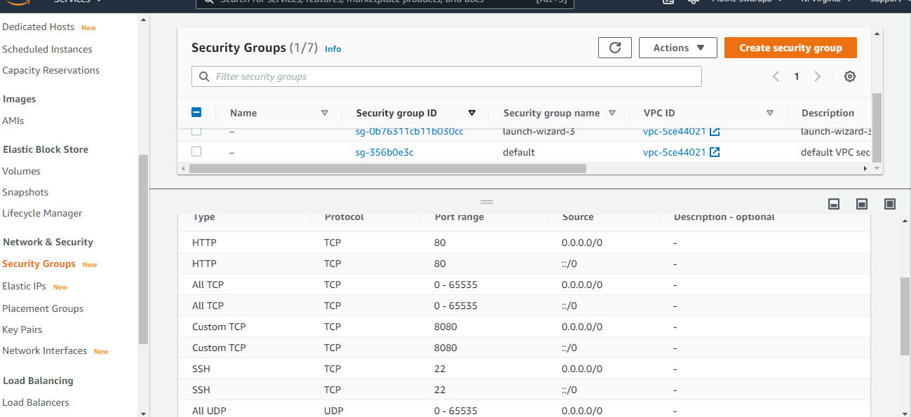

Step3: Then open instance using putty and provide instance public IP address and Keypair.

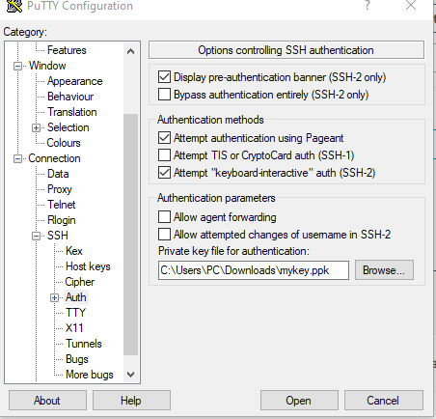

Step4: Download and Install JDK1.8 (Taken from Oracle account).

Step5: Install and configure **TOMCAT** (Document following).

Step5: Then start the tomcat server using **startup.sh** command.

Step6: Using instance public IP open the browser.

Step7: Then goto **webapps** create one Folder, in that we have create Index.html file.

Note: we will put project war file In webapps folder.

