SOFTWARE REQUIREMENTS SPECIFICATION (SRS)
AI Smart Customer Support System

1. INTRODUCTION
a) Purpose
The purpose of this Software Requirements Specification (SRS) document is to provide a detailed description of the “AI Smart Customer Support System.” It defines the functional and non-functional requirements, system architecture, and design constraints to guide developers, testers, and stakeholders during the development process.
b) Scope
The system aims to automate customer support using Artificial Intelligence, including chatbot interaction, ticket management, sentiment analysis, and admin analytics. It improves response time, reduces manual effort, and enhances customer satisfaction.

1.1 Problem Description
a) Purpose of SRS
This document describes the system requirements clearly to ensure proper design, development, and testing of the application.
b) Intended Audience
- Developers
- Project Team Members
- Faculty/Guide
- Testers

1.2 Scope
a) Product Name
AI Smart Customer Support System
b) System Functionality
The system will:
- Provide chatbot-based support
- Generate and manage tickets
- Perform AI-based sentiment and intent analysis
- Provide admin dashboard with analytics
The system will not:
- Replace human agents completely
- Provide real-time voice support
c) Applications & Benefits
- E-commerce support
- IT helpdesk
- Banking complaint systems
- Telecom services
Benefits:
- Faster response
- Reduced workload
- Improved user experience

2. OVERALL DESCRIPTION
2.1 Product Perspective
2.1.1 Block Diagram
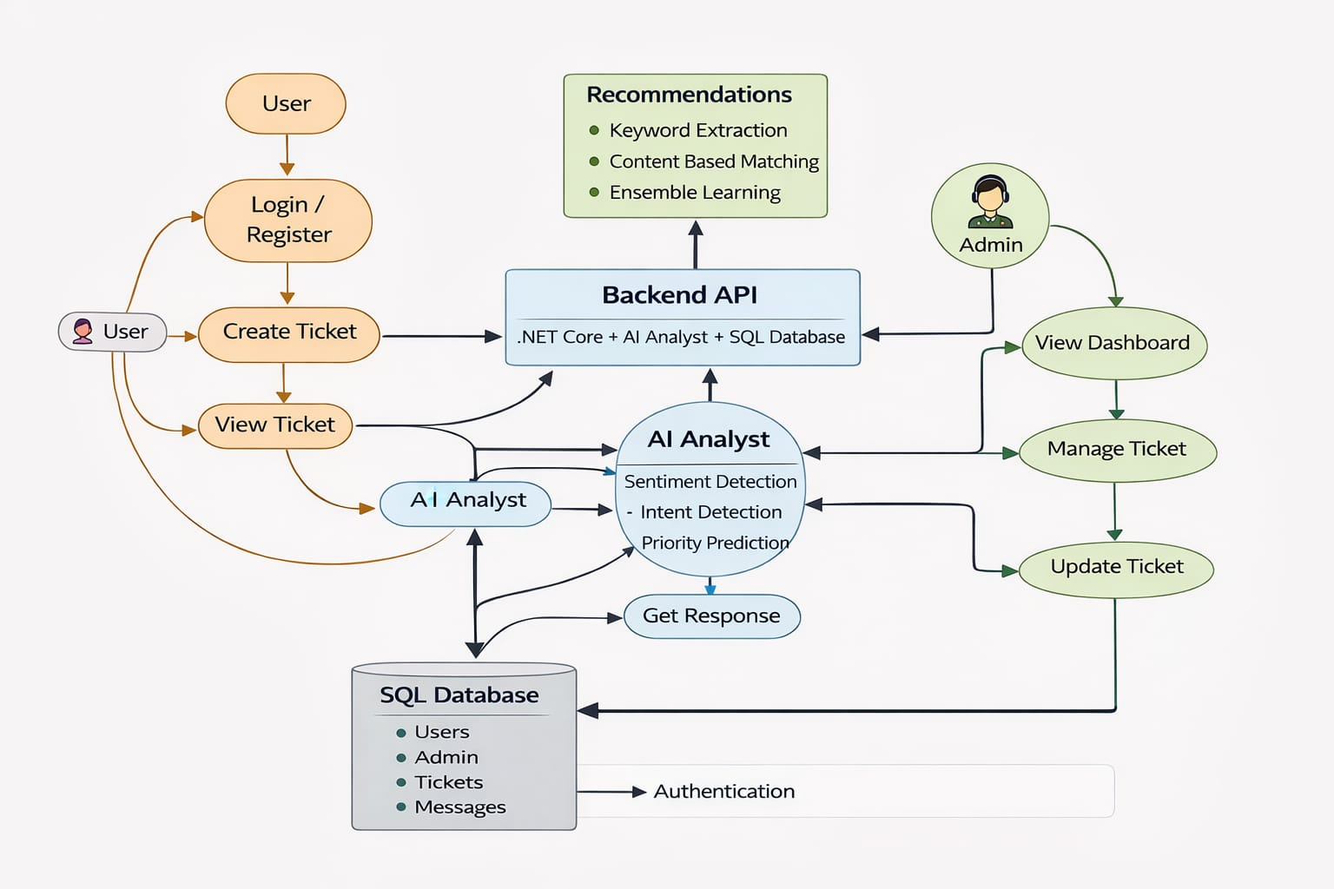

2.1.2 Hardware Requirements
- Minimum 8GB RAM
- i3/i5 Processor
- Internet connection
- Laptop/Desktop

2.1.3 Software Requirements
- React.js
- ASP.NET Core
- Node.js
- MySQL
- MongoDB
- VS Code / Visual Studio
- REST API

2.2 Product Functions
- User Registration/Login
- Chatbot Interaction
- Ticket Creation
- Ticket Tracking
- Sentiment Analysis
- Intent Detection
- Priority Prediction
- Admin Dashboard

3. SPECIFIC REQUIREMENTS
3.1 External Interfaces
Inputs:
- User messages
- Login details
- Ticket information
Outputs:
- Chatbot responses
- Ticket updates
- Analytics reports

3.2 Functional Requirements
- The system shall allow user registration and login.
- The system shall provide chatbot-based responses.
- The system shall generate tickets automatically.
- The system shall analyze user messages using AI.
- The system shall classify tickets into categories.
- The system shall predict ticket priority.
- The system shall allow admin to manage tickets.
- The system shall display analytics dashboard.

3.3 Performance Requirements
Static Requirements:
- Support at least 100 users
- Store large ticket data
Dynamic Requirements:
- Response time < 2 seconds
- Handle multiple requests simultaneously

3.4 Design Constraints
- Must use React + .NET + Node.js
- Must use MySQL + MongoDB
- Must follow REST API architecture
- Must use JWT authentication

3.5 Logical Database Requirements
MySQL:
- Users
- Admins
MongoDB:
- Tickets
- Messages
- AI Analysis
- Ticket History
Requirements:
- Data integrity
- Fast retrieval
- Scalability

3.6 Software System Attributes
3.6.1 Reliability
- System should perform consistently
- Accurate AI predictions
3.6.2 Availability
- Available 24/7
3.6.3 Security
- JWT authentication
- Password hashing

3.6.4 Maintainability
- Modular code structure
- Easy updates
3.6.5 Portability
- Deployable on cloud
- Works on multiple OS

4. SOFTWARE DESIGN DOCUMENT
4.1 Structural Design
a) Class Diagram
Entities:
- User
- Ticket
- Message
- Admin
- AI Analysis
b) Object Diagram
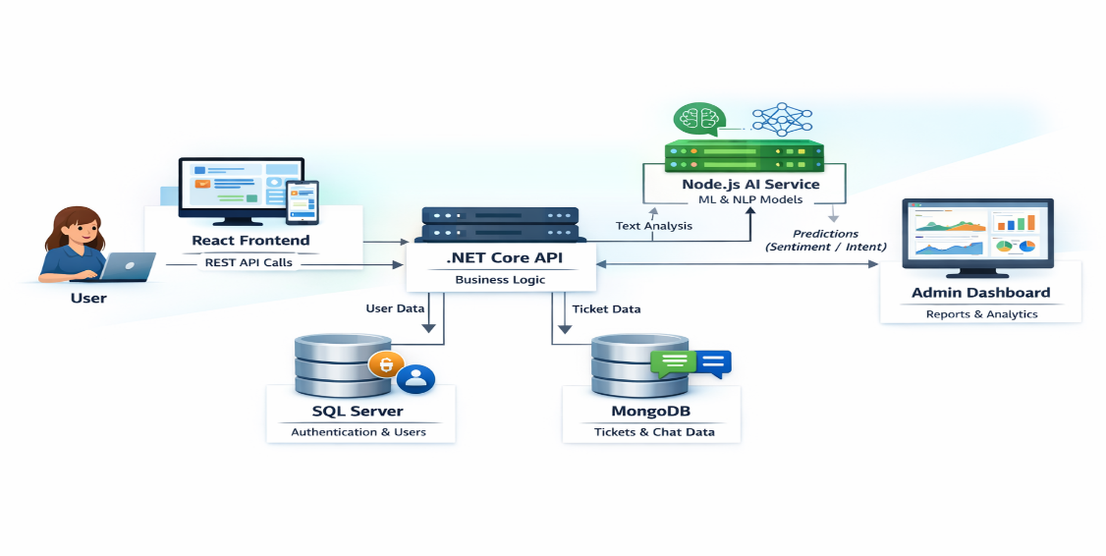

E-R Diagram

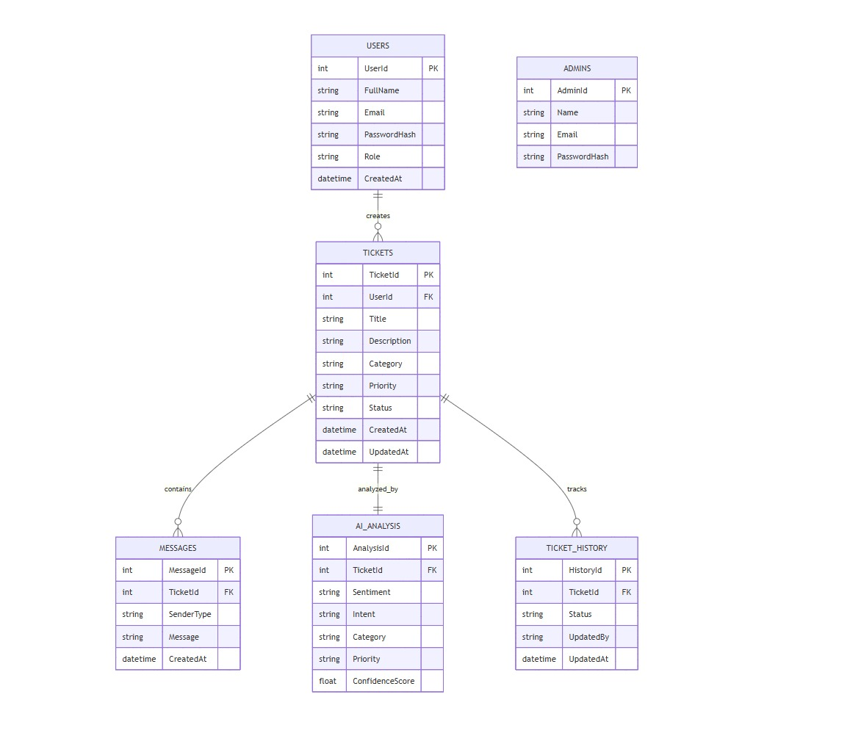

Use Case Diagram

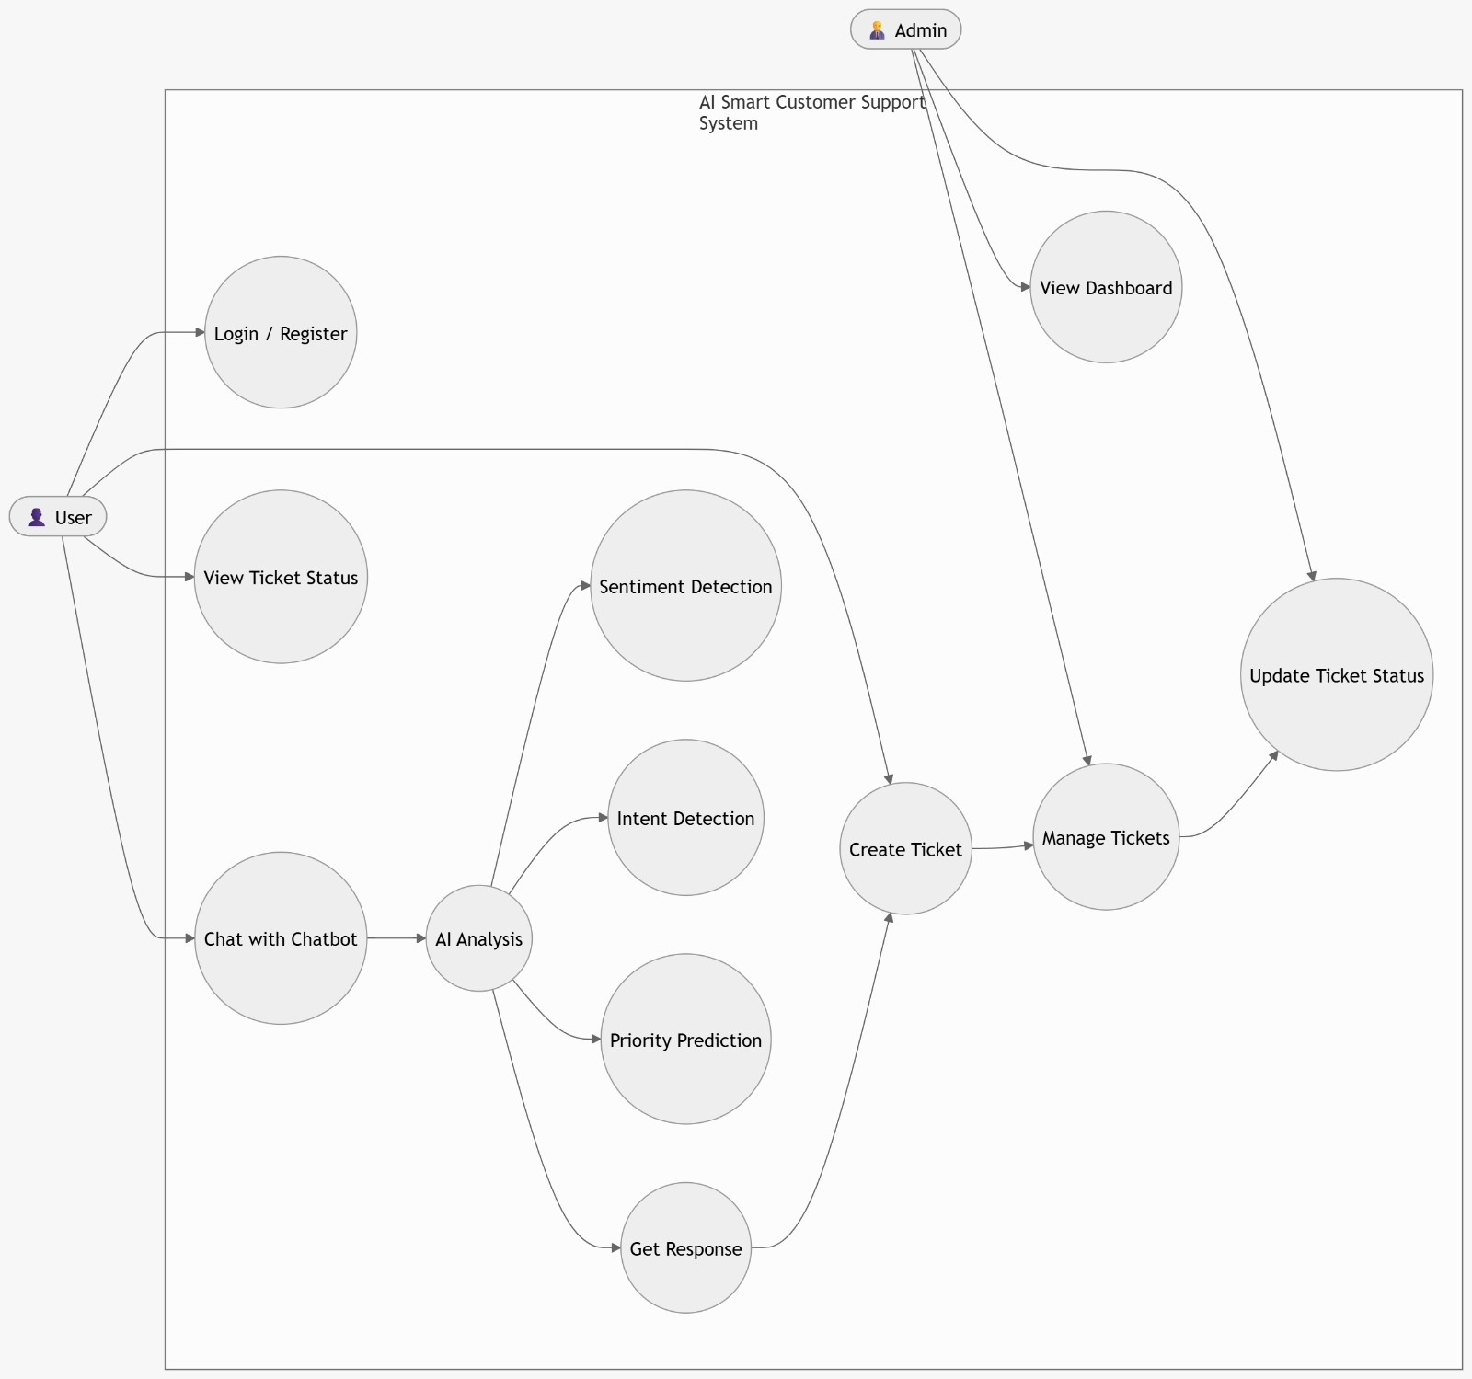

5. REFERENCES
[1] Kanimozhi Selvi et al., “Ticket Categorization Using NLP,” INCOFT 2025
[2] Jayadi, “Sentiment Analysis,” IEEE 2024
[3] Kumari et al., “Chatbot System,” IJSRET 2024
[4] Truss & Boehm, “Ticket Classification,” arXiv 2024
[5] Uzan et al., “Chatbot Optimization,” Applied Sciences 2025

