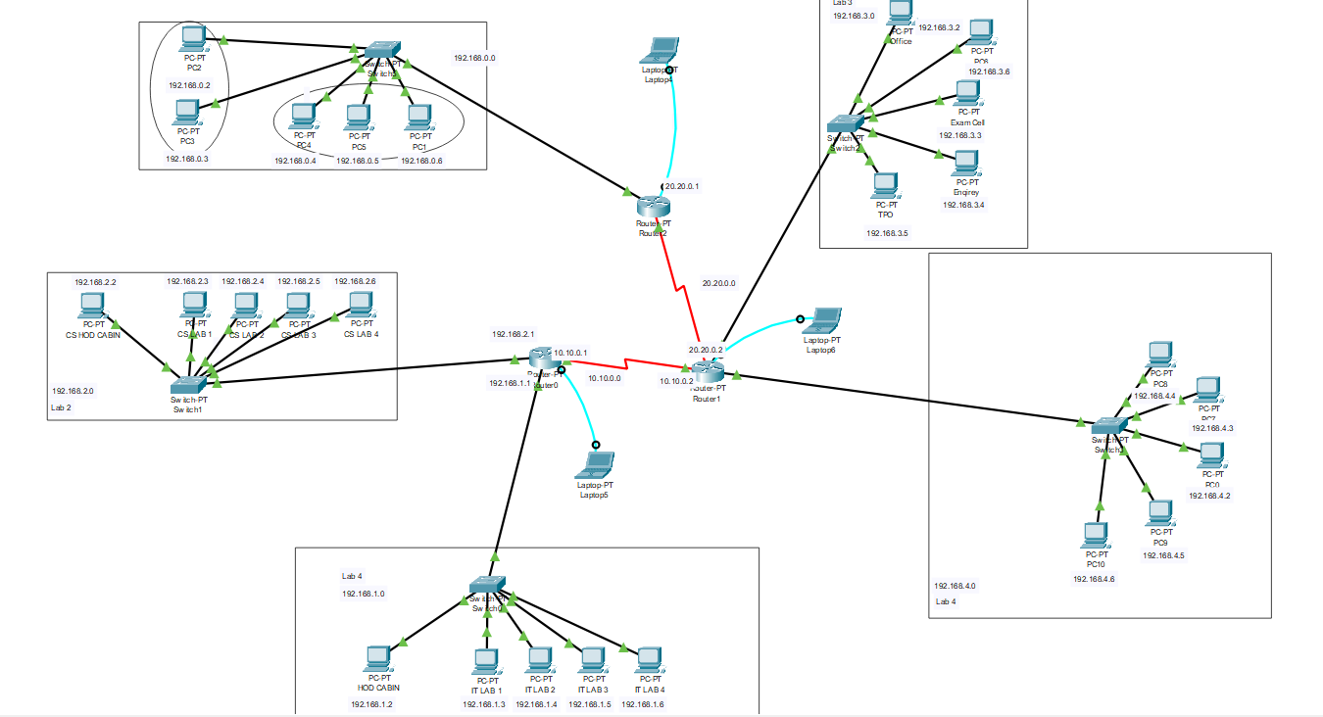  
Creating a network layout involves various components such as devices, IP addressing, VLANs, and routing protocols.  
1. Interconnecting Labs:

Use Layer 3 switches to enable routing between VLANs.

Implement OSPF routing protocol for inter-VLAN communication.

2. IP Addressing:

Assign IP addresses based on the 192.168.0.0 network.

3. Security Measures:

Use secure passwords for devices.

Employ encryption protocols for sensitive data transmission.

4. Additional Security Considerations:

Regularly update and patch network devices to address security vulnerabilities.

Note:

This is a basic representation, and the actual implementation may vary based on specific hardware and software configurations.