Obstacle Avoidance Robot Project Report

1. Introduction
The obstacle avoidance robot is an autonomous robotic vehicle designed to navigate its environment by detecting and avoiding obstacles. It makes use of an Arduino Uno board with a motor driver shield, ultrasonic sensor, IR sensors, DC motors, and a servo motor to perform navigation tasks.
This project demonstrates the integration of sensors, actuators, and microcontroller programming for real-time decision-making in robotics.

2. Objectives
- To design a robot capable of autonomous navigation.
- To implement obstacle detection using an ultrasonic sensor.
- To use IR sensors for line-following or side obstacle detection.
- To control the motion of the robot using a motor driver shield.
- To demonstrate servo motor integration for sensor movement.

3. Components Used
- Arduino Uno with Motor Driver Shield
- Ultrasonic Sensor (HC-SR04) for obstacle detection
- IR Sensors for side detection
- DC Motors (4) for robot movement
- Servo Motor (1) for ultrasonic sensor rotation
- Battery Pack (power supply)
- Connecting wires and chassis

4. Circuit Diagram
The circuit diagram is shown below:
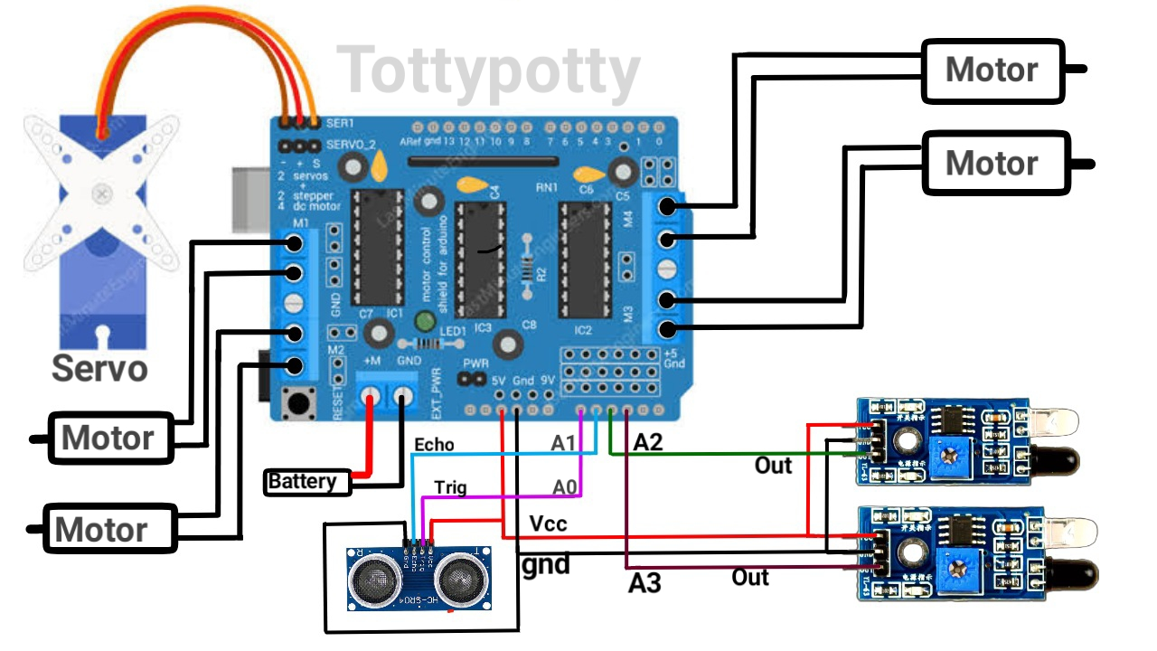
Explanation of connections:
- The DC motors are connected to the motor driver shield outputs (M1, M2, M3, M4).
- The servo motor is connected to the servo output pins of the shield.
- The ultrasonic sensor is connected to A0 (Trig) and A1 (Echo).
- The IR sensors are connected to A2 and A3 analog inputs.
- The battery pack powers the motor driver shield.

5. Working Principle
1. The ultrasonic sensor mounted on the servo continuously scans the front area for obstacles.
2. If an obstacle is detected within a certain range, the Arduino decides whether to turn left or right based on IR sensor input.
3. The IR sensors detect nearby objects or line boundaries, helping with path correction.
4. The motor driver shield controls the movement of the motors based on the sensor input and Arduino logic.
5. The servo motor rotates the ultrasonic sensor to scan the surroundings.

6. Arduino Code
The Arduino program used for this project is shown below:
//ARDUINO OBSTACLE AVOIDING CAR//
// Before uploading the code you have to install the necessary library//
//AFMotor Library https://learn.adafruit.com/adafruit-motor-shield/library-install //
//NewPing Library https://github.com/livetronic/Arduino-NewPing//
//Servo Library https://github.com/arduino-libraries/Servo.git //
// To Install the libraries go to sketch >> Include Library >> Add .ZIP File >> Select the Downloaded ZIP files From the Above links //
#include <AFMotor.h>
#include <NewPing.h>
#include <Servo.h>
#define TRIG_PIN A0
#define ECHO_PIN A1
#define SENS1_PIN A2
#define SENS2_PIN A3
#define MAX_DISTANCE 200
#define MAX_SPEED 100 // sets speed of DC motors
#define MAX_SPEED_OFFSET 20
NewPing sonar(TRIG_PIN, ECHO_PIN, MAX_DISTANCE);
AF_DCMotor motor1(1, MOTOR12_1KHZ);
AF_DCMotor motor2(2, MOTOR12_1KHZ);
AF_DCMotor motor3(3, MOTOR34_1KHZ);
AF_DCMotor motor4(4, MOTOR34_1KHZ);
Servo myservo;
boolean goesForward=false;
int distance = 100;
int speedSet = 0;
int SENS1_val;
int SENS2_val;
void setup() {
pinMode(SENS1_PIN,INPUT);
pinMode(SENS2_PIN,INPUT);
myservo.attach(10);
myservo.write(115);
delay(2000);
distance = readPing();
delay(100);
distance = readPing();
delay(100);
distance = readPing();
delay(100);
distance = readPing();
delay(100);////
}
void loop() {
int distanceR = 0;
int distanceL = 0;
delay(40);
SENS1_val=digitalRead(SENS1_PIN);
SENS2_val=digitalRead(SENS2_PIN);
if(distance<=20 || SENS1_val==1 || SENS2_val==1)
{
moveStop();
delay(50);
moveBackward();
delay(500);
moveStop();
delay(200);
distanceR = lookRight();
delay(200);
distanceL = lookLeft();
delay(200);
if(distanceR>=distanceL)
{
turnRight();
moveStop();
}else
{
turnLeft();
moveStop();
}
}else
{
moveForward();
}
distance = readPing();
}
int lookRight()
{
myservo.write(50);
delay(500);
int distance = readPing();
delay(100);
myservo.write(115);
return distance;
}
int lookLeft()
{
myservo.write(170);
delay(500);
int distance = readPing();
delay(100);
myservo.write(115);
return distance;
delay(100);
}
int readPing() {
delay(70);
int cm = sonar.ping_cm();
if(cm==0)
{
cm = 250;
}
return cm;
}
void moveStop() {
motor1.run(RELEASE);
motor2.run(RELEASE);
motor3.run(RELEASE);
motor4.run(RELEASE);
}
void moveForward() {
if(!goesForward)
{
goesForward=true;
motor1.run(FORWARD);
motor2.run(FORWARD);
motor3.run(FORWARD);
motor4.run(FORWARD);
for (speedSet = 0; speedSet < MAX_SPEED; speedSet +=2) // slowly bring the speed up to avoid loading down the batteries too quickly
{
motor1.setSpeed(speedSet);
motor2.setSpeed(speedSet);
motor3.setSpeed(speedSet);
motor4.setSpeed(speedSet);
delay(5);
}
}
}
void moveBackward() {
goesForward=false;
motor1.run(BACKWARD);
motor2.run(BACKWARD);
motor3.run(BACKWARD);
motor4.run(BACKWARD);
for (speedSet = 0; speedSet < 190; speedSet +=2) // slowly bring the speed up to avoid loading down the batteries too quickly
{
motor1.setSpeed(speedSet);
motor2.setSpeed(speedSet);
motor3.setSpeed(speedSet);
motor4.setSpeed(speedSet);
// delay(5);
}
}
void turnRight() {
motor1.run(FORWARD);
motor2.run(FORWARD);
motor3.run(BACKWARD);
motor4.run(BACKWARD);
delay(500);
motor1.run(FORWARD);
motor2.run(FORWARD);
motor3.run(FORWARD);
motor4.run(FORWARD);
}
void turnLeft() {
motor1.run(BACKWARD);
motor2.run(BACKWARD);
motor3.run(FORWARD);
motor4.run(FORWARD);
delay(500);
motor1.run(FORWARD);
motor2.run(FORWARD);
motor3.run(FORWARD);
motor4.run(FORWARD);
}

7. Conclusion
This project successfully demonstrates how an Arduino-based robot can navigate autonomously by avoiding obstacles using ultrasonic and IR sensors. It highlights the importance of sensor integration and real-time decision-making in robotics systems.

