ENTERPRISE AGENTIC
UNDERWRITING PIPELINE
System Design • Multi-Agent Workflow • ML Models • Explainability • Fairness

Technical Project Documentation
Prepared from the supplied Python agents, FastAPI application, MCP server, training scripts and audit utilities.

1. Project Overview
The Enterprise Agentic Underwriting Pipeline is a prototype credit-risk assessment system. It accepts applicant information, checks explicit consent, derives alternative-data indicators, runs fraud and credit-risk models, applies a policy decision, generates an explanation, performs a rules-based self-review, and records the outcome. FastAPI exposes the workflow through REST APIs. A separate MCP server exposes selected applicant, model, history and audit operations as tools.
The system combines conventional applicant information (such as a traditional score, income and debt-to-income ratio) with behavioural or alternative signals (such as UPI activity, repayment regularity, telecom recharge patterns and gig-income stability). It is designed as a demonstrator: the supplied dataset generator creates synthetic data, so the trained model is not evidence of real-world lending performance.

Main objectives
- Enforce a consent gate before the primary underwriting endpoint processes applicant data.
- Use alternative signals alongside traditional financial features.
- Identify unusual patterns with an Isolation Forest and transparent heuristic checks.
- Estimate probability of default with XGBoost and convert it into a 0–100 credit-risk score.
- Explain model behaviour with SHAP and generate a readable decision letter using local Ollama when available.
- Check policy consistency and protected-attribute leakage before returning the result.
- Support fairness analysis, behavioural event updates, MCP tool access and decision history.

2. High-Level Architecture
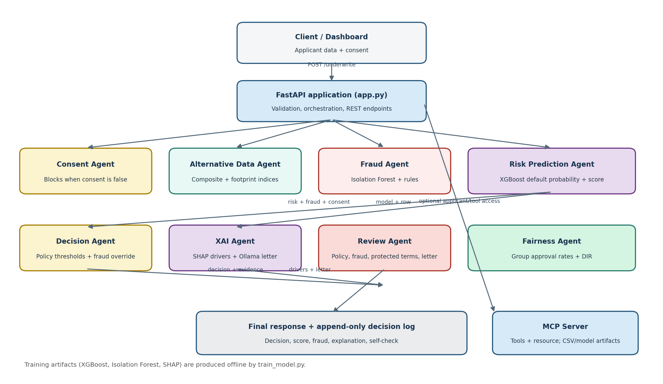
Figure 1. Logical architecture. The FastAPI application orchestrates the primary request. The MCP server is a separate tool interface and is not the same thing as the agent orchestrator.

Architecture components
Component | Responsibility
Client / dashboard | Submits applicant data and consent to FastAPI; displays the returned decision, score, explanation and checks.
FastAPI (app.py) | Validates request schemas, loads trained artifacts at startup, calls agents, exposes endpoints and assembles JSON responses.
Agent layer | Contains focused classes for consent, alternative data, fraud, risk, explainability, decision policy, fairness and review.
ML artifacts | underwriting_artifacts.pkl stores the trained XGBoost model, Isolation Forest, SHAP explainer and feature lists.
Dataset | underwriting_dataset.csv contains generated applicant rows used for training, MCP lookups and fairness analysis.
MCP server | Exposes selected operations through standardized MCP tools and a system resource.
Decision log | decision_log.csv stores a minimal append-only record of decisions for later history queries.
Local LLM | Ollama at localhost:11434 is used to draft a natural-language letter; a deterministic fallback is used if unavailable.

3. End-to-End Underwriting Flow
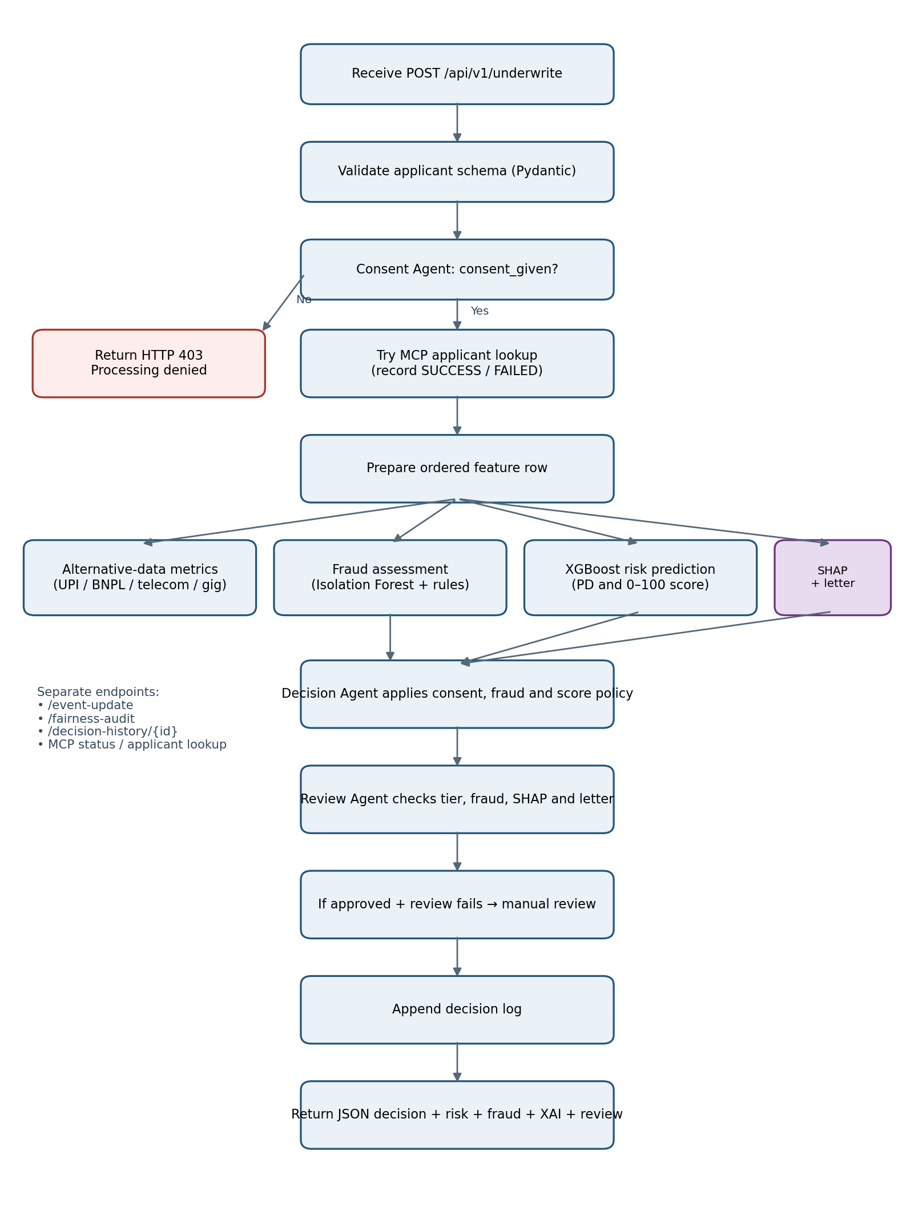
Figure 2. Main request flow for POST /api/v1/underwrite.

Workflow explained
Request validation: FastAPI receives a FullApplicantSchema payload. Pydantic validates types and configured bounds such as score 300–850 and rate fields 0–1.
Consent check: ConsentAgent.verify_consent() checks consent_given. If false, the endpoint returns HTTP 403 and stops the primary underwriting path.
MCP lookup: The API attempts get_applicant_data for the applicant ID and records SUCCESS or FAILED. The current code continues if MCP lookup fails.
Feature preparation: prepare_feature_df() creates a one-row DataFrame in the exact feature order expected by the trained model. Missing model features are currently filled with zero.
Parallel-style assessments: Alternative-data metrics, fraud assessment and XGBoost risk prediction are computed from the applicant payload. They are sequential function calls in the current implementation, not concurrent execution.
Decision policy: DecisionAgent combines the credit-risk score, fraud result and consent flag to return an outcome.
Explainability: XAIAgent calculates SHAP attributions, sorts them by absolute impact and generates a short applicant-facing letter.
Self-review: ReviewAgent checks score-tier consistency, fraud/approval conflict, protected-term leakage in SHAP drivers and whether the letter names the decision and score.
Fail-safe and audit: If self-review fails and the current outcome is APPROVED, app.py changes it to FLAGGED_FOR_MANUAL_REVIEW. The decision is appended to decision_log.csv.
Response: The API returns the decision, reason, score, risk tier, default probability, alternative metrics, fraud result, top SHAP drivers, explanation letter and self-check.

4. Agent-by-Agent Explanation

1. ConsentAgent — agents/consent_agent.py
Purpose: establish the consent gate. verify_consent(consent_given, applicant_id) returns verified, applicant_id, status_code and a message. A false flag produces status 403; true produces 200. The class stores the regulation label 'Indian DPDP Act 2023'.
Implementation note: Important: a Boolean flag is only a technical gate. It does not by itself prove that consent was informed, specific, freely given, recorded, withdrawable or legally sufficient. The project should not be described as DPDP-compliant solely because this class exists.

2. AltDataAgent — agents/alt_data_agent.py
Purpose: convert selected alternative signals into summary indicators. UPI health is capped at 50 transactions and contributes up to 25 points. BNPL repayment, telecom regularity and gig-income stability each contribute up to 25 points. The sum is alt_composite_score (0–100 under expected input ranges).
Implementation note: It also calculates financial_footprint_index as the mean of BNPL repayment and utility punctuality, and digital_reliability_index as the mean of telecom regularity and digital-footprint consistency. The current agent reports these summaries; the XGBoost model consumes the underlying feature columns rather than this composite score.

3. FraudAgent — agents/fraud_agent.py
Purpose: identify unusual applicant patterns using two mechanisms. First, IsolationForest.predict() labels the row as an inlier (1) or anomaly (-1), and decision_function() provides an anomaly score. Second, deterministic rules flag device changes above 3, e-commerce return rate above 0.60, and digital-footprint consistency below 0.40.
Implementation note: is_anomalous becomes true when the model predicts an anomaly or at least two heuristic flags are triggered. Risk level is CRITICAL when at least two heuristic flags exist, ELEVATED when anomalous for another reason, and LOW otherwise. NumPy scalar values are converted to native Python values for JSON compatibility.

4. RiskPredictionAgent — agents/risk_prediction_agent.py
Purpose: predict probability of default (PD) using XGBoost. It selects features in the saved training order, reads predict_proba() class-1 probability, and computes credit_risk_score = (1 − PD) × 100. Higher score therefore means lower predicted default probability.
Implementation note: Risk tiers: 75+ TIER_1_EXCELLENT; 60–74.9 TIER_2_GOOD; 45–59.9 TIER_3_MODERATE; below 45 TIER_4_HIGH_RISK.

5. DecisionAgent — agents/decision_agent.py
Purpose: apply deterministic underwriting policy. Missing consent yields REJECTED_NON_COMPLIANT. An anomalous applicant or CRITICAL fraud level is routed to FLAGGED_FOR_MANUAL_REVIEW. Otherwise score >=60 is APPROVED, score >=45 is CONDITIONAL_APPROVAL, and below 45 is DECLINED.
Implementation note: The code's policy is score-based, not a direct default-probability threshold. Conditional approval is described as a lower credit line recommendation, but no actual credit-limit calculation is implemented in this class.

6. XAIAgent — agents/xai_agent.py
Purpose: explain the XGBoost prediction. It normalizes SHAP output shapes across common library versions, extracts one row of attributions, pairs each feature with its raw value, and sorts by absolute SHAP value. The explanation prompt includes the decision, score and top three drivers.
Implementation note: It calls a local Ollama endpoint with model llama3.2 and a five-second timeout. If the request fails, it uses a hard-coded fallback letter. The letter is generated text and should be validated before being treated as a legally sufficient adverse-action explanation.

7. FairnessAgent — agents/fairness_agent.py
Purpose: evaluate approval rates across gender and age groups for consented rows. It calculates approval using the live policy definition score >= approval_score (default 60), then calculates the disparate-impact ratio (group approval rate / privileged-group approval rate), demographic-parity difference and whether the ratio meets the configured 0.80 threshold.
Implementation note: The configured reference groups are Male for gender and 25_50 for age. This agent is for monitoring/audit; gender and age_group are excluded from the XGBoost training feature list.

8. ReviewAgent — agents/review_agent.py
Purpose: perform a rules-based pre-release check. It verifies the decision matches score bands, checks that anomalous cases are not approved, scans SHAP driver names for protected-attribute-like terms, and checks the letter for a decision phrase and numeric score.
Implementation note: If the self-check fails, the current FastAPI fail-safe only changes an APPROVED decision to manual review. Other outcomes are not automatically changed by this block; issues are still returned in the self-check object.

5. Model Training and Synthetic Data

generate_dataset.py
generate_underwriting_data() creates a synthetic table (default 2,000 rows, seed 42). It samples demographic groups, consent flags, traditional credit variables and alternative signals from selected statistical distributions. A latent risk expression combines these signals with random noise; a logistic function converts it into a default probability, and values above 0.45 become default_flag=1. The output is underwriting_dataset.csv.

train_model.py
- Reads underwriting_dataset.csv and filters to consented records when possible. If the filtered data has fewer than five rows or only one target class, it falls back to the full dataset.
- Uses the explicit FEATURE_COLUMNS list; gender and age_group are intentionally excluded from model inputs and retained for fairness auditing.
- Splits data into 80% training and 20% testing with stratification when the class counts permit it.
- Trains XGBClassifier with 150 estimators, max depth 4, learning rate 0.05, subsample 0.8 and column subsampling 0.8.
- Prints ROC-AUC and a classification report using a 0.45 probability threshold when the test set contains both classes.
- Fits IsolationForest on three anomaly features, creates shap.TreeExplainer for XGBoost, and serializes all artifacts to underwriting_artifacts.pkl using joblib.
The model evaluation is performed on a held-out split of synthetic data. A high metric on this dataset would mainly show that the model learned the synthetic label-generation formula; it does not establish predictive validity on actual borrowers.

6. Feature Dictionary
Feature | Meaning
traditional_score | Traditional credit score-like input; constrained 300–850 in API.
monthly_income_inr | Applicant's monthly income in Indian rupees.
debt_to_income_ratio | Debt relative to income; expected range 0–1.
num_existing_loans | Number of existing loans.
upi_monthly_tx_volume | Monthly UPI transaction volume.
bnpl_repayment_rate | Buy-now-pay-later repayment regularity, expected 0–1.
utility_pay_punctuality | On-time utility payment indicator, expected 0–1.
telecom_recharge_regularity | Regularity of telecom recharges, expected 0–1.
ecommerce_monthly_spend | Monthly e-commerce spend in rupees.
ecommerce_return_rate | Share/rate of e-commerce returns, expected 0–1.
gig_income_stability_index | Stability of gig income, expected 0–1.
digital_footprint_consistency | Consistency of digital identity signals, expected 0–1.
device_change_frequency | Number of device changes in the measured period.
mobile_wallet_tx_freq | Mobile wallet transaction frequency.

7. Decision Policy and Score Interpretation
Credit risk score | Outcome (when no fraud override) | Meaning
60–100 | APPROVED | Meets the automatic approval score threshold.
45–59.9 | CONDITIONAL_APPROVAL | Moderate score; lower credit line is suggested.
0–44.9 | DECLINED | Below the minimum score threshold.
Override order matters: consent is checked first; then anomaly/CRITICAL fraud causes manual review; only then are score bands applied. A score of 60 is not sufficient for automatic approval when the fraud rule triggers.

8. Fairness and Audit Utilities
FairnessAgent.audit() filters to consented records, predicts default probabilities, converts them to credit-risk scores, and applies the same score >=60 auto-approval threshold as DecisionAgent. For each gender and age group it reports approval_rate, disparate_impact_ratio, demographic_parity_difference and passes_80_percent_rule.
fairness_audit.py is a separate command-line audit script. It currently defines approval as default probability <0.45, which is equivalent to credit-risk score >55, not the live DecisionAgent threshold of score >=60 (equivalent to PD <=0.40). Therefore its results can differ from FairnessAgent. Use one shared decision-policy function or update the standalone script before comparing reports.
A ratio below 0.80 is a screening signal for further investigation, not by itself proof of unlawful discrimination or proof of fairness. Check sample sizes, confidence intervals, intersectional groups, data quality and the business/legal context. The current implementation also needs safeguards for missing reference groups and empty consented datasets.

9. MCP Server and Available Tools
mcp_server.py uses FastMCP and serves at 127.0.0.1:8001 using the streamable HTTP transport. At startup it loads underwriting_artifacts.pkl and initializes the fraud, risk and fairness agents.
MCP tool / resource | What it does
get_applicant_data(applicant_id) | Fetches a row from underwriting_dataset.csv and converts NumPy scalars to Python values.
get_alternative_data(applicant_id) | Requires consent in the stored row and returns AltDataAgent metrics.
run_risk_prediction(applicant_id) | Requires consent and returns XGBoost risk output.
run_fraud_check(applicant_id) | Requires consent and returns Isolation Forest + heuristic fraud output.
get_decision_history(applicant_id) | Returns matching entries from decision_log.csv.
run_fairness_audit() | Runs the current FairnessAgent audit over the dataset.
underwriting://system resource | Describes the system, agents, ML models and MCP purpose.
The FastAPI app calls get_applicant_data as an optional lookup, but its underwriting calculations use the request body (applicant.model_dump()). The MCP result is returned as diagnostic information; it does not replace the submitted request data in the current implementation.

10. REST API Reference
Method | Endpoint | Purpose
POST | /api/v1/underwrite | Main underwriting request; returns decision, score, fraud, SHAP and review data. Consent false returns 403.
POST | /api/v1/event-update | Re-scores supplied applicant data after one named metric is changed; returns original score, new score, delta and new decision.
GET | /api/v1/fairness-audit | Runs gender and age-group fairness analysis.
GET | /api/v1/decision-history/{applicant_id} | Returns logged decisions for one applicant.
GET | /api/v1/mcp-status | Checks MCP connection and lists tools.
GET | /api/v1/mcp-applicant/{applicant_id} | Calls MCP get_applicant_data for a given ID.

11. Supporting Files and Their Roles
File | Responsibility
agents/alt_data_agent.py | Alternative-data summary indices.
agents/consent_agent.py | Consent verification gate.
agents/decision_agent.py | Score and fraud-based decision policy.
agents/fairness_agent.py | Fairness metrics aligned to the score threshold.
agents/fraud_agent.py | Isolation Forest and heuristic anomaly checks.
agents/review_agent.py | Rules-based output quality and policy checks.
agents/risk_prediction_agent.py | XGBoost default probability and risk score.
agents/xai_agent.py | SHAP feature explanations and Ollama/fallback letter.
generate_dataset.py | Creates synthetic applicant dataset.
train_model.py | Trains and serializes ML models and SHAP explainer.
app.py | FastAPI orchestration and REST API.
mcp_server.py | MCP tools and underwriting system resource.
decision_log.py | Append-only CSV logging and applicant history.
fairness_audit.py | Standalone fairness audit script.

12. Running the Project
Run commands from the project root, where the Python files and agents/ package are located.
pip install fastapi uvicorn pandas numpy scikit-learn xgboost shap joblib pydantic requests mcp
python generate_dataset.py
python train_model.py
ollama pull llama3.2 (optional, for locally generated explanation letters)
python mcp_server.py (terminal 1; MCP server on port 8001)
python app.py (terminal 2; FastAPI on port 8000)
Open http://127.0.0.1:8000/docs to inspect and test the FastAPI endpoints with Swagger UI.
Operational note: the app uses relative paths for underwriting_artifacts.pkl, underwriting_dataset.csv and decision_log.csv. Start processes from the project root or replace these with configured absolute paths.

13. Important Technical Findings and Recommended Fixes
Consent is not a complete compliance framework: The consent agent checks one Boolean. Add a consent record with purpose, data categories, source, timestamp, notice version, withdrawal status and auditable proof. Obtain legal review; do not label the prototype compliant based on the flag.
Synthetic data only: Do not use this model for real lending or claim production-grade accuracy. Train and validate on lawful, representative, independently governed data; test calibration, drift, stability and out-of-time performance.
Standalone fairness threshold mismatch: fairness_audit.py uses PD <0.45 (score >55), while the live policy uses score >=60 (PD <=0.40). Centralize the policy so training reports, audits and live decisions agree.
MCP result is not the inference source: The API performs an MCP lookup but continues to score applicant.model_dump(). Decide which source is authoritative, verify identity/consent, and prevent mismatched IDs or stale records.
Missing feature values default to zero: Zero may be an unrealistic value and can distort predictions. Validate required fields or apply training-fitted imputation and explicit missingness indicators.
Review fail-safe is partial: Only APPROVED is downgraded when self-check fails. Consider routing every failed review to manual review or defining explicit handling for each outcome.
Explanation fallback assumes at least one SHAP driver: top_features[0] will fail if the list is empty. Add an empty-list fallback and ensure conditional/manual-review outcomes are described accurately.
Explanation letter may misstate rights or outcomes: Fallback text labels every non-APPROVED outcome as DECLINED and states a 30-day human re-evaluation right. Verify legal basis and policy before making such claims; distinguish conditional, declined and manual-review outcomes.
Fairness edge cases: Handle empty consented datasets, missing privileged groups, zero privileged approval rate and small group counts explicitly. Current grouped.get(..., 1.0) can produce misleading ratios when the reference group is absent.
Feature/metric input validation: AltDataAgent assumes rates are between 0 and 1 and UPI transaction counts are non-negative. Validate/clamp inputs consistently before calculating metrics.
Event endpoint bypasses some checks: /event-update uses a hard-coded non-anomalous fraud result and consent=True for its decision calculation. Reuse the real consent and fraud policy or clearly limit this endpoint to a what-if simulation.
CORS and deployment settings: allow_origins=['*'] and host='0.0.0.0' are convenient for development. Restrict origins, add authentication/authorization, TLS, rate limits, secrets management and secure logging before deployment.
Audit log robustness: CSV append is a demo mechanism without locking, access control, retention policy or tamper evidence. Use a transactional database and protected audit storage for production.

14. Security, Privacy and Responsible Use
- Collect only data that is necessary, permitted and transparently disclosed to the applicant.
- Record consent and withdrawal in a durable, auditable manner; stop future processing when consent is withdrawn where required.
- Protect applicant identifiers and financial/behavioural signals with encryption, role-based access and retention controls.
- Keep protected attributes out of model inputs where appropriate, but continue to audit outcomes for group disparities.
- Provide meaningful human review and an applicant-facing explanation process for adverse or uncertain outcomes.
- Do not treat an anomaly score as proof of fraud. Fraud flags should trigger investigation, not automatic accusations.
- Do not deploy the synthetic-data model for credit decisions. Obtain domain, legal, privacy, security and model-risk validation.

15. Glossary
Term | Explanation
Underwriting | Assessing the risk of providing credit to an applicant.
PD / Probability of Default | Model-estimated probability that an applicant will default, represented here as a value from 0 to 1.
Credit-risk score | A transformed score: (1 − PD) × 100. Higher is better in this implementation.
XGBoost | Gradient-boosted decision-tree algorithm used for default classification.
Isolation Forest | Unsupervised anomaly-detection algorithm that isolates unusual observations.
SHAP | A feature-attribution method that estimates how features contribute to a model prediction.
Disparate-impact ratio (DIR) | A subgroup approval rate divided by the approval rate of a chosen reference group.
80% rule | A commonly used screening threshold: a subgroup/reference selection-rate ratio of at least 0.80.
MCP | Model Context Protocol; a standardized interface for exposing tools and resources to compatible clients.
FastAPI | Python framework used to expose the underwriting workflow as HTTP endpoints.
Ollama | Local model runner used here to generate explanation text without a hosted LLM API.

16. Conclusion
The project demonstrates an end-to-end multi-agent underwriting prototype: consent gating, alternative-data summaries, anomaly detection, XGBoost risk prediction, SHAP explanations, policy decisions, self-review, fairness auditing, event updates, MCP tool access and decision logging. Its strongest architectural idea is separation of responsibilities into small agents. The most important next steps are to align all decision thresholds, harden consent and data governance, correct the identified edge cases, and validate the models with representative real-world data before any operational use.

