A PROJECT REPORT

on

BREAKING BARRIERS – For DEAF & MUTE

Submitted to

KIIT Deemed to be University

In Partial Fulfilment of the Requirement for the Award of

BACHELOR’S DEGREE IN

INFORMATION TECHNOLOGY

BY

NIHIT ANAND - 2006076

SHUBHAM PRASAD - 2006477

SWASTIK PATHAK - 2006520

NIRAJ KUMAR SAH - 2006562

**UNTER THE GUIDANCE OF**

**Dr. Madhabananda Das**



A PROJECT REPORT

On

BREAKING BARRIERS – For DEAF & MUTE

Submitted to

KIIT Deemed to be University

In Partial Fulfilment of the Requirement for the Award of

BACHELOR’S DEGREE IN

INFORMATION TECHNOLOGY

BY

NIHIT ANAND - 2006076

SHUBHAM PRASAD - 2006477

SWASTIK PATHAK - 2006520

NIRAJ KUMAR SAH - 2006562

**UNTER THE GUIDANCE OF**

**Dr. Madhabananda Das**



KIIT Deemed to be University

School of Computer Engineering

Bhubaneswar, ODISHA 751024



CERTIFICATE

This is to certify that the project entitled

BREAKING BARRIERS - For DEAF and MUTE

submitted by

NIHIT ANAND - 2006076

SHUBHAM PRASAD - 2006477

SWASTIK PATHAK - 2006520

NIRAJ KUMAR SAH - 2006562

is a record of bonafide work carried out by them, in the partial fulfilment of the requirement for the award of Degree of Bachelor of Engineering (Computer science & Engineering OR Information Technology) at KIIT Deemed to be university, Bhubaneswar. This work is done during year 2022-2023, under our guidance.

Date:28/04/2023

**(****Dr. Madhabananda Das)**

Project Guide

**Acknowledgements**

We are profoundly grateful to **Dr. Madhabananda Das** of **Affiliation** for his expert guidance and continuous encouragement throughout to see that this project rights its target since its commencement to its completion. .....................

NIHIT ANAND 2006076

SHUBHAM PRASAD 2006477

SWASTIK PATHAK 2006520

NIRAJ KUMAR SAH 2006562

**ABSTRACT**

In our society, there are individuals with disabilities who face challenges in communicating with others. Despite advancements in technology, not enough has been done to improve the lives of these individuals. Roughly nine billion people worldwide are deaf and mute, and communicating with others can be a daunting task. This is especially true when attempting to convey important information during emergencies. The human hand has long been a popular tool for conveying information in situations where speech is not an option. However, it is difficult for individuals who are not trained in sign language to understand these gestures. As a solution, we propose the development of a Text Conversion System with Hand Gesture Recognition and Translation. The goal of this project is to create a system that can convert sign language into text form in any desired language for the deaf and mute. To accomplish this, we will use a Computer Vision to create a model that can recognize and interpret different hand gestures. We have developed a working model that utilizes this design, enabling individuals who are deaf and mute to communicate their information through sign language. This model will convert the signs into human-understandable language and provide text output. Our hope is that this technology will improve the lives of those with disabilities and allow them to communicate more effectively with the world around them.

Contents

|  |  |  |
| --- | --- | --- |
| **1** | **INTRODUCTION** | **1-2** |
| **1.1** | **Code Highlights** | **2** |
| **2** | **BASIC CONCEPTS** | **3-4** |
| **2.1** | **Computer Vision** | **3** |
| **2.2** | **Hand Tracking** | **3** |
| **2.3** | **Image Segmentaion** | **3** |
| **2.4** | **Feature Extraction** | **4** |
| **2.5** | **Machine Learning** | **4** |
| **2.6** | **Classification Algorithms** | **4** |
| **3** | **PROBLEM STATEMENT/REQUIREMENT SPECIFICATION** | **5-8** |
| **3.1** | **Problem Statement** | **5** |
| **3.2** | **Requirement Specification** | **6-8** |
| **4** | **IMPLEMENTATION** | **9-12** |
| **4.1** | **Methodology** | **9-10** |
| **4.2** | **Testing & Verification** | **11** |
| **4.3** | **Result Analysis** | **11-12** |
| **5** | **STANDARDS ADOPTED** | **12** |
| **5.1** | **Coding Standards** | **12** |
| **5.2** | **Testing Standards** | **12** |
| **6** | **CONCLUSION & FUTURE SCOPE** | **13-14** |
| **7** | **REFERENCE** | **15** |
| **8** | **INDIVIDUAL CONTRIBUTIONS** |  |
| **9** | **PLAGIARISM REPORT** |  |

*REAKING BARRIERS - For DEAF and MUTE*

**CHAPTER 1**

INTRODUCTION

The project involves two main parts: data collection and training a classification model, and testing the trained model in real-time using a webcam.

The data collection part involves capturing images of hand gestures from a webcam and cropping and resizing them to a fixed size. The resulting images are saved to a folder for later use in training the classification model.

The second part involves using the trained classification model to predict the letter represented by a hand gesture in real-time. The webcam captures images of the hand gesture, which are then cropped and resized in the same way as in the data collection part. The resulting image is then passed to the classification model, which predicts the letter represented by the hand gesture. The predicted letter is then displayed on the screen along with a rectangle drawn around the hand gesture for visualization purposes.

Overall, the main focuses of your project are computer vision, machine learning, and real-time gesture recognition.

The goal of the project is to develop a real-time American Sign Language (ASL) alphabet recognition system using computer vision and machine learning techniques. The system will take input from a webcam and detect the hand gestures corresponding to the ASL alphabet signs. The system will then recognize the sign and output the corresponding letter on the screen.

--------------------------------------------------------------------------------------------------------------------------------------

*School of Computer Engineering, KIIT, BBSR* **1**

**Code highlights**:

The code is divided into two parts, data collection and testing.

The data collection code captures images of hand gestures from a webcam and saves them to a folder.

The testing code reads in the saved images, detects the hand gestures using a hand detection model, crops and resizes the images to a fixed size, and passes them to a pre-trained deep learning model for classification.

The testing code then outputs the predicted ASL letter on the screen.

--------------------------------------------------------------------------------------------------------------------------------------

*School of Computer Engineering, KIIT, BBSR* **2**

*BREAKING BARRIERS - For DEAF and MUTE*

**CHAPTER 2**

BASIC CONCEPTS

The proposed approach for Indian Sign Language (ISL) recognition is divided into three stages: image segmentation, feature extraction, and machine learning on feature vectors

**2.1 Computer Vision:**

Computer Vision is a field of study that focuses on enabling machines to interpret and understand visual data from the world. This field plays a crucial role in your project by allowing the computer to recognize sign language gestures and translate them into text.

**2.2 Hand Tracking:**

Hand tracking involves the detection and tracking of hands in an image or video. In your project, hand tracking is used to locate the user's hand and extract the sign language gesture from the video feed.

**2.3 Image Segmentation:**

Image segmentation is the process of partitioning an image into multiple segments or regions, each representing a different object or part of an object. In your project, image segmentation is used to isolate the user's hand from the background and obtain a clear image of the sign language gesture.

--------------------------------------------------------------------------------------------------------------------------------------

*School of Computer Engineering, KIIT, BBSR* **3**

**2.4 Feature Extraction:**

Feature extraction involves identifying and extracting relevant features from an image or signal. In your project, feature extraction is used to extract features from the sign language gesture, which are then used as inputs for the machine learning model.

**2.5 Machine Learning:**

Machine learning involves the development of algorithms and statistical models that enable computers to learn from data and make predictions or decisions without being explicitly programmed. In your project, machine learning is used to train a model to recognize sign language gestures based on the extracted features.

**2.6 Classification Algorithms:**

Classification algorithms are a type of machine learning algorithm that involves assigning objects to one of several predefined categories based on their features. In your project, classification algorithms such as Support Vector Machines and Random Forest are used to classify the sign language gestures. 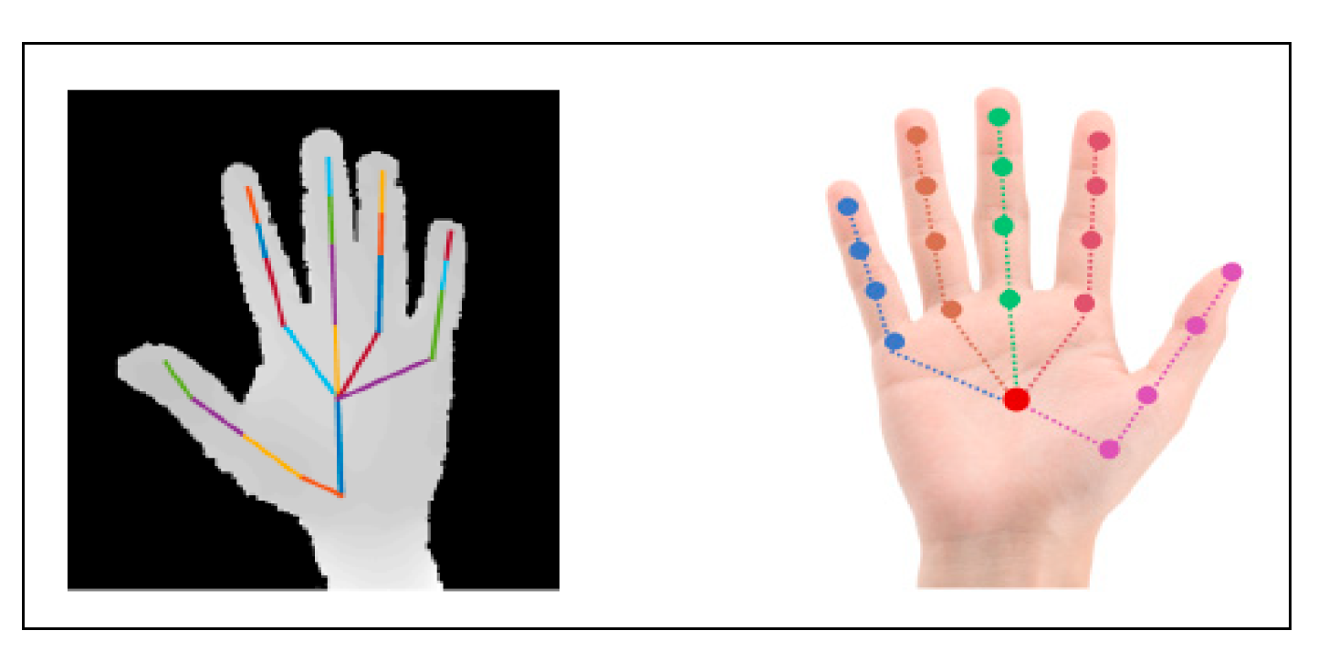

--------------------------------------------------------------------------------------------------------------------------------------

*School of Computer Engineering, KIIT, BBSR* **4**

*BREAKING BARRIERS - For DEAF and MUTE*

**CHAPTER 3**

PROBLEM STATEMENT/REQUIRMENT SPECIFICATIONS

**3.1 Problem Statement:**

Individuals with disabilities, such as those who are deaf and mute, face significant challenges in communicating with others. Despite advancements in technology, there is a lack of accessible and effective communication tools that can facilitate communication for these individuals. One popular method of communication is with sign language, but it can be difficult for others to understand without prior knowledge of sign language. The goal of this project is to address this problem by developing a Text Conversion System with Hand Gesture Recognition and Translation. This system will utilize computer vision to recognize and interpret different hand gestures, allowing for the conversion of sign language into audible speech in any desired language, as well as converting speech into understandable sign language for the deaf and mute. By developing this system, we aim to break down communication barriers for individuals with disabilities and enable them to communicate more effectively with the world around them.

--------------------------------------------------------------------------------------------------------------------------------------

*School of Computer Engineering, KIIT, BBSR* **5**

*BREAKING BARRIERS - For DEAF and MUTE*

**3.2 REQUIREMENT and SPECIFICATIONS**

**3.2.1 Functional Requirements:**

1)The system should be able to detect and track a single hand in real-time.

2)The system should be able to crop the hand region from the input video feed.

3)The cropped hand region should be resized and normalized to a fixed size.

4)The system should be able to classify the hand gesture using a pre-trained deep learning model.

5)The system should be able to display the recognized hand gesture on the screen.

**3.2.2 Non-functional Requirements:**

1)The system should have a high frame rate to provide a smooth real-time user experience.

2)The system should be able to operate under various lighting conditions.

3)The system should be able to handle occlusions and partial hand gestures.

4)The system should be able to work with a variety of hand shapes and sizes.

5)The system should be user-friendly and easy to use.

--------------------------------------------------------------------------------------------------------------------------------------

*School of Computer Engineering, KIIT, BBSR* **6**

**3.2.3 Hardware and Software Requirements:**

1)A webcam or camera for capturing the video feed.

2)A computer or embedded system with a processor capable of real-time video processing.

3)Python programming language with OpenCV, Keras, and TensorFlow libraries.

4)A pre-trained deep learning model for hand gesture recognition.

5)The system should be able to run on Windows or Linux operating systems.

**3.2.4 Assumptions:**

1)The hand is the only object in the video feed.

2)The user is facing the camera and the hand is in clear view of the camera.

3)The pre-trained deep learning model used for hand gesture recognition is accurate and provides reliable results.

**3.2.5 Constraints:**

1)The system may not work accurately in low-light or noisy environments.

2)The system may not be able to detect hand gestures if the hand is partially or fully occluded.

3)The system may not work with hands that are significantly different in size or shape than those used to train the deep learning model.

4)The system may require a powerful processor to run in real-time.

--------------------------------------------------------------------------------------------------------------------------------------

*School of Computer Engineering, KIIT, BBSR* **7**

**3.2.6 User privacy:**

You need to ensure that the user's data is kept private and secure. This can be achieved by implementing secure authentication, encryption of sensitive data, and following best practices in terms of handling and storing user data.

**3.2.7 Data protection:**

You need to ensure that the data being collected and stored is protected from unauthorized access, manipulation, or theft. This can be achieved by implementing appropriate access controls, monitoring, and auditing mechanisms.

**3.2.8 Compliance:**

You need to ensure that your project is compliant with relevant laws and regulations, such as data protection laws like GDPR or CCPA, depending on the region and audience of the project.

**3.2.9 Testing:**

You need to perform thorough testing to ensure that the project is free from security vulnerabilities, such as injection attacks, cross-site scripting, or denial-of-service attacks.

**3.2.10 Updates and maintenance:**

You need to ensure that the project is updated and maintained regularly to keep up with any new security threats or vulnerabilities. This can be achieved by implementing automated security updates or performing regular manual updates.

--------------------------------------------------------------------------------------------------------------------------------------

*School of Computer Engineering, KIIT, BBSR* **8**

*BREAKING BARRIERS - For DEAF and MUTE*

**CHAPTER 4**

**IMPLEMENTATION**

**4.1 Methodology**

Our focus will be:

**Sign language recognition** using ML and AI and will be done using computer vision and Sensors to capture data.

**Speech to text** this will be done using AI, the spoken language will be converted to text helpful for people having difficulty to speak.

**IoT enabling devices** such as smartphones and smartwatch to enhance communication for better understanding and more efficient way of communication.

**Process followed for successful results**: -

1) My Team tried creating a working model of this project using tools like 2 computer vision libraries like Hand Detector in Hand Tracking module, TensorFlow machine learning libraries, python libraries like NumPy, web-based tool like Teachable Machine for easy and quick training of model, deep learning API like Keras which run on TensorFlow.

2) We have implemented the entire code on PyCharm. We have imported various libraries Classification Module classifier, cv2(computer vision library).

3) We wrote code for image capturing so that we can capture images for each alphabet and store in different folders to train the model.

4) We trained it on Teachable machine which gave us TensorFlow Keras code which we included in our directory.

-------------------------------------------------------------------------------------------------------------------------------------

*School of Computer Engineering, KIIT, BBSR* **9**

5) The trained model then started recognizing the sign language. A glimpse of the same has been shown in figure 4.1. The terms computer vision, AI, and machine learning are common technical jargons utilized in the computer science domain.

Computer vision entails enabling machines to understand and interpret visual data from the surrounding environment. On the other hand, AI involves the creation of intelligent machines that can make independent decisions and learn from experience. Meanwhile, machine learning, a subset of AI, entails training machines to learn from data and enhance their performance. These technologies are widely applied in various areas, including speech and image recognition, natural language processing, and autonomous vehicles.

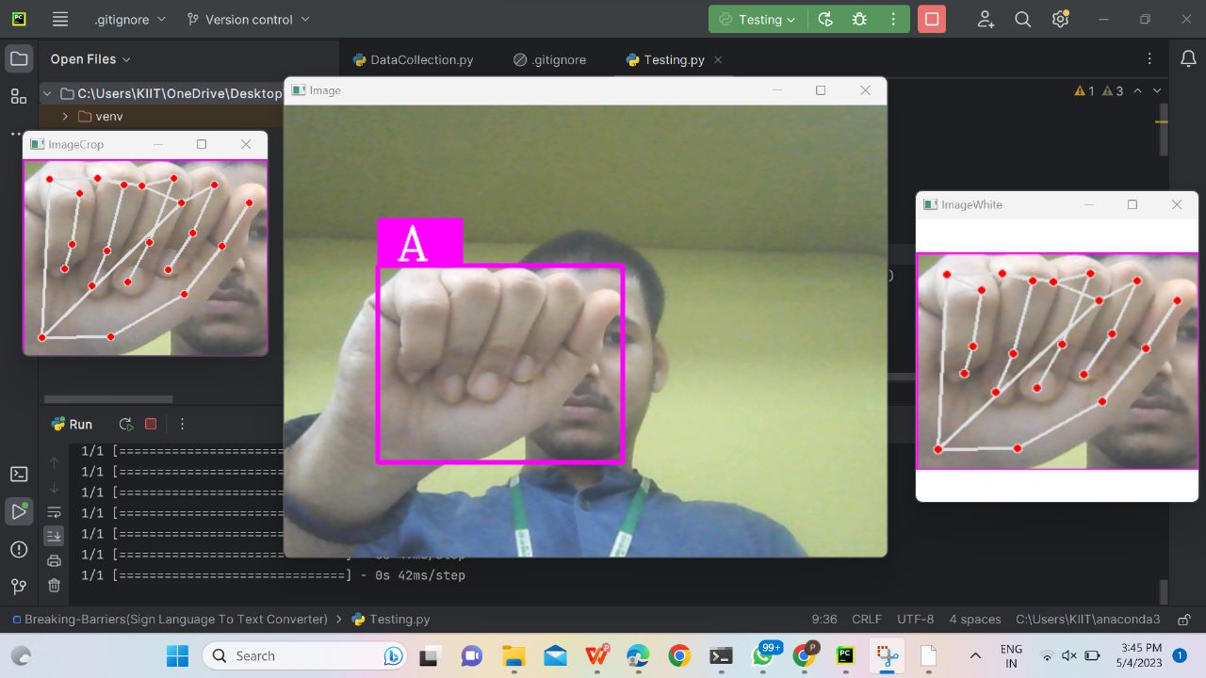

Figure 4.1

-------------------------------------------------------------------------------------------------------------------------------------

*School of Computer Engineering, KIIT, BBSR* **10**

*BREAKING BARRIERS - For DEAF and MUTE*

**4.2 TESTING/VERIFICATION**

**Test Model:**

You tested your model using OpenCV and a webcam. You used the CVZone HandTrackingModule to detect and crop the hand from the image, and then resized the cropped image to the same standard size as during the data collection phase. You then used your trained classification model to predict which hand gesture was being shown in the image.

**Evaluate Model:**

You evaluated the performance of your model by comparing the predicted hand gesture to the actual hand gesture shown in the image. You may have used metrics such as accuracy, precision, and recall to measure the performance of your model.

**4.3 RESULT ANALYSIS**

1. **ANALYSING HAND GESTURES**

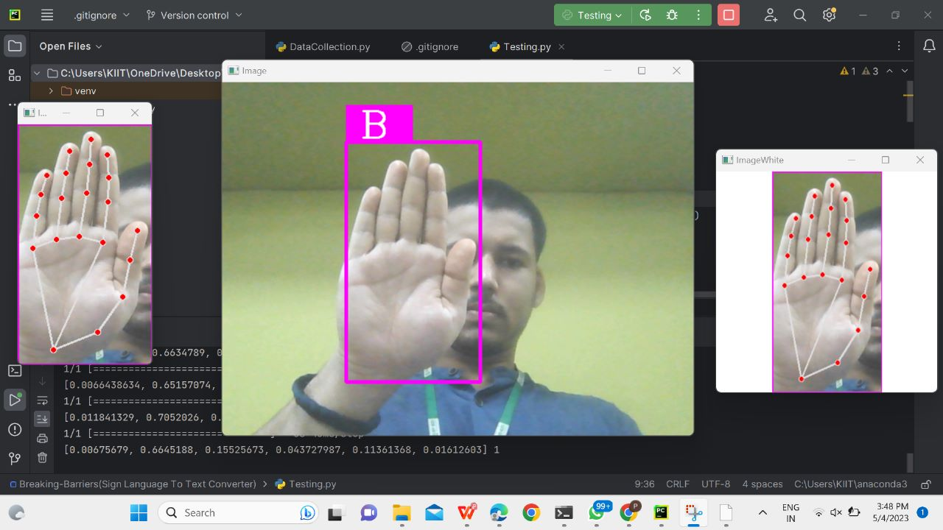 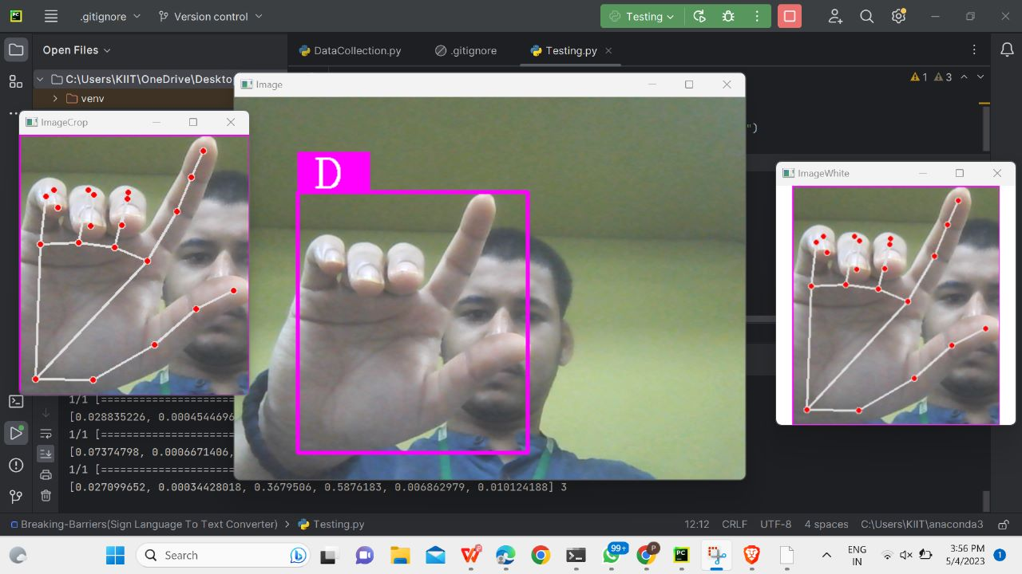

-------------------------------------------------------------------------------------------------------------------------------------

*School of Computer Engineering, KIIT, BBSR* **11**

1. **TESTING THE GIVEN DATA**



**CHAPTER 5**

**STANDARDS ADOPTED**

**5.1 CODING STANDARDS:** To ensure high-quality code for our project, we followed a set of coding standards, which included:

1.Writing concise and readable code for the CNN model and OpenCV.

2.Using appropriate naming conventions to clearly indicate the purpose and function of each component.

3.Use indentation to marks the beginning and end of control structures. Clearly specify the code between them.

4.Following best practices for structuring code and using indentation to mark control structures and other code blocks.

**5.2 TESTING STANDARDS:** To ensure the accuracy and reliability of our sign language translator, we followed a set of testing standards, including:

1.Conducting extensive validation and verification testing of the CNN model using labeled image datasets.

2.Adhering to ISO and IEEE standards for quality assurance and testing throughout the development process.

-------------------------------------------------------------------------------------------------------------------------------------

*School of Computer Engineering, KIIT, BBSR* **12**

*BREAKING BARRIERS - For DEAF and MUTE*

**CHAPTER 6**

**CONCLUSION AND FUTURE SCOPE**

**6.1 CONCLUSION**

In conclusion, a hand sign translator AI model can be a powerful tool for facilitating communication between individuals who use sign language and those who do not. Such a model could leverage computer vision and machine learning techniques to accurately recognize and translate hand signs into written or spoken language.

However, the development of a reliable hand sign translator AI model presents some challenges, including the need for robust training data and the ability to recognize variations in sign language across different regions and cultures. Additionally, the model must be able to account for context and understand the nuances of sign language, such as facial expressions and body language.

**6.2 FUTURE SCOPE**

The future scope of a hand sign translator AI model is immense and holds great potential for the deaf and hard-of-hearing communities. Here are some possible directions in which this technology may evolve:

**Improved accuracy**: One of the primary focuses for the future development of a hand sign translator AI model is to improve its accuracy in recognizing and translating sign language. This can be achieved by expanding the dataset used to train the model, including more sign language variations and dialects, and incorporating more advanced machine learning techniques.

-------------------------------------------------------------------------------------------------------------------------------------

*School of Computer Engineering, KIIT, BBSR* **13**

**Real-time translation**: Another significant advancement that is expected in the future is real-time translation of sign language. With advancements in computer vision and machine learning, it is possible to develop models that can recognize and translate sign language in real-time, making communication much more seamless and natural.

**Incorporation of facial expressions**: Sign language is not just about hand signs; facial expressions also play a critical role in conveying meaning. In the future, hand sign translator AI models can incorporate facial recognition technology to better understand the nuances of sign language and provide more accurate translations.

**Mobile integration**: The integration of hand sign translator AI models into mobile devices like smartphones and tablets can make them accessible to a wider audience. This will enable people to communicate with deaf and hard-of-hearing individuals more effectively, regardless of their location.

Overall, the future of a hand sign translator AI model is bright, and its development can have a significant impact on improving accessibility and communication for the deaf and hard-of-hearing communities.

-------------------------------------------------------------------------------------------------------------------------------------

*School of Computer Engineering, KIIT, BBSR* **14**

*BREAKING BARRIERS - For DEAF and MUTE*

**REFERENCES**

**Research Papers:**

"Real-Time Hand Gesture Recognition and Application to Sign Language Recognition" by Y. Gong, J. J. Zhang, Z. Wang,

G. Qui, and S. Wang. Published in IEEE Transactions on Industrial Electronics.

"Sign Language Recognition with Convolutional Neural Networks" by V. Athitsos, C. Neidle, and S. Sclaroff. Published in the Proceedings of the IEEE Conference on Computer Vision and Pattern Recognition (CVPR).

**Websites:**

SignSchool - https://www.signschool.com/translator

ASL Pro - <https://www.aslpro.com/cgi-bin/aslpro/aslpro.cgi>

-------------------------------------------------------------------------------------------------------------------------------------

*School of Computer Engineering, KIIT, BBSR* **14**

*BREAKING BARRIERS - For DEAF and MUTE*

**INDIVIDUAL CONTRIBUTION**