Subject and Code: Industrial Training (315004) Academic Year:2026-27 Course Name: Computer Engineering Semester: Fifth

A Report ON
Industrial Training at ‘LiveTech India’

Sr. No | Roll no | Names of Students | Enrolment | Seat no
1 | 43 | Ved Nishad Gharat | 24112470263

Under the Guidance of

Prof. Juilee Kini
Three Years Diploma Programme in Engineering &Technology of Maharashtra State Board of Technical
Education, Mumbai (Autonomous) ISO 9001:2008 (ISO/IEC-27001:2013)


MAHARASHTRA STATE BOARD OF TECHNICAL EDUCATION, MUMBAI

CERTIFICATE

This is to certify that Mr. Ved Nishad Gharat Roll No: 43 of Fifth Semester of Third Year Diploma in Computer Engineering at ST. JOHN COLLEGE OF ENGINEERING & MANAGEMENT has successfully completed the 12 weeks Internship of ITR (315004) in the Academic Year 2026-2027 as prescribed in the MSBTE prescribed curriculum of K Scheme.

Place: Palghar Enrollment No:24112470263

Date: / / Exam. Seat No:

External Project Guide Head of the Department Principal
examiner

Seal of Institute

Index

SR No | Title | Page No
1 | Acknowledgement | 4
2 | Abstract | 5
3 | Introduction | 6
4 | Internship Work | 7
5 | Project Worked On | 10
6 | Tools and Technologies Used | 13
7 | Project Development Stages | 16
8 | Code | 22
9 | Project Screenshots | 75
10 | Database Design | 84
11 | Testing and Debugging | 87
12 | Future Scope | 88
13 | Conclusion | 89
14 | Certificate | 90

Acknowledgement

I am incredibly thankful for the valuable learning experience I gained during my internship at LiveTech India. This internship was both insightful and rewarding, providing me with an excellent opportunity to bridge the gap between academic knowledge and real-world web development. I sincerely thank everyone who contributed to making my internship and the development of my Civic Sense AI a meaningful and enriching experience.
I am incredibly thankful for the valuable learning experience I gained while developing my project, Civic Sense AI. This project was both insightful and rewarding, providing me with an excellent opportunity to bridge the gap between academic knowledge and real-world software development. I sincerely thank everyone who contributed to making the development of my Civic Sense AI platform a meaningful and enriching experience.
First and foremost, I would like to express my deep appreciation to my mentors, guides, and instructors for their continuous support, guidance, and encouragement throughout the course of this project. Their positive and collaborative guidance helped me improve my technical knowledge and practical skills. During this period, I learned and applied technologies such as Python, Streamlit, SQLite, Folium, and the Anthropic Claude API while developing the Civic Sense AI platform.
I am especially grateful to my project guide and reviewers, whose technical expertise, patience, and valuable feedback played an important role in the successful development of my project. Their guidance helped me understand backend development, database management, AI integration, interactive map handling, session-based authentication, and project execution. Their constructive suggestions enabled me to solve technical problems and improve the overall design and functionality of the Civic Sense AI platform.
My sincere thanks also go to my classmates and fellow project members, who supported me throughout the development process and created an environment of teamwork and mutual learning. The discussions, brainstorming sessions, and collaborative activities helped me improve not only my technical abilities but also my communication, problem-solving, creativity, and time-management skills. Their cooperation made this project experience enjoyable, productive, and memorable.
I would also like to express my gratitude to my institution for providing me with a well-structured curriculum and the opportunity to work on a practical, real-world project. The development of Civic Sense AI gave me valuable experience in planning, designing, coding, testing, debugging, and managing a complete AI-integrated web application. Through this project, I gained a clearer understanding of the software development lifecycle and the professional standards followed in the IT industry.
The Civic Sense AI platform allowed me to apply my knowledge by developing various modules such as Report Incident, AI-based Photo Safety Analysis, Incident Map, My Reports, AI Assistant, Login and Registration System, and Admin Dashboard. Working on these modules strengthened my understanding of backend and AI integration, database connectivity, interactive map implementation, session-based authentication, and user-friendly interface design.
Lastly, I am truly thankful for being given this exceptional opportunity to learn, grow, and contribute meaningfully. This project has strengthened my foundation in Python and AI-driven web technologies and inspired me to continue building innovative, efficient, and user-centric applications. I will always value the knowledge, practical experience, professional skills, and confidence I gained while developing the Civic Sense AI project, as they will play an important role in shaping my future career in software and AI development.

Abstract

- The main project developed was Civic Sense AI – An AI-Powered Civic Issue Reporting and Management Platform. Civic Sense AI is designed to provide citizens with a single digital platform to report civic issues and track their resolution. Its main objective is to help citizens easily report problems such as potholes, garbage accumulation, water logging, and damaged streetlights, and enable administrators to manage and resolve them efficiently.
- The Civic Sense AI platform includes important modules such as Report Incident, AI-based Photo Safety Analysis, Incident Map, My Reports, AI Assistant, Login and Registration System, and Admin Dashboard. Each module was developed to fulfil the requirements of citizens, administrators, and civic authorities.
- The user interface of the application was developed using Streamlit, styled with a custom "Neon Grid" design system to create a modern, dark, glassmorphic look. Python was used for backend operations such as form processing, login authentication, session management, and CRUD operations. SQLite was used to store and manage users, incident reports, images, and status updates.
- The application also integrates AI capabilities through the Anthropic Claude API, allowing it to automatically suggest the category and priority of a reported issue from free-text descriptions, analyze uploaded photos to suggest safety precautions, and power a conversational AI assistant. When no API key is configured, the application falls back to built-in rule-based logic, ensuring no functionality is lost.
- The Incident Map module uses Folium to plot all reported issues on an interactive map, color-coded by status, with filtering options for easier navigation. The Admin Dashboard provides centralized control over all reports, with KPI overviews, category- and priority-wise charts, and options to update status or delete reports.
- Throughout the project, I gained practical experience in requirement analysis, user-interface design, database creation, backend and AI integration, session handling, interactive map implementation, testing, debugging, and project documentation. I also learned how to use tools such as Visual Studio Code, Python virtual environments, Git, and Docker for deployment.
- This project improved my technical knowledge and developed my communication, teamwork, problem-solving, creativity, adaptability, and time-management skills. Civic Sense AI gave me practical experience in building an AI-integrated, database-driven web application and strengthened my confidence in full-stack and AI-powered software development.

Introduction

Introduction of LiveTech India
The rapid development of digital technology has transformed the way citizens interact with civic bodies and report problems in their surroundings. Everyday civic issues such as potholes, garbage accumulation, water logging, and damaged streetlights often go unreported or take a long time to reach the concerned authorities, as there is no simple, centralized way for citizens to report and track them. To address this challenge, I developed Civic Sense AI – An AI-Powered Civic Issue Reporting and Management Platform.
Civic Sense AI is designed to let citizens report civic issues quickly and track their resolution through a single digital platform. Through the Report Incident module, users can describe an issue in free text, and an AI layer automatically suggests the category and priority of the complaint. Users can pinpoint the exact location of the issue on an interactive map by clicking on it or searching a place name, with manual latitude and longitude fields available as a fallback.
The platform also includes an AI-based photo safety analysis feature, where citizens can attach photos of the incident. The Incident Map section displays all reported issues on an interactive map, color-coded by status — Pending, In Progress, or Resolved — with filtering options for easier navigation. The My Reports section allows citizens to track the status of the issues they have personally submitted. Civic Sense AI also includes an AI Assistant, a chat-based interface that answers civic-related questions and guides users through the app, working fully offline by default and upgrading automatically to a Claude-powered assistant when an API key is provided.
The website includes secure Login and Registration with session-based authentication backed by SQLite, along with pre-seeded demo accounts for both citizens and administrators. The Admin Dashboard provides a centralized control panel with KPI overviews, category- and priority-wise charts, and controls to update the status of reports or delete them, giving administrators complete oversight of all civic complaints.
The frontend and overall user interface of Civic Sense AI was built using Streamlit, styled with a custom "Neon Grid" design system — a dark, glassmorphic sci-fi command-center theme with animated gradient backgrounds and glowing neon cyan and violet accents, defined through a dedicated styling module and Streamlit's configuration file. The backend was developed using Python, with SQLite used as the persistence layer for storing users, reports, and incident data. Interactive maps were implemented using Folium and its Streamlit integration, while the AI-powered classification, chatbot, and photo analysis features were built using the Anthropic Claude API. The project was developed and tested using Visual Studio Code, Python virtual environments, and the Streamlit local development server.
The main purpose of Civic Sense AI is to bring civic issue reporting, AI-assisted categorization, safety guidance, live incident tracking, and administrative management together on one platform. Developing this project helped me gain practical experience in Python backend development, AI integration using the Claude API, database design with SQLite, building interactive maps, session-based authentication, dashboard design, and full-stack application development using Streamlit.

Internship Work

Timeline Summary:
The 11-week internship provided me with practical knowledge and hands-on experience in Python Programming, Machine Learning, Natural Language Processing, Large Language Models, Generative AI, Power BI, and Deep Learning. During the internship, I learned how to analyze data, build machine learning models, develop AI chatbots, create interactive dashboards, and apply deep learning concepts through practical exercises and projects.
The main project developed during the internship was Civic Sense AI – An AI-Powered Civic Issue Reporting and Management Platform.. The project was created to let citizens report civic issues quickly and track their resolution through a single digital platform

Week 1:

The internship began with an introduction to the internship program, company requirements, and project objectives. I learned Python fundamentals, including variables, data types, operators, loops, and functions. I was introduced to the basics of Machine Learning and its real-world applications. I also practiced Python programming using NumPy and Pandas and completed hands-on coding exercises to strengthen the concepts learned.

Week 2:

During the second week, I learned data preprocessing and Exploratory Data Analysis (EDA) techniques. I practiced handling and analyzing datasets and created visualizations using Matplotlib. I implemented Simple Linear Regression using Python and learned how to evaluate model performance and interpret the results through practical exercises.

Week 3:

In the third week, I studied Multiple Linear Regression and advanced regression techniques including Ridge, Lasso, and ElasticNet Regression. I also implemented Logistic Regression for classification problems. Model performance was evaluated using Accuracy Score, Confusion Matrix, and Classification Report. Practical exercises helped me understand and apply different machine learning algorithms.

Week 4:

The fourth week focused on Natural Language Processing (NLP) and its applications. I learned text preprocessing techniques such as tokenization, stemming, and lemmatization. I also worked with TF-IDF and Count Vectorizer for converting text into numerical representations. Basic NLP models were developed for text analysis and classification.

Week 5:

During the fifth week, I explored the fundamentals of Large Language Models (LLMs). Prompt Engineering, and Retrieval-Augmented Generation (RAG). I developed a basic Al chatbot using Python and tested its responses to improve its performance. This week provided practical knowledge of modern Generative Al and conversational Al systems.

Week 6:

The sixth week focused on Power BI and data visualization. I learned to import, clean, and transform datasets using Power Query. I created KPIs, charts, slicers, and interactive dashboards and used DAX measures for calculations and data analysis. I also practiced improving dashboard design and presenting insights effectively.

Week 7:

During the seventh week, I developed an Al-based Car Recommendation Chatbot using Python. I applied Machine Learning and NLP techniques to provide intelligent car recommendations and explored the use of LLMs to improve chatbot responses. I also worked on Power BI visualization and designed dashboards to represent project insights and KPIs. The project was tested, refined, and documented.

Week 8:

In the eighth week, I verified and improved the Formula 1 Power BI Dashboard based on mentor feedback. I enhanced the dashboard using KPIs, DAX measures, charts, and slicers to improve its usability and visual representation. I presented the mini project and explained its features and insights. I also revised Power BI concepts and finalized the project documentation.

Week 9:

The ninth week focused on Artificial Neural Networks (ANN) and Convolutional Neural Networks (CNN). I learned the basic concepts and working of ANN and CNN through examples and practical exercises. I performed a CNN experiment, analyzed its results, and revised the concepts through hands-on implementation.

Week 10:

During the tenth week, I learned Recurrent Neural Networks (RNN) and practiced related examples. I studied deep learning fundamentals and concepts such as logic gates and epochs. Along with revising previous concepts, I continued the development and coding of my major project and applied the learned Al and deep learning concepts where required.

Week 11:

The eleventh week focused on the major project,Civic Sense AI - An AI-Powered Civic Issue Reporting and Management Platform.. I presented the project idea, understood and explained its features, and worked on its implementation. I completed final code updates, tested the complete project workflow, and reviewed the project concepts. The week also involved practical revision, testing, and preparation of the final project documentation.

Finally, the Civic sense AI project was presented with its major modules, technologies, database structure, features, challenges, and future improvements. The internship concluded successfully with valuable experience in full-stack web development.

Project Worked On

Civic Sense AI is a dynamic, AI-integrated web application designed to provide citizens with a single platform to report civic issues, track their resolution, and receive AI-driven guidance and safety advice. The main purpose of the project is to support citizens by simplifying the process of reporting problems such as potholes, garbage accumulation, water logging, and damaged streetlights, while giving administrators an organized way to manage and resolve them.
Citizens often depend on scattered offline channels, such as phone calls or in-person visits to municipal offices, to report civic issues. This process can be slow, inconsistent, and difficult to track. Civic Sense AI was developed to reduce these difficulties by bringing issue reporting, location mapping, AI-assisted analysis, and administrative management together on one digital platform.
The application was developed using Python and the Streamlit framework. Streamlit was used to build the entire user interface and handle page rendering, while a custom "Neon Grid" design system — a dark, glassmorphic theme with animated gradient backgrounds and glowing neon accents — was built using CSS to give the app a distinctive, modern look. Python was used for backend logic, including authentication, session management, and database operations. SQLite was used to store and manage the application's data.
The Civic Sense AI platform contains several important modules, including the Login and Registration System, Report Incident, Incident Map, My Reports, AI Assistant, and Admin Dashboard. Every module was developed to meet the different requirements of citizens and administrators.
Login and Registration System:
The Login and Registration System provides secure, session-based access to personalized features of Civic Sense AI. User passwords are hashed before being stored in the database, and each account is assigned a role of either "citizen" or "admin," which determines the sections of the application a user can access.
The system is pre-seeded with a demo admin account and a demo citizen account so that the application can be explored immediately after setup. Registered users can log in using valid credentials, and their session is maintained throughout their use of the app, preventing unauthorized access to protected pages such as the Admin Dashboard.
Report Incident:
The Report Incident module allows citizens to submit civic issues they encounter. Users enter a free-text description of the problem, and an AI layer automatically analyzes the text to suggest an appropriate category (such as Pothole, Garbage, Water Logging, or Streetlight) and a priority level.
An interactive map is embedded in this module, allowing citizens to pinpoint the exact location of the incident by clicking directly on the map or searching for a place name. Manual latitude and longitude input fields are also provided as a fallback for cases where the interactive map cannot be used.
Citizens can additionally attach one or more photos of the incident. When an Anthropic API key is configured, these photos are analyzed using Claude's vision capabilities, and the application suggests immediate safety precautions and mitigation steps, along with a fixed, non-AI-generated table of relevant helpline contacts, such as the fire brigade, police, electricity board, and sanitation department, based on the incident category. If no API key is configured, the application automatically falls back to rule-based logic, so no functionality is lost.
Incident Map:
The Incident Map module displays all reported issues on an interactive map, using Folium for map rendering. Each incident is color-coded according to its status — Pending, In Progress, or Resolved — allowing users to quickly identify unresolved problems in their area. Filtering options are provided so that users can narrow down the displayed incidents by category or status.
My Reports:
The My Reports module allows citizens to view the status and details of the incidents they have personally submitted. This module retrieves data specific to the logged-in user from the database, ensuring that citizens can only view and track their own reports.
AI Assistant:
The AI Assistant module provides a chat-based interface where citizens can ask civic-related questions and get guidance on using the application. The assistant works fully offline using built-in rule-based responses, and automatically upgrades to a Claude-powered conversational assistant when an Anthropic API key is provided, offering more natural and detailed responses.
Admin Dashboard:
The Admin Dashboard is the main management system of Civic Sense AI and can only be accessed by users with the "admin" role. It displays a KPI overview along with category-wise and priority-wise charts summarizing all reported incidents.
Through the dashboard, administrators can:
- View all submitted incidents
- Update the status of a report (Pending, In Progress, Resolved)
- Delete reports that are invalid or resolved
- Monitor overall trends in civic issues by category and priority
The Admin Dashboard supports CRUD operations, allowing administrators to read, update, and delete incident records directly from the database.
Multilingual Support:
Civic Sense AI includes support for multiple languages through a dedicated language module, making the platform more accessible to users from different linguistic backgrounds. Interface labels and content can be displayed in the selected language, improving usability for a wider range of citizens.
Database Management:
A relational SQLite database was created to store and manage the information required by Civic Sense AI. The main database tables include:
- Users — stores usernames, hashed passwords, email addresses, and roles
- Incidents — stores the reporting user, category, description, location (text and coordinates), priority, status, attached image reference, and timestamps
A foreign key relationship connects each incident to the user who reported it. Python's SQLite library was used to insert, retrieve, update, and delete records through parameterized SQL queries.
Testing and Debugging:
After developing the modules, the complete Civic Sense AI application was tested to identify and resolve functional and design-related issues. The testing process included checking the login and registration flow, form submissions, map interactions, image uploads, AI classification results, status updates from the Admin Dashboard, and responsive behavior of the interface.
Different valid and invalid inputs were used to test authentication and form handling. The application was also tested with and without an Anthropic API key configured, to confirm that the offline fallback logic worked correctly in both the AI Assistant and photo safety analysis features.
Deployment:
Civic Sense AI was configured to support multiple deployment options. A Dockerfile enables container-based deployment on platforms such as Render, Railway, and Fly.io, while a Procfile and runtime.txt support Heroku-style buildpack deployment. The application can also be deployed directly on Streamlit Community Cloud by connecting the project repository.
Final Reflection:
Developing the Civic Sense AI application was one of the most valuable practical experiences of this project. It helped me understand the complete process of developing an AI-integrated full-stack application, from requirement analysis and interface design to coding, database integration, AI API integration, testing, and documentation.
Through this project, I improved my knowledge of Python, Streamlit, SQLite, and the Anthropic Claude API. I also gained practical experience in session-based authentication, interactive map integration, AI-assisted classification, database design, CRUD operations, and responsive interface development.
The development of the different Civic Sense AI modules improved my problem-solving ability, logical thinking, creativity, communication, and time-management skills. The project strengthened my confidence in building AI-powered, database-driven web applications.

Tools and Technologies Used

Visual Studio Code (VS Code):
Visual Studio Code was the primary code editor used for developing the Civic Sense AI application. It provided an organised workspace for writing and managing Python code across all the application's modules.
Features such as syntax highlighting, code suggestions, automatic indentation, error detection, search and replace, and file management helped improve development speed and code quality. Extensions such as the Python extension, Pylance, and GitLens were also useful for writing clean, error-free code and tracking changes.
The integrated terminal in VS Code was used to run the Streamlit development server, install dependencies, and manage project files. Its folder structure helped organise the application's Python modules, styling files, database file, and uploaded images.
Python Virtual Environment:
A Python virtual environment was used to isolate the project's dependencies from the system-wide Python installation. This ensured that packages such as Streamlit, pandas, folium, and the Anthropic SDK could be installed and managed without conflicting with other projects.
The requirements.txt file was used to list all required packages, making it easy to recreate the same environment on a different machine or deployment platform.
Streamlit:
Streamlit was the core framework used to build the entire Civic Sense AI application. It allowed the user interface, navigation, and interactivity to be built directly using Python, without writing separate HTML, CSS, or JavaScript files for the page structure.
Streamlit features used in the project included:
- Session state for managing login and navigation
- Forms and widgets for user input
- Sidebar-based navigation between application sections
- File uploader for incident photos
- Custom CSS injection for the "Neon Grid" theme
- .streamlit/config.toml for theme and server configuration
Streamlit's rerun-based execution model was used to keep the interface updated in response to user actions, such as submitting a report or updating an incident's status.
SQLite:
SQLite was used as the database-management system for the Civic Sense AI project. It stored all important application data in structured tables, without requiring a separate database server to be installed or configured.
SQLite managed data related to:
- User accounts and roles
- Incident reports (category, description, location, priority, status)
- Image references for uploaded incident photos
SQL queries were executed through Python's built-in sqlite3 library to perform Create, Read, Update, and Delete operations. A foreign key relationship was used to link each incident report to the user who submitted it.
Anthropic Claude API:
The Anthropic Claude API was integrated into the project to power the application's AI features. It was used for:
- Classifying incident descriptions into categories and priority levels
- Analyzing uploaded incident photos to suggest safety precautions
- Powering the conversational AI Assistant
The API key was managed securely through environment variables and Streamlit's secrets management, so it was never hard-coded into the application. When no API key was configured, the application automatically fell back to built-in rule-based logic, ensuring the app remained fully functional offline.
Folium and Streamlit-Folium:
Folium was used to generate interactive maps for the Report Incident and Incident Map modules. It allowed incidents to be plotted as markers on a map, color-coded according to their status.
The streamlit-folium package was used to embed these interactive Folium maps directly inside the Streamlit interface, allowing users to click on the map to select a location or view existing reports.
Web Browsers and Developer Tools:
Web browsers such as Google Chrome and Microsoft Edge were used to test and debug the Civic Sense AI application while it ran locally through Streamlit.
Browser Developer Tools provided several useful features. The Elements panel was used to inspect the rendered HTML and CSS to fix spacing, alignment, and layout issues in the custom "Neon Grid" theme. The Console panel helped identify any client-side errors related to custom styling or embedded components. The Network panel was useful for checking whether images, stylesheets, and API requests were loading and completing correctly.
Git and GitHub:
Git was used for version control throughout the development of the project, allowing changes to be tracked and reverted if necessary. GitHub was used to host the project repository, which also served as the source for deployment to Streamlit Community Cloud.
Docker:
A Dockerfile was created to containerise the Civic Sense AI application, allowing it to be deployed consistently across different hosting platforms such as Render, Railway, and Fly.io. Docker ensured that the application's dependencies and runtime environment remained consistent between local development and production deployment.
Overall Use of Tools:
These tools and technologies worked together to support the successful development of the Civic Sense AI platform. Visual Studio Code was used for writing and organising code, while a Python virtual environment kept dependencies isolated and manageable. Streamlit powered the entire user interface and application logic, while SQLite managed persistent data storage.
The Anthropic Claude API added intelligent, AI-driven features to the platform, and Folium enabled interactive map-based reporting and tracking. Git and GitHub supported version control and collaboration, while Docker enabled consistent, portable deployment. Browser developer tools helped identify and resolve interface and functionality issues throughout development.
Using these tools provided me with practical knowledge of developing, testing, debugging, and deploying a complete AI-integrated full-stack application.

Project Development Stages
1. Requirement Analysis:
The first stage of the Civic Sense AI project was to identify the problems faced by citizens while reporting civic issues such as potholes, garbage accumulation, water logging, and damaged streetlights, and the difficulties faced by administrators while tracking and resolving them.
The main requirements of the project were identified as:
- Secure citizen login and registration
- A simple way for citizens to report civic issues with location details
- AI-assisted classification of issue category and priority
- AI-based safety analysis of incident photos
- A visual, map-based view of all reported incidents
- A way for citizens to track their own submitted reports
- A conversational assistant to guide users through the app
- Centralised admin control to update or remove reports
- Offline functionality when no AI API key is available
- Responsive, easy-to-use interface across devices
This stage helped define the purpose, users, features, and scope of the Civic Sense AI platform.
2. Project Planning:
After analysing the requirements, the project was divided into different modules to simplify development.
The main modules planned were:
- Login and Registration
- Report Incident
- Incident Map
- My Reports
- AI Assistant
- Admin Dashboard
A development sequence was prepared so that database design, authentication, core reporting functionality, AI integration, map integration, testing, and documentation could be completed systematically. The technologies selected for the project were Python, Streamlit, SQLite, Folium, and the Anthropic Claude API.
3. User Interface Design:
The user interface of Civic Sense AI was designed with a distinctive "Neon Grid" appearance — a dark, glassmorphic, sci-fi command-center theme. Glowing neon cyan and violet accents were selected to give the platform a modern, futuristic feel suited to an AI-powered application.
The interface included:
- A sidebar-based navigation menu
- Frosted-glass cards for forms and content sections
- An animated gradient background
- Interactive maps for location selection and incident viewing
- Status badges color-coded by Pending, In Progress, and Resolved
- Chat-style layout for the AI Assistant
The layout was planned to provide easy navigation and clear information to both citizens and administrators. The theme was implemented entirely through a dedicated styling module and Streamlit's configuration file, ensuring visual consistency across every section of the app.
4. Application Development Setup:
The application development stage focused on setting up the Streamlit project structure and building each section as an independent, render-based module.
Rather than using Streamlit's folder-based multipage system, navigation between sections was handled manually inside the main entry-point file using a sidebar selector. This kept the project structure flat, with every file placed directly in the project root, and gave finer control over how login state and role-based access affected which sections a user could see.
Reusable elements such as page headers, status badges, and styled containers were created in the styling module to maintain consistency throughout the application.
5. Database Design:
A relational SQLite database was created to store and manage all Civic Sense AI information.
The main database tables included:
- Users — id, username, hashed password, email, role, created_at
- Incidents — id, user_id, username, category, description, location_text, latitude, longitude, priority, status, image_name, created_at, updated_at
Each table was created with suitable columns, data types, and primary keys. A foreign key relationship was established between the incidents table and the users table, linking every report to the citizen who submitted it.
The database file is created automatically on first run, along with a seeded admin account, a demo citizen account, and a couple of sample incidents so the map and dashboard are not empty when the app is first explored.
6. Backend Development:
Python was used to develop the backend functionality of the Civic Sense AI application.
The backend handled:
- Database connection and queries
- Registration and login
- Password hashing and session management
- Incident submission and retrieval
- AI-based category and priority classification
- AI-based photo safety analysis
- Admin status updates and report deletion
- CRUD operations
Python scripts were connected with SQLite to insert, retrieve, update, and delete records. Input validation was applied to prevent incomplete or incorrect data from being stored in the database.
7. Login and Registration Development:
The Login and Registration system was developed to provide secure access to the Civic Sense AI platform.
The registration form collected user details such as username, email address, and password. Passwords were hashed before being stored in the database rather than saved as plain text.
Streamlit's session state was used to maintain the login status of users and prevent unauthorised access to protected pages. Separate access was provided according to user roles, with administrators gaining access to the Admin Dashboard in addition to the standard citizen features.
8. Report Incident Development:
The Report Incident module was developed as the core reporting feature of the platform.
It allowed citizens to:
- Enter a free-text description of the civic issue
- Receive an AI-suggested category and priority based on the description
- Select the exact incident location using an interactive map or a place search
- Enter latitude and longitude manually as a fallback
- Upload one or more photos of the incident
- Receive AI-generated safety precautions and a fixed table of relevant helpline contacts based on the incident category
Submitted reports were stored in the SQLite database along with their timestamps, and uploaded images were saved to a local folder with a reference stored in the incidents table.
9. Incident Map Development:
The Incident Map module was developed to give citizens and administrators a visual overview of all reported issues.
It displayed:
- Markers for every reported incident
- Colour-coding based on status (Pending, In Progress, Resolved)
- Filtering options by category and status
Folium was used to generate the interactive map, and the streamlit-folium package was used to embed it directly within the Streamlit interface.
10. My Reports Development:
The My Reports module was developed to let citizens track the issues they had personally submitted.
It displayed the status, category, priority, and details of each of the logged-in user's own reports, retrieved dynamically from the database using the citizen's user ID.
11. AI Assistant Development:
The AI Assistant module was developed as a chat-based interface to help citizens navigate the app and get answers to civic-related questions.
The assistant was built to work fully offline using rule-based responses by default, and to automatically upgrade to a Claude-powered conversational assistant whenever an Anthropic API key was configured, without requiring any change to the rest of the application.
12. Admin Dashboard Development:
The Admin Dashboard was developed to give administrators complete oversight of the platform.
It provided:
- A KPI overview of total reports and their statuses
- Category-wise and priority-wise charts
- The ability to update the status of any report
- The ability to delete invalid or resolved reports
Dashboard cards and charts were built using Streamlit's native components, styled to match the "Neon Grid" theme.
13. Multilingual Feature Development:
Civic Sense AI was developed with support for multiple languages through a dedicated language module.
A language selector was added to the interface, allowing key labels, headings, and messages to be displayed in the user's preferred language. This functionality improved accessibility for a wider range of citizens.
14. Module Integration:
After completing the individual modules, they were connected to create a complete application.
Each module was structured with its own render() function and linked to the sidebar navigation in the main entry-point file. Session state was checked before rendering any protected section, ensuring that only logged-in users — and only admins, in the case of the Admin Dashboard — could access the relevant pages.
User actions such as registration, login, report submission, AI classification, photo analysis, and status updates were integrated end-to-end with the backend and database layers.
15. Testing and Debugging:
The complete Civic Sense AI application was tested to identify and resolve functional and design-related issues.
Testing included:
- Registration and login flows
- Session handling and role-based access
- Report submission with and without photos
- AI classification accuracy on sample descriptions
- Map marker placement and filtering
- Admin status updates and report deletion
- Behaviour with and without an Anthropic API key configured
- Responsive layout behaviour in the browser
Problems related to session state, database connections, missing images, and layout spacing in the custom theme were identified and corrected.
16. Deployment Preparation:
The application was prepared for deployment across multiple hosting options. A Dockerfile was created for container-based deployment on platforms such as Render, Railway, and Fly.io. A Procfile and runtime.txt were added to support Heroku-style buildpack deployment, and the project was structured to also deploy directly on Streamlit Community Cloud.
Configuration for secrets, such as the Anthropic API key, was kept separate from the codebase using environment variables and Streamlit's secrets management, with a .gitignore entry ensuring secrets were never committed to version control.
17. Final Review and Documentation:
The final stage included complete project review, documentation, screenshots, and presentation preparation.
All modules were checked for consistent design, functionality, responsive behaviour, and database accuracy.
The final report included:
- Project overview
- Tools and technologies
- Development stages
- Important code
- Database structure
- Project screenshots
- Testing details
- Conclusion

The completed Civic Sense AI project demonstrated the practical application of full-stack, AI-integrated application development concepts and successfully combined civic issue reporting, AI-assisted analysis, map-based tracking, and administrative management into one digital platform.

CODE

"""
app.py
Civic Sense AI — single entry point.
This app is intentionally FLAT (no pages/ or .streamlit/ directories).
Navigation between sections is handled manually via a sidebar radio +
imported render() functions, instead of Streamlit's folder-based
multipage system.
Run with:
streamlit run app.py
"""
import streamlit as st
import database as db
import auth
import style
import i18n
from i18n import t
import report_incident
import incident_map
import my_reports
import admin_dashboard
import assistant_page
st.set_page_config(
page_title="Civic Sense AI",
page_icon="🏙️",
layout="wide",
)
db.init_db()
auth.init_session()
i18n.init_language()
style.inject_css()
# ---------------------------------------------------------------------------
# Internal navigation IDs are deliberately kept in plain English — they're
# used as session_state values / dict keys, never shown to the user directly.
# Their on-screen label is looked up via i18n.t() at render time, so the menu
# updates immediately when the citizen switches language.
# ---------------------------------------------------------------------------
NAV_HOME = "home"
NAV_REPORT = "report"
NAV_MAP = "map"
NAV_MY_REPORTS = "my_reports"
NAV_ASSISTANT = "assistant"
NAV_ADMIN = "admin"
NAV_LABEL_KEYS = {
NAV_HOME: "nav_home",
NAV_REPORT: "nav_report",
NAV_MAP: "nav_map",
NAV_MY_REPORTS: "nav_my_reports",
NAV_ASSISTANT: "nav_assistant",
NAV_ADMIN: "nav_admin",
}
def nav_label(nav_id):
return t(NAV_LABEL_KEYS.get(nav_id, nav_id))
# IMPORTANT: "current_page" is a plain session_state variable, deliberately
# NOT tied to any widget's `key`. The sidebar radio below uses a *different*
# key ("nav_radio_widget"). Keeping these separate avoids Streamlit's
# restriction on writing to a widget's own state key, so buttons elsewhere
# in the app can freely redirect navigation without conflicting with the
# radio widget.
if "current_page" not in st.session_state:
st.session_state.current_page = NAV_HOME
def go_to(section):
"""Safe to call from a button's on_click — updates plain state, not a widget key.
Also syncs the sidebar radio's own key: once a keyed widget has a stored
value, Streamlit ignores any `index` passed on later runs, so without this
the radio would silently snap back to its last manually-selected value."""
st.session_state.current_page = section
st.session_state.nav_radio_widget = section
def home_view():
user = st.session_state.user
role_label = t("role_admin") if user["role"] == "admin" else t("role_citizen")
style.hero(
t("hero_title"),
t("home_welcome", name=user["username"], role=role_label),
eyebrow=t("eyebrow_community"),
)
st.markdown(t("home_what_todo"))
col1, col2 = st.columns(2)
with col1:
st.markdown(
f'<div class="cs-feature-card"><span class="cs-icon">📝</span>'
f'<h4>{t("card_report_title")}</h4><p>{t("card_report_desc")}</p></div>',
unsafe_allow_html=True,
)
st.button(t("btn_open_report"), use_container_width=True,
key="btn_open_report", on_click=go_to, args=(NAV_REPORT,))
st.write("")
st.markdown(
f'<div class="cs-feature-card"><span class="cs-icon">🗺️</span>'
f'<h4>{t("card_map_title")}</h4><p>{t("card_map_desc")}</p></div>',
unsafe_allow_html=True,
)
st.button(t("btn_open_map"), use_container_width=True,
key="btn_open_map", on_click=go_to, args=(NAV_MAP,))
st.write("")
st.markdown(
f'<div class="cs-feature-card"><span class="cs-icon">📄</span>'
f'<h4>{t("card_my_reports_title")}</h4><p>{t("card_my_reports_desc")}</p></div>',
unsafe_allow_html=True,
)
st.button(t("btn_open_my_reports"), use_container_width=True,
key="btn_open_my_reports", on_click=go_to, args=(NAV_MY_REPORTS,))
with col2:
st.markdown(
f'<div class="cs-feature-card"><span class="cs-icon">🤖</span>'
f'<h4>{t("card_assistant_title")}</h4><p>{t("card_assistant_desc")}</p></div>',
unsafe_allow_html=True,
)
st.button(t("btn_open_assistant"), use_container_width=True,
key="btn_open_assistant", on_click=go_to, args=(NAV_ASSISTANT,))
if user["role"] == "admin":
st.write("")
st.markdown(
f'<div class="cs-feature-card"><span class="cs-icon">📊</span>'
f'<h4>{t("card_admin_title")}</h4><p>{t("card_admin_desc")}</p></div>',
unsafe_allow_html=True,
)
st.button(t("btn_open_admin"), use_container_width=True,
key="btn_open_admin", on_click=go_to, args=(NAV_ADMIN,))
def login_register_view():
# Citizens can pick their language before they've even logged in.
lang_col, _ = st.columns([1, 3])
with lang_col:
i18n.language_selector(key="lang_code_logged_out")
style.hero(
t("hero_title"),
t("hero_subtitle_logged_out"),
eyebrow=t("eyebrow_community"),
)
fcol1, fcol2, fcol3 = st.columns(3)
with fcol1:
st.markdown(
f'<div class="cs-feature-card"><span class="cs-icon">📝</span>'
f'<h4>{t("feat_report_title")}</h4><p>{t("feat_report_desc")}</p></div>',
unsafe_allow_html=True,
)
with fcol2:
st.markdown(
f'<div class="cs-feature-card"><span class="cs-icon">🗺️</span>'
f'<h4>{t("feat_track_title")}</h4><p>{t("feat_track_desc")}</p></div>',
unsafe_allow_html=True,
)
with fcol3:
st.markdown(
f'<div class="cs-feature-card"><span class="cs-icon">🤖</span>'
f'<h4>{t("feat_help_title")}</h4><p>{t("feat_help_desc")}</p></div>',
unsafe_allow_html=True,
)
st.write("")
tab_login, tab_register = st.tabs([t("tab_login"), t("tab_register")])
with tab_login:
with st.form("login_form"):
username = st.text_input(t("username"))
password = st.text_input(t("password"), type="password")
submitted = st.form_submit_button(t("login_btn"), use_container_width=True)
if submitted:
if auth.login(username, password):
st.rerun()
else:
st.error(t("login_error"))
with tab_register:
with st.form("register_form"):
new_username = st.text_input(t("choose_username"))
new_phone = st.text_input(t("phone"), placeholder="e.g. 9876543210", max_chars=10)
new_password = st.text_input(t("choose_password"), type="password")
confirm_password = st.text_input(t("confirm_password"), type="password")
submitted = st.form_submit_button(t("create_account"), use_container_width=True)
if submitted:
phone_digits = new_phone.strip()
if not new_username or not new_password:
st.error(t("register_required"))
elif new_password != confirm_password:
st.error(t("register_mismatch"))
elif not (phone_digits.isdigit() and len(phone_digits) == 10):
st.error(t("register_invalid_phone"))
else:
ok, msg = db.create_user(new_username, new_password, phone_digits, role="citizen")
if ok:
st.success(msg + t("register_success_suffix"))
else:
st.error(msg)
def do_logout():
auth.logout()
st.session_state.current_page = NAV_HOME
st.session_state.nav_radio_widget = NAV_HOME
def sidebar_nav():
user = st.session_state.user
with st.sidebar:
st.markdown(
f'<div style="padding:8px 0 18px 0;">'
f'<div style="font-family:\'Space Grotesk\',sans-serif;font-size:1.3rem;font-weight:700;">🏙️ Civic Sense AI</div>'
f'<div style="color:#9FB4C4;font-size:0.85rem;">{user["username"]} · {user["role"].capitalize()}</div>'
f'</div>',
unsafe_allow_html=True,
)
options = [NAV_HOME, NAV_REPORT, NAV_MAP, NAV_MY_REPORTS, NAV_ASSISTANT]
if user["role"] == "admin":
options.append(NAV_ADMIN)
current = st.session_state.current_page
if current not in options:
current = NAV_HOME
st.session_state.current_page = NAV_HOME
default_index = options.index(current)
# Deliberately a DIFFERENT key from "current_page" — see note above.
selected = st.radio(
"Navigate", options, index=default_index,
key="nav_radio_widget", label_visibility="collapsed",
format_func=nav_label,
)
if selected != st.session_state.current_page:
st.session_state.current_page = selected
st.divider()
# Citizens can change their language from any page, at any time.
i18n.language_selector(key="lang_code_sidebar")
st.divider()
st.button(t("logout"), use_container_width=True, on_click=do_logout)
return st.session_state.current_page
def render_page(current):
"""Render the selected section, catching errors so a broken section
shows a clear message instead of an empty/blank page."""
try:
if current == NAV_HOME:
home_view()
elif current == NAV_REPORT:
report_incident.render()
elif current == NAV_MAP:
incident_map.render()
elif current == NAV_MY_REPORTS:
my_reports.render()
elif current == NAV_ASSISTANT:
assistant_page.render()
elif current == NAV_ADMIN:
admin_dashboard.render()
except Exception as e:
st.error(f"⚠️ Something went wrong while loading this section: {e}")
st.exception(e)
# ---------------- ROUTER ----------------
if not auth.is_logged_in():
login_register_view()
else:
current_section = sidebar_nav()
render_page(current_section)

"""
auth.py
Session-state based authentication helpers for the Streamlit app.
"""
import streamlit as st
import database as db
def init_session():
if "logged_in" not in st.session_state:
st.session_state.logged_in = False
if "user" not in st.session_state:
st.session_state.user = None
def login(username, password):
user = db.verify_user(username, password)
if user:
st.session_state.logged_in = True
st.session_state.user = user
return True
return False
def logout():
st.session_state.logged_in = False
st.session_state.user = None
def is_logged_in():
return st.session_state.get("logged_in", False)
def is_admin():
user = st.session_state.get("user")
return bool(user and user["role"] == "admin")
def require_login():
"""Call at the top of protected pages. Stops rendering if not logged in."""
init_session()
if not is_logged_in():
st.warning("Please log in from the main page to access this feature.")
st.stop()
def require_admin():
require_login()
if not is_admin():
st.error("This page is restricted to administrators only.")
st.stop()

"""
report_incident.py
Report Incident section — rendered inline by app.py's sidebar router
(no pages/ directory; this is a plain importable module).
"""

import os
import uuid
import streamlit as st
import database as db
import style
from i18n import t
from ai_assistant import (
classify_incident,
CATEGORY_KEYWORDS,
analyze_incident_photos,
get_helpline_info,
)

try:
import folium
from streamlit_folium import st_folium
MAP_PICKER_AVAILABLE = True
except ImportError:
MAP_PICKER_AVAILABLE = False

DEFAULT_LAT, DEFAULT_LON = 19.4559, 72.8117

# Where uploaded incident photos are actually saved. Previously only the
# photo's *filename* was recorded in the DB and the file itself was
# discarded — nothing was ever available to display later. Now the bytes
# are written here, and the saved (unique) relative path is what gets
# stored in incidents.image_name.
UPLOAD_DIR = "uploaded_images"
os.makedirs(UPLOAD_DIR, exist_ok=True)

# Same key-free Esri satellite source used on the Incident Map page.
SATELLITE_TILE_URL = "https://server.arcgisonline.com/ArcGIS/rest/services/World_Imagery/MapServer/tile/{z}/{y}/{x}"
SATELLITE_ATTRIBUTION = "Tiles &copy; Esri — Source: Esri, Maxar, Earthstar Geographics"
STREET_TILE_URL = "https://{s}.tile.openstreetmap.org/{z}/{x}/{y}.png"
STREET_ATTRIBUTION = "&copy; OpenStreetMap contributors"

def render():
user = st.session_state.user

style.hero(t("report_hero_title"),
t("report_hero_subtitle"),
eyebrow=t("eyebrow_new_report"))

if "report_lat" not in st.session_state:
st.session_state.report_lat = DEFAULT_LAT
if "report_lon" not in st.session_state:
st.session_state.report_lon = DEFAULT_LON

categories = list(CATEGORY_KEYWORDS.keys()) + ["Other"]

description_preview = st.text_area(
"Describe the issue",
key="description_input",
placeholder="e.g. Large pothole near the bus stop causing two-wheeler accidents...",
height=120,
)

suggested_category, suggested_priority = ("Other", "Low")
if description_preview.strip():
suggested_category, suggested_priority = classify_incident(description_preview)
st.markdown(
f'<div class="cs-card" style="border-left-color:{style.AMBER};">'
f'🤖 <b>AI suggests:</b> {style.category_badge(suggested_category)}'
f'{style.priority_badge(suggested_priority)}'
f'<div class="cs-card-meta" style="margin-top:6px;">You can override this below.</div></div>',
unsafe_allow_html=True,
)

# ---------------- PHOTO UPLOAD + AI SAFETY ANALYSIS ----------------
# Deliberately placed OUTSIDE the form (like description_preview above) so
# it reacts immediately when a citizen attaches photo(s), rather than only
# after the whole report is submitted.
st.markdown("#### 📸 Attach Photo(s)")
photos = st.file_uploader(
"Attach photo(s) of the issue (optional)",
type=["png", "jpg", "jpeg"],
accept_multiple_files=True,
key="incident_photos",
)

if photos:
# Signature of the current upload set, so we only re-run the (possibly
# paid/slow) analysis when the actual files change, not on every rerun.
photo_signature = tuple((p.name, p.size) for p in photos)
analysis_category = suggested_category # best guess before the form's own category picker

if st.session_state.get("_photo_advice_sig") != photo_signature:
with st.spinner("🔍 Analyzing photo(s) for safety tips..."):
photo_payload = [
{"bytes": p.getvalue(), "mime_type": p.type or "image/jpeg"} for p in photos
]
advice_text = analyze_incident_photos(photo_payload, description_preview, analysis_category)
st.session_state._photo_advice_sig = photo_signature
st.session_state._photo_advice_text = advice_text
st.session_state._photo_advice_category = analysis_category

_, contacts = get_helpline_info(st.session_state.get("_photo_advice_category", analysis_category))
contacts_html = "".join(
f'<div style="margin:3px 0;">☎️ <b>{name}:</b> {number}</div>' for name, number in contacts
)
st.markdown(
f'<div class="cs-card" style="border-left-color:{style.CORAL};">'
f'🩺 <b>AI Safety Tip:</b>'
f'<div class="cs-card-desc" style="margin-top:6px;">{st.session_state._photo_advice_text}</div>'
f'<div class="cs-card-meta" style="margin-top:12px;">'
f'<b>Who to contact</b> — general helplines, please confirm the exact local number for your '
f'area/ward where possible:</div>{contacts_html}</div>',
unsafe_allow_html=True,
)

# ---------------- LOCATION PICKER MAP ----------------
st.markdown("#### 📍 Pinpoint the Location")

if MAP_PICKER_AVAILABLE:
st.caption("Click anywhere on the map to mark exactly where the incident occurred, "
"or search for a place below.")

search_col, btn_col = st.columns([4, 1])
with search_col:
search_query = st.text_input(
"Search for a place", placeholder="e.g. MG Road, Virar", label_visibility="collapsed"
)
with btn_col:
search_clicked = st.button("🔍 Search", use_container_width=True)

view_mode = st.radio(
t("map_view_toggle"),
[t("map_view_street"), t("map_view_satellite")],
horizontal=True,
key="report_map_view_mode",
)
satellite_on = view_mode == t("map_view_satellite")

if search_clicked and search_query.strip():
try:
import requests
resp = requests.get(
"https://nominatim.openstreetmap.org/search",
params={"q": search_query, "format": "json", "limit": 1},
headers={"User-Agent": "civic-sense-ai-app"},
timeout=6,
)
results = resp.json()
if results:
st.session_state.report_lat = float(results[0]["lat"])
st.session_state.report_lon = float(results[0]["lon"])
st.success(f"📍 Found: {results[0].get('display_name', search_query)}")
else:
st.warning("No matching place found. Try a different search or click the map directly.")
except Exception:
st.warning("Couldn't reach the location search service. Please click the map directly instead.")

m = folium.Map(
location=[st.session_state.report_lat, st.session_state.report_lon],
zoom_start=14,
tiles=None,
)
if satellite_on:
folium.TileLayer(
tiles=SATELLITE_TILE_URL, attr=SATELLITE_ATTRIBUTION,
name="Satellite", overlay=False, control=False,
).add_to(m)
else:
folium.TileLayer(
tiles=STREET_TILE_URL, attr=STREET_ATTRIBUTION,
name="Street", overlay=False, control=False,
).add_to(m)
folium.Marker(
[st.session_state.report_lat, st.session_state.report_lon],
tooltip="Incident location",
icon=folium.Icon(color="red", icon="exclamation-triangle", prefix="fa"),
).add_to(m)

map_state = st_folium(m, height=380, width=None, key="incident_location_picker")

if map_state and map_state.get("last_clicked"):
clicked_lat = map_state["last_clicked"]["lat"]
clicked_lon = map_state["last_clicked"]["lng"]
if (round(clicked_lat, 6), round(clicked_lon, 6)) != (
round(st.session_state.report_lat, 6), round(st.session_state.report_lon, 6)
):
st.session_state.report_lat = clicked_lat
st.session_state.report_lon = clicked_lon
st.rerun()

st.markdown(
f'<div class="cs-card" style="padding:10px 16px;">📌 <b>Selected coordinates:</b> '
f'{st.session_state.report_lat:.6f}, {st.session_state.report_lon:.6f}</div>',
unsafe_allow_html=True,
)
else:
st.info("Install `folium` and `streamlit-folium` (see requirements.txt) to enable the "
"click-to-pin map. Using manual coordinate entry for now.")

# ---------------- REPORT FORM ----------------
with st.form("report_form", clear_on_submit=True):
default_index = categories.index(suggested_category) if suggested_category in categories else len(categories) - 1
category = st.selectbox("Category", categories, index=default_index)

priority_options = ["Low", "Medium", "High"]
priority = st.selectbox(
"Priority",
priority_options,
index=priority_options.index(suggested_priority) if suggested_priority in priority_options else 0,
)

location_text = st.text_input("Location (landmark / street / area)")

col1, col2 = st.columns(2)
with col1:
lat = st.number_input(
"Latitude", value=float(st.session_state.report_lat), format="%.6f",
help="Auto-filled from the map above — fine-tune here if needed.",
)
with col2:
lon = st.number_input(
"Longitude", value=float(st.session_state.report_lon), format="%.6f",
help="Auto-filled from the map above — fine-tune here if needed.",
)

if photos:
st.caption(f"📎 {len(photos)} photo(s) attached (uploaded above).")

submitted = st.form_submit_button("🚀 Submit Report", use_container_width=True)

if submitted:
if not description_preview.strip() or not location_text.strip():
st.error("Please provide both a description and a location.")
else:
image_name = None
if photos:
saved_paths = []
for photo in photos:
ext = os.path.splitext(photo.name)[1]
saved_filename = f"{uuid.uuid4().hex}{ext}"
saved_path = os.path.join(UPLOAD_DIR, saved_filename)
with open(saved_path, "wb") as f:
f.write(photo.getbuffer())
saved_paths.append(saved_path)
# Multiple photos are stored as a comma-separated list of
# paths in the single image_name column (no schema change).
image_name = ",".join(saved_paths)
incident_id = db.add_incident(
user_id=user["id"],
username=user["username"],
category=category,
description=description_preview.strip(),
location_text=location_text.strip(),
lat=lat,
lon=lon,
priority=priority,
image_name=image_name,
)
st.success(f"✅ Incident #{incident_id} reported successfully! Thank you for helping your community.")
st.balloons()
st.session_state.report_lat = DEFAULT_LAT
st.session_state.report_lon = DEFAULT_LON
st.session_state.pop("_photo_advice_sig", None)
st.session_state.pop("_photo_advice_text", None)
st.session_state.pop("_photo_advice_category", None)
# Note: the photo uploader lives outside the form, so unlike the
# form's own fields it isn't auto-cleared by clear_on_submit —
# citizens can remove the attached files manually before their
# next report.

st.divider()
st.info(t("past_reports_pointer"))
"""
admin_dashboard.py
Admin Dashboard section — rendered inline by app.py's sidebar router.
Only reachable via the nav when the logged-in user's role is 'admin';
includes a defensive check here too.
"""

import os
import streamlit as st
import pandas as pd
import database as db
import style
from i18n import t

STATUS_EMOJI = {"Pending": "🔴", "In Progress": "🟡", "Resolved": "🟢"}

def render():
user = st.session_state.user
if user["role"] != "admin":
st.error("This section is restricted to administrators only.")
return

style.hero(t("admin_hero_title"),
t("admin_hero_subtitle"),
eyebrow=t("role_admin"))

stats, full_df = db.get_stats()

c1, c2, c3, c4 = st.columns(4)
c1.metric("Total Incidents", stats["total"])
c2.metric("🔴 Pending", stats["pending"])
c3.metric("🟡 In Progress", stats["in_progress"])
c4.metric("🟢 Resolved", stats["resolved"])

st.write("")

col1, col2 = st.columns(2)
with col1:
st.markdown("##### By Category")
if stats["by_category"]:
cat_df = pd.DataFrame(list(stats["by_category"].items()), columns=["Category", "Count"]).set_index("Category")
st.bar_chart(cat_df, color=style.TEAL)
else:
st.caption("No data yet.")

with col2:
st.markdown("##### By Priority")
if stats["by_priority"]:
pr_df = pd.DataFrame(list(stats["by_priority"].items()), columns=["Priority", "Count"]).set_index("Priority")
st.bar_chart(pr_df, color=style.AMBER)
else:
st.caption("No data yet.")

st.divider()
st.markdown("#### 🛠️ Manage Incidents")

fcol1, fcol2 = st.columns(2)
with fcol1:
status_filter = st.selectbox("Filter by status", ["All", "Pending", "In Progress", "Resolved"])
with fcol2:
categories = ["All"] + sorted(full_df["category"].unique().tolist()) if not full_df.empty else ["All"]
category_filter = st.selectbox("Filter by category", categories)

df = db.get_incidents(status=status_filter, category=category_filter)

if df.empty:
st.info("No incidents match the selected filters.")
return

for _, row in df.iterrows():
label = f"{STATUS_EMOJI.get(row['status'], '⚪')} #{row['id']} · {row['category']} · {row['priority']} priority · {row['status']}"
with st.expander(label):
st.markdown(
f"{style.category_badge(row['category'])}{style.priority_badge(row['priority'])}{style.status_badge(row['status'])}",
unsafe_allow_html=True,
)
st.write("")
reporter_phone = db.get_user_phone(row["username"])
phone_display = f" &nbsp;•&nbsp; 📞 {reporter_phone}" if reporter_phone else " &nbsp;•&nbsp; 📞 —"
st.markdown(
f"**Reported by:** {row['username']}{phone_display}",
unsafe_allow_html=True,
)
st.write(f"**Location:** {row['location_text']} (lat: {row['lat']}, lon: {row['lon']})")
st.write(f"**Description:** {row['description']}")
st.write(f"**Reported at:** {row['created_at']}")

image_field = row.get("image_name")
if image_field:
for image_path in str(image_field).split(","):
image_path = image_path.strip()
if image_path and os.path.exists(image_path):
st.image(image_path, caption="Attached photo", width=320)

colA, colB, colC = st.columns([2, 1, 1])
with colA:
new_status = st.selectbox(
"Update status",
["Pending", "In Progress", "Resolved"],
index=["Pending", "In Progress", "Resolved"].index(row["status"]),
key=f"status_{row['id']}",
)
with colB:
st.write("")
st.write("")
if st.button("💾 Save", key=f"save_{row['id']}", use_container_width=True):
db.update_incident_status(row["id"], new_status)
st.success("Status updated.")
st.rerun()
with colC:
st.write("")
st.write("")
if st.button("🗑️ Delete", key=f"delete_{row['id']}", use_container_width=True):
db.delete_incident(row["id"])
st.warning("Incident deleted.")
st.rerun()
"""
ai_assistant.py
A lightweight "civic sense" AI layer.

* classify_incident(): keyword-based auto-categorization + priority suggestion
for incident reports (works fully offline, no API key required).
* get_ai_response(): a rule-based civic assistant chatbot. If an
ANTHROPIC_API_KEY is available (env var or st.secrets), it will
automatically upgrade to a real Claude-powered assistant; otherwise it
falls back to the built-in rule-based responder so the app always works
out of the box.
"""

import os
import re
import base64

CATEGORY_KEYWORDS = {
"Pothole": ["pothole", "road damage", "broken road", "crater", "road crack"],
"Garbage": ["garbage", "trash", "waste", "litter", "dump", "rubbish"],
"Streetlight": ["streetlight", "street light", "lamp post", "no light", "dark street"],
"Water Logging": ["water logging", "flooding", "flood", "drain overflow", "stagnant water"],
"Sewage": ["sewage", "drainage", "manhole", "gutter", "sewer"],
"Electricity": ["power cut", "electricity", "wire", "transformer", "short circuit"],
"Stray Animals": ["stray dog", "stray cattle", "stray animal", "animal menace"],
"Illegal Construction": ["illegal construction", "encroachment", "unauthorized building"],
"Tree/Vegetation": ["fallen tree", "tree branch", "overgrown", "tree fall"],
"Traffic": ["traffic signal", "traffic jam", "signal not working", "encroached footpath"],
}

HIGH_PRIORITY_WORDS = ["accident", "injury", "fire", "collapse", "danger", "electrocution",
"child", "hospital", "emergency", "death", "flood"]
MEDIUM_PRIORITY_WORDS = ["overflow", "broken", "leak", "blocked", "damaged"]

def classify_incident(description: str):
"""Return (category, priority) suggested from free-text description."""
text = description.lower()

category = "Other"
best_hits = 0
for cat, keywords in CATEGORY_KEYWORDS.items():
hits = sum(1 for kw in keywords if kw in text)
if hits > best_hits:
best_hits = hits
category = cat

if any(word in text for word in HIGH_PRIORITY_WORDS):
priority = "High"
elif any(word in text for word in MEDIUM_PRIORITY_WORDS):
priority = "Medium"
else:
priority = "Low"

return category, priority

# ---------------- PHOTO ANALYSIS + HELPLINES ----------------
#
# Contacts below are deliberately generated from this fixed table rather than
# asked of the AI model — an LLM describing a photo has no way to actually
# know a real phone number, so letting it invent one would risk showing a
# citizen a wrong emergency contact. The numbers here are the commonly-used
# *national/state-level* Indian helplines; local municipal wards often also
# have their own number, so the UI reminds citizens to confirm locally.
CATEGORY_HELPLINES = {
"Pothole": {
"advice": "Avoid driving straight over the pothole, especially on two-wheelers, and warn "
"other road users if it's safe to do so. If it's on a busy or high-speed stretch, "
"report it as High priority so the roads department can barricade or fill it quickly.",
"contacts": [
("Municipal Corporation – Roads / PWD", "Local ward office"),
("Traffic Police", "103"),
],
},
"Garbage": {
"advice": "Keep the area clear of children and pets, don't attempt to burn or move waste "
"yourself (especially if it looks medical or hazardous), and note whether it's "
"attracting stray animals or blocking drainage nearby.",
"contacts": [
("Municipal Solid Waste / Sanitation Dept.", "Local ward office"),
("Swachh Bharat Mission Helpline", "1969"),
],
},
"Streetlight": {
"advice": "Take extra care walking or driving through the area after dark until it's fixed — "
"use a torch/phone light if needed and avoid the spot at night if an alternative "
"route exists.",
"contacts": [
("Municipal Electrical / Streetlight Dept.", "Local ward office"),
("State Electricity Board Complaint Line", "1912"),
],
},
"Water Logging": {
"advice": "Don't wade through standing water if depth or current is unclear — it can hide open "
"manholes or electrical hazards. Keep children away, and if it's rising fast or "
"near homes, treat it as an emergency.",
"contacts": [
("Municipal Disaster Management Cell", "1078"),
("Fire Brigade", "101"),
],
},
"Sewage": {
"advice": "Avoid direct contact with sewage overflow — it's a health hazard. Keep children and "
"pets away, and if a manhole cover is missing or broken, treat it as an immediate "
"danger and flag it as High priority.",
"contacts": [
("Municipal Sewerage / Drainage Dept.", "Local ward office"),
("Public Health Helpline", "104"),
],
},
"Electricity": {
"advice": "Stay well away from exposed wires, sparking equipment, or a leaning/damaged "
"transformer or pole — treat any downed line as live even if it looks dead, and "
"keep others away too. If there's smoke or fire risk, call the fire brigade "
"immediately.",
"contacts": [
("State Electricity Board Complaint Line", "1912"),
("Fire Brigade", "101"),
],
},
"Stray Animals": {
"advice": "Keep a safe distance, don't corner or provoke the animal(s), and keep children away. "
"If someone has been bitten, seek medical attention right away rather than waiting "
"for the report to be actioned.",
"contacts": [
("Animal Birth Control / Municipal Veterinary Cell", "Local ward office"),
("Ambulance (for bites/injury)", "102 / 108"),
],
},
"Illegal Construction": {
"advice": "Keep a safe distance if the structure looks unstable, and avoid confronting anyone "
"on-site directly — document what you can from a public area and let the municipal "
"authority handle enforcement.",
"contacts": [
("Town Planning / Encroachment Dept.", "Local ward office"),
("Police (if safety is at risk)", "100"),
],
},
"Tree/Vegetation": {
"advice": "Keep clear of a leaning tree or hanging branch, especially in wind or rain, and warn "
"others nearby. If it's blocking a road or has damaged wires, mark it High priority.",
"contacts": [
("Municipal Garden / Tree Authority", "Local ward office"),
("Fire Brigade (if blocking a road/wires)", "101"),
],
},
"Traffic": {
"advice": "Follow any traffic police or manual signals in the area, and drive/cross with extra "
"caution while the issue persists.",
"contacts": [
("Traffic Police", "103"),
("Municipal Traffic Engineering Cell", "Local ward office"),
],
},
"_default": {
"advice": "Keep a safe distance from the issue, warn others nearby if it looks hazardous, and "
"avoid trying to fix or move anything yourself. Include a clear photo and precise "
"location so the response team can act quickly.",
"contacts": [
("Police", "100"),
("Fire Brigade", "101"),
("Ambulance", "102 / 108"),
],
},
}

def get_helpline_info(category: str):
"""Returns (advice_text, contacts_list) for a category. Falls back to a
generic emergency-services set for categories not in the table."""
info = CATEGORY_HELPLINES.get(category, CATEGORY_HELPLINES["_default"])
return info["advice"], info["contacts"]

def _rule_based_photo_advice(category: str) -> str:
advice, _ = get_helpline_info(category)
return advice

def analyze_incident_photos(photos, description: str, category: str) -> str:
"""
photos: list of dicts like {"bytes": <raw image bytes>, "mime_type": "image/jpeg"}
description / category: the citizen's report text and (suggested) category.

Returns a short natural-language safety/mitigation suggestion. Uses Claude's
vision capability when an API key is configured; otherwise falls back to the
fixed per-category advice in CATEGORY_HELPLINES so the feature still works
offline. Contact numbers are never generated by the model — see
get_helpline_info() — only this descriptive advice text is AI-written.
"""
if not photos:
return _rule_based_photo_advice(category)

api_key = _get_api_key()
if not api_key:
return _rule_based_photo_advice(category)

try:
import anthropic
client = anthropic.Anthropic(api_key=api_key)

content = []
for p in photos[:4]: # cap number of images per request
content.append({
"type": "image",
"source": {
"type": "base64",
"media_type": p.get("mime_type") or "image/jpeg",
"data": base64.b64encode(p["bytes"]).decode(),
},
})
content.append({
"type": "text",
"text": (
f"This photo (or these photos) was attached to a civic incident report. "
f"Reported category: {category}. Citizen's description: "
f"{description.strip() if description and description.strip() else '(none given)'}. "
"In 3-5 short sentences: (1) briefly note what the photo shows, (2) give any immediate "
"safety precaution bystanders should take, and (3) suggest a practical way to reduce "
"harm until the municipal team fixes it. Do not invent or state any phone number or "
"contact detail — those are handled separately."
),
})

response = client.messages.create(
model="claude-sonnet-4-6",
max_tokens=300,
messages=[{"role": "user", "content": content}],
)
return response.content[0].text
except Exception as e:
fallback = _rule_based_photo_advice(category)
return f"{fallback}\n\n_(Note: AI photo analysis failed — showing general guidance. {e})_"

# ---------------- CHATBOT ----------------

FAQ_RESPONSES = {
r"\b(hi|hello|hey)\b": "Hello! I'm your Civic Sense AI Assistant. Ask me how to report an issue, "
"check incident status, or learn about civic responsibilities.",
r"report.*(pothole|road)": "To report a pothole: go to **Report Incident**, choose category "
"'Pothole', describe the location clearly, and attach a photo if possible. "
"It will automatically be marked with a priority level.",
r"report.*(garbage|trash|waste)": "To report a garbage issue: open **Report Incident**, select "
"'Garbage', and mention the exact street/landmark so sanitation "
"teams can locate it quickly.",
r"(status|track).*(incident|report|complaint)": "You can track your reports from the **Report "
"Incident** page — your past submissions and their "
"current status are listed at the bottom.",
r"(who|what).*(admin|resolve)": "Reported incidents are reviewed by municipal admins through the "
"**Admin Dashboard**, where they update status to In Progress or "
"Resolved.",
r"(map|near me|nearby)": "Check the **Incident Map** page to see all reported civic issues plotted "
"by location, color-coded by status.",
r"(civic sense|responsibility|clean|litter)": "Civic sense means taking small daily actions — not "
"littering, reporting hazards, conserving water and "
"electricity, and respecting public property — that "
"collectively keep our community safe and clean.",
r"(thank|thanks)": "You're welcome! Together we can build a cleaner, safer community. 🙂",
}

def _rule_based_response(query: str) -> str:
q = query.lower().strip()
for pattern, response in FAQ_RESPONSES.items():
if re.search(pattern, q):
return response

# Try to at least suggest a category if it looks like an incident description
category, priority = classify_incident(q)
if category != "Other":
return (f"That sounds like it could be a **{category}** issue "
f"(suggested priority: **{priority}**). Head to the Report Incident page to file it, "
f"or ask me anything else about civic reporting.")

return ("I can help with reporting civic issues (potholes, garbage, streetlights, water logging, "
"sewage, and more), tracking complaint status, or explaining how the platform works. "
"Could you rephrase your question?")

def _get_api_key():
key = os.environ.get("ANTHROPIC_API_KEY")
if key:
return key
try:
import streamlit as st
return st.secrets.get("ANTHROPIC_API_KEY")
except Exception:
return None

def get_ai_response(query: str, history=None) -> str:
"""
Main entry point used by the AI Assistant page.
Uses Claude via the Anthropic API if a key is configured, otherwise
falls back to the offline rule-based assistant.
"""
api_key = _get_api_key()
if not api_key:
return _rule_based_response(query)

try:
import anthropic
client = anthropic.Anthropic(api_key=api_key)

messages = []
if history:
for role, content in history[-6:]:
messages.append({"role": role, "content": content})
messages.append({"role": "user", "content": query})

system_prompt = (
"You are Civic Sense AI, a helpful assistant embedded in a citizen incident-reporting "
"platform. Help users report civic issues (potholes, garbage, water logging, streetlights, "
"sewage, illegal construction, stray animals, etc.), understand app features (Report "
"Incident, Incident Map, Admin Dashboard), and encourage civic responsibility. Keep answers "
"concise and practical."
)

response = client.messages.create(
model="claude-sonnet-4-6",
max_tokens=400,
system=system_prompt,
messages=messages,
)
return response.content[0].text
except Exception as e:
# Fail gracefully to the offline assistant rather than breaking the app
fallback = _rule_based_response(query)
return f"{fallback}\n\n_(Note: AI API call failed — using offline assistant. {e})_"
"""
assistant_page.py
AI Assistant chat section — rendered inline by app.py's sidebar router.
(Named separately from ai_assistant.py, which holds the classification/
chatbot logic this page calls into.)
"""

import streamlit as st
import style
from i18n import t
from ai_assistant import get_ai_response

def render():
style.hero(t("assistant_hero_title"),
t("assistant_hero_subtitle"),
eyebrow=t("eyebrow_always_online"))

if "chat_history" not in st.session_state:
st.session_state.chat_history = [
("assistant", "Hi! I'm your Civic Sense AI Assistant. Ask me how to report an issue, "
"track a complaint, or anything about civic responsibility.")
]

for role, content in st.session_state.chat_history:
avatar = "🤖" if role == "assistant" else "🧑"
with st.chat_message(role, avatar=avatar):
st.markdown(content)

prompt = st.chat_input("Type your question here...")
if prompt:
st.session_state.chat_history.append(("user", prompt))
with st.chat_message("user", avatar="🧑"):
st.markdown(prompt)

api_history = [("user" if r == "user" else "assistant", c) for r, c in st.session_state.chat_history[:-1]]

with st.chat_message("assistant", avatar="🤖"):
with st.spinner("Thinking..."):
response = get_ai_response(prompt, history=api_history)
st.markdown(response)

st.session_state.chat_history.append(("assistant", response))

st.divider()
with st.expander("💡 Try asking..."):
qcol1, qcol2 = st.columns(2)
with qcol1:
st.markdown("- How do I report a pothole?\n- Where can I see nearby incidents?")
with qcol2:
st.markdown("- How do I track my complaint?\n- What is civic sense?")
"""
database.py
Handles all SQLite persistence for the Civic Sense AI app:
* users (login/roles)
* incidents (citizen-reported civic issues)
"""

import sqlite3
import hashlib
from datetime import datetime
import pandas as pd

DB_PATH = "civic_sense.db"

def get_connection():
conn = sqlite3.connect(DB_PATH, check_same_thread=False)
conn.row_factory = sqlite3.Row
return conn

def hash_password(password: str) -> str:
return hashlib.sha256(password.encode()).hexdigest()

def init_db():
conn = get_connection()
cur = conn.cursor()

cur.execute("""
CREATE TABLE IF NOT EXISTS users (
id INTEGER PRIMARY KEY AUTOINCREMENT,
username TEXT UNIQUE NOT NULL,
password TEXT NOT NULL,
email TEXT,
role TEXT NOT NULL DEFAULT 'citizen',
created_at TEXT
)
""")

# Migration: add a 'phone' column for existing databases created before
# this field existed. New installs get it via the CREATE TABLE above's
# ALTER on first run too, since SQLite has no "ADD COLUMN IF NOT EXISTS" —
# so we check first. 'email' is kept (unused going forward) purely so any
# already-deployed DB doesn't lose that historical data.
cur.execute("PRAGMA table_info(users)")
existing_columns = {row["name"] for row in cur.fetchall()}
if "phone" not in existing_columns:
cur.execute("ALTER TABLE users ADD COLUMN phone TEXT")
conn.commit()

cur.execute("""
CREATE TABLE IF NOT EXISTS incidents (
id INTEGER PRIMARY KEY AUTOINCREMENT,
user_id INTEGER,
username TEXT,
category TEXT,
description TEXT,
location_text TEXT,
lat REAL,
lon REAL,
priority TEXT,
status TEXT DEFAULT 'Pending',
image_name TEXT,
created_at TEXT,
updated_at TEXT,
FOREIGN KEY (user_id) REFERENCES users (id)
)
""")

conn.commit()

# Seed default admin + demo citizen if users table is empty
cur.execute("SELECT COUNT(*) as c FROM users")
if cur.fetchone()["c"] == 0:
now = datetime.now().isoformat()
cur.execute(
"INSERT INTO users (username, password, phone, role, created_at) VALUES (?, ?, ?, ?, ?)",
("admin", hash_password("admin123"), "9999900000", "admin", now),
)
cur.execute(
"INSERT INTO users (username, password, phone, role, created_at) VALUES (?, ?, ?, ?, ?)",
("citizen", hash_password("citizen123"), "9999911111", "citizen", now),
)
conn.commit()

# Seed a couple of sample incidents so the map/dashboard aren't empty on first run
sample = [
(2, "citizen", "Pothole", "Large pothole causing traffic slowdown near main junction.",
"MG Road, Vasai", 19.4667, 72.8000, "High", "Pending", None, now, now),
(2, "citizen", "Garbage", "Overflowing garbage bin not collected for a week.",
"Station Road, Virar", 19.4559, 72.8117, "Medium", "In Progress", None, now, now),
]
cur.executemany("""
INSERT INTO incidents (user_id, username, category, description, location_text,
lat, lon, priority, status, image_name, created_at, updated_at)
VALUES (?, ?, ?, ?, ?, ?, ?, ?, ?, ?, ?, ?)
""", sample)
conn.commit()

conn.close()

# ---------------- USER FUNCTIONS ----------------

def create_user(username, password, phone, role="citizen"):
conn = get_connection()
cur = conn.cursor()
try:
cur.execute(
"INSERT INTO users (username, password, phone, role, created_at) VALUES (?, ?, ?, ?, ?)",
(username, hash_password(password), phone, role, datetime.now().isoformat()),
)
conn.commit()
return True, "Account created successfully."
except sqlite3.IntegrityError:
return False, "Username already exists."
finally:
conn.close()

def get_user_phone(username):
"""Look up the phone number linked to a username (used by the admin
dashboard to show who to contact about a given incident)."""
conn = get_connection()
cur = conn.cursor()
cur.execute("SELECT phone FROM users WHERE username = ?", (username,))
row = cur.fetchone()
conn.close()
return row["phone"] if row and row["phone"] else None

def verify_user(username, password):
conn = get_connection()
cur = conn.cursor()
cur.execute("SELECT * FROM users WHERE username = ?", (username,))
row = cur.fetchone()
conn.close()
if row and row["password"] == hash_password(password):
return dict(row)
return None

# ---------------- INCIDENT FUNCTIONS ----------------

def add_incident(user_id, username, category, description, location_text, lat, lon, priority, image_name=None):
conn = get_connection()
cur = conn.cursor()
now = datetime.now().isoformat()
cur.execute("""
INSERT INTO incidents (user_id, username, category, description, location_text,
lat, lon, priority, status, image_name, created_at, updated_at)
VALUES (?, ?, ?, ?, ?, ?, ?, ?, 'Pending', ?, ?, ?)
""", (user_id, username, category, description, location_text, lat, lon, priority, image_name, now, now))
conn.commit()
incident_id = cur.lastrowid
conn.close()
return incident_id

def get_incidents(status=None, category=None, username=None):
conn = get_connection()
query = "SELECT * FROM incidents WHERE 1=1"
params = []
if status and status != "All":
query += " AND status = ?"
params.append(status)
if category and category != "All":
query += " AND category = ?"
params.append(category)
if username:
query += " AND username = ?"
params.append(username)
query += " ORDER BY created_at DESC"
df = pd.read_sql_query(query, conn, params=params)
conn.close()
return df

def update_incident_status(incident_id, status):
conn = get_connection()
cur = conn.cursor()
cur.execute(
"UPDATE incidents SET status = ?, updated_at = ? WHERE id = ?",
(status, datetime.now().isoformat(), incident_id),
)
conn.commit()
conn.close()

def delete_incident(incident_id):
conn = get_connection()
cur = conn.cursor()
cur.execute("DELETE FROM incidents WHERE id = ?", (incident_id,))
conn.commit()
conn.close()

def get_stats():
conn = get_connection()
df = pd.read_sql_query("SELECT * FROM incidents", conn)
conn.close()
stats = {
"total": len(df),
"pending": len(df[df["status"] == "Pending"]) if not df.empty else 0,
"in_progress": len(df[df["status"] == "In Progress"]) if not df.empty else 0,
"resolved": len(df[df["status"] == "Resolved"]) if not df.empty else 0,
"by_category": df["category"].value_counts().to_dict() if not df.empty else {},
"by_priority": df["priority"].value_counts().to_dict() if not df.empty else {},
}
return stats, df
"""
i18n.py
Lightweight translation layer for Civic Sense AI.

Design:
* All *internal* identifiers (nav section ids, status values, category
keys stored in the DB, session_state keys) stay in English — only the
text a citizen actually reads on screen gets translated.
* `t(key)` looks up `key` in the dictionary for the currently selected
language (`st.session_state.lang_code`), falling back to English if
the key or language is missing, and finally to the key itself so a
missing translation never crashes the page.
* `set_language_selector()` renders the picker and is safe to call from
both the logged-out (login/register) view and the logged-in sidebar.
"""

import streamlit as st

LANGUAGES = {
"en": "English",
"hi": "हिंदी",
"mr": "मराठी",
"gu": "ગુજરાતી",
}

_TRANSLATIONS = {
# ---------------- Nav ----------------
"nav_home": {"en": "🏠 Home", "hi": "🏠 होम", "mr": "🏠 मुख्यपृष्ठ", "gu": "🏠 હોમ"},
"nav_report": {"en": "📝 Report Incident", "hi": "📝 शिकायत दर्ज करें", "mr": "📝 तक्रार नोंदवा", "gu": "📝 ફરિયાદ નોંધાવો"},
"nav_map": {"en": "🗺️ Incident Map", "hi": "🗺️ घटना मानचित्र", "mr": "🗺️ घटना नकाशा", "gu": "🗺️ ઘટના નકશો"},
"nav_my_reports":{"en": "📄 My Reports", "hi": "📄 मेरी शिकायतें", "mr": "📄 माझ्या तक्रारी", "gu": "📄 મારી ફરિયાદો"},
"nav_assistant": {"en": "🤖 AI Assistant", "hi": "🤖 एआई सहायक", "mr": "🤖 एआय सहाय्यक", "gu": "🤖 એઆઈ સહાયક"},
"nav_admin": {"en": "📊 Admin Dashboard", "hi": "📊 एडमिन डैशबोर्ड", "mr": "📊 प्रशासक डॅशबोर्ड", "gu": "📊 એડમિન ડેશબોર્ડ"},
"language_label": {"en": "🌐 Language", "hi": "🌐 भाषा", "mr": "🌐 भाषा", "gu": "🌐 ભાષા"},
"logout": {"en": "🚪 Log out", "hi": "🚪 लॉग आउट", "mr": "🚪 लॉग आउट", "gu": "🚪 લૉગ આઉટ"},

# ---------------- Home ----------------
"home_welcome": {"en": "Welcome back, <b>{name}</b> — signed in as {role}.",
"hi": "वापसी पर स्वागत है, <b>{name}</b> — {role} के रूप में साइन इन।",
"mr": "पुन्हा स्वागत आहे, <b>{name}</b> — {role} म्हणून साइन इन.",
"gu": "ફરી સ્વાગત છે, <b>{name}</b> — {role} તરીકે સાઇન ઇન."},
"role_admin": {"en": "Administrator", "hi": "प्रशासक", "mr": "प्रशासक", "gu": "એડમિનિસ્ટ્રેટર"},
"role_citizen": {"en": "Citizen", "hi": "नागरिक", "mr": "नागरिक", "gu": "નાગરિક"},
"home_what_todo": {"en": "#### What would you like to do?", "hi": "#### आप क्या करना चाहेंगे?",
"mr": "#### तुम्हाला काय करायचे आहे?", "gu": "#### તમે શું કરવા માંગો છો?"},
"card_report_title": {"en": "Report Incident", "hi": "शिकायत दर्ज करें", "mr": "तक्रार नोंदवा", "gu": "ફરિયાદ નોંધાવો"},
"card_report_desc": {"en": "File a new civic issue with AI-suggested category & priority.",
"hi": "एआई-सुझाई गई श्रेणी और प्राथमिकता के साथ नई नागरिक समस्या दर्ज करें।",
"mr": "एआय-सुचवलेल्या श्रेणी आणि प्राधान्यक्रमासह नवीन नागरी समस्या नोंदवा.",
"gu": "એઆઈ-સૂચિત શ્રેણી અને પ્રાથમિકતા સાથે નવો નાગરિક મુદ્દો નોંધાવો."},
"card_map_title": {"en": "Incident Map", "hi": "घटना मानचित्र", "mr": "घटना नकाशा", "gu": "ઘટના નકશો"},
"card_map_desc": {"en": "See every reported issue plotted live, color-coded by status.",
"hi": "स्थिति के अनुसार रंग-कोडित, हर दर्ज समस्या को लाइव मानचित्र पर देखें।",
"mr": "स्थितीनुसार रंग-कोडित, नोंदवलेली प्रत्येक समस्या थेट नकाशावर पहा.",
"gu": "સ્થિતિ પ્રમાણે રંગ-કોડેડ, દરેક નોંધાયેલ મુદ્દો લાઇવ નકશા પર જુઓ."},
"card_my_reports_title": {"en": "My Reports", "hi": "मेरी शिकायतें", "mr": "माझ्या तक्रारी", "gu": "મારી ફરિયાદો"},
"card_my_reports_desc": {"en": "Track the status of every issue you've personally reported.",
"hi": "आपके द्वारा दर्ज हर समस्या की स्थिति ट्रैक करें।",
"mr": "तुम्ही नोंदवलेल्या प्रत्येक समस्येची स्थिती ट्रॅक करा.",
"gu": "તમે નોંધાવેલા દરેક મુદ્દાની સ્થિતિ ટ્રૅક કરો."},
"card_assistant_title": {"en": "AI Assistant", "hi": "एआई सहायक", "mr": "एआय सहाय्यक", "gu": "એઆઈ સહાયક"},
"card_assistant_desc": {"en": "Ask how to report, track, or resolve a civic concern.",
"hi": "नागरिक समस्या को दर्ज, ट्रैक या हल करने का तरीका पूछें।",
"mr": "नागरी समस्या नोंदवण्याबद्दल, ट्रॅक करण्याबद्दल किंवा सोडवण्याबद्दल विचारा.",
"gu": "નાગરિક મુદ્દો કેવી રીતે નોંધાવવો, ટ્રૅક કરવો કે ઉકેલવો તે પૂછો."},
"card_admin_title": {"en": "Admin Dashboard", "hi": "एडमिन डैशबोर्ड", "mr": "प्रशासक डॅशबोर्ड", "gu": "એડમિન ડેશબોર્ડ"},
"card_admin_desc": {"en": "Review stats and manage every incident in the system.",
"hi": "आंकड़े देखें और सिस्टम की हर घटना प्रबंधित करें।",
"mr": "आकडेवारी पहा आणि प्रणालीतील प्रत्येक घटना व्यवस्थापित करा.",
"gu": "આંકડા જુઓ અને સિસ્ટમની દરેક ઘટના મેનેજ કરો."},
"btn_open_report": {"en": "Open Report Incident", "hi": "शिकायत दर्ज करें खोलें", "mr": "तक्रार नोंदवा उघडा", "gu": "ફરિયાદ નોંધાવો ખોલો"},
"btn_open_map": {"en": "Open Incident Map", "hi": "घटना मानचित्र खोलें", "mr": "घटना नकाशा उघडा", "gu": "ઘટના નકશો ખોલો"},
"btn_open_my_reports": {"en": "Open My Reports", "hi": "मेरी शिकायतें खोलें", "mr": "माझ्या तक्रारी उघडा", "gu": "મારી ફરિયાદો ખોલો"},
"btn_open_assistant": {"en": "Open AI Assistant", "hi": "एआई सहायक खोलें", "mr": "एआय सहाय्यक उघडा", "gu": "એઆઈ સહાયક ખોલો"},
"btn_open_admin": {"en": "Open Admin Dashboard", "hi": "एडमिन डैशबोर्ड खोलें", "mr": "प्रशासक डॅशबोर्ड उघडा", "gu": "એડમિન ડેશબોર્ડ ખોલો"},

# ---------------- Login / Register ----------------
"hero_title": {"en": "🏙️ Civic Sense AI", "hi": "🏙️ सिविक सेंस एआई", "mr": "🏙️ सिव्हिक सेन्स एआय", "gu": "🏙️ સિવિક સેન્સ એઆઈ"},
"hero_subtitle_logged_out": {
"en": "Report civic issues, track them on a live map, and get instant AI-powered guidance.",
"hi": "नागरिक समस्याओं की रिपोर्ट करें, उन्हें लाइव मानचित्र पर ट्रैक करें, और तुरंत एआई-संचालित मार्गदर्शन पाएं।",
"mr": "नागरी समस्यांची तक्रार करा, त्या थेट नकाशावर ट्रॅक करा आणि त्वरित एआय-आधारित मार्गदर्शन मिळवा.",
"gu": "નાગરિક મુદ્દાઓ નોંધાવો, તેમને લાઇવ નકશા પર ટ્રૅક કરો અને તરત જ એઆઈ-સંચાલિત માર્ગદર્શન મેળવો.",
},
"eyebrow_community": {"en": "Community Reporting Platform", "hi": "सामुदायिक रिपोर्टिंग प्लेटफ़ॉर्म",
"mr": "सामुदायिक तक्रार व्यासपीठ", "gu": "સામુદાયિક રિપોર્ટિંગ પ્લેટફોર્મ"},
"feat_report_title": {"en": "Report", "hi": "रिपोर्ट करें", "mr": "तक्रार करा", "gu": "ફરિયાદ કરો"},
"feat_report_desc": {"en": "Flag potholes, garbage, water logging & more in seconds.",
"hi": "गड्ढे, कचरा, जलभराव आदि को सेकंडों में फ़्लैग करें।",
"mr": "खड्डे, कचरा, पाणी साचणे इत्यादी काही सेकंदात नोंदवा.",
"gu": "ખાડા, કચરો, પાણી ભરાવો વગેરે સેકંડોમાં ફ્લેગ કરો."},
"feat_track_title": {"en": "Track", "hi": "ट्रैक करें", "mr": "ट्रॅक करा", "gu": "ટ્રૅક કરો"},
"feat_track_desc": {"en": "Watch issues move from Pending to Resolved on the map.",
"hi": "मानचित्र पर समस्याओं को लंबित से हल तक जाते देखें।",
"mr": "नकाशावर समस्या प्रलंबित ते निकाली अशा हलताना पहा.",
"gu": "નકશા પર મુદ્દાઓને પેન્ડિંગથી ઉકેલાયેલા થતા જુઓ."},
"feat_help_title": {"en": "Get Help", "hi": "मदद पाएं", "mr": "मदत मिळवा", "gu": "મદદ મેળવો"},
"feat_help_desc": {"en": "Ask the AI Assistant anything about civic reporting.",
"hi": "नागरिक रिपोर्टिंग के बारे में एआई सहायक से कुछ भी पूछें।",
"mr": "नागरी तक्रारींबद्दल एआय सहाय्यकाला काहीही विचारा.",
"gu": "નાગરિક રિપોર્ટિંગ વિશે એઆઈ સહાયકને કંઈપણ પૂછો."},
"tab_login": {"en": "🔑 Login", "hi": "🔑 लॉगिन", "mr": "🔑 लॉगिन", "gu": "🔑 લૉગિન"},
"tab_register": {"en": "🆕 Register", "hi": "🆕 पंजीकरण करें", "mr": "🆕 नोंदणी करा", "gu": "🆕 રજિસ્ટર કરો"},
"username": {"en": "Username", "hi": "उपयोगकर्ता नाम", "mr": "वापरकर्तानाव", "gu": "વપરાશકર્તા નામ"},
"password": {"en": "Password", "hi": "पासवर्ड", "mr": "पासवर्ड", "gu": "પાસવર્ડ"},
"login_btn": {"en": "Log in", "hi": "लॉग इन करें", "mr": "लॉग इन करा", "gu": "લૉગ ઇન કરો"},
"login_error": {"en": "Invalid username or password.", "hi": "अमान्य उपयोगकर्ता नाम या पासवर्ड।",
"mr": "अवैध वापरकर्तानाव किंवा पासवर्ड.", "gu": "અમાન્ય વપરાશકર્તા નામ અથવા પાસવર્ડ."},
"demo_creds": {"en": "💡 Demo credentials", "hi": "💡 डेमो लॉगिन जानकारी", "mr": "💡 डेमो लॉगिन माहिती", "gu": "💡 ડેમો લૉગિન વિગતો"},
"choose_username": {"en": "Choose a username", "hi": "उपयोगकर्ता नाम चुनें", "mr": "वापरकर्तानाव निवडा", "gu": "વપરાશકર્તા નામ પસંદ કરો"},
"email": {"en": "Email", "hi": "ईमेल", "mr": "ईमेल", "gu": "ઈમેલ"},
"choose_password": {"en": "Choose a password", "hi": "पासवर्ड चुनें", "mr": "पासवर्ड निवडा", "gu": "પાસવર્ડ પસંદ કરો"},
"confirm_password": {"en": "Confirm password", "hi": "पासवर्ड की पुष्टि करें", "mr": "पासवर्डची पुष्टी करा", "gu": "પાસવર્ડની પુષ્ટિ કરો"},
"create_account": {"en": "Create account", "hi": "खाता बनाएं", "mr": "खाते तयार करा", "gu": "ખાતું બનાવો"},
"register_required": {"en": "Username and password are required.", "hi": "उपयोगकर्ता नाम और पासवर्ड आवश्यक हैं।",
"mr": "वापरकर्तानाव आणि पासवर्ड आवश्यक आहेत.", "gu": "વપરાશકર્તા નામ અને પાસવર્ડ જરૂરી છે."},
"register_mismatch": {"en": "Passwords do not match.", "hi": "पासवर्ड मेल नहीं खाते।",
"mr": "पासवर्ड जुळत नाहीत.", "gu": "પાસવર્ડ મેળ ખાતા નથી."},
"register_success_suffix": {"en": " You can now log in from the Login tab.",
"hi": " अब आप लॉगिन टैब से लॉगिन कर सकते हैं।",
"mr": " आता तुम्ही लॉगिन टॅबवरून लॉगिन करू शकता.",
"gu": " હવે તમે લૉગિન ટૅબમાંથી લૉગિન કરી શકો છો."},

# ---------------- Report Incident ----------------
"report_hero_title": {"en": "📝 Report a Civic Incident", "hi": "📝 नागरिक शिकायत दर्ज करें",
"mr": "📝 नागरी तक्रार नोंदवा", "gu": "📝 નાગરિક ફરિયાદ નોંધાવો"},
"report_hero_subtitle": {"en": "Describe the issue — our AI will suggest a category and priority automatically.",
"hi": "समस्या का वर्णन करें — हमारा एआई अपने आप श्रेणी और प्राथमिकता सुझाएगा।",
"mr": "समस्येचे वर्णन करा — आमचा एआय आपोआप श्रेणी आणि प्राधान्यक्रम सुचवेल.",
"gu": "મુદ્દાનું વર્ણન કરો — અમારું એઆઈ આપમેળે શ્રેણી અને પ્રાથમિકતા સૂચવશે."},
"eyebrow_new_report": {"en": "New Report", "hi": "नई शिकायत", "mr": "नवीन तक्रार", "gu": "નવી ફરિયાદ"},
"past_reports_pointer": {
"en": "📄 Want to see your past reports and their status? Visit **My Reports** in the sidebar.",
"hi": "📄 अपनी पिछली शिकायतें और उनकी स्थिति देखना चाहते हैं? साइडबार में **मेरी शिकायतें** पर जाएं।",
"mr": "📄 तुमच्या मागील तक्रारी आणि त्यांची स्थिती पहायची आहे? साइडबारमध्ये **माझ्या तक्रारी** ला भेट द्या.",
"gu": "📄 તમારી અગાઉની ફરિયાદો અને તેમની સ્થિતિ જોવી છે? સાઇડબારમાં **મારી ફરિયાદો** ની મુલાકાત લો.",
},

# ---------------- My Reports ----------------
"my_reports_hero_title": {"en": "📄 My Reports", "hi": "📄 मेरी शिकायतें", "mr": "📄 माझ्या तक्रारी", "gu": "📄 મારી ફરિયાદો"},
"my_reports_hero_subtitle": {
"en": "Every civic issue you've reported, and where it stands right now.",
"hi": "आपके द्वारा दर्ज हर नागरिक समस्या, और उसकी वर्तमान स्थिति।",
"mr": "तुम्ही नोंदवलेली प्रत्येक नागरी समस्या, आणि सध्याची तिची स्थिती.",
"gu": "તમે નોંધાવેલ દરેક નાગરિક મુદ્દો, અને તેની હાલની સ્થિતિ.",
},
"eyebrow_your_activity": {"en": "Your Activity", "hi": "आपकी गतिविधि", "mr": "तुमची क्रियाकलाप", "gu": "તમારી પ્રવૃત્તિ"},
"no_reports_yet": {"en": "You haven't reported any incidents yet. Head to **Report Incident** to file your first one!",
"hi": "आपने अभी तक कोई शिकायत दर्ज नहीं की है। अपनी पहली शिकायत दर्ज करने के लिए **शिकायत दर्ज करें** पर जाएं!",
"mr": "तुम्ही अद्याप कोणतीही तक्रार नोंदवलेली नाही. तुमची पहिली तक्रार नोंदवण्यासाठी **तक्रार नोंदवा** वर जा!",
"gu": "તમે હજુ સુધી કોઈ ફરિયાદ નોંધાવી નથી. તમારી પહેલી ફરિયાદ નોંધાવવા **ફરિયાદ નોંધાવો** પર જાઓ!"},
"filter_status": {"en": "Filter by status", "hi": "स्थिति के अनुसार फ़िल्टर करें", "mr": "स्थितीनुसार फिल्टर करा", "gu": "સ્થિતિ પ્રમાણે ફિલ્ટર કરો"},
"filter_category": {"en": "Filter by category", "hi": "श्रेणी के अनुसार फ़िल्टर करें", "mr": "श्रेणीनुसार फिल्टर करा", "gu": "શ્રેણી પ્રમાણે ફિલ્ટર કરો"},
"no_match_filters": {"en": "No reports match the selected filters.", "hi": "चयनित फ़िल्टर से कोई शिकायत मेल नहीं खाती।",
"mr": "निवडलेल्या फिल्टरशी कोणतीही तक्रार जुळत नाही.", "gu": "પસંદ કરેલા ફિલ્ટર સાથે કોઈ ફરિયાદ મેળ ખાતી નથી."},

# ---------------- Incident Map ----------------
"map_hero_title": {"en": "🗺️ Incident Map", "hi": "🗺️ घटना मानचित्र", "mr": "🗺️ घटना नकाशा", "gu": "🗺️ ઘટના નકશો"},
"map_hero_subtitle": {"en": "All civic issues reported by citizens, plotted by location.",
"hi": "नागरिकों द्वारा दर्ज सभी नागरिक समस्याएं, स्थान के अनुसार अंकित।",
"mr": "नागरिकांनी नोंदवलेल्या सर्व नागरी समस्या, स्थानानुसार दर्शवलेल्या.",
"gu": "નાગરિકો દ્વારા નોંધાયેલા તમામ નાગરિક મુદ્દા, સ્થાન પ્રમાણે દર્શાવેલા."},
"eyebrow_live_overview": {"en": "Live Overview", "hi": "लाइव अवलोकन", "mr": "थेट आढावा", "gu": "લાઇવ ઓવરવ્યૂ"},
"map_view_toggle": {"en": "Map view", "hi": "मानचित्र दृश्य", "mr": "नकाशा दृश्य", "gu": "નકશા દૃશ્ય"},
"map_view_street": {"en": "🗺️ Street", "hi": "🗺️ सड़क दृश्य", "mr": "🗺️ रस्ता दृश्य", "gu": "🗺️ સ્ટ્રીટ"},
"map_view_satellite": {"en": "🛰️ Satellite", "hi": "🛰️ उपग्रह दृश्य", "mr": "🛰️ उपग्रह दृश्य", "gu": "🛰️ સેટેલાઇટ"},
"no_incidents_filters": {"en": "No incidents match the selected filters.", "hi": "चयनित फ़िल्टर से कोई घटना मेल नहीं खाती।",
"mr": "निवडलेल्या फिल्टरशी कोणतीही घटना जुळत नाही.", "gu": "પસંદ કરેલા ફિલ્ટર સાથે કોઈ ઘટના મેળ ખાતી નથી."},
"incident_list": {"en": "#### 📋 Incident List", "hi": "#### 📋 घटना सूची", "mr": "#### 📋 घटना यादी", "gu": "#### 📋 ઘટના યાદી"},

# ---------------- Assistant ----------------
"assistant_hero_title": {"en": "🤖 Civic Sense AI Assistant", "hi": "🤖 सिविक सेंस एआई सहायक",
"mr": "🤖 सिव्हिक सेन्स एआय सहाय्यक", "gu": "🤖 સિવિક સેન્સ એઆઈ સહાયક"},
"assistant_hero_subtitle": {
"en": "Ask about reporting issues, tracking complaints, or general civic responsibility.",
"hi": "समस्याएं दर्ज करने, शिकायतें ट्रैक करने, या सामान्य नागरिक जिम्मेदारी के बारे में पूछें।",
"mr": "समस्या नोंदवण्याबद्दल, तक्रारी ट्रॅक करण्याबद्दल किंवा सर्वसाधारण नागरी जबाबदारीबद्दल विचारा.",
"gu": "મુદ્દા નોંધાવવા, ફરિયાદો ટ્રૅક કરવા અથવા સામાન્ય નાગરિક જવાબદારી વિશે પૂછો.",
},
"eyebrow_always_online": {"en": "Always Online", "hi": "हमेशा उपलब्ध", "mr": "नेहमी उपलब्ध", "gu": "હંમેશા ઓનલાઇન"},

# ---------------- Admin ----------------
"admin_hero_title": {"en": "📊 Admin Dashboard", "hi": "📊 एडमिन डैशबोर्ड", "mr": "📊 प्रशासक डॅशबोर्ड", "gu": "📊 એડમિન ડેશબોર્ડ"},
"admin_hero_subtitle": {"en": "Overview and management of all reported civic incidents.",
"hi": "सभी दर्ज नागरिक घटनाओं का अवलोकन और प्रबंधन।",
"mr": "नोंदवलेल्या सर्व नागरी घटनांचा आढावा आणि व्यवस्थापन.",
"gu": "તમામ નોંધાયેલ નાગરિક ઘટનાઓની ઝાંખી અને સંચાલન."},
}

def t(key: str, **kwargs) -> str:
"""Translate `key` into the currently selected language, with `{placeholders}`
filled in from kwargs. Falls back to English, then to the raw key."""
lang = st.session_state.get("lang_code", "en")
entry = _TRANSLATIONS.get(key)
if not entry:
return key
text = entry.get(lang) or entry.get("en") or key
if kwargs:
try:
text = text.format(**kwargs)
except Exception:
pass
return text

def init_language():
if "lang_code" not in st.session_state:
st.session_state.lang_code = "en"

def language_selector(key="lang_code_widget"):
"""Renders a selectbox that drives st.session_state.lang_code directly
(the widget's own key IS the language state, so no manual sync needed)."""
codes = list(LANGUAGES.keys())
current = st.session_state.get("lang_code", "en")
index = codes.index(current) if current in codes else 0
choice = st.selectbox(
t("language_label"),
codes,
index=index,
format_func=lambda c: LANGUAGES[c],
key=key,
)
st.session_state.lang_code = choice
"""
incident_map.py
Incident Map section — rendered inline by app.py's sidebar router.
"""

import streamlit as st
import database as db
import style
from i18n import t

try:
import folium
from streamlit_folium import st_folium
FOLIUM_AVAILABLE = True
except ImportError:
FOLIUM_AVAILABLE = False

# Public, key-free satellite tile source (Esri World Imagery). Passed to
# folium.TileLayer directly (with its required attribution) rather than
# relying on pydeck's TileLayer, which needs a Mapbox-backed WebGL context
# and fails silently in the browser with no key configured.
SATELLITE_TILE_URL = "https://server.arcgisonline.com/ArcGIS/rest/services/World_Imagery/MapServer/tile/{z}/{y}/{x}"
SATELLITE_ATTRIBUTION = "Tiles &copy; Esri — Source: Esri, Maxar, Earthstar Geographics"

STATUS_HEX = {
"Pending": "#E4572E",
"In Progress": "#F2A93B",
"Resolved": "#2E9E64",
}

def render():
style.hero(t("map_hero_title"),
t("map_hero_subtitle"),
eyebrow=t("eyebrow_live_overview"))

col1, col2, col3 = st.columns([1, 1, 1])
with col1:
status_filter = st.selectbox(t("filter_status"), ["All", "Pending", "In Progress", "Resolved"])
with col2:
all_incidents_df = db.get_incidents()
categories = ["All"] + sorted(all_incidents_df["category"].unique().tolist()) if not all_incidents_df.empty else ["All"]
category_filter = st.selectbox(t("filter_category"), categories)
with col3:
view_mode = st.radio(
t("map_view_toggle"),
[t("map_view_street"), t("map_view_satellite")],
horizontal=True,
)
satellite_on = view_mode == t("map_view_satellite")

df = db.get_incidents(status=status_filter, category=category_filter)
df = df.dropna(subset=["lat", "lon"])

if df.empty:
st.info(t("no_incidents_filters"))
return

if satellite_on:
_render_satellite_map(df)
else:
_render_street_map(df)

st.markdown(
f"""
<div style="margin: 4px 0 18px 0;">
<span class="cs-legend-item"><span class="cs-dot" style="background:{style.CORAL};"></span>Pending</span>
<span class="cs-legend-item"><span class="cs-dot" style="background:{style.AMBER};"></span>In Progress</span>
<span class="cs-legend-item"><span class="cs-dot" style="background:{style.GREEN};"></span>Resolved</span>
</div>
""",
unsafe_allow_html=True,
)

st.divider()
st.markdown(t("incident_list"))
for _, row in df.iterrows():
st.markdown(style.render_incident_card(row), unsafe_allow_html=True)

def _render_street_map(df):
"""Default colored-scatter view over the standard basemap (unchanged from before)."""
STATUS_COLORS_RGB = {
"Pending": [228, 87, 46],
"In Progress": [242, 169, 59],
"Resolved": [46, 158, 100],
}
map_df = df.copy()
map_df["color"] = map_df["status"].map(STATUS_COLORS_RGB)

try:
import pydeck as pdk

layer = pdk.Layer(
"ScatterplotLayer",
data=map_df,
get_position="[lon, lat]",
get_fill_color="color",
get_radius=120,
get_line_color=[255, 255, 255],
line_width_min_pixels=2,
stroked=True,
pickable=True,
)
view_state = pdk.ViewState(
latitude=map_df["lat"].mean(),
longitude=map_df["lon"].mean(),
zoom=11,
)
tooltip = {
"html": "<b>{category}</b> ({priority})<br/>{location_text}<br/>Status: {status}",
"style": {"backgroundColor": style.INK, "color": "white", "borderRadius": "8px"},
}
st.pydeck_chart(pdk.Deck(
layers=[layer], initial_view_state=view_state, tooltip=tooltip,
))
except Exception:
st.map(map_df.rename(columns={"lat": "latitude", "lon": "longitude"}))

def _render_satellite_map(df):
"""Real satellite imagery via folium + Esri tiles — works with no API key."""
if not FOLIUM_AVAILABLE:
st.warning("Install `folium` and `streamlit-folium` (see requirements.txt) to enable "
"the satellite view. Showing the street map instead.")
_render_street_map(df)
return

center_lat = df["lat"].mean()
center_lon = df["lon"].mean()

m = folium.Map(
location=[center_lat, center_lon],
zoom_start=13,
tiles=None,
)
folium.TileLayer(
tiles=SATELLITE_TILE_URL,
attr=SATELLITE_ATTRIBUTION,
name="Satellite",
overlay=False,
control=False,
).add_to(m)

for _, row in df.iterrows():
color = STATUS_HEX.get(row["status"], "#999999")
popup_html = (
f"<b>{row['category']}</b> ({row['priority']})<br/>"
f"{row['location_text']}<br/>Status: {row['status']}"
)
folium.CircleMarker(
location=[row["lat"], row["lon"]],
radius=8,
color="white",
weight=2,
fill=True,
fill_color=color,
fill_opacity=0.95,
popup=folium.Popup(popup_html, max_width=250),
tooltip=f"{row['category']} · {row['status']}",
).add_to(m)

st_folium(m, height=420, width=None, returned_objects=[], key="satellite_incident_map")
"""
my_reports.py
My Reports section — rendered inline by app.py's sidebar router.

Shows the logged-in citizen every incident *they personally* submitted,
with status/category filters and a quick per-status count summary. Admins
see this page too (it just filters to their own username, same as anyone).
"""

import os
import streamlit as st
import database as db
import style
from i18n import t

STATUS_EMOJI = {"Pending": "🔴", "In Progress": "🟡", "Resolved": "🟢"}

def render():
user = st.session_state.user

style.hero(
t("my_reports_hero_title"),
t("my_reports_hero_subtitle"),
eyebrow=t("eyebrow_your_activity"),
)

my_df = db.get_incidents(username=user["username"])

if my_df.empty:
st.info(t("no_reports_yet"))
return

# ---- Quick summary of the citizen's own reports ----
total = len(my_df)
pending = len(my_df[my_df["status"] == "Pending"])
in_progress = len(my_df[my_df["status"] == "In Progress"])
resolved = len(my_df[my_df["status"] == "Resolved"])

c1, c2, c3, c4 = st.columns(4)
c1.metric("Total", total)
c2.metric("🔴 Pending", pending)
c3.metric("🟡 In Progress", in_progress)
c4.metric("🟢 Resolved", resolved)

st.write("")
st.divider()

fcol1, fcol2 = st.columns(2)
with fcol1:
status_filter = st.selectbox(t("filter_status"), ["All", "Pending", "In Progress", "Resolved"])
with fcol2:
categories = ["All"] + sorted(my_df["category"].unique().tolist())
category_filter = st.selectbox(t("filter_category"), categories)

df = db.get_incidents(status=status_filter, category=category_filter, username=user["username"])

if df.empty:
st.info(t("no_match_filters"))
return

for _, row in df.iterrows():
st.markdown(style.render_incident_card(row), unsafe_allow_html=True)
image_field = row.get("image_name")
if image_field:
for image_path in str(image_field).split(","):
image_path = image_path.strip()
if image_path and os.path.exists(image_path):
st.image(image_path, caption="Attached photo", width=320)
"""
report_incident.py
Report Incident section — rendered inline by app.py's sidebar router
(no pages/ directory; this is a plain importable module).
"""

import os
import uuid
import streamlit as st
import database as db
import style
from i18n import t
from ai_assistant import (
classify_incident,
CATEGORY_KEYWORDS,
analyze_incident_photos,
get_helpline_info,
)

try:
import folium
from streamlit_folium import st_folium
MAP_PICKER_AVAILABLE = True
except ImportError:
MAP_PICKER_AVAILABLE = False

DEFAULT_LAT, DEFAULT_LON = 19.4559, 72.8117

# Where uploaded incident photos are actually saved. Previously only the
# photo's *filename* was recorded in the DB and the file itself was
# discarded — nothing was ever available to display later. Now the bytes
# are written here, and the saved (unique) relative path is what gets
# stored in incidents.image_name.
UPLOAD_DIR = "uploaded_images"
os.makedirs(UPLOAD_DIR, exist_ok=True)

# Same key-free Esri satellite source used on the Incident Map page.
SATELLITE_TILE_URL = "https://server.arcgisonline.com/ArcGIS/rest/services/World_Imagery/MapServer/tile/{z}/{y}/{x}"
SATELLITE_ATTRIBUTION = "Tiles &copy; Esri — Source: Esri, Maxar, Earthstar Geographics"
STREET_TILE_URL = "https://{s}.tile.openstreetmap.org/{z}/{x}/{y}.png"
STREET_ATTRIBUTION = "&copy; OpenStreetMap contributors"

def render():
user = st.session_state.user

style.hero(t("report_hero_title"),
t("report_hero_subtitle"),
eyebrow=t("eyebrow_new_report"))

if "report_lat" not in st.session_state:
st.session_state.report_lat = DEFAULT_LAT
if "report_lon" not in st.session_state:
st.session_state.report_lon = DEFAULT_LON

categories = list(CATEGORY_KEYWORDS.keys()) + ["Other"]

description_preview = st.text_area(
"Describe the issue",
key="description_input",
placeholder="e.g. Large pothole near the bus stop causing two-wheeler accidents...",
height=120,
)

suggested_category, suggested_priority = ("Other", "Low")
if description_preview.strip():
suggested_category, suggested_priority = classify_incident(description_preview)
st.markdown(
f'<div class="cs-card" style="border-left-color:{style.AMBER};">'
f'🤖 <b>AI suggests:</b> {style.category_badge(suggested_category)}'
f'{style.priority_badge(suggested_priority)}'
f'<div class="cs-card-meta" style="margin-top:6px;">You can override this below.</div></div>',
unsafe_allow_html=True,
)

# ---------------- PHOTO UPLOAD + AI SAFETY ANALYSIS ----------------
# Deliberately placed OUTSIDE the form (like description_preview above) so
# it reacts immediately when a citizen attaches photo(s), rather than only
# after the whole report is submitted.
st.markdown("#### 📸 Attach Photo(s)")
photos = st.file_uploader(
"Attach photo(s) of the issue (optional)",
type=["png", "jpg", "jpeg"],
accept_multiple_files=True,
key="incident_photos",
)

if photos:
# Signature of the current upload set, so we only re-run the (possibly
# paid/slow) analysis when the actual files change, not on every rerun.
photo_signature = tuple((p.name, p.size) for p in photos)
analysis_category = suggested_category # best guess before the form's own category picker

if st.session_state.get("_photo_advice_sig") != photo_signature:
with st.spinner("🔍 Analyzing photo(s) for safety tips..."):
photo_payload = [
{"bytes": p.getvalue(), "mime_type": p.type or "image/jpeg"} for p in photos
]
advice_text = analyze_incident_photos(photo_payload, description_preview, analysis_category)
st.session_state._photo_advice_sig = photo_signature
st.session_state._photo_advice_text = advice_text
st.session_state._photo_advice_category = analysis_category

_, contacts = get_helpline_info(st.session_state.get("_photo_advice_category", analysis_category))
contacts_html = "".join(
f'<div style="margin:3px 0;">☎️ <b>{name}:</b> {number}</div>' for name, number in contacts
)
st.markdown(
f'<div class="cs-card" style="border-left-color:{style.CORAL};">'
f'🩺 <b>AI Safety Tip:</b>'
f'<div class="cs-card-desc" style="margin-top:6px;">{st.session_state._photo_advice_text}</div>'
f'<div class="cs-card-meta" style="margin-top:12px;">'
f'<b>Who to contact</b> — general helplines, please confirm the exact local number for your '
f'area/ward where possible:</div>{contacts_html}</div>',
unsafe_allow_html=True,
)

# ---------------- LOCATION PICKER MAP ----------------
st.markdown("#### 📍 Pinpoint the Location")

if MAP_PICKER_AVAILABLE:
st.caption("Click anywhere on the map to mark exactly where the incident occurred, "
"or search for a place below.")

search_col, btn_col = st.columns([4, 1])
with search_col:
search_query = st.text_input(
"Search for a place", placeholder="e.g. MG Road, Virar", label_visibility="collapsed"
)
with btn_col:
search_clicked = st.button("🔍 Search", use_container_width=True)

view_mode = st.radio(
t("map_view_toggle"),
[t("map_view_street"), t("map_view_satellite")],
horizontal=True,
key="report_map_view_mode",
)
satellite_on = view_mode == t("map_view_satellite")

if search_clicked and search_query.strip():
try:
import requests
resp = requests.get(
"https://nominatim.openstreetmap.org/search",
params={"q": search_query, "format": "json", "limit": 1},
headers={"User-Agent": "civic-sense-ai-app"},
timeout=6,
)
results = resp.json()
if results:
st.session_state.report_lat = float(results[0]["lat"])
st.session_state.report_lon = float(results[0]["lon"])
st.success(f"📍 Found: {results[0].get('display_name', search_query)}")
else:
st.warning("No matching place found. Try a different search or click the map directly.")
except Exception:
st.warning("Couldn't reach the location search service. Please click the map directly instead.")

m = folium.Map(
location=[st.session_state.report_lat, st.session_state.report_lon],
zoom_start=14,
tiles=None,
)
if satellite_on:
folium.TileLayer(
tiles=SATELLITE_TILE_URL, attr=SATELLITE_ATTRIBUTION,
name="Satellite", overlay=False, control=False,
).add_to(m)
else:
folium.TileLayer(
tiles=STREET_TILE_URL, attr=STREET_ATTRIBUTION,
name="Street", overlay=False, control=False,
).add_to(m)
folium.Marker(
[st.session_state.report_lat, st.session_state.report_lon],
tooltip="Incident location",
icon=folium.Icon(color="red", icon="exclamation-triangle", prefix="fa"),
).add_to(m)

map_state = st_folium(m, height=380, width=None, key="incident_location_picker")

if map_state and map_state.get("last_clicked"):
clicked_lat = map_state["last_clicked"]["lat"]
clicked_lon = map_state["last_clicked"]["lng"]
if (round(clicked_lat, 6), round(clicked_lon, 6)) != (
round(st.session_state.report_lat, 6), round(st.session_state.report_lon, 6)
):
st.session_state.report_lat = clicked_lat
st.session_state.report_lon = clicked_lon
st.rerun()

st.markdown(
f'<div class="cs-card" style="padding:10px 16px;">📌 <b>Selected coordinates:</b> '
f'{st.session_state.report_lat:.6f}, {st.session_state.report_lon:.6f}</div>',
unsafe_allow_html=True,
)
else:
st.info("Install `folium` and `streamlit-folium` (see requirements.txt) to enable the "
"click-to-pin map. Using manual coordinate entry for now.")

# ---------------- REPORT FORM ----------------
with st.form("report_form", clear_on_submit=True):
default_index = categories.index(suggested_category) if suggested_category in categories else len(categories) - 1
category = st.selectbox("Category", categories, index=default_index)

priority_options = ["Low", "Medium", "High"]
priority = st.selectbox(
"Priority",
priority_options,
index=priority_options.index(suggested_priority) if suggested_priority in priority_options else 0,
)

location_text = st.text_input("Location (landmark / street / area)")

col1, col2 = st.columns(2)
with col1:
lat = st.number_input(
"Latitude", value=float(st.session_state.report_lat), format="%.6f",
help="Auto-filled from the map above — fine-tune here if needed.",
)
with col2:
lon = st.number_input(
"Longitude", value=float(st.session_state.report_lon), format="%.6f",
help="Auto-filled from the map above — fine-tune here if needed.",
)

if photos:
st.caption(f"📎 {len(photos)} photo(s) attached (uploaded above).")

submitted = st.form_submit_button("🚀 Submit Report", use_container_width=True)

if submitted:
if not description_preview.strip() or not location_text.strip():
st.error("Please provide both a description and a location.")
else:
image_name = None
if photos:
saved_paths = []
for photo in photos:
ext = os.path.splitext(photo.name)[1]
saved_filename = f"{uuid.uuid4().hex}{ext}"
saved_path = os.path.join(UPLOAD_DIR, saved_filename)
with open(saved_path, "wb") as f:
f.write(photo.getbuffer())
saved_paths.append(saved_path)
# Multiple photos are stored as a comma-separated list of
# paths in the single image_name column (no schema change).
image_name = ",".join(saved_paths)
incident_id = db.add_incident(
user_id=user["id"],
username=user["username"],
category=category,
description=description_preview.strip(),
location_text=location_text.strip(),
lat=lat,
lon=lon,
priority=priority,
image_name=image_name,
)
st.success(f"✅ Incident #{incident_id} reported successfully! Thank you for helping your community.")
st.balloons()
st.session_state.report_lat = DEFAULT_LAT
st.session_state.report_lon = DEFAULT_LON
st.session_state.pop("_photo_advice_sig", None)
st.session_state.pop("_photo_advice_text", None)
st.session_state.pop("_photo_advice_category", None)
# Note: the photo uploader lives outside the form, so unlike the
# form's own fields it isn't auto-cleared by clear_on_submit —
# citizens can remove the attached files manually before their
# next report.

st.divider()
st.info(t("past_reports_pointer"))
"""
style.py
Shared design system for Civic Sense AI.

Theme: "Neon Grid" — a dark, glassmorphic, sci-fi command-center look:
near-black space background, animated gradient glow, neon cyan/violet
accents, frosted-glass cards, and glowing borders. Orbitron for display
type (headings, hero), Space Grotesk for UI labels, Inter for body text.

Import and call inject_css() once near the top of every page (after
st.set_page_config). Use badge_html() / render_incident_card() to keep
incident displays visually consistent everywhere. Function names and
the .cs-* CSS classes are unchanged from the previous theme, so every
other page module keeps working without edits.
"""

import streamlit as st

# ---- Design tokens ----
BG = "#060A14" # deep space background
BG_ALT = "#0A1122" # secondary panels
GLASS = "rgba(255,255,255,0.045)" # glassmorphic card fill
GLASS_BORDER = "rgba(255,255,255,0.09)"
INK = "#E9F3FF" # primary light text on dark bg
INK_SOFT = "#8CA0C4" # secondary text
NAVY = "#101B33" # solid dark surface (sidebar base)

TEAL = "#00E5C7" # primary neon accent (brand)
TEAL_DARK = "#00A98F"
CYAN = "#3AD7FF" # secondary neon accent
VIOLET = "#8B5CF6" # tertiary neon accent
AMBER = "#FFB020" # pending / in-progress accent
CORAL = "#FF4D6D" # high priority / danger
GREEN = "#26E39A" # resolved / success

PAPER = BG # kept for backward-compat with any old references
CARD = GLASS

STATUS_STYLE = {
"Pending": {"bg": "rgba(255,77,109,0.14)", "fg": "#FF8FA3", "dot": CORAL},
"In Progress": {"bg": "rgba(255,176,32,0.14)", "fg": "#FFCA6B", "dot": AMBER},
"Resolved": {"bg": "rgba(38,227,154,0.14)", "fg": "#7CF3C6", "dot": GREEN},
}

PRIORITY_STYLE = {
"High": {"bg": "rgba(255,77,109,0.14)", "fg": "#FF8FA3"},
"Medium": {"bg": "rgba(255,176,32,0.14)", "fg": "#FFCA6B"},
"Low": {"bg": "rgba(58,215,255,0.14)", "fg": "#8FE3FF"},
}

def inject_css():
st.markdown(
f"""
<style>
@import url('https://fonts.googleapis.com/css2?family=Orbitron:wght@500;600;700;800&family=Space+Grotesk:wght@500;600;700&family=Inter:wght@400;500;600;700&family=JetBrains+Mono:wght@400;500&display=swap');

html, body, [class*="css"] {{
color-scheme: dark;
font-family: 'Inter', sans-serif;
}}
:root {{
color-scheme: dark;
}}

h1, h2, h3, .cs-display {{
font-family: 'Orbitron', sans-serif !important;
letter-spacing: 0.01em;
}}
h4, h5, h6 {{
font-family: 'Space Grotesk', sans-serif !important;
letter-spacing: 0.01em;
}}

/* ---- Animated deep-space app background ---- */
.stApp {{
background:
radial-gradient(1100px 550px at 12% -8%, rgba(0,229,199,0.16), transparent 60%),
radial-gradient(900px 500px at 105% 8%, rgba(139,92,246,0.16), transparent 55%),
radial-gradient(800px 480px at 50% 115%, rgba(58,215,255,0.10), transparent 55%),
linear-gradient(180deg, {BG} 0%, #050810 100%);
background-attachment: fixed;
}}
.stApp::before {{
content: "";
position: fixed;
inset: 0;
pointer-events: none;
background-image:
linear-gradient(rgba(255,255,255,0.025) 1px, transparent 1px),
linear-gradient(90deg, rgba(255,255,255,0.025) 1px, transparent 1px);
background-size: 42px 42px;
mask-image: radial-gradient(circle at 50% 0%, rgba(0,0,0,0.55), transparent 70%);
z-index: 0;
}}
.block-container {{
position: relative;
z-index: 1;
}}

/* ---- Sidebar ---- */
section[data-testid="stSidebar"] {{
background: linear-gradient(180deg, {NAVY} 0%, #060A14 100%);
border-right: 1px solid {GLASS_BORDER};
}}
section[data-testid="stSidebar"] * {{
color: {INK} !important;
}}
section[data-testid="stSidebar"] .stButton button {{
background: {GLASS};
border: 1px solid {GLASS_BORDER};
backdrop-filter: blur(8px);
}}
section[data-testid="stSidebar"] .stButton button:hover {{
border-color: {TEAL};
box-shadow: 0 0 16px rgba(0,229,199,0.35);
}}
div[role="radiogroup"] label {{
border-radius: 10px;
padding: 6px 10px;
transition: background 0.15s ease, box-shadow 0.15s ease;
}}
div[role="radiogroup"] label:hover {{
background: rgba(0,229,199,0.10);
}}

/* ---- Buttons ---- */
.stButton > button, .stFormSubmitButton > button {{
background: linear-gradient(135deg, {TEAL} 0%, {CYAN} 60%, {VIOLET} 130%);
color: #04141A;
border: none;
border-radius: 10px;
font-weight: 700;
letter-spacing: 0.01em;
padding: 0.6em 1.25em;
transition: transform 0.08s ease, box-shadow 0.2s ease, filter 0.2s ease;
box-shadow: 0 0 0 1px rgba(0,229,199,0.25), 0 6px 20px rgba(0,229,199,0.22);
}}
.stButton > button:hover, .stFormSubmitButton > button:hover {{
transform: translateY(-1px);
filter: brightness(1.08);
box-shadow: 0 0 0 1px rgba(0,229,199,0.4), 0 10px 30px rgba(58,215,255,0.35);
color: #04141A;
}}
.stButton > button:active, .stFormSubmitButton > button:active {{
transform: translateY(0px) scale(0.99);
}}

/* ---- Metrics as glass cards ---- */
div[data-testid="stMetric"] {{
background: {GLASS};
backdrop-filter: blur(10px);
border: 1px solid {GLASS_BORDER};
border-left: 3px solid {TEAL};
border-radius: 14px;
padding: 14px 18px 10px 18px;
box-shadow: 0 0 24px rgba(0,229,199,0.06), 0 8px 24px rgba(0,0,0,0.35);
}}
div[data-testid="stMetricValue"] {{
font-family: 'Orbitron', sans-serif;
text-shadow: 0 0 18px rgba(0,229,199,0.35);
}}
div[data-testid="stMetricLabel"] {{
color: {INK_SOFT} !important;
}}

/* ---- Tabs ---- */
.stTabs [data-baseweb="tab-list"] {{
gap: 6px;
border-bottom: 1px solid {GLASS_BORDER};
}}
.stTabs [data-baseweb="tab"] {{
border-radius: 10px 10px 0 0;
padding: 8px 18px;
font-weight: 600;
color: {INK_SOFT};
background: transparent;
}}
.stTabs [aria-selected="true"] {{
background: {GLASS};
color: {TEAL} !important;
border-bottom: 2px solid {TEAL};
box-shadow: 0 -6px 18px rgba(0,229,199,0.10);
}}

/* ---- Inputs ---- */
.stTextInput input, .stTextArea textarea, .stNumberInput input,
div[data-baseweb="select"] > div {{
background: rgba(255,255,255,0.03) !important;
color: {INK} !important;
border-radius: 10px !important;
border: 1px solid {GLASS_BORDER} !important;
backdrop-filter: blur(6px);
}}
.stTextInput input:focus, .stTextArea textarea:focus, .stNumberInput input:focus {{
border-color: {TEAL} !important;
box-shadow: 0 0 0 3px rgba(0,229,199,0.18) !important;
}}
.stTextInput input::placeholder, .stTextArea textarea::placeholder {{
color: {INK_SOFT} !important;
opacity: 0.8;
}}
.stTextInput div[data-baseweb="input"] {{
background: transparent !important;
}}
.stTextInput button {{
background: transparent !important;
}}
.stTextInput button svg {{
fill: {INK_SOFT} !important;
}}

/* ---- Folium map component ---- */
iframe {{
background: {BG_ALT} !important;
border-radius: 14px;
}}
div[data-testid="stIFrame"], div[data-testid="stCustomComponentV1"] {{
background: {BG_ALT} !important;
border-radius: 14px;
overflow: hidden;
border: 1px solid {GLASS_BORDER};
}}

/* ---- File uploader ---- */
section[data-testid="stFileUploaderDropzone"] {{
background: {GLASS} !important;
border: 1px dashed {GLASS_BORDER} !important;
border-radius: 14px;
}}
section[data-testid="stFileUploaderDropzone"]:hover {{
border-color: {TEAL} !important;
}}
section[data-testid="stFileUploaderDropzone"] * {{
color: {INK} !important;
}}
section[data-testid="stFileUploaderDropzone"] button {{
background: rgba(255,255,255,0.05) !important;
border: 1px solid {GLASS_BORDER} !important;
color: {INK} !important;
}}

/* ---- Expander (admin incident cards) ---- */
details {{
background: {GLASS};
backdrop-filter: blur(10px);
border: 1px solid {GLASS_BORDER} !important;
border-radius: 14px !important;
box-shadow: 0 8px 24px rgba(0,0,0,0.35);
margin-bottom: 10px;
}}
details summary {{
color: {INK} !important;
}}

/* ---- Chat message bubbles ---- */
.stChatMessage {{
background: {GLASS} !important;
border: 1px solid {GLASS_BORDER} !important;
border-radius: 14px !important;
backdrop-filter: blur(10px);
}}

/* ---- Custom classes ---- */
@keyframes cs-hero-glow {{
0%, 100% {{ box-shadow: 0 0 40px rgba(0,229,199,0.18), 0 18px 50px rgba(0,0,0,0.45); }}
50% {{ box-shadow: 0 0 60px rgba(139,92,246,0.22), 0 18px 50px rgba(0,0,0,0.45); }}
}}
.cs-hero {{
position: relative;
background:
linear-gradient(135deg, rgba(0,229,199,0.14) 0%, rgba(139,92,246,0.14) 55%, rgba(58,215,255,0.14) 100%),
linear-gradient(160deg, #0A1226 0%, #060A14 100%);
border: 1px solid {GLASS_BORDER};
border-radius: 22px;
padding: 40px 36px;
color: {INK};
margin-bottom: 22px;
backdrop-filter: blur(14px);
animation: cs-hero-glow 6s ease-in-out infinite;
overflow: hidden;
}}
.cs-hero::after {{
content: "";
position: absolute;
top: -50%; right: -10%;
width: 340px; height: 340px;
background: radial-gradient(circle, rgba(0,229,199,0.25), transparent 70%);
pointer-events: none;
}}
.cs-hero h1 {{
color: {INK} !important;
font-size: 2.3rem;
margin-bottom: 8px;
text-shadow: 0 0 30px rgba(0,229,199,0.25);
}}
.cs-hero p {{
color: {INK_SOFT};
font-size: 1.05rem;
margin: 0;
max-width: 62ch;
}}
.cs-eyebrow {{
display: inline-block;
background: rgba(255,176,32,0.14);
color: {AMBER};
font-family: 'Space Grotesk', sans-serif;
font-weight: 700;
font-size: 0.72rem;
letter-spacing: 0.14em;
text-transform: uppercase;
padding: 4px 12px;
border: 1px solid rgba(255,176,32,0.3);
border-radius: 999px;
margin-bottom: 14px;
}}

.cs-feature-card {{
background: {GLASS};
border: 1px solid {GLASS_BORDER};
border-radius: 16px;
padding: 18px 16px;
height: 100%;
backdrop-filter: blur(10px);
box-shadow: 0 8px 24px rgba(0,0,0,0.3);
transition: transform 0.15s ease, border-color 0.15s ease, box-shadow 0.15s ease;
}}
.cs-feature-card:hover {{
transform: translateY(-2px);
border-color: rgba(0,229,199,0.4);
box-shadow: 0 0 30px rgba(0,229,199,0.12), 0 12px 28px rgba(0,0,0,0.35);
}}
.cs-feature-card .cs-icon {{
font-size: 1.6rem;
filter: drop-shadow(0 0 10px rgba(0,229,199,0.35));
}}
.cs-feature-card h4 {{
margin: 8px 0 4px 0;
color: {INK};
}}
.cs-feature-card p {{
color: {INK_SOFT};
font-size: 0.88rem;
margin: 0;
}}

.cs-card {{
background: {GLASS};
border: 1px solid {GLASS_BORDER};
border-left: 3px solid {TEAL};
border-radius: 14px;
padding: 14px 18px;
margin-bottom: 12px;
backdrop-filter: blur(10px);
box-shadow: 0 6px 20px rgba(0,0,0,0.3);
}}
.cs-card-title {{
font-family: 'Space Grotesk', sans-serif;
font-weight: 700;
color: {INK};
font-size: 1.02rem;
margin-bottom: 4px;
}}
.cs-card-meta {{
color: {INK_SOFT};
font-size: 0.82rem;
margin-bottom: 8px;
}}
.cs-card-desc {{
color: #C8D6EC;
font-size: 0.92rem;
}}

.cs-badge {{
display: inline-block;
font-family: 'Space Grotesk', sans-serif;
font-size: 0.72rem;
font-weight: 700;
padding: 3px 10px;
border-radius: 999px;
margin-right: 6px;
letter-spacing: 0.02em;
border: 1px solid rgba(255,255,255,0.08);
}}
.cs-dot {{
display: inline-block;
width: 7px; height: 7px;
border-radius: 50%;
margin-right: 5px;
box-shadow: 0 0 8px currentColor;
}}

.cs-legend-item {{
display: inline-flex;
align-items: center;
margin-right: 18px;
font-size: 0.85rem;
color: {INK_SOFT};
}}

/* ---- Force light, readable text on the dark theme, overriding ---- */
/* ---- the visitor's OS/browser light-mode preference if any ---- */
.stApp, .stApp p, .stApp span, .stApp li, .stApp label,
.stApp h1, .stApp h2, .stApp h3, .stApp h4, .stApp h5,
.stMarkdown, .stMarkdown p {{
color: {INK};
}}
details, details *,
div[data-testid="stMetricValue"], div[data-testid="stMetricDelta"],
div[data-testid="stMetricLabel"],
.stDataFrame, .stDataFrame * ,
.stChatMessage, .stChatMessage p,
.stTextInput label, .stTextArea label, .stSelectbox label,
.stNumberInput label, .stFileUploader label,
div[data-baseweb="select"] * ,
.cs-card, .cs-card *:not(.cs-badge):not(.cs-dot),
.cs-feature-card, .cs-feature-card p, .cs-feature-card h4 {{
color: {INK} !important;
}}
/* Sidebar already forced light-on-dark above; re-assert after the block */
section[data-testid="stSidebar"], section[data-testid="stSidebar"] * {{
color: {INK} !important;
}}
/* Hero banner text */
.cs-hero, .cs-hero h1, .cs-hero p, .cs-hero *, .cs-hero h1 * {{
color: {INK} !important;
-webkit-text-fill-color: {INK} !important;
}}
.cs-hero p {{
color: {INK_SOFT} !important;
-webkit-text-fill-color: {INK_SOFT} !important;
}}
.cs-eyebrow {{
-webkit-text-fill-color: {AMBER} !important;
}}

/* ---- Scrollbar ---- */
::-webkit-scrollbar {{ width: 10px; height: 10px; }}
::-webkit-scrollbar-track {{ background: {BG}; }}
::-webkit-scrollbar-thumb {{
background: linear-gradient(180deg, {TEAL}, {VIOLET});
border-radius: 8px;
}}
</style>
""",
unsafe_allow_html=True,
)

def status_badge(status: str) -> str:
s = STATUS_STYLE.get(status, {"bg": "rgba(255,255,255,0.08)", "fg": "#CCC", "dot": "#999"})
return (f'<span class="cs-badge" style="background:{s["bg"]};color:{s["fg"]};">'
f'<span class="cs-dot" style="background:{s["dot"]};color:{s["dot"]};"></span>{status}</span>')

def priority_badge(priority: str) -> str:
p = PRIORITY_STYLE.get(priority, {"bg": "rgba(255,255,255,0.08)", "fg": "#CCC"})
return f'<span class="cs-badge" style="background:{p["bg"]};color:{p["fg"]};">{priority} priority</span>'

def category_badge(category: str) -> str:
return f'<span class="cs-badge" style="background:rgba(58,215,255,0.14);color:#8FE3FF;">{category}</span>'

def render_incident_card(row) -> str:
"""Build an HTML card for a single incident row (dict-like with the usual fields)."""
return f"""
<div class="cs-card">
<div class="cs-card-title">#{row['id']} — {row['category']}</div>
<div class="cs-card-meta">📍 {row.get('location_text', '—')} &nbsp;•&nbsp; 🕒 {str(row.get('created_at',''))[:16]}
&nbsp;•&nbsp; 👤 {row.get('username','—')}</div>
{status_badge(row['status'])}{priority_badge(row['priority'])}
<div class="cs-card-desc" style="margin-top:8px;">{row.get('description','')}</div>
</div>
"""

def hero(title: str, subtitle: str, eyebrow: str = None):
eyebrow_html = f'<span class="cs-eyebrow">{eyebrow}</span><br/>' if eyebrow else ""
st.markdown(
f"""
<div class="cs-hero">
{eyebrow_html}
<h1>{title}</h1>
<p>{subtitle}</p>
</div>
""",
unsafe_allow_html=True,
)
And many more such codes……
Project Screenshots

Login Page:

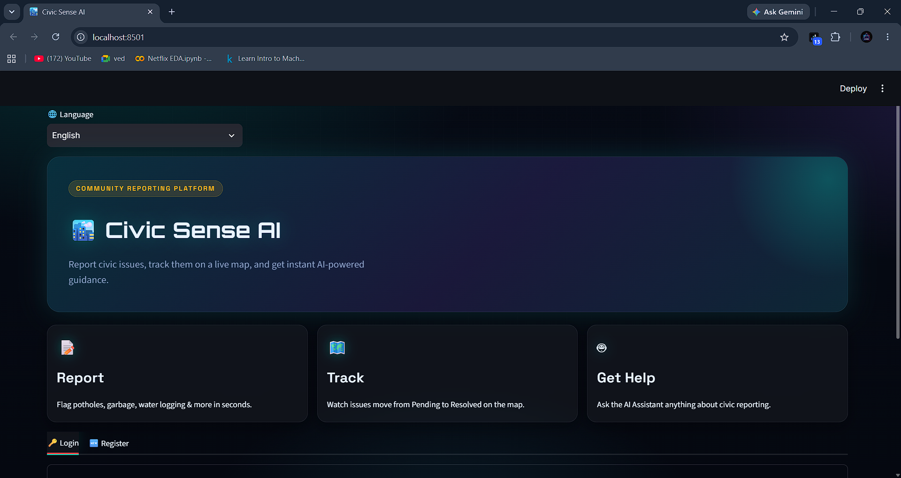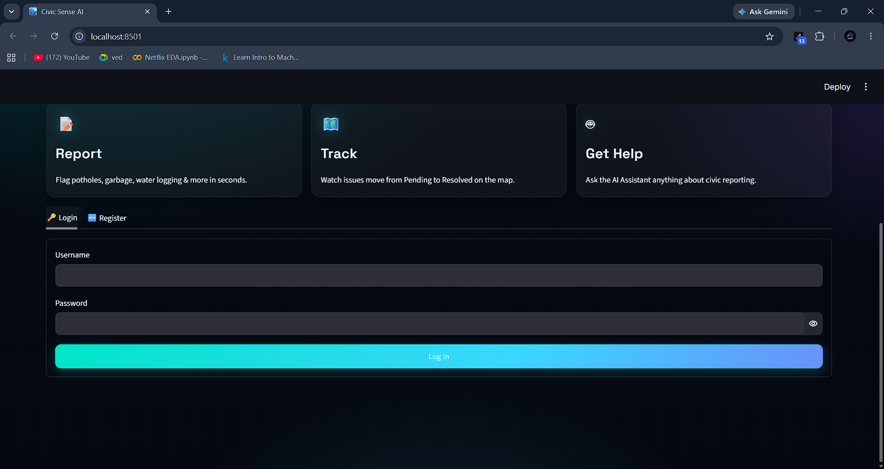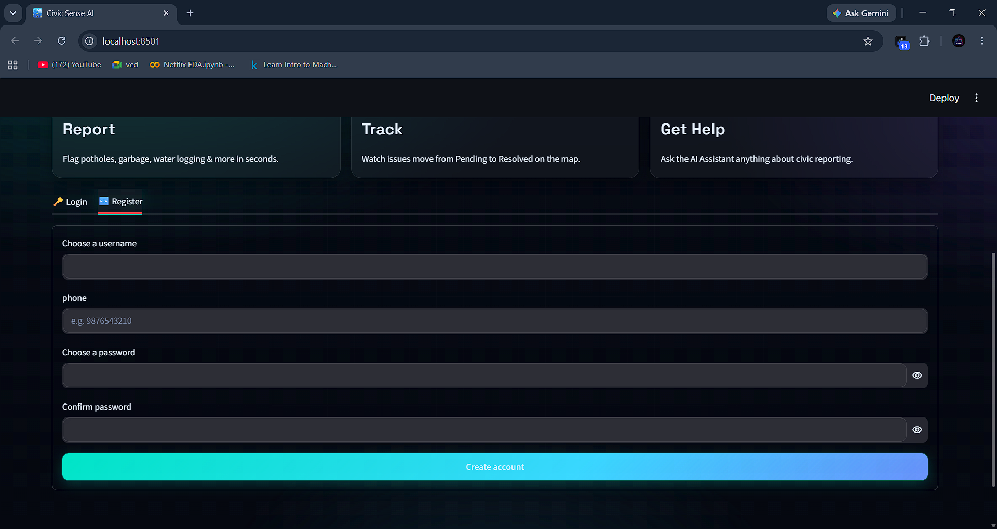

Client Side:
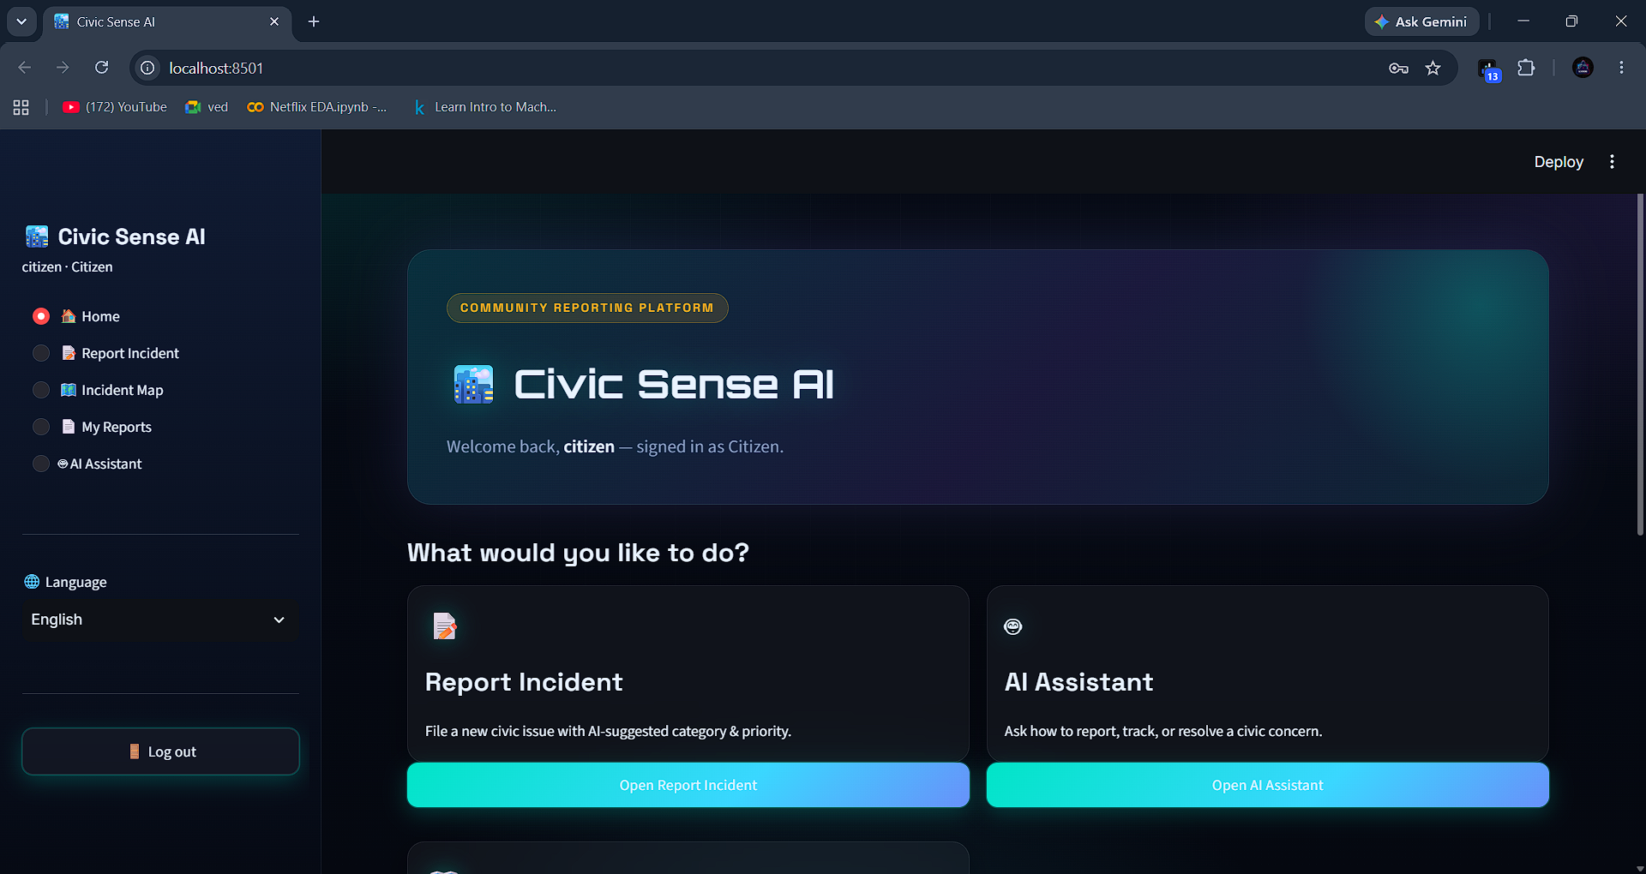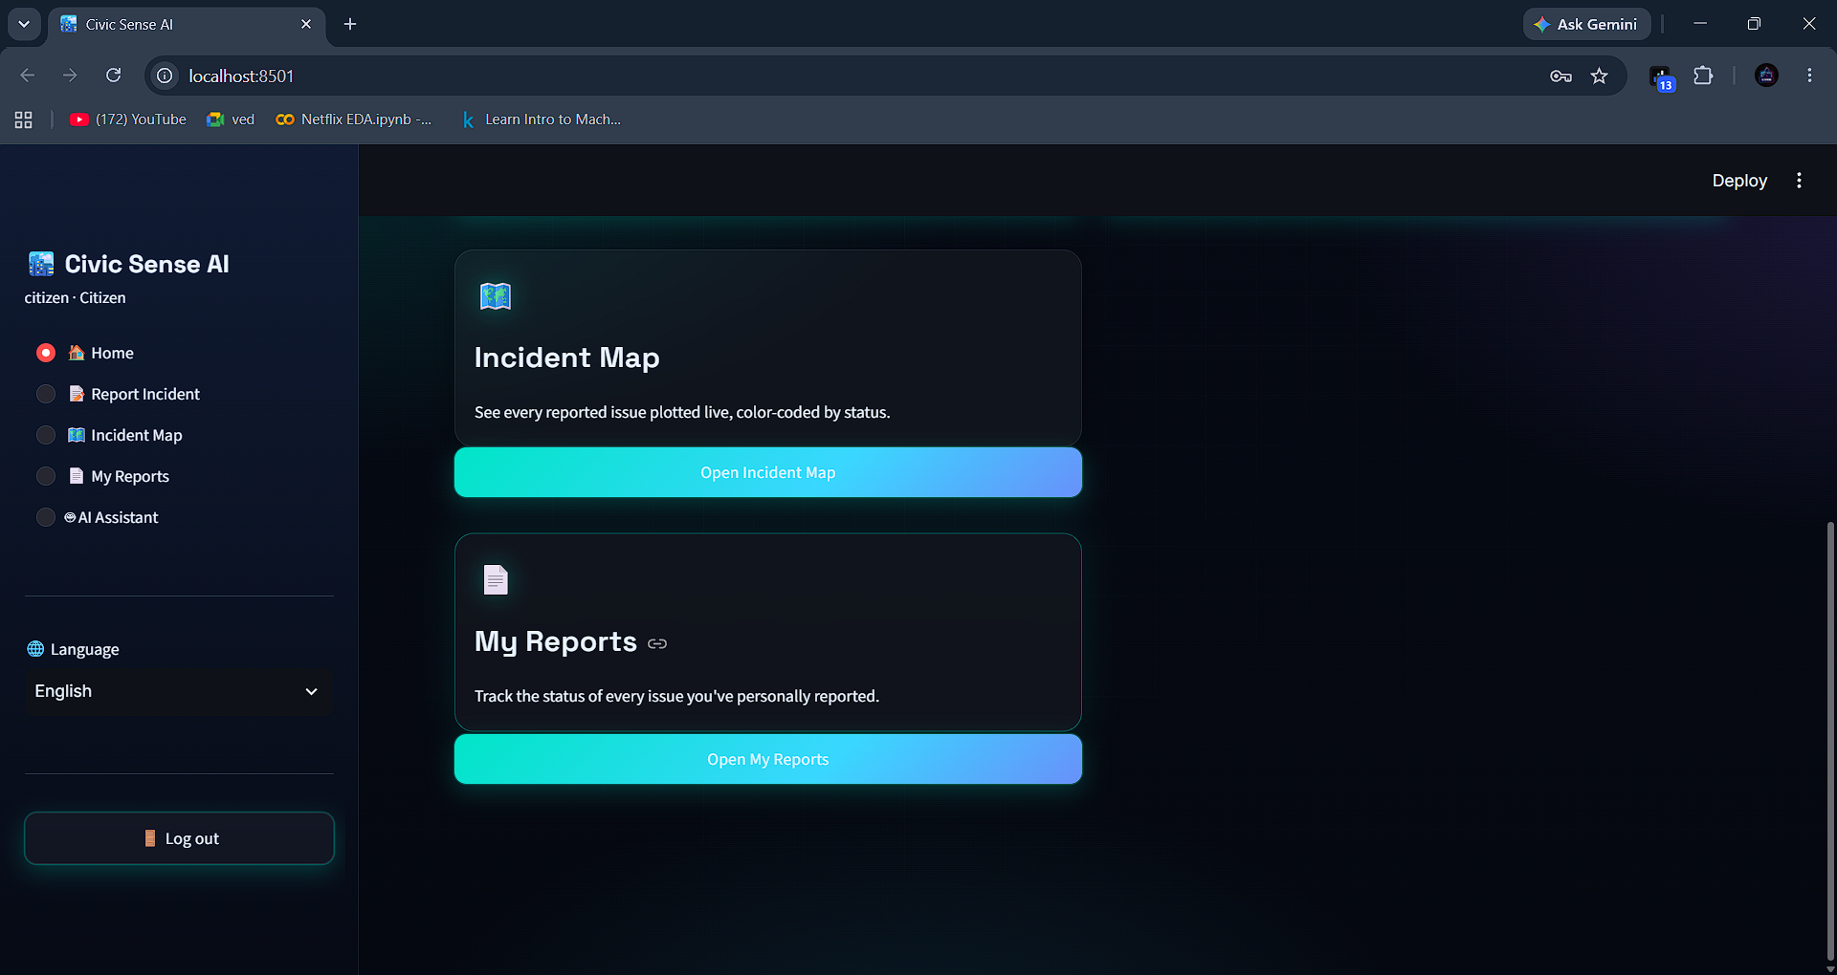
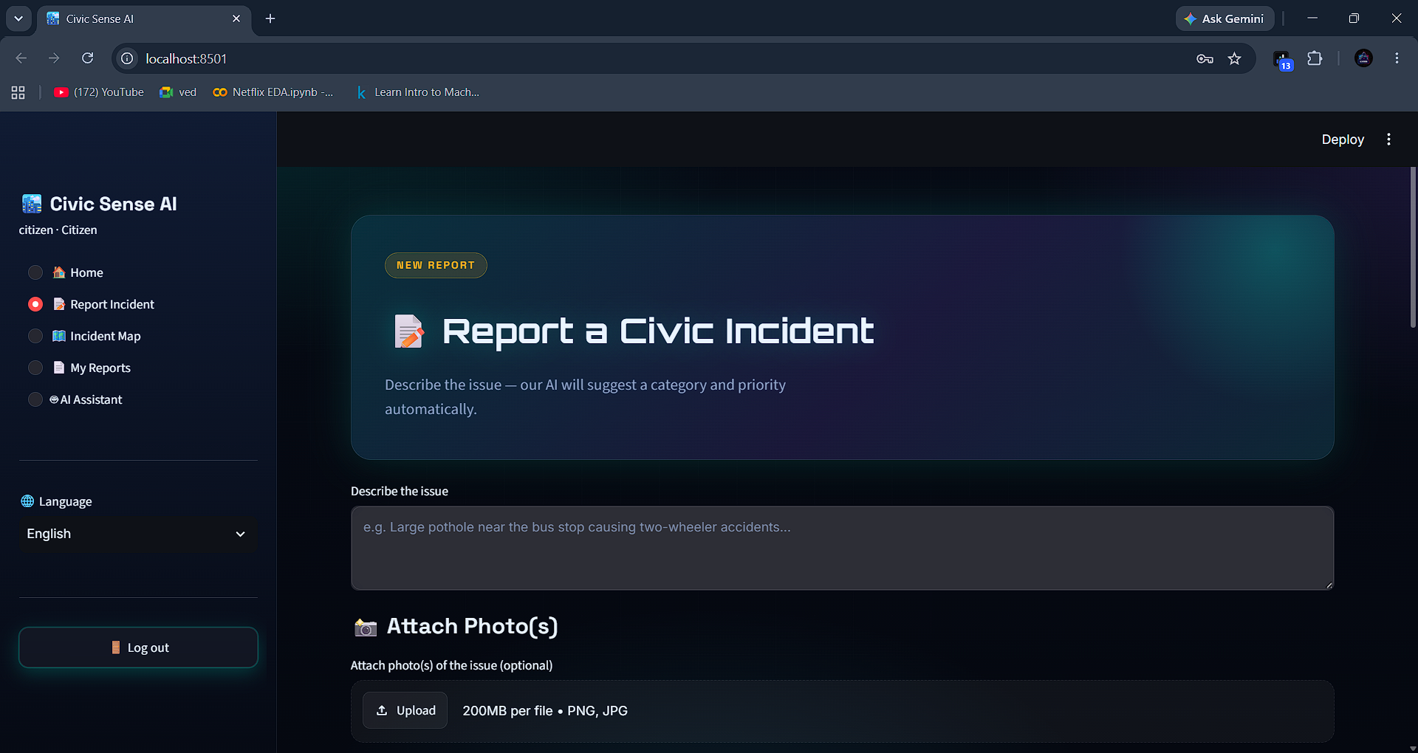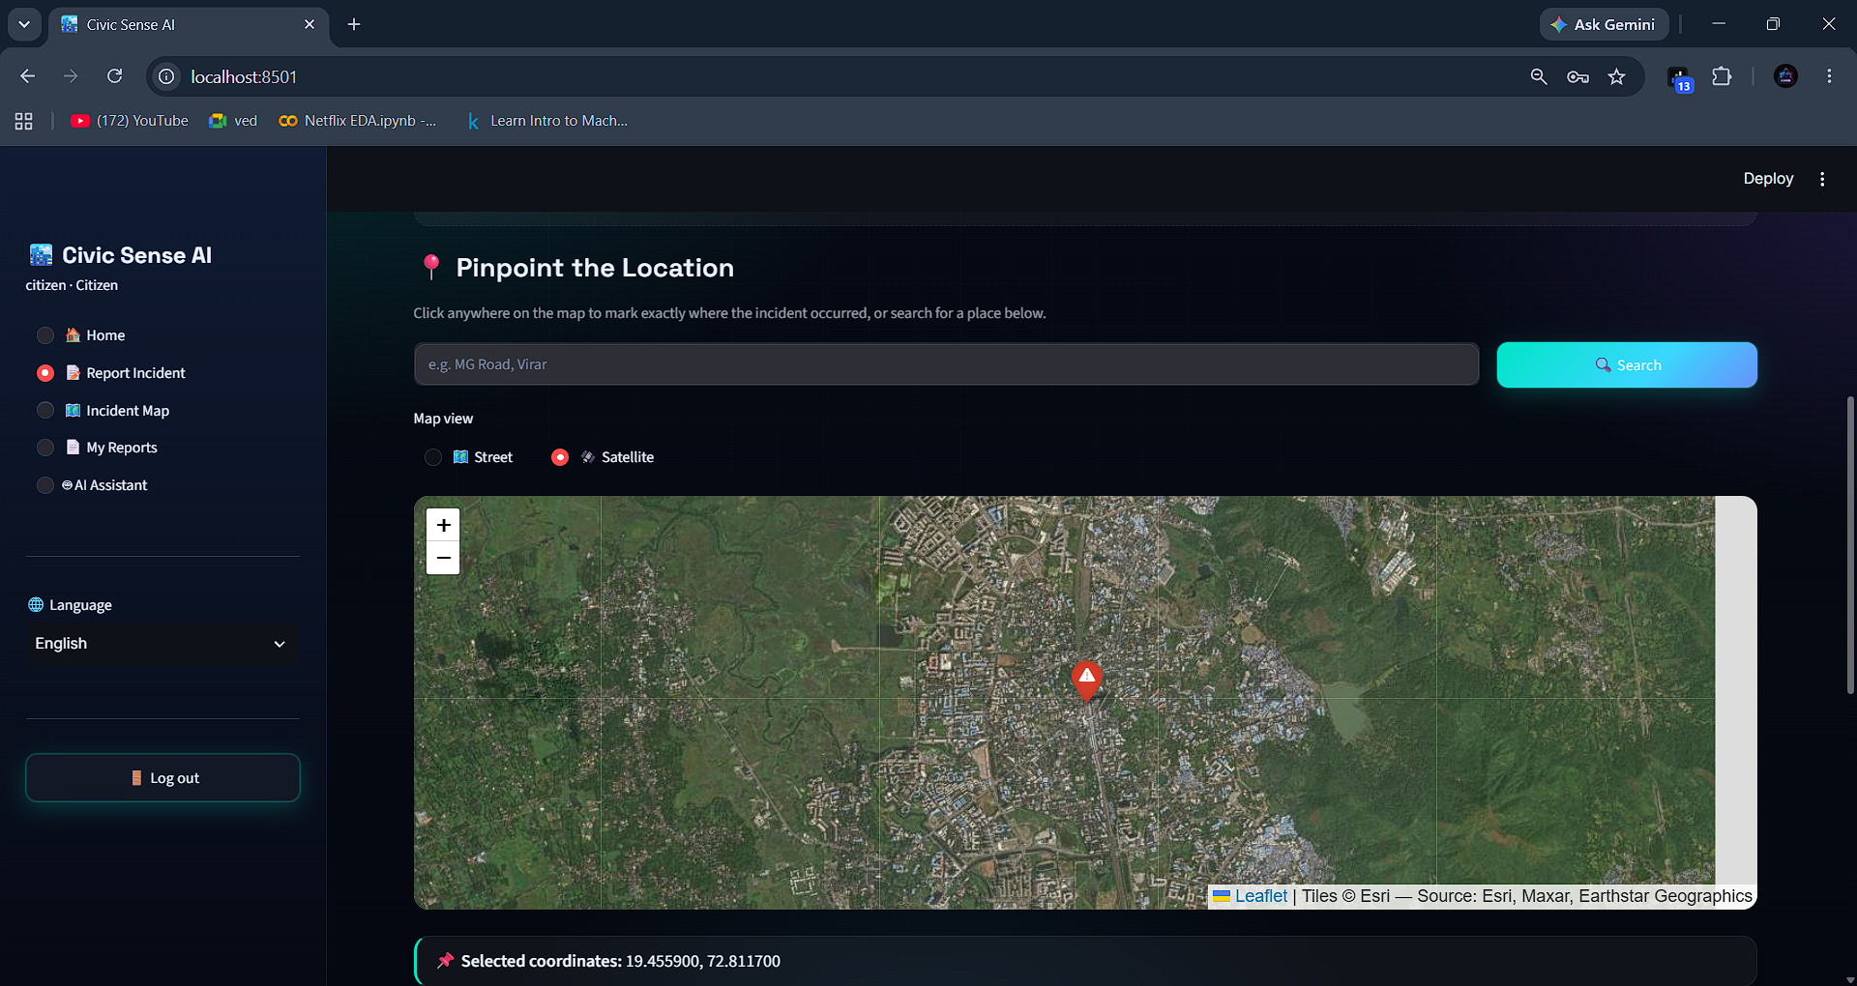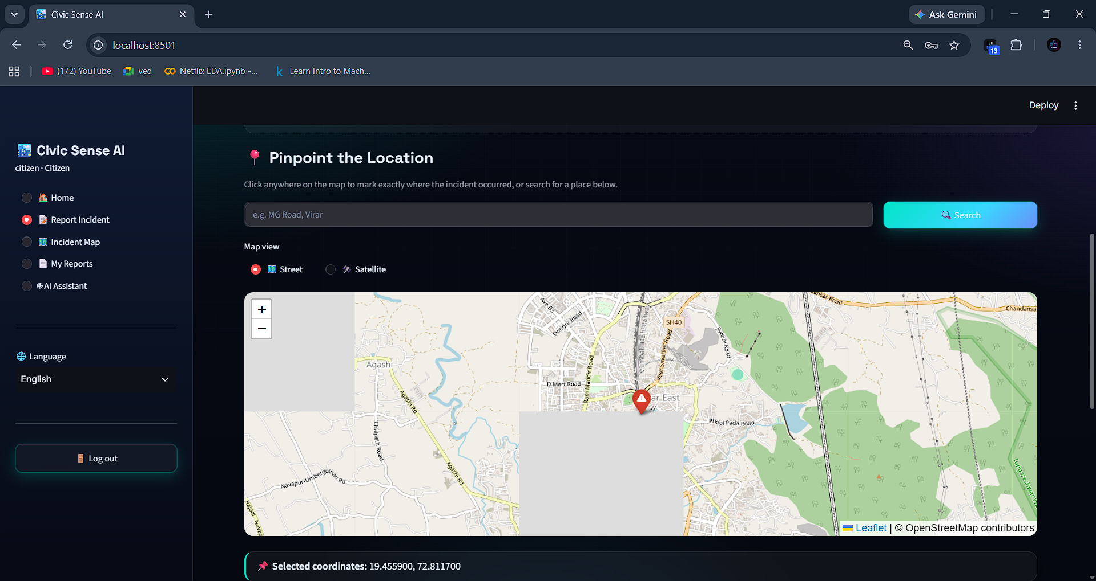
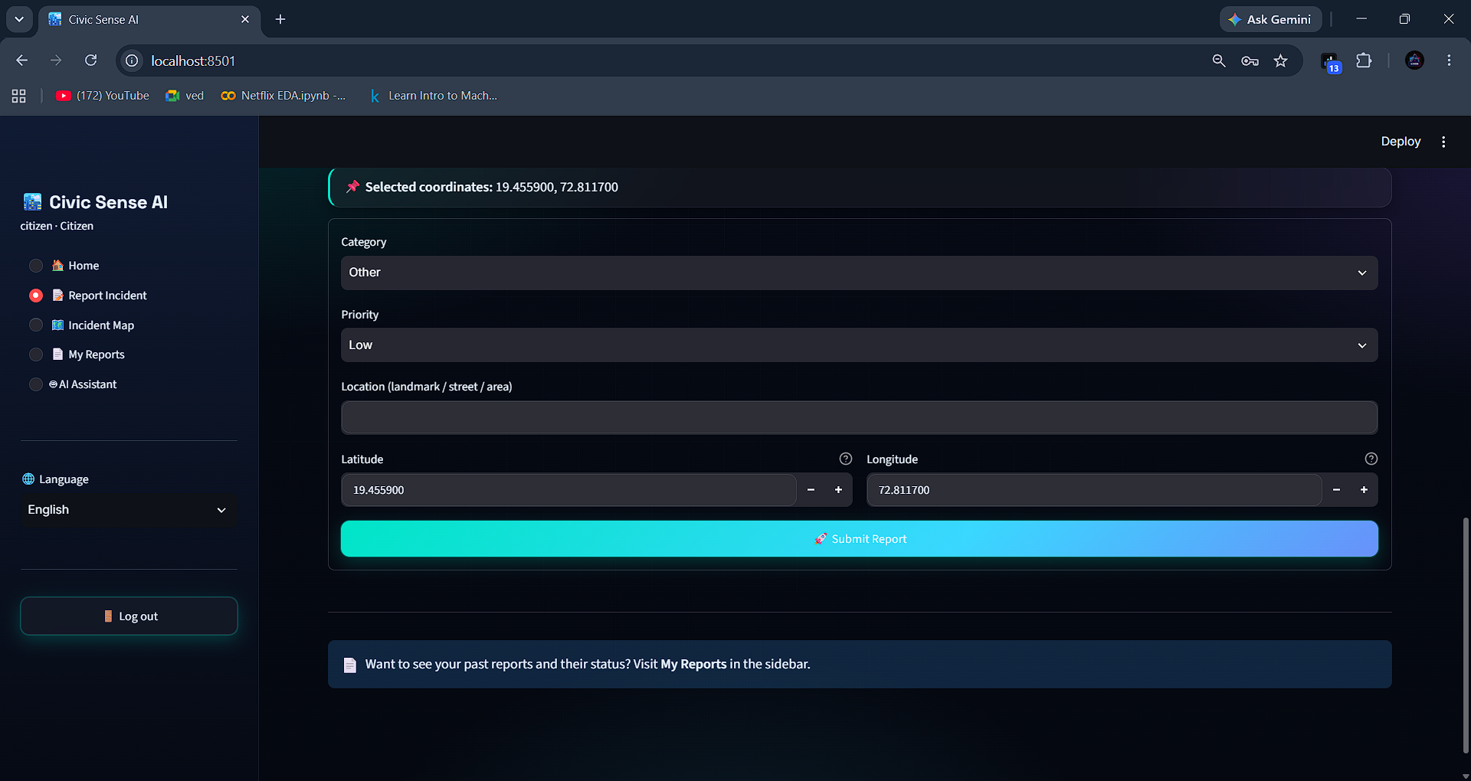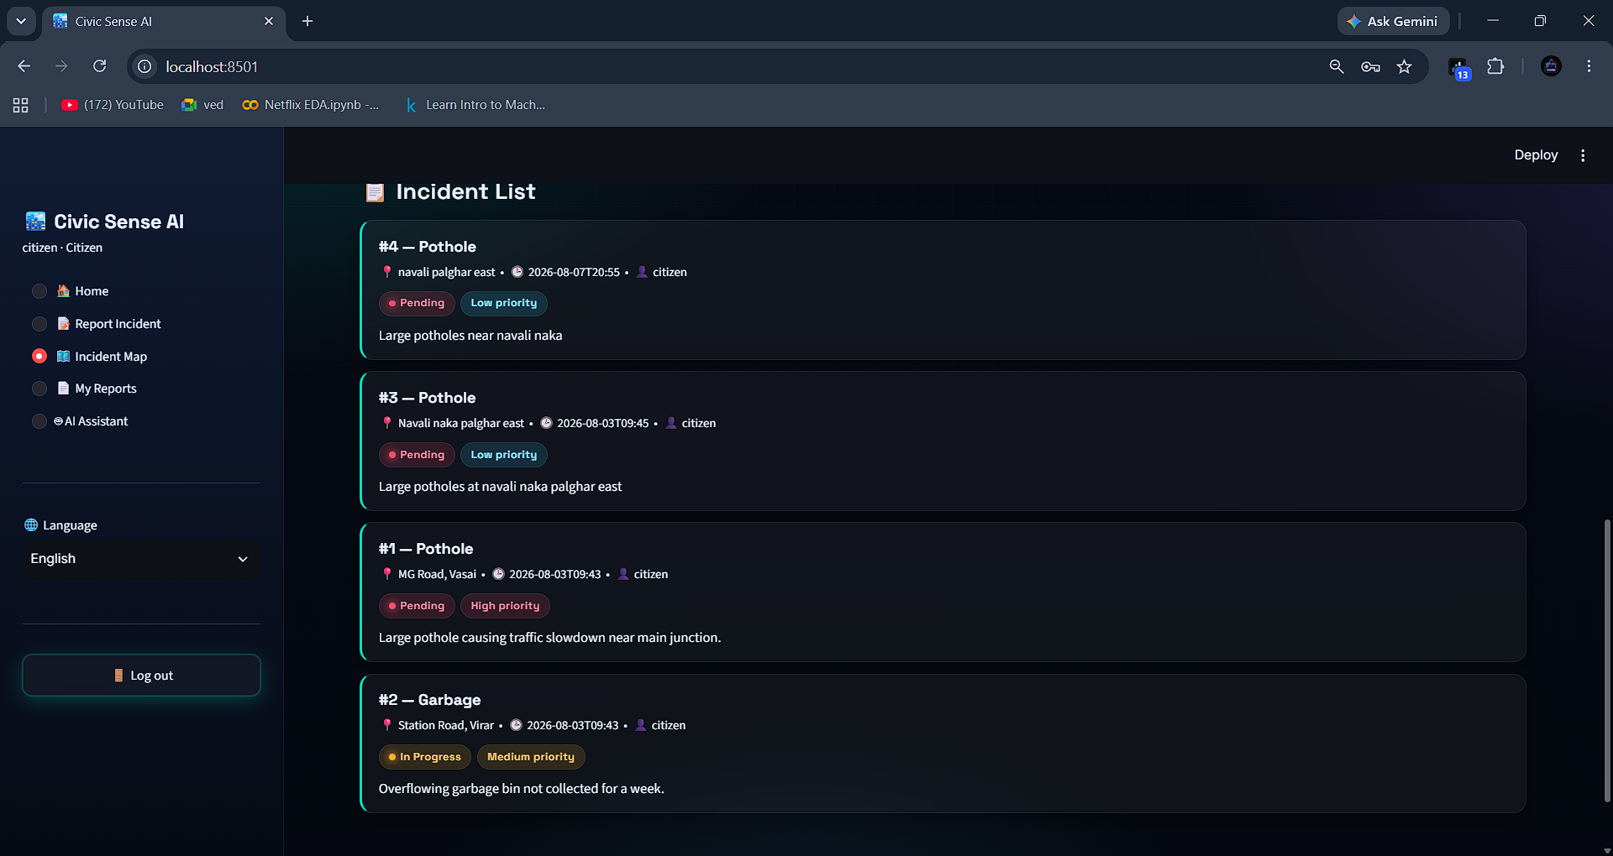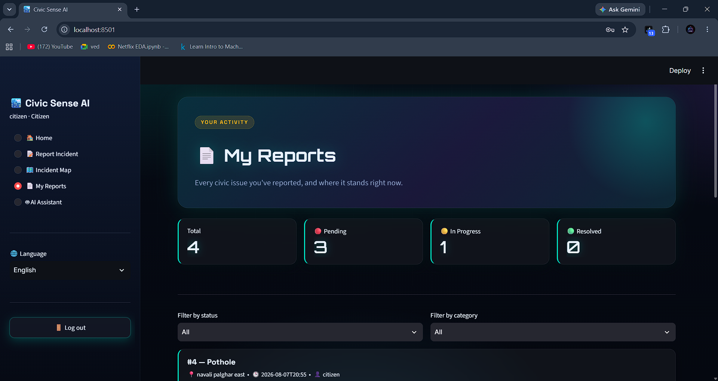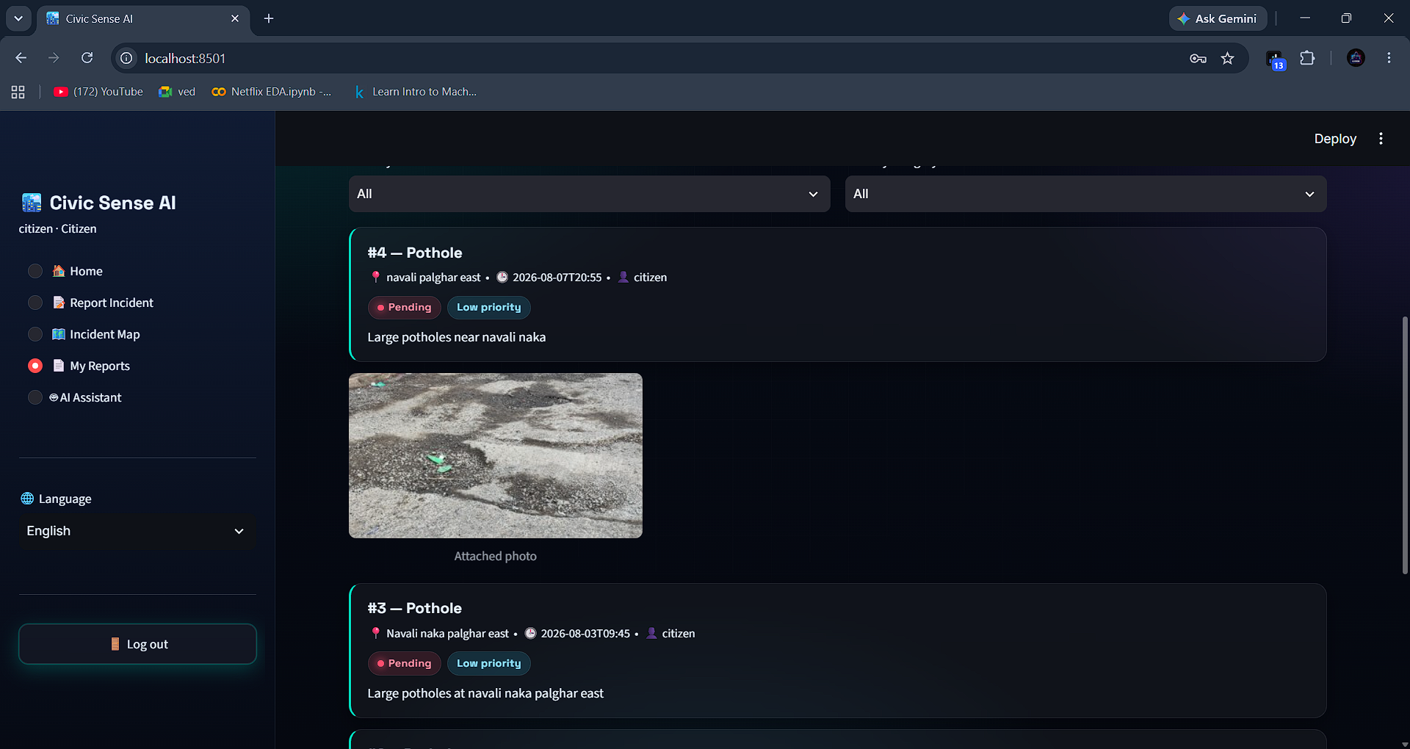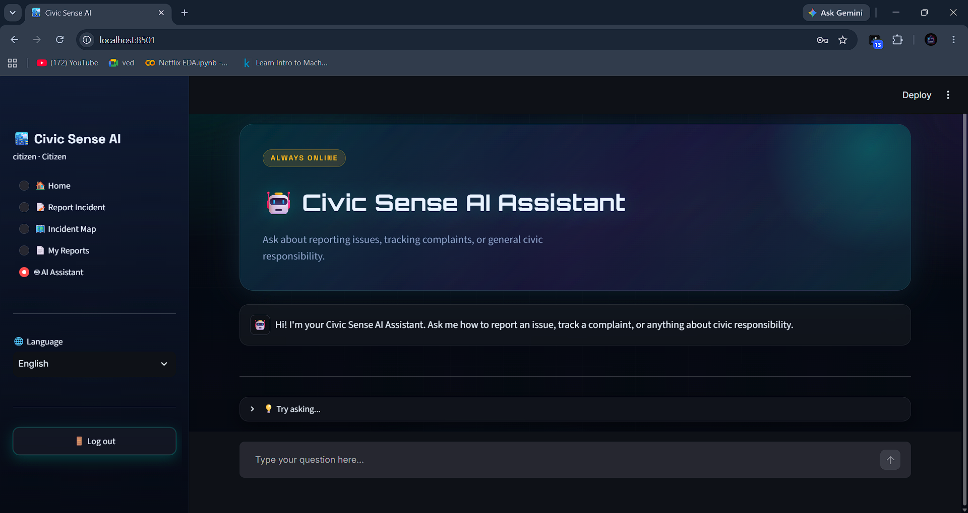

Admin Dashboard: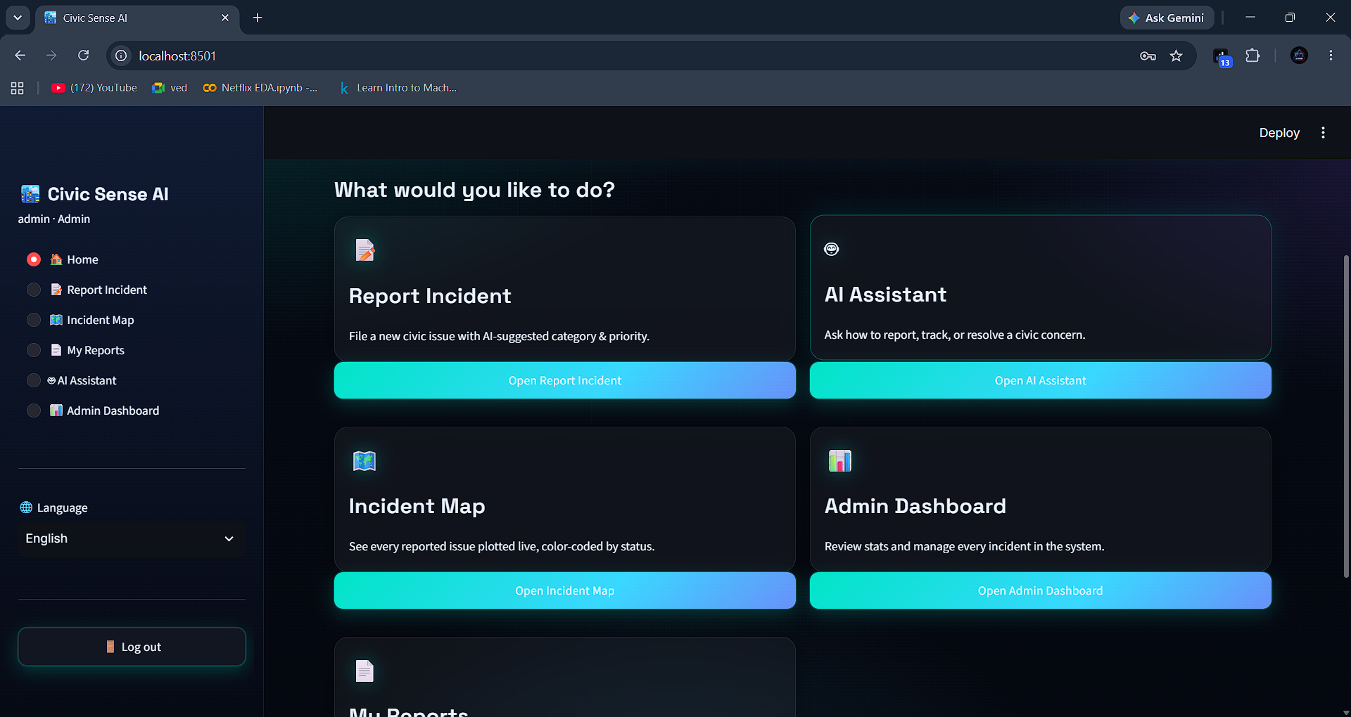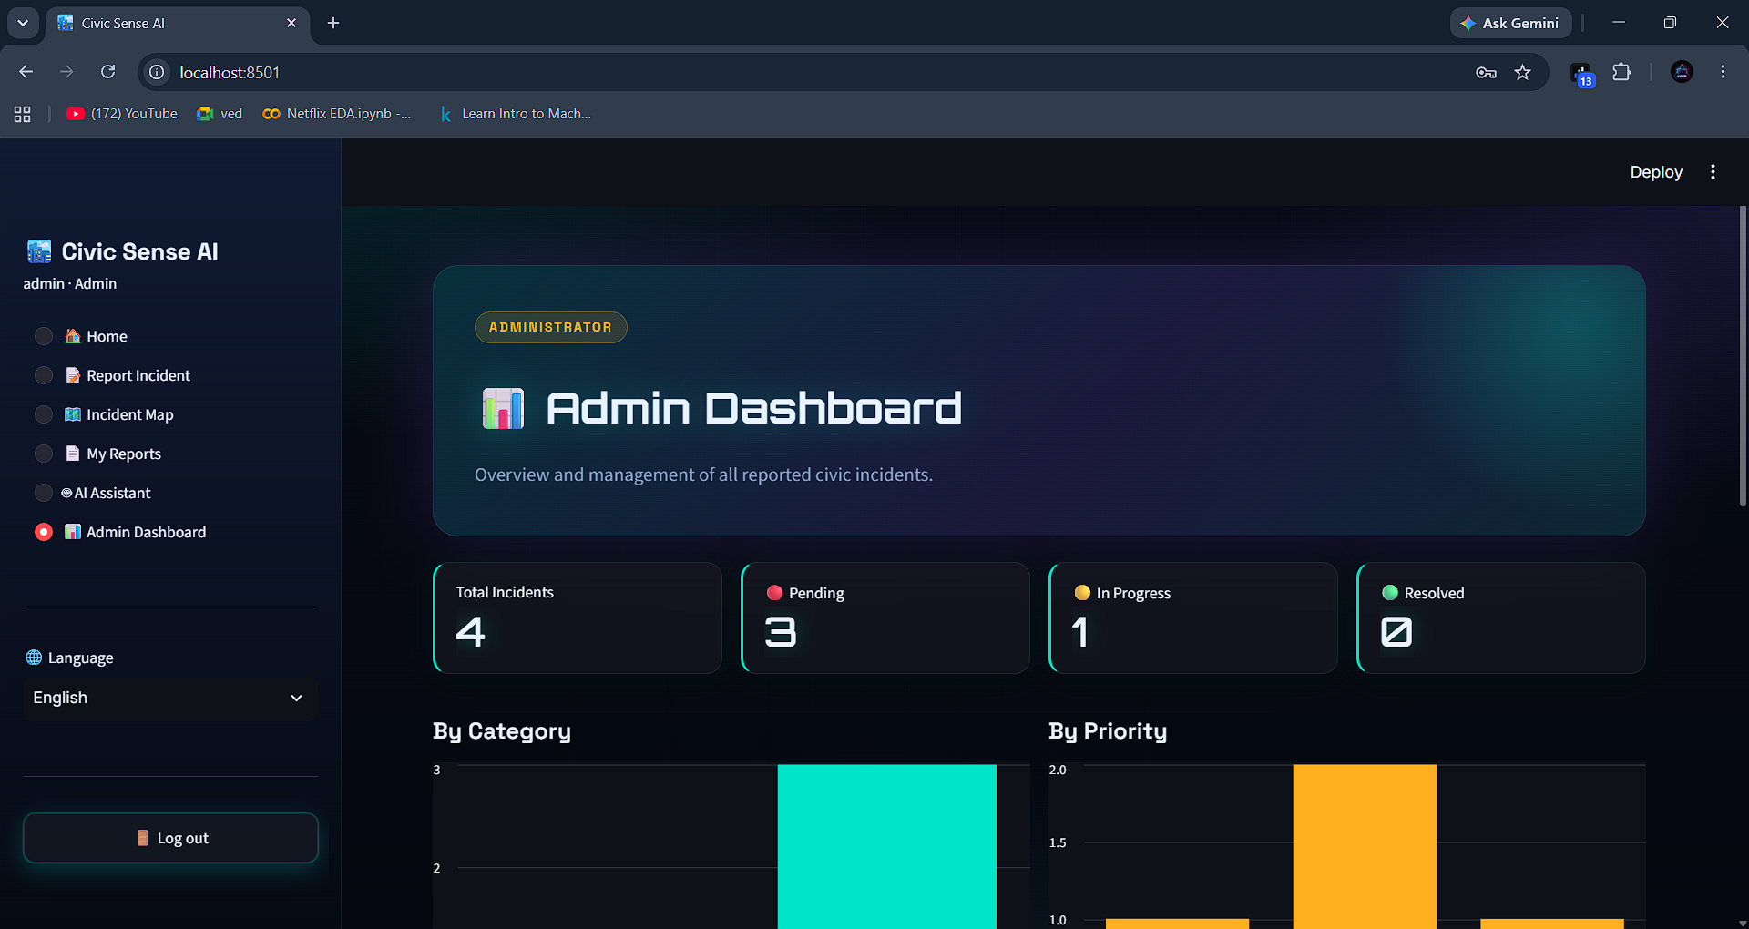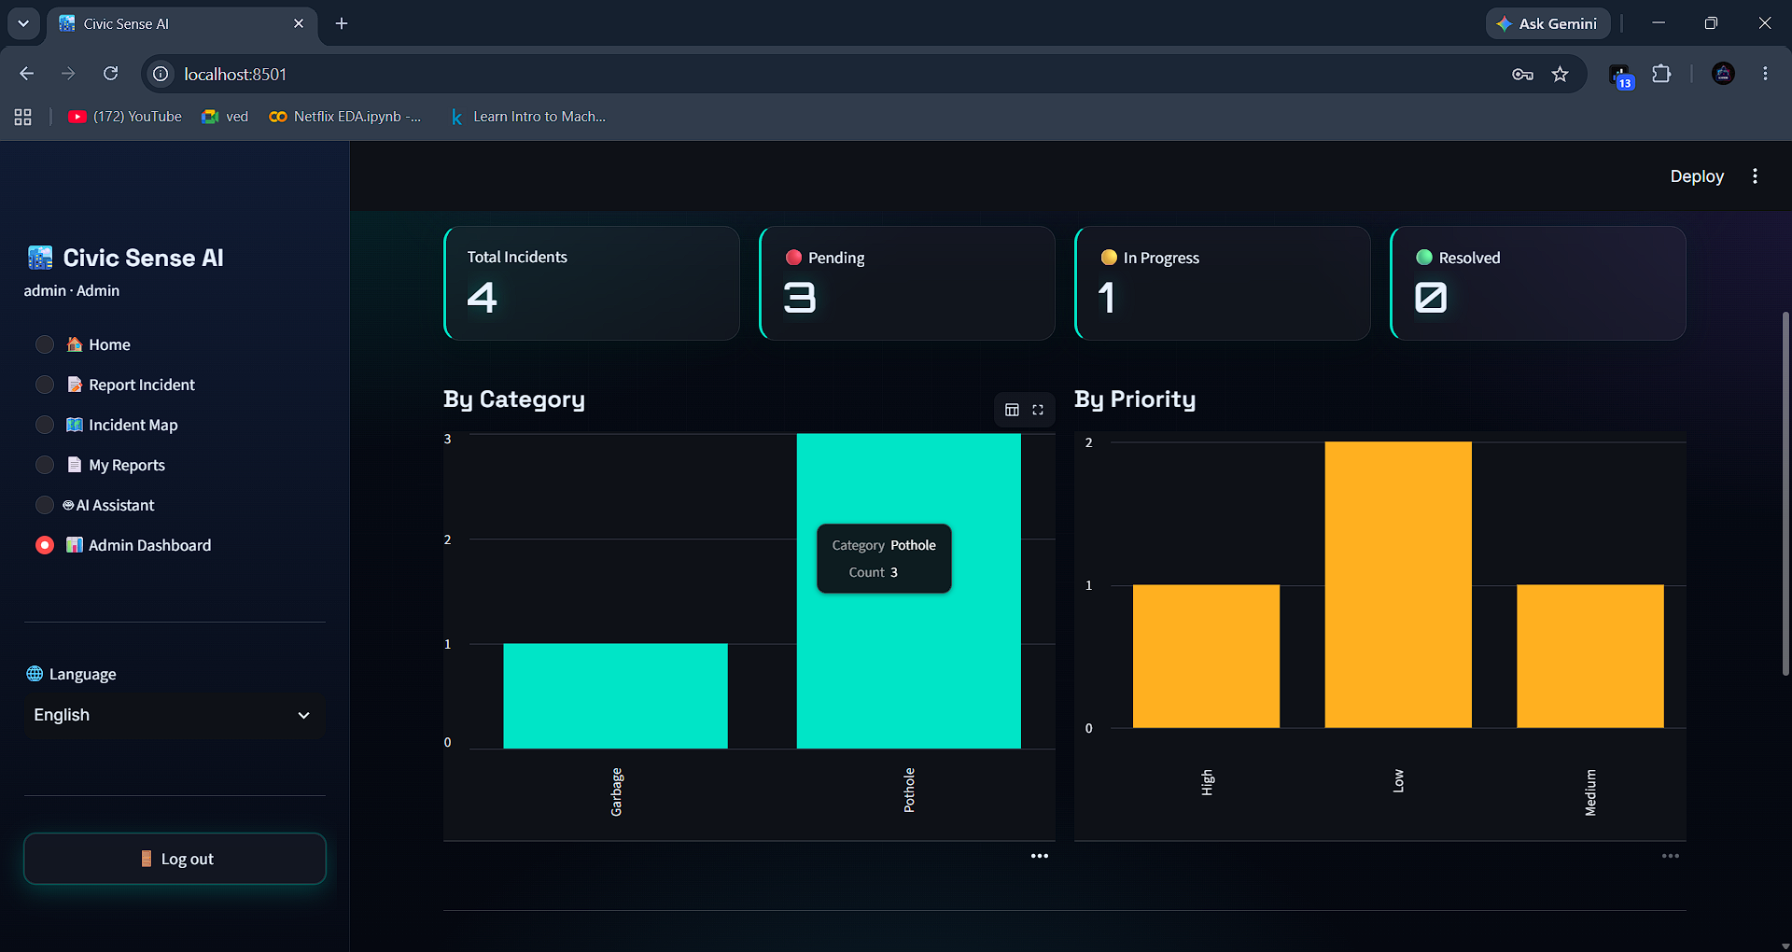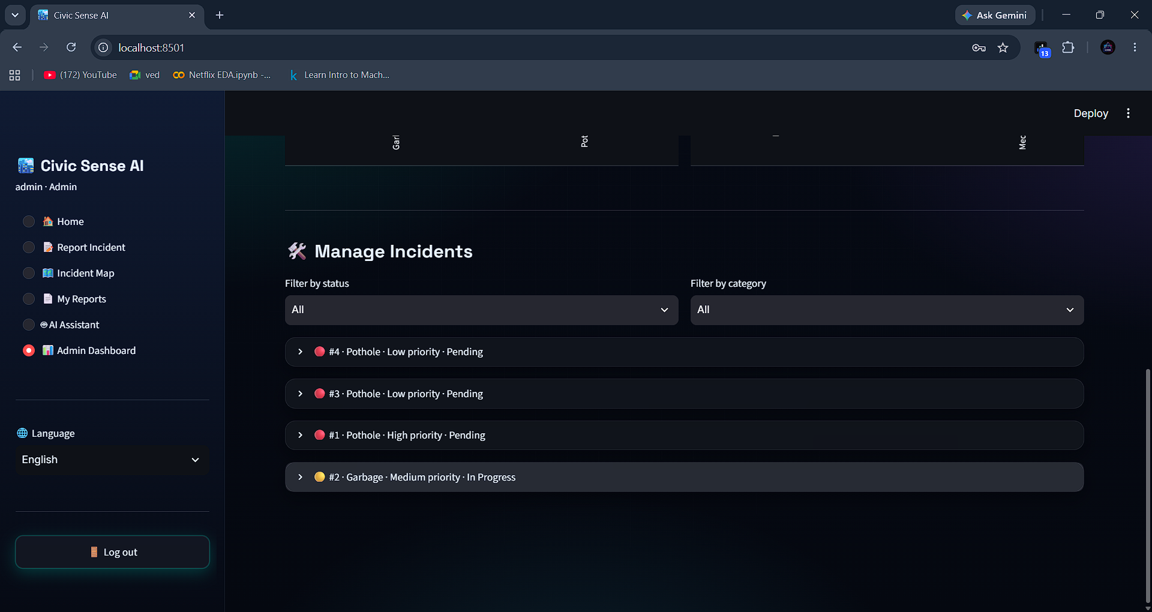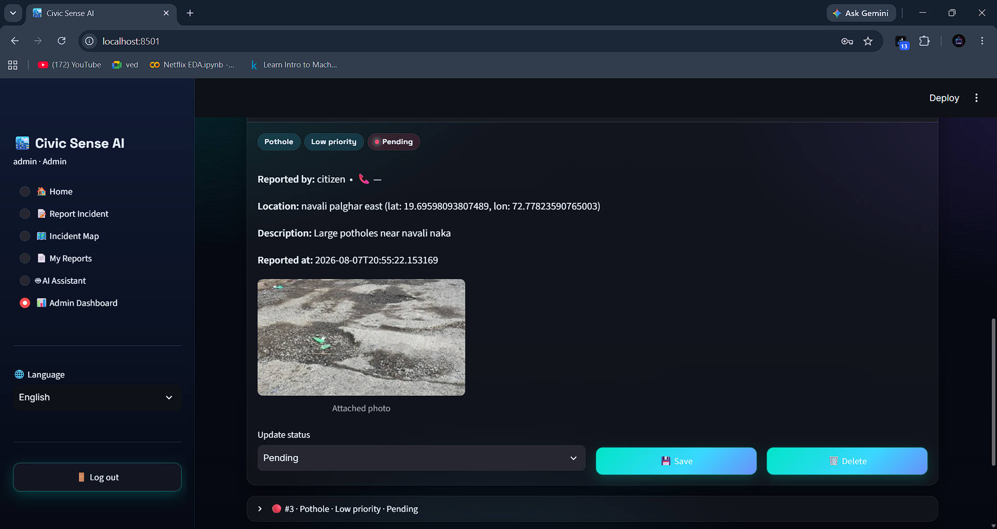

DATABASE Design
Civic Sense AI uses SQLite as its database-management system, chosen for its lightweight, serverless nature, which makes it well suited to a Streamlit application that can be run locally or deployed to the cloud without configuring a separate database server. All database logic is centralised in a single module, database.py, which handles connections, table creation, seeding, and all Create, Read, Update, and Delete (CRUD) operations used by the rest of the application.
Database Connection:
python
"""
database.py
Handles all SQLite persistence for the Civic Sense AI app:
- users (login/roles)
- incidents (citizen-reported civic issues)
"""

import sqlite3
import hashlib
from datetime import datetime
import pandas as pd

DB_PATH = "civic_sense.db"

def get_connection():
conn = sqlite3.connect(DB_PATH, check_same_thread=False)
conn.row_factory = sqlite3.Row
return conn

def hash_password(password: str) -> str:
return hashlib.sha256(password.encode()).hexdigest()
Every function in the module opens its own connection using get_connection() and closes it once the operation is complete, which keeps the SQLite connection lightweight and avoids locking issues in Streamlit's multi-rerun execution model. check_same_thread=False allows the same database file to be safely accessed across Streamlit's internal threads, and row_factory = sqlite3.Row lets query results be accessed like dictionaries (e.g., row["username"]) instead of plain tuples, making the rest of the codebase easier to read.
Passwords are never stored as plain text. The hash_password() function uses SHA-256 hashing so that only a hashed value is ever written to or compared against the database.
Table Structure:
python
def init_db():
conn = get_connection()
cur = conn.cursor()

cur.execute("""
CREATE TABLE IF NOT EXISTS users (
id INTEGER PRIMARY KEY AUTOINCREMENT,
username TEXT UNIQUE NOT NULL,
password TEXT NOT NULL,
email TEXT,
role TEXT NOT NULL DEFAULT 'citizen',
created_at TEXT
)
""")

cur.execute("""
CREATE TABLE IF NOT EXISTS incidents (
id INTEGER PRIMARY KEY AUTOINCREMENT,
user_id INTEGER,
username TEXT,
category TEXT,
description TEXT,
location_text TEXT,
lat REAL,
lon REAL,
priority TEXT,
status TEXT DEFAULT 'Pending',
image_name TEXT,
created_at TEXT,
updated_at TEXT,
FOREIGN KEY (user_id) REFERENCES users (id)
)
""")

conn.commit()
The users table stores each registered account's username, hashed password, email, and role (citizen or admin), along with a creation timestamp. The username column is marked UNIQUE to prevent duplicate accounts.
The incidents table stores every civic issue reported through the app, including its category, free-text description, location (both as a readable string and as latitude/longitude coordinates), AI-suggested priority, current status, and an optional reference to an uploaded image. A FOREIGN KEY constraint links each incident back to the id of the user who submitted it, connecting the two tables.
Both CREATE TABLE statements use IF NOT EXISTS, so init_db() can be safely called every time the application starts without recreating or wiping existing data.
Automatic Seeding:
To ensure the application is usable immediately after setup, init_db() checks whether the users table is empty and, if so, seeds it with a demo administrator account, a demo citizen account, and two sample incident reports:
python
cur.execute("SELECT COUNT(*) as c FROM users")
if cur.fetchone()["c"] == 0:
now = datetime.now().isoformat()
cur.execute(
"INSERT INTO users (username, password, email, role, created_at) VALUES (?, ?, ?, ?, ?)",
("admin", hash_password("admin123"), "admin@civicsense.ai", "admin", now),
)
cur.execute(
"INSERT INTO users (username, password, email, role, created_at) VALUES (?, ?, ?, ?, ?)",
("citizen", hash_password("citizen123"), "citizen@civicsense.ai", "citizen", now),
)
conn.commit()
This means the Incident Map and Admin Dashboard are populated with realistic-looking data the first time the app is run, rather than appearing empty.

Testing and Debugging

Testing and debugging were important stages in the development of the Civic Sense AI application. After completing the frontend, backend, database, and AI integration, every module was tested to ensure that it worked correctly and provided a smooth user experience.

The testing process covered the Login and Registration System, Report Incident, Incident Map, My Reports, AI Assistant, and Admin Dashboard. Navigation links, sidebar menus, buttons, forms, interactive maps, image uploads, AI classification results, and dashboard functions were checked carefully.Form validation was tested by entering both valid and invalid information. Registration, login, and incident-reporting forms were checked for empty fields, incorrect email formats, weak passwords, and duplicate usernames. Input validation was applied in Python to improve data accuracy before information was stored in the database.

Database operations were tested by directly inspecting the SQLite database file. Records were inserted, retrieved, updated, and deleted to verify CRUD functionality. User accounts, incident reports, status updates, and role assignments were checked to ensure that data was stored correctly across the users and incidents tables.

The Login and Registration system was tested using valid and invalid credentials. Streamlit's session state was checked to ensure that unauthorised users could not access protected pages. Role-based access was also tested to confirm that only accounts with the "admin" role could view and use the Admin Dashboard, while citizen accounts remained restricted to the standard reporting features.

The AI features were tested extensively, since they form the core value of the application. The category-and-priority classification was tested with a range of sample incident descriptions to check that reasonable suggestions were generated. The photo safety analysis feature was tested by uploading sample images and confirming that appropriate precautions and helpline information were returned. Both AI features were also tested with the Anthropic API key removed, to confirm that the application correctly fell back to rule-based logic without crashing or losing functionality.

The Incident Map module was tested by verifying that markers appeared at the correct coordinates, that colour-coding matched each incident's status, and that filtering by category and status worked as expected.Responsive testing was performed by resizing the browser window and viewing the app on different screen sizes, since Streamlit automatically adapts its layout. The custom "Neon Grid" CSS theme was checked across these sizes to ensure spacing, card alignment, and readability remained consistent.

Browser Developer Tools were used to inspect the rendered HTML and CSS of the custom theme, identify any client-side errors, and check that network requests to the Claude API completed correctly. Problems such as missing images, incorrect file paths, database-locking errors, session-state inconsistencies, and layout spacing issues were identified and resolved during debugging.After completing the testing and debugging process, the application became more stable, responsive, secure, and user-friendly. This process improved the overall quality and reliability of the Civic Sense AI platform.

Future Scope

Civic Sense AI can be further improved by adding advanced technologies and real-time civic services. These improvements can make the platform more useful, secure, and accessible to citizens, administrators, and municipal authorities.

Integration with actual municipal or government complaint-management systems can be added, allowing reports submitted through Civic Sense AI to be automatically forwarded to the relevant civic department, rather than being managed solely within the app's own Admin Dashboard.

Real-time status notifications can be introduced, so citizens receive push notifications, SMS alerts, or email updates whenever the status of their reported incident changes from Pending to In Progress or Resolved. This would keep citizens informed without needing to manually check the My Reports section.

An upvoting or duplicate-detection system can be added, allowing multiple citizens reporting the same issue in the same location to be automatically grouped together, helping administrators prioritise widely affected problems.

The AI classification system can be enhanced using a fine-tuned or specialised model trained specifically on civic-issue data, improving the accuracy of category and priority suggestions beyond what a general-purpose model can offer. Similarly, the photo safety analysis feature could be extended to detect the severity of visual damage (e.g., pothole depth, garbage volume) directly from the image.Geofencing and ward-based routing can be implemented, so incidents are automatically assigned to the administrator or department responsible for that specific area, based on the reported location's coordinates.

A dedicated mobile application for Android and iOS can be developed, giving citizens a faster, camera-integrated way to report issues directly from the field, with offline queuing for areas with poor network connectivity.The Admin Dashboard can be expanded with advanced analytics, such as resolution-time tracking, department-wise performance metrics, and heatmaps of recurring issue hotspots, to help civic bodies plan long-term infrastructure improvements.

Additional security features such as OTP-based verification, two-factor authentication for admin accounts, encrypted storage of uploaded images, rate-limiting on report submissions, and automatic database backups can be implemented to improve the platform's robustness at scale.

Migrating from SQLite to a more scalable database such as PostgreSQL or MySQL can be considered if the platform is deployed for a larger city or region, along with cloud-based hosting to support a higher number of concurrent users.

With these future improvements, Civic Sense AI can become a comprehensive civic-engagement ecosystem that supports citizens and municipal authorities throughout the entire lifecycle of issue reporting, tracking, and resolution.

Conclusion

The Civic Sense AI project was successfully developed as a responsive, AI-integrated, database-driven civic-issue reporting platform. The main objective of this project was to provide citizens with a simple way to report civic issues, receive AI-assisted guidance, and track the resolution of their complaints, while giving administrators a centralised system to manage and act on those reports.
The project includes several important modules, such as the Login and Registration System, Report Incident, Incident Map, My Reports, AI Assistant, and Admin Dashboard. Each module was developed according to the requirements of citizens and administrators. The Admin Dashboard provides centralised control over all reported incidents, including status updates and report deletion, along with a visual overview of issue trends by category and priority.
The Civic Sense AI application was developed using Python and the Streamlit framework, with SQLite used to store and manage application data. Streamlit was used to build the entire user interface, including a custom "Neon Grid" theme, without requiring separate frontend technologies. Folium was used to power the interactive incident map, while the Anthropic Claude API was integrated to provide AI-based classification of incident reports, AI-based photo safety analysis, and a conversational AI Assistant — all of which gracefully fall back to rule-based logic when no API key is configured.
Civic Sense AI also supports multiple language options, making the platform easier to use for citizens from different linguistic backgrounds. The application was tested across its core workflows, including login, registration, incident reporting, AI classification, map display, and admin operations, to ensure reliable and consistent behaviour.
During the development of this project, I faced several challenges related to database connectivity, session-state management, integrating the Claude API for both text and image analysis, designing a consistent custom theme within Streamlit's component model, and handling the AI fallback logic reliably. Solving these problems improved my logical thinking, debugging ability, and problem-solving skills.
This project provided me with valuable practical experience in full-stack, AI-integrated application development. It improved my knowledge of Python programming, database management, AI API integration, interactive map implementation, and responsive interface design. It also helped me develop communication, creativity, adaptability, confidence, and time-management skills.
Overall, Civic Sense AI demonstrates how digital technology and artificial intelligence can be combined to make civic governance more accessible, transparent, and responsive. The project successfully combines issue reporting, AI-assisted analysis, safety guidance, live incident tracking, and administrative management into one platform. In the future, the project can be improved by adding real-time notifications, municipal system integration, mobile application support, advanced analytics, and stronger security features.

Certificate

