**Industrial Internship Report on**

**”File Organizer”**

**Prepared by**

**Swastik Suryaji Patil**

|  |
| --- |
| *Executive Summary* |
| This report provides details of the Industrial Internship provided by upskill Campus and The IoT Academy in collaboration with Industrial Partner UniConverge Technologies Pvt Ltd (UCT).  This internship was focused on a project/problem statement provided by UCT. We had to finish the project including the report in 6 weeks’ time i.e. June 1st to July 14th .  My project was “ File Organizer “. It is an automated file organization application. This application aims to simplify the process of categorizing, renaming, and moving files based on their types into designated folders.  This internship gave me a very good opportunity to get exposure to Industrial problems and design/implement solution for that. It was an overall great experience to have this internship. |

**TABLE OF CONTENTS**

1 Preface 3

2 Introduction 4

2.1 About UniConverge Technologies Pvt Ltd 4

2.2 About upskill Campus 9

2.3 Objective 10

3 Problem Statement 11

4 Existing and Proposed solution 12

5 Proposed Design/ Model 14

5.1 High Level Diagram 15

5.2 Low Level Diagram 15

6 Performance Test 16

6.1 Test Plan/ Test Cases 18

6.2 Test Procedure 19

6.3 Performance Outcome 20

7 Result and Analysis 21

8 Conclusion 24

9 My learnings 25

10 Future work scope 26

# Preface

In today's digital age, individuals and organizations deal with an ever-increasing volume of files and documents. Efficiently managing and organizing these files is crucial for maintaining productivity and ensuring easy access to valuable information. However, manual file organization processes often prove to be time-consuming, error-prone, and challenging to maintain consistency.

The File Organizer project addresses these challenges by proposing the development of an automated file organization application. This application aims to simplify the process of categorizing, and moving files based on their types into designated folders. By leveraging the power of technology, the File Organizer application will streamline file management, enhance accessibility, and save users valuable time and effort.

This project preface sets the stage for understanding the goals and objectives of the File Organizer application. It outlines the problem statement, highlights the limitations of existing manual approaches to file organization, and introduces the proposed solution. By automating the file organization process and providing a user-friendly interface, the File Organizer application aims to revolutionize how users manage their files, promoting efficiency, consistency, and enhanced productivity.

Throughout this project, we will explore the development of the File Organizer application, from the initial problem analysis to the implementation of a production-ready solution. We will examine the functionalities, design considerations, and the incorporation of user feedback to ensure the application meets the needs of its users.

# Introduction

## About UniConverge Technologies Pvt Ltd

A company established in 2013 and working in Digital Transformation domain and providing Industrial solutions with prime focus on sustainability and RoI.

For developing its products and solutions it is leveraging various**Cutting Edge Technologies e.g. Internet of Things (IoT), Cyber Security, Cloud computing (AWS, Azure), Machine Learning, Communication Technologies (4G/5G/LoRaWAN), Java Full Stack, Python, Front end**etc.



1. UCT IoT Platform **(****)**

**UCT Insight** is an IOT platform designed for quick deployment of IOT applications on the same time providing valuable “insight” for your process/business. It has been built in Java for backend and ReactJS for Front end. It has support for MySQL and various NoSql Databases.

* It enables device connectivity via industry standard IoT protocols - MQTT, CoAP, HTTP, Modbus TCP, OPC UA
* It supports both cloud and on-premises deployments.

It has features to  
• Build Your own dashboard  
• Analytics and Reporting  
• Alert and Notification  
• Integration with third party application(Power BI, SAP, ERP)  
• Rule Engine.

. 

1. **Smart Factory Platform (****)**

Factory watch is a platform for smart factory needs.

It provides Users/ Factory

* with a scalable solution for their Production and asset monitoring
* OEE and predictive maintenance solution scaling up to digital twin for your assets.
* to unleased the true potential of the data that their machines are generating and helps to identify the KPIs and also improve them.
* A modular architecture that allows users to choose the service that they what to start and then can scale to more complex solutions as per their demands.

Its unique SaaS model helps users to save time, cost and money.

 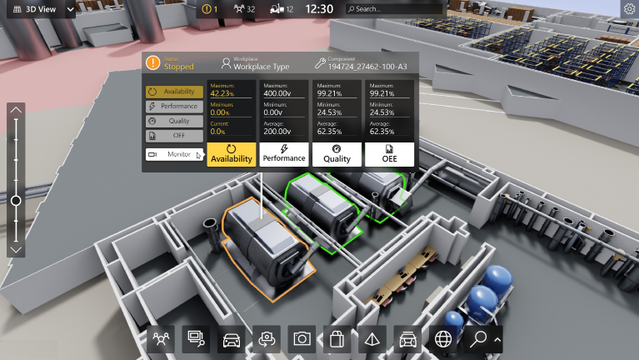

1. 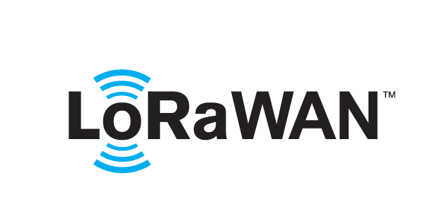 based Solution

UCT is one of the early adopters of LoRAWAN teschnology and providing solution in Agritech, Smart cities, Industrial Monitoring, Smart Street Light, Smart Water/ Gas/ Electricity metering solutions etc.

1. Predictive Maintenance

UCT is providing Industrial Machine health monitoring and Predictive maintenance solution leveraging Embedded system, Industrial IoT and Machine Learning Technologies by finding Remaining useful life time of various Machines used in production process.



## About upskill Campus (USC)

upskill Campus along with The IoT Academy and in association with Uniconverge technologies has facilitated the smooth execution of the complete internship process.

USC is a career development platform that delivers **personalized executive coaching** in a more affordable, scalable and measurable way.



Seeing need of upskilling in self paced manner along-with additional support services e.g. Internship, projects, interaction with Industry experts, Career growth Services

upSkill Campus aiming to upskill 1 million learners in next 5 year

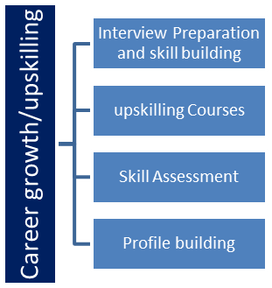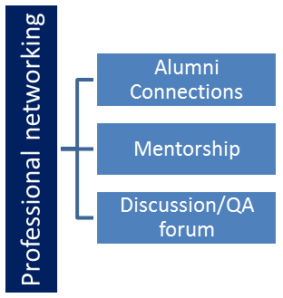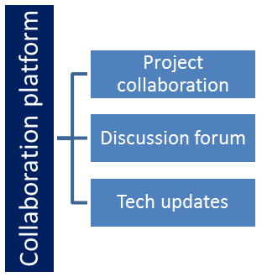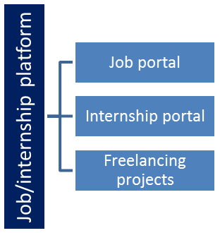

## The IoT Academy

The IoT academy is EdTech Division of UCT that is running long executive certification programs in collaboration with EICT Academy, IITK, IITR and IITG in multiple domains.

## Objectives of this Internship program

The objective for this internship program was to

 ☛ get practical experience of working in the industry.

 ☛ to solve real world problems.

 ☛ to have improved job prospects.

 ☛ to have Improved understanding of our field and its applications.

 ☛ to have Personal growth like better communication and problem solving.

# Problem Statement

Inefficient file organization can lead to cluttered directories and difficulty in locating and managing files. The lack of a systematic approach to file organization can hamper productivity and waste valuable time. The problem at hand is to develop a File Organizer application that automates the process of categorizing, renaming, and moving files based on their types into designated folders. The goal is to provide a user-friendly solution that enhances file organization, improves accessibility, and saves time for users dealing with large volumes of files across various file types. The application should simplify the file management process, allowing users to effortlessly organize their files and maintain a structured and well-organized file system.

# Existing and Proposed solution

Currently, users manually organize their files by creating folders and moving files to appropriate locations based on their types. However, this manual approach is time-consuming and prone to human error. Users often struggle to keep track of file locations and maintain consistent naming conventions, leading to disorganized directories and difficulties in locating specific files.

The proposed solution is to develop a File Organizer application that automates the file organization process. The application will provide a user-friendly interface where users can select a source directory containing their files. The application will then scan the directory, categorize the files based on their types (such as documents, images, videos, etc.), rename them consistently for improved readability, and move them to designated folders based on their categories.

The value addition that we plan to incorporate in the proposed File Organizer application includes the following:

1. Automation: The application will automate the file organization process, eliminating the need for manual intervention. This automation will save users considerable time and effort that would otherwise be spent on manually categorizing, renaming, and moving files.
2. Efficiency: By automatically categorizing files based on their types and moving them to designated folders, the application will ensure a more efficient file organization process. Users will no longer have to spend time searching for files or creating folders manually, as the application will handle these tasks seamlessly.
3. Consistency: The application will enforce consistent naming conventions for files, ensuring that they are named in a standardized format. This consistency will enhance file readability and make it easier for users to identify and locate specific files.
4. User-Friendly Interface: The application will have a user-friendly interface, making it easy for users to interact with and navigate through the file organization process. Intuitive controls, progress indicators, and error handling mechanisms will enhance the user experience and simplify the overall file management workflow.

## Code submission (Github link) :

<https://github.com/Swastik-Patil/FileOrganizer>

## Report submission (Github link) :

# Proposed Design/ Model

**User Interface (UI):**

The UI will provide an intuitive and user-friendly interface for users to interact with the application.

It will include buttons, file lists, progress indicators, and feedback messages to guide users through the file organization process.

**Source Directory Selection:**

Users will be able to select the source directory containing the files they want to organize.

This can be done using a file dialog or a dedicated directory selection widget in the UI.

**File Scanning:**

The application will scan the selected source directory to retrieve a list of files present in the directory.

This can be achieved using file system APIs to retrieve file information and populate the file list.

**Categorization:**

The application will categorize files based on their types, such as documents, images, videos, etc.

This can be done by examining file extensions or utilizing file content analysis techniques for more accurate categorization.

## High Level Diagram

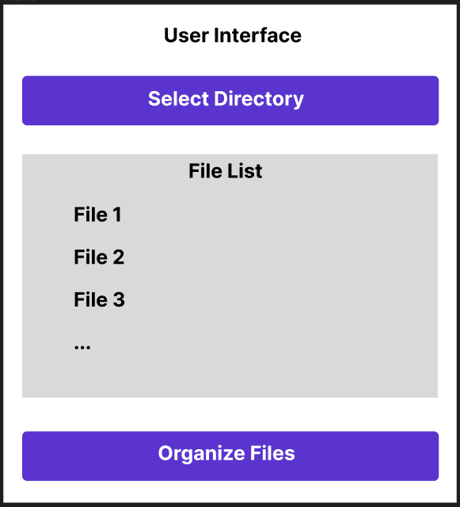

Figure 1: High Level Diagram of File Organizer

## Low Level Diagram

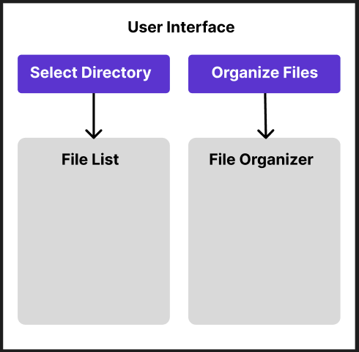

**Figure 2: Low Level Diagram of File Organizer**

# Performance Test

**Processing Speed and Efficiency:**

Constraint: If the file organization process is time-consuming or inefficient, it may lead to a poor user experience, especially when dealing with a large number of files.

Recommendation: Implement efficient algorithms and data structures to optimize file processing speed. Consider using parallel processing techniques or asynchronous operations to improve overall performance. Employ caching mechanisms to minimize redundant operations and optimize resource usage.

**Memory Consumption:**

Constraint: The File Organizer application may face memory constraints, especially when handling large files or a significant number of files simultaneously.

Recommendation: Implement efficient memory management techniques, such as using memory buffers or streaming mechanisms to process files in chunks. Employ memory optimization strategies like releasing unused resources promptly and minimizing memory leaks. Consider leveraging external storage solutions or cloud-based file management services for handling large file volumes.

**Scalability and Resource Utilization:**

Constraint: As the number of users or the volume of files grows, the application may experience scalability issues or resource limitations.

Recommendation: Design the application to be scalable, utilizing distributed computing or cloud-based solutions to handle increased user loads. Implement load balancing techniques to distribute the workload efficiently across multiple resources. Use resource monitoring and auto-scaling mechanisms to dynamically allocate resources based on demand. Consider implementing caching mechanisms or file indexing techniques to optimize file retrieval and organization.

**User Interface Responsiveness:**

Constraint: If the user interface becomes unresponsive or sluggish during file organization operations, it can lead to frustration and a poor user experience.

Recommendation: Implement responsive design principles to ensure smooth and interactive user interface performance. Utilize asynchronous processing and background threads to offload resource-intensive tasks, enabling the UI to remain responsive. Employ progress indicators or status updates to provide real-time feedback to users during long-running operations.

## Test Plan/ Test Cases

**Test Objective:**

The objective of testing the File Organizer application is to ensure that it functions correctly, performs efficiently, and meets the specified requirements. The testing process will validate the application's functionality, usability, and performance under various scenarios.

**Test Scope:**

The test scope includes the following areas:

* Source directory selection and scanning.
* File categorization based on types.
* Destination folder creation.
* User interface responsiveness.
* Performance and scalability.

**Test Environment:**

The test environment should consist of:

* Test machines with hardware specifications similar to the target production environment.
* Operating system(s) compatible with the application.
* Sufficient storage space and file system access for performing file organization operations.
* Realistic test data, including files of different types, sizes, and directory structures.

**Test Cases:**

**a. Source Directory Selection:**

* Verify that the application allows the user to select a source directory successfully.
* Test the application's behavior when the user cancels the directory selection.
* Verify that the application handles invalid or non-existent directories appropriately.

**b. File Scanning:**

* Validate that the application scans the selected directory and retrieves the list of files accurately.
* Test the application's performance when scanning directories with a large number of files.
* Verify that the application handles various file types, including files with different extensions.

**c. File Categorization:**

* Test the application's ability to categorize files correctly based on their types.
* Validate that the application assigns files to the appropriate categories consistently.
* Verify the application's behavior when encountering files with unknown or unsupported types.

**d. Destination Folder Creation:**

* Test the creation of destination folders for each file type and verify that files are moved to the correct folders.
* Verify the application's behavior when destination folders already exist or when there are permission restrictions.

|  |  |  |  |  |  |
| --- | --- | --- | --- | --- | --- |
| **Test Case** | **Description** | **Test Steps** | **Expected Result** | **Actual Result** | **Pass/Fail** |
| 1 | Source Directory Selection | 1. Launch the application.  2. Click on "Select Directory" button.  3. Select a valid source directory. | The selected directory is displayed correctly in the application. | Successfully Selected source destination. | Pass |
| 2 | File Scanning | 1. Select a directory with various files.  2. Click on "Select Directory" button. | The file list is populated with files from the selected directory. The file list includes files of different types and sizes. | Successfully Scanned the source directory. | Pass |
| 3 | File Categorization | 1. Verify that files are accurately categorized based on their types. | Files are assigned to the appropriate categories consistently. | Successfully categorized different files. | Pass |
| 4 | Destination Folder Creation | 1. Initiate the file organization process.  2. Check that destination folders are created for each file type and files are moved to the correct folders. | Files are renamed correctly. Destination folders are created, and files are moved to the appropriate folders. | Successfully created different folders according to existing files. | Pass |

# Result and Analysis

Directory Before Organization :

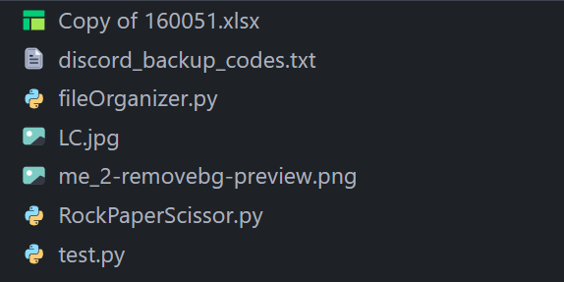

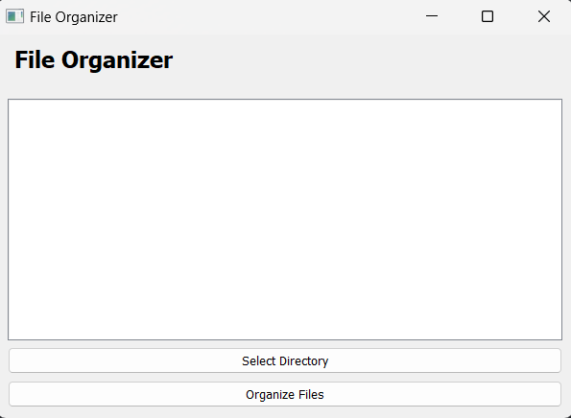

Before selecting directory

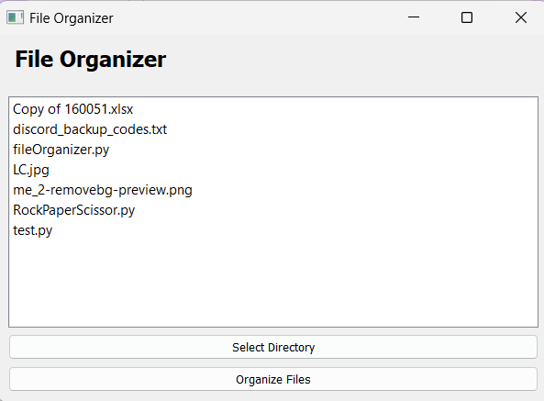

After Selecting Directory

Directory After Organization :

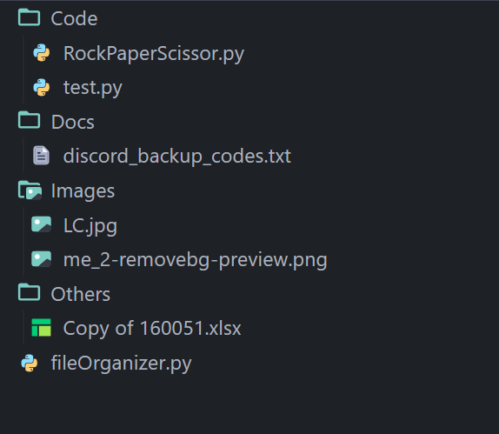

# Conclusion

The File Organizer project successfully addressed the problem of file clutter and disorganization by automating the process of file organization. The application developed using Python provides an efficient and user-friendly solution for users to categorize, rename, and move their files effortlessly. By achieving the defined milestones, the project has met the set objectives and delivered a valuable tool for enhanced productivity and organization.

Thank you for the opportunity to work on this project, and I am grateful for the guidance and support provided throughout the internship.

# My learnings

Throughout the internship program and working on the File Organizer project, I have gained valuable learnings that will contribute to my career growth in several ways:

**1. Technical Skills:** Developing the File Organizer application in Python has enhanced my programming skills, particularly in areas such as file handling, GUI development, and algorithm implementation.

**2. Problem-Solving Abilities:** Working on the File Organizer project has allowed me to tackle real-world problems and find effective solutions. From designing the application's architecture to implementing complex functionalities, I have sharpened my problem-solving abilities, including analyzing requirements, breaking down tasks, and debugging issues

**3. Project Management:** Managing the File Organizer project, including setting milestones, planning tasks, and meeting deadlines, has honed my project management skills. I have learned to prioritize work, allocate resources effectively, and adapt to changing requirements. These project management skills will serve me well in future endeavors, allowing me to efficiently manage and deliver projects on time and within budget.

**4. Continuous Learning:** Engaging in the internship program and working on the File Organizer project has highlighted the importance of continuous learning and staying updated with emerging technologies and best practices. I have cultivated a growth mindset, fostering a passion for lifelong learning.

Overall, the File Organizer project and the internship program as a whole have been instrumental in my professional development. The technical skills, problem-solving abilities, collaboration, communication, project management, and commitment to continuous learning gained through this experience will undoubtedly contribute to my career growth. I am excited to apply these learnings to future projects, take on new challenges, and advance in my chosen field.

# Future work scope

While working on the File Organizer project, there were some ideas and features that could not be implemented due to time limitations but hold potential for future development. Here are some suggestions for future work:

**Advanced File Categorization:**

Enhance the file categorization capabilities by incorporating machine learning algorithms or natural language processing techniques. This would allow the application to automatically classify files based on their content or context, providing more accurate and intelligent categorization.

**Customizable Naming Conventions:**

Provide users with the ability to define their own naming conventions for file organization. Allow for flexible naming patterns and options to include file metadata, date/time stamps, or user-defined variables to create personalized naming conventions.

**Rule-Based File Organization:**

Implement a rule-based system where users can define specific rules or conditions for organizing files. For example, users could set rules to automatically move files of a certain type to a specific folder or rename files based on specific criteria.

**Integration with Cloud Storage Services:**

Enable integration with popular cloud storage services such as Google Drive, Dropbox, or OneDrive. This would allow users to organize and synchronize files between their local storage and cloud storage seamlessly.

**File Preview and Metadata Display:**

Incorporate file preview capabilities within the application, allowing users to preview files before organizing them. Display relevant file metadata, such as file size, date modified, or file properties, to provide additional information for organizing decisions.