

**GOVERNMENT POLYTECHNIC**

**PEN**

COMPUTER DEPARTMENT

**“Programming with Python”**

**Submitted By**

|  |  |
| --- | --- |
| **Name of Students :** | **Roll no. :** |
| Swastik Patil  Onkar Pisal  Prem Kantak  Prerana Mhatre  Vrunali Rasal | 3356  3357  3358  3359  3360 |

**Guided By**

**Ms. Minal Thavai**

(2021-2022)



**GOVERNMENT POLYTECHNIC**

**PEN(0129)**

## *CERTIFICATE*

This is to certify that

|  |  |
| --- | --- |
| **Name of Students :** | **Roll no. :** |
| Swastik Patil  Onkar Pisal  Prem Kantak  Prerana Mhatre  Vrunali Rasal | 3356  3357  3358  3359  3360 |

Of “Sixth” Semester of Diploma in Computer Technology Of Institute Government Polytechnic Pen (Code: 0129) has completed the micro-project satisfactorily in Course “Programming with Python” (Course Code 22616) For the academic year 2021-2022 as prescribed in curriculum.

**Ms. Minal Thavai Mrs. Harshada Pawar** (micro-project guide) (Head of Department)

**Dr.** **S. S. Bhamare**

(Principal Govt. Polytechnic,Pen)

## ACKNOWLEDGEMEMT

It is with profoundly sense of gratitude that we acknowledge from our guide **Ms. Minal Thavai** has been guide in the true sense of word, a guide who satisfaction from our word & progress.

We are highly obliged to **Mrs.Harshada Pawar** head of Computer Department for aberrance & good co-operation given to us for bringing this project to almost standard.

We are grateful to our principal **Dr. S. S. Bhamare** for proceeding acknowledgement to us in the connection of this project concluding. We appreciate the assistance of all staff that helps us in for their sincere & obliging help to make our project successfully.

**Part A**

**A Micro Project Proposal on**

**Subject: Programming with ‘Python’**

**“PDF converter”**

1. **Brief Introduction:**

A PDF is a Portable Document Format file format.  This file format was “discovered/invented” in the 1990’s as a way to share information between users with different computer set-ups.

It is a format of document that is easily read by multiple user systems. It is independent of operating systems (Windows, Mac, etc), hardware (Dell, HP, Toshiba, etc.) and also software.

This effectively breaks down the barriers to the adversity introduced by different brands hardware, running different operating systems & software.

1. **Aim of the Micro-Project:**
2. Demonstrate the personal abilities, skills & some action required to produced and present an extended piece of work.
3. Identify the strength & weakness of the project at different stages of development.
4. Analyse the information in terms of goal and focus of the project andimproving team works.
5. To develop a program to convert a document to pdf file.
6. **Action Plan:**

|  |  |  |  |  |
| --- | --- | --- | --- | --- |
| **Sr no.** | **Details of Activity** | **Plan start**  **Date** | **Plan End**  **Date** | **Name of team**  **Member** |
| 1 | Searched a topic for micro project | 27/09/2021 | 30/10/2021 | All the group members |
| 2 | Teachers opinion / suggestion and finalization of topic | 4/10/2021 | 06/10/2021 | All the group members |
| 3 | Started learning basics of shell script | 7/10/2021 | 9/10/2021 | Swastik Patil |
| 4 | Collecting information and introduction on the topic from internet sources | 11/10/2021 | 18/10/2021 | All the group members |
| 5 | Started creating program code for project | 23/10/2021 | 23/11/2021 | Swastik Patil |
| 6 | Run the program in linux command prompt | 23/10/2021 | 23/10/2021 | Swastik Patil |
| 7 | Using MS word for creating report of the project | 25/10/2021 | 26/10/2021 | Prerana Mhatre |
| 8 | Collecting Information  regarding 3d printing | 1/11/2021 | 8/11/2021 | Prerana Mhatre Swastik Patil |
| 9 | Started creating project report | 9/11/2021 | 11/11/2021 | Vrunali Rasal  Prerana Mhatre |
| 10 | Preparation of final project report | 15/11/2021 | 22/11/2021 | Prerana Mhatre  Swastik Patil |
| 11 | Making proposal for micro project. | 24/11/2021 | 25/11/2021 | Prem Kantak  Onkar Pisal |

**4.0) Resources Required :**

|  |  |  |
| --- | --- | --- |
| **Sr. No** | **Name of Resources / Materials** | **Specification** |
| 1 | Computer System | Ryzen 3 3300x |
| 2 | Ram | 16 GB |
| 3 | Hard Disk | 1 TB |
| 4 | Operating System | windows 10 64 bit |
| 5 | python | version 3.9 |

**Ms. Minal Thavai**

**(Microproject Guide)**

**Part B**

**A Micro Project Report on**

**Subject: Programming with ‘Python’**

**“PDF converter”**

1. **Brief Introduction:**

A PDF is a Portable Document Format file format.  This file format was “discovered/invented” in the 1990’s as a way to share information between users with different computer set-ups.

It is a format of document that is easily read by multiple user systems. It is independent of operating systems (Windows, Mac, etc), hardware (Dell, HP, Toshiba, etc.) and also software.

This effectively breaks down the barriers to the adversity introduced by different brands hardware, running different operating systems & software.

1. **Aim of the micro-project:**

* Demonstrate the personal abilities, skills & some action required to produced and present an extended piece of work.
* Identify the strength & weakness of the project at different stages of development.
* Analyse the information in terms of goal and focus of the project andimproving team works.
* To develop program to convert a document to pdf file.

1. **Course Outcomes:**

* Understand how file conversion is done.
* Understand how file conversion can be implemented.

1. **Actual Procedure followed**:

* Started for searching of project topics on internet and in other resources.
* Decided to develop a program to convert document to pdf file.
* For collecting information about libraries that help to convert a document to pdf ,we used internet as a source.
* For writing the report we used microsoft’s word.
* We created program that converts a document into pdf file.
* For creating this program we used python’s librairies that are : **docx2pdf** and **fpdf.**
* We used pip installer to install docx2pdf library i.e : pip install docx2pdf
* We also used pip installer to install fpdf library i.e : pip install fpdf

**5.0) Resources Required:**

|  |  |  |
| --- | --- | --- |
| Sr. No | Name of Resources / Materials | Specification |
| 1 | Computer System | Ryzen 3 3300x |
| 2 | Ram | 16 GB |
| 3 | Hard Disk | 1 TB |
| 4 | Operating System | windows 10 64 bit |
| 5 | Python | version 3.9 |

1. **Output of Micro-project:**

**Code :**

from fpdf import FPDF

from docx2pdf import convert

file = input("Enter the file name: ")

filePrefix = file.split(".")[0]

fileSuffix = file.split(".")[1]

if(fileSuffix == 'txt'):

print("Converting txt to pdf")

pdf = FPDF()

pdf.add_page()

pdf.set_font("Arial", size = 15)

fileOutput = filePrefix + ".pdf"

f = open(file, "r")

for x in f:

pdf.cell(200, 10, txt = x, ln = 1, align = 'C')

pdf.output(fileOutput)

print("Done")

elif(fileSuffix == "docx" or fileSuffix == "doc"):

print("Converting docx to pdf")

convert(file)

print("Done")

else:

print("This file format is not supported !!")

* Directory at Initial Stage :

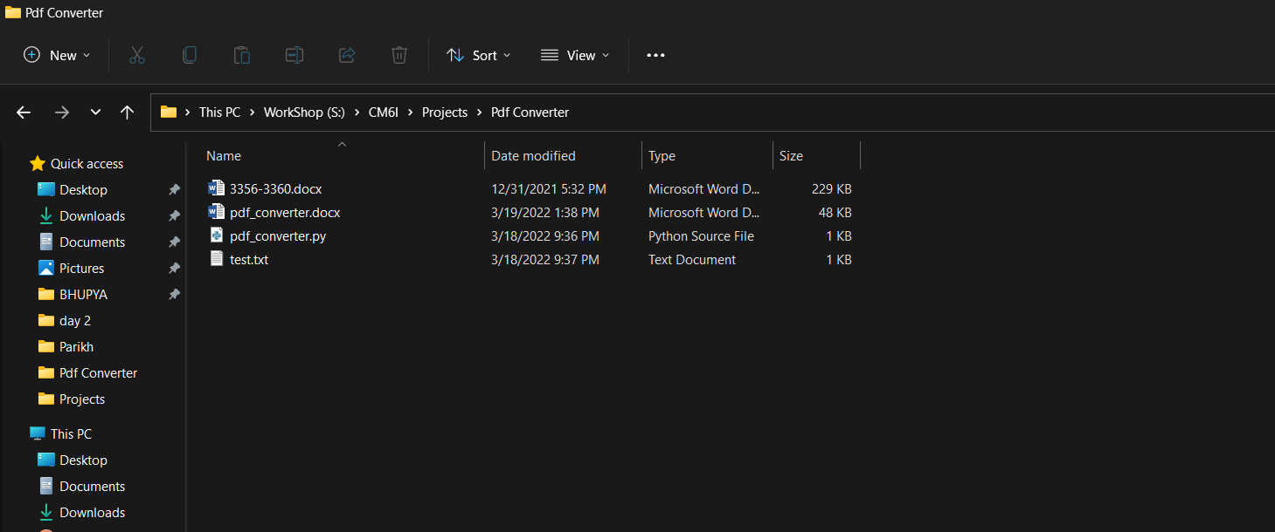

* 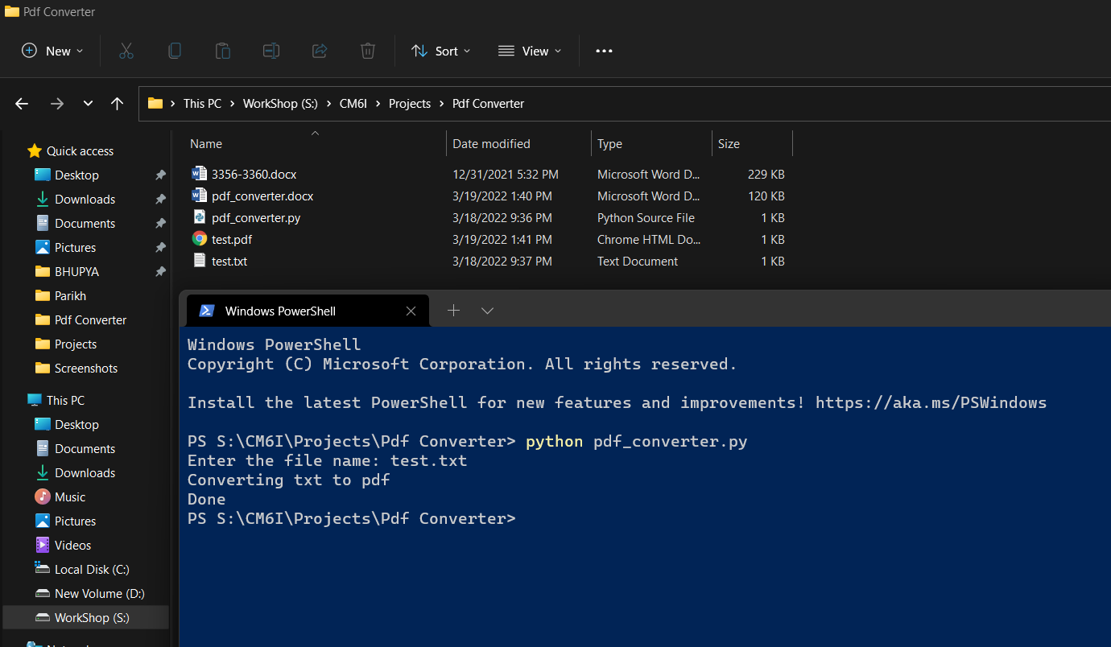Converting Txt file into PDF file
* 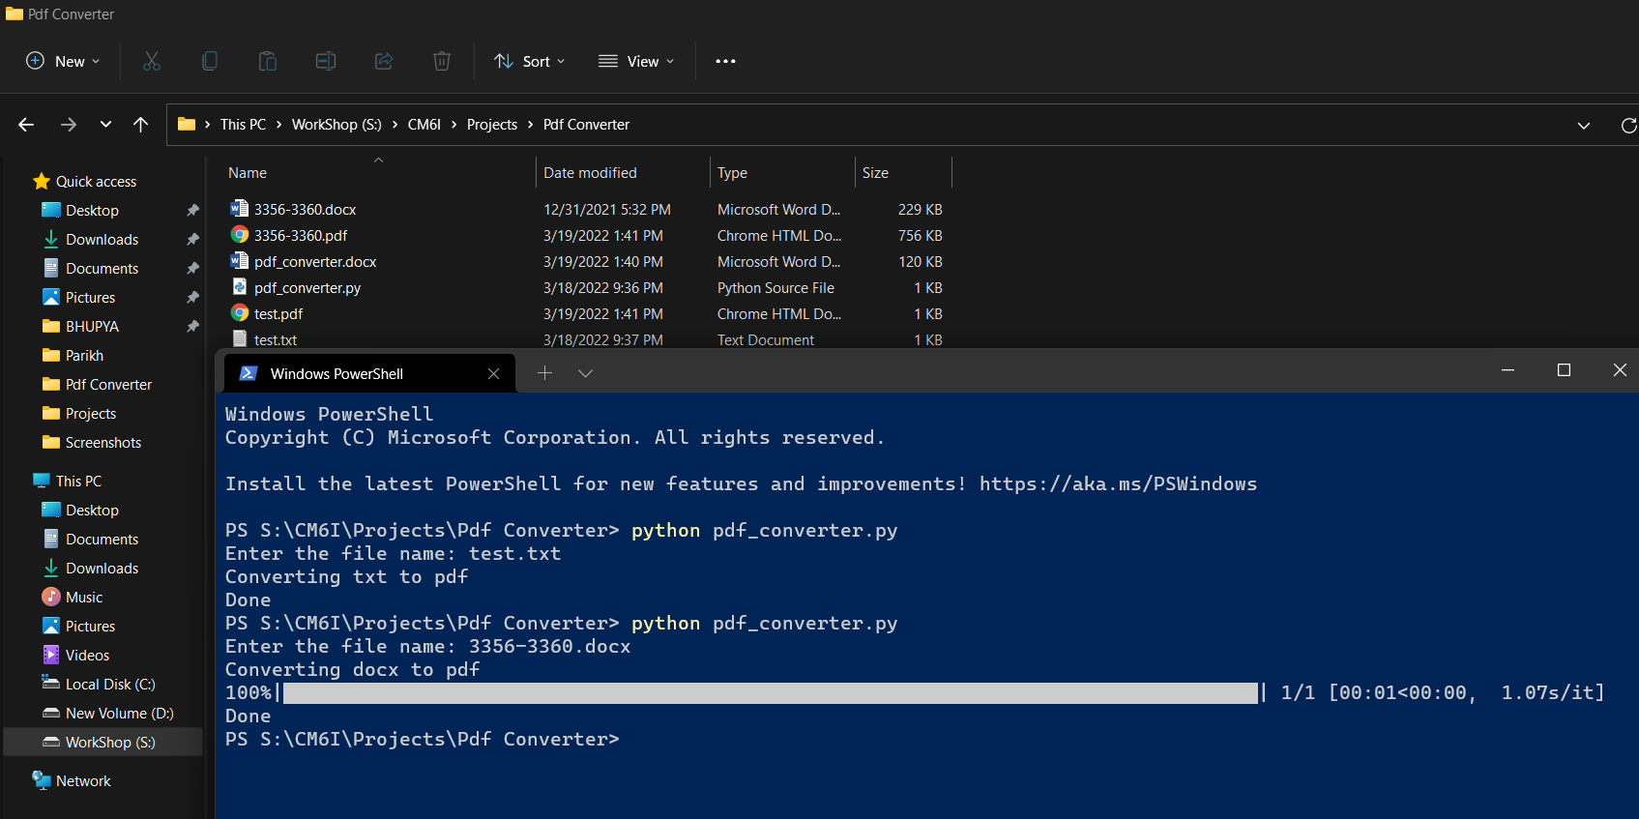Converting Docx file to PDF file
* 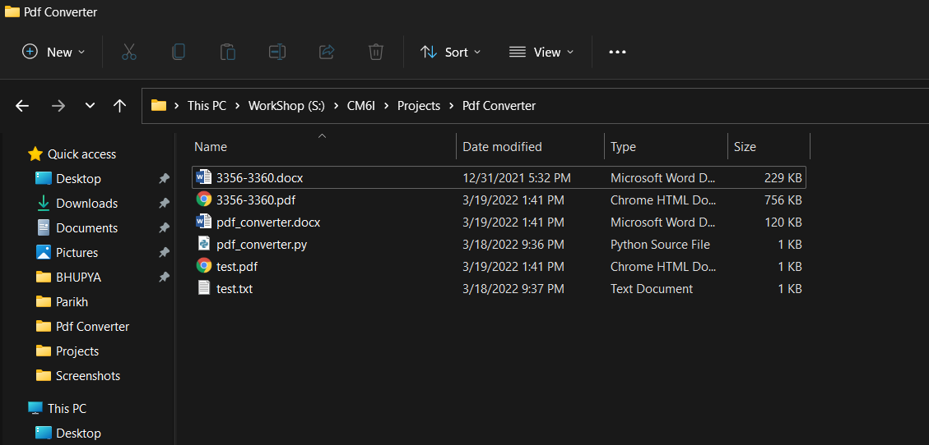Directory after completing conversion

**7.0) Skills Developed :**

* Learned how to work together in a group.
* Gained the qualities of the team work.

**8.0) Reference :**

* <https://pypi.org/project/docx2pdf/>
* <https://pypi.org/project/fpdf/>

**9.0) Conclusion :**

* The main objective of our project is to study and develop a program that converts documents into pdf file.
* We have made detailed research on conversion of files using python.