Assignment-1

1. Find output:
2. System.out.println(5/2);
3. System.out.println(5/2.0);
4. char ch=’a’;

System.out.println((((int)ch+1)%2)==0);

1. Find output:
2. int a=8;

int x;

x=a++ + ++a + a + ++a + a++;

System.out.println(x+” , ”+a);

1. int a=8;

System.out.println(a++ +”,”+ ++a + ”,”+ a++);

System.out.println(--a +”,”+ a + ”,”+ a--);

1. The following question describes some bitwise operations,find output:

int a=7,b=9

1. System.out.println(a&b); //bitwise AND
2. System.out.println(a|b); //bitwise OR
3. System.out.println(a^b); //bitwise XOR
4. System.out.println(a<<2); //left shift
5. System.out.println(a>>2); //right shift
6. Write a java program to find the greatest among 4 numbers using ternary operator.
7. You can use a multiple-alternative if statement to implement a decision table that describes several alternatives. For instance, let’s say you are an accountant setting up a payroll system based on the given table , which shows five different ranges for salaries up to $150,000.00. Each table line shows the base tax amount (column 2) and tax percentage (column 3) for a particular salary range (column 1). Given a person’s salary, you can calculate the tax due by adding the base tax to the product of the percentage times the excess salary over the minimum salary for that range. For example, the second line of the table specifies that the tax due on a salary of $20,000.00 is $2,250.00 plus 18 percent of the excess salary over $15,000.00 (that is, 18 percent of $5000.00, or $900.00). Therefore, the total tax due is $2,250.00 plus $900.00, or $3,150.00.

Write a java program to compute the tax due based on a tax table, output will be -1.0 if salary is outside the table range.

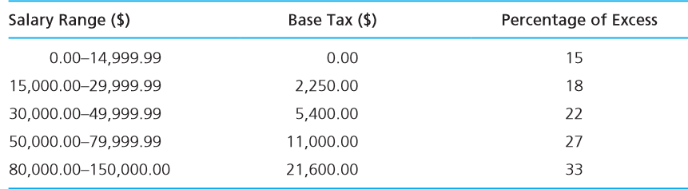

1. Write a java program to find whether a year is leap year or not using:
2. If-else
3. Nested if-else
4. If-else if ladder
5. Write a menu driven java program using switch case to show the basic usage of a calculator:

Addition will be denoted by ‘+’

Subtraction will be denoted by ‘-’

Multiplication will be denoted by ‘\*’

Division will be denoted by ‘/’

Power will be denoted by ‘^’ \*\*(this case is optional)

*Answers to selected questions:*

1. a. 2 , b. 2.5, c .true
2. a. 50,12

b. 8,10,10

10,10,10

1. a.1, b.15, c.14, d.28, e.1