Q1) What is the difference between 'Paste' and 'Paste Special' in Excel? Briefly explain with examples.

Ans1)

In Excel, Paste and Paste Special differ in the level of control they provide over what is copied to the destination cell. The Paste option copies everything from the selected cell, including the data, formulas, formatting, and comments, and pastes it exactly as it is into another location. For example, if a cell contains a formula like =A1+B1 with bold formatting, using Paste will copy both the formula and the formatting to the new cell.

On the other hand, Paste Special allows the user to choose specific elements to paste instead of copying everything. For instance, you can paste only values (the calculated result of a formula), only formulas, only formats, or even transpose rows into columns. As an example, if a cell contains the formula =A1+B1 and displays the value 50, using Paste Special → Values will paste only 50 in the new cell, without the formula. This makes Paste Special especially useful when you want more control over how data is pasted in Excel.

Q2) Describe the functions and usefulness of 'Freeze Panes' and 'Split Panes' in Excel.
Ans2)

In Excel, Freeze Panes and Split Panes are used to improve worksheet navigation, especially when working with large datasets. Freeze Panes is used to lock specific rows or columns so that they remain visible while scrolling through the worksheet. For example, if the first row contains column headings and the data extends downward, freezing the top row ensures that the headings stay visible even when you scroll down. This feature is very useful for comparing data and understanding column information without repeatedly scrolling back to the top.

Split Panes, on the other hand, divides the worksheet window into two or four separate panes that can be scrolled independently. This allows the user to view and work on different parts of the same worksheet at the same time. For example, you can split the screen to view data at the top and bottom of a long sheet simultaneously. Unlike Freeze Panes, Split Panes does not lock rows or columns permanently but only creates multiple viewing areas. Both features enhance efficiency, with Freeze Panes being ideal for keeping headings visible and Split Panes being helpful for comparing distant sections of data within a worksheet.

Q3) Explain the difference between inserting a new row and inserting a new column in Excel. Can you insert multiple rows or columns at once?
Ans3)

In Excel, inserting a new row adds a horizontal line of cells above the selected row, shifting existing data downward, while inserting a new column adds a vertical line of cells to the left of the selected column, shifting existing data to the right. For example, if you insert a new row above row 5, the existing row 5 and all rows below it move down by one position. Similarly, inserting a new column at column C will push column C and all columns to its right one place to the right.
Excel allows you to insert multiple rows or columns at once. To do this, you simply select the number of rows or columns you want to insert, then right-click and choose Insert. For instance, selecting three consecutive rows and inserting will add three new rows together, and selecting two columns before inserting will add two new columns at the same time. This feature helps save time when modifying large worksheets.

Q4) What are logical functions in Excel? Provide examples of at least two logical functions and their applications.

Ans4)

Logical functions in Excel are used to perform logical tests and return results based on whether a given condition is true or false. These functions help in decision-making and data analysis by allowing Excel to evaluate conditions and produce different outputs depending on the results. Logical functions are commonly used in grading systems, financial analysis, and data validation.

One commonly used logical function is the IF function. It checks a condition and returns one value if the condition is true and another value if it is false. For example, the formula =IF(A1>=40,"Pass","Fail") is used in a marksheet to determine whether a student has passed or failed based on their score. Another important logical function is AND, which checks multiple conditions at the same time. For instance, =AND(A1>=40,B1>=40) returns TRUE only if marks in both subjects are 40 or above. These logical functions help automate decisions and make Excel spreadsheets more efficient and accurate.

Q5) Discuss the purpose of 'XLOOKUP' and how it differs from the traditional 'VLOOKUP' function.

Ans5)

The XLOOKUP function in Excel is used to search for a value in a range or array and return a corresponding result from another range, making it a more modern and flexible replacement for traditional lookup functions. Its main purpose is to simplify data lookup tasks while reducing common errors associated with older functions.

XLOOKUP differs from VLOOKUP in several important ways. Unlike VLOOKUP, which can only search from left to right, XLOOKUP can search in any direction, meaning the return column can be to the left or right of the lookup value. XLOOKUP also does not require a column index number; instead, it directly references the return array, making formulas easier to read and less error-prone. Additionally, XLOOKUP provides built-in handling for missing values, allowing users to define a custom message (such as “Not Found”) if the lookup fails, whereas VLOOKUP returns an error by default. For example, XLOOKUP is ideal for dynamic and large datasets where structure may change, while VLOOKUP is more limited and sensitive to column changes.

Q6) Create a worksheet titled 'Employee Data' with columns: Name, Age,
Department. Add 5 rows of data.
Format as follows:
- Bold and center-align the header row
- Apply a fill color
- Auto-fit column width

Ans6)

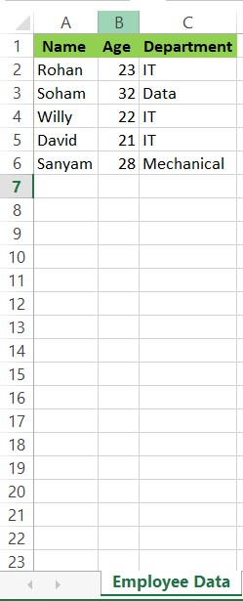

Q7)Demonstrate how to insert and delete multiple rows and columns in Excel.

Ans7)

selected no. of rows 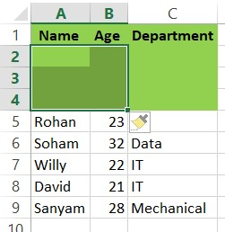

INSERTED rows

INSERTED columns 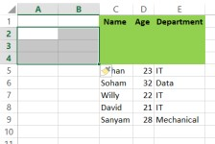

DELETION of rows 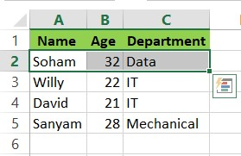

DELETION of columns 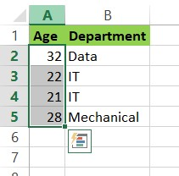

Q8) Use Excel's 'Find and Replace' feature to update department names in a sample table.

Ans8)

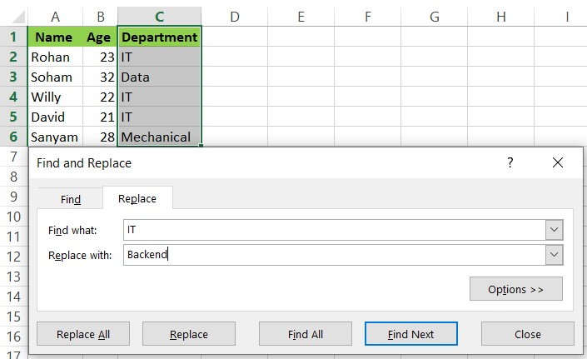

Q9) Create a small numerical dataset and apply the following functions:
- AVERAGE
- MAX
- MIN

Ans9)
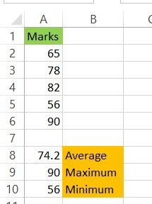

Q10) You're working with a dataset that contains missing values. As a Data
Scientist, explain how you'd detect and handle missing data using Excel. Mention tools like:
- Go To Special
- ISBLANK
- COUNTBLANK

Ans10)

When working with a dataset that contains missing values, detecting and handling missing data is an important step in data cleaning. In Excel, this can be done using built-in tools and functions that help identify empty cells quickly and accurately.

To detect missing values, one useful tool is Go To Special. By selecting the dataset and going to Home → Find & Select → Go To Special → Blanks, Excel automatically highlights all blank cells in the selected range. This allows the data scientist to visually inspect missing values and decide how they should be handled, such as filling them with default values or removing affected rows.

Another method is using the ISBLANK function, which checks whether a specific cell is empty. For example, the formula =ISBLANK(A2) returns TRUE if cell A2 has no value and FALSE otherwise. This function is useful for creating helper columns to flag missing data and apply conditional formatting or logical rules.

The COUNTBLANK function is used to count the total number of empty cells in a given range. For instance, =COUNTBLANK(A2:A100) tells how many values are missing in that column. This helps in understanding the extent of missing data before deciding on a strategy such as deletion, replacement with mean/median, or forward filling. Using these Excel tools together ensures efficient detection and proper handling of missing data.

