Synopsis

Project Title

Problem Id: 06

Student Name-
- Swastik Gairola
- Abhay Singh Butola
- Hardik Raturi
University Roll number-

- 2028506
- 2028376
- 2028424

Section- L

- Problem Description:
The tricky part is figuring out exactly how much water a household uses each day, so nobody wastes it and everyone gets enough. Students tackle this by collecting data. They look at details like how many people live in the house, the time of year, and even the size of the garden—since all these things affect how much water gets used.
Once the numbers are in decent shape, they use something called StandardScaler to level the playing field. That keeps one factor from overpowering everything else when they start analyzing. Then they go for Linear Regression. Basically, they use it to see which factors matter most for water use, and to make predictions about what’s coming next.
They don’t just stop there—they check how good their guesses are. By running residual analysis, they compare their predictions with what actually happened, just to see how close they came.This isn’t just some school project, either. City planners and water departments actually use this kind of work. It helps them predict demand, avoid running out, and manage supplies smartly.

Steps of Implementation:

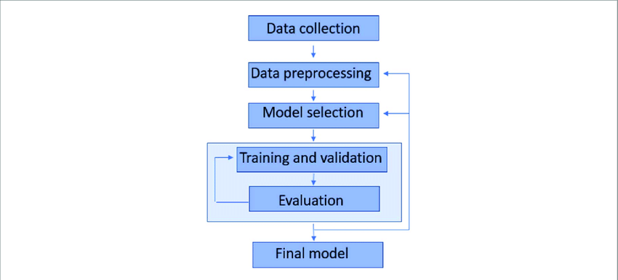

- Dataset Curation (Data Collection)
The first step is to collect relevant data on daily water usage. This includes factors such as Household Size, Seasonal Index (summer, winter, etc.), and Garden Area. The data can be gathered through surveys, research articles, or online sources. The goal is to build a meaningful dataset that reflects real-life water consumption patterns.
- Data Cleaning (Preprocessing)
Once the dataset is created, it is cleaned to handle missing or incorrect values. This may involve filling missing entries, removing duplicates, and correcting inconsistent data. Clean data ensures better model performance and reliable results.
- Feature Standardization (StandardScaler)
Since the features (like household size and garden area) have different units and scales, StandardScaler is applied. It transforms the data so that all features have a similar scale, helping the model learn more effectively.
- Model Building (Linear Regression)
A Linear Regression model is trained using the processed dataset. It identifies relationships between input features and predicts the target variable, which is Daily Liters Used.
- Residual Analysis (Evaluation)
Finally, residual analysis is performed to evaluate the model’s accuracy. It checks the difference between actual and predicted values, helping to understand errors and improve the model if needed.

- Expected Modules/ Libraries to be used :
NumPy:
Used for numerical operations and generating synthetic data efficiently using arrays and random functions.
Pandas:
Helps in creating, organizing, and manipulating the dataset in tabular (DataFrame) format.
Matplotlib: Used for visualizing data through plots like scatter plots and elbow graphs for cluster analysis.
Scikit-learn:
machine learning tools like StandardScaler for normalization .

- Expected Evaluation metrics and Plots to be used:
Scatter Plot:
Helps visualize customer segments based on spending and frequency.
MAE:
Measures the average absolute difference between predicted and actual values.
MSE:
Calculates squared errors to penalize larger deviations in predictions.
R² Score:
Represents how well the model explains the variance in data.
Residual Plot:
Helps identify patterns in prediction errors.
Regression Plot:
Shows relationship between predicted and actual values.

- Required topics from the subject:

Data Structures (Arrays & DataFrames):
Arrays and DataFrames are used to store and organize the dataset efficiently. NumPy arrays help in handling numerical data, while Pandas DataFrames make it easier to manage and analyze information such as household size, seasonal index, garden area, and daily water usage.

Functions:
Functions are used to divide the program into smaller, manageable parts. Separate functions can be created for tasks like data collection, preprocessing, scaling using StandardScaler, and training the Linear Regression model.

File Handling:
Used to save and load the dataset (e.g., CSV files) for future use and analysis.

Loops & Conditionals:
Loops are used to process data step by step, such as iterating through dataset entries or performing repeated operations. Conditionals help in making decisions, like handling missing values or applying specific actions based on conditions.

Libraries & Modules:
Various Python libraries are used to simplify the implementation. NumPy and Pandas are used for data handling, Scikit-learn for StandardScaler and Linear Regression, and Matplotlib or Seaborn for visualization and analysis.

- Platform Required:
Jupyter Notebook:
Used as the primary development environment for writing, executing, and interactively visualizing Python code.

Python (Anaconda Distribution):
Provides all required libraries and package management needed for data analysis and machine learning.

- Books and Link Sources:
- https://www.geeksforgeeks.org/ml-linear-regression/
- https://www.geeksforgeeks.org/standardscaler-in-python/
- https://scikit-learn.org/stable/

