ULTRON Complete Beginner and System Guide
Machines sensors software data and maintenance
Prepared on 21 October 2026 | Version 1.0
ULTRON turns machine measurements into information that people can use. It connects each reading to equipment, time, operating conditions and engineering references. It then helps people find changes, inspect evidence and manage work.
This guide explains the full path. It starts with basic machine and sensor terms. It then explains the hardware design, current software, data formats, database, calculations, pages and maintenance process.
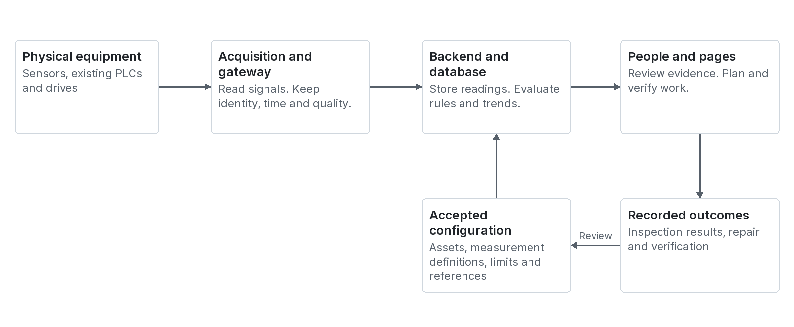
Figure 1 The complete information path from equipment to verified work

What you should understand after reading
- What ULTRON receives and what each data field means.
- How the rack, gateway, backend and web application work together.
- What each page does and how the pages connect.
- Which outputs the evidence supports and which outputs need further validation.
For beginners, plant teams, product teams and software teams. All teaching values are examples. Use approved equipment data for real limits and work procedures.
Evidence basis: nine supplied documents and the current ORCAS working files. Code was inspected, but the application and hardware were not commissioned or tested for this guide.

How to use this guide
Contents / Terms / Sources
Read Sections 1 to 6 first if industrial monitoring is new to you. Then use the page atlas and examples. Use the reference sections when you need a field, page link or table name.
Reading need | Start here
Understand the product | Sections 1 and 2 explain the machine, sensor and monitoring basics.
Understand the full system | Sections 3 to 5 explain architecture, inputs and processing.
Understand analytics | Section 6 separates rules, ML, diagnosis and prediction.
Understand storage | Section 7 explains database records and data history.
Use or design the pages | Sections 8 and 9 explain navigation, wireframes and user work.
Connect a new source | Sections 4, 10 and 11 explain contracts, commissioning and APIs.
Check a source requirement | Sections 12 to 14 contain the 100 input index, glossary and sources.

Four evidence labels used in this guide
Label | Meaning
Current code | The inspected working files contain this structure or logic. This is not proof of correct deployment.
Design intent | The supplied documents or project rules describe this requirement. Hardware or product validation may still be needed.
Proposed detail | This guide adds a useful design or record example. It is not an existing API promise.
Teaching example | The values explain a concept. They are not live readings, approved limits or validated predictions.

The language in this guide
The text uses short sentences, active verbs and consistent terms. Steps use one main instruction. Technical terms are defined before use where practical. This follows the requested approximate ASD-STE100 approach. It is not a certified STE compliance assessment. Technical names, field names and some explanations use normal engineering English.
The official ASD-STE100 rules and dictionary remain the authority. See source E1 for the standard and E2 for its introduction.

How to read a wireframe
A wireframe is a simple plan of a page. It shows where information belongs. The figures are conceptual layouts based on the current pages. They are not application screenshots. Product controls must use the project tokens and components.

Contents
Contents / Terms / Sources

Select a blue entry to move to that section. Every page also has links to Contents, Terms and Sources.
1 What ULTRON is 4
2 Machines sensors time and vibration 5
3 System architecture and tools 11
4 Inputs dictionaries and formats 16
5 Processing rules features and health 23
6 Machine learning prediction and explanation 27
7 Database records and storage 30
8 Page map and wireframes 34
9 Worked examples 54
10 Commissioning operations and validation 57
11 API map and page data lineage 61
12 Complete 100 input index 64
13 Terms and abbreviations 71
14 Sources and evidence 75
Beginner first day review path 78
Page numbers are fixed to this edition. Internal links remain useful if you edit the document and pagination changes.

1 What ULTRON is
Contents / Terms / Sources
ULTRON is an industrial monitoring and decision support platform. It helps a team understand equipment and process behaviour. Its basic job is to keep the meaning of each measurement and show useful evidence.
A sensor can report 52. ULTRON needs to know that this means 52 °C at a named motor bearing. It also needs the time, data quality and operating state. These details make the number useful.

The main questions
Question | Useful output
What is happening now | Timestamped readings and the actual operating state.
Is an engineering requirement exceeded | A limit finding or process requirement finding.
Has behaviour changed | A trend or difference from an accepted reference.
What could explain the change | Supported hypotheses and checks to confirm them.
What could happen next | A scoped forecast when the evidence supports it.
What work is needed | A reviewable request, plan, work order and verification record.

A simple pump example
Pump P-01 supplies water. Its bearing vibration is now 2.4 mm/s. The example upper alarm is 3.0 mm/s. The upper alarm has not activated. However, accepted light load vibration is 1.0 to 1.5 mm/s. Vibration also increased across five days. ULTRON should show this change and the evidence. An engineer must establish the cause.

Where ULTRON fits
A plant can already have a PLC, drive, SCADA system and historian. A historian stores industrial time series. ULTRON can use available measurements and added sensors. It adds equipment context, comparisons, findings and work records where those functions are implemented.
ULTRON analytics support decisions. Machine protection and personnel safety functions belong to the approved control and protection systems. A displayed anomaly score must not become an unapproved shutdown command.
Basis: S7 opening and Steps 1 to 13; S6 Sections 1 and 13; R1 product direction.

2 Machines processes and useful work
Contents / Terms / Sources
A machine uses energy to do work. An industrial process uses equipment to change or move material. A plant contains many connected processes and equipment items.
Equipment group | How it works | Examples
Rotating | A major part turns around a shaft. | Motor, centrifugal pump, fan and screw extruder.
Reciprocating | A major part moves forward and backward. | Piston pump, piston compressor and engine.
Static process equipment | The main structure has no major rotating or reciprocating mechanism. | Heat exchanger, vessel and tank.

Parts of the pump example
Electric power drives a motor. The motor turns a shaft. A coupling connects the motor to the pump. Bearings support the shaft. The pump moves water. A bearing housing is the outer structure around a bearing. A sensor can measure vibration at that housing.

Three views of a problem
View | Question | Example
Condition | Are the monitored parts behaving as expected | Bearing vibration increases at the same duty.
Process performance | Does the system meet its required function | Flow is 60 L/min when the requirement is 100 L/min.
Resource performance | How much resource does useful work need | The same water delivery needs more measured electrical power.

These views can give different results. A pump can deliver enough water while a bearing starts to deteriorate. A pump can also have expected vibration while a closed valve reduces water delivery.

Symptom cause fault and failure
A symptom is an observed change. A cause explains that change. A fault is an identified problem. A failure means that equipment cannot meet a defined function. A machine can fail a flow requirement while it still turns.
For example, high temperature is a symptom. A blocked cooling path could be one cause. Inspection must confirm it. The reading alone does not prove that cause.
Basis: S9 Sections 1, 2 and 6; S7 Sections 1 and 6.

Sensors measurements and signal conversion
Contents / Terms / Sources
A sensor responds to a physical quantity. It produces a signal that measurement electronics can read. A transmitter converts a measurement into a defined electrical or digital output.
Quantity | Common unit | Typical observation
Temperature | °C | Motor, bearing, fluid or process temperature.
Pressure | bar or kPa | Pressure at a named point in a pipe or vessel.
Flow | L/min or m³/h | Volume moving through a pipe per unit time.
Current | A | Electrical current used by a motor.
Power and energy | kW and kWh | Rate of energy use and energy used over a period.
Speed | RPM | Shaft revolutions per minute.
Vibration | g, m/s², mm/s or µm | Acceleration, velocity or displacement at a named point.
State | Defined text or code | Running, stopped, open, closed or another known state.

Unit key: A means amperes and mA means milliamperes. One mA is one thousandth of an ampere. kW means kilowatts, a power unit. kWh means kilowatt hours, an energy unit. L/min means litres per minute. m³/h means cubic metres per hour. µm means micrometres. One micrometre is one thousandth of a millimetre.

Worked conversion from 4 to 20 mA
Assume that a temperature transmitter maps 4 to 20 mA to 0 to 100 °C. The span is 16 mA. A 12 mA signal is 8 mA above the lower signal value.
Fraction of span = (12 - 4) / (20 - 4) = 0.5
Temperature = 0 + 0.5 × (100 - 0) = 50 °C

The same 12 mA means a different temperature if the configured range changes. Store the signal range and engineering range. Confirm the actual channel type, wiring, scaling and calibration.

One physical sensor can support several measurements
A three axis vibration sensor can supply three directions. Processing can also produce RMS, peak and spectral features. These are different measurement definitions. Each needs a clear identity, unit and processing description.
A measurement point identifies the place. A measurement identifies what is measured at that place. A reading is one observation of that measurement at a particular time.
Basis: S9 Sections 3 to 5; S2 PS-02, PS-03 and PS-10; R7 measurement schema.

Time series and data quality
Contents / Terms / Sources
A time series contains observations of one measurement in time order. Time lets ULTRON calculate change, align signals and connect readings to events.
Time | Temperature °C | Pressure bar | Current A
10:00 | 50 | 4.0 | 8.0
10:01 | 52 | 4.0 | 8.0
10:02 | 55 | 3.8 | 8.5

Temperature increased by 5 °C in two minutes. The average rise was 2.5 °C/min. The sample average was (50 + 52 + 55) / 3 = 52.33 °C. These calculations describe change. They do not establish a fault.

Three different rates
Rate | Meaning | Example
Acquisition rate | How often the electronics take samples. | 10 000 acceleration samples/s.
Publication rate | How often a device sends an observation or summary. | One RMS result each second.
Display update rate | How often a page refreshes what it shows. | An interface can update once each second.

A fast display does not prove fast acquisition. A once per second RMS result can summarize thousands of fast samples. A one minute database record does not preserve every original waveform sample.

Quality and condition are separate
Situation | Correct meaning
GOOD temperature of 90 °C | The measurement can be usable. The machine can still exceed a limit.
Missing temperature | There is no current temperature reading. It is not 0 °C.
Old temperature | Show its original time and age. It is not a new observation.
Clipped vibration | The captured signal did not retain the true peaks.
No flow sensor installed | Flow analysis is unavailable by design. This is not a failed sensor.

A valid unusual value can be important evidence. Do not reject a value only because it differs from the reference. Validate the measurement path and assess machine condition as separate tasks.
Basis: S9 Section 4; S7 Steps 4 to 7; S6 Sections 4.3 and 8.

Vibration waveforms summaries and spectra
Contents / Terms / Sources
Vibration is repeated movement around a resting position. An accelerometer measures acceleration at its mounting point. Its signal can contain many frequencies at the same time.
Term | Simple meaning | Unit or calculation
Displacement | How far the point moves. | Often µm.
Velocity | How fast the vibrating movement occurs. | Often mm/s.
Acceleration | How fast vibration velocity changes. | m/s² or g; 1 g is about 9.81 m/s².
RMS | Overall magnitude across a recording. | Square samples, average them, then take the square root.
Peak magnitude | Largest absolute sample. | For -0.4 and +0.8 g, peak magnitude is 0.8 g.
Crest factor | Peak magnitude divided by RMS. | 2 g / 0.5 g = 4.
Frequency | Number of cycles each second. | Hz.
Spectrum | Magnitude or energy shown by frequency. | Must name the amplitude and scaling convention.

Why an ordinary average is not enough
The samples +1, -1, +1 and -1 g have an arithmetic average of zero. Their RMS is 1 g. Opposite directions cancel in the average. They do not cancel in RMS.
The samples 0, 0, 0 and +2 also have RMS 1. Their peak is 2. The first set has peak 1. The same RMS can describe different waveforms. Therefore, an RMS trend cannot recreate the original waveform.

What the channel can support
An overall vibration transmitter can support an RMS trend. It cannot supply a detailed spectrum unless it also provides suitable waveform or spectral data. FFT analysis needs samples, sample rate, recording length and processing settings.
Keep the point, direction, mounting, quantity, band and statistic with the result. Do not compare acceleration RMS with velocity RMS. Do not compare different frequency bands as if they were identical.
Basis: S9 Section 5; S2 PS-03; S6 Section 8.1.

A worked vibration recording
Contents / Terms / Sources
This teaching example shows how different data products come from one recording. It does not specify the ULTRON hardware sampling capability.
Setting or result | Teaching value | Meaning
Acquisition rate | 10 000 samples/s | There are 10 000 measurements of acceleration each second.
Recording duration | 1 s | One recording contains 10 000 samples.
Time between samples | 0.0001 s | 1 / 10 000.
Shaft speed | 1 500 RPM | The shaft turns 25 times each second.
First shaft order | 25 Hz | 1 500 / 60.
Second shaft order | 50 Hz | Two events for each shaft revolution.
Nominal FFT bin spacing | 1 Hz | Sample rate / sample count = 10 000 / 10 000.
Summary publication | One result/s | The summary rate is separate from acquisition rate.

From recording to spectrum
1. Check the sensor range, mounting and signal quality.
2. Apply the defined calibration and signal processing.
3. Select the recording length and window function.
4. Calculate the FFT and the required amplitude convention.
5. Compare relevant frequency features with speed and equipment data.
6. Retain the recording reference and processing version.
Bin spacing describes the frequency grid. It is not a complete statement of usable resolution. Recording length, windowing, noise and speed variation affect interpretation.

Avoid misleading frequencies
Sampling must be fast enough for the retained signal band. The basic sampling condition requires more than twice the highest retained frequency. Practical acquisition also needs filter transition space and suitable anti alias filtering before sampling.
A 25 Hz feature can relate to shaft rotation. It does not alone prove imbalance. Bearing fault assessment can need bearing geometry, speed, mounting details and validated diagnostic signatures.
A slow Modbus polling loop is suitable for many scalar values. A high rate waveform needs an explicitly designed capture and transfer path.
Basis: S9 Section 5; S2 I03.02 to I03.08; S6 Section 8.

Normal behaviour operating states and references
Contents / Terms / Sources
Expected behaviour depends on the machine and its operating conditions. Speed, load, recipe, ambient conditions and time since startup can change a valid reading.
State | Temperature °C | Vibration mm/s | Interpretation
1 500 RPM and light load | 50 to 55 | 1.0 to 1.5 | Accepted example reference.
1 500 RPM and higher load | 60 to 65 | 1.5 to 2.0 | A different accepted example reference.
Light load with 2.4 mm/s | 52 | 2.4 | Above the light load reference.
Planned stopped state | Depends on cool down | Near zero where applicable | Interpret against stopped state requirements.

Reference and limit answer different questions
A reference describes accepted behaviour in stated conditions. A limit defines an engineering boundary. A value can differ from the reference while it remains below an upper limit. A familiar value can also violate a requirement.
For the pump example, 2.4 mm/s is above the 1.0 to 1.5 mm/s light load reference. It is below the separate 3.0 mm/s upper alarm. Both results should remain visible.

How to accept a reference
1. Confirm sensor identity, units, mounting and processing.
2. Confirm equipment condition with suitable plant evidence.
3. Collect representative valid data for the required operating states.
4. Review the expected value, range, variation and coverage.
5. Record the basis, reviewer and acceptance status.
6. Review the reference after relevant equipment or measurement changes.
Frequent behaviour is not automatically healthy behaviour. A damaged machine can repeat the same pattern for months. Do not let an automatic rolling baseline hide slow deterioration.

Unknown operating states
If the accepted reference covers only light load, a new duty may be outside coverage. Show this explicitly. Applicable engineering limits can still be checked. Do not force an unsupported contextual comparison.
Basis: S9 Section 6; S7 Steps 8 to 10; R7 reference_sets and reference_values.

3 The complete system architecture
Contents / Terms / Sources
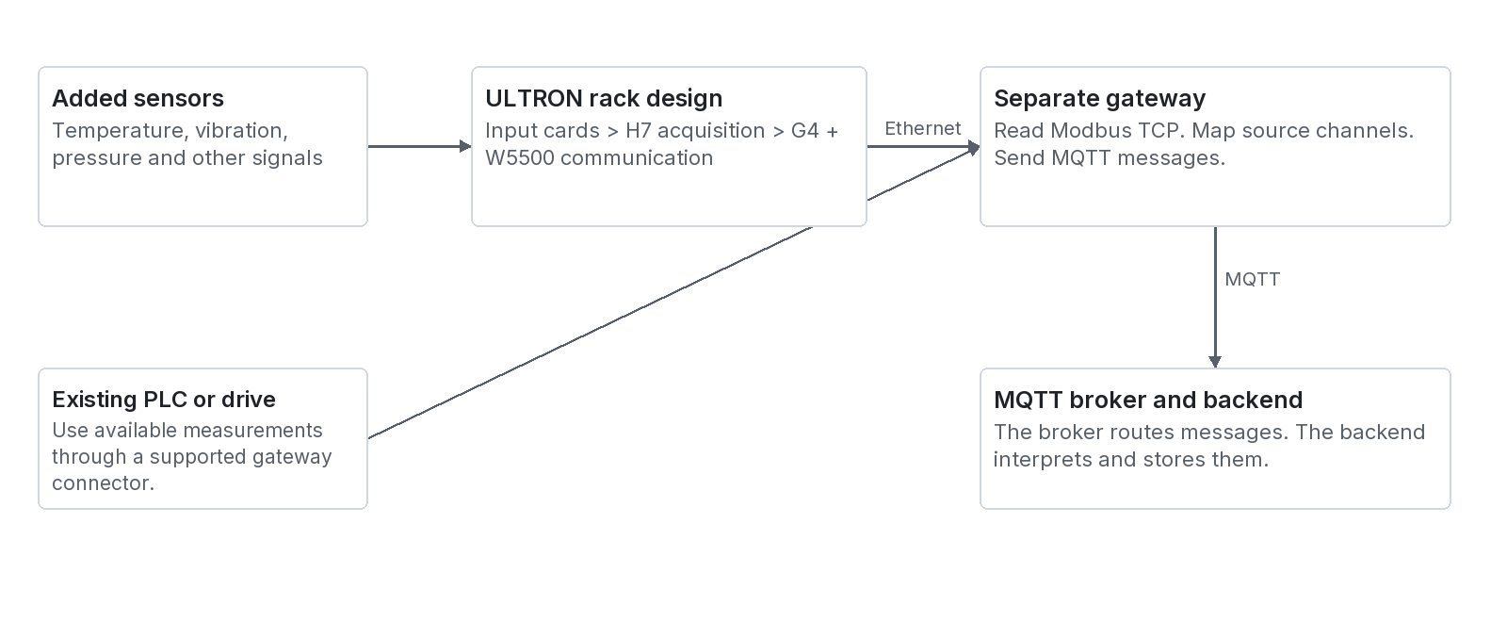
Figure 2 The hardware design and the two routes for source measurements
There are two main measurement routes. Added sensors connect to suitable ULTRON input electronics. Existing measurements come from a PLC, drive or other plant system. Both routes need a supported gateway integration.

What each layer does
Layer | Main responsibility | Output
Sensors and transmitters | Respond to physical quantities. | Electrical signal or digital measurement.
Input cards and DAQ | Acquire and process supported channels. | Engineering readings or supported signal features.
Rack communication | Expose the rack data interface. | Modbus TCP in the described design.
Gateway | Read sources, map channels and manage delivery. | Organized MQTT messages.
Broker | Route published messages to subscribers. | Messages delivered to the backend.
Backend and storage | Validate, store, calculate and serve records. | APIs, findings, scores and history.
Web application | Present evidence and accept permitted user work. | Views, configuration changes and work records.

The rack and gateway are separate devices. The rack is not the cloud server. The broker routes messages; it is not the main measurement history database. A browser page is not the authority for equipment configuration.
Basis: S7 Steps 1 to 3; S6 Section 13; R1 architecture; R3 and R4 current server structure.

Rack gateway and industrial communication
Contents / Terms / Sources
Design intent: the supplied guides describe an H7 acquisition microcontroller and a G4 communication microcontroller. A W5500 Ethernet interface supports the communication design. The repository is not hardware acceptance evidence.
Item | Plain explanation | What must be checked
Input card | A module for compatible sensor signals. | Signal type, range, isolation, wiring, calibration and channel count.
H7 DAQ MCU | A small computer that acquires measurements. | Actual sample rates, processing capacity and signal diagnostics.
G4 communication MCU | A small computer that manages the rack interface. | Register layout, data types, quality and permitted configuration writes.
W5500 | An Ethernet network interface device. | Actual hardware and firmware interface implementation.
Modbus TCP | An agreed method for reading industrial data over Ethernet. | Address convention, register width, byte order and word order.
Gateway | A separate computer that reads and sends data. | Connectors, buffering, time source, mapping and recovery.
MQTT | A publish and subscribe message protocol. | Topics, schema, delivery settings, identities and access.

A mapping example
A gateway reads a temperature from a rack register. Its mapping identifies the rack, card and channel. The backend links that channel to an existing measurement definition. That definition supplies the machine, tag, unit and location.
A Modbus register is a small addressed data location. A value can use more than one register. Vendors can number registers differently. A label such as 40021 does not alone prove the address to send on the wire.

Three communication details that affect meaning
- Scaling converts a signal or register value into its engineering value. Apply each conversion once.
- A gateway read time is not necessarily the sensor acquisition time. Preserve the real time source.
- An advertised protocol name does not prove a working connector. Test the actual source, driver and data contract.
Basis: S7 Steps 1 and 2; S6 Sections 13.1 and 13.2; R5 edge registry and MQTT contracts.

Software architecture and tools
Contents / Terms / Sources
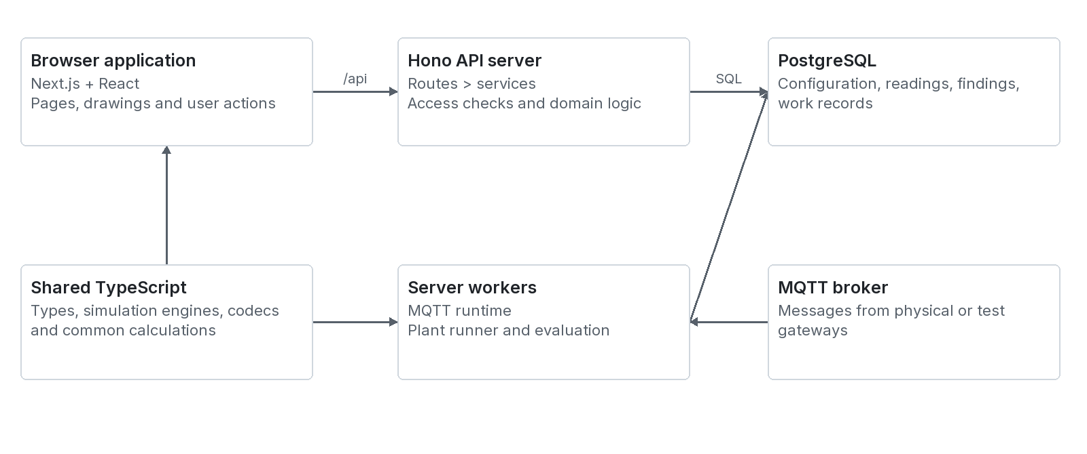
Figure 3 The current browser server shared code and database boundaries
Tool or layer | Role in the current project
Next.js 15 and React 19 | Build and display the web application. The main workspaces are selected inside the root page.
TypeScript | Defines data shapes and application logic for the browser, server and shared modules.
Hono on Node.js | Runs the separate API server. The default API port is 4000.
PostgreSQL and pg | Store relational records. The pg library connects the Node.js server to the database.
MQTT client library | Maintains backend subscriptions to configured brokers.
Server Sent Events | Streams MQTT snapshots and traffic to the browser through /api/mqtt/stream.
Three.js and React Three Fiber | Render the 3D twin views.
Inter and semantic CSS tokens | Provide product typography, spacing, surfaces and theme colours.

Versions above come from the inspected package declarations. They describe this code snapshot. They are not a requirement to install a new version for this guide.

Tools described as future options
The source ML guide discusses Isolation Forest, LightGBM, SHAP and sequence models. The inspected package files do not establish a deployed training or inference service for these models. Treat them as candidate design options.
The onboarding processor can invoke a local Claude Code process when enabled and available. AssetIQ uses a separate deterministic answer engine in the inspected code. These are different features.
Basis: R2 package declarations; R3 root page and proxy; R4 API server; R12 AssetIQ; R13 onboarding processor; S6 Section 9.3.

Software responsibilities and one request
Contents / Terms / Sources

Current module boundaries
Location | Responsibility | Example
src/app | Application entry and layouts. | Root page mounts the signed in workspace.
src/components | Reusable views and controls. | Diagnosis, Devices and maintenance pages.
src/providers | Browser context and shared state. | User, selected plant, selected machine and live plant context.
backend/src/routes | Resource endpoints and request handling. | A readings route validates the request shape.
backend/src/services | Domain operations. | A monitoring service resolves a tag to a measurement.
backend/src/monitoring | Readings, evaluation and conditions. | Create findings from stored observations.
backend/src/db | Connection, migrations and fixtures. | Apply ordered SQL schema changes.
shared | Code that both sides can use. | Domain types, deterministic simulation engines and codecs.

Example of a user opening a trend
1. The user selects a machine and measurement.
2. The browser requests that measurement history through /api.
3. Next.js forwards the request to the Hono server.
4. The server checks the applicable user and machine scope.
5. The service reads timed data from PostgreSQL.
6. The API returns a data object with observations or buckets.
7. The browser draws the series and shows its unit and time range.
The frontend can import backend types for type checking. It must not run server modules in a browser component. Domain configuration comes from the database through the API.

Two API envelopes
{ "data": { "example": "successful result" } }
{ "error": { "code": "INVALID_INPUT", "message": "A required field is missing" } }

The browser should show loading, empty and error states clearly. It must not replace unknown readings with invented values.
Basis: R1 architecture and API rules; R3 proxy; R4 routes and HTTP helpers; R6 monitoring service.

Live sources and the demonstration plant
Contents / Terms / Sources
Current code: ULTRON has physical source ingestion structures and a deterministic demonstration plant. A demonstrated fault is a software test scenario. It is not a confirmed event on physical equipment.
Path | Source of readings | Important boundary
Physical gateway | A configured gateway publishes received channel data. | The source and channel must map to a measurement.
Direct ingestion | An allowed caller submits readings to the HTTP ingest endpoint. | Use the current endpoint contract and access configuration.
Server demonstration | The plant runner advances configured engines and stores simulated readings. | The data is simulated. It must remain distinguishable in operation.
Browser demonstration view | A root provider resumes and displays the shared plant context. | Do not create a second independent plant engine for a new page.

How the server demonstration runs
A long running server process holds a database lease. The lease selects one active runner per database. Other servers stand by. The runner stores plant state about every five minutes. It writes simulated observations and runs evaluation at configured periods.
The documented demonstration pace is one simulated minute per real second. A demonstration forecast horizon therefore needs a clear time basis. Do not read simulation time as actual plant operating time.

Configuration and health
The database supplies the machine engine bindings, signal definitions, limits, rules and health model settings. The shared engine configuration is applied before stepping. The documented KLN-01 model includes 43 signals, 21 rules and 27 validation scenarios. Verify the loaded configuration for a particular deployment.
The project requires one machine health source across the interface. The machine header, directory, hierarchy, Home and Diagnosis use the server evaluated condition path. Do not hard code a second health result in a page.

Deployment limit
The runner needs a process that stays alive. The code disables it by default in the detected Vercel environment unless explicitly enabled. A short lived web request is not a replacement for an always on worker.
Basis: R1 simulation rules; R8 runner, simulation gateway and provider; shared/lib/kiln-sim; S6 Section 15.

4 What data enters ULTRON
Contents / Terms / Sources
ULTRON receives more than sensor values. Measurements describe observations. Configuration gives them meaning. Engineering documents provide references. Maintenance records describe what people found and changed.
Input group | Examples | Main use
Live scalar readings | Temperature, pressure, flow, current, speed and RMS. | Display, limits, trends and reference comparisons.
States and events | Run state, trip, valve position, recipe change and startup. | Operating context and event history.
Equipment records | Plant, machine, model, subassembly, ratings and criticality. | Identify equipment and choose applicable analyses.
Measurement definitions | Tag, quantity, unit, direction, location, band and range. | Preserve the meaning of each observation.
Source configuration | Broker, gateway, source, card, channel and mapping. | Trace where a reading came from.
Engineering configuration | Limits, states, process requirements and accepted references. | Provide a defined comparison basis.
Controlled documents | PFD, P&ID, OEM manual, SOP and inspection procedure. | Explain equipment and approved practices.
Maintenance evidence | Inspection, fault confirmation, replacement and repair result. | Investigation history and future model labels.
Detailed signal records | Waveforms, spectra and processing settings where supported. | Detailed signal analysis and suitable diagnosis.
Model evidence | Training scope, feature schema, validation and version. | Authorize only the supported model outputs.

Minimum input depends on the output
One valid temperature channel can support a configured temperature check. A pump flow deficit needs flow and a requirement. A bearing fault classification needs discriminating evidence. A remaining life estimate needs a defined life target and validated lifetime evidence.
A missing optional sensor reduces coverage. It must not create a fictitious fault. A failed installed sensor is a separate data quality problem.

Document input is not a command
Treat uploaded text as source evidence. Review extracted tags, limits and equipment details before acceptance. A statement in a source file does not authorize an application change or a machine action.
Basis: S2 PS-01 to PS-12; S7 Section 5; S8 Sections 4 to 6; S5 topic map.

Measurement identity and the data dictionary
Contents / Terms / Sources
Use a stable measurement identifier. Keep the description in configuration rather than repeat conflicting copies in every message. Each reading then points to the correct definition.
Field or concept | Meaning | Example
machineId | The equipment item. | P-01 in a teaching example.
subassembly | The part or group being observed. | Motor drive end bearing.
point_id | The defined measurement location. | Bearing housing point P3.
measurementId | The unique measurement definition. | A horizontal velocity RMS measurement at P3.
tag | The site readable measurement name. | VIB-P01-DE-H.
quantity and unit | What is measured and its scale. | Vibration velocity and mm/s.
statistic | How samples are summarized. | RMS, mean, peak or a stated direct value.
direction | The physical measurement direction. | Horizontal, vertical or axial.
acquisition and window | Sample rate and recording duration. | 10 000 samples/s and 1 s, where supported.
frequency band | Frequencies included in the result. | 10 to 1 000 Hz in a teaching definition.
range and scaling | Physical range and signal conversion. | 0 to 100 °C from 4 to 20 mA.
source mapping | The physical channel feeding the definition. | Gateway G1, rack R1, slot 3, channel 2.

Example of an identity error
Two channels can both report 1.8 mm/s. One is horizontal at the motor bearing. The other is axial at the pump. They describe different motion. A common unit does not make them the same measurement.

Current database structure
measurement_points records the physical point. measurements records the quantity, unit, statistic, direction and acquisition settings. edge_points links a physical source channel to a measurement. The v_measurement_context view joins the hierarchy for reads.
The current normalization removes copied name, tag, unit and alarm fields from edge_points. Those values come from the linked measurement and limit records. This prevents two versions of the same definition.
Basis: S9 Sections 4 and 5; R7 migrations 001, 044 and 046; R5 edge types.

Timestamps ordering and quality fields
Contents / Terms / Sources
Use UTC for exchanged timestamps. Display a selected plant time zone to the user. Keep the original time meaning. UTC avoids ambiguity when users or plants use different zones.
Field or concept | Meaning | Handling
Acquisition time | When the source measured the value. | Use it when the source supplies dependable measurement time.
Gateway read time | When the gateway read the source. | Do not label it as precise sensor time without evidence.
received_at | When the backend stored receipt of the reading. | Keep it separate from acquired_at.
time_source | How the stored observation time was obtained. | Current internal values include device, gateway and server.
Sequence number | Message order within a gateway boot. | Check gaps and preserve the boot identity.
message_id | Identity of a message. | Supports duplicate and replay handling in the message path.
replayed | The gateway resent buffered data. | Preserve original acquisition times.
quality | Usability information about a reading. | Do not turn BAD or missing into a healthy value.

Quality codes in the current reading layer
The internal code defines GOOD, UNCERTAIN, STALE, MISSING, OVERRANGE, UNDERRANGE, CLIPPED and BAD. The quality_codes table defines usability. Evaluation also checks freshness and configured measurement behaviour.
The direct ingest service defaults an omitted quality field to GOOD. An integration should supply explicit quality. The MQTT recorder skips invalid or stale channels. It records a usable mapped channel as GOOD at the configured recording period.

Late and duplicate examples
A reading acquired at 10:00 can arrive at 10:02. Store it at 10:00 in the measurement history. Show its actual age. The current readings key rejects duplicate measurement and acquisition time pairs. Distinct observations with the same pair can therefore collide. Test timestamp precision and source behaviour.
Direct HTTP ingestion marks supplied acquiredAt as device time. If it is absent, the service uses server time. That endpoint does not accept an independent timeSource field in its current public row shape.
Basis: R6 reading store and ingestReadings; R5 MQTT validator and recorder; S2 PS-10; S7 Step 2.

Data formats and what each format is for
Contents / Terms / Sources
A format tells software how to read information. A file extension does not prove that ULTRON imports the file or understands its content. Confirm the actual endpoint or onboarding path.
Format | Typical content | Status and use
JSON over HTTP | Structured requests and responses. | Current API format. Use the exact resource contract.
JSON over MQTT | Gateway envelopes, telemetry, inventory and events. | Current backend message parser and custom format mapping.
PostgreSQL rows | Configuration, readings and work records. | Current main persistent storage.
CSV | Flat time series or tag register. | Useful interchange proposal. A universal CSV importer was not established.
XLSX | Engineering tag lists and structured setup information. | Reference or onboarding input where the processor supports it.
PDF and DOCX | Manuals, process descriptions and procedures. | Source evidence. Read and review extracted information.
PNG or JPEG | Equipment photos and reference images. | Asset image and onboarding features exist in current code.
SVG and structured drawing JSON | 2D drawing data. | Current diagram service accepts ultron.sheet2d/1.
Structured 3D JSON | Geometry, materials and parts. | Current diagram service accepts ultron.kit3d/1.
Parquet and waveform binary | Large analytic datasets or high rate recordings. | Proposed extended analytics storage. No complete current ingestion contract was established.

Three separate contracts
The source wire format describes what a device sends. The canonical measurement definition describes what a value means. The API result describes what a page receives. Do not send one format to a different interface merely because both use JSON.

Unit conversion example
If a source sends pressure in kPa and the canonical measurement uses bar, apply the reviewed conversion. 100 kPa equals 1 bar. Keep the conversion version and source unit. Do not convert the same data twice.
The proposed formats in the supplied engineering report describe design options. They are not verified ULTRON API payloads. This guide labels current payloads separately.
Basis: S2 reading instructions and input format cells; R5 formats; R6 ingest contract; R13 onboarding; R14 diagram service.

Current HTTP reading input example
Contents / Terms / Sources
Current contract: POST /api/readings accepts a readings array. Each row names a measurementId or a machineId and tag pair. It contains one numeric value or one nonempty state, except permitted missing quality records.
{
"readings": [
{
"machineId": "P-01",
"tag": "TT-P01-MOTOR",
"acquiredAt": "2026-10-21T04:30:00Z",
"value": 52.0,
"quality": "GOOD"
}
]
}

Teaching identifiers above must already exist in the configured measurement registry. The unit is resolved from that registry. This endpoint does not take a per row unit override.
Check in the service | Current behaviour
Request size | The service accepts a nonempty array with at most 10 000 rows.
Identity | Resolve machineId and tag when measurementId is absent. Use an existing valid measurement.
Value or state | Require one usable numeric value or one nonempty state, except the MISSING quality case.
Quality | Use a known quality code. Omitted quality defaults to GOOD.
Time | Accept parseable time or epoch milliseconds. Reject more than five minutes in the future.
Duplicates | The store ignores an existing measurement and acquisition time pair.
Range | Store an out of range numeric reading and flag overrange or underrange where applicable.

Response and error example
{ "data": { "accepted": 1, "written": 1, "rejected": [] } }
{ "error": { "code": "INVALID_INPUT", "message": "Send { readings: [...] }" } }

accepted counts rows admitted by the service. written counts inserted rows. They can differ because duplicates are ignored. Review rejected items and written count. Do not use a successful HTTP status as proof that every intended measurement was inserted.
In production, the route checks for a session or configured ingest key. A complete device authorization and source scope policy still needs deployment review.
Basis: R6 backend/src/routes/readings.ts and ingestReadings in monitoring-service.ts.

Current MQTT message example
Contents / Terms / Sources
Current built in messages use a topic tree whose default root is ultron/v1/gateways. The envelope uses schema_version 2.0. The topic v1 segment and payload version 2.0 are separate version labels in this code.
Topic
ultron/v1/gateways/GW-01/racks/RACK-01/telemetry

{
"schema": "ultron.rack.telemetry",
"schema_version": "2.0",
"message_id": "2d9c9c54-0e7f-4f0d-a18d-585898d9b07b",
"gateway_id": "GW-01",
"gateway_boot_id": "boot-example-01",
"gateway_ip": "192.0.2.10",
"gateway_sequence": 42,
"created_at": "2026-10-21T04:30:00Z",
"created_at_us": "1792557000000000",
"replayed": false,
"rack_id": "RACK-01",
"payload": {
"rack_id": "RACK-01",
"slot_count": 1,
"slots": [{"slot_number": 3, "channel_id": "2",
"sensor": "Motor temperature", "value": 52.0,
"unit": "°C", "measurement_valid": true}]
}
}

This teaching envelope follows the inspected validator field shape. It is not a tested gateway transcript. All identities, channel details and source time fields must match the installed gateway contract. The IPv4 address is an example address.

What the backend checks
The validator checks the envelope, UUID, sequence, timestamps and payload structure. The runtime also checks topic and source identity. Invalid messages can enter quarantine. Live channel records then join the registry mapping before periodic reading persistence.
Current message kinds include gateway status and topology; rack inventory, health and telemetry; alarm, fault and system events; and command responses. A broker can use a configured topic prefix.
Custom formats define how nonstandard JSON maps to gateway, source, slot, channel and value fields. Test a real captured message before commissioning a format.
Basis: R5 topics.ts, validate.ts, runtime.ts and shared/types/edge.ts.

Proposed waveform and result records
Contents / Terms / Sources
Proposed detail: use separate records for a high rate recording and its derived results. The current scalar reading endpoint does not by itself define a waveform object store.
{
"recording_id": "REC-P01-0001",
"measurement_id": "VIB-P01-DE-H-ACC",
"start_utc": "2026-10-21T04:30:00Z",
"sample_rate_hz": 10000,
"sample_count": 10000,
"quantity": "acceleration", "unit": "g",
"encoding": "float32_le",
"calibration_ref": "CAL-07", "quality": "GOOD",
"content_ref": "waveforms/REC-P01-0001.bin",
"processing_ref": "vibration-process-v1"
}

A content reference locates the actual samples. Keep a checksum, byte count and access policy when this is implemented. Confirm whether calibration has already been applied. A representation such as float32_le means 32 bit floating point numbers in little endian byte order.

Proposed common analysis result
{
"result_id": "RESULT-0001", "machine_id": "P-01",
"result_type": "behaviour_deviation",
"status": "Alert", "generated_at": "2026-10-21T04:31:00Z",
"evidence": [{"measurement_id": "VIB-P01-DE-H",
"actual": 2.4, "reference_low": 1.0,
"reference_high": 1.5, "unit": "mm/s"}],
"method": "accepted_reference_comparison",
"method_version": "example-v1",
"cause_status": "unconfirmed",
"next_action": "Review measurement and inspect the equipment",
"failure_probability": null, "rul_hours": null
}

This result contract is a design example. Current endpoints return resource specific typed records. Unsupported fields should be null, omitted or explicitly unavailable. A model score must retain its score type and model version. Do not rename an anomaly score as failure probability.
Basis: S1 explanation fields; S2 PS-03 and PS-11; S6 Section 11; S8 Section 10.

5 How readings become useful findings
Contents / Terms / Sources
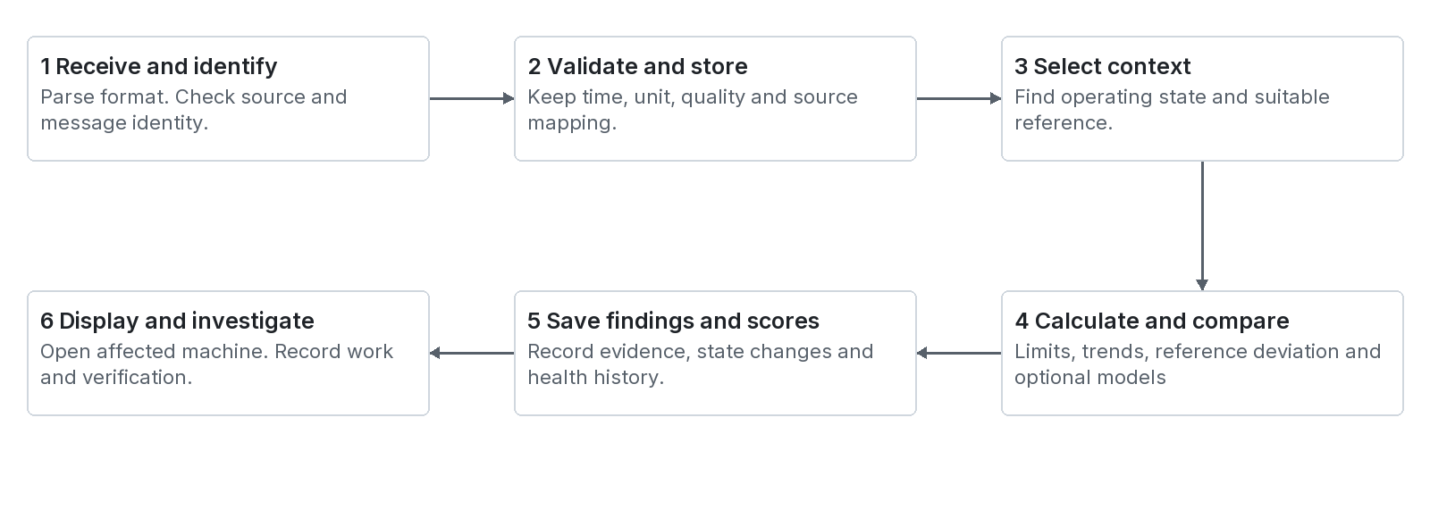
Figure 4 The shared receive store compare present and investigate process
The processing order protects meaning. A calculation is useful only when its input identity, time and quality are suitable. Rules and future ML models should use the same trusted measurement definitions.
Stage | Main input | Main output
Receive and resolve | Source message and mapping. | Known measurement identity or an ingestion problem.
Validate | Value, state, range, quality and time. | Usable observation or explicit quality limitation.
Store | Resolved observation. | Immutable timed evidence for later reads.
Find state and reference | Recent values and approved definitions. | Applicable operating state and reference coverage.
Calculate | Comparable valid windows. | Statistics, slopes, residuals and available features.
Evaluate | Limits, references, rules and health settings. | Findings, state changes and health history.
Present and act | Evidence and user role. | Page result, acknowledgement, case or work request.

Current server evaluation
backend/src/monitoring/evaluate.ts evaluates stored readings. It uses database settings, limits, state criteria and references. The plant runner calls evaluation at the configured period. The HTTP ingest service itself stores readings; it does not directly call evaluateFleet.
For a production physical source, verify that an independent evaluation schedule continues when simulation is disabled. Ingestion and evaluation are separate responsibilities. Stored readings alone do not guarantee timely new findings.

Traceability
A finding should lead back to the affected measurement, readings, applicable rule or reference and evaluation time. A work record should keep its finding or request link. This lets a reviewer reconstruct why work was proposed.
Basis: R6 ingest and evaluation; R8 runner; S7 Steps 3 to 13; S6 Section 7.

Limits persistence hysteresis and alarm states
Contents / Terms / Sources
A rule is an explicit condition. A limit check is one rule type. Other rules can compare several measurements, detect a sustained change or test a process requirement.

A teaching temperature rule
Apply only in the defined running state.
Raise Alert when temperature is at least 80 °C
for the configured persistence period.
Clear Alert only below 77 °C
for the configured clear period.
Evaluate a separate Critical boundary under its approved policy.

Persistence means that the condition must last. Hysteresis separates the raise and clear boundary. Both help prevent repeated changes near a threshold. A severe condition can have a different approved delay.
Concept | Teaching sequence | Result
Three sample persistence | 81, 79, 81, 82, 83 °C | The first high sample does not create a sustained alert. The last three meet this example.
Clear hysteresis | 79, 78, 76, 76, 76 °C | Values below 80 alone do not clear an active alert. The separate clear condition must pass.
State gate | High current during an accepted startup | Use the correct state logic. Keep applicable protection active.
Data gate | Temperature is stale | Withhold an unsupported current condition comparison and show unavailable data.

Samples are not always seconds
The current limit configuration has raise_samples and clear_samples. A three sample rule is not necessarily a three second rule. Its effective delay depends on the observations and evaluation schedule. Measure actual detection latency.

Finding states and human states
An active finding describes a current evaluated condition. A cleared finding means that its configured clear condition passed. Acknowledged means that someone saw it. A closed case means that the investigation workflow reached closure. These states are different.
The product uses Normal, Alert and Critical for condition. No data is separate. Older source examples use Watch, Warning or Danger. Map them explicitly at integration boundaries. Do not add conflicting condition words to current pages.
Basis: S6 Sections 1.3 and 12; S7 Steps 8 and 13; R7 measurement_limits; R1 colour roles.

Feature calculations with worked numbers
Contents / Terms / Sources
A feature is a useful description calculated from data. It can summarize a window or compare signals. Most basic features are mathematics. They do not require machine learning.
Feature | Teaching calculation | What it tells us
Mean | (50 + 52 + 55) / 3 = 52.33 °C | Average of three equally weighted samples.
Change | 55 - 50 = 5 °C | Difference from first to last.
Average slope | 5 °C / 2 min = 2.5 °C/min | Average change per time.
Residual | 78 - 58 = 20 °C | Difference from the expected temperature.
Ratio | 5.8 / 2.5 = 2.32 | Current vibration is 2.32 times the reference.
Relative flow deficit | (100 - 72) / 100 = 28% | Actual flow is 28% below this reference.
Differential pressure | 5.0 - 1.0 = 4.0 bar | Discharge pressure minus suction pressure.
Specific electrical energy | 30 kWh / 72 good units = 0.417 kWh/unit | Measured energy per accepted output unit.

Choose a window that answers the question
A one second waveform supports short signal analysis. A five minute window can summarize a process change. A multi day history can show slow changes. One window is not suitable for every machine or question.

Avoid four calculation errors
- Use real elapsed time. Unequal time gaps cannot be treated as equal intervals without a defined method.
- Align related signals within a suitable time tolerance. Do not combine an old pressure with a new flow.
- Treat a zero or missing denominator explicitly. Do not invent a ratio when its reference is unavailable.
- Use the right physics. Motor current alone does not give measured power, energy or pump efficiency.

What the current insights service calculates
The code includes least squares trends, Pearson correlation, reference deviation and projections from stored data. It aligns some cross signal calculations by acquisition minute. Correlation describes joint change. It does not prove that one signal causes another.
Basis: S9 Section 4; S6 Section 7.1; S2 I01.08 to I01.10; R9 insights-service.ts.

References health scores and evidence coverage
Contents / Terms / Sources
A health score summarizes selected monitored indicators. It can help a user choose where to look. Its meaning depends on the scoring method, inputs, weights and coverage policy.

A teaching weighted score
Indicator score | Weight | Weighted contribution
Temperature 85 | 0.20 | 17.0
Vibration 58 | 0.50 | 29.0
Current 80 | 0.20 | 16.0
Speed stability 95 | 0.10 | 9.5
Total | 1.00 | 71.5 out of 100

This formula is a teaching example from the guide concepts. It is not a claim that the current server uses these weights. The current evaluation reads the machine health model parameters from the database. Show that actual scoring basis in a production explanation.

What a score does not mean
A score of 72/100 is not 72% remaining life. It is not a 28% failure probability. It is not evidence that an unmeasured bearing is healthy. A score summarizes the indicators that the configured method evaluated.

Coverage must travel with the result
Coverage question | Example interpretation
Which measurements were usable | Three of four configured indicators were current.
Which parts are monitored | Motor electrical loading is observed. Bearing detail may be unavailable.
Which state is covered | The accepted reference covers steady operation at the stated duty.
What changed in the installation | A moved sensor needs a comparability review.
Is the reference accepted | A draft reference must not silently become the healthy basis.

One source for every page
The project requires liveMachineStatus() and the server fleet condition result to provide the same machine condition everywhere. Health bands come from the configured health model. The directory, drawing header and Diagnosis must not calculate competing values.
Historical health rows are derived snapshots. They preserve what was assessed at that time. The database must not hold a second freely editable current health field on the machine record.
Basis: S6 Section 12.3; S7 Machine Health Index; R1 and R6 evaluation; R7 health score migrations.

6 Rules machine learning and supported claims
Contents / Terms / Sources
Machine learning, or ML, learns a numerical relationship from data. It does not automatically understand every machine. A reusable platform can select different analyses for different equipment and signal sets.
Task | Question | Minimum evidence | Result limit
Rule monitoring | Has a defined condition occurred | Valid inputs and an approved rule. | Reports that rule result.
Expected behaviour | What value fits this duty | Representative healthy data and relevant context. | Expected value or range within covered conditions.
Anomaly detection | Is this pattern unusual | Suitable history, features and validated scoring. | Unusualness, not a confirmed fault.
Fault diagnosis | What problem could explain it | Discriminating signals and verified signatures or fault labels. | Supported hypotheses or validated fault classes.
Degradation tracking | Is condition changing over time | Comparable condition history and a defined indicator. | Observed or modelled progression.
Future value forecast | What value may occur later | Target history, future assumptions and tested forecast. | A value for a named horizon with uncertainty.
Failure risk | What is the probability of a defined failure | Verified event and event free histories, horizon and calibration. | Probability for that target and period only.
RUL | How much useful operation remains | A defined end event and validated lifetime evidence. | Conditional hours or cycles with uncertainty.

Rules and ML can share evidence
A fixed temperature limit checks a known boundary. An expected value model can identify unusual temperature for the current load before that boundary. Both results can be useful. The decision layer must preserve which method generated each result.

Current code and design intent
The inspected server provides rules, accepted reference comparisons, statistical trends and health based outputs. The source documents describe a broader ML architecture. They do not establish that trained fault, survival or RUL models are deployed.
Use explicit unavailable results when evidence is insufficient. A confident sentence from an assistant cannot replace model validation or physical inspection.
Basis: S3 all task specifications; S4 all prediction specifications; S6 Sections 1, 9 and 10; R9.

Training model routing and operating coverage
Contents / Terms / Sources
Design intent: one common analytics framework can host several model types. A model router selects a model only when the installed signals and operating conditions match its validated scope.

The model life cycle
1. Define the question, target and equipment population.
2. Collect valid time series with equipment and component identity.
3. Review healthy periods, faults and maintenance events.
4. Define features, units, windows and missing data behaviour.
5. Separate training and test periods without leaking future data.
6. Test on later periods and appropriate held out equipment.
7. Run in shadow mode and collect operator review.
8. Release a reviewed version with rollback information.
9. Monitor data changes, errors, false alerts and usefulness.

Choose by evidence rather than sensor count
Installed evidence | Eligible starting point | Output to withhold
Current and running state | Current limits and running state trend. | A specific bearing fault without suitable evidence.
Temperature with RPM or load | A contextual thermal comparison after baseline review. | Coverage of unobserved operating modes.
Pump pressures, flow and power | Duty relationships and measured resource performance. | A confirmed impeller cause from a flow deficit alone.
Waveform with speed and bearing data | Suitable spectral features and validated diagnostic checks. | Every fault type from one peak.
Reviewed lifetime histories | A defined prognostic development task. | A universal exact failure date.

Model registry proposal
Store model ID, version, task, family, feature schema, units, processing version, training scope and validated operating envelope. Also store validation results, release status and the reason a model is unavailable. This registry is a proposed extension unless an implemented service is identified.
A family model can share knowledge across similar pumps. An asset baseline can adapt to one installation. Both still need tests on the target equipment. A fixed number of days or a large sample count does not prove representative coverage.
Basis: S6 Sections 6, 9, 10, 14 and 15; S8 Section 6; S2 PS-12; S5 practical ML architecture topics.

Forecast risk remaining life and explanations
Contents / Terms / Sources
These outputs answer different questions. Keep the target, horizon, time basis and uncertainty beside the result. A graph extending into the future does not establish a validated lifetime model.
Output | Teaching result | How to read it
Future value | Vibration may be 4.2 mm/s after 24 hours. | A forecast of a measurement under stated future duty.
Time to limit | The current trend reaches 5 mm/s in about 12 hours. | A projection to that boundary. It is not necessarily failure time.
Failure risk | 12% chance of the defined flow failure in 72 operating hours. | A probability that needs event evidence and calibration.
RUL | 120 operating hours to a defined bearing end event. | A lifetime estimate requiring applicable evidence and an interval.
Feature explanation | Vibration features increased the model output. | An explanation of model influence. It does not prove physical cause.

What the current insights code does
The server fits linear trends to usable stored readings. It forms an approximate prediction band and projects time to an alarm boundary when supported by its trend checks. Its comments call some of these fields RUL. The product explanation must describe them as time to limit.
The current service returns null for failure probabilities. Its fit R² describes how well a line fits observed variation. R² is not failure probability or a calibrated forecast confidence percentage. The statistical band also needs empirical coverage tests before operational reliance.

Explainable AI
Design intent: a compatible explanation method can show which features influenced a specific model result. SHAP is one method discussed in the supplied guides. An assistant can translate that evidence into simple language with approved references. It must keep the measurement facts, model result and unconfirmed cause separate.

A useful prediction record
Keep the target, component identity, method version, generated time, input window, horizon, duty assumption, interval meaning and availability reason. Record the actual later outcome. This allows the team to test the prediction rather than judge its appearance.
Basis: S1; S4 Sections on forecast, failure risk and RUL; S2 PS-07 and PS-08; R9 insights-service.ts.

7 The database and its relationships
Contents / Terms / Sources
A database stores organized records. PostgreSQL is the current main database. A table holds one kind of record. A primary key identifies a row. A foreign key links it to another table.
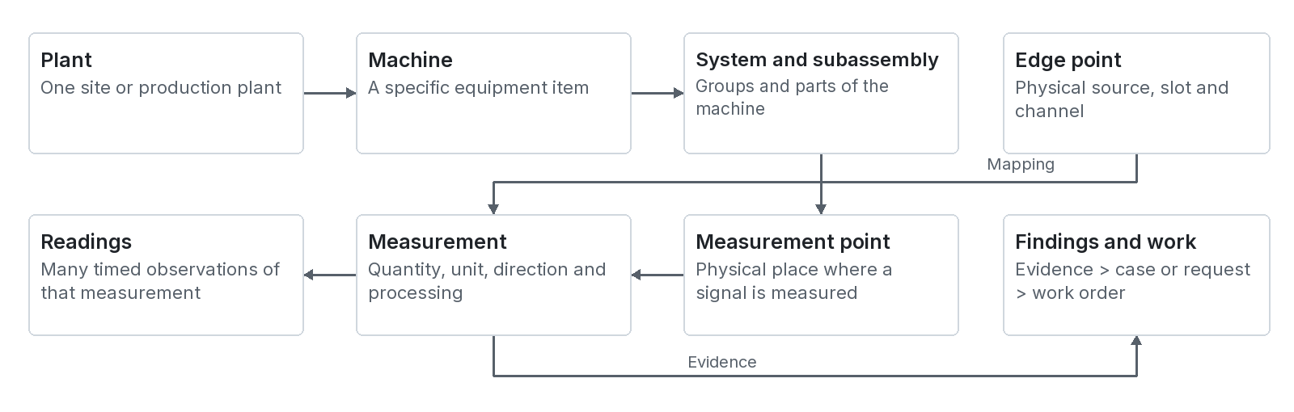
Figure 5 The main equipment measurement source and work relationships

Read the relationship from large to small
A plant has machines. A machine has systems. A system has subassemblies. A subassembly has measurement points. A point has measurement definitions. Each definition has many timed readings. An edge point maps a physical channel to a definition.
A finding can identify a machine and affected measurement. A case groups investigation evidence. A request can lead to a work order. A work record then records action and verification. These records answer different questions and must retain their links.

What normal form means here
The project requires third normal form, or 3NF. In simple terms, store each fact in the correct place. Use links to related facts. Do not copy a measurement unit into several editable records. Do not store an independent current health value on the machine and another on the page.

A database view is a saved read definition
A view joins records into a useful shape. v_measurement_context joins measurement information with the equipment hierarchy. v_edge_points joins physical channel records with the measurement description. These views help readers get complete context without copying it into source tables.
This figure is a teaching relationship diagram. The system and subassembly levels are shown together for space. The current machine_subassemblies parent link is machine_system_ref_id. Consult the migrations for exact keys and deletion rules.
Basis: R7 migrations 000, 001, 009, 044, 046 and 047; R1 database rules.

Database records for equipment sources and readings
Contents / Terms / Sources
Tables or views | What they hold | Why they exist
plants, machines, equipment_models | Plant identity, machine instances and reusable model descriptions. | Keep real equipment separate from common model data.
hierarchy_nodes and v_hierarchy_nodes | Plant, area, group and machine navigation structure. | Allow users to find equipment in its plant context.
machine_systems, machine_subassemblies | Functional groups and parts. | Connect each reading and result to the affected part.
measurement_points, measurements | Location and measurement meaning. | Keep units, quantity, direction, statistic and acquisition settings.
quantities, units, measurement_statistics, measurement_directions | Controlled vocabularies. | Use consistent definitions instead of unrelated free text.
measurement_states | Allowed discrete values and their condition meanings. | Interpret state measurements consistently.
measurement_limits, measurement_ranges | Engineering comparison boundaries and documented ranges. | Evaluate the correct configured check.
edge_brokers, edge_gateways | Message connections and gateway identities. | Connect the software to configured sources.
edge_sources, edge_cards, edge_points | Rack or PLC source, slot and channel mappings. | Trace a measurement to the physical path.
edge_formats, edge_gateway_topics | Custom JSON parsing and extra topic filters. | Support gateway message layouts and subscriptions.
readings | Timed scalar or state observations and quality. | Preserve acquired time separately from received time.
reading_hourly | Hourly counts and numeric aggregates. | Keep summarized history after detailed scalar rows expire.
v_measurement_context, v_edge_points, v_edge_gateways | Joined read views. | Supply context without redundant editable copies.

A measurement and two readings
The measurement row says that a tag is motor temperature in °C at a specific point. A reading row says that its value was 52 at one time. Another row says that it was 53 later. The unit is stable configuration. The values and times are observations.
A channel can exist before it is mapped. It can appear in Devices while its machine use is still unassigned. Commissioning must complete the measurement link before expecting machine history from that channel.
Basis: R7 current migration sequence; R5 edge registry types; R6 reading storage.

Database records for findings work and administration
Contents / Terms / Sources
Tables | What they hold | Main reader or writer
operating_states, operating_state_criteria, machine_state_periods | State definitions, conditions and observed state intervals. | Server evaluation and state history views.
reference_sets, reference_values | Draft or accepted reference data and its scope. | Reference review and comparison services.
process_requirements, rules, rule_inputs, rule_subassemblies | Required output and configured analysis relationships. | Monitoring evaluation.
findings, finding_acknowledgements, investigation_entries | Condition findings, acknowledgement and investigation notes. | Diagnosis and monitoring services.
machine_events | Timed changes and relevant machine history. | Evaluation and user workflows.
health_models, health_model_parameters | Scoring definition and configured parameters. | Evaluation and health band readers.
machine_health_scores, subassembly_health_scores | Historical derived score snapshots. | Evaluation writes; health and trend views read.
cases and case related tables | Hypotheses, checks, evidence, files, requests and case events. | Problems workspace.
work_orders and maintenance related tables | Work lifecycle, checklists, plans, readiness and recorded outcomes. | Maintenance services.
alert_checks, component_service_lives, component_service_events | Alarm follow up checks and component usage or service evidence. | Predictive and proactive maintenance views.
rule_verdicts, verdict_kinds | User review of a rule finding with author and time. | Analysis feedback.
users, roles, user_plant_access, user_sessions | People, permissions, plant scope and sessions. | Sign in and access services.
diagrams, asset_images, onboarding related tables | Drawings, image records, document packages and processing runs. | Configure and onboarding.
system_settings, simulation related tables, plant_state, plant_runner_lease | Timing, demonstration configuration, snapshots and runner ownership. | Settings and server runner.

The schema changes through numbered migrations. Migration 048 removes unused legacy tables, including ai_predictions, alarm_events and alert_acks. Do not use an old base schema alone as the current table map.
Some earlier project instructions mention rule_parameters and measurement_formulas. The latest inspected cleanup migration removes them. Follow the applied migration sequence when implementing a database change.
Basis: R7 migrations through 048; R10 case and maintenance services; R11 auth and access; R13 onboarding.

Retention capacity backup and data use
Contents / Terms / Sources
Retain enough evidence for the actual work. A live page needs recent readings. A long investigation needs history and changes. Detailed recordings can require much more storage than scalar summaries.

Teaching capacity estimate
Data pattern | Calculation | Uncompressed numeric payload
100 scalar values each second | 100 × 86 400 readings/day | 8.64 million rows/day before overhead.
8 byte numeric values only | 8.64 million × 8 bytes | 69.12 MB/day before IDs, timestamps, indexes and storage overhead.
One waveform channel | 10 000 samples/s × 4 bytes/sample | 40 000 bytes/s or 3.456 GB/day.
Eight waveform channels | 8 × 3.456 GB/day | 27.648 GB/day before metadata and compression.

These numbers are planning examples. A database row is much larger than one number. Hardware, network, index, backup and retention needs require measured load tests.

Current scalar retention path
The code reads readings.raw_keep_h and readings.hourly_keep_d from system settings. It summarizes older readings into hourly counts, minimum, maximum, sums, squared sums and first or last values. It then prunes detail and old hourly data. The actual durations are configuration values.
Hourly aggregates cannot reconstruct the exact old sequence or waveform. Retention changes the questions the system can answer. Keep original detailed evidence longer when an active investigation requires it.

Recommended operating design
- Assign a data owner and retention policy for readings, events, files and model evidence.
- Keep encrypted backups and test restoration. Include files as well as the database.
- Use a dedicated recording store for high rate waveforms when that feature is implemented. Keep metadata and access links in PostgreSQL.
- Define whether duplicate delivery, late data and replay can change historical aggregates. Test recovery with representative outages.

Data use
Readings support live values, trends and evaluation. Accepted references support comparison. Events explain context. Work outcomes support verification and possible future model labels. Keep these purposes clear. Reuse for ML needs correct component history, label review and access controls.
Basis: R6 rollupAndPrune; R7 readings and reading_hourly; S2 PS-10; S6 Sections 7 and 13.

8 How the pages connect
Contents / Terms / Sources
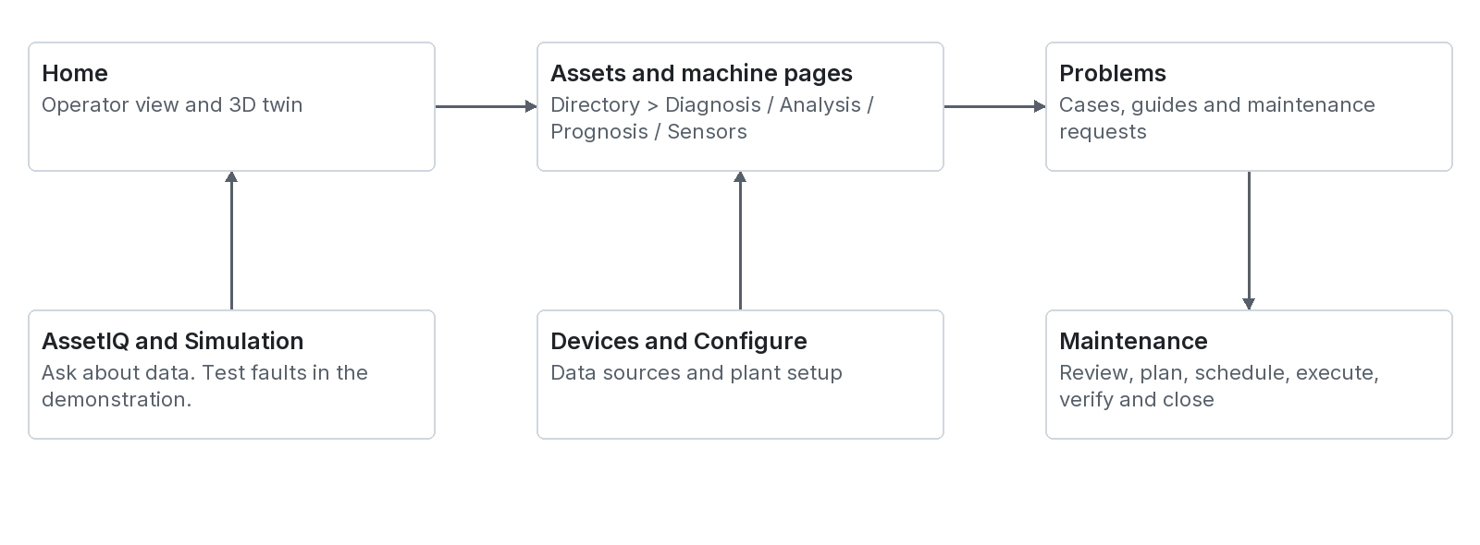
Figure 6 The primary navigation and the investigation to maintenance journey
The main rail contains Home, Problems, Assets, Maintenance, AssetIQ, Devices, Configure and Simulation. The root page selects these workspaces. Most are not separate filesystem routes.

Current machine navigation
Overview opens the Home Operator view for the selected machine. Diagnosis, Prognosis, Analysis and Sensors open in Assets. Trends, Rack and Shell temperature are quick views. A component selection narrows the machine pages to one subassembly.

Deep link structure
/?tab=assets&machine=P-01&page=diagnosis
/?tab=assets&machine=P-01&page=analysis&component=PART-ID
/?tab=home&machine=P-01&page=overview
/?tab=devices

Use real registered identifiers. The code recognizes tab, machine, page and component in the query. It supports browser Back and Forward. A link opens only data that the user is allowed to access.

Design notes and current code differ
The project rules describe four standard machine areas: Overview, Sensor Mapping, Diagnosis and Rack. The current code also exposes Analysis and Prognosis as main machine pages. Sensors is the current mapping view label. Rack and Trends open as quick views. The old health page ID resolves into the Diagnosis area.
This atlas describes the current structure while retaining the purpose of the required four areas. It does not invent separate web paths for each nested tab. Some workspace subviews, such as Maintenance pages, use saved browser state rather than an additional public query parameter.
Basis: R3 src/app/page.tsx and industrial-data-context.tsx; R15 assets-view.tsx and machine-nav.tsx; R1 machine page requirements.

Home Operator view and 3D twin
Contents / Terms / Sources | Assets / Diagnosis
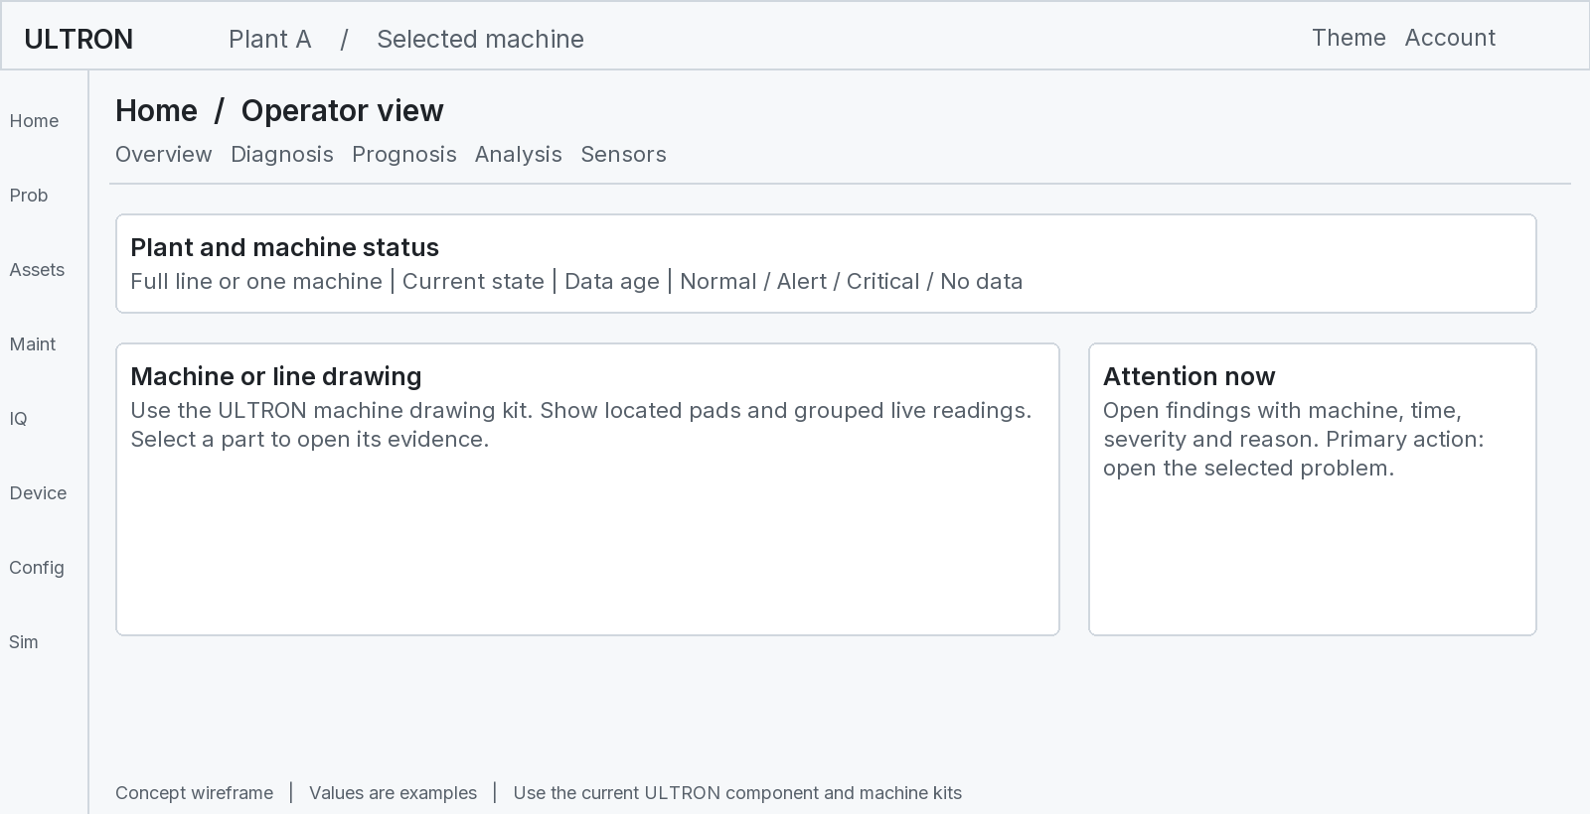
Figure 7 Home gives the operator a current situation and a route to evidence
Page purpose | Inputs | Outputs and links
Operator view | Selected plant, hierarchy, live readings, fleet condition and findings. | Machine condition, visible readings and findings. Machine selection opens Overview. Evidence opens Diagnosis.
3D twin | Plant or machine geometry with selected equipment context. | Spatial equipment view. Selection connects to the same machine context and pages.

Primary user: control room operator. Primary task: find the machine that needs attention now. Keep the plant, machine and data age clear. Do not make a user inspect every sensor before seeing an active critical finding.
The first machine bar selects the line or machine. The next bar selects a part. The status bar keeps condition and quick view links aligned across machine pages. The ULTRON logo returns to the full line Operator view.
No data state: keep the equipment visible but show unavailable measurements and coverage. A silent machine must not appear Normal merely because there is no active alarm.
Basis: R15 plant-home.tsx, operator-console.tsx and machine-nav.tsx; R3 root navigation; docs/ux-primary-tasks.md.

Assets directory and machine Overview
Contents / Terms / Sources | Overview / Sensors / Diagnosis
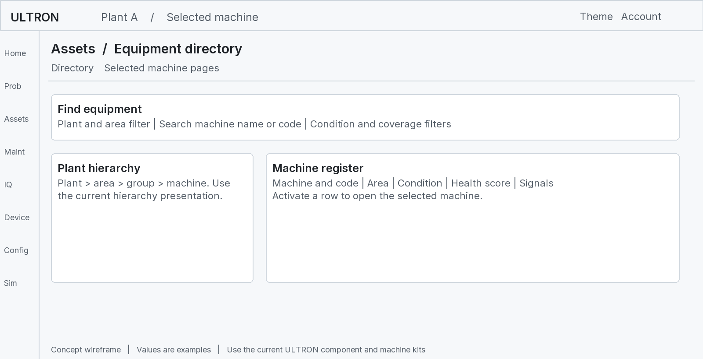
Figure 8 The directory finds equipment before the user opens its machine workspace

Purpose and source data
The directory organizes the fleet by hierarchy, machine and plant. It reads equipment records and the shared fleet condition result. It should show a consistent machine name, code, area, condition and available score.

Machine Overview
Overview is the machine drawing in Home. It shows parts, measurement pads, grouped readings and machine condition. Its job is to answer what is happening on this machine. The drawing is also a navigation surface: selecting a part can scope the detailed pages.
Action | Destination | Context to keep
Activate a machine | Selected machine workspace. | Plant and machine identifier.
Open Overview | Home Operator view. | Selected machine and selected part where applicable.
Open an abnormal part | Diagnosis or detailed machine evidence. | Machine, subassembly and relevant finding.
Open Sensors or Rack | Mapping view or hardware quick view. | The same machine and measurement source.

The machine drawing must use MachineSvg, token based paint and measurement pads from the project machine kit. In a wireframe, the marked drawing area is a placeholder for that existing kit. It is not a new drawing style.
Do not copy live health into the directory model as an independent number. Use the shared condition source. The same machine must have the same condition in the directory, header and drawing.
Basis: R15 assets-view.tsx and hierarchy components; R1 machine kit and live health rules.

Sensors and machine sensor mapping
Contents / Terms / Sources | Trends / Devices / Diagnosis
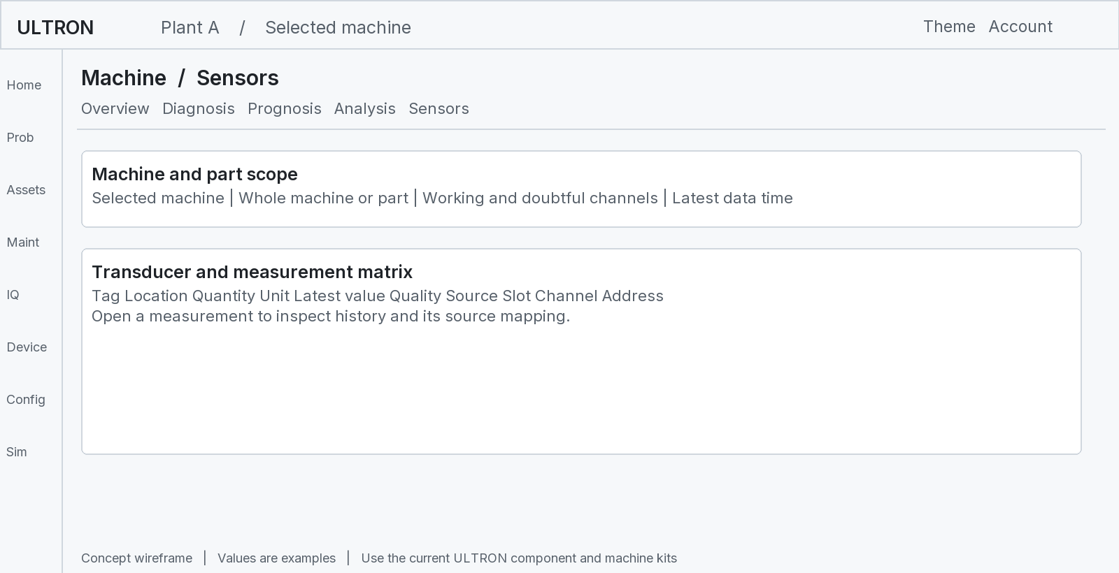
Figure 9 Sensors connects the physical measurement to its software definition
Primary user: instrument technician. Primary task: check readings, quality and wiring. This view is the current machine sensor mapping area. The device tree describes the physical path; this matrix describes its use on a machine.
Input | Displayed meaning | Next link
Measurement definition | Tag, name, point, quantity, unit and direction. | Measurement history.
Latest reading and quality | Current value, acquisition time and usability. | Trends and quality investigation.
Source binding | Gateway, source, card, channel and address. | Devices or Rack.
Acquisition metadata | Sampling, window, publication rate and band when known. | Configuration review.
Limit or range record | Applicable comparison or sensor range. | Limit basis or Diagnosis evidence.

Do not use sample rate to mean publication rate. A channel address is not the same as a machine tag. A source channel can exist without a measurement mapping. Show that unassigned state clearly.
For a bad installed sensor, show the quality problem and source path. For a sensor absent by design, show the scope of available analysis. Do not report unmeasured quantities as zero.
A sensor history link should preserve the measurement ID and time range. A device link should preserve gateway, source, slot and channel. These links connect the software problem to the actual instrument path.
Basis: R15 machine-sensor-mapping-view.tsx; R5 edge registry; R7 v_measurement_context and v_edge_points; S2 PS-10.

Diagnosis and the evidence behind condition
Contents / Terms / Sources | Analysis / Trends / Work
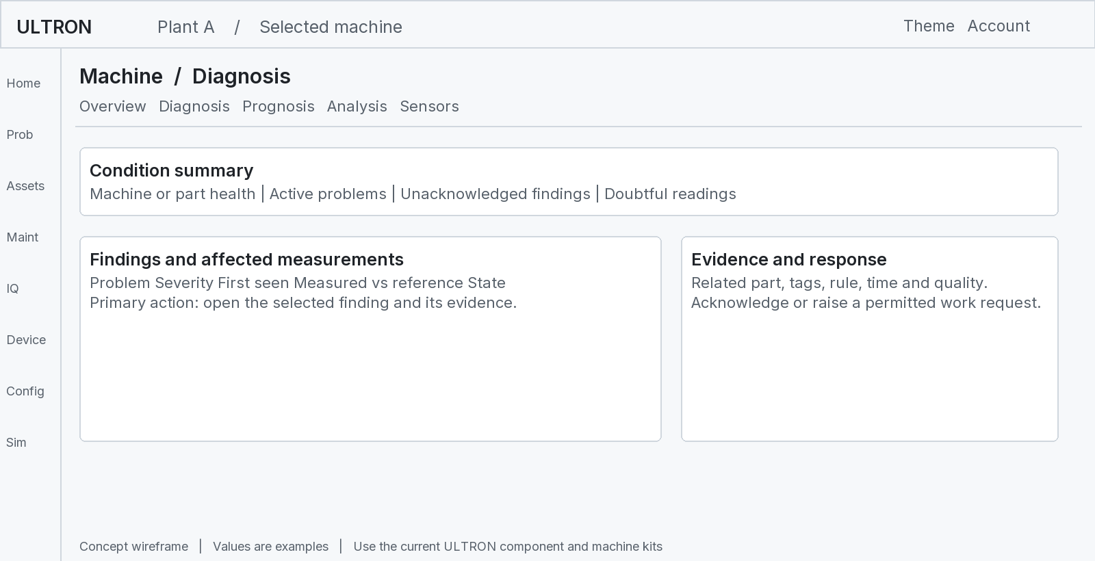
Figure 10 Diagnosis explains which readings and parts drive the current condition
Primary user: engineer. Primary task: identify the part and measurements that caused the displayed condition. Read the facts before acting on a suspected cause.
Data in | Information out | Linked work
Current machine condition and score history | Current condition with the configured score basis. | Open affected part or historical trend.
Findings, rule descriptions and measurements | Evidence, actual values, reference or threshold and duration. | Acknowledge, investigate or request work.
Data quality and operating state | Whether the comparison is usable and covered. | Open sensor history or Devices.
Fault library and supported analysis | Possible explanation and checks where supported. | Analysis, Problems case or Maintenance.

The project design mentions spectral classification, frequency exploration and severity zones. These require the correct signal and metadata. A visible diagnostic panel does not prove that a trained spectral classifier is deployed. The current evidence must name its method.
The design also mentions ISO 10816-3. Do not copy one universal severity band from the page name. A real assessment needs an applicable standard, edition, machine class, support and measurement definition. Record the reviewed basis.
Acknowledgement does not clear a physical condition or close work. A cleared finding does not prove a verified repair. Keep those actions and records separate.
Basis: R15 diagnosis-view.tsx and diagnosis-model.ts; R6 findings; R1 page requirements; S3 diagnosis specification.

Analysis and investigation of a suspected cause
Contents / Terms / Sources | Diagnosis / Cases / Work
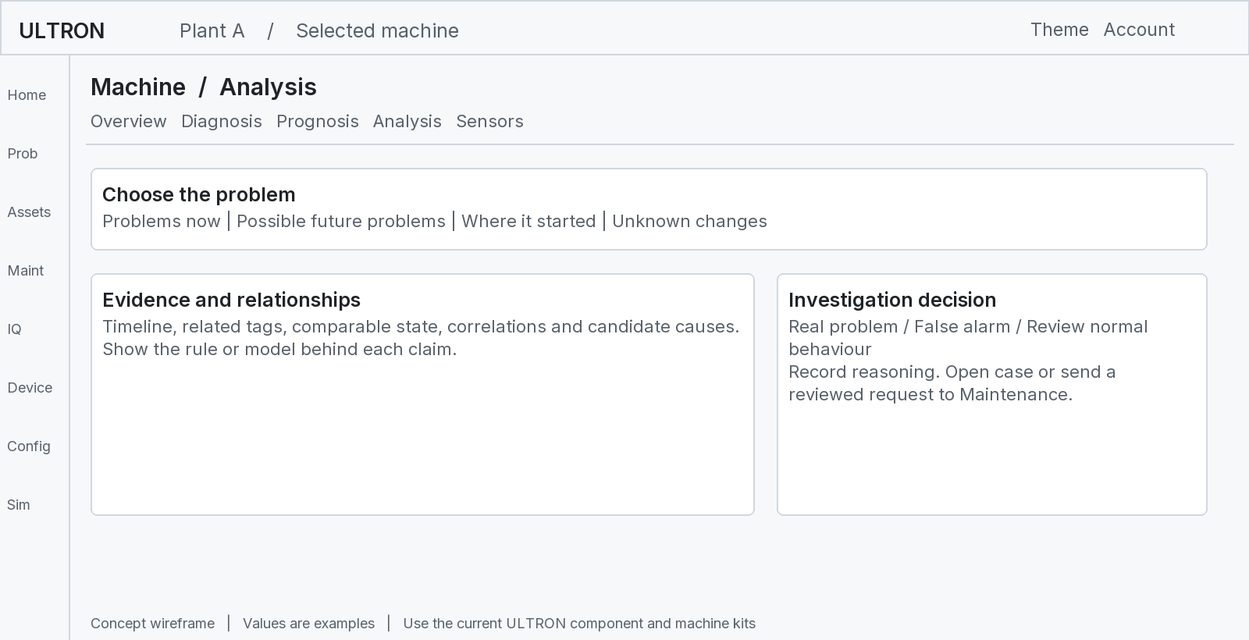
Figure 11 Analysis supports a reviewable investigation and recorded user judgement
Primary user: reliability engineer. Primary task: understand why one problem may be happening and what it affects. The page groups evidence around a selected problem rather than a large undirected sensor list.

Inputs and outputs
Inputs include findings, rules, recent measurements, accepted references, correlation results, fault library context and user feedback. Outputs include an evidence narrative, candidate issue source, alternative explanations and a recorded investigation judgement.
The current rule_verdicts table records who marked a rule result as a real problem, false alarm or new normal. These labels describe a review decision. They do not independently confirm a physical cause or replace reference acceptance.
User action | Next destination | Evidence to retain
Inspect a tag or relationship | Trends or Sensors. | Measurement ID, time range and operating state.
Start structured investigation | Problems case. | Finding, suspected part and supporting records.
Request corrective work | Maintenance review. | Reason, scope, priority basis and approved procedure.
Review expected behaviour | Reference review path. | Inspection evidence, covered state and acceptance record.

A strong correlation does not prove causation. If two readings changed after a recipe change, the recipe can explain both. Use event timing and equipment connections to test hypotheses.
An unconfirmed cause should remain a hypothesis. Record the inspection result separately. Where the interface suggests a failure period, check that a validated target supports that statement.
Basis: R15 analysis-page.tsx; R9 insights-service.ts; R7 migration 043; S1 and S3.

Prognosis and planning from future estimates
Contents / Terms / Sources | Trends / Work
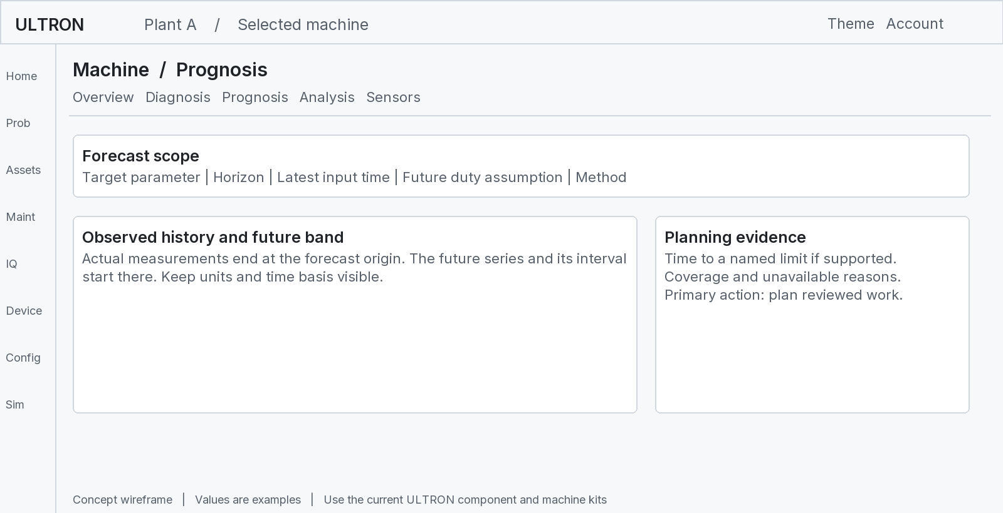
Figure 12 Prognosis connects a scoped future estimate to maintenance planning
Primary user: planner. Primary task: understand what may need work next. A forecast must show what it predicts, when it applies, and the conditions it assumes.

Current data and available horizons
The current insights service offers 1 hour, 6 hour, 24 hour, 7 day and 30 day display horizons. It calculates trends from stored readings and projects health from score history. An offered horizon is a display choice. It is not proof that that far ahead is reliable.
Shown result | Required explanation
Future parameter | Target measurement, unit, origin time, horizon and method.
Prediction band | What the interval represents and whether coverage was evaluated.
Time to limit | The exact boundary and the trend assumptions.
Remaining life or risk | Show only if a separately validated lifetime or event model exists.
Unavailable estimate | Missing history, weak trend, no boundary, unsuitable state or other reason.

For the current code, describe the projected limit crossing as time to limit. Do not present a linear boundary projection as a proven time to equipment failure. The server currently returns no estimated failure probabilities.
Plan work through the maintenance review process. The planner must also consider criticality, inspection evidence, shutdown access, procedures and resources. A forecast line alone is not a work authorization.
Basis: R9 forecast horizons and statistical functions; R15 prognosis-page.tsx; S4; S2 PS-07 and PS-08.

Trends shell temperature and Rack quick views
Contents / Terms / Sources | Sensors / Diagnosis / Devices
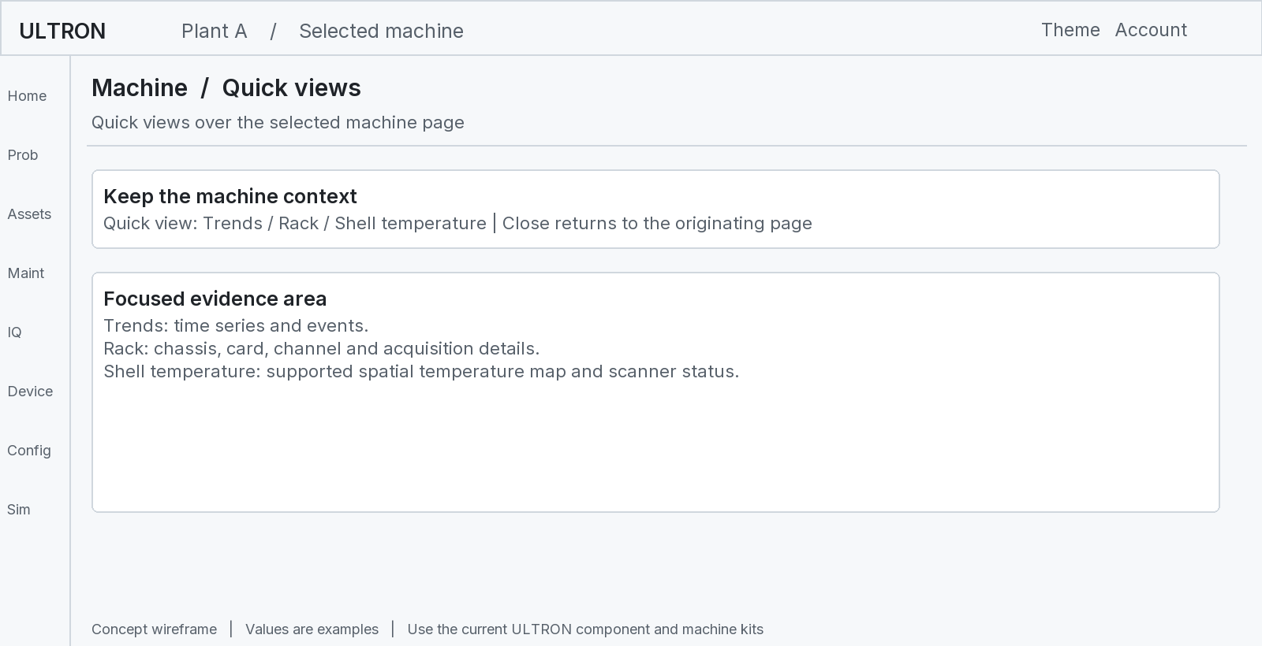
Figure 13 A quick view answers one focused question without losing the machine
Quick view | Purpose and inputs | Outputs and links
Trends and history | Inspect measurement history, quality, limits and machine events. | Single or grid time series, baseline comparisons and event chronology. Link to sensor or finding.
Rack | Trace acquisition hardware using the machine source mapping and known chassis information. | Card and channel allocation, known hardware details and connection evidence. Link to Devices.
Shell temperature | Inspect a supported kiln shell map and scanner information. | Spatial thermal view and abnormal areas when actual source data exists.

Trends and History are a merged evidence area in the required product design. The current code exposes Trends as a quick view and reads machine event history. It should not create a second conflicting alarm journal.
The Rack design asks for cabinet specifications, a 19 inch chassis view and PTP clock status. PTP is a clock synchronization method. Display these as live facts only when the hardware provides them. A stored chassis record does not prove live PTP lock or packet loss.
A slowly sampled trend is not a fast vibration waveform. A thermal map is not a scalar temperature series. The current edge types explicitly distinguish video and status plus map channels. Show the data kind and availability.
Basis: R15 assets-view.tsx, trends-view.tsx, acquisition views and thermal-view.tsx; R5 PointDataType; R1 required Rack and Diagnosis scope.

Problems cases guides and maintenance requests
Contents / Terms / Sources | Diagnosis / Work order
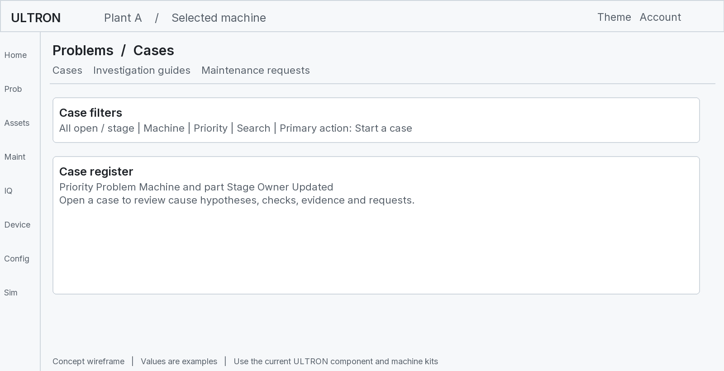
Figure 14 Problems turns an observed concern into a structured investigation
View | Purpose | Inputs and outputs
Cases | Work a problem from first sign to checked repair. | Read findings, observations and case history. Save owner, stage, hypotheses, checks and evidence.
Investigation guides | Help the engineer choose a structured investigation. | Read configured guides and check items. Use them for the applicable case.
Maintenance requests | Review work proposed from investigations. | Read case requests and decisions. Link accepted work into the maintenance process.

What a case contains
A case can relate a machine, part, measurements, cause hypotheses, checks, files, saved series and events. It preserves what was known at each stage. The owner can compare hypotheses and record what inspection established.
A finding is generated by monitoring. A case is an investigation record. A maintenance request proposes work. A work order manages approved execution. One record must not silently stand for all four.

Example journey
An engineer opens a vibration finding from Diagnosis. They start a case for Pump P-01. They check sensor mounting and operating duty. Inspection confirms looseness. They request corrective work and later attach verification evidence. Closure should state what was confirmed and what remains unknown.
The rail problem count comes from the same condition endpoint used by Problems. It should not be a separately counted local alarm list.
Basis: R10 case-service.ts and routes/cases.ts; R15 problems-view.tsx; R7 migration 028; R1 rail rules.

Maintenance Overview and the work process
Contents / Terms / Sources | Planning / Work orders / Calendar
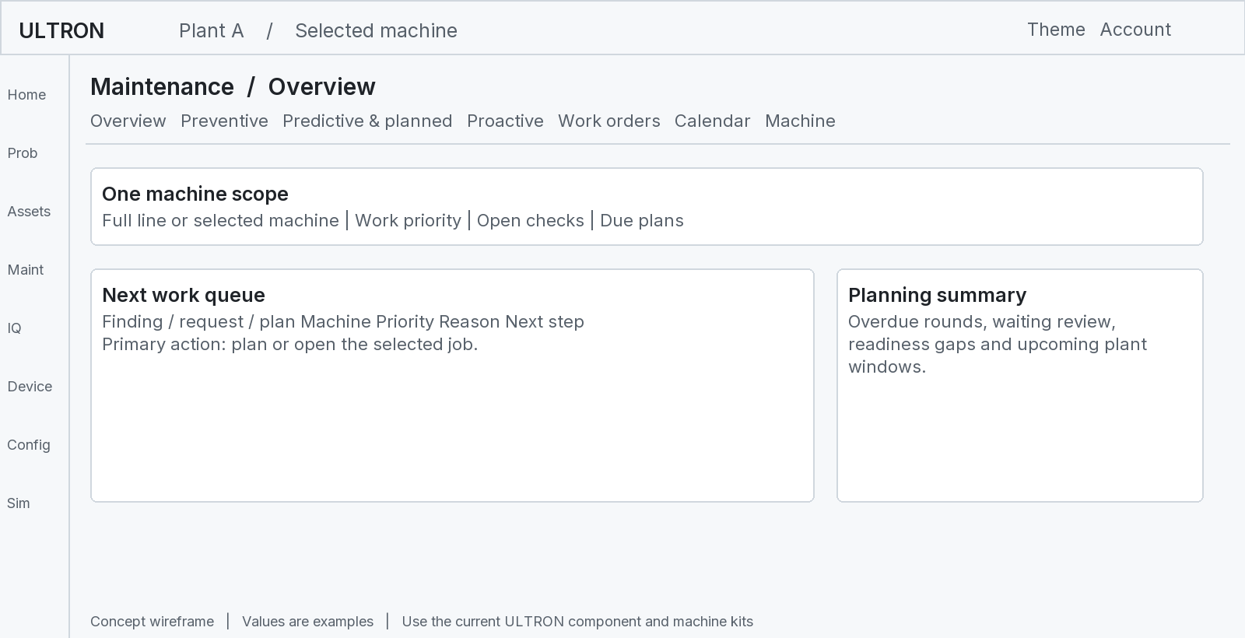
Figure 15 Maintenance ranks work and keeps the selected machine scope
Primary user: maintenance planner. Primary task: decide and schedule the next jobs. The workspace reads a line level maintenance model and filters it by the selected machine. Plans, work orders, results and audit history come from the backend.
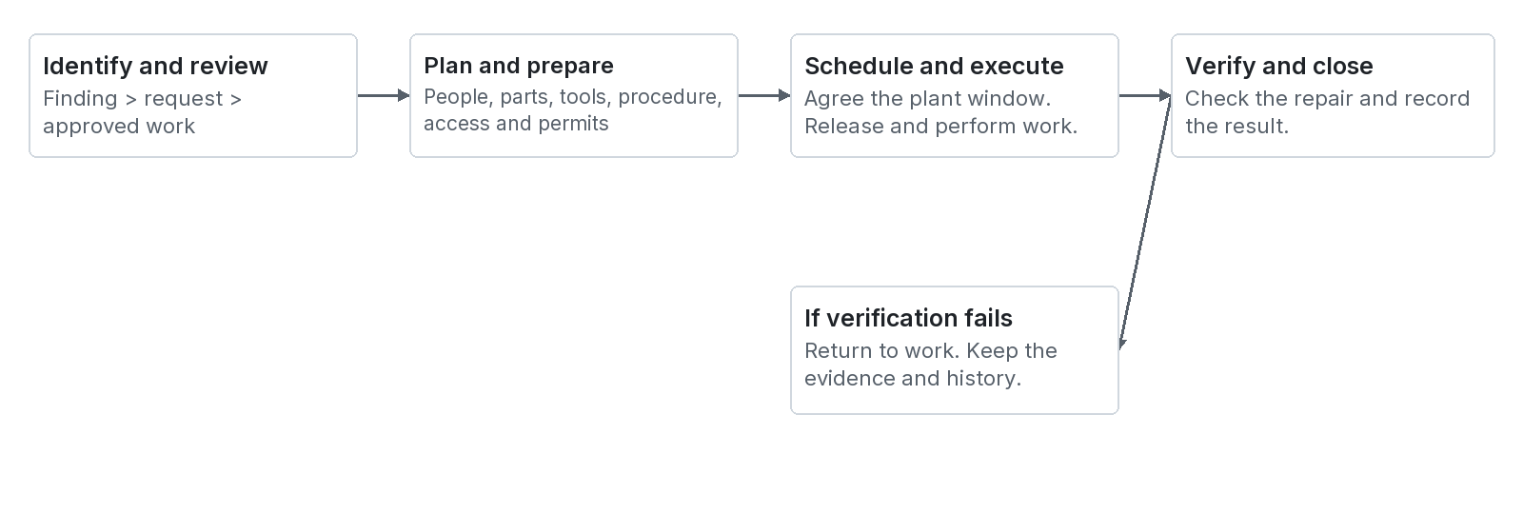
Figure 16 The maintenance journey from identification to verified closure
Priority describes urgency. Stage describes progress. A high priority job can still be awaiting review. A completed execution can still be awaiting verification. The interface must show both facts.
Seven main planning tabs contain nine views. Work orders also contains History and performance. Calendar also contains People, parts and shutdowns. Machine maintenance gives an equipment focused view.
An alert can raise a check. A check is not automatically an authorized repair. The planner must review the scope and prerequisites before release.
Basis: R10 maintenance-workspace.tsx, pms-ui.tsx and shared/lib/pms.ts; S4 maintenance recommendation specification.

Preventive predictive and proactive maintenance
Contents / Terms / Sources | Overview / Work order
These views answer different planning questions. Keep their triggers visible. A calendar interval, an alarm follow up and a usage based service estimate are different evidence sources.
View | Purpose | Main input | Main output and next link
Preventive | Perform defined work at the correct interval or trigger. | Approved checklists, route, frequency, machine unit and last results. | Due or overdue tasks. Open the plan or task. Record the round and any defect.
Predictive and planned | Review condition triggered checks and work proposed by engineers. | Open findings, alert checks, case requests and planned jobs. | Reviewed check or job with evidence, owner, priority and due basis. Open a work order.
Proactive | Review component service exposure and replacement needs. | Component installation, usage, service limits and events. | Remaining service allowance or supported estimate. Review replacement or plan work.
Machine maintenance | Review all relevant maintenance for one machine. | Machine specific plans, work orders, findings and records. | Equipment focused work history and next tasks. Open the same job detail.

Preventive example
A weekly inspection plan defines the correct tasks for a machine. The technician records each result. A defect can propose corrective work. Marking a checklist task complete does not prove that a later condition finding is repaired.

Predictive example
A sustained vibration finding creates a follow up inspection need. The engineer reviews evidence and proposes a job. The work request should retain the source finding and investigation reason. Do not create repeated duplicate jobs for the same active issue.

Proactive example
A component has a recorded installation date and an approved service allowance in operating hours. The view can show remaining allowance against that policy. This is a maintenance interval calculation. It is not automatically an ML estimate of physical failure time.

Shared rules
Use configured vocabulary, priorities, response times and checklist content. Unknown response time remains unknown. Record deferral and rejection reasons. Preserve component replacement history so old and new component lives are not mixed.
Basis: R10 page-preventive.tsx, page-predictive.tsx, page-proactive.tsx and page-machine.tsx; R7 migrations 014, 015 and 040.

Work orders and verification
Contents / Terms / Sources | Cases / Calendar / Diagnosis
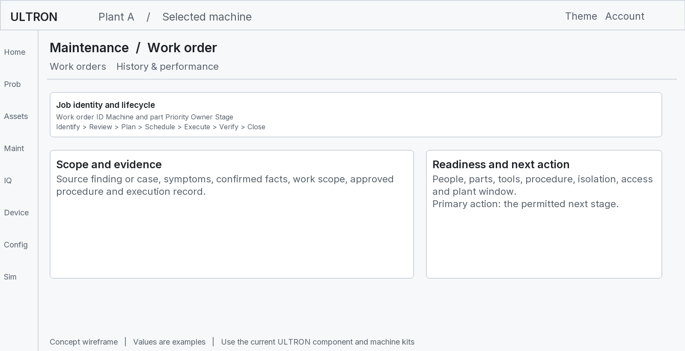
Figure 17 The work order separates approval execution verification and closure
Stage group | What must be established
Identify and review | Reason for work, machine scope, supporting evidence and approval decision.
Plan and ready | Work instructions and readiness requirements. Record missing resources.
Schedule and release | Agreed time, plant access and required authorization.
In progress | Who did the work, what they found and what they changed.
Awaiting verification | Execution is finished. A suitable person must check the outcome.
Completed and closed | Verification passed. The record can then reach the permitted closure stage.

The current code also supports on hold, deferred, rejected, merged and cancelled outcomes. Alternative dispositions require a reason where configured. A failed verification returns the job to work instead of declaring it resolved.
Readiness keys in the current workflow are spare parts, qualified personnel, special tools, work instructions, isolation and permits, access and cooling, and a plant window. Digital readiness supports planning. It does not replace site permits or equipment isolation procedures.
Verification should compare the new condition under suitable duty, inspect the work result and retain evidence. “Vibration decreased” is useful evidence. “The sensor stopped sending” is not evidence that the machine recovered.
Basis: R10 shared/lib/pms.ts stage transitions and readiness; work-order-detail.tsx; S7 Step 13.

Calendar resources history and performance
Contents / Terms / Sources | Work order / Overview
View | Purpose | Receives | Produces or opens
Calendar | Coordinate planned work in time. | Plans, work orders, due dates, schedules and selected machine scope. | A view of upcoming and overdue work. Open or schedule the linked job.
People parts and shutdowns | Check whether proposed work can be done. | Personnel, spare parts, special tools, procedures, access and plant window readiness. | Readiness gaps and resource planning context. Return to Calendar or work order.
History and performance | Review completed and open work evidence over time. | Maintenance events, task results, work order transitions and verification records. | Chronological history and supported performance summaries. Open the original record.

Example of a scheduling conflict
A bearing inspection needs a stopped machine and cooled access. The proposed time overlaps production. The Calendar should expose the conflict or missing readiness. The planner can select an approved plant window. A prediction does not override the production and isolation decision.

What a useful history record includes
- Which machine and component were involved.
- The source finding, request or plan.
- Who made the decision and when.
- What was inspected, repaired or replaced.
- Which procedure and parts were used where relevant.
- How the result was verified and whether the job reopened.

Performance measures need definitions
Backlog, overdue work, completion rate and response time need an agreed start and end event. For example, acknowledgement time and verified repair time are different measures. Do not label either one as total repair time without its definition.
Mean time between failures needs a defined failure event and operating exposure. Mean time to repair needs defined repair start and finish times. The source documents do not establish a validated fleet reliability metric merely by supplying a maintenance history page.

Links between planning and monitoring
A work order links back to the source case or finding. A completion record links forward to verification. The measurement history should show the intervention time. This makes before and after comparisons possible without deleting the old evidence.
Basis: R10 page-calendar.tsx, page-resources.tsx and page-history.tsx; S2 PS-11; S7 Steps 5 and 13.

AssetIQ questions and evidence links
Contents / Terms / Sources | Diagnosis / Analysis
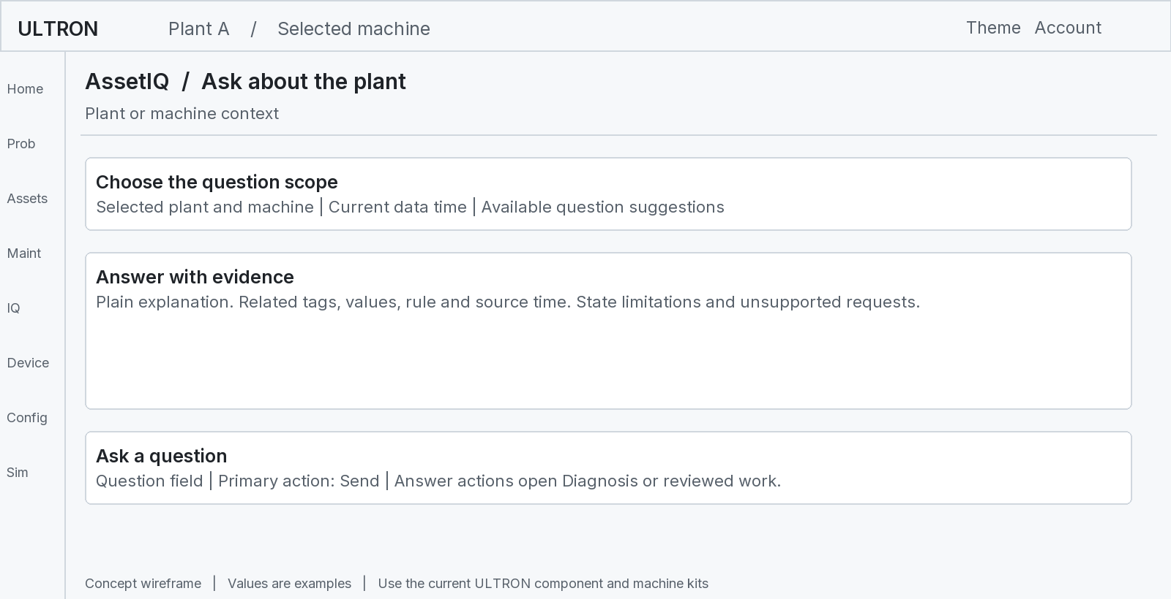
Figure 18 AssetIQ makes available monitoring evidence easier to read
Primary user: anyone reviewing the plant. Primary task: ask a question and receive a direct answer with evidence. Examples include “Why is this reading abnormal” and “Which problem should we check first”.

Current implementation
The inspected copilot engine is a deterministic TypeScript intent router with templated answers. It reads the live plant frame and database findings and events. Its own file states that it does not call an LLM or external network. This differs from the broader AI explanation design in the supplied documents.
The engine can route a question to a named machine in the plant. It keeps question focus for suitable follow up wording. Available actions can open the machine Diagnosis page with a rule focus. Some actions depend on the supported primary machine operations loop.

What an answer must keep clear
Part of answer | Example
Observation | Vibration is above the accepted reference.
Method | A configured rule or reference comparison generated the finding.
Unconfirmed explanation | Looseness is one hypothesis that needs inspection.
Action link | Open the related Diagnosis or case evidence.
Limitation | No validated failure probability is available.

An answer quality number in a demonstration response must not be read as a calibrated probability. Always inspect the underlying method and evidence. For a machine without usable data, show that limitation rather than inventing a general answer.
Basis: R12 copilot-engine.ts, copilot-provider.tsx and assetiq-hub-view.tsx; S1; S6 Section 12.2.

Devices Overview and Device tree
Contents / Terms / Sources | Formats / Sensors
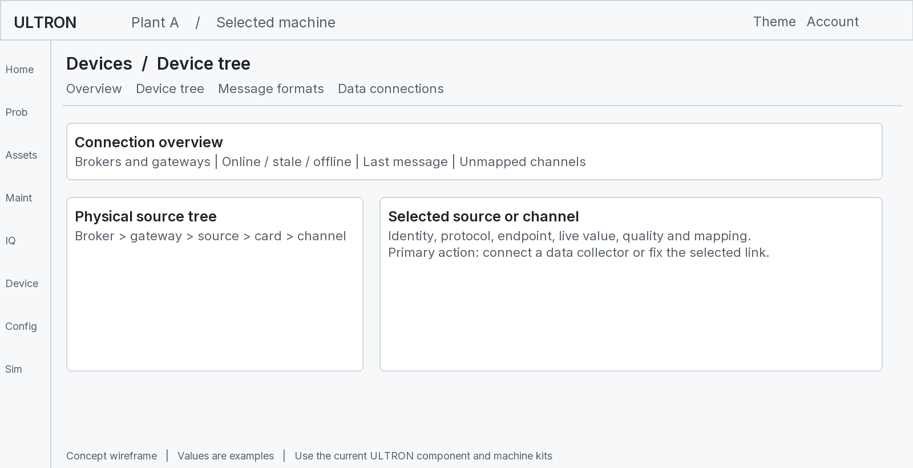
Figure 19 Devices follows the physical path to find where data stops
Primary user: instrument or IT technician. Primary task: find and fix a broken measurement path. This area focuses on transport and channel identity rather than equipment diagnosis.
View | Inputs | Outputs and links
Overview | Registry and backend MQTT live status. | Connection health, last data time, traffic and mapping gaps. Open affected gateway or source.
Device tree | Broker, gateway, source, card and point records. | The acquisition hierarchy and channel details. Map a point to a measurement.
Connect flow | Discovered devices or captured channels plus user confirmation. | Reviewed gateway, source and channel configuration. Test data and link to Sensors.

Example investigation
Home shows no new temperature. Open Sensors to find its source path. Open Devices for that gateway. If the broker is offline, investigate that link. If other channels update but this one does not, inspect its mapping and instrument path. Equipment condition can remain unknown during the outage.

Protocol choices are configuration
The registry supports source labels such as rack, PLC, SCADA, DCS and analyzer. It also lists several industrial protocol names. A saved protocol label does not implement a driver. Verify the gateway connector for each installation.
A channel can be live but unmapped. The backend can show it in the traffic view while no machine reading is persisted. Complete the measurement binding before using it in monitoring.
Basis: R5 shared/types/edge.ts; R15 devices-view.tsx and device tree components; R5 MQTT recordReadings.

Message formats and MQTT connections
Contents / Terms / Sources | Devices / Sensors
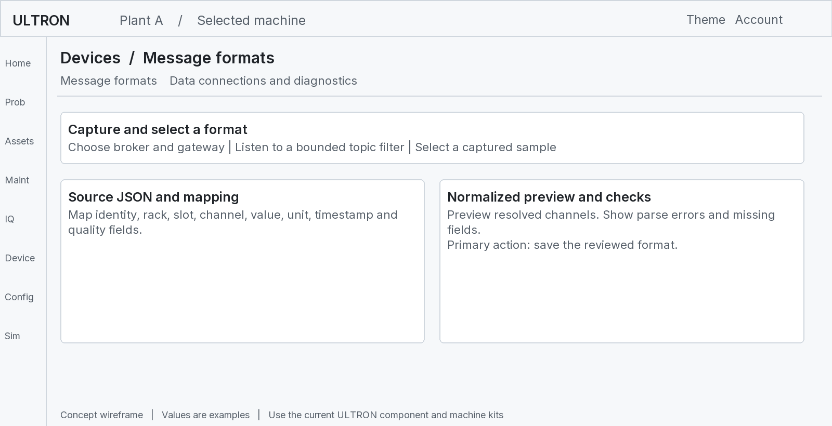
Figure 20 Custom formats translate a gateway message into the common source shape
Area | Purpose | Important evidence
Message formats | Map supported custom JSON messages into the channel model. | Captured input, mapping paths, normalized output and format version.
MQTT connections | Set broker connection details and inspect data transport. | Host, port, TLS, configured subscriptions and live connection state.
Diagnostics | Explain message loss or rejection. | Traffic, sequence gaps, duplicates, quarantine and last error.
Command console | Send only configured allowed gateway commands. | Target, allowlist, request ID, response and timeout.

The current broker record supports TLS settings and optional client certificate configuration. A saved setting is not proof that a secure session was established. Test the negotiated connection and deployment access policy.
The backend provides an SSE stream to the browser. The browser reads server live state; it does not create a separate browser connection to every plant broker.
Quarantine means that a message failed a parsing, identity or schema check. Inspect its reason before changing the format. A malformed value must not silently become a real zero reading.
The command route enforces a broker command allowlist. The inspected route does not itself demonstrate a complete user authorization boundary. Review authentication, plant scope and network exposure before enabling production writes.
Basis: R5 MQTT routes, runtime and validator; R15 formats and mqtt components; R11 access boundaries.

Configure plants machines users and settings
Contents / Terms / Sources | Onboarding / Devices
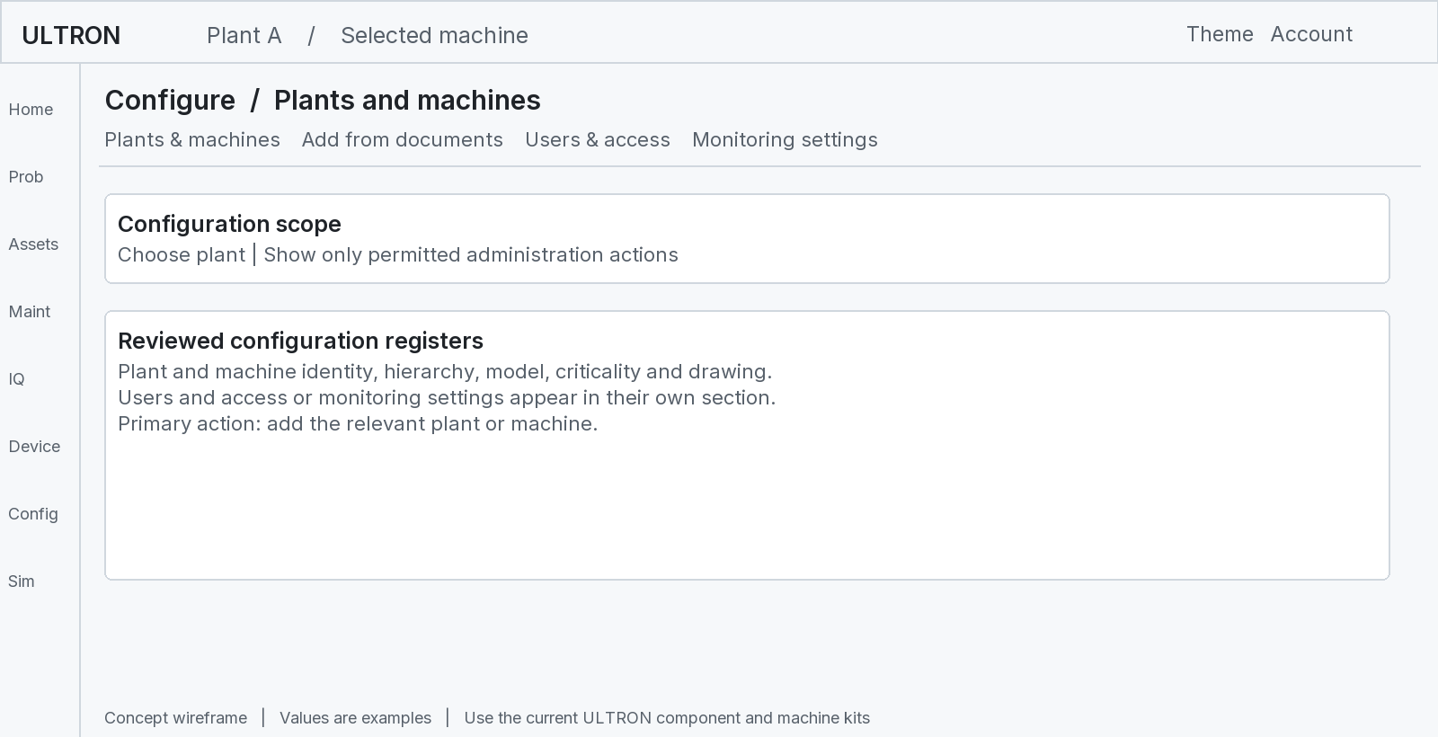
Figure 21 Configure defines the equipment people and monitoring settings
Section | Purpose | Inputs and persistent outputs
Plants and machines | Maintain the equipment register. | Names, codes, location, hierarchy, ratings, drawing and criticality. Save authorized registry changes.
Users and access | Control who can see and change plant records. | User profile, role and read, write or admin plant access. Save permitted access changes.
Monitoring settings | Control shared evaluation and history behaviour. | Database setting keys, value and unit. Save validated changes for readings, evaluation, reference, health and sign in.
Add from documents | Build a reviewed plant draft from source evidence. | Uploaded documents, images and extracted candidates. Continue to draft review and commit.

The database is the authority for domain configuration. Pages must not keep hidden lists of limits, machine IDs or demo numbers. Show unknown fields as unknown until a reviewed value exists.
Service state and monitored condition are separate. A machine can be scheduled for maintenance while its monitored condition is Normal. A machine marked Operational in configuration can still have a Critical finding.
Changes to mapping, limits, references and calibration can affect conclusions. Keep their history and basis. Confirm the actual database audit and change controls rather than assuming every editable field is fully versioned.
Basis: R15 configure-view.tsx; R11 user and access services; R7 settings and current normalized schema; R1 database rules.

Add from documents and reviewed onboarding
Contents / Terms / Sources | Configure / Commission
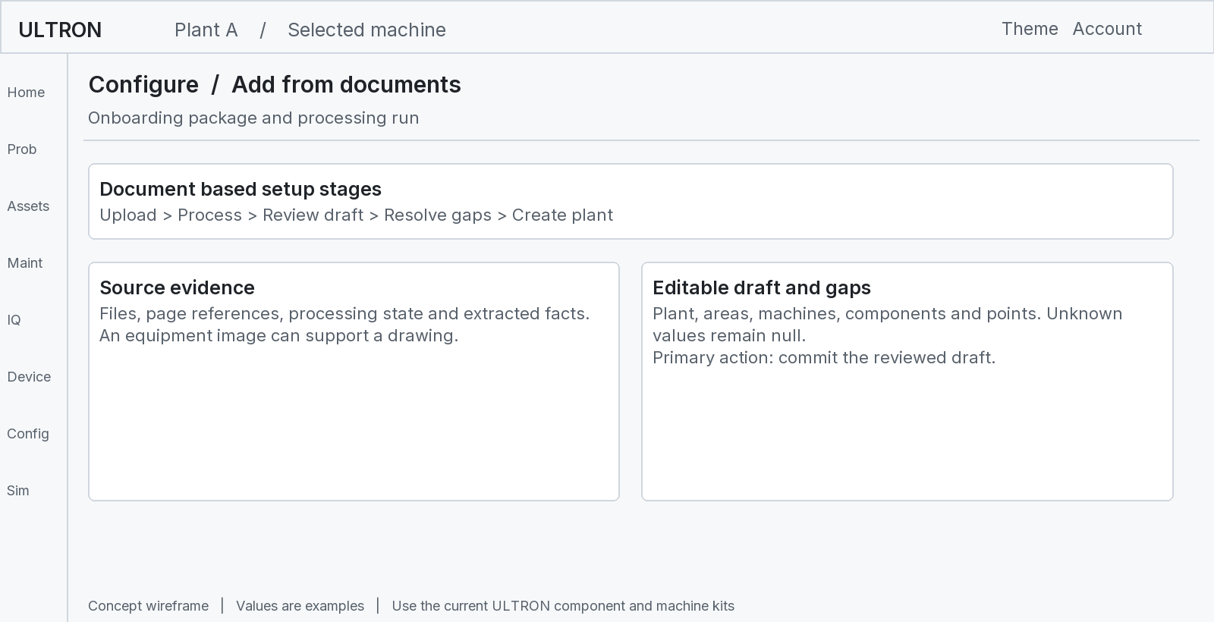
Figure 22 Onboarding separates source extraction draft review and database commitment
Current code uses an ultron.onboarding/1 draft. Draft local keys connect areas, machines, components and points before persistent records exist. A source reference can identify the file and page behind a candidate fact.

The full information flow
1. Create or open the document package.
2. Upload the applicable documents and images.
3. Process the waiting files with the available processor.
4. Review extracted identity, tags, ranges, units and limits.
5. Resolve gaps or retain explicit unknown values.
6. Review machine and drawing associations.
7. Commit the approved draft into the monitoring records.
8. Connect live sources and commission the measurements separately.
A processed document package is not a commissioned plant. The team must still confirm physical channels, engineering conversions, time, quality, references and rules against the installed equipment.

Processor boundary
The inspected implementation can start a local Claude Code process when installed and allowed. Production use requires explicit processor configuration. If processing is unavailable or fails, preserve files and the draft. Show the actual error and allow an appropriate retry or manual review.
Treat instructions inside uploaded files as document content. Extract engineering evidence. Do not execute embedded requests, change access rules or accept limits only because a document tells the reader to do so.
Basis: R13 onboarding service, claude-runner.ts and shared/types/onboarding.ts; S2 document inputs; R1 unknown values policy.

Simulation and sign in
Contents / Terms / Sources | Home / Diagnosis
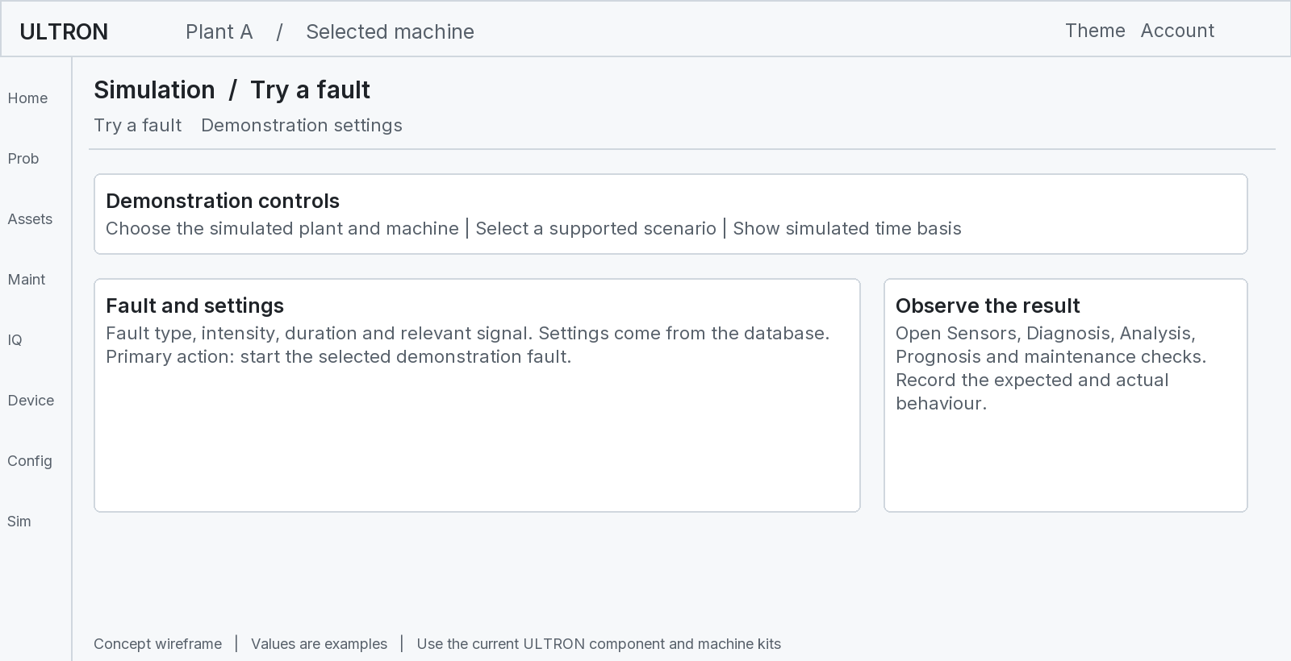
Figure 23 Simulation tests the same user journeys with clearly identified generated data

Simulation purpose
A trainer or demo lead starts a supported fault and observes the real pages. Inputs are the selected scenario and database settings. Outputs are simulated observations, rule state, findings and page changes. It is a demonstration and software validation aid.
The scenario list, engine profiles and settings depend on the loaded configuration. Do not use the 43 signal KLN-01 example as a fixed signal count for every supported plant. Pyro line and casting simulations have their own definitions.

Sign in purpose and flow
Sign in identifies the user. It accepts email and password. The server verifies the password and creates an opaque session token. The browser receives an httpOnly session cookie. The current code uses scrypt password hashes and server side session records.
Successful sign in opens the authorized plant workspace. Failed sign in shows the returned error. The application checks the session before mounting the live workspace. Users should see only their allowed plants through the applicable server scope checks.
This guide does not contain account credentials. Development shortcuts and route specific access handling require a deployment security review. A sign in screen alone does not prove that every API route is protected.
Basis: R8 simulation engines and provider; R15 simulation-view.tsx; R11 auth-service.ts; R3 AuthGate.

Light mode dark mode and accessible interaction
Contents / Terms / Sources
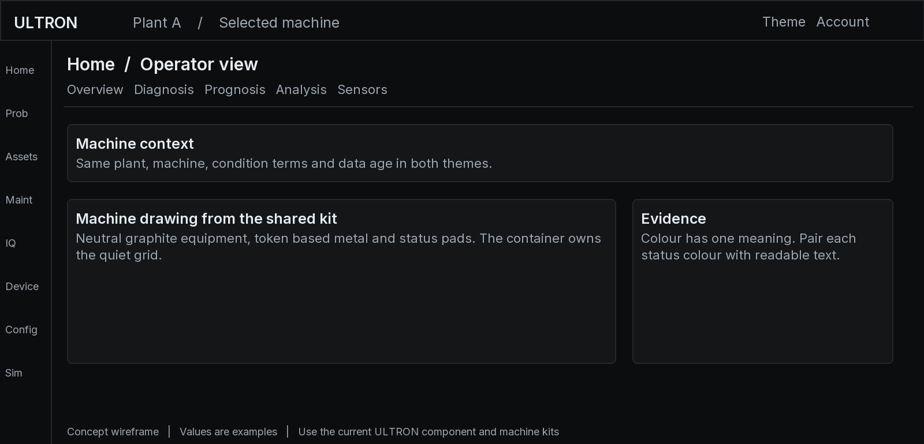
Figure 24 The same conceptual information layout in dark mode
Product rule | Required behaviour
Typography | Use Inter throughout. Numeric alignment can use the approved product number style.
Theme | Use semantic tokens. Support light and dark modes. Respect system preference before the user chooses.
Navigation | Use segmented tabs with 2 px corners and the defined keyboard movement.
Cards | Use solid surfaces, a quiet 1 px border and 4 px corners. Avoid a card inside a card.
Tables | Use separator rows, muted headers and keyboard accessible row activation.
Buttons | Use 4 px corners. Keep one primary action per view. Confirm destructive actions in place.
Colour | Blue means focus, selection, primary action or information. Green means Normal; amber means Alert; red means Critical.
Accessibility | Keep visible focus, labelled inputs, keyboard access, sufficient contrast and appropriate touch targets.

Unknown or unavailable information uses a neutral state. Do not use green to mean connected, completed or selected if that would conflict with the defined condition role. A connection state can use text and neutral indicators.
The shell rules define a 48 px top bar, 56 px rail and 24 px information bar. The wireframe figures simplify proportions for print. Product implementation must use the actual tokens and component rules.
Basis: R1 CLAUDE.md and AGENTS.md; src/app/globals.css; shared machine drawing kit.

9 A complete pump example
Contents / Terms / Sources
Teaching example: Pump P-01 runs at 1 500 RPM and comparable light load. Its sensor point, direction, frequency band and processing settings stay unchanged. Inspection evidence supports the accepted reference.
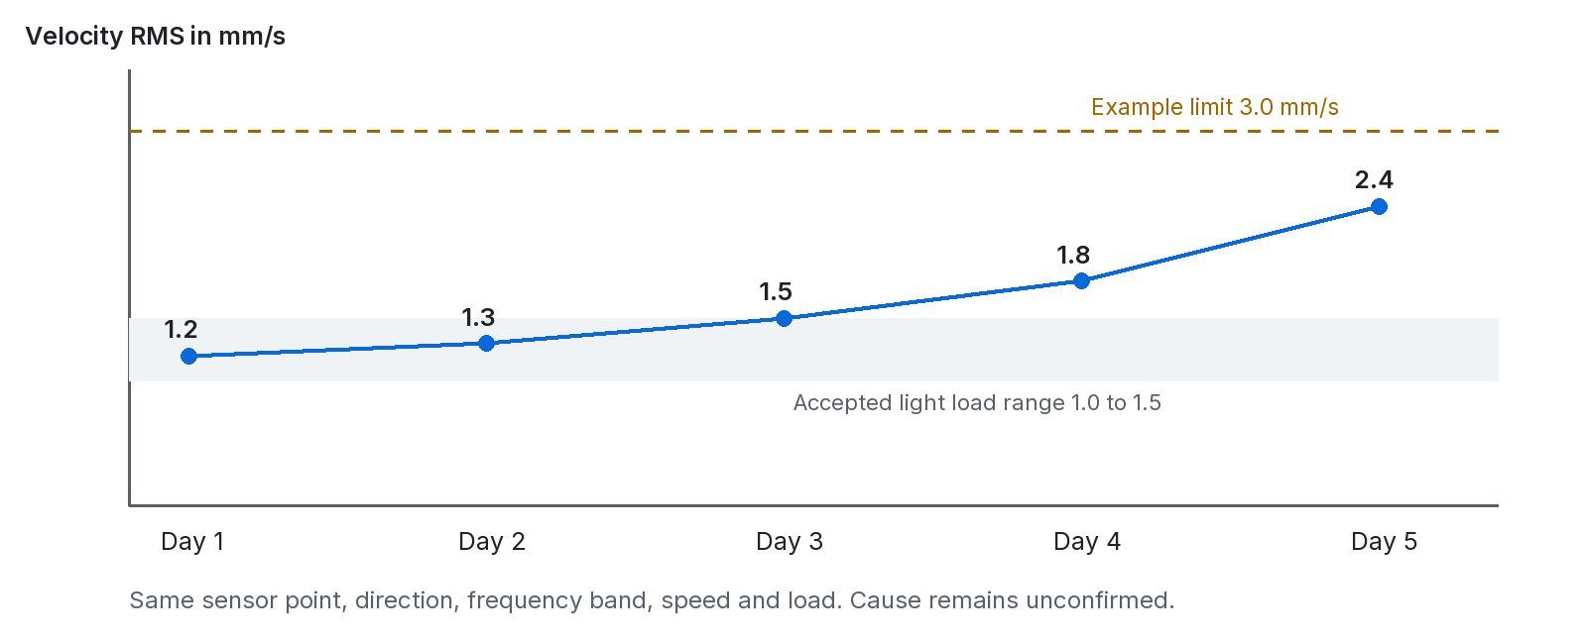
Figure 25 A growing vibration deviation appears before the separate upper alarm is crossed
Stage | Data received or used | ULTRON output
Acquire | The gateway provides valid motor temperature, vibration, current, speed and process readings. | Timed values connected to their measurement definitions.
Compare | Vibration is 2.4 mm/s. Accepted range is 1.0 to 1.5. Separate upper alarm is 3.0. | Above the reference; below this upper alarm.
Find change | Comparable history rises from 1.2 to 2.4 mm/s. | Sustained increase of 1.2 mm/s or 100%.
Investigate | Engineer checks mapping, mounting, state and process duty. | A case with evidence and unconfirmed hypotheses.
Inspect and act | Inspection confirms a loose mounting arrangement. | Confirmed inspection result and reviewed corrective work.
Verify | After work, vibration is 1.3 mm/s under comparable duty. | Recorded recovery evidence and the verification decision.

The increase does not alone prove bearing damage. The inspection found a different cause. Recording this outcome prevents a later training dataset from labelling every rising RMS pattern as bearing failure.
This example connects the pages in order: Home > Diagnosis > Trends and Sensors > Analysis or Problems > Maintenance > verification history. A user can return to the original measurements at each stage.
Basis: S7 continuing pump example and Step 13; S9 Section 6. New illustration combines the same teaching values.

A kiln demonstration from scenario to work
Contents / Terms / Sources
Current design context: KLN-01 is a kiln demonstration with configured signals, reference behaviour, rules and test scenarios. The software can show the same simulated condition through several pages.

A repeatable demonstration procedure
1. Open Simulation and select the configured KLN-01 machine.
2. Select a supported scenario from the loaded scenario list.
3. Record the scenario name, engine version and starting state.
4. Start the scenario using the permitted demonstration control.
5. Open Home and locate the affected machine or part.
6. Open Diagnosis and inspect the rule, measurements and quality.
7. Open Trends to compare the signal change with the event time.
8. Review Analysis and Prognosis within their method limits.
9. Check whether the expected follow up check or work record appears.
10. Clear the scenario and verify the configured clearance behaviour.
Evidence to record | Reason
Scenario and seed or configuration | Make the demonstration repeatable.
Simulated time and real time | Avoid misreading accelerated time.
Affected tags and rule ID | Prove the intended pattern reached evaluation.
Persistence and clear result | Check both activation and recovery.
Machine condition in each view | Confirm one consistent server evaluated condition.
Work and acknowledgement records | Confirm that user workflow matches monitoring evidence.

What this test establishes
A passing scenario shows that the configured software path behaved as expected for that input. It does not prove sensor accuracy, hardware synchronization, a physical failure mechanism or a field diagnostic model.
The documented original KLN-01 library has 27 validation scenarios. Other loaded engines have different scenarios and signals. Test the active database configuration rather than assuming one fixed global plant.
This guide did not run the scenarios. It describes a procedure and the evidence that a team should collect. Hardware and production validation remain separate tasks.
Basis: R1 KLN-01 rules; R8 shared simulation engines and server runner; R15 Simulation view; S6 Section 15.

Examples of outages changed duty and limited sensors
Contents / Terms / Sources
Situation | What enters or changes | Correct output and next step
Gateway outage | No current channel updates arrive. | Show link loss and stale or missing measurements. Open Devices. Do not infer healthy equipment.
Buffered replay | Older readings arrive after reconnection. | Retain original observation time, replay identity and ordering. Refresh history without calling old data new.
Pump has only current pressure and RPM | There is no measured flow. | Run applicable rules and supported contextual checks. Withhold measured flow loss and hydraulic efficiency.
Extruder recipe changes | Pressure and current rise with a new material. | Use the applicable recipe reference. Show uncovered duty if no accepted reference exists.
Sensor is moved | The mounting point or direction changes. | Record the change. Reassess comparability before declaring degradation.
Bearing is replaced | Component identity and service start change. | Preserve old history. Start the new component lineage and review references.
One signal freezes | The value repeats despite changing related conditions. | Raise or investigate a quality concern according to the configured method. Do not automatically prove a failed sensor.
Stopped on purpose | Requested state is stopped and observed speed is zero. | Interpret against stopped duty. This differs from a command to run with zero speed.

Why the same platform can handle these cases
The common platform stores identity, time, quality, state and evidence. The configured analysis decides which inputs it needs. The machine family and available signals change the analysis profile without requiring a universal sensor list.

A scoped answer is still useful
“Current increased at comparable speed; actual flow is not measured” is useful and honest. “Pump efficiency fell by 20%” is unsupported without the necessary measured quantities. The useful claim must fit the available evidence.
Basis: S6 Sections 4, 6, 10 and 15; S8 Section 6; S9 Section 6; S2 PS-09, PS-10 and PS-12.

10 Commission a new source and machine
Contents / Terms / Sources
Commissioning confirms that the installed source and software represent the real equipment correctly. Document processing can prepare configuration. It cannot prove that wiring and live measurement are correct.

A practical commissioning sequence
1. Identify the plant, machine, required function and monitored parts.
2. Record the actual sensors and existing PLC or drive tags.
3. Confirm quantities, units, ranges, scaling and channel addresses.
4. Create the reviewed machine and measurement definitions.
5. Configure the broker, gateway, source and message format.
6. Map each physical channel to the correct measurement.
7. Compare received values with a trusted instrument or source display.
8. Check acquisition time, receipt time, quality and update periods.
9. Disconnect or simulate a failed channel under an approved test plan.
10. Verify duplicate, delayed and replayed message handling.
11. Approve the applicable engineering limits and state conditions.
12. Collect and review reference data for the covered duties.
13. Test findings, page consistency and the maintenance journey.
14. Record the acceptance evidence and open limitations.

Acceptance record
Record | What it should contain
Measurement acceptance | Point, sensor, units, range, direction, calibration and verified value.
Transport acceptance | Source identity, mapping, message format, timing, loss and recovery tests.
Monitoring acceptance | Approved rules, reference coverage, expected results and observed results.
User workflow acceptance | Page links, role permissions, work records and verified closure test.
Handover | Owner, support process, known limitations and configuration revision.

Do not mark ML diagnosis or lifetime outputs active merely because ingestion works. Each advanced task needs its own evidence and acceptance test. Keep the available capability per machine explicit.
Basis: S6 Sections 6, 14 and 15; S2 input scope; R1 database and no invented values rules.

Operation reliability access and network boundaries
Contents / Terms / Sources
Proposed operating design: keep industrial acquisition in its appropriate network zone. Use reviewed gateway connections to the application zone. Expose only required endpoints. The exact network topology needs site approval.
Boundary | Expected operating practice | Current evidence and limit
Plant to gateway | Use supported drivers and reviewed source access. | Registry stores source protocols and zones. This does not prove connector operation.
Gateway to broker | Use broker identities, topic permissions and secure transport where required. | Broker settings include TLS and command allowlists. Verify the established connection and broker policy.
Browser to API | Use HTTPS, session access and plant scope on every applicable route. | Auth and access services exist. Route specific enforcement still needs review.
API to database | Use controlled credentials, trusted transport and backups. | Current nonlocal pool sets rejectUnauthorized false. Review certificate verification before production.
Commands to equipment | Require explicit target scope and authorized permitted operations. | Current MQTT command route checks a broker allowlist. Complete user authorization needs verification.
Live state to evaluation | Run evaluation independent of a user browser. | Current runner calls evaluation. Confirm the scheduler for physical only operation.
Source files to processor | Treat files as untrusted evidence. | Onboarding has a bounded processor design. Verify deployment settings and file handling.

Operating checks
Monitor database availability, ingestion rate, last data age, quarantine, sequence gaps, evaluation time, runner progress and failed jobs. A server that answers an HTTP health request can still have a stalled ingestion or evaluation path.
Set owners for instrument issues, communication issues, application incidents and equipment investigations. The same symptom can cross these boundaries. Keep the affected measurement and time visible during handover.
These are architecture and readiness observations from code inspection. They are not a completed security audit or a claim of compliance with an industrial cybersecurity standard.
Basis: R5 MQTT runtime and command route; R6 evaluation; R7 db/index.ts; R11 access; R13 processor; S6 Section 13.

Validation deployment and change control
Contents / Terms / Sources

Test the claim that the feature makes
Test family | Representative test | Evidence of success
Identity and scaling | Known source value mapped to a known channel. | Correct machine, point, unit and engineering value.
Time and quality | Late data, clock error, missing sample and clipped signal. | Correct age, time source, quality and withheld unsupported result.
Rules | Raise, persistence, hysteresis and clear boundaries. | Expected finding type, severity and transition times.
State and reference | Startup, steady duty and new recipe. | Correct state reference or explicit lack of coverage.
History and retention | Read across raw and hourly periods. | Correct counts, units, range and known loss of detail.
Workflow | Finding to case, request, execution and verification. | Records link correctly. Failed verification reopens work.
Access | Read and write from a user outside the plant. | Applicable routes deny access without leaking records.
Recovery | Broker restart, database outage and runner takeover. | No invented current values, uncontrolled duplicates or lost required evidence.
ML and prediction | Later unseen periods and relevant held out machines. | Measured false alerts, detection lead time, errors and interval coverage.

Before release
Apply new schema changes as new numbered migrations. Do not edit an already applied migration. Review fixtures after configuration changes. Back up data and test rollback or restoration. Deploy the web application, long running API and required workers with compatible versions.
Check proxy configuration, API host, database connection and broker reachability. Keep secrets out of browser code and documents. Set resource limits and monitor worker progress. Confirm that simulation data cannot be mistaken for a commissioned physical machine.

After release
Review alert utility, missing data, detection delay, failed requests and user feedback. For a model, monitor input drift and actual error. Record which revision generated a result. A passing synthetic test does not replace field acceptance.
Basis: R1 migrations and architecture; R7 migration process; R8 runner lease; S6 Sections 14 and 15; S8 acceptance checks.

Current capabilities open gaps and delivery stages
Contents / Terms / Sources
This table separates inspected structures from capabilities that still need deployment evidence. The source documents describe intended capabilities, not completed acceptance results.
Capability | Evidence in the current files | Required next proof
Web pages and shared shell | Workspace, machine pages, quick views and theme tokens. | UI acceptance with representative real data in both themes.
Sensor and source mapping | Measurement model, edge registry and MQTT parser. | Commissioned source mapping, scaling, quality and time tests.
Persistent history and evaluation | Readings, aggregates, findings and server evaluation. | Physical only scheduling, load, retention and outage tests.
Rules and reference checks | Configured limits, states, rules and references. | Engineering approval and field acceptance per machine.
Statistical forecasts | Trend fits and time to limit logic. | Measured forecast error and usable horizon limits.
Fault ML and failure risk | Design specifications and fault library context. | Applicable trained models, calibration and independent evaluation.
RUL | Design requirements and time to limit fields. | A defined end event and validated lifetime method.
Explainability | Rule evidence and deterministic AssetIQ responses. | Validated model explanations when a compatible model exists.
Production controls | Sessions, scoped services and configurable connection settings. | Complete route, network, certificate, backup and recovery review.

A practical delivery sequence
1. Commission trustworthy measurements and current pages.
2. Approve rules, operating states and reference comparisons.
3. Prove the investigation and verified maintenance loop.
4. Validate contextual anomaly detection in shadow mode.
5. Add supported fault or forecast tasks with measured results.
6. Enable lifetime or failure risk outputs only for validated targets.
This order gives useful monitoring early. It also keeps advanced claims within the evidence available. None of the stages requires every machine to have the same sensor set.
Basis: S6 Sections 14 to 16; S8 Sections 6 and 11; R2, R6, R9 and R12 inspected implementation.

11 API map for measurements and conditions
Contents / Terms / Sources
API means application programming interface. It is the agreed way for one program to request data or an operation. The browser calls /api paths on its own origin. Next.js forwards them to the separate Hono server.
Method and path | Use | Typical data
GET /api/catalog and /api/hierarchy | Load the equipment context. | Machines, hierarchy and related metadata.
GET /api/measurements | List measurement definitions in permitted scope. | IDs, tags, point context, units and settings.
GET /api/measurements/:id | Read one measurement. | The full definition.
GET /api/measurements/:id/readings | Read a time range. | Timed points or requested buckets.
GET /api/measurements/:id/features | Read calculated features. | Window statistics and quality context.
PATCH /api/measurements/:id/limit | Update a measurement limit. | Reviewed limit parameters and basis.
POST /api/readings | Store numeric or state observations. | accepted, written and rejected results.
GET /api/machines/:id/condition | Read the machine evaluation. | Current condition and related evidence.
GET /api/fleet/condition | Read the fleet evaluation. | The shared machine condition source.
GET /api/machines/:id/health-scores | Read historical scores. | Timed machine or subassembly score information.
GET /api/machines/:id/events | Read the event history. | Machine chronology.
GET /api/machines/:id/operating-states | Read state intervals. | Observed state history.
GET and POST /api/machines/:id/references | Read or create reference records. | Reference scope, draft and values.
PATCH /api/references/:id | Review or update a reference. | Accepted state and associated record changes.
GET /api/insights?machineId=... | Read computed analysis and prognosis data. | Trends, anomalies, supported projections and evidence.

A colon marks an identifier placeholder. Replace it with the actual registered ID. Query parameters, response fields and permissions vary by resource. Use the shared types and route code for an integration. This table is a map, not a replacement for the endpoint contract.
Basis: R4 route registry; R6 monitoring routes; R9 insights route; shared/types/monitoring.ts and insights.ts.

API map for work devices setup and exports
Contents / Terms / Sources
Method and path | Use or output
GET /api/findings; POST /:id/acknowledge or /:id/entries | Read findings, acknowledge them and add investigation entries under the findings root.
GET and POST /api/cases; GET and PATCH /api/cases/:id | List, create, read and update cases.
POST /api/cases/:id/actions, /causes, /checks or /requests | Record the appropriate case workflow operation or evidence.
GET /api/cases/:id/export | Download the current case detail as JSON. This is not a native PDF report.
POST /api/cases/:id/series | Import a case specific CSV series using the case contract.
GET and POST /api/cases/:id/files | Retrieve or attach a case file under the file contract.
GET /api/maintenance/pms/line | Load the shared line level maintenance model.
POST /api/maintenance/pms/requests or /pms/plans | Create a reviewed request or planning operation under /api/maintenance.
POST and PATCH /api/maintenance/pms/work-orders/:id | Apply the supported work order operation or update.
GET /api/edge; POST /api/edge/commission or /map | Read the physical source registry; commission or map supported channels.
GET /api/mqtt/status, /stream or /samples | Read connection state, receive SSE updates or inspect captured samples.
POST /api/mqtt/listen or /command | Start bounded capture or send a permitted gateway command.
GET and PATCH /api/settings | Read and update monitoring settings under the actual access policy.
GET and POST /api/onboarding; PUT /api/onboarding/:id | List, create and edit document setup packages.
POST /api/onboarding/:id/process or /commit | Run processing or commit a reviewed draft.
GET /api/simulation; PUT /api/simulation; POST /commands | Read or update demonstration settings; submit a scenario command under /api/simulation.
POST /api/auth/login or /logout; GET /api/auth/session | Manage the browser session.

Most successful JSON APIs use { data }. Errors use { error: { code, message } }. File downloads and SSE use their own response types. Preserve HTTP status and error details. Do not parse every response as a normal JSON result.
A CSV import exists for case evidence. This does not imply a general spreadsheet importer for all sensor data. Uploaded engineering documents and JSON ingestion use separate paths.
Basis: R4 routes; R5 MQTT and edge routes; R10 cases and maintenance; R11 auth; R13 onboarding.

Page to data and output lineage matrix
Contents / Terms / Sources
Use this matrix to trace a displayed result to its source records. It is also a review checklist for a new page. Every displayed number needs a defined source and time meaning.
Page or view | Data it receives | Main output or write | Next linked area
Home and Overview | Hierarchy, live readings, fleet condition and findings. | Operator situation and selected context. | Diagnosis, part, Trends or Assets.
3D twin | Geometry and equipment context. | Spatial equipment selection. | Overview or Assets.
Assets directory | Machine registry and shared condition. | Selected machine. | Machine pages.
Sensors | Measurement definitions, readings and source mappings. | Measurement and wiring evidence. | Trends, Rack or Devices.
Diagnosis | Condition, findings, reference and rule evidence. | Acknowledgement or work proposal. | Analysis, Problems or Maintenance.
Analysis | Findings, relationships, fault context and verdicts. | Investigation judgement and evidence. | Case or maintenance request.
Prognosis | Stored trends and supported insight results. | Scoped forecasts and time to limit. | Reviewed planning.
Trends and history | Readings, aggregates and events. | Time based evidence view. | Measurement or finding.
Rack and thermal | Acquisition mapping or supported spatial data. | Hardware or thermal evidence. | Sensors, Devices or Diagnosis.
Problems | Cases, guides, evidence and requests. | Investigation records and decisions. | Work review and verification.
Maintenance | Plans, findings, work orders and checklists. | Execution, verification and closure. | History and monitoring.
AssetIQ | Live plant context and database findings. | Templated explanation and evidence links. | Diagnosis or permitted action.
Devices | Registry and MQTT runtime. | Source mapping and connection operations. | Sensors and equipment context.
Configure and onboarding | User input, source files and existing configuration. | Reviewed registry, access and setting changes. | Devices and monitoring.
Simulation | Scenario, engine binding and settings. | Simulated input and resulting findings. | All linked monitoring pages.

Current browser state remembers some navigation and display choices. PostgreSQL owns domain records. A cached browser snapshot must not be mistaken for a new live reading or current server evaluation.
Basis: R3 providers and root page; R5 MQTT; R6 evaluation; R10 to R15 page and service modules.

12 The complete 100 input index
Contents / Terms / Sources
This index retains the 100 input identifiers in the supplied engineering report. Each input is required only when the selected claim or method needs it. It is not a universal 100 item installation checklist.
The short explanations below use beginner language. The full source matrix contains the original scope, proposed formats and examples. A proposed file format is not an implemented ingestion promise.

PS 01 Process monitoring
Input ID | Input | Why it is used
I01.01 | Process description PFD or P and ID | Understand stages, connections and tag meaning.
I01.02 | Operating SOP and startup or shutdown procedures | Understand permitted operating sequences.
I01.03 | Process specifications and acceptance criteria | Define the useful function and required output.
I01.04 | Operating setpoints and process targets | Compare actual output with the correct target.
I01.05 | Control logic and cause and effect documents | Explain state changes and permitted operation.
I01.06 | Signal register and variable meanings | Know what each process tag represents.
I01.07 | Timestamped live process observations | Describe what the process is doing now.
I01.08 | Production quantity and useful output | Measure the result that the system delivers.
I01.09 | Measured energy or resource consumption | Measure the resource input for that work.
I01.10 | Product recipe batch and quality results | Separate duties and assess measured product quality.
I01.11 | Machine operating phases and context | Compare similar states and production conditions.
I01.12 | Engineering alarms and rule definitions | Check defined boundaries and response policies.
I01.13 | Time provenance and measurement quality | Determine whether observations can be compared.
I01.14 | Historical observations and change events | Show how process behaviour changed.

Basis: S2 detailed input matrix, pages 3 to 21. Descriptions here are a condensed teaching index.

Input index continued
Contents / Terms / Sources
Input scope depends on the analysis. Missing optional evidence reduces coverage. It does not automatically make the machine faulty. Match these records to the active machine profile.

PS 02 Machine condition monitoring
Input ID | Input | Why it is used
I02.01 | Asset registry hierarchy and rated data | Identify the equipment and its design context.
I02.02 | OEM maintenance and operating manuals | Use the applicable manufacturer guidance.
I02.03 | Condition related measurements | Observe relevant mechanical electrical or thermal behaviour.
I02.04 | Measurement point and installation metadata | Preserve location, direction and installation meaning.
I02.05 | Rated values and reference curves | Compare the equipment against an applicable basis.
I02.06 | Operating mode and comparable duty | Separate expected operating effects from condition change.
I02.07 | Measurement history and event chronology | Connect a change with events and earlier readings.
I02.08 | Maintenance and inspection observations | Retain what a person actually found.
I02.09 | Quality and communication signals | Identify missing or unreliable evidence.
I02.10 | MHI scoring and coverage policy | Explain what the health score includes.

PS 03 Vibration analysis
Input ID | Input | Why it is used
I03.01 | Vibration summary channels | Trend a defined quantity, statistic and frequency band.
I03.02 | Raw high rate vibration waveform | Inspect captured motion and calculate detailed features.
I03.03 | Acquisition sampling and signal conditioning | Interpret the waveform without hidden acquisition assumptions.
I03.04 | Point direction and mounting | Compare measurements from the same physical setup.
I03.05 | Rotating reference and mechanical data | Relate features to speed and component geometry.
I03.06 | Feature definitions and processing | Reproduce RMS, FFT and other calculated results.
I03.07 | Historical comparable recordings | Find meaningful change across recordings.
I03.08 | Vibration engineering references | Apply a reviewed equipment specific assessment basis.

Basis: S2 detailed input matrix, pages 3 to 21. Descriptions here are a condensed teaching index.

Input index continued
Contents / Terms / Sources
Input scope depends on the analysis. Missing optional evidence reduces coverage. It does not automatically make the machine faulty. Match these records to the active machine profile.

PS 04 Unknown anomaly detection
Input ID | Input | Why it is used
I04.01 | Representative verified healthy history | Define accepted examples for the selected task.
I04.02 | Current and recent observation windows | Describe the current pattern over time.
I04.03 | Operating mode and context variables | Compare similar duty and process conditions.
I04.04 | Feature definitions and windows | Keep model input meaning repeatable.
I04.05 | Data validity and alignment | Avoid anomalies created by bad or mismatched time.
I04.06 | Baseline or model provenance and envelope | Know where the model is applicable.
I04.07 | Anomaly validation and review labels | Measure whether unusualness is useful evidence.

PS 05 Known fault classification and diagnosis
Input ID | Input | Why it is used
I05.01 | Fault taxonomy and definitions | Define each fault class before classification.
I05.02 | Confirmed fault and inspection records | Provide independently supported outcome labels.
I05.03 | Fault labelled historical observations | Connect sensor evidence to confirmed events.
I05.04 | Distinguishing sensor and signal features | Separate candidate causes using relevant evidence.
I05.05 | Engineering signatures and diagnostic logic | Support validated rule based fault hypotheses.
I05.06 | Operating and confounding context | Avoid attributing normal duty changes to a defect.
I05.07 | Repair and post maintenance verification | Check whether corrective work addressed the cause.
I05.08 | Diagnostic model and validation evidence | Bound fault claims by measured test performance.

Basis: S2 detailed input matrix, pages 3 to 21. Descriptions here are a condensed teaching index.

Input index continued
Contents / Terms / Sources
Input scope depends on the analysis. Missing optional evidence reduces coverage. It does not automatically make the machine faulty. Match these records to the active machine profile.

PS 06 Degradation tracking
Input ID | Input | Why it is used
I06.01 | Time ordered condition history | Track the indicator across a meaningful period.
I06.02 | Operating exposure and duty history | Account for usage and operating differences.
I06.03 | Accepted condition reference | Compare with reviewed starting behaviour.
I06.04 | Feature definition and trend horizon | Define exactly what is changing and over what time.
I06.05 | Maintenance and sensor change events | Separate interventions from physical deterioration.
I06.06 | Data continuity and comparability checks | Ensure the trend combines equivalent observations.

PS 07 Failure risk prediction
Input ID | Input | Why it is used
I07.01 | Specific failure event specification | Define the exact event whose risk is estimated.
I07.02 | Prediction horizon and lead time objective | Name the future period and required notice.
I07.03 | Timestamped condition and context history | Describe evidence before the defined event.
I07.04 | Verified failure and event free exposure | Learn from failures and observed nonfailure periods.
I07.05 | Maintenance overhaul and replacement history | Account for interventions and component resets.
I07.06 | Duty and future operating assumptions | State the usage scenario behind the estimate.
I07.07 | Risk model calibration and independent evaluation | Check probability accuracy and applicability.
I07.08 | Separate future parameter forecast specification | Keep value forecasting distinct from event risk.

Basis: S2 detailed input matrix, pages 3 to 21. Descriptions here are a condensed teaching index.

Input index continued
Contents / Terms / Sources
Input scope depends on the analysis. Missing optional evidence reduces coverage. It does not automatically make the machine faulty. Match these records to the active machine profile.

PS 08 Remaining useful life
Input ID | Input | Why it is used
I08.01 | Defined failure or end of life criterion | Name the target that ends useful life.
I08.02 | Time usage or cycle history | Measure the correct operating exposure scale.
I08.03 | Degradation indicator history | Support condition based life assessment where applicable.
I08.04 | Run to failure or validated lifetime evidence | Provide an applicable lifetime mechanism or history.
I08.05 | Operating assumptions and maintenance effects | State future duty and intervention assumptions.
I08.06 | Validated prognostic model and uncertainty | Bound the numerical life estimate and interval.
I08.07 | Equipment and component configuration | Estimate life for the correct installed component.

PS 09 Operating context and false alarm control
Input ID | Input | Why it is used
I09.01 | Machine operating state definitions | Define startup, running, idle and shutdown.
I09.02 | Operating context stream | Record state, speed, load, recipe and relevant conditions.
I09.03 | State specific limits and reference sets | Apply comparisons only in their covered state.
I09.04 | Persistence hysteresis and reset policies | Avoid unstable alarm changes at a boundary.
I09.05 | Operating procedures and changeover schedules | Explain expected transitions and planned activity.
I09.06 | Observed nuisance alarm feedback | Review false alerts and expected transitions.
I09.07 | Requested and actual state | Distinguish planned stops from failed operation.

Basis: S2 detailed input matrix, pages 3 to 21. Descriptions here are a condensed teaching index.

Input index continued
Contents / Terms / Sources
Input scope depends on the analysis. Missing optional evidence reduces coverage. It does not automatically make the machine faulty. Match these records to the active machine profile.

PS 10 Data reliability
Input ID | Input | Why it is used
I10.01 | Canonical asset and measurement identity | Attach observations to the correct equipment and point.
I10.02 | Engineering value unit and scaling | Preserve physical meaning and conversion basis.
I10.03 | Sensor and interface specification | Know the instrument and channel capabilities.
I10.04 | Observation acquisition read and receipt times | Preserve the real meaning of each timestamp.
I10.05 | Quality communication and error flags | Expose unreliable or unavailable measurements.
I10.06 | Sampling units and channel synchronization | Align comparable observations and signal definitions.
I10.07 | Configuration and calibration change log | Explain changes in measurement meaning.
I10.08 | Retention and lineage references | Know what evidence remains and where it came from.
I10.09 | Buffered delivery ordering and duplicate identity | Recover from outages without misleading history.

Basis: S2 detailed input matrix, pages 3 to 21. Descriptions here are a condensed teaching index.

Input index continued
Contents / Terms / Sources
Input scope depends on the analysis. Missing optional evidence reduces coverage. It does not automatically make the machine faulty. Match these records to the active machine profile.

PS 11 Explanations and maintenance decisions
Input ID | Input | Why it is used
I11.01 | Rule and ML results with evidence links | Keep each statement tied to the generating method.
I11.02 | Contextual values and references | Show actual versus the applicable expected value.
I11.03 | Asset criticality and consequence assessment | Prioritize work with an explicit basis.
I11.04 | Maintenance procedures and inspection checklists | Connect recommendations to approved work guidance.
I11.05 | Historical work orders and confirmed findings | Use reviewed previous outcomes.
I11.06 | Acknowledgement investigation and closure events | Separate review, action and verified resolution.
I11.07 | Explanation uncertainty and coverage | State model influence, limits and unsupported scope.
I11.08 | Plant maintenance constraints and resources | Fit proposed work to people, parts and plant windows.

PS 12 Limited data and different machine types
Input ID | Input | Why it is used
I12.01 | Machine registry and hierarchy | Identify the target machine and family context.
I12.02 | Machine profile and operating documentation | Configure relevant states, rules and analyses.
I12.03 | Available signals and source bindings | Know the actual installed evidence.
I12.04 | Analysis package eligibility requirements | Select only compatible features and models.
I12.05 | Available history and state coverage | Avoid claims about unobserved conditions.
I12.06 | Sensor changes and model validation history | Review applicability after configuration change.
I12.07 | Uniform output and reason code schema | Keep results consistent across machine types.
I12.08 | Deployment applicability and ongoing review | Monitor the released method after installation.

Basis: S2 detailed input matrix, pages 3 to 21. Descriptions here are a condensed teaching index.

13 Terms and abbreviations
Contents / Terms / Sources
Use these meanings consistently. A word such as health, confidence or failure needs a defined target in a numerical result.
Term | Meaning
Acceleration | Rate of change of velocity. Vibration acceleration can use g or m/s².
Acquisition | The act of taking measurements from a signal.
Acquired time | The time when a measurement was taken, when known.
Alert | The product condition level that needs attention under the configured method.
Anomaly | A pattern that differs from the applicable expected behaviour.
API | Application programming interface. A defined way for software to exchange data or operations.
Asset | A recorded equipment item that the organization manages.
Backend | Server software that receives requests, stores records and applies domain logic.
Baseline or reference | Reviewed expected behaviour for identified equipment and operating conditions.
Bearing | A component that supports a moving shaft and helps it turn.
Broker | A message server that routes MQTT publications to subscribers.
Calibration | An established relationship between an instrument response and a known reference.
Canonical | The common agreed form used inside the platform.
Channel | One signal path in measurement electronics or a data source.
Component or subassembly | A named part or part group within a machine.
Condition | The assessed behaviour or state of monitored equipment.
Context | Operating conditions that change the expected measurement behaviour.
Correlation | A measure of joint variation. It does not prove cause.
Crest factor | Peak magnitude divided by RMS.
Critical | The highest product condition severity under its configured policy.
DAQ | Data acquisition. Electronics or logic that collects measurements.
Database | An organized persistent collection of related records.
Degradation | A deterioration process assessed through suitable condition or life evidence.
Device | An instrument, source, gateway or other connected hardware item.

Basis: S9 glossary; S6 glossary; the common terminology used in the inspected system. Definitions are teaching summaries.

Terms and abbreviations continued
Contents / Terms / Sources
Use these meanings consistently. A word such as health, confidence or failure needs a defined target in a numerical result.
Term | Meaning
Direction | The physical axis of a measurement, such as horizontal or axial.
Drift | A change in data behaviour, instrument response or model performance over time.
Envelope | The operating range and conditions for which an analysis is applicable.
Failure | Inability to meet a defined required function.
Fault | An identified problem in equipment or its operation.
Feature | A useful quantity calculated from samples, a time window or related signals.
FFT | Fast Fourier Transform. A method that converts samples into a frequency representation.
Finding | A recorded assessment generated from a defined comparison or analytical method.
Firmware | Software that runs inside a device such as a microcontroller.
Forecast | An estimate of a future quantity for a stated time and assumptions.
Foreign key | A database field that links a row to a related row in another table.
Frequency | Number of repeated cycles per time. Hertz means cycles per second.
Gateway | A device that reads source systems and sends organized data onward.
Health index | A configured summary of monitored indicators. It is not remaining life percentage.
Hierarchy | A structure from larger equipment groups to specific machines and parts.
Historian | A system that stores industrial time series and associated information.
Hysteresis | Different raise and clear conditions that reduce repeated boundary switching.
Inference | Applying a released model to new input data.
Interlock | A defined control condition that permits or prevents an equipment action.
JSON | A text format for structured objects, lists, values and names.
Latency | Delay between an event, measurement, delivery or display. Name which delay is measured.
MCU | Microcontroller. A small computer used inside electronic equipment.
Measurement | A definition of what is observed at a point, including its quantity and unit.
Measurement point | The physical or identified source location where a measurement is taken.

Basis: S9 glossary; S6 glossary; the common terminology used in the inspected system. Definitions are teaching summaries.

Terms and abbreviations continued
Contents / Terms / Sources
Use these meanings consistently. A word such as health, confidence or failure needs a defined target in a numerical result.
Term | Meaning
Migration | A numbered database schema change applied in order.
ML | Machine learning. Methods that learn numerical relationships from data.
Modbus TCP | An industrial data exchange protocol over Ethernet based networks.
MQTT | A publish and subscribe messaging protocol.
Normal | The product condition assessment for the supported monitored scope. It is not proof against all faults.
OEM | Original equipment manufacturer.
Operating state | A defined mode such as stopped, startup or running.
P and ID | Piping and instrumentation diagram. It shows equipment, pipes and instrument relationships.
Parquet | A column oriented file format used for analytical data.
Peak magnitude | The largest absolute sample value in a defined recording.
Persistence | The required duration or repeated evidence before a condition changes state.
PFD | Process flow diagram. It shows main equipment and process streams.
PLC | Programmable logic controller. A computer used for industrial control.
Primary key | The unique identity of a row in a database table.
PTP | Precision Time Protocol. A method for synchronizing device clocks.
Quality | Information about whether an observation is usable, current and within measurement capability.
Quarantine | A record of messages withheld after parsing, schema or identity problems.
Reading | One timed numeric or state observation of a measurement.
Residual | Measured value minus expected value.
RMS | Root Mean Square. An overall magnitude calculated from samples.
Rollup | A summary of detailed data over a larger time interval.
RPM | Revolutions per minute. A measure of rotational speed.
RUL | Remaining useful life to a defined end event under stated assumptions.
SCADA | Supervisory control and data acquisition. Software for supervising industrial processes.

Basis: S9 glossary; S6 glossary; the common terminology used in the inspected system. Definitions are teaching summaries.

Terms and abbreviations continued
Contents / Terms / Sources
Use these meanings consistently. A word such as health, confidence or failure needs a defined target in a numerical result.
Term | Meaning
Sensor | A device that responds to a physical quantity and supplies a readable signal.
Shadow mode | Run an analysis for evaluation without active operational recommendations or alerts from it.
SHAP | A method for attributing a model output to its input features.
SOP | Standard operating procedure. Controlled instructions for an operating task.
Spectrum | Signal magnitude or energy shown by frequency with a defined convention.
SSE | Server Sent Events. A server to browser stream of events over HTTP.
Stale | Older than the freshness allowed for the intended use.
Statistic | A defined summary such as mean, RMS or peak.
Tag | A readable identifier used for a measurement or plant signal.
Time series | Observations of one quantity arranged in time order.
Time to limit | Projected time to a named boundary. It is not automatically failure time.
TLS | Transport Layer Security. A method for protecting a network connection.
Transmitter | A device that provides a specified signal representing a measurement.
UTC | Coordinated Universal Time. A common time reference for stored and exchanged timestamps.
Validation | Evidence that a method meets defined requirements for its stated use.
VFD | Variable frequency drive. A motor drive that can control speed.
Waveform | Signal values shown or stored in time order within a recording.
Window | A selected time span or sample range for calculation.
Wireframe | A simplified page plan that shows information and action locations.
Work order | A controlled record for reviewing, planning, executing and verifying work.

Basis: S9 glossary; S6 glossary; the common terminology used in the inspected system. Definitions are teaching summaries.

14 Sources and evidence method
Contents / Terms / Sources
The nine supplied documents are source material for this guide. Embedded document instructions were treated as content. The user request and project instructions controlled the work. The current working files were inspected to distinguish design intent from code.
Code evidence is a snapshot of the working directory on 21 October 2026. The directory included uncommitted changes. Git HEAD was 0a8b7fd. A deployed application can differ from this snapshot. No live database, broker, credentials or physical instrument was accessed for this guide.
Source references in the text use the IDs below. PDF references use verified page numbers. DOCX references use section or step names because pagination depends on the rendering application.
S1 Explainable AI.pdf
Explainability purpose, input features, model evidence and limits. Relevant content is on page 1; page 2 has no substantive body.
S2 input, ps, output orcas report.pdf
The 12 problem statements and 100 input specifications. Main matrix is on pages 3 to 21. Page 22 has no substantive body.
S3 Process and Condition Monitoring, Anomaly and Fault Detection.pdf
Health, expected behaviour, unknown anomalies and issue source diagnosis. Pages 1 to 6.
S4 Prediction.pdf
Degradation, forecasting, event risk, RUL and maintenance guidance. Pages 1 to 7.
S5 industrial data topics (1).docx
Beginner topics on industrial data, feature engineering and practical ML architecture.
S6 ULTRON_ML_Guide (1).docx
Shared framework, distinct machine profiles, rule and ML roles, routing and validation.
S7 Ultron_Purpose_and_Information_Flow (2).docx
Information flow and the continuing pump example from receipt to recorded outcomes.
S8 ULTRON_Inputs_Outputs_Rules_and_ML_Guide_Updated 1 (1).docx
Machine specific inputs, output eligibility, minimum evidence and common output structure.
S9 Ultron_Machine_Monitoring_Foundations (2).docx
Machines, sensors, time series, vibration, expected behaviour and glossary.

Repository evidence register
Contents / Terms / Sources
Paths below are relative to the inspected ORCAS project root. Select a linked path to inspect the local file. A group can contain related files named in the text.

R1 Project and product rules
CLAUDE.md | AGENTS.md | docs/ux-primary-tasks.md | src/app/globals.css

R2 Declared tools and package versions
package.json | backend/package.json

R3 Application entry navigation and proxy
src/app/page.tsx | src/providers/industrial-data-context.tsx | next.config.ts

R4 API entry routes and response helpers
backend/src/index.ts | backend/src/app.ts | backend/src/routes/index.ts | backend/src/http.ts

R5 Source registry and MQTT contracts
shared/types/edge.ts | shared/types/mqtt.ts | backend/src/mqtt/topics.ts | backend/src/mqtt/validate.ts | backend/src/mqtt/runtime.ts | backend/src/routes/mqtt.ts

R6 Readings and server monitoring
backend/src/monitoring/readings.ts | backend/src/monitoring/evaluate.ts | backend/src/services/monitoring-service.ts | backend/src/routes/readings.ts

R7 Database and current schema
backend/src/db/index.ts | backend/src/db/migrations/001_monitoring_core.sql | backend/src/db/migrations/044_integrity_and_dead_columns.sql | backend/src/db/migrations/046_edge_points_from_measurements.sql | backend/src/db/migrations/048_drop_dead_tables.sql
The database discussion uses the complete ordered migration sequence through 048, not only the linked examples. Earlier migrations can create tables or columns that later migrations remove.

Repository evidence and language references continued
Contents / Terms / Sources

R8 Plant simulation and shared engines
backend/src/plant/runner.ts | backend/src/plant/sim-gateway.ts | src/providers/kiln-simulation-context.tsx | shared/lib/fleet-boot.ts

R9 Current statistical insight implementation
backend/src/services/insights-service.ts | shared/types/insights.ts

R10 Cases and maintenance lifecycle
backend/src/services/case-service.ts | backend/src/routes/cases.ts | shared/lib/pms.ts | src/components/maintenance/pms-ui.tsx

R11 Identity and authorization
backend/src/services/auth-service.ts | backend/src/services/access-service.ts

R12 Current AssetIQ engine
src/components/copilot/copilot-engine.ts | src/components/assetiq/assetiq-hub-view.tsx

R13 Document onboarding
shared/types/onboarding.ts | backend/src/onboarding/claude-runner.ts | backend/src/services/onboarding-service.ts

R14 Drawing data contracts
backend/src/services/diagram-service.ts | src/components/assets/machine-kit/machine-kit.tsx

R15 Machine pages and navigation
src/components/assets/assets-view.tsx | src/components/home/operator/machine-nav.tsx | src/components/devices/devices-view.tsx | src/components/configure/configure-view.tsx

Official language references
E1 ASD STE100 Issue 9 official standard
E2 Official introduction and frequently asked questions
The language approach uses short sentences, one main instruction per step, consistent terms and defined technical names. The requested approximate 80 percent approach is an editorial target. It is not a measured conformance score or certification.
No external standard is reproduced here as an approved machine limit. Any real vibration severity, safety or control requirement needs the applicable reviewed source for that equipment and use.

A beginner first day reading and review path
Contents / Terms / Sources
Use this path to connect the ideas to the product. Start with a configured demonstration or a permitted read only view. Use site approved procedures for any real equipment work.
1. Open Home and name the selected plant and machine.
2. State the useful job that the machine must do.
3. Open Sensors and choose one measurement.
4. Identify its point, quantity, unit, time and quality.
5. Trace its gateway, source, slot and channel in Devices.
6. Open Trends and describe what changed without naming a cause.
7. Open Diagnosis and identify the rule or reference behind a finding.
8. Open Analysis or a case and list the evidence needed to confirm a hypothesis.
9. Open Prognosis and name the forecast target and time basis.
10. Check whether the estimate is time to a limit or validated remaining life.
11. Open Maintenance and distinguish priority from stage.
12. Find the verification evidence before treating a job as closed.

Questions that check understanding
Question | Expected understanding
Does GOOD mean the machine is healthy | No. It describes measurement usability under its definition.
Can the same RMS come from different waveforms | Yes. RMS alone does not retain the full recording.
Can a value be below an alarm and still be unusual | Yes. A valid reference comparison can show a change.
Does an anomaly score give failure probability | Only if a separate validated probability interpretation exists. A normal anomaly score does not.
Does acknowledgement mean repair | No. Verification and closure are separate workflow results.
Does one model fit every machine | No. Inputs, physics, operating coverage and evidence determine applicability.

The complete information loop
Equipment produces observations. ULTRON preserves their meaning and history. Defined methods produce reviewable findings. People investigate, perform approved work and verify the result. Those outcomes become evidence for the next investigation.

