Section A

1. (2)
2. (1,3,4,5)
3. (2)
4. (1)
5. (1)
6. (2)
7. (3,4,5)
8. (2)
9. (3)
10. (4)
11. (4)
12. (2,3,4)
13. (4)
14. (4)
15. (4)
16. (4)
17. (1)
18. (2)
19. (3)
20. (4)

SECTION B

1. **Validation Rules (15 Marks)**

A)While closing the opportunity ( 'Closed Won') , an Opportunity Line Item

should be present. If  opportunity line item is not present under a opportunity ,

it should give the error message "Opportunity Line Item should be present while closing the opportunity.

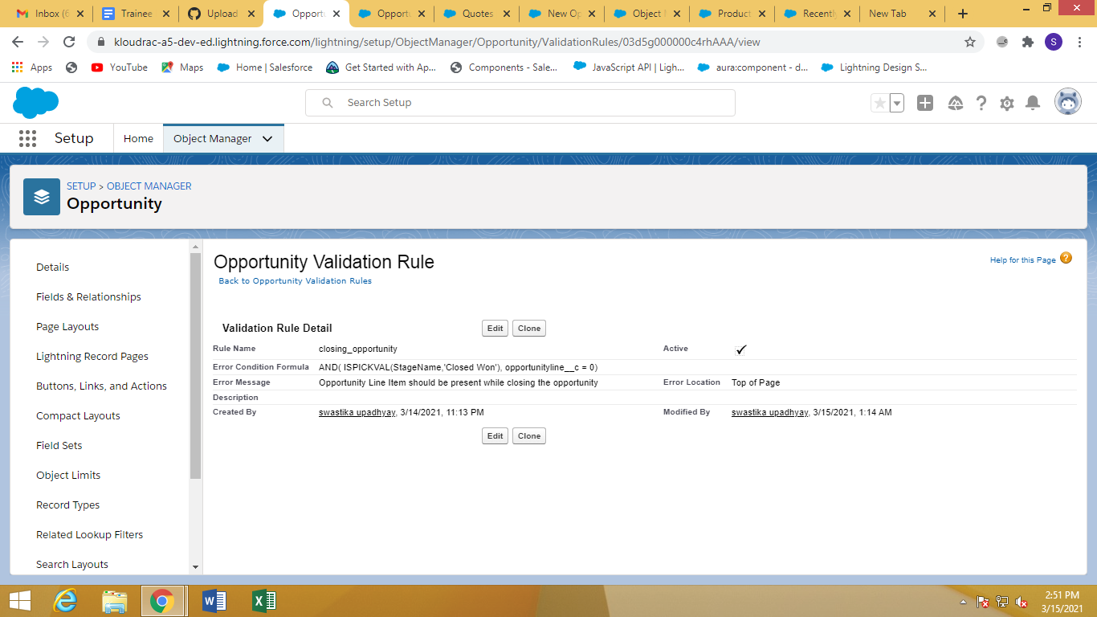

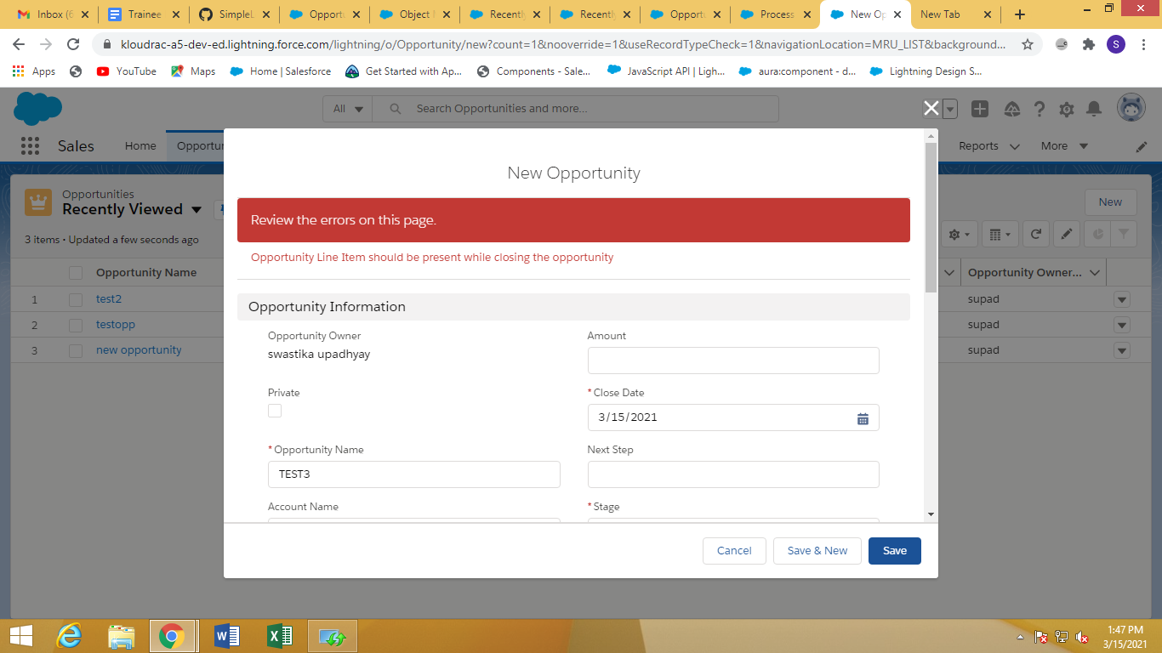

1. Only Admins should be allowed to change the account owner.

Error Message : "You are not authorised to transfer the account."

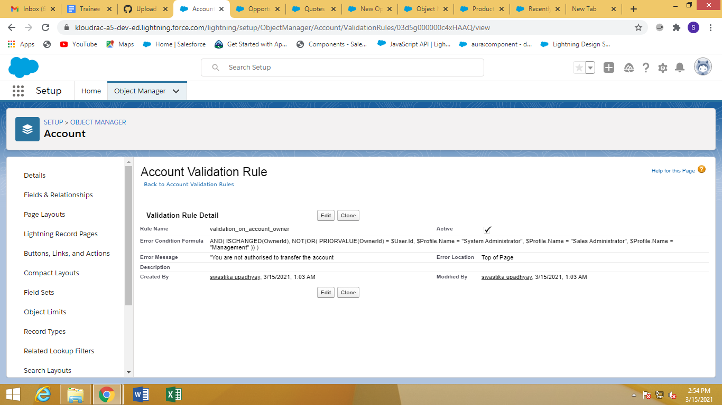

1. **Workflow Rule (5 Marks)**

If Amount > $10,000 send an email alert on opportunity **closed won (Stage field value)** to pgoyal@kloudrac.com and msharma@kloudrac.com

Email Template .

Subject : Deal closed Alert - $Amount - Opportunity Name

Opportunity Name :

Account Name :

Account Owner :

Amount :

Close Date :

Best Regards

Salesforce Team - Kloudrac

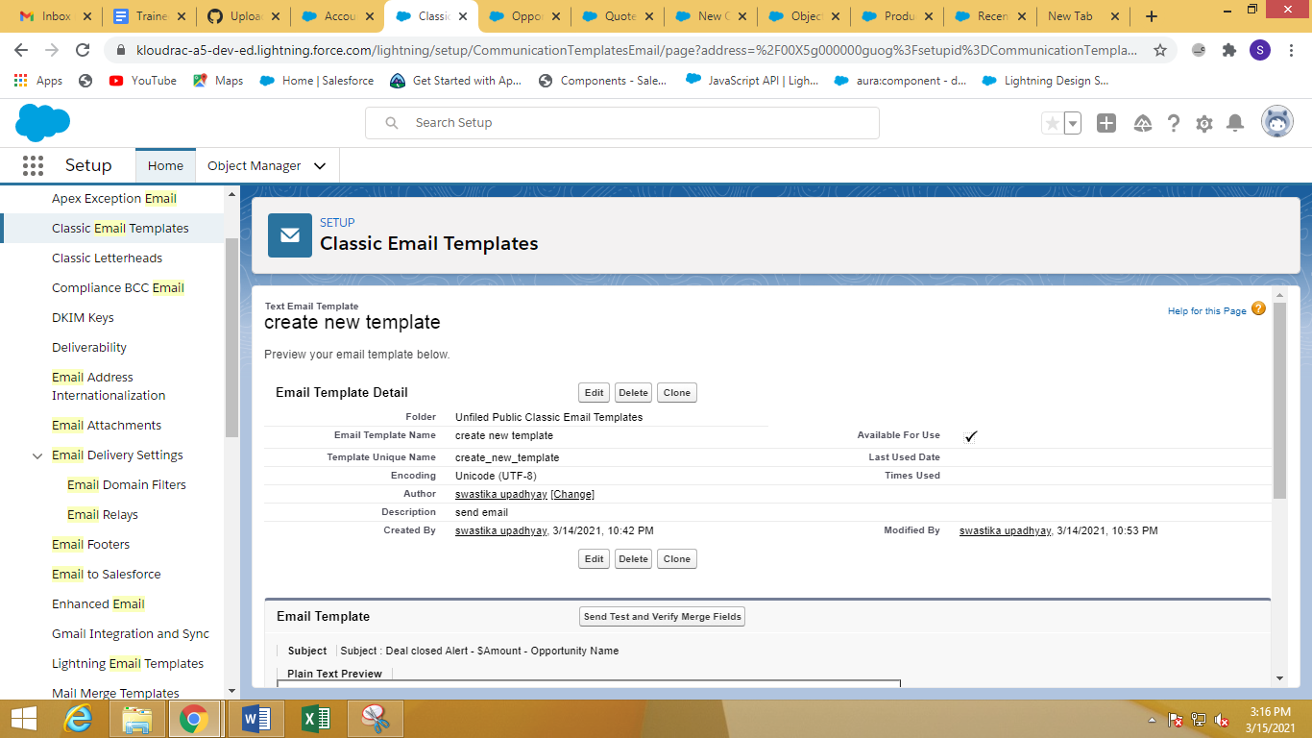

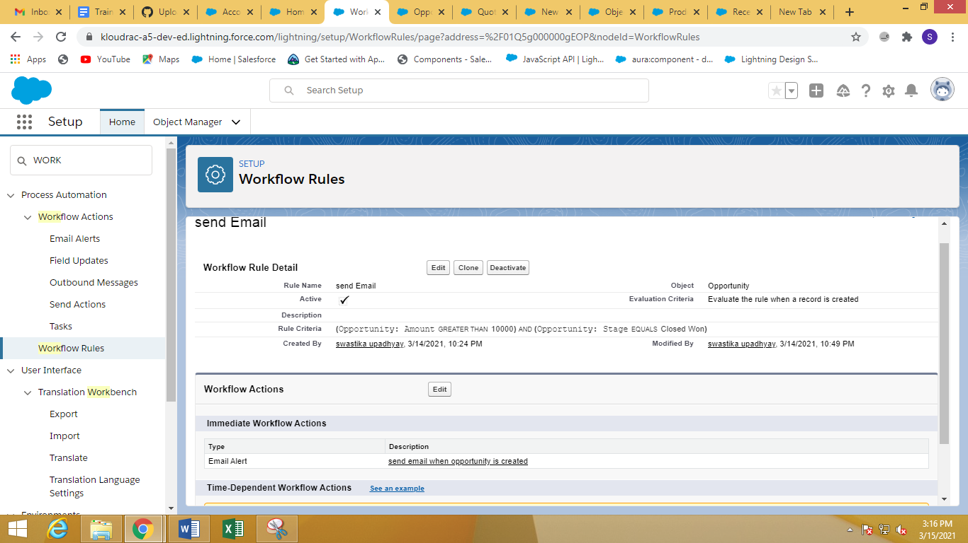

Section c

3)Quote and Quote Line Item should get auto created while Opportunity revenue is greater than 100000.

