TRIBHUVAN UNIVERSITY
INSTITUTE OF SCIENCE AND TECHNOLOGY


COLLEGE MANAGEMENT SYSTEM

A PROJECT REPORT
Submitted to
Ms. Pratima Gautam
Software Engineering (CSC375)
Vedas College
Jawalakhel, Lalitpur

Submitted By
Bibash Sangroula (5-2-149-14-2022)
Bipana Kapali (5-2-149-15-2022)
Lokendra Kumar KC (5-2-149-06-2022)
BSc.CSIT 6th Semester
ACKNOWLEDGEMENT
This report is the result of the collective eﬀorts of our team as part of the SoftwareEngineeringcourseundertheBachelor'sinComputerScienceandInformationTechnology (BSc.CSIT)program.Thesuccessfulcompletionofthisstudywouldnothavebeenpossible without the structured guidance provided throughout the semester.
We would like to extend our sincere appreciation to our course instructor, Ms. Pratima Gautam,forherexpertguidanceandcontinuoussupport.Herinsightsandrecommendations have been invaluable in shaping the direction of our research.
Additionally, we would like to recognize the valuable resources, including web articles, reports,andindustrycasestudies,whichprovidedessentialinsightsandsupportedthedepth of this study.

ABSTRACT
This project focuses on the development of a College Management System (CMS) designed to overcome the administrative inefficiencies faced by educational institutions still dependent on outdated paper-based or fragmented systems. Such legacy approaches often result in time-consuming manual processes, higher risks of human error, restricted real-time data access, and weak data security.
The proposed CMS addresses these challenges by automating and centralizing core administrative functions, including admissions, course allocation, attendance tracking, fee management, and examination handling. The system aims to provide a secure, user-friendly, and scalable platform that enhances operational efficiency and data reliability. To ensure robust security, role-based access control is implemented, enabling tailored privileges for students, faculty, and administrators.
The development follows the Waterfall methodology, ensuring a structured and systematic approach to requirement gathering, system design, implementation, and testing. The anticipated outcome is an efficient, accurate, and reliable system that reduces manual effort, minimizes errors, saves time, and improves the overall administrative environment. By enabling real-time data access and strengthening data security, the CMS is expected to transform administrative processes and significantly enhance the operational effectiveness of educational institutions.

Table of Contents
Chapter 1: Introduction 1
1.1. Introduction 1
1.2. Objectives 1
1.3. Target Audience and Business Types 1
1.4. Tools and Techologies Used 2
Chapter 2: System Requirement 3
2.1.Introduction 3
2.2.Hardware Requirement 3
2.2.Software Requirement 4
Chapter 3: System Architecture & Design 5
3.1.Architecture Diagram 5
3.2.Use Case Diagram 5
3.3.Database Schema 6
3.4. How modules interact 7
Chapter 4: Implementation Details 9
4.1. Product Categories and Filtering 9
4.2. Shopping Card Logic 9
4.3. Payment Gateway Simulation 9
4.4. User Interface Component and Design system 10
4.5. Performance Optimization Strategies 10
4.6. Security Features 10
Chapter 5: User Interface Design 11
5.1. Stella Jewellers E-commerce Website Design 11
5.2. About Us Page Design 12
5.3. Contact Us Section 13
5.4. Shop Section 14
5.5. Cart Section 15
Chapter 6: Challenges Faced and Solutions 16
6.1. Introduction 16
6.1. Challenge Faced 16
Chapter 7: Conclusion 18
7.1. Summary 18
7.2. Challenge Faced 18
Reference 20

List of Figures
Figure 1:The Waterfall Model Showing the sequential flow of different phases for the CMS Error! Bookmark not defined.
Figure 2: Gantt chart Representation of Task Schedule of Project (CMS) Error! Bookmark not defined.
Figure 3:General Block Diagram of (CMS) Error! Bookmark not defined.
Figure 4:Generic Layered Architecture Pattern Error! Bookmark not defined.
Figure 5:Repository Architecture Pattern Error! Bookmark not defined.
Figure 6:Client Server Architecture Pattern Error! Bookmark not defined.
Figure 7:Use Case Diagram for College Management System Error! Bookmark not defined.
Figure 8:Sequence Diagram for CMS Error! Bookmark not defined.
Figure 9:Activity Diagram for CMS Error! Bookmark not defined.
Figure 10:Class Diagram for CMS Error! Bookmark not defined.
Figure 11:Activity Diagram for CMS Error! Bookmark not defined.
Figure 12:Homepage of College Management System 11
Figure 13:About Us Page of College Management System 12
Figure 14:Contact Us Section 13

List of Tables
Table 1:Task Division of Project (CMS) Error! Bookmark not defined.
Table 2:Unit Testing Key Components Tested Error! Bookmark not defined.
Table 3:Interation Testing Output Scenarios Error! Bookmark not defined.
Table 4:Performance Testing Output Scenarios Error! Bookmark not defined.
Table 5:Beta Testing Process Error! Bookmark not defined.
Table 6:Smoke Testing Process Error! Bookmark not defined.
Table 7:Approach for User Acceptance Testing Error! Bookmark not defined.
Table 8:COCOMO Mode values Error! Bookmark not defined.

Chapter 1: Introduction

Introduction
Stella E-commerce represents a comprehensive online shopping platform developed as a part of the academis curriculum to demonstrate practical implementation of e-commerce principles and web development technologies. The platform represents a modern approach to digital retail, featuring an asthetically pleasing interface combined with robus funtionality tha mirrors real world commerical applications. The project serves as a proof to the integration of theoretical knowledge with practical execution, creating a seamless shoppng experience that prioritizes user engagement intuitive navigation and transactional efficiency. The website stands a complete e- commerce ecosystem from product discovery to simulated purchased completion, showcasing the end-to-end journey of an online customer in today's digital marketplace.

Objectives
The main goals of the Stella E-commerce sites are:
- To build a complete, working shopping website that peple could actually use to browse, add to cart and checkout.
- To make it work perfectly on all devices- phones, tablet and computers using responsive design.
- To practice and improve my web development skills using HTML, CSS and Javascript in a real project.
- To solve real coding challenges like cart persistence and responsive layouts to become better developer

Target Audience and Business Types
The tageted audience of e-commerce site are
- Jewellery Lovers Customer, people specifically looking for necklaces, earrings, rings and bracelets.
- Gift Shoppers, those buying presents for birthdays, anniversaries or special occasions.
- Fashion- Conscious Women (Primary Audience), aged 16-35 who follow trennds and accessorise.
- Customers looking for stylish jewellery at affortable prices.
This is a specialized online jewellery store selling :
- Earrings
- Necklace & Pendant
- Rings
- Bracelet and Bangles

Tools and Techologies Used
Frontend Development
- HTML5 - For website structure and content
- CSS3 - For styling and design
- JavaScript - For interactive features
- Bootstrap - for responsive mobile- friendly design
Development Tools
- VS Code - Code editor for writing HTML, CSS, JavaScript
- GitHub - For storing and managing code versions.
- GitHub Pages - Free hosting to put websie online

Chapter 2: System Requirement

2.1.Introduction
System requirements explain what equipment and programs are needed to either use or develop the Stella Jewellery website. This section is divided int hardaware (physical devices and components) and software (programs and application) to make it clear what is required for different situations.

2.2.Hardware Requirement
Hardwaare requirements define the physical components needed to develop, run and access the e-commerce system efficiently. These components ensure smooth performance, fast, response time, and reliable user interaction with the website.
For users (Shopping online)
Since the website is web-based, users only require simple hardware and an internet connection to access and use the system.
- Computer or SmartPhone : Required to browse products and view pages.
- Minimum 2 GB RAM: Ensures smooth browsing without lag.
- Internet Connections; Needed to load website content and images.
For developers
Development work involves using code editors, browsers, and version control systems, which require better hardware performance.Computer or SmartPhone : Required to browse products and view pages.
- Computer or Laptop : Used for coding and testing the application.
- Minimum 8 GB RAM : Required to run development tools smoothly.
- Sufficient Storage (HDD/SDD) : To store project files and tools.
- Internet Connection : Needed for GitHub deployment and updates.
- Processor: Intel Core i3 or equivalent AMD processor

2.2.Software Requirement
Software requirement is a clear description of the software tools, programs, and technologies needed to develop, run, and use a system effectively. It specifies the operating systems, applications, browsers, and development tools required to ensure the software works correctly for both users and developers.
For users (Shopping online)
The e-commerce system runs on a web browser, so no additional software installation is required for users.
- Operating System : Windows, Andriod, iOS, Linux
- Web Browswe: Chrome, Firefox
- Internet Access : Required to open the website.
For developers
These tools help developers create, test, manage, and deploy the e-commerce website efficiently.
- Operating System: Windows/ Linux/ macOS
- Code Editor: Visual Studio Code for writing HTML, CSS and JavaScript
- Web Browswe: For testing and Debugging the website.
- GitHub : For version control and hosting the project.

Chapter 3: System Architecture & Design

3.1.Architecture Diagram
An architecture diagram is a visual representation of the overall structure of an e-commerce system. It shows how different components such as users, the website interface, server, database, and external services are connected and how data flows between them. The diagram helps in understanding how the system works as a whole, how requests are processed, and how various parts interact to deliver features like product browsing, ordering, and payment processing.ful submission, students must receive a confirmation email with enrollment details.
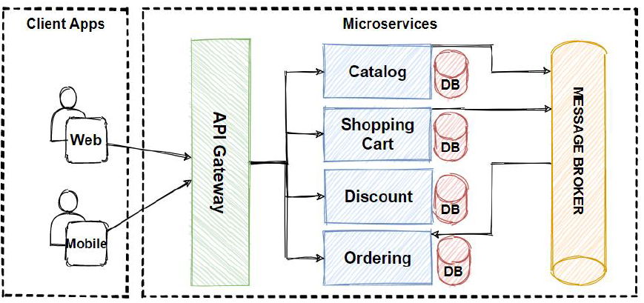
Fig: Architecture Diagram of E-commercce Site

3.2.Use Case Diagram
Use case is a description of a specific way a user interacts with a system to achieve a particular goal or complete a task. It defines what the system should do in response to user actions, focusing on functional requirement rather than technical details. Use cases help developers and skateholders understand the expected behavior of the system, the different types of users, and the main operations each user can perform. They are often represented visually in a Use Case Diagram, where actors and theor interactions with system functions.
For a E-commerce site, main actors of Use Case Diagaram could be:
- Customer/User
- Admin
- Payment Gateway
- 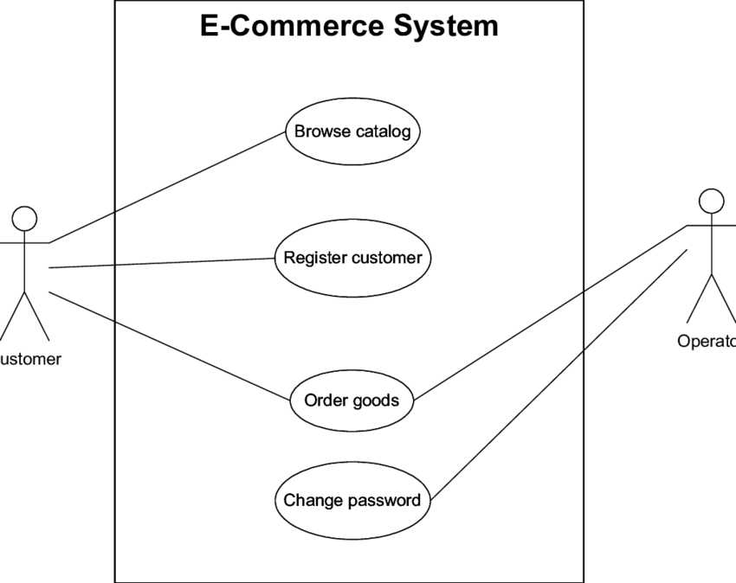Delivery/Logistics

Fig: Use Case Diagram of E-commerce Site

3.3.Database Schema
A database schema or ER (Entity-Relationship) diagram represents the structure of a database by showing how data is organized and how different entities are related to each other. In an e-commerce system, for example, entities like Customer, Product, Order, Cart, and Payment are identified, along with their attributes such as CustomerID, ProductName, OrderDate, etc. The relationships between these entities such as a customer placing an order, an order containing multiple products, or a payment linked to an order are also depicted. This visual representation helps developers and database designers understand how data flows through the system, ensures data consistency, and guides the creation of actual database tables with proper primary and foreign keys to maintain connections between entities.
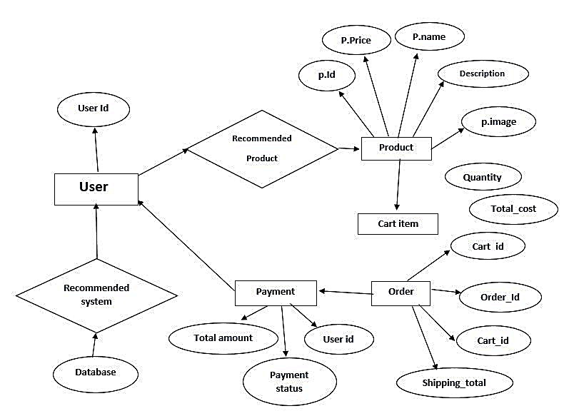
Fig: ER diagram of E-commerce site

3.4. How modules interact
In your e-commerce site, the various modules work together to provide a seamless shopping experience. The frontend displays products and allows users to browse, search, and add items to their shopping cart. The product catalog stores all product details, including prices, descriptions, and stock levels, which the frontend retrieves to show users. When a user proceeds to checkout, the cart module collects the selected items and order information, which is then sent to the payment integration module to process transactions securely. Once payment is confirmed, the order management module records the order, updates its status, and enables tracking. Additionally, the user account module handles registration, login, and order history, ensuring a personalized experience. Together, these modules communicate and interact to enable browsing, purchasing, and order fulfillment efficiently.
Several key modules my E-commerce site includes are:
- Frontend/User Interface
- Product Catalog
- Shopping Cart & Checkout
- Payment Integration
- Order Management
- User Accounts

Chapter 4: Implementation Details

4.1. Product Categories and Filtering
The product catalog organizes and displays all the products on the site. Products are grouped into categories and subcategories, making it easy for users to browse. Each product includes important details like images, descriptions, specifications, price, stock availability, and customer reviews. On the website, products are shown in responsive cards that adjust to different screen sizes. Users can navigate through products using pagination or infinite scroll. They can also use filters to quickly find products by price, brand, size, color, or ratings, and the filters remember their choices while browsing.

4.2. Shopping Card Logic
The shopping cart lets users keep track of the products they want to buy throughout their visit. Items added to the cart are saved using the browser’s localStorage, so they stay even if the user leaves the site or isn’t logged in. Users can add products with specific quantities, remove items, or clear the cart entirely. The cart automatically calculates totals, taxes, shipping, and discounts. On the website, a cart icon shows the number of items and total cost, and users can view a detailed cart page or popup with product images, descriptions, prices, and editable quantities. The system also handles special cases like out-of-stock items or multiple browser tabs to ensure the cart works reliably.

4.3. Payment Gateway Simulation
The checkout guides users through a few easy steps from reviewing their cart to confirming the order. First, users can check and edit their cart items. The payment step simulates a secure transaction, letting users select a payment method and complete the payment. Before finishing, users see an order summary with all details. After submitting, they get an order confirmation with a reference number, estimated delivery, and receipt. The process shows progress, handles errors clearly, and lets users go back to make changes without losing information.

4.4. User Interface Component and Design system
The visual design of the site creates a consistent and attractive look. It uses a defined color palette with a main brand color, neutral tones, and accent colors for buttons and links, ensuring good contrast for readability. Typography is chosen carefully for headings, body text, and labels, with font sizes that adjust for different screen sizes. The layout uses CSS Grid and Flexbox to make the site responsive on mobile, tablet, and desktop. Buttons, forms, navigation, and product cards follow the same style and include hover and click effects. Simple animations and transitions are used to make interactions smooth without slowing down the site.

4.5. Performance Optimization Strategies
The website is optimized to be fast and responsive for all users. Images are compressed, provided in multiple sizes for different devices, and use modern formats like WebP. Images below the screen are loaded only when users scroll to them to save time. Code files such as HTML, CSS, and JavaScript are made smaller and organized so the browser can load them efficiently, with only the necessary code loaded first. Important styles for the top of the page appear immediately, making content visible quickly. Caching stores static files in the browser so returning visitors don’t have to reload everything, and advanced techniques like service workers allow offline use and faster repeat visits. All these measures work together to make the site load quickly, respond smoothly, and give users a better browsing experience.

4.6. Security Features
The e-commerce site includes security features to protect user data and ensure safe transactions. These measures include encrypted connections (HTTPS) to secure data in transit, input validation to prevent malicious attacks, and safe handling of sensitive information like payment details. An important part of this is authentication, which verifies a user’s identity during registration and login. Users provide a username or email and password, and the system checks these credentials to ensure only legitimate users can access their accounts, keeping personal information and order history secure.

Chapter 5: User Interface Design

5.1. Stella Jewellers E-commerce Website Design

Figure 1:Homepage of E-commerce Website
The home page serves as the main entry point of the e-commerce site, providing users with an attractive and intuitive interface. It features a navigation bar at the top with links to Home, Shop, About, Contact pages, and a cart icon for quick access to the shopping cart. The hero section highlights ongoing promotions and offers, such as “Super value deals on all products” with up to 30% discount, encouraging users to explore the products. The layout is clean, responsive, and designed to immediately capture user attention while providing easy navigation to other sections of the site.
Below the hero section, the home page highlights the key features and benefits of the e-comerce site. each feature is represented with an icon and label such as Online Shopping, Free Shipping, Save money etc. Also inclides Featured products section, which display selected products with images, allowing userd to quickly browse poplar items. At the bottom of the page, the footer provides additional naviation and information which includes links to the social medias like instagaram.

5.2. About Us Page Design
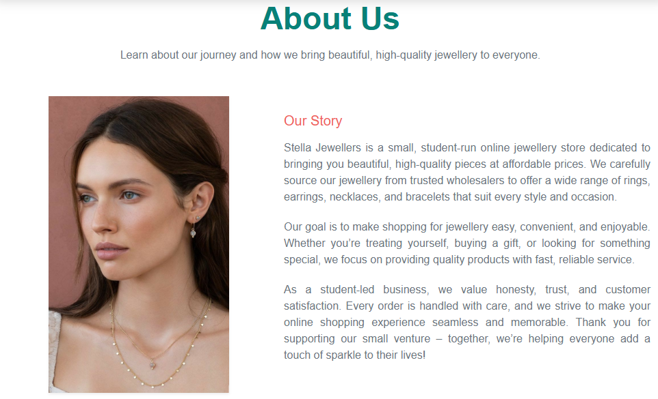
Figure 2:About Us Page E-commerce Website
This image shows the About Us section of a E-commerce Website. The section is titled About Us, followed by the heading Our Story. The About Us section of Stella Jewellers introduces the store as a student-run online jewellery business dedicated to offering high-quality, beautiful, and affordable pieces. It highlights that the products are carefully sourced from trusted wholesalers, providing a diverse collection of rings, earrings, necklaces, and bracelets for various styles and occasions. The section emphasizes the store’s commitment to convenience, fast service, and customer satisfaction, while reflecting core values of honesty, trust, and care in handling every order. Overall, it positions Stella Jewellers as a small, student-led venture focused on making online jewellery shopping enjoyable and helping customers add elegance and sparkle to their lives.

5.3. Contact Us Section
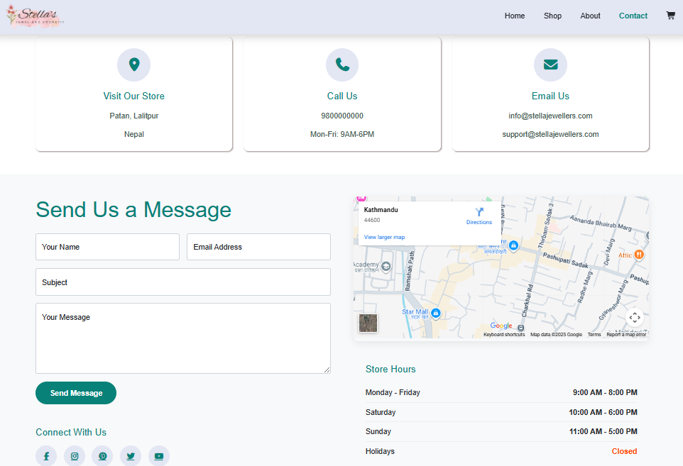
Fig: Contact Us Section
This image represents the Contact Us page of a E-commerce website. The top navigation bar contains options like Home, Shop, About, Contact, and Cart. Below this, it include the location of Shop, Contact Details and Email Address of Stella Jewellers.The section is titled Contact Us and includes a simple form with four input fields: Name, Email, Subject and Message, allowing users to provide their details and queries. Below the form, there is a Send Message button for submission. At the right side, it include the map of location of ths shop of Stella Jewellers and also include the Store Hours. At the bottom, the Footer is included which have additional links and informations.

5.4. Shop Section
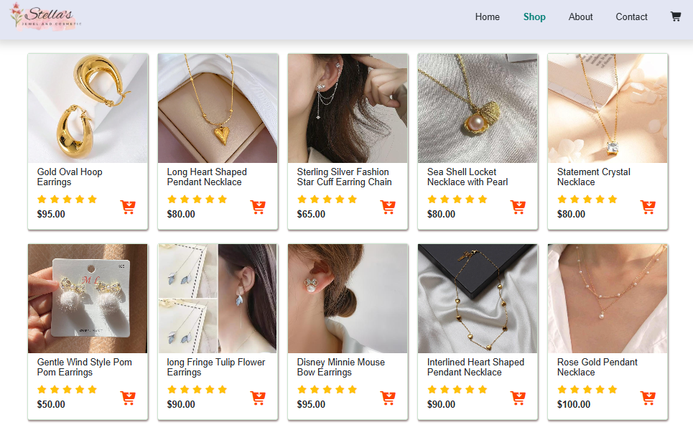
Fig: Shop Section
The Shop section of the ecommerce website displays a variety of products, each presented with an image, name, price, and an Add to Cart button for easy purchasing. The Add to Cart feature in the Shop section enables users to select products they wish to purchase and temporarily store them in a virtual shopping cart. When a user clicks the button, the selected item, along with its details such as name, price, and quantity, is added to the cart.This section allows users to browse the collection of earrings, necklaces, and bracelets, compare options, and select items they wish to buy. The design focuses on clarity and usability, ensuring that customers can quickly make selections, and add items to their cart, creating a seamless and convenient shopping experience.

5.5. Cart Section
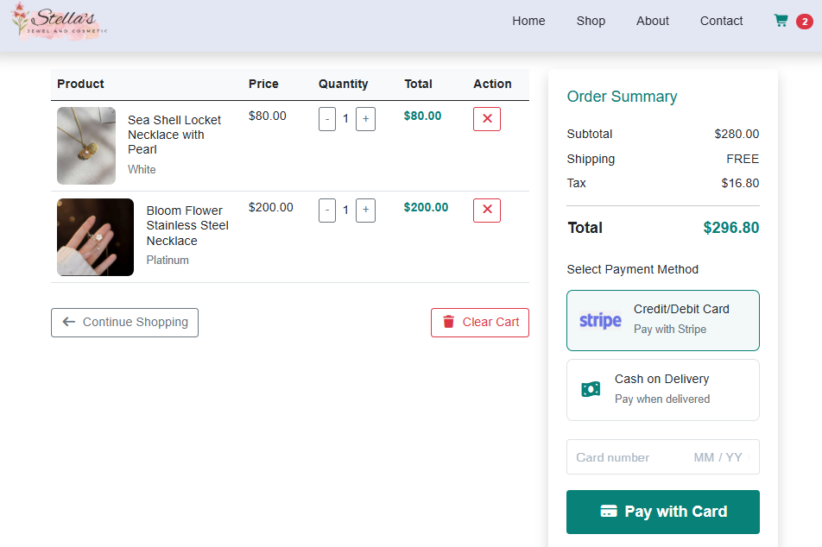
Fig: Cart Section
The Cart section displays a shopping cart table listing all selected products along with their details, including name, price, quantity, and a remove button for deleting items. Users can easily increase or decrease the quantity of each product, with the section dynamically updating the total price based on these changes. On the right side, the total price is calculated and displayed, providing a clear summary of the order. This section also integrates a payment gateway, allowing users to securely proceed with payment and complete their purchase, ensuring a smooth and convenient checkout experience.

Chapter 6: Challenges Faced and Solutions

6.1. Introduction
During the development of Stella Jewellers, several challenges were encountered, including making the website responsive across all devices, managing the shopping cart consistently, optimizing performance with high-quality images, and implementing user-friendly form validation. To address these issues, a mobile-first design approach with CSS Grid and Flexbox ensured layouts adapted to all screen sizes, while persistent cart storage using localStorage and sessionStorage kept selected items consistent across sessions and tabs. Performance was improved through image compression, lazy loading, and optimized scripts, and form validation was implemented both on the client and server sides with clear, real-time feedback for users. These solutions ensured the website was visually consistent, reliable, fast, and easy to use.

6.1. Challenge Faced
Challenge 1: Shopping Cart Management
- Problem: The cart lost items on page refresh or showed inconsistent data across tabs, and handling product variations was tricky. The JavaScript part to add to cart with its name price and handling the quantity of product was difficult.
- Solution: Used localStorage and sessionStorage to persist cart data, a central cart manager to maintain consistency, and synchronized changes across tabs.
Challenge 2: Responsive Design
- Problem: The website layout looked inconsistent on different devices, with overlapping elements and small buttons on mobile screens. Making responsive website for different types and sizes of devices was difficult, tested many times but the problem wasn't solving.
- Solution: Implemented a mobile-first approach using CSS, BootStrap Grid and Flexbox, responsive images with multiple sizes on content. Testing on multiple devices ensured consistency.
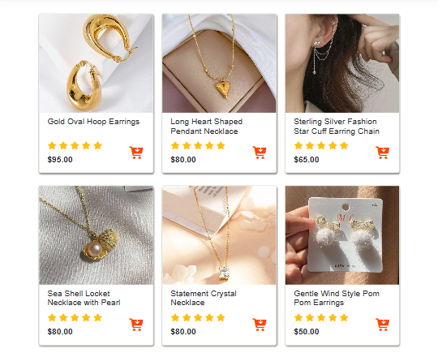
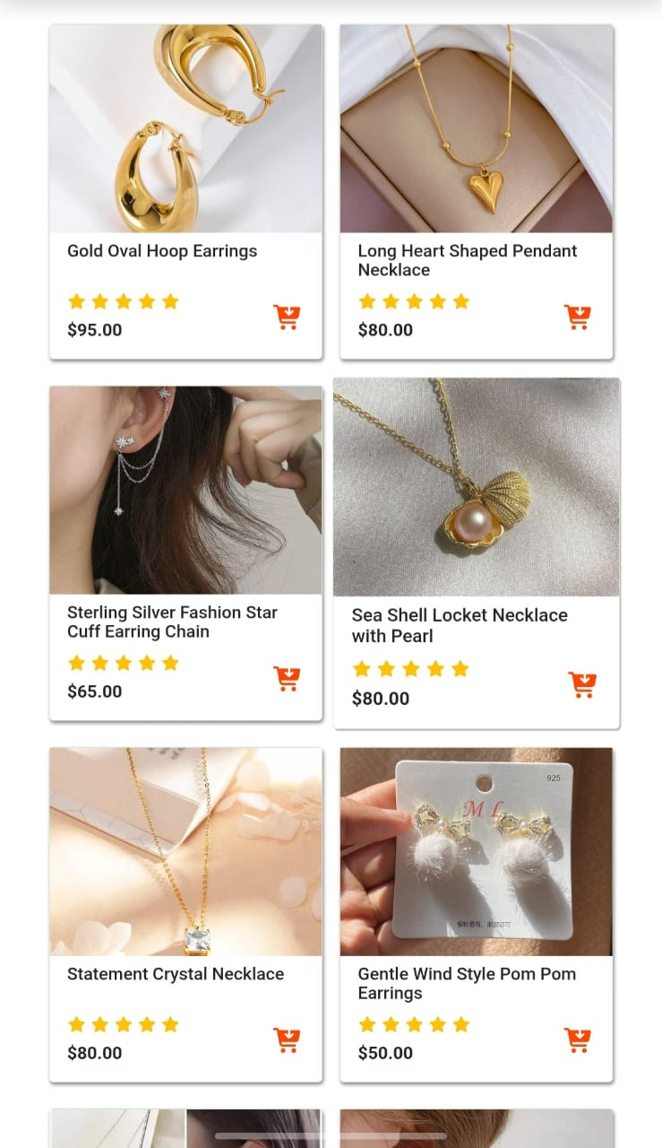
Fig: Responsive design for different devices and size
Challenge 3: Performance Optimization
- Problem: High-quality images slowed down loading times, causing delays on mobile devices.
- Solution: Optimized images (compression and WebP format), implemented lazy loading, extracted critical CSS, deferred non-essential scripts, and used a service worker for caching.

Chapter 7: Conclusion

7.1. Summary
In conclusion, this e-commerce website successfully provides a seamless and engaging online shopping experience for users across different devices and screen sizes, thanks to its fully responsive design. The website allows customers to easily browse products, view details, and make purchases without the need for an administrator panel, making it simple and accessible. During the development process, challenges such as ensuring consistent layout across devices, optimizing performance, and implementing intuitive navigation were effectively addressed. This project demonstrates the practical application of modern web development technologies, combining HTML, CSS, JavaScript, and other tools to create a functional and visually appealing online store. Overall, the website not only meets the core objectives of showcasing products and facilitating transactions but also provides a strong foundation for future enhancements, scalability, and improved user engagement.

7.2. Challenge Faced
During the development of this e-commerce website, several key lessons were learned. Working on responsive design enhanced understanding of how to create layouts that adapt smoothly to various screen sizes and devices, ensuring a consistent user experience. The project also provided practical experience in implementing product displays, navigation, and secure purchase workflows, reinforcing knowledge of web development technologies like HTML, CSS, and JavaScript.
For future improvements, several enhancements can be considered:
- Administrator Panel: Adding a backend admin panel to manage products, orders, and users efficiently.
- Enhanced Security: Implementing stronger security measures for payment processing and user data protection.
- Advanced Features: Introducing user accounts, wishlists, reviews, and filtering options to improve usability.
- Performance Optimization: Further optimizing loading times and responsiveness for large product catalogs.
- Scalability: Designing the system to handle more users and products as the business grows.
Overall, this project has been a valuable learning experience, laying the foundation for creating more complex and robust e-commerce platforms in the future.

Reference
Web Resources / Online Tutorials
- W3Schools Tutorials: https://www.w3schools.com
- Tutorials Point Tutorials: https://www.tutorialspoint.com/
Libraries / Frameworks / Tools Used
- Bootstrap Documentation: https://getbootstrap.com
- Font Awesome Icons: https://fontawesome.com
- Stripe Payment Gateway Documentation : https://stripe.com/docs

