COMP40610 Information Visualisation Assignment: Channelling Hans!

A Homage to Hans Rosling

This assignment aims to pay homage to the Gap Minder creator Hans Rosling. Similar to his creation, we have generated a visualization to visualize data for Gross Domestic Product(GDP) of different countries and their Global Competitive Index. The visualization also allows one to look at the different pillars for competitiveness like Innovation, Financial Market Development, Technological readiness etc. for each country and compare them between two countries.

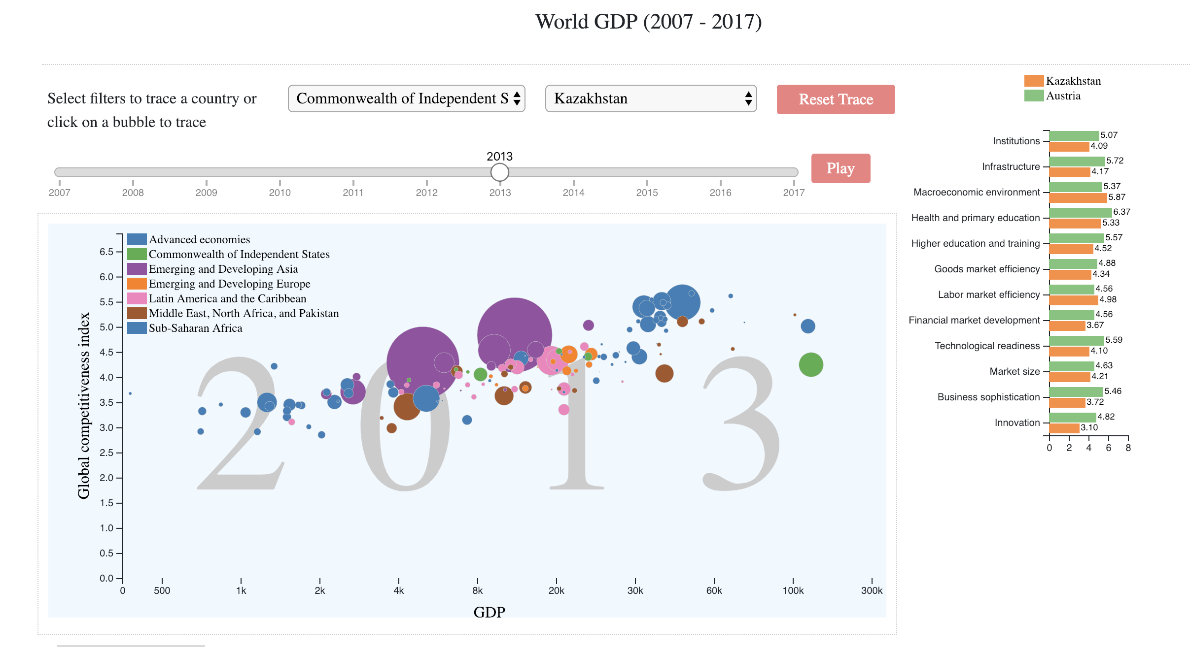

Below are the key features in this visualization.

Key Features - Part 1

1. Ability to view the overall growth of different countries as a bubble chart via a Slider-controlled animation through a series of years from 2007 to 2017.

2. The animation can be paused for a particular year and the data for one country can be viewed through a customized tooltip which displays the selected country‚Äôs Population, Region and Income Group, on hovering over the country.

3. Also on hovering, the exact values of GCI and GDP can also be viewed on top of the dotted lines connecting from the circles to X and Y axis.

4. The trace of a particular country(the travel through the years) can be viewed by 'click'ing on the desired country. OR the desired region can be selected from the drop down boxes provided. The list of countries belonging to a region is also visible in the next drop down corresponding to the selected region.

5. After the trace is generated, the data for GDP, GCI, Population, Region and Income Group can be viewed by hovering on each bubble on the trace.

6. The trace of the country can be removed by using the 'Reset Trace' button. This will bring all the bubbles back to life.

Key Features - Part 2

As the second part of the assignment, there is a connected visualization which will be generated when the countries are selected from the drop down.

1. The individual pillars for the competitiveness for each country that is selected(clicked) can be viewed in the bar chart.

2. The bars project values of the individual pillars and data is available for the years 2007-2017.

3. On clicking the bubble of one country or by selecting the countries from the drop down, the individual pillars are visible for the selected country/countries. This enables us to view the data efficiently for each pillar.

4. On clicking the bubble of the second country or by selecting the next country from the drop down , the individual pillars of both the countries are visible along with their values on the sides of the bars.