**AIM -** Executing java programming and integration of GitHub with

Jenkins.

**Theory –**

Jenkins: Jenkins comes with a pretty basic setup, so you will need to install the required plugins to enable respective third-party application support. GitHub is a web-based repository of code which plays a major role in DevOps. It provides a common platform for multiple developers working on the same code/project to upload and retrieve updated code, thereby facilitating continuous integration. Jenkins needs to have GitHub plugin installed to be able to pull code from the GitHub repository.

Step 1 -Go to any folder and create one java file

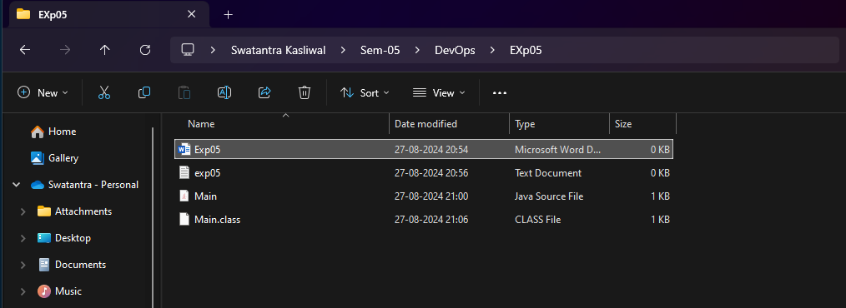

Step 2 – Create the new job with freestyle enviroment.

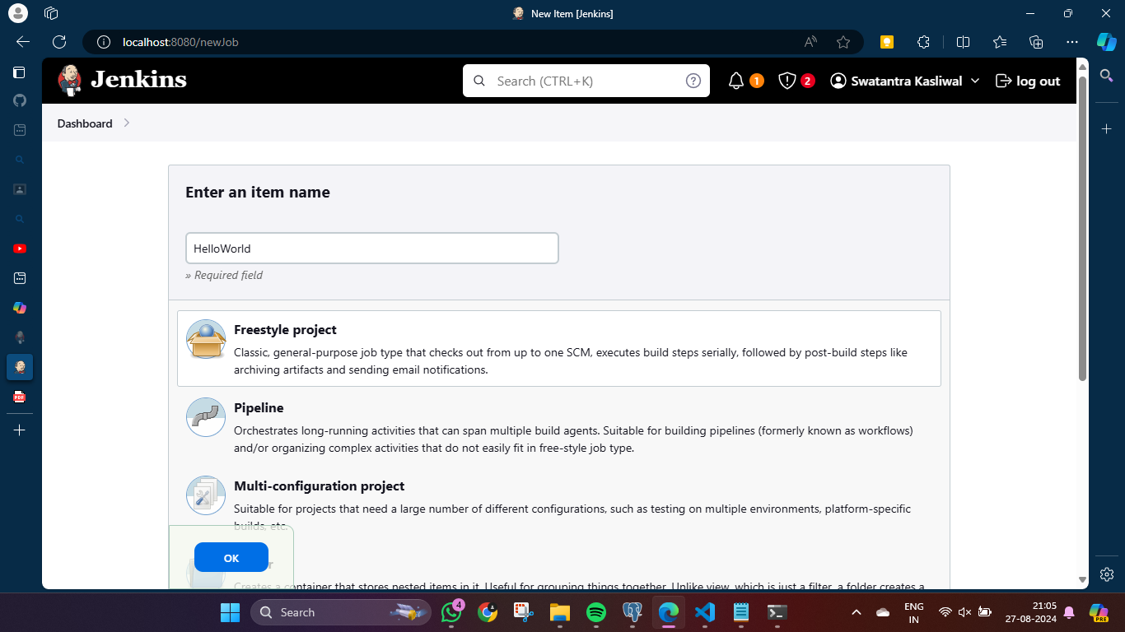

Step 3 – In “Advance” use “Use Custom Workspace ” and add the location of your java file

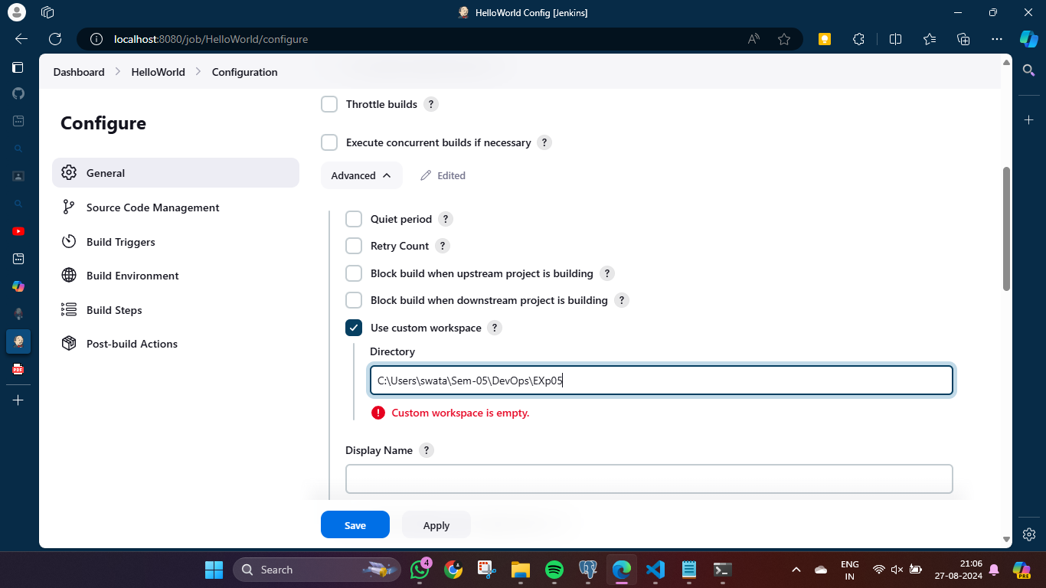

Step 4 – In “Build Steps” select “Execute Windows batch command” and enter the commands to run your java file and save it.

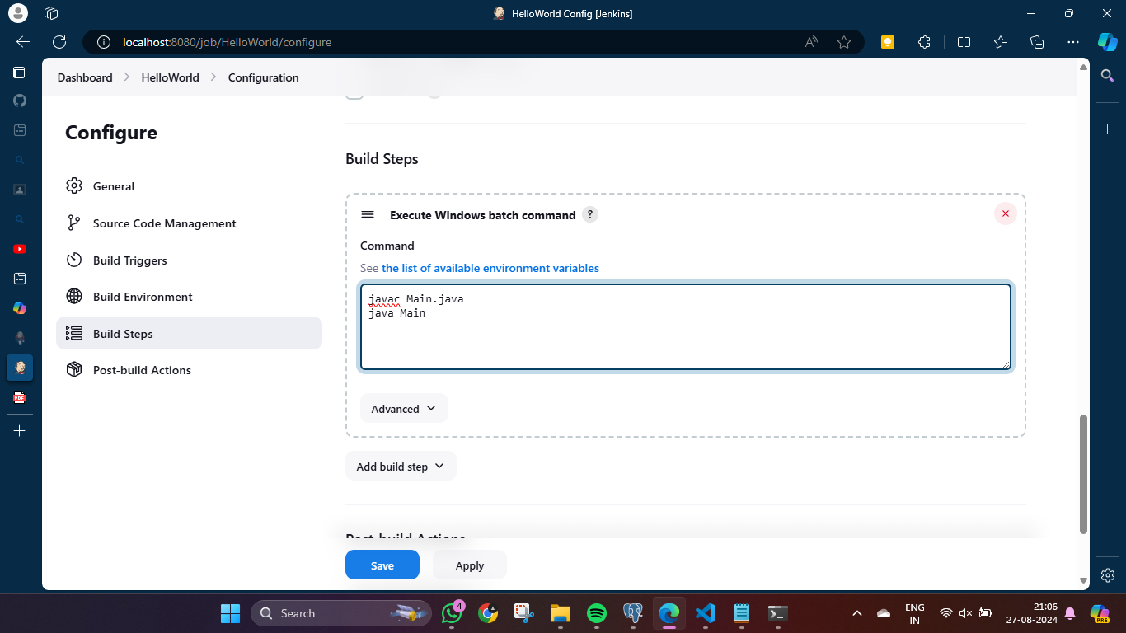

Step 5 – Now click on Build Now , it everything is correct it will show a green tick and console output , if there is error then it will show red tick.

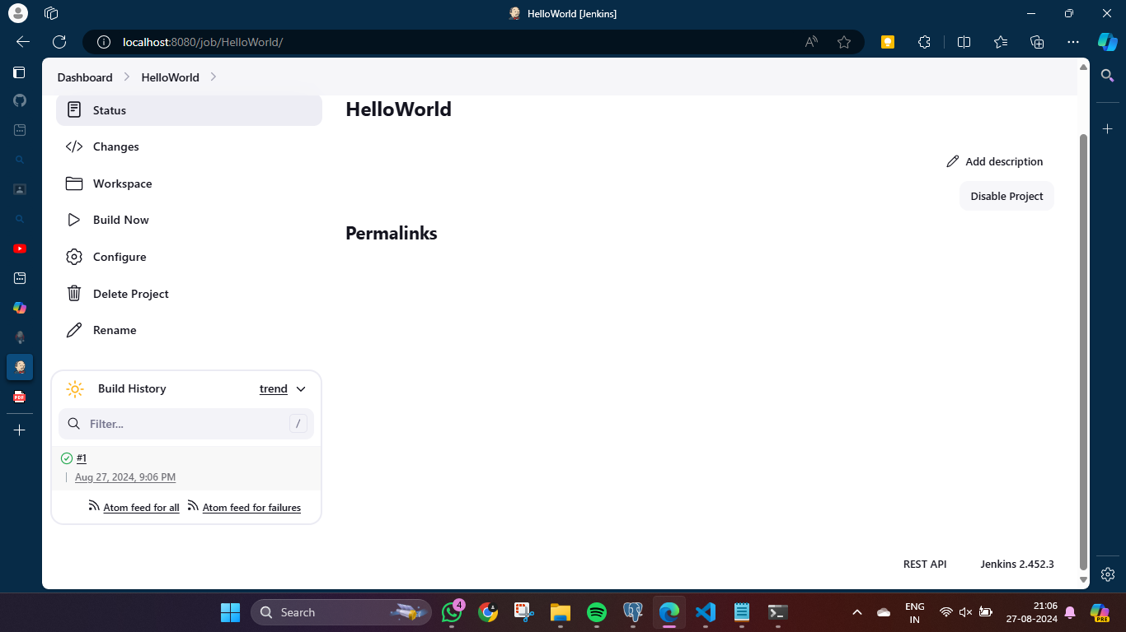

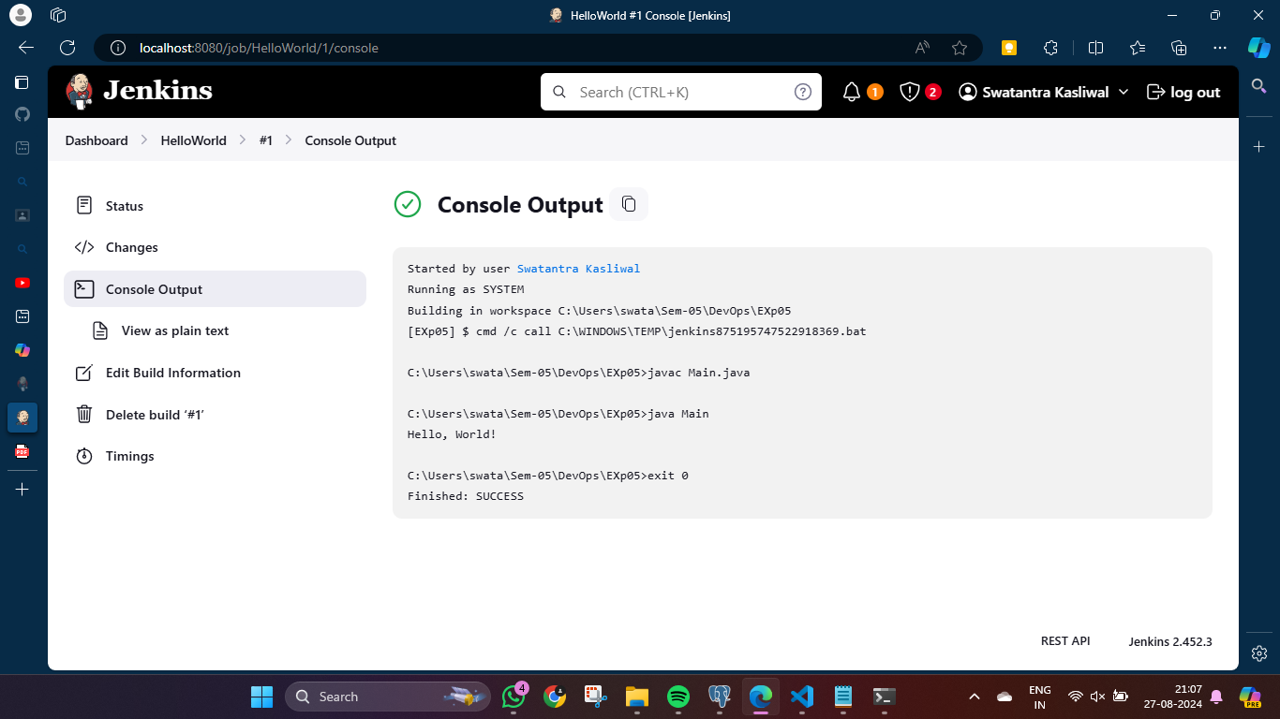

**Integrating Jenkins with GITHUB –**