Solving TSP using SA and GA:
Author Name: Swatej Parmar
Git hub link:- https://github.com/Swatej15/AI_Project
Id: 25042860
Abstract :
This research aims that analyze the application of Simulated Annealing (SA) and Genetic Algorithms (GA) on the Travelling Salesman Problem with Python.The outcomes demonstrate that SA is always faster and delivers high-quality solutions with short computation time but the GA is slower but sometimes it gives better results for bigger problems.The discussion reflects an evident compromise between speed and quality of the solution.
- Introduction

Lots of optimisation challenges are facing very large search spaces as a result the conventional exact methods become slow or even unfeasible. The Travelling Salesman Problem (TSP) is just such a case, since the number of routes increases exponentially with each new city. The aim of this research is to provide a thorough investigation on how Simulated Annealing and Genetic Algorithms deal with TSP in an efficient manner bу assessing their solution quality, runtime performance, and scalability on the increasing problem sizes.

- Problem Definition

The Travelling Salesman Problem (TSP) is the problem of finding a route that is as short as possible, visits every city once, and returns to the starting point. The challenge is that the number of possible routes increases dramatically, that is, exponentially, with every new city. A state stands for a total tour represented as an ordered list of city indices providing n! possible routes for n cities. Swapping of cities and reversing of segments create new states. Each city must be visited once, and the distances are calculated based on Euclidean metrics in a fixed setting.

- Literature Review / Related Work

According to Zhan et al. (2016), a List-Based Simulated Annealing (LBSA) was proposed that employs a dynamic temperature list in place of the fixed cooling schedule. This technique not only enhances the stability of SA but also simplifies the tuning process and allows for the generation of TSP solutions that are superior to those obtained by the conventional version.

- Methodology
Chosen Search Techniques with the justification

In the Simulated Annealing (SA) and the Genetic Algorithm (GA) chose because they offer two widely used and powerful strategies for solving combinatorial optimisation problems such as the TSP.
Simulated Annealing is selected as the single solution method because it is simple to implement, requires only a few parameters and also it is highly effective at escaping local minima through probabilistic acceptance of worse moves. This makes SA fast and reliable for finding good quality solutions within limited computation time.

The Genetic Algorithm is selected because it represent the population based approach capable of exploring a wider range of possible tours at once. Through selection, crossover, and mutation, GA maintains the diversity and often discovers higher quality routes, especially as the number of cities increasing. Although GA requires more computational effort, it provides a useful contrast to SA by prioritising solution quality over speed.

Tabu Search is not used because it requires maintaining memory structures, also neighbourhood rules, and several parameters that making it more complex and time consuming to configure for this project. Choosing SA and GA offered a balanced comparison between a fast local search method and a more exploratory evolutionary method.

Hyperparameters
For SA, a starting temperature of 1000 and cooling rate of 0.995 allowed broad early exploration and slow, stable convergence.
For GA, a population size of 50 and ordered crossover and a mutation rate of 0.01 providing the enough diversity to avoid premature convergence while keeping runtime manageable. Generations was chosen to ensure gradual improvement without excessive computation.

- Implementation Details

The Travelling Salesman Problem is solved by the python assigning city coordinates from a CSV file as input. The Euclidean distance was then use to create a distance matrix that would show the cost of travelling between all the cities. The problem was represented with city indices, where each city had to be visited only once.

Simulated Annealing is starts with a random tour and create the new solutions by performing 2 opt swaps. The new solutions are then accepted as per a temperature controlled probability that means the even worse tours can sometimes be accepted to prevent getting stuck in local minima. After acceptance, the temperature is allowed to decrease slowly according to a cooling schedule until convergence is achieved.

The Genetic Algorithm uses a population of tours that has been create the randomly to begin with. It does selection, order crossover, and mutation to change the population over generations and the change is based on fitness evaluation relating to the length of the tour.

- Results and Analysis

Simulated Annealing gradually enhances the quality of the tour throughout the iterations also It’s never fails to deliver satisfaction results in a matter of minutes and its speed is not affected even when the number of cities grows. Although SA might not find the optimal route for large-scale issues every time, still it is a very fast and dependable method for prompt optimization.

Figure 1: Simulated Annealing Convergence Curve

This convergence plot of simulated annealing showing improvements in tour length in every iteration.
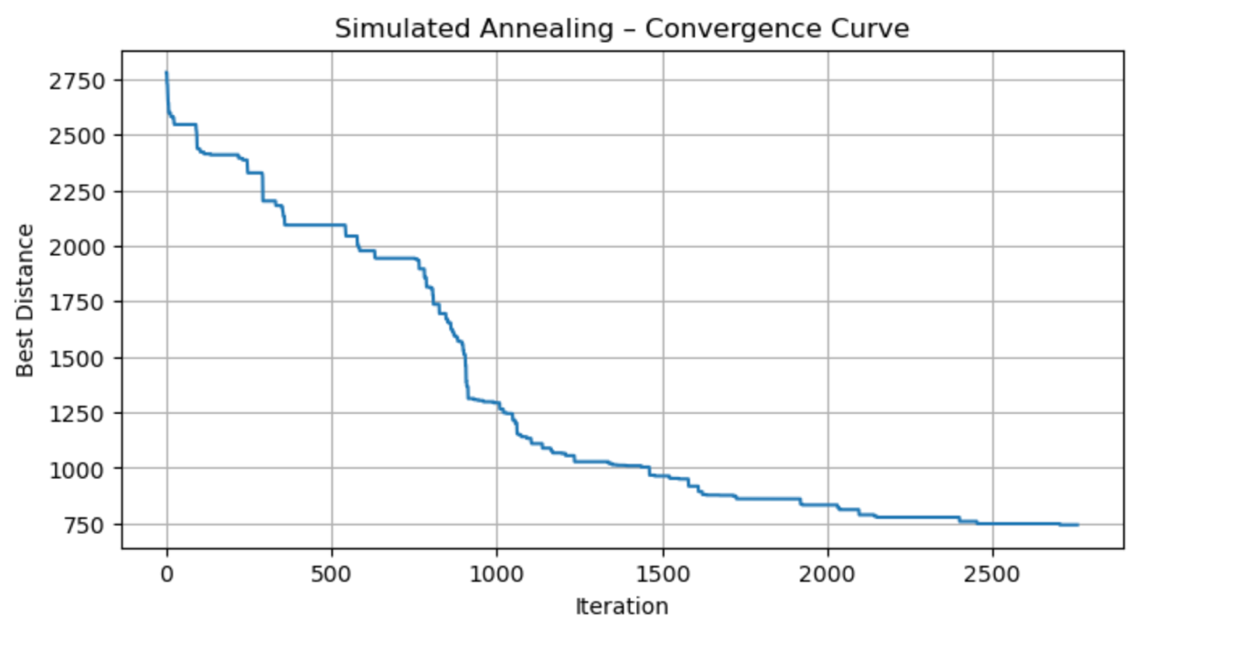

Simulated Annealing is very fast and good at finding solutions quickly and making it perfect for those problems that demand quick solutions. However, its main drawback is the potential trapping in a local optimum because it only uses one solution.

Simulated Annealing is an extremely effective strategy as it executing the fast and gradually enhances solutions also its single solution exploration might restrict its capacity to discover the global optimum.

Genetic Algorithm

The Genetic Algorithm, represented by its convergence curve, demonstrates a continuous improvement in the quality of the tour for each generation. For the larger problem sizes, GA frequently yields tours of higher quality than SA, however, this is accompanied by a longer computation time.

In GA there is Exploration that is strong produces solutions of better quality and the use of a population reduces the risk of getting stuck in local optima also It is effective in large and complicated TSP cases but the process is slower than SA because of the evaluation of manycandidates. There are more parameters to tune so it will make it harder to configure.

Figure 2: Genetic Algorithm Convergence Curve
In this Genetic Algorithm, the convergence curve is very active in showing progressive enhancements in the quality of the solutions over generations.
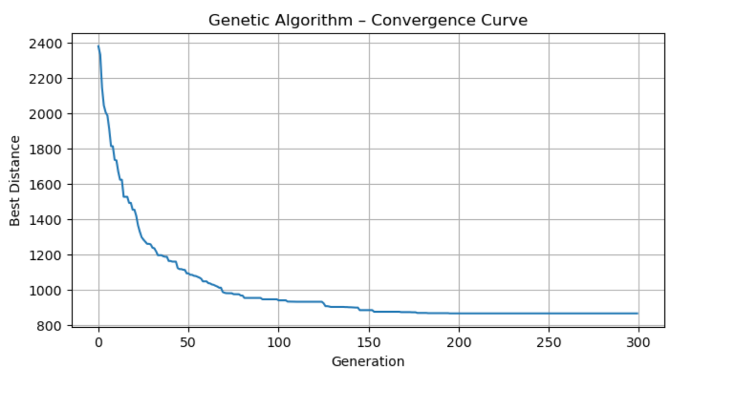
Although the Genetic Algorithm takes more time to executing and it still finds very good solutions. The algorithm's evolution-based alternative to search allows it to perform a wide exploration and do a gradual solution improvement at the same time. Also genetic algorithm is the best option when quality of the solution is a priority over its speed.

Scalability Analysis

The longer tours produced by both the algorithms as the number of cities increases. Simulated Annealing has a faster time performance which is still under 0.1 seconds and the Genetic Algorithm has longer processing time because it is evaluating bigger populations. In case of larger TSP instances, GA may occasionally outperform in terms of solutions but this comes along with substantial computation time.

Figure 3 : Scalability Analysis

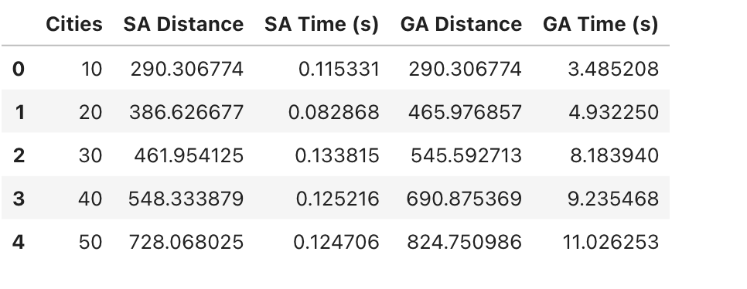
SA: Extremely quick and indeed scales nicely with the increase in problem size.
GA: For larger TSP cases, GA can deliver better solutions than SA
Weaknesses:
SA: When it comes to huge problems, it might not be able to get the best solution.
GA: The time needed for the algorithm to run rises a lot with the addition of each city.

Simulated Annealing is very efficient in a such way that the runtime is almost constant even when the size of the problems are increases. GA shows that the search space to a greater extent and hence may discover better routes but the evaluation of numerous generations and individuals causes its efficiency to drop. On the other hand, SA is the best option for getting rapid results and GA ranks higher on the quality of the solution.

Route Found by Genetic Algorithm

Figure 4: Route Found by Genetic Algorithm
Visualise the top-end tour generated by the Genetic Algorithm for the TSP instance.

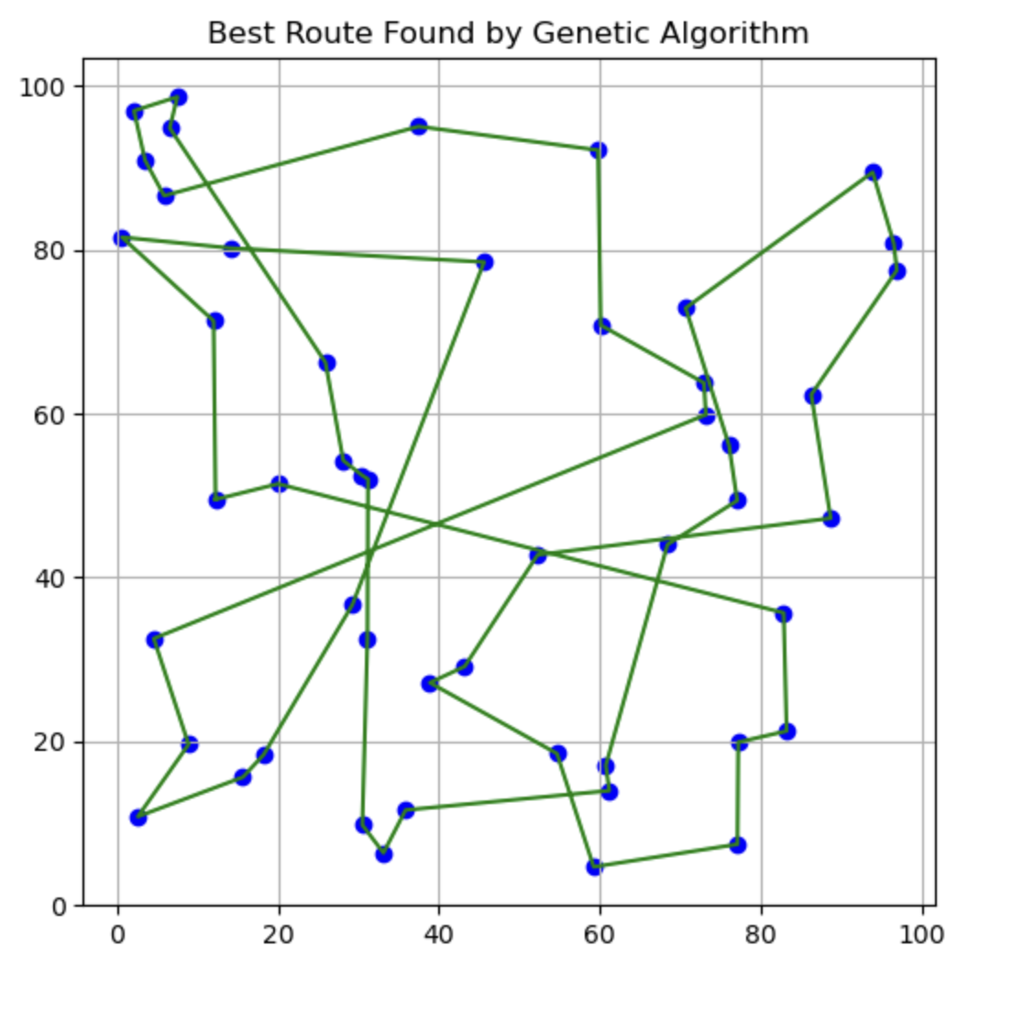
In the end, Simulated Annealing is more efficient in terms of runtime, whereas the Genetic Algorithm provides a higher quality solution as the problem size increases. This underlines the existence of a trade-off between speed and optimization effectiveness.

- Comparison and Discussion

Figure 5. SA vs GA Convergence Comparison
In this experiment, how the simulated annealing and the genetic algorithm perform over the same TSP instance.
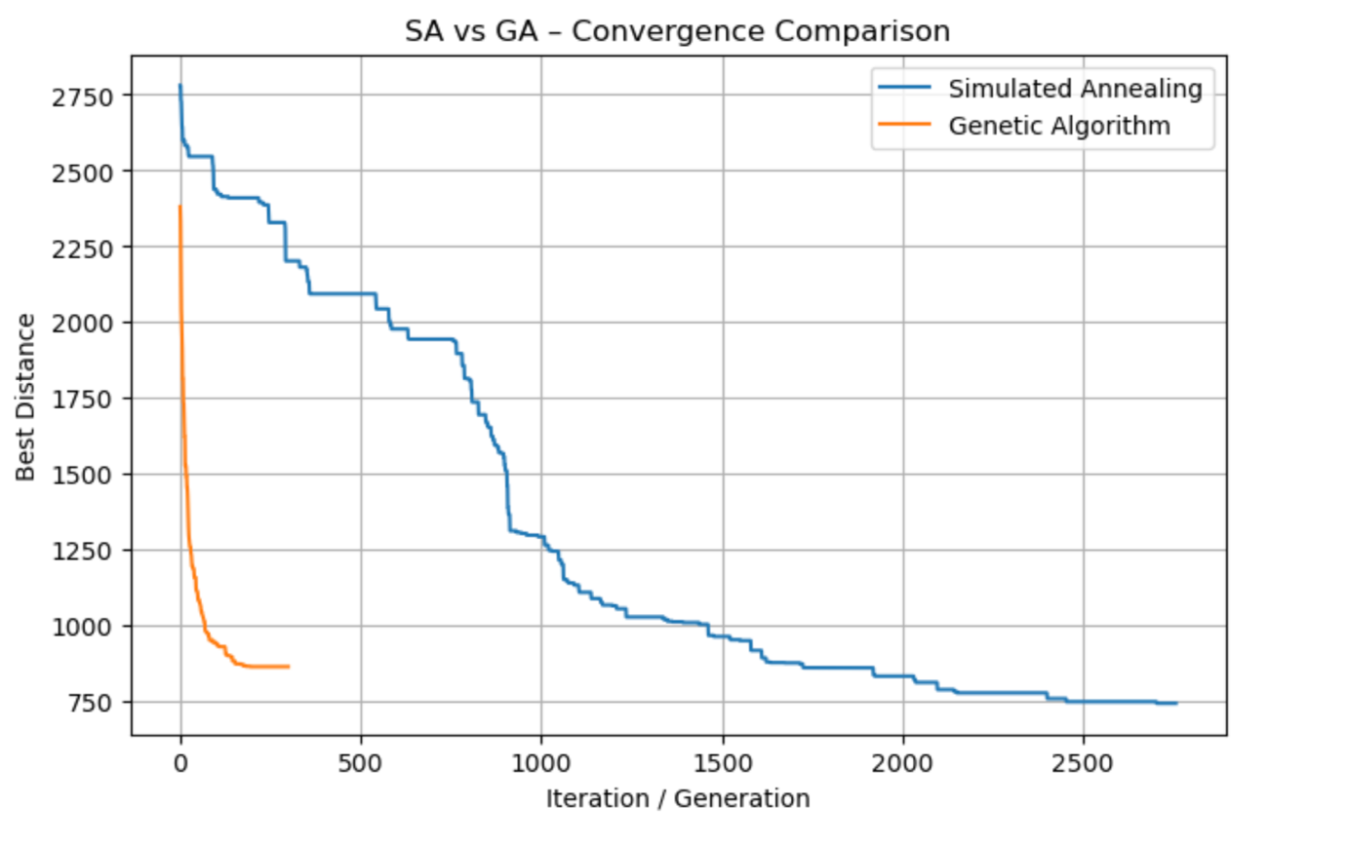

The findings indicate show that Simulated Annealing provide the excellent solutions at a significantly reduced computation time, and it is the best choice when fast optimization is necessary. The Genetic Algorithm requires more time but it handles the search space more efficiently most of the time, generating better tours for larger problem sizes. This validates the anticipate compromise between speed (SA) and solution quality (GA).

The static TSP assumed in this study with fixed coordinates and Euclidean distances might not represent the actual scenarios with traffic or changes in a dynamic way. The performance of the algorithm depend greatly on parameter tuning and it only a narrow range of settings was tested.Also the number of experiments conducted was limited by computational constraints.

One of the most interesting results is that Simulated Annealing is a single-solution method, was still competitive with larger TSP sizes. The Genetic Algorithm demonstrated greater variability in results at times, so the underlining the necessity of appropriate parameter tuning and multiple runs for fair comparison due to its stochastic nature.

- Conclusion & Future Work

Simulated Annealing showed that the most rapid method for TSP resolution and provided fast convergence with little computational time. The Genetic Algorithm on the other hand, was slower yet at times delivered the solutions of the better quality for the larger problem sizes.Parameters like SA cooling schedule and GA population or mutation rate could be adjusted to enhance performance and the Conducting several experiments and averaging the results would also increase the reliability of the comparison.The future research could investigate a combination of SA and GA approaches, use these techniques for actual TSP variations, and carry out the testing on datasets that are considerably bigger.

- Ethical, Legal, and Responsible Use Considerations

The code and algorithms were created independently for educational purposes, and external resources were duly credited. Generative AI were employed responsibly just to clear up concepts and to make the explanations better also the whole implementation and analysis still belong to the student.

Summing up, the project observes ethical academic practice, software licensing is respected, and responsible use of Generative AI is shown.

- References

Zhan, S., Lin, J., Zhang, Z. and Zhong, Y. (2016) ‘List-Based Simulated Annealing Algorithm for Traveling Salesman Problem’, Computational Intelligence and Neuroscience, 2016, pp. 1–12.
Available at: https://doi.org/10.1155/2016/1712630

A.R. and Alaykıran, K. (2020) ‘Analysis of TSP: Simulated Annealing and Genetic Algorithm Approaches’, International Journal of Computational and Experimental Science and Engineering, 6(1), pp. 23–28.
Available at:
https://uwe.primo.exlibrisgroup.com/permalink/44UWE_INST/52fmuk/cdi_crossref_primary_10_22399_ijcesen_637445 (Accessed: 12 December 2025)

Puspita, F.M., Meitriova, A. and Yaldin, S. (2020) ‘Mathematical modelling of travelling salesman problem (TSP) by implementing simulated annealing and genetic algorithms’, Journal of Physics: Conference Series, 1480(1), p. 012029.
Available at: https://doi.org/10.1088/1742-6596/1480/1/012029

Puspita, F. M., Meitriova, A., & Yaldin, S. (2020). Mathematical modelling of traveling salesman problem (TSP) by implementing simulated annealing and genetic algorithms. Journal of Physics: Conference Series, 1480(1), 012029. https://doi.org/10.1088/1742-6596/1480/1/012029

