PROJECT DOCUMENTATION
Auto Ticket Classification
using Flow Designer
ServiceNow Flow Designer / Incident Management Automation

Team ID | SWTID-2026-5543
Team Size | 4
Team Leader | Swathi U  swathiswathi0670@gmail.com
Team Member | Varshini R  varshinirenganathan6@gmail.com
Team Member | Ramela G  ramelagnanavel@gmail.com
Team Member | Dharshini V  dharshinivadivel96@gmail.com
Project Topic | Auto Ticket Classification using Flow Designer
Platform | ServiceNow

Academic Project Report – 2026

1. Introduction

1.1 Project Overview
IT support teams receive a large number of incident tickets every day. When tickets are classified manually, the support team may spend additional time checking the category, subcategory, and other incident details before deciding how the ticket should be handled. This project demonstrates a ServiceNow-based approach for improving ticket classification using Flow Designer.
The project focuses on incident records and their classification fields. The supplied ServiceNow screenshots show incident forms containing Category and Subcategory values, along with an example incident record. The documentation uses these screens as the visual evidence for the classification workflow.

1.2 Objective
- To create a structured incident ticket classification process in ServiceNow.
- To use Flow Designer to automate classification-related processing.
- To use Category and Subcategory values to organize incident tickets.
- To reduce repetitive manual classification work for support teams.
- To provide a consistent and trackable ticket-handling process.

1.3 Project Outcome
The intended outcome is a repeatable incident-classification workflow in which ticket information can be evaluated and the appropriate classification can be applied consistently. The supplied screenshots demonstrate the ServiceNow incident fields used for Category and Subcategory selection and an incident record containing classification information.

1.4 Technologies and Components Used
Component | Purpose
ServiceNow Incident Management | Provides the incident ticket record and classification fields.
Flow Designer | Builds and manages the automation workflow.
Category | Provides a high-level classification for an incident.
Subcategory | Provides a more specific classification under a category.
Incident Record | Stores the ticket details and classification information.
Update Sets | Supports controlled movement of configuration changes between ServiceNow instances.

2. Problem Statement and Proposed Solution

2.1 Problem Statement
Manual ticket classification can lead to inconsistent category and subcategory selection. Different users may classify similar incidents differently, which can make reporting, routing, prioritization, and tracking more difficult. Repetitive classification work can also increase the time required to process support tickets.

2.2 Proposed Solution
The proposed solution uses ServiceNow Flow Designer to support an automated and consistent classification process. When an incident is created or updated, the flow can evaluate the available incident information and apply the appropriate classification logic. Category and Subcategory fields provide the structured values used to organize the ticket.

2.3 Process Flow
- User creates or updates an incident ticket.
- The Flow Designer process is triggered by the configured incident event.
- The flow reads the relevant incident information.
- Classification logic evaluates the ticket information.
- The appropriate Category and Subcategory are selected or updated.
- The classified incident can then be routed, tracked, and reported consistently.

2.4 Scope
- Incident ticket classification using ServiceNow.
- Category and Subcategory based classification.
- Flow Designer automation for classification-related processing.
- Basic validation using incident records and the supplied screenshots.

2.5 Out of Scope
- External help-desk or third-party system integration.
- AI/ML model training for natural-language classification.
- Advanced SLA, notification, approval, or vendor integrations unless separately configured.
- Production deployment beyond the demonstrated ServiceNow configuration.

3. Implementation

3.1 Create the Flow
- Open Workflow Studio / Flow Designer from the ServiceNow instance.
- Create a new flow for incident ticket classification.
- Configure the appropriate incident-based trigger.
- Add the actions required to evaluate and update classification fields.

3.2 Configure Classification Logic
The flow should use the information available in the incident record to determine the appropriate classification. Category provides the broad classification, while Subcategory provides a more specific classification. The exact decision conditions can be customized according to the organization's incident-management rules.

3.3 Update the Incident Record
- Read the incident data exposed by the trigger.
- Evaluate the configured classification conditions.
- Set or update the Category field.
- Set or update the corresponding Subcategory field.
- Save the updated incident record and allow the ticket to continue through the support process.

3.4 ServiceNow Update Sets
Update Sets can be used to capture configuration changes made during development. The supplied screenshot shows the ServiceNow navigation area containing Update Sets, including Local Update Sets. This supports the configuration-management side of the project.

3.5 Activate and Test
After configuration is completed, the flow can be activated and tested using incident records. A successful test should show that the incident contains the expected Category and Subcategory values and that the classification process behaves consistently.

4. Screenshots and Demonstrated Configuration

Figure 1. Incident category and subcategory selection
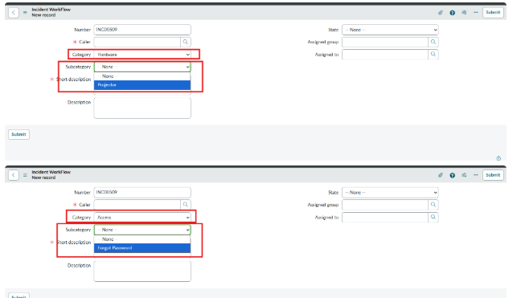
Observation: The screenshot shows the ServiceNow Incident Workflow form with the Category field and an opened Subcategory list. The highlighted area demonstrates that subcategory values depend on the selected category.

4. Screenshots and Demonstrated Configuration

Figure 2. Classified incident record
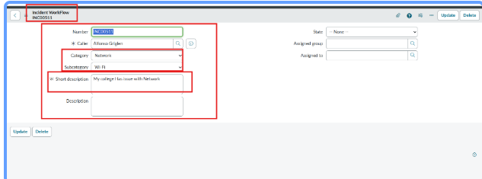
Observation: The incident record contains an incident number, caller, Category, Subcategory, and Short description. The example demonstrates a Network category with a Wi-Fi subcategory and a short description describing a network issue.

4. Screenshots and Demonstrated Configuration

Figure 3. ServiceNow Update Sets navigation
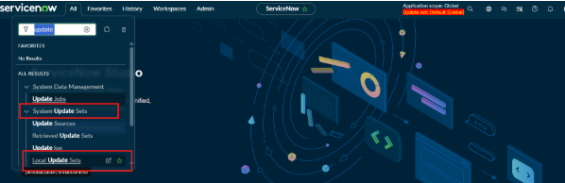
Observation: The screenshot shows the ServiceNow application navigator with Update Sets options, including Local Update Sets. This demonstrates the area used for managing captured configuration changes.

Screenshot Summary
Figure | What is shown | Purpose
Figure 1 | Category and Subcategory selection | Shows structured incident classification fields.
Figure 2 | Incident record | Shows a classified incident with Network / Wi-Fi values.
Figure 3 | Update Sets navigation | Shows the configuration-management area in ServiceNow.

5. Testing and Validation

5.1 Test Case 1 – Category and Subcategory
Expected: The incident form should provide structured Category and Subcategory fields. Observed: Figure 1 shows these fields and the available Subcategory values.

5.2 Test Case 2 – Incident Classification
Expected: An incident should contain a meaningful classification and description. Observed: Figure 2 shows an incident record with Network as the Category, Wi-Fi as the Subcategory, and a related short description.

5.3 Test Case 3 – Update Set Availability
Expected: The ServiceNow environment should provide access to Update Sets for managing configuration changes. Observed: Figure 3 shows Update Sets and Local Update Sets in the application navigator.

5.4 Test Summary
Test | Expected | Observed | Status
T1 | Classification fields available | Category + Subcategory visible | Pass
T2 | Incident contains classification | Network / Wi-Fi shown | Pass
T3 | Update Sets accessible | Update Sets navigation visible | Pass

6. Benefits, Limitations and Future Enhancements

6.1 Benefits
- Reduces repetitive manual classification work.
- Provides a consistent structure for incident Category and Subcategory values.
- Makes incidents easier to organize, search, report, and track.
- Supports repeatable processing through ServiceNow Flow Designer.
- Provides a foundation for routing and other support-process automation.

6.2 Limitations of the Demonstrated Scope
- The supplied screenshots demonstrate incident classification fields and ServiceNow configuration areas; they do not by themselves prove a complete automated Flow Designer execution.
- The exact classification rules are organization-specific and must be configured in the flow.
- No external help-desk, AI/ML, or vendor integration is demonstrated in the supplied screenshots.

6.3 Future Enhancements
- Add automatic assignment to the correct support group based on Category and Subcategory.
- Add notifications when a ticket is classified or routed.
- Add priority calculation based on incident information.
- Use more detailed decision logic for common incident types.
- Integrate knowledge articles or additional ServiceNow automation.
- Add reporting dashboards to measure classification accuracy and processing time.

7. Conclusion
The project, “Auto Ticket Classification using Flow Designer,” demonstrates how ServiceNow can be used to organize and automate incident ticket classification. The core idea is to use structured Category and Subcategory information together with Flow Designer logic so that tickets can be processed in a consistent manner.
The supplied screenshots show the ServiceNow incident classification interface, an example classified incident, and the Update Sets configuration area. Together, these screenshots provide supporting evidence for the incident-management and configuration aspects of the project.

8. Key Learnings
- Understanding incident records in ServiceNow.
- Understanding the purpose of Category and Subcategory fields.
- Understanding how Flow Designer can be used for automation.
- Understanding how structured classification can support ticket routing and tracking.
- Understanding the role of Update Sets in ServiceNow configuration management.
- Learning how to validate an incident-management workflow using test records.

Appendix A – Project Configuration Summary
Configuration Item | Project Value
Project | Auto Ticket Classification using Flow Designer
Platform | ServiceNow
Primary Record | Incident
Classification Fields | Category and Subcategory
Automation | Flow Designer
Configuration Management | Update Sets
Team ID | SWTID-2026-5543
Team Size | 4

