Unit1
1 ⭐ *Network Topologies*
*Network topology* refers to the *arrangement or layout* of computers, cables, and network devices in a network.
There are *6 important topologies*:
1. *Bus Topology*
2. *Star Topology*
3. *Ring Topology*
4. *Mesh Topology*
5. *Tree Topology*
6. *Hybrid Topology*
1️⃣ *Bus Topology*
### ✔ Definition
A single central cable (called *backbone*) connects all devices.
### ✔ Advantages
* Easy to install.
* Less cable required → inexpensive.
### ✔ Disadvantages
* If main cable fails → whole network fails.
* Performance decreases when many devices are connected.
# 2️⃣ *Star Topology*
### ✔ Definition
All computers are connected to a central device such as *Hub/Switch*.### ✔ Advantages
* Easy to troubleshoot.
* Failure of one node doesn’t affect others.
* High performance.
### ✔ Disadvantages
* Central device failure → entire network down.
* More cable needed.
# 3️⃣ *Ring Topology*
### ✔ Definition
Each device is connected to exactly two neighbors forming a *closed loop*.
### ✔ Advantages
* Data flows in a single direction → avoids collisions.
* Good performance for small networks.
### ✔ Disadvantages
* If any node fails → entire ring breaks.
* Adding/removing computers is difficult.
# 4️⃣ *Mesh Topology*
### ✔ Definition
Every device is connected to every other device.
### ✔ Advantages

* Very reliable.
* No single point of failure.
* High security and high data speed.
### ✔ Disadvantages
* Very expensive (more cables).
* Complex installation and maintenance.
# 5️⃣ *Tree Topology* (Hierarchical)
### ✔ Definition
Combination of *Star + Bus*. Devices are arranged in a hierarchical form (like a tree).
##### ✔ Advantages
* Easy to expand.
* Fault isolation is simple.
### ✔ Disadvantages
* If backbone fails → whole network affected.
* Needs more cable.
# 6️⃣ *Hybrid Topology*
### ✔ Definition
Combination of two or more topologies (Star + Ring, Star + Mesh, e
### ✔ Advantages
* Flexible and scalable.
* Used in large organizations.
### ✔ Disadvantages
* Expensive and complex.
* Design is difficult
2.# ⭐ *1. Network – Definition (Points)*
1. A computer network is a group of interconnected computers.
2. These devices share data, resources, and services.
3. The connection can be wired or wireless.
4. It allows communication between users.
5. Examples: Internet, office network.
# ⭐ *2. LAN – Local Area Network (Points)*
1. LAN covers a *small geographic area*.
2. Used in homes, schools, offices, buildings.
3. Provides *high data transfer speed* (Mbps to Gbps).
4. Owned and managed by a single organization.
5. Easy to install and maintain.
6. Examples: Computer lab network.
# ⭐ *3. MAN – Metropolitan Area Network (Points)*
1. MAN covers a *city or metropolitan area*.
2. Larger than LAN but smaller than WAN.
3. Connects multiple LANs within a city.
4. Usually maintained by telecom companies or ISPs.
5. Used for city-wide communication services.
6. Examples: Cable TV networks, city Wi-Fi.
# ⭐ *4. WAN – Wide Area Network (Points)*
1. WAN covers a *large geographical area* (country or world).
2. Used to connect long-distance networks.
3. Lower speed compared to LAN and MAN.
4. Uses telephone lines, satellites, and fiber cables.
5. Managed by multiple organizations or service providers.
6. Example: Internet (largest WAN).

3 .# ⭐ *ISO – International Organization for Standardization*
### ✔ Meaning
ISO is an international body that develops *standards* for technology, communication, and business processes.
### ⭐ *Points about ISO*
1. ISO stands for *International Organization for Standardization*.
2. It is a *non-government* international standards organization.
3. Established in *1947* and headquartered in *Geneva, Switzerland*.
4. ISO creates standards to ensure *quality, **safety, and **interoperability*.
5. In computer networking, ISO developed the *OSI Reference Model*.
6. OSI model standardizes how communication should happen between computers.
# ⭐ *OSI Reference Model*
### ✔ Definition
The *OSI (Open Systems Interconnection) Model* is a *7-layer architecture* designed by ISO to explain how data travels from one device to another in a network.
# ⭐ *7 Layers of the OSI Model (Points-wise Explanation)*
## *1️⃣ Physical Layer*
* Lowest layer.
* Deals with *physical transmission* of data.
* Defines cables, connectors, voltages, data rates.
* Converts data into *electrical/optical signals*.
## *2️⃣ Data Link Layer*
* Responsible for *node-to-node* communication.
* Creates *frames*.
* Performs *error detection* and *flow control*.
* Has two sublayers: MAC & LLC.
## *3️⃣ Network Layer*
* Responsible for *routing* packets from source to destination.
* Uses *IP addressing*.
* Handles packet forwarding and logical addressing.
# *4️⃣ Transport Layer*
* Provides *end-to-end communication*.
* Ensures *reliable data transfer*.
* Performs segmentation and reassembly.
* Uses protocols like *TCP* and *UDP*.
## *5️⃣ Session Layer*
* Manages *sessions* between two devices.
* Establishes, maintains, and terminates sessions.
* Controls dialogs between applications.
## *6️⃣ Presentation Layer*
* Deals with *data translation, **encryption, and **compression*.
* Converts data into a format understood by the application layer.
* Example: JPEG, MP3, MP4, encryption.
## *7️⃣ Application Layer*
* Closest layer to the *end user*.
* Provides network services like:
* Email (SMTP)
* Web browsing (HTTP/HTTPS)
* File transfer (FTP)
* Interfaces between user and network.
# ⭐ *Diagram of OSI Model (Text-based)*
7. Application Layer
6. Presentation Layer
5. Session Layer
4. Transport Layer
3. Network Layer
2. Data Link Layer
1. Physical Layer

4 .Applications of Computer Networks
Computer networks allow computers and devices to share information and resources. They support many important applications in our daily life.
1. Resource Sharing
One of the major applications of computer networks is resource sharing. Hardware resources like printers, scanners, storage devices, and software applications can be shared among multiple users. This reduces duplication of equipment and improves efficiency.
2. High Reliability (Alternative Sources of Data)
A network increases overall system reliability. If one computer or server fails, users can still access data from another system. Data can be stored in multiple locations, providing backup and redundancy. This prevents data loss and ensures continuous operation.

3. Cost Saving (Economical Operation)
Computer networks reduce cost significantly. Shared resources eliminate the need for each user to buy separate hardware or software. Centralized management reduces maintenance and administration costs. Organizations save money in the long run.

4. Effective Communication Medium
Networks provide a powerful communication platform. Users can communicate through email, instant messages, voice calls, video conferencing, and social media. Communication becomes fast, reliable, and inexpensive, supporting both personal and business activities.

5. Types of Transmission Media
Transmission media refers to the physical path through which data is transmitted from one place to another in a network. It is broadly classified into Guided (Wired) and Unguided (Wireless) media.

1. Guided Transmission Media (Wired Media)
This media provides a physical path like cables or wires for data transmission. Signals travel through the wire.
a) Twisted Pair Cable
- Most commonly used in LAN.
- Consists of two insulated copper wires twisted together.
- Reduces electromagnetic interference.
Types:
- UTP (Unshielded Twisted Pair)
  - Inexpensive
  - Used in telephone lines and LAN
- STP (Shielded Twisted Pair)
  - Has metallic shield
  - Better noise protection
Advantages: Cheap, easy to install
Disadvantages: Limited bandwidth, affected by noise

b) Coaxial Cable
- Has a central copper conductor, surrounded by insulation, braided shield, and outer cover.
- Better shielding than twisted pair.
Used in: Cable TV networks, broadband internet
Advantages: Higher bandwidth, less noise
Disadvantages: More expensive than twisted pair, bulky

c) Fiber Optic Cable
- Uses light signals instead of electrical signals.
- Made of glass or plastic fibers.
Features:
- Very high bandwidth
- Very fast data transmission
- Immune to electromagnetic interference
Types:
- Single Mode Fiber – Long-distance communication
- Multimode Fiber – Short-distance communication
Advantages: Highest speed, secure, long-distance transmission
Disadvantages: Expensive, difficult to install

2. Unguided Transmission Media (Wireless Media)
b) Microwaves
- Travel in line of sight (straight line).
- High frequency and high bandwidth.
Used in: Satellite communication, telecommunication networks
Advantages: High data rate
Disadvantages: Affected by weather (rain fade)

c) Infrared Waves
- Used for short-range communication.
- Requires direct line of sight.
- Cannot penetrate walls.
Used in: TV remote controls, short-range data transfer
Advantages: Secure (closed space)
Disadvantages: Short distance, line-of-sight
Types of Transmission Media
Transmission media refers to the physical path through which data is transmitted from one place to another in a network. It is broadly classified into Guided (Wired) and Unguided (Wireless) media.

Unit3
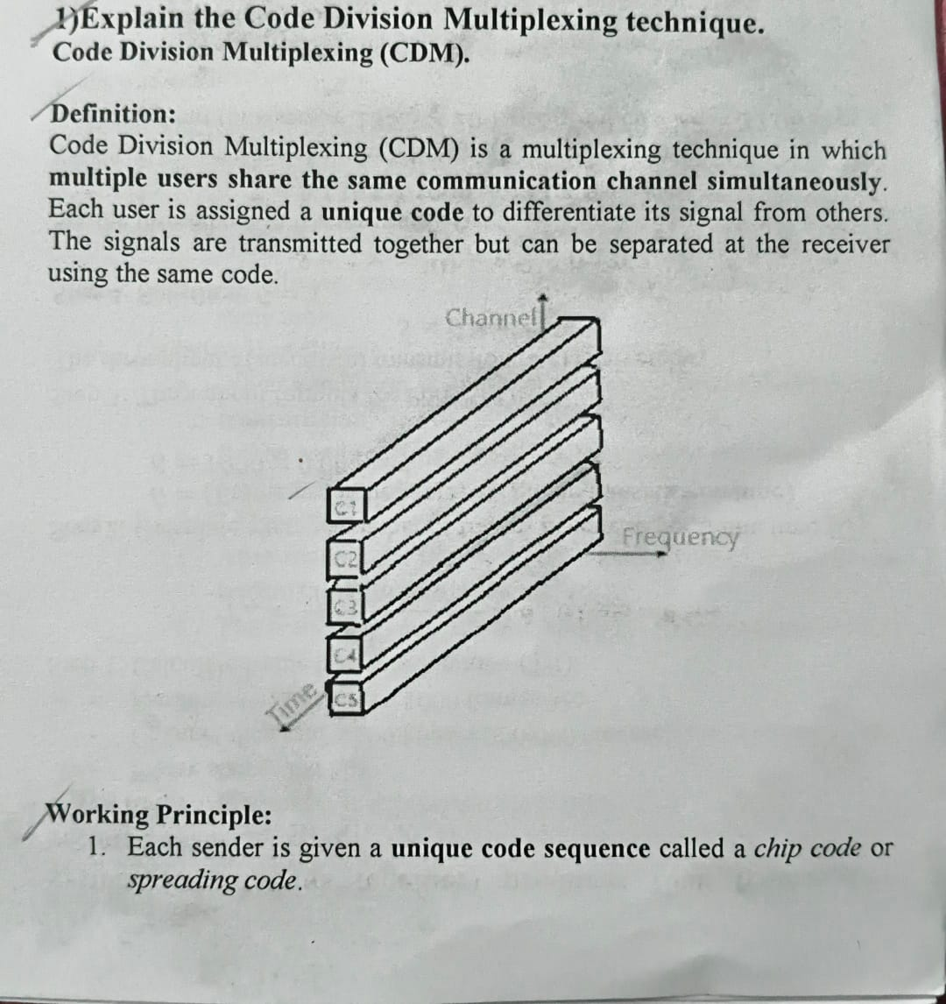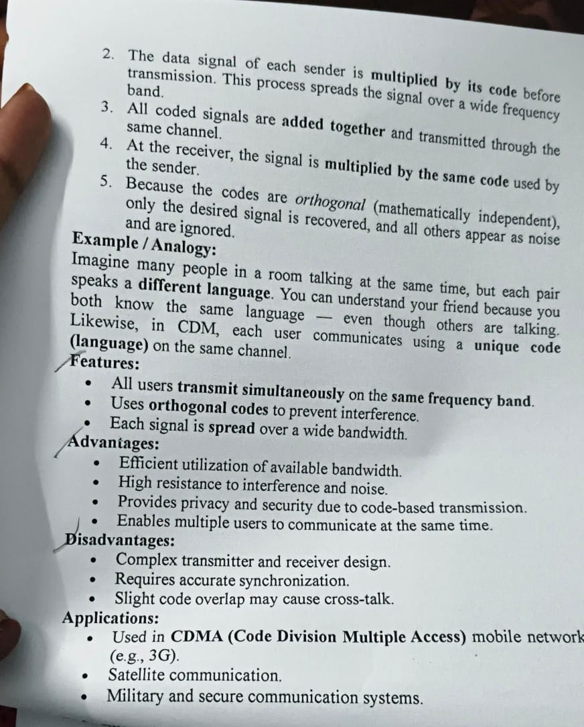
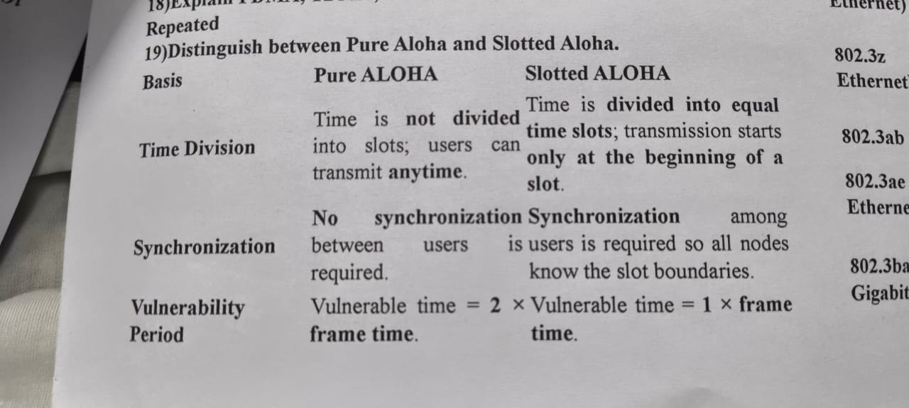

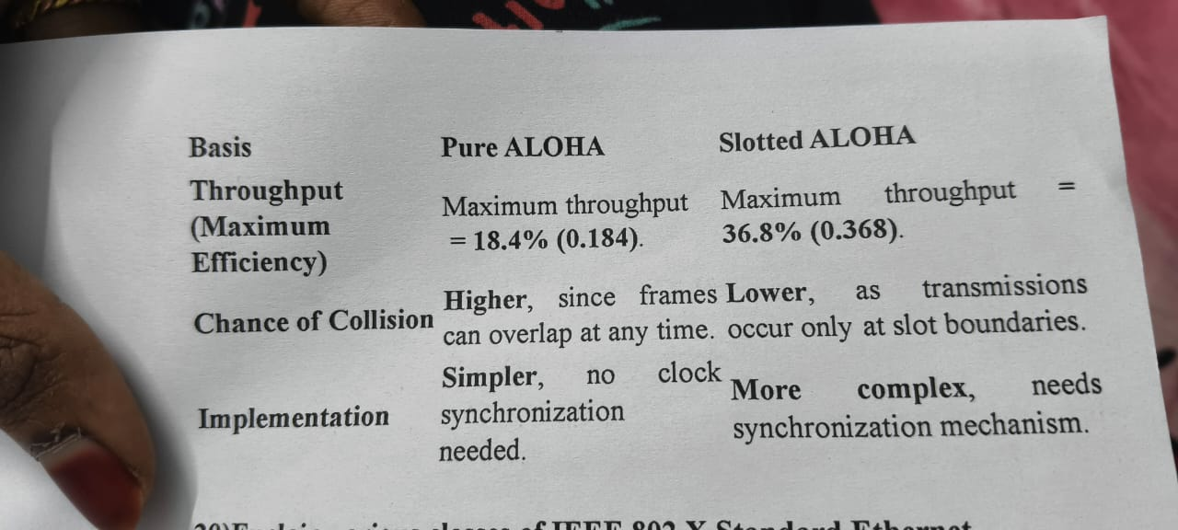

Random Access (Random Media Access Protocols)
Definition:
Random access protocols allow multiple stations to share a common transmission medium without centralized control. Each station transmits whenever it has data, making the access random and independent.
Main idea:
- No pre-scheduled time/slot.
- All nodes compete for the channel.
- Collision may occur when two or more nodes transmit at the same time.
Characteristics:
- Contention-based — stations compete for the medium.
- Distributed — no central controller.
- Simple design — easy to implement.
- Collision possibility — performance depends on traffic load.
- Used in LANs — Ethernet, wireless networks.
Examples of Random Access Protocols:
- ALOHA
- Slotted ALOHA
- CSMA
- CSMA/CD
- CSMA/CA
Advantages:
- Easy, flexible, decentralized
- Good for bursty traffic
Disadvantages:
- Collisions reduce efficiency
- Throughput decreases under heavy load
3. CSMA (Carrier Sense Multiple Access)
Definition:
In CSMA, a station listens to the channel before transmitting.
If the channel is idle → transmit.
If busy → wait.
Purpose:
To reduce collisions by sensing the carrier signal.
Types of CSMA:
- 1-persistent CSMA
  - If channel idle → transmit immediately.
  - If busy → keep listening and transmit as soon as free.
  - High chance of collision due to persistence.
- Non-persistent CSMA
  - If busy → wait a random time before sensing again.
  - Reduces collisions but increases delay.
- p-persistent CSMA (for slotted channels)
  - If idle → transmit with probability p.
  - With probability (1–p), wait for next slot.
Advantages:
- Reduces collisions compared to ALOHA
- Suitable for wired LANs (Ethernet)
Disadvantages:
- Still cannot avoid collisions completely
- Performance degrades under heavy load

4. CSMA/CD (CSMA with Collision Detection)
Definition:
Protocol used in wired Ethernet.
Stations sense the channel and also detect collisions while transmitting.
Working:
- Station senses channel → if idle → transmit.
- While transmitting, it listens for collisions.
- If collision detected →
  - Stop transmission
  - Send a jam signal to inform others
  - Use Binary Exponential Backoff (BEB) to wait random time before retrying.
Features:
- Collisions detected quickly
- Minimizes wastage of time
- Requires that a station must be able to detect signals while sending (half-duplex)
Limitations:
- Works only in wired networks
- Not suitable for wireless (nodes can't detect collisions while transmitting)
Advantages:
- Fast collision detection
- Efficient for medium traffic

5. CSMA/CA (CSMA with Collision Avoidance)
Definition:
Used in wireless networks (Wi-Fi) because collision detection is not possible in wireless.
Goal:
Avoid collisions before transmission.
Working Mechanism:
- Station senses channel.
- If idle → wait for Inter Frame Space (IFS).
- Choose a random backoff time.
- After backoff expires → transmit.
- Uses RTS/CTS (Request to Send / Clear to Send) mechanism to avoid hidden-terminal problems.
Advantages:
- Reduces chances of collision
- Works well for wireless communication
- Solves hidden and exposed node problems
Disadvantages:
- Slower than CSMA/CD
- Extra overhead of RTS/CTS
- Collisions still possible during RTS phase

6. Channelization Techniques (FDMA, TDMA, CDMA)
Channelization:
Technique to allow multiple users to share the same communication channel by dividing bandwidth/time/codes.

a) FDMA (Frequency Division Multiple Access)
Concept:
Total bandwidth is divided into several frequency bands.
Each user gets a separate frequency (channel).
Features:
- No interference between frequency bands
- Used in radio, early cellular systems
Advantages:
- Simple and continuous transmission
- No timing synchronization required
Disadvantages:
- Wastage due to guard bands
- Limited number of users

b) TDMA (Time Division Multiple Access)
Concept:
Time is divided into slots.
Each user gets a specific time slot to transmit.
Features:
- Users share same frequency but at different times
- Used in 2G GSM systems
Advantages:
- Efficient use of bandwidth
- More users than FDMA
- Flexible frame structure
Disadvantages:
- Requires strict time synchronization
- Delay for users

c) CDMA (Code Division Multiple Access)
Concept:
All users transmit in the same frequency band at the same time, but using unique codes.
Features:
- Uses spread-spectrum technology
- Signals separated by orthogonal codes
Advantages:
- High security
- High capacity (more users)
- Resistant to interference and noise
Disadvantages:
- Complex encoding/decoding
- Power control needed to avoid near-far effect

Unit4
# ✅ *1. IPv4 (5 Marks)*

### *1. Definition:*

IPv4 (Internet Protocol Version 4) is used to identify devices in a network.
It uses a *32-bit address, written in **dotted decimal format*, for example:
*192.168.1.1*
### *2. Structure:*
* Total *32 bits, divided into **4 parts* (each part = 8 bits).
* It has *two main parts*:
* *Network ID:* Identifies the network.
* *Host ID:* Identifies the device within that network.
### *3. Classes of IPv4:*
| *Class* | *Range* | *Use* |
| --------- | --------------------------- | --------------- |
| *A* | 0.0.0.0 – 127.255.255.255 | Large networks |
| *B* | 128.0.0.0 – 191.255.255.255 | Medium networks |
| *C* | 192.0.0.0 – 223.255.255.255 | Small networks |
| *D* | 224.0.0.0 – 239.255.255.255 | Multicast |
| *E* | 240.0.0.0 – 255.255.255.255 | Experimental |
### *4. Types of Addresses:*
* *Unicast:* One-to-one communication.
* *Broadcast:* One-to-all communication.
* *Multicast:* One-to-many communication.

---

### *5. Limitations:*

* Limited to *4.3 billion addresses* only.
* Not secure and suffers from *address shortage, which led to **IPv6*.
# ✅ *2. IPv6 (5 Marks)*
### *1. Definition:*
IPv6 (Internet Protocol Version 6) is the advanced version of IPv4.
It uses a *128-bit address*, allowing a huge number of devices to connect to the Internet.
Example: *2001:0db8:85a3::8a2e:0370:7334*
### *2. Structure:*
* Total *128 bits* written in *8 groups*, separated by colons (:).
* Provides *almost unlimited unique addresses*.
### *3. Features of IPv6:*
* Much larger address space than IPv4.
* *Fixed 40-byte header* → faster processing.
* *No broadcast, only **multicast & anycast*.
* *Built-in IPsec security*.
* Supports *auto-configuration (SLAAC)*.
### *4. Advantages:*
* No need for NAT.
* Better performance and routing.
* Supports mobile devices efficiently.

### *5. Limitations:*
* Not fully supported by old hardware.
* Migration from IPv4 to IPv6 is slow.
# ✅ *4. IPv4 Header Format (5 Marks)*
### *Definition:*
IPv4 header contains control information used for packet forwarding.
It ranges from *20 to 60 bytes*.
### *Main Fields:*
* *Version:* Indicates IPv4.
* *Header Length:* Size of header.
* *Type of Service:* QoS priority.
* *Total Length:* Packet size (header + data).
* *Identification:* Used for fragmentation.
* *Flags:* Controls fragmentation.
* *Fragment Offset:* Location of fragment.
* *TTL (Time To Live):* Limits packet lifetime.
* *Protocol:* TCP/UDP/ICMP etc.
* *Header Checksum:* Error checking.
* *Source IP & Destination IP:* 32-bit addresses.
* *Options:* Additional features.
# ✅ *5. IPv6 Header Format (5 Marks)*
### *Definition:*
IPv6 header is *fixed 40 bytes*, simpler and faster than IPv4.
### *Main Fields:*
* *Version:* 6
* *Traffic Class:* Similar to IPv4 ToS.
* *Flow Label:* Identifies packet flow.
* *Payload Length:* Size of data.
* *Next Header:* Extension or upper layer (TCP/UDP).
* *Hop Limit:* IPv6 equivalent of TTL.
* *Source Address:* 128-bit.
* *Destination Address:* 128-bit.
# ✅ *6. IP Address (5 Marks)*
### *Definition:*
An IP address is a unique number assigned to each device on a network for identification and communication.
### *Types:*
*IPv4 Address:* 32-bit (e.g., 192.168.0.1)
* *IPv6 Address:* 128-bit (e.g., 2001:db8::1)
### *IPv4 Address Classes:*
Same as explained above → A, B, C, D, E.
### *Address Types:*
* *Unicast*
* *Broadcast*
* *Multicast*
* *Anycast (only in IPv6)*
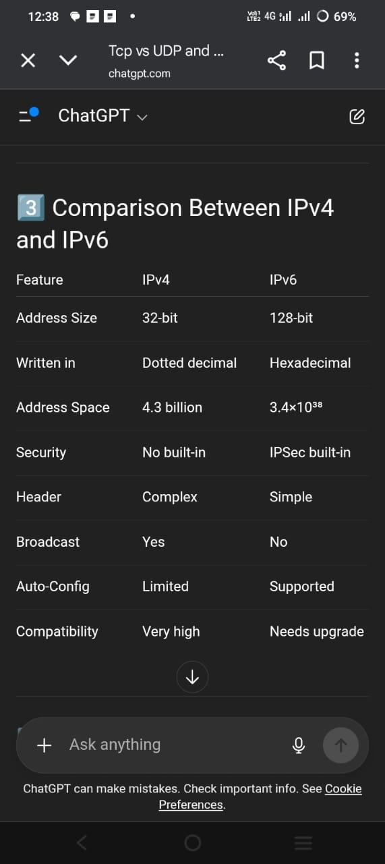

# *Distance Vector Routing Algorithm (5–8 Marks)*

### *Definition*
Distance Vector Routing is a *dynamic routing algorithm* in which every router maintains a table (vector) containing the *distance (cost)* to reach all other routers in the network.
Routers share this information *periodically* with their immediate neighbors.
It is also called *Bellman–Ford Routing Algorithm*.
# *General Idea*
* Each router knows only two things:
1. *Distance to every destination*
2. *Which neighbor to forward the packet to*
* Routers exchange their distance tables with neighbors.
* Each router updates its table using:
*New Cost = Neighbor Cost + Cost from Neighbor to Destination*
# *Working of the Algorithm (Step-by-Step)*
### *1. Initialization*
* Each router initially knows:
* Cost to itself = 0
* Cost to direct neighbors = link cost
* Cost to others = ∞
### *2. Sharing Distance Vectors*
* Each router sends its routing table to its *direct neighbors* only.
### *3. Updating Table*
For every entry received from a neighbor:
New Cost = Cost to Neighbor + Neighbor's Cost to Destination
* If *New Cost < Old Cost, the router updates its table and sets the **next-hop*.
### *4. Periodic Updates*
* Routers exchange tables at regular intervals.
* Gradually, all routers learn the best path to every destination.
# *Example*
Consider the network below:
A
/ \
1 3
/ \
B---1---C
\ 2 /
D
### *Initial Cost Table (Only direct links known)*
| Router | A | B | C | D |
| ------ | - | - | - | - |
| *A* | 0 | 1 | 3 | ∞ |
| *B* | 1 | 0 | 1 | 2 |
| *C* | 3 | 1 | 0 | 1 |
| *D* | ∞ | 2 | 1 | 0 |
## *Update Example (Step-by-step)*
### *At Router A*
Neighbor tables received from *B* and *C*.
✔ From *B*:
* Cost A→B = 1
* B→C = 1 → A→C via B = 1 + 1 = *2* (better than 3, update)
* B→D = 2 → A→D = 1 + 2 = *3*
✔ From *C*:
* Cost A→C = 3
* C→D = 1 → A→D via C = 3 + 1 = *4* (but 3 already via B, so NO update)
### *Updated A Table*
Destination | Cost | Next Hop |
| ----------- | ----- | -------- |
| B | 1 | B |
| C | *2* | B |
| D | *3* | B |
# *Final Routing Tables (After Convergence)*
| Router | A | B | C | D |
| ------ | - | - | - | - |
| *A* | 0 | 1 | 2 | 3 |
| *B* | 1 | 0 | 1 | 2 |
| *C* | 2 | 1 | 0 | 1 |
| *D* | 3 | 2 | 1 | 0 |
Each router now knows the *shortest path to all destinations*.
# *Advantages*
* Simple and easy to implement.
* Requires *less computation* and *less memory*.
* Works well for *small networks*.
# *Limitations*
* *Count-to-infinity problem* (slow convergence after a link failure).
* Routers have *limited knowledge* (only neighbors' tables).
* Not suitable for *large networks*

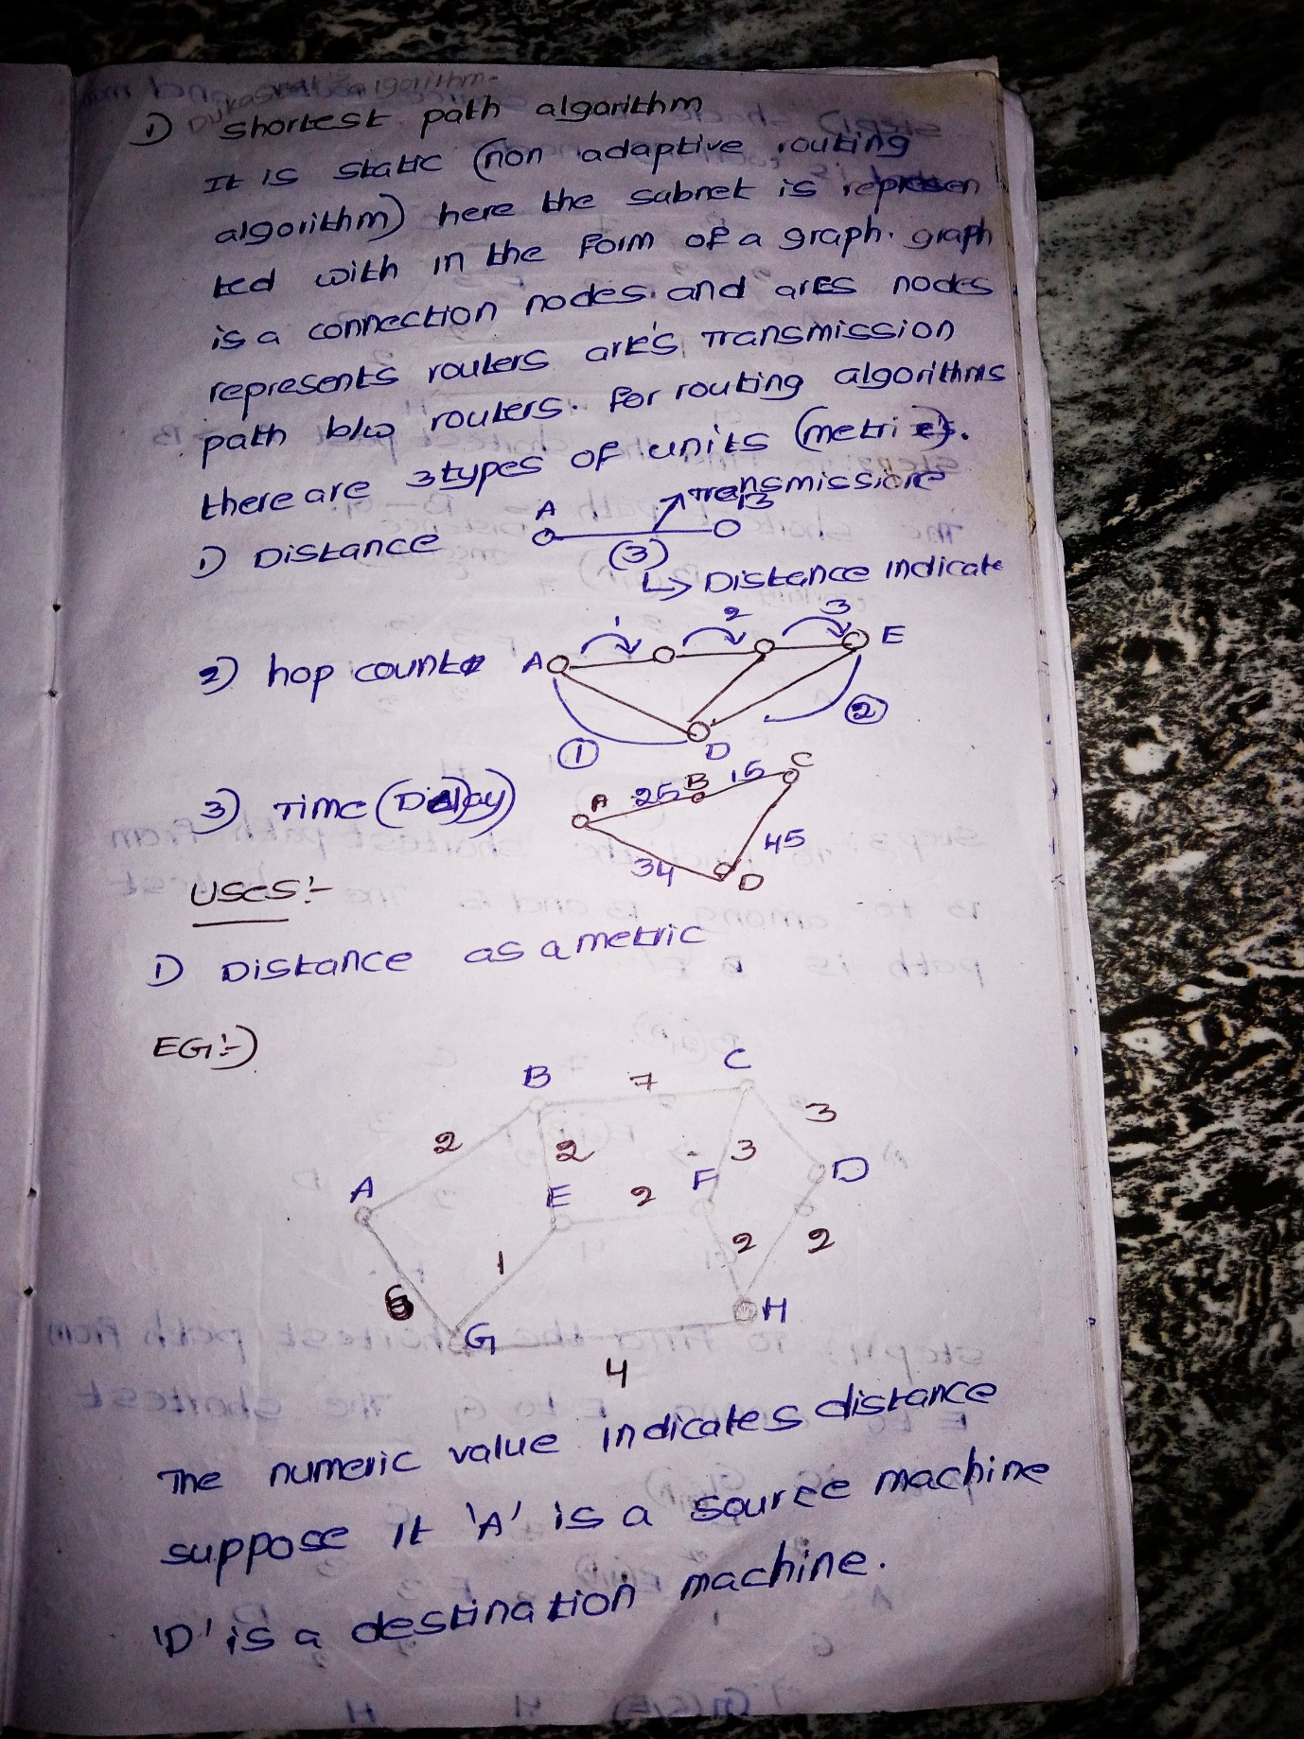

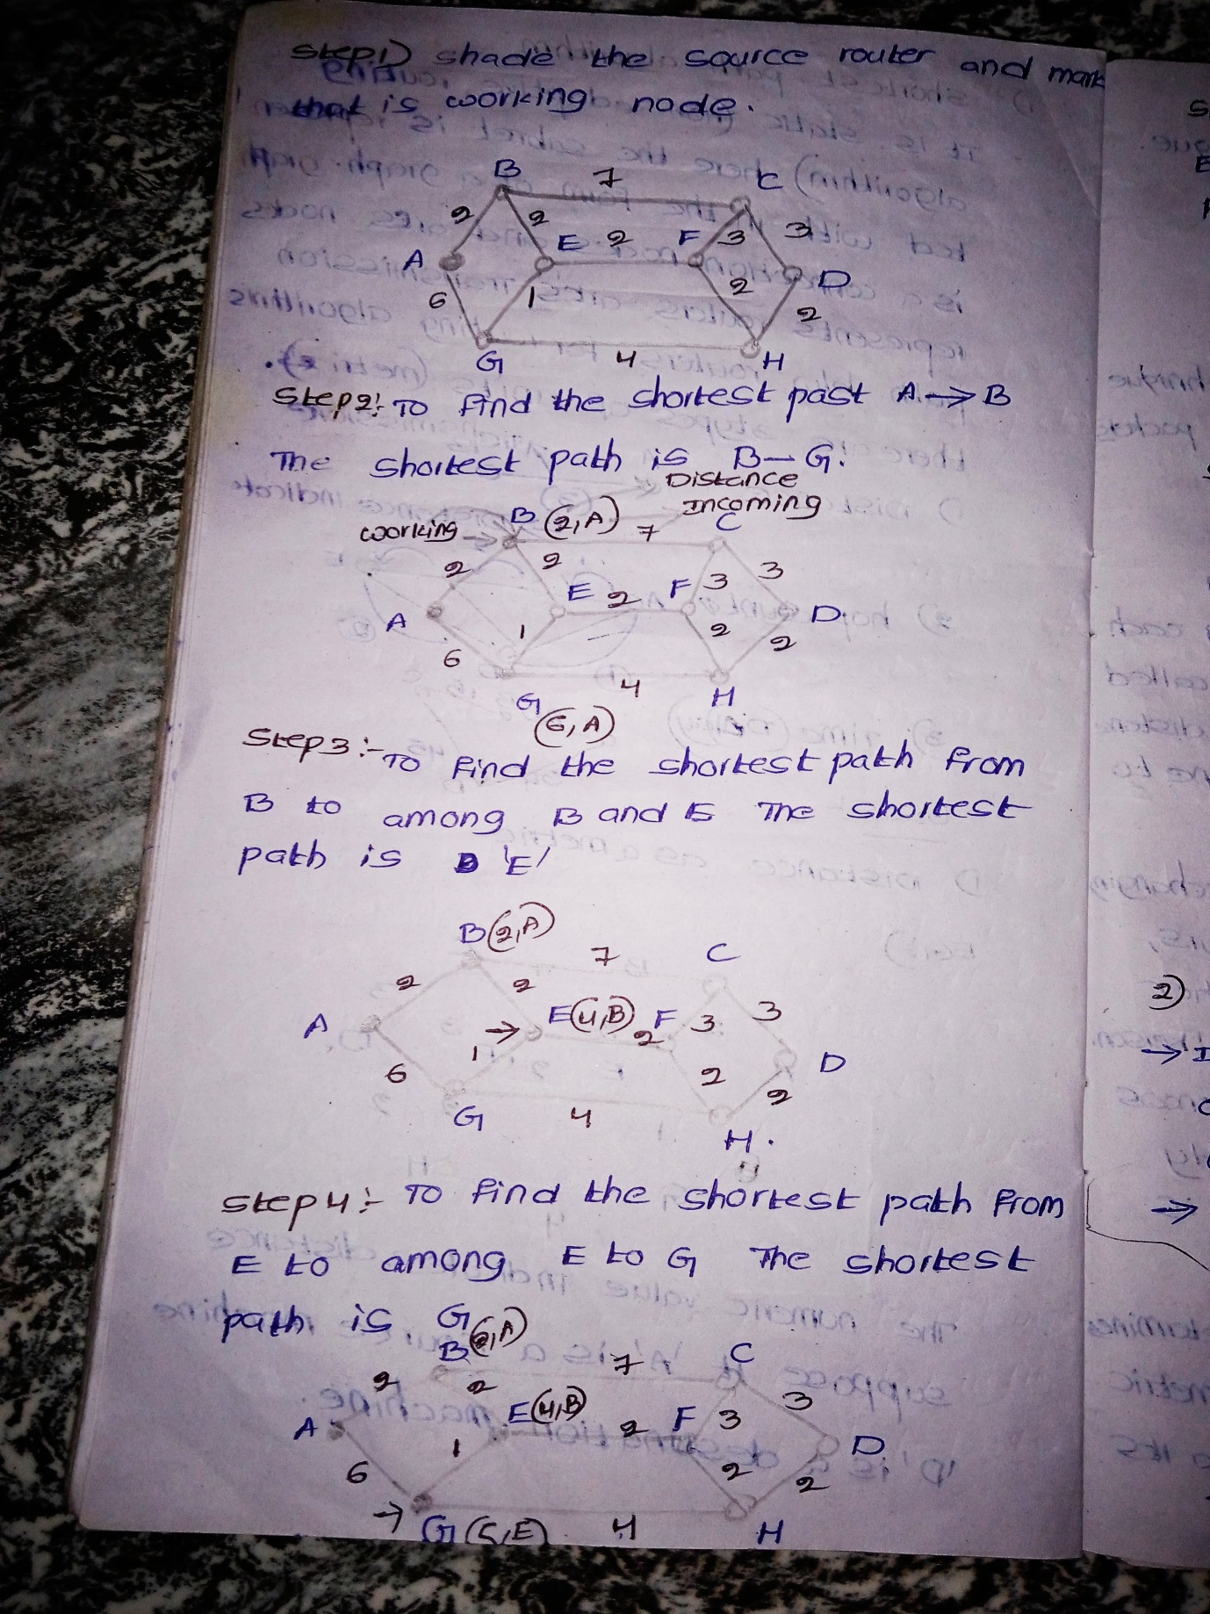

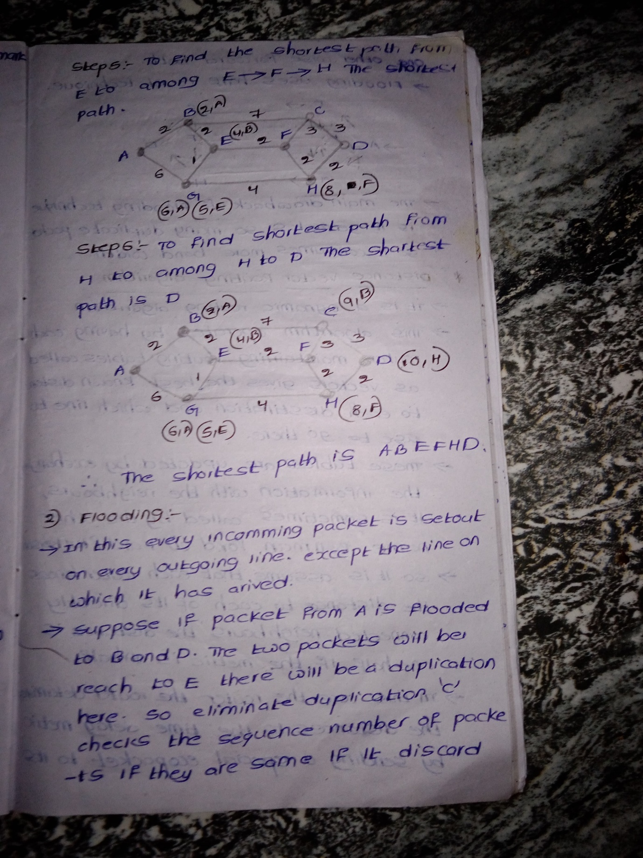

Unit5
Domain Name System (DNS) – 5 Marks

  - Definition
DNS (Domain Name System) is a system that converts domain names into IP addresses.
Working of DNS (Simple Explanation)
1. You type a website name in the browser (example: www.google.com).
2. Your computer sends a request to the DNS Resolver to find the IP address.
3. The resolver asks the Root Server where to find the domain.
4. The root server sends the address of the TLD Server (like .com, .in).
5. The resolver then asks the TLD Server.
6. The TLD server sends the address of the Authoritative DNS Server.
7. The resolver asks this authoritative server for the exact IP address.
8. Authoritative server replies with the IP address of the website.
9. Your browser uses that IP address to open the website.
4.Advantages
Makes internet easy to to use
Reduces need to remember IP addresses
Fast and efficient name resolution

---

⭐ World Wide Web (WWW) and HTTP – 5 Marks Notes

1. Introduction to World Wide Web

The World Wide Web (WWW) is a large collection of documents, images, videos, and other resources linked through hyperlinks and accessible via the Internet. It is a distributed information system that allows users to access information using web browsers like Chrome, Firefox, etc
2. Components of WWW
The WWW has three major components:
a) Web Client (Browser)
Software used to request, display and interact with web content.
Examples: Chrome, Edge, Firefox.
b) Web Server
Stores web pages and delivers them to clients on request.
Runs web server software like Apache, Nginx, IIS.
c) Web Documents
Web content is written using HTML, CSS, JavaScript, etc.
Each document is identified by a URL.
3. Working of WWW
1. User enters a URL in the browser.
2. Browser sends an HTTP request to the web server.
3. Server processes the request and sends back the required web page.
4. Browser displays the content to the user.
This model works on a client–server architecture.
4. HTTP (HyperText Transfer Protocol)
HTTP is the main protocol used by the WWW. It defines how messages are formulated and transmitted between client and server.
Key Features of HTTP:
Stateless: Server does not store client information between requests.
Connectionless: Each request is independent.
Simple and Fast: Uses plain text commands.
Uses TCP port 80, HTTPS uses port 443 for secure communication.
5. HTTP Request and Response
a) HTTP Request
Sent by client. Contains:
Request line (GET, POST, etc.)
Headers (Host, User-Agent)
Optional message body
b) HTTP Response
Sent by server. Contains:
Status code (200 OK, 404 Not Found)
Response headers
Web page body (HTML)
6. Applications of WWW
Online information access
E-commerce
e-Learning
Social networking
Online multimedia (YouTube, Netflix)

4. Email Security (Long Answer)
Email security ensures protection of email content, sender identity, and receiver information from threats such as hacking, phishing, and spam.
Major Security Challenges
Spam messages
Malware and virus attachments
Phishing attacks
Email spoofing
Unauthorized access
Email Security Techniques
1. Encryption
Protects email data during transmission.
Uses SSL/TLS encryption to secure connections.
2. Digital Signatures
Verifies sender identity.
Ensures email content is not modified during transit.
3. Authentication Protocols
SPF (Sender Policy Framework): Checks if email is sent from authorized server.
DKIM (DomainKeys Identified Mail): Verifies message integrity.
DMARC: Helps prevent spoofing and phishing.
4. Spam Filtering
Removes unwanted and harmful emails.
Uses machine learning and rule-based filtering.
5. Anti-Malware Protection
Scans attachments for malicious content.
Result
These methods ensure secure, authenticated, and reliable email communication.

Here is a *clear, neat, exam-ready long answer* on *TCP Congestion Control* — perfect for 5 or 8 marks.
Simple language + diagram explanation + all phases covered

---

# ⭐ *TCP Congestion Control (Long Answer)*

### *Definition:*

TCP Congestion Control is a mechanism used by the Transmission Control Protocol (TCP) to *avoid network congestion* and ensure *efficient, reliable data transmission*.
It prevents a sender from overwhelming the network by *controlling the amount of data* it sends.

---

# ⭐ *Why Congestion Happens?*

Congestion occurs when:

* Too many packets are sent into the network
* Routers become overloaded
* Packets start getting dropped
* Transmission slows down

To avoid this, TCP uses *congestion control algorithms*.

---

# ⭐ *Main Goals of TCP Congestion Control*

1. Prevent congestion before it happens
2. Use available bandwidth efficiently
3. Reduce packet loss
4. Increase transmission speed in a controlled manner

# ⭐ *TCP Congestion Control Methods*
TCP uses four major mechanisms:
# *1️⃣ Slow Start*
* Used at the beginning of a connection.
* Sender starts with *a small congestion window (cwnd), typically **1 MSS*.
* cwnd *doubles* every RTT (Round-Trip Time).
→ *Exponential growth*
### *Why?*
To test network capacity slowly and avoid sudden congestion.
# *2️⃣ Congestion Avoidance*
* When cwnd reaches a threshold called *ssthresh (slow start threshold)*, TCP switches to congestion avoidance.
* Now growth becomes *linear*, not exponential.
### *How it grows:*
cwnd = cwnd + 1 MSS per RTT
→ This prevents network overload.
# *3️⃣ Fast Retransmit*
* If receiver gets *3 duplicate ACKs, it means a **packet is lost*.
* Instead of waiting for timeout, TCP *immediately retransmits* the lost packet.
### *Benefit:*
Helps recover faster and reduces waiting time.
# *4️⃣ Fast Recovery*
After fast retransmit:
* TCP avoids going into slow start.
* cwnd is reduced but not reset to 1.
* It sets:
ssthresh = cwnd / 2
cwnd = ssthresh + 3 MSS
Then it continues with *congestion avoidance⭐ **Advantages of TCP Congestion Control*
* Avoids packet loss
* Prevents network collapse
* Maximizes throughput
* Fair sharing of bandwidth
* Automatically adapts to network capacity

