Heart Disease Risk Prediction
An End-to-End MLOps Pipeline

Course: Machine Learning Operations (MLOps) — AIMLCZG523
Assignment: Assignment 01
Student: Swathi
GitHub: https://github.com/Swathi-A01/heart-disease-mlops
Dataset: UCI Heart Disease (Cleveland)

1. Project Overview
This project delivers a production-grade machine learning system for predicting the risk of heart disease from clinical patient measurements. The work spans the complete MLOps lifecycle: raw data acquisition, exploratory analysis, feature engineering grounded in clinical knowledge, multi-model training with experiment tracking, a REST API, containerisation, Kubernetes deployment, and live monitoring. Every component is automated, tested, and reproducible from a single git clone.
The dataset is the UCI Heart Disease (Cleveland) collection — 303 patients, 13 clinical features, and a binary target indicating presence or absence of heart disease. The problem is medically significant: early identification of at-risk patients allows timely intervention and is a well-studied classification benchmark.

1.1 Technology Stack
Category | Tool / Library
Language | Python 3.11
ML Framework | scikit-learn 1.4, XGBoost 2.0
Experiment Tracking | MLflow 2.11 (SQLite backend)
API Framework | FastAPI 0.110 + Uvicorn
Testing | Pytest 8.1 — 24 tests
Linting | flake8 7.0
CI/CD | GitHub Actions
Containerisation | Docker 29.6 (python:3.11-slim)
Orchestration | Kubernetes via Docker Desktop
Monitoring | Prometheus + Grafana (docker-compose)
Version Control | Git + GitHub

2. Setup and Installation
Prerequisites: Python 3.11, Git, Docker Desktop (with Kubernetes enabled).
Clone and install:
git clone https://github.com/Swathi-A01/heart-disease-mlops.git
cd heart-disease-mlops
python -m venv venv && source venv/bin/activate
pip install -r requirements.txt
Download the dataset:
python data/download_data.py
Train models and track experiments:
python src/train.py
Launch MLflow UI:
mlflow ui --backend-store-uri sqlite:///mlflow.db
Run the API locally:
uvicorn api.main:app --reload # http://localhost:8000/docs
Run all 24 tests:
pytest tests/ -v

3. Data Acquisition and Exploratory Data Analysis
The dataset was downloaded programmatically from the UCI Machine Learning Repository via data/download_data.py. The raw Cleveland file contains no column headers and uses '?' to denote missing values. The download script adds the 14 column names, replaces '?' with NaN, and binarises the multi-class target (0–4 severity) into a binary label: 0 for no disease, 1 for disease present. The cleaned file is saved to data/heart.csv.

3.1 Missing Value Analysis
Six rows contained missing values: four in 'ca' (number of major vessels) and two in 'thal' (thalassemia type). At 2% of 303 rows, these were dropped rather than imputed — the dataset is small enough that imputation would introduce noise without meaningful benefit. The final working dataset contains 297 rows.
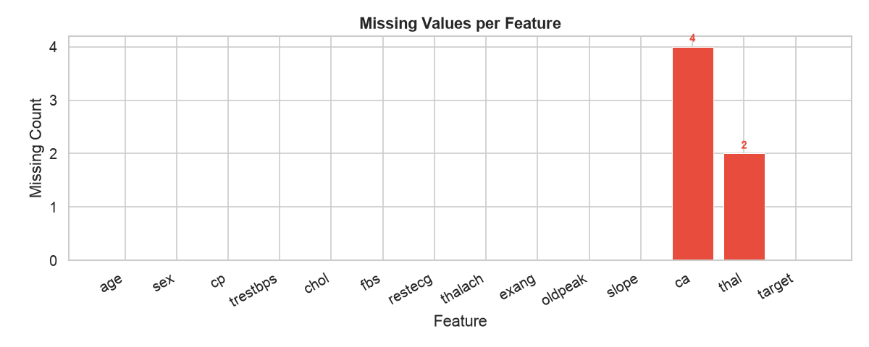
Figure 1. Missing values by feature. Red bars indicate affected columns.

3.2 Class Balance
The dataset is well-balanced: 160 patients without heart disease (53.9%) and 137 with it (46.1%). This near-even split means accuracy is a reliable metric and no resampling technique such as SMOTE is needed.
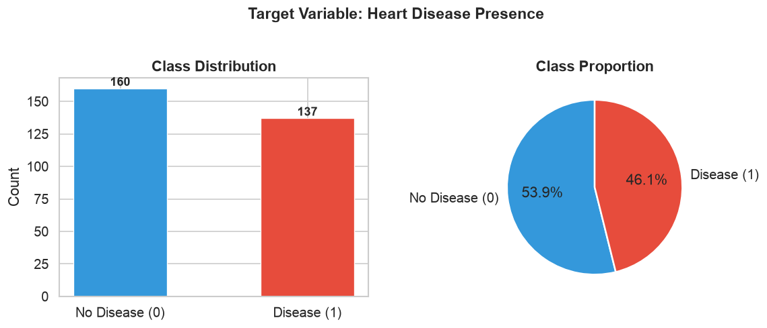
Figure 2. Class distribution showing near-equal split between classes.

3.3 Feature Distributions
Numeric features were examined as overlaid histograms split by target class. The most visually discriminating features are 'thalach' (maximum heart rate — disease patients achieve a lower maximum), 'oldpeak' (ST depression — elevated in disease), and 'ca' (vessel count — higher in disease). Age shows a moderate shift but is not a standalone strong predictor.
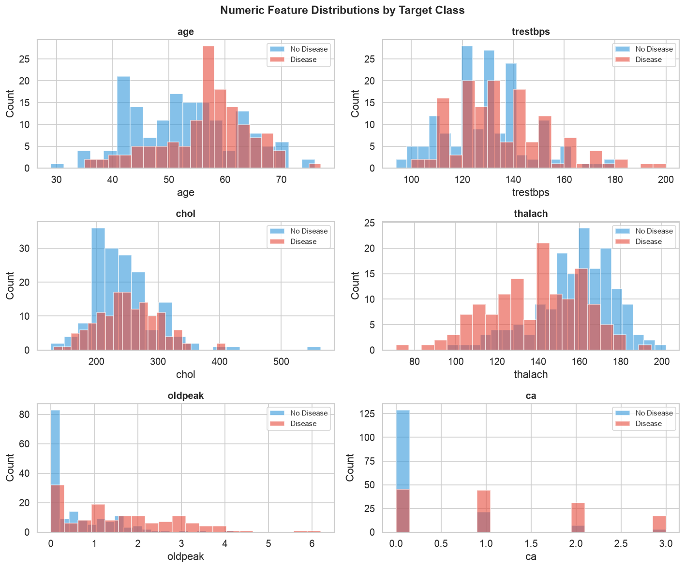
Figure 3. Numeric feature distributions by class.
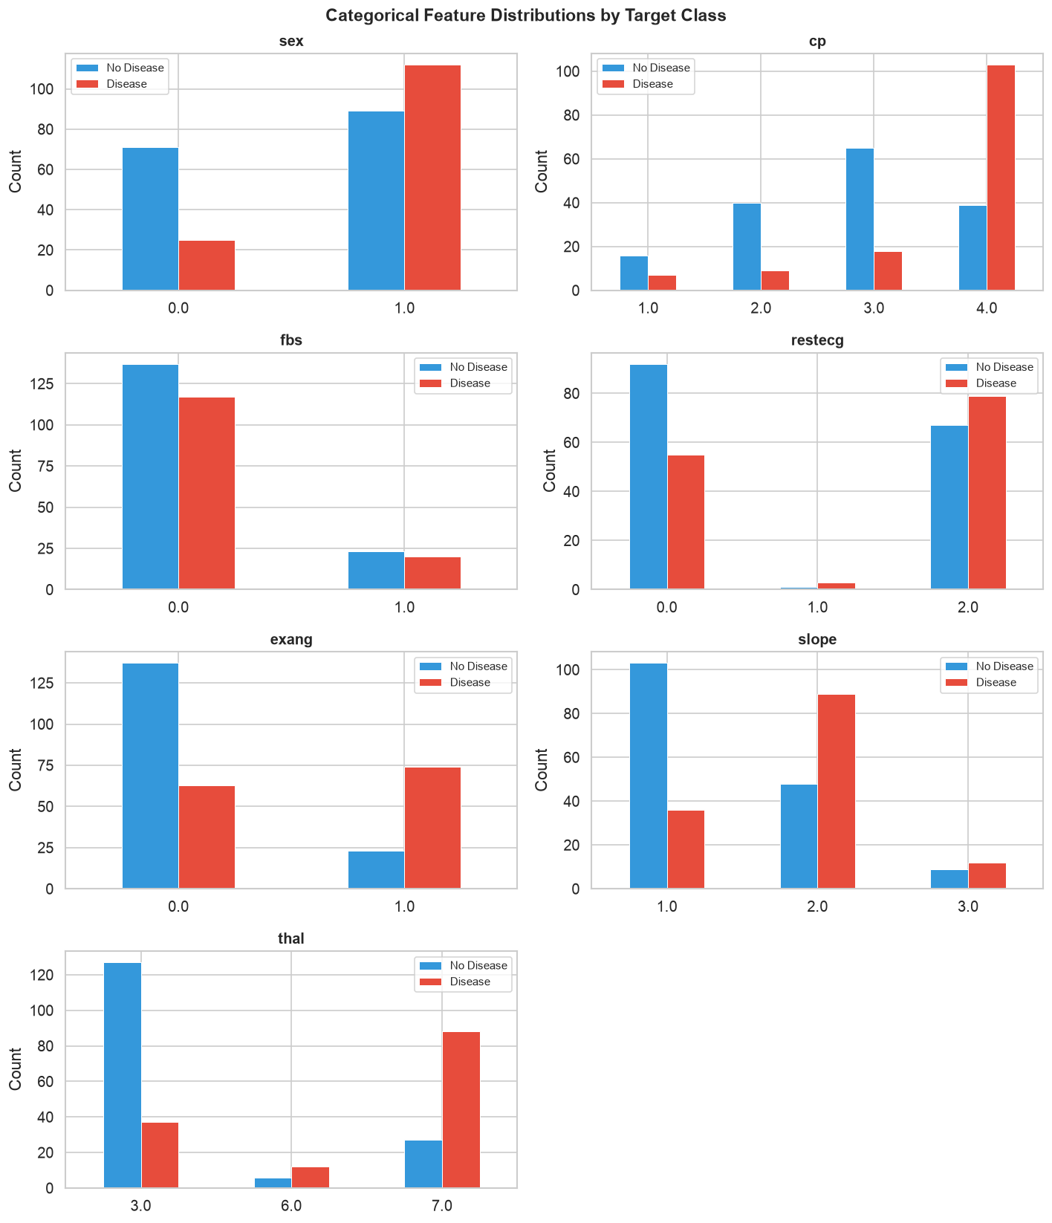
Figure 4. Categorical feature distributions by class.

3.4 Correlation Heatmap
Pearson correlations between all features and the target reveal the five strongest signals: thal (0.53), ca (0.46), thalach (−0.42), exang (0.42), and oldpeak (0.42). Notably, cholesterol shows almost no correlation with the target (0.08) in this dataset — a finding that contradicts the popular belief that high cholesterol alone predicts heart disease.
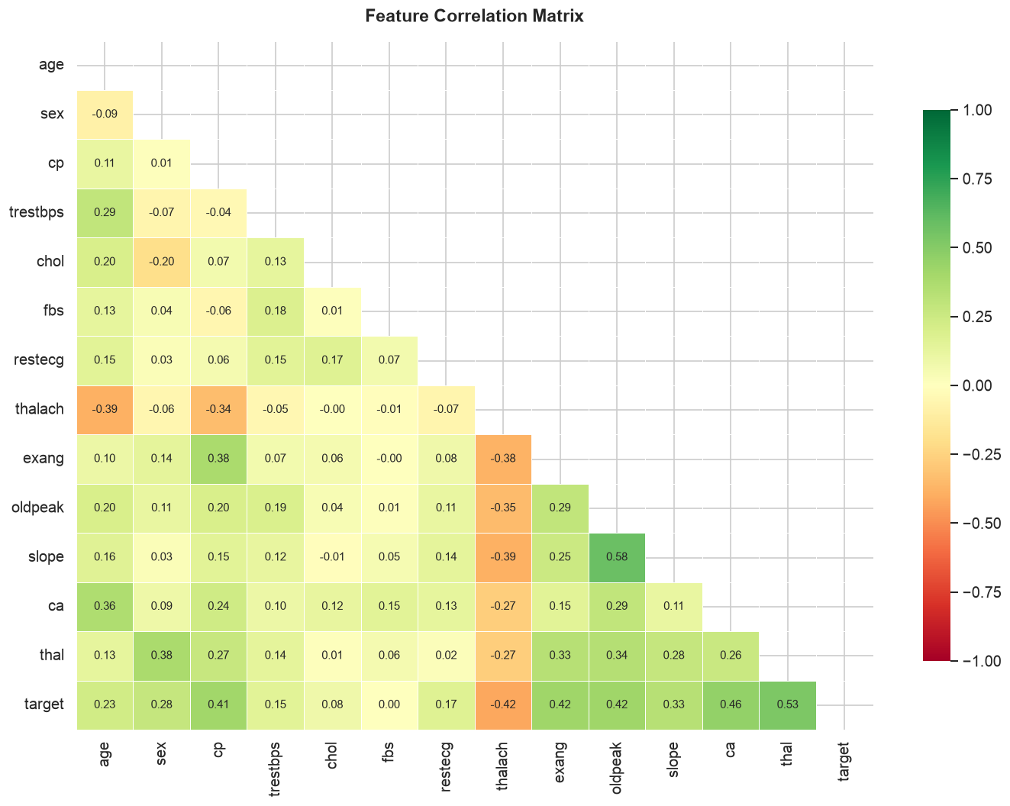
Figure 5. Feature correlation matrix (lower triangle).

3.5 Boxplots and Feature Relationships
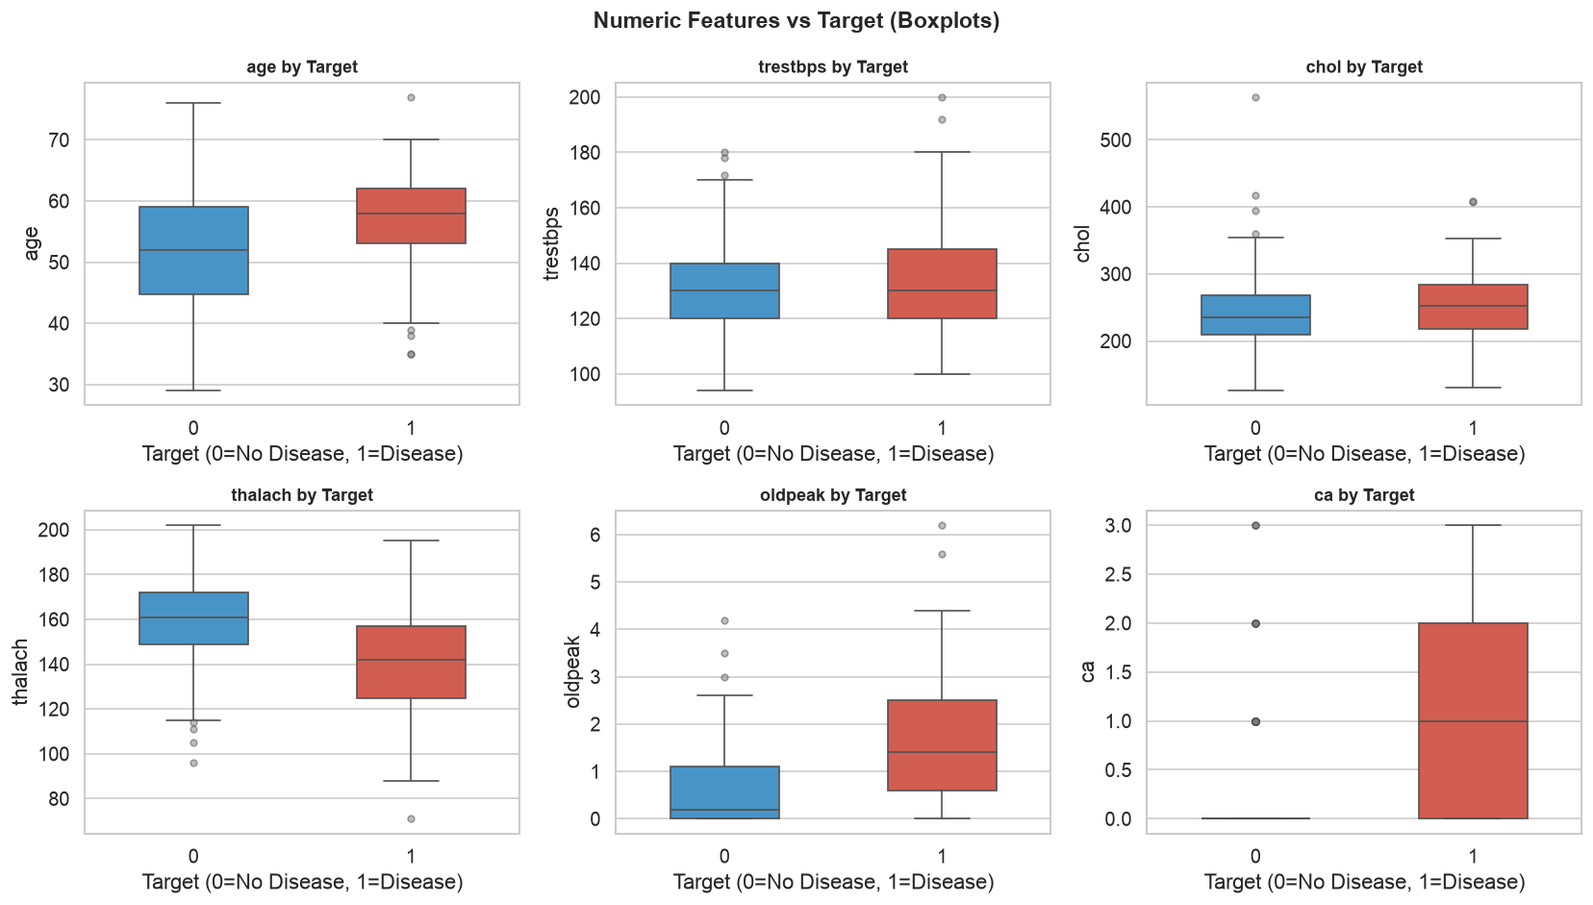
Figure 6. Numeric features vs target class (boxplots).
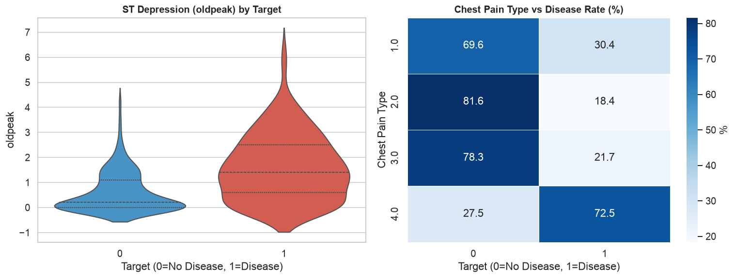
Figure 7. ST depression (violin) and chest pain type disease rate.
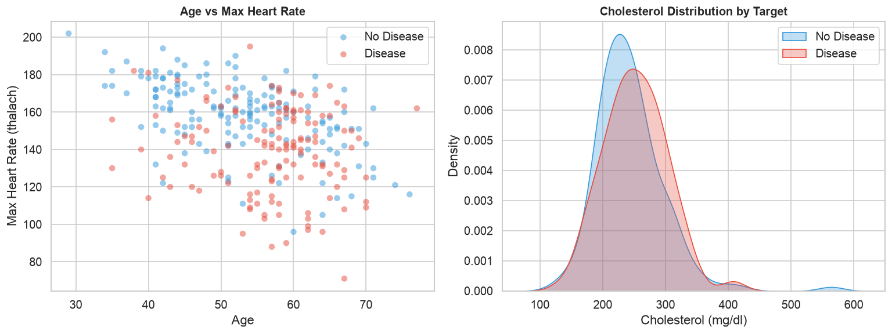
Figure 8. Age vs max heart rate scatter and cholesterol KDE by class.

3.6 Demographic Risk Analysis
Disease rate increases with age, peaking in the 60–70 bracket. The dataset is 68% male, which reflects the original clinical study demographics. Female patients in this dataset show a lower disease rate, though this partially reflects the smaller female sample size rather than a definitive biological finding.
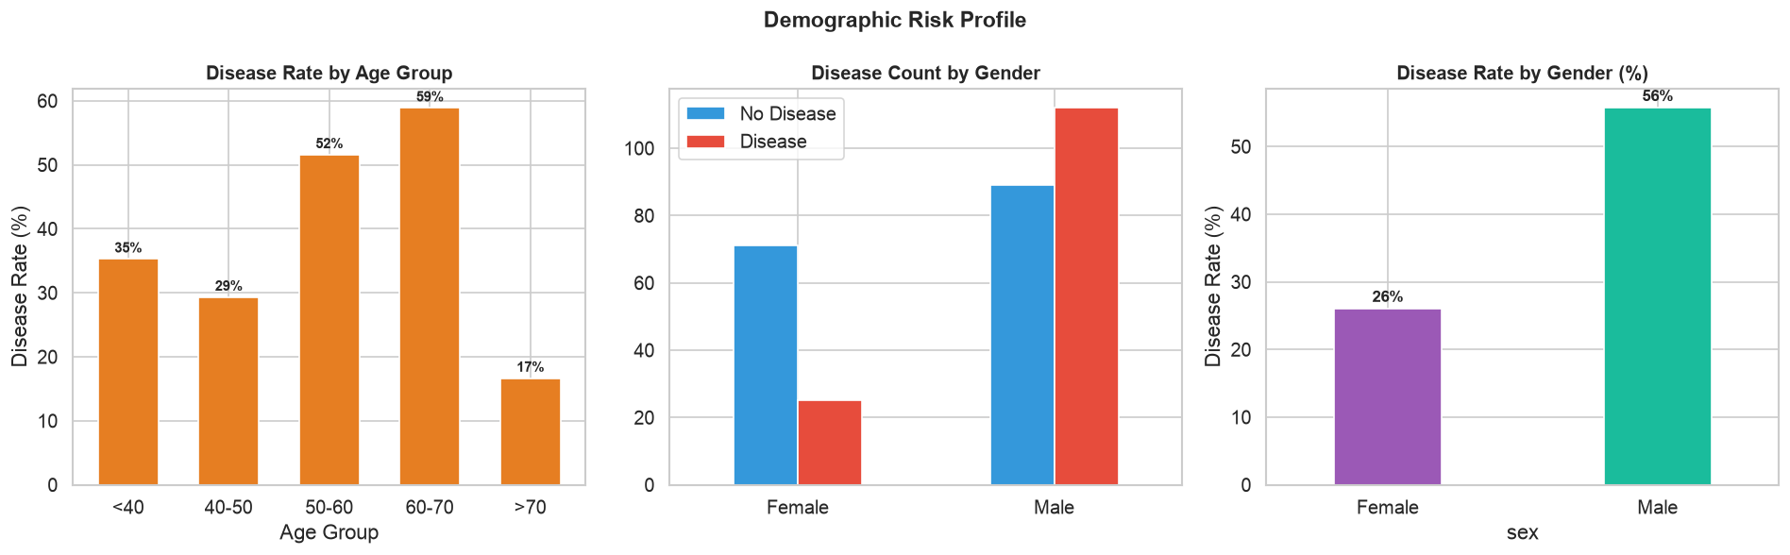
Figure 9. Disease rate by age group and gender.

3.7 Parallel Coordinates
A parallel coordinates plot across the six most important numeric features shows a consistent visual pattern: disease patients (red) tend toward lower thalach, higher oldpeak and ca values. This multi-dimensional view confirms that no single feature is sufficient — the risk signal emerges from the combination.
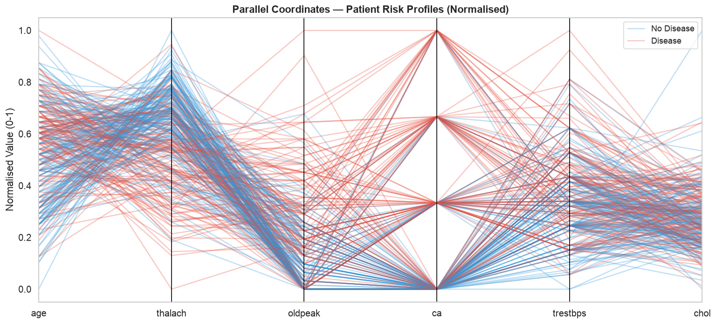
Figure 10. Parallel coordinates — normalised patient profiles by class.

4. Feature Engineering
Beyond the raw 13 features, five clinically motivated derived features were created in src/preprocess.py. Each is grounded in established medical guidelines.
Feature | Formula / Rule | Clinical Basis
heart_rate_reserve | (220 − age) − thalach | Difference between predicted max HR and achieved max HR. Reduced reserve indicates impaired cardiac output.
age_thalach_ratio | thalach / age | Normalises achieved heart rate by age. Captures fitness relative to expected age-adjusted capacity.
st_slope_interaction | oldpeak × slope | Combines ST depression magnitude with the slope direction. Downsloping + high depression = high-risk signal.
bp_category | JNC-8 stages 0–3 | Ordinal hypertension classification: 0=Normal (<120), 1=Elevated, 2=Stage1 HTN (130–139), 3=Stage2 HTN (≥140).
chol_risk | ATP III tiers 0–2 | Cholesterol risk tier: 0=Desirable (<200 mg/dl), 1=Borderline (200–239), 2=High (≥240).

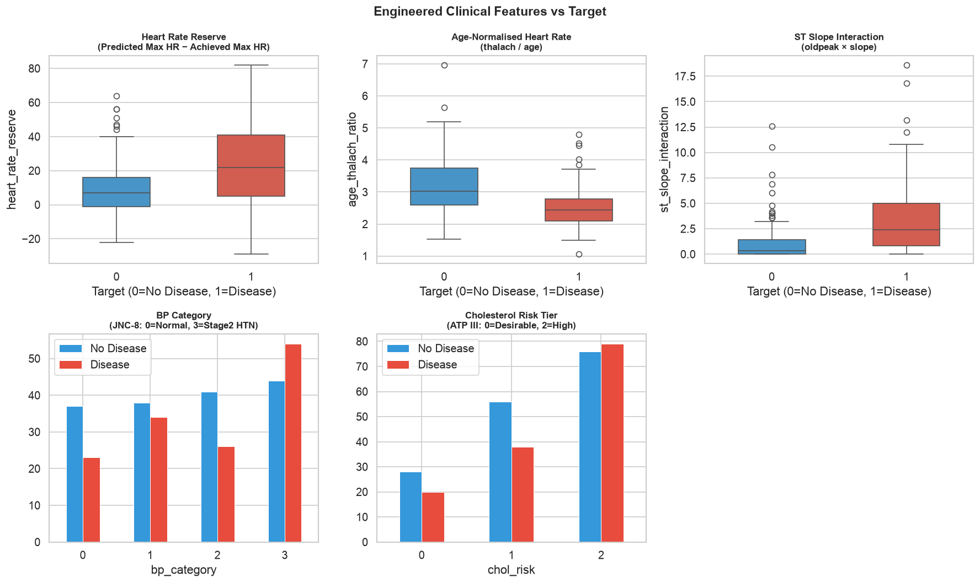
Figure 11. Engineered clinical features vs target class.

4.1 Preprocessing Pipeline
All feature transformations are encapsulated in a scikit-learn ColumnTransformer, which is then wrapped in a Pipeline together with the classifier. This is the correct MLOps pattern: the transformer is fitted once on training data only, and the identical fitted object is used at inference time, preventing data leakage.
Feature Group | Features | Transformation
Numeric (9) | age, trestbps, chol, thalach, oldpeak, ca,  heart_rate_reserve, age_thalach_ratio, st_slope_interaction | StandardScaler — zero mean, unit variance
Categorical (6) | cp, restecg, slope, thal, bp_category, chol_risk | OneHotEncoder(drop='first') — removes dummy variable trap
Binary (3) | sex, fbs, exang | Passthrough — already 0/1, no transformation needed

5. Model Development and Evaluation
Three classification algorithms were trained and compared: Logistic Regression, Random Forest, and XGBoost. Each model was hyperparameter-tuned using 5-fold StratifiedKFold cross-validation with ROC-AUC as the scoring metric. Stratified folds preserve the class ratio in each split, which is important for medical classification tasks.

5.1 Hyperparameter Tuning
Model | Tuning Method | Search Space
Logistic Regression | GridSearchCV | C: [0.01, 0.1, 1, 10, 100]
Random Forest | RandomizedSearchCV (10 iter) | n_estimators: [100,200,300], max_depth: [None,5,10,15], min_samples_split: [2,5,10]
XGBoost | RandomizedSearchCV (8 iter) | n_estimators: [100,200], max_depth: [3,5,7], learning_rate: [0.01,0.1,0.2]

5.2 Model Comparison
Model | CV ROC-AUC | Test ROC-AUC | Accuracy | Precision | Recall | F1
Logistic Regression | 0.8905 | 0.9397 | 0.850 | 0.852 | 0.821 | 0.836
Random Forest | 0.8866 | 0.9464 | 0.833 | 0.875 | 0.750 | 0.808
XGBoost | 0.8914 | 0.9252 | 0.850 | 0.880 | 0.786 | 0.830
Best → Random Forest | — | 0.9464 | — | — | — | —

Random Forest achieved the highest test ROC-AUC of 0.9464 and was selected as the production model. The gap between CV AUC (~0.89) and test AUC (~0.94) is positive — the model generalises well and is not overfitting. Logistic Regression is a close second and remains competitive given its interpretability advantage.

5.3 ROC Curves
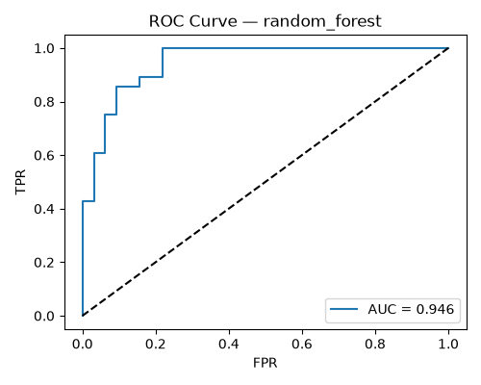
Figure 12. ROC curve — Random Forest (AUC = 0.9464).

5.4 Confusion Matrices
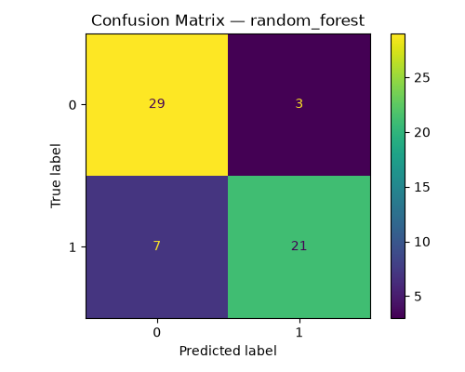
Figure 13. Confusion matrix — Random Forest (test set).

5.5 Precision-Recall Curves
Precision-recall curves are particularly informative for clinical applications where false negatives (missed disease) carry a higher cost than false positives. The curves confirm that the Random Forest maintains high precision across a wide recall range.
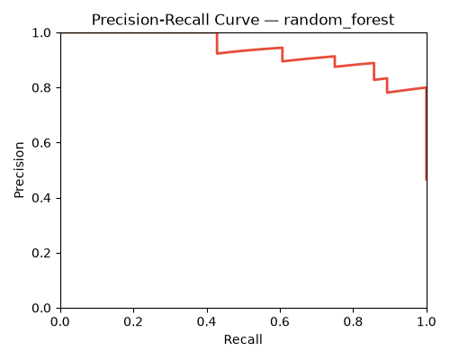
Figure 14. Precision-Recall curve — Random Forest.

5.6 Calibration and Feature Importance
Calibration plots assess whether predicted probabilities reflect true frequencies. A well-calibrated model is essential in medical settings — a prediction of 80% risk should correspond to 80% of those patients actually having disease.
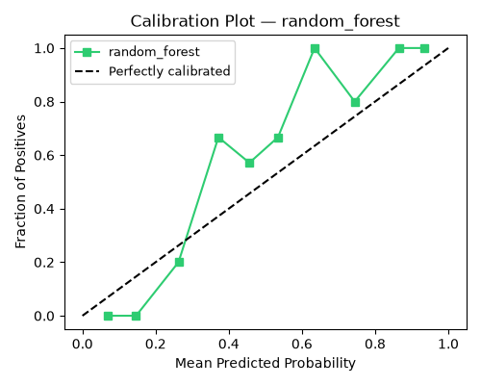
Figure 15. Calibration plot — Random Forest.
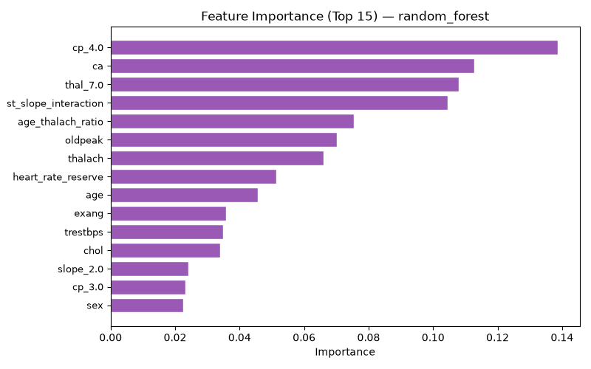
Figure 16. Feature importance — Random Forest (top 15 features).

5.7 Learning Curve
The learning curve confirms the model is not severely overfitting: training AUC converges toward validation AUC as data size increases. The validation score plateaus around 200 samples, suggesting the dataset is near its information capacity for this model class.
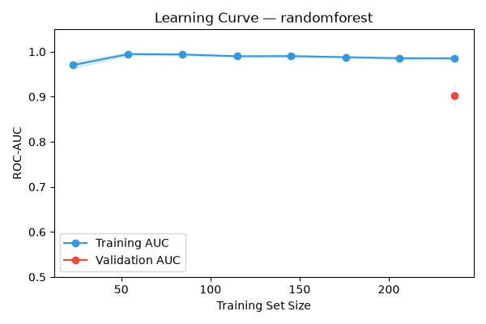
Figure 17. Learning curve — Random Forest.

6. Experiment Tracking with MLflow
MLflow 2.11 was used to track all training runs. Given that MLflow 3.x deprecated the file-based tracking store, a SQLite backend (mlflow.db) was configured via mlflow.set_tracking_uri(). This is the recommended approach for single-machine experiment tracking and avoids the alembic migration conflicts that affect the file store.

6.1 What Was Logged Per Run
Item | MLflow API | Example Value
Model name | log_param('model', ...) | RandomForest
Hyperparameters | log_param(...) | n_estimators=200, max_depth=10
CV folds | log_param('cv_folds', 5) | 5
CV ROC-AUC | log_metric('cv_roc_auc', ...) | 0.8866
Test accuracy | log_metric('accuracy', ...) | 0.833
Test ROC-AUC | log_metric('roc_auc', ...) | 0.9464
Precision / Recall / F1 | log_metric(...) | 0.875 / 0.750 / 0.808
Confusion matrix | log_artifact(cm_path) | plots/cm_random_forest.png
ROC curve | log_artifact(roc_path) | plots/roc_random_forest.png
PR curve | log_artifact(pr_path) | plots/pr_random_forest.png
Calibration plot | log_artifact(cal_path) | plots/calibration_random_forest.png
Feature importance | log_artifact(fi_path) | plots/feature_importance_random_forest.png
Saved pipeline | log_artifact(pkl_path) | models/_tmp_random_forest.pkl

To launch the MLflow UI and inspect runs:
mlflow ui --backend-store-uri sqlite:///mlflow.db
Then navigate to http://localhost:5000 to view the heart-disease-classification experiment.

7. Model Packaging and Reproducibility
The production model is saved as a joblib-serialised sklearn Pipeline object at models/pipeline.pkl. Because the Pipeline bundles the ColumnTransformer preprocessor and the classifier together, a single joblib.load() call at inference time is sufficient to produce predictions — no separate preprocessing step or re-fitting is needed.

7.1 Why joblib over pickle
joblib is the standard serialisation method in the scikit-learn ecosystem. It handles numpy arrays more efficiently than Python's built-in pickle by memory-mapping large arrays instead of copying them. For pipelines containing fitted transformers (which store numpy arrays internally), this results in faster load times and smaller file sizes.

7.2 Reproducibility Guarantees
Mechanism | How it Ensures Reproducibility
requirements.txt with pinned versions | Exact dependency versions prevent library update from changing model behaviour
random_state=42 everywhere | train_test_split, all classifiers, and StratifiedKFold produce identical splits and models
Preprocessor fitted on train set only | No information from the test set leaks into scaling/encoding parameters
engineer_features() in preprocess.py | Derived features use the same deterministic formula at train time and inference time
Docker image trains model at build time | The saved .pkl and the sklearn version that loads it are guaranteed to match

8. CI/CD Pipeline with GitHub Actions
A GitHub Actions workflow at .github/workflows/ci.yml runs automatically on every push to the main branch. The pipeline runs entirely on a fresh ubuntu-latest virtual machine, which proves that the code is reproducible in a clean environment with only the requirements.txt dependencies installed.

8.1 Pipeline Steps
Step | Tool | Purpose
1. Checkout code | actions/checkout@v4 | Fetch latest commit
2. Set up Python 3.11 | actions/setup-python@v5 | Pin interpreter version
3. Cache pip packages | actions/cache@v4 | Speed up repeated runs
4. Install dependencies | pip install -r requirements.txt | Reproduce environment
5. Lint | flake8 src/ api/ tests/ --max-line-length=100 | Catch style errors and unused imports
6. Download dataset | python data/download_data.py | Fetch UCI data on clean VM
7. Unit tests (preprocessing) | pytest tests/test_preprocess.py --junitxml | Verify data pipeline correctness
8. Train model | python src/train.py --quick-run | Smoke test full training pipeline
9. Unit tests (API) | pytest tests/test_api.py --junitxml | Verify API endpoints
10. Upload test results | actions/upload-artifact@v4 | JUnit XML saved per run
11. Upload trained model | actions/upload-artifact@v4 | pipeline.pkl saved per run

The --quick-run flag passed to train.py skips hyperparameter tuning, reducing CI runtime to under 60 seconds while still exercising the complete data loading, preprocessing, training, MLflow logging, and model saving pathway.
The pipeline is configured to fail hard on any error — a failed lint check, a single failing test, or a runtime error in train.py will stop the run immediately with a non-zero exit code and mark the commit as broken.

8.2 Test Coverage
Test File | Tests | What Is Verified
test_preprocess.py | 10 | Data loading, no missing values, binary target, preprocessor shape,  pipeline fit/predict, engineered feature columns, HR reserve formula,  BP/cholesterol category bounds, accuracy threshold
test_api.py | 14 | Health endpoint, all response fields, binary output, probability range,  risk label consistency, 422 on invalid input, batch endpoint,  batch empty/overlimit validation, response time < 500ms

9. Model Containerisation with Docker
The application is packaged as a Docker image using python:3.11-slim as the base. The image is fully self-contained — it downloads the dataset and trains the model at build time, so the saved pipeline.pkl and the sklearn version that loads it are guaranteed to be identical, eliminating cross-version serialisation errors.

9.1 Dockerfile Design
FROM python:3.11-slim
WORKDIR /app
COPY requirements.txt .
RUN pip install --no-cache-dir -r requirements.txt
COPY src/ src/ && COPY data/ data/ && COPY api/ api/
RUN python data/download_data.py
RUN mkdir -p models plots && python src/train.py --quick-run
EXPOSE 8000
HEALTHCHECK CMD python -c "import urllib.request; urllib.request.urlopen('http://localhost:8000/health')"
CMD ["uvicorn", "api.main:app", "--host", "0.0.0.0", "--port", "8000"]

9.2 API Endpoints
Endpoint | Method | Description
/health | GET | Liveness check — returns status and version
/predict | POST | Single patient prediction — returns prediction, probability, risk, heart_rate_reserve, age_thalach_ratio
/predict-batch | POST | Batch prediction (up to 100 patients) with aggregate summary
/model-info | GET | Model type, feature list, dataset info
/stats | GET | Live prediction counts and high-risk rate since startup
/metrics | GET | Prometheus metrics — request count, latency histograms, custom counters
/docs | GET | Auto-generated Swagger UI (FastAPI)

9.3 Build and Run
docker build -t heart-risk-api:latest .
docker run -d -p 8000:8000 --name heart-risk heart-risk-api:latest
curl http://localhost:8000/health
# {"status":"ok","model":"heart-disease-classifier","version":"1.0.0"}
curl -X POST http://localhost:8000/predict \
-H "Content-Type: application/json" \
-d '{"age":67,"sex":1,"cp":4,"trestbps":160,"chol":286,"fbs":0,
"restecg":2,"thalach":108,"exang":1,"oldpeak":1.5,
"slope":2,"ca":3,"thal":7}'
# {"prediction":1,"probability":0.9982,"risk":"high","heart_rate_reserve":45.0,"age_thalach_ratio":1.6119}

10. Production Deployment on Kubernetes
The containerised API was deployed to Kubernetes using Docker Desktop's built-in Kubernetes cluster. This simulates a production deployment without requiring a cloud account. The manifests at k8s/deployment.yaml and k8s/service.yaml define the desired state; Kubernetes continuously reconciles actual state to match.

10.1 Deployment Configuration
Parameter | Value | Reason
Replicas | 2 | High availability — one pod crashing does not cause downtime
Image pull policy | IfNotPresent | Use locally built image; no Docker Hub push required
Memory request/limit | 256Mi / 512Mi | Prevent OOM kills while allowing burst
CPU request/limit | 250m / 500m | Fair scheduling with headroom for inference spikes
Readiness probe | GET /health every 5s | Pod only receives traffic when it is ready
Liveness probe | GET /health every 10s | Kubernetes restarts unhealthy pods automatically

10.2 Service Configuration
A LoadBalancer service exposes the deployment on port 80, routing to the container's port 8000. Docker Desktop maps LoadBalancer services to localhost automatically.

10.3 Deploy Commands
kubectl apply -f k8s/
kubectl get pods
# NAME READY STATUS RESTARTS AGE
# heart-risk-deployment-7dc9f489b4-9vtl2 1/1 Running 0 2m
# heart-risk-deployment-7dc9f489b4-dpnqv 1/1 Running 0 2m
kubectl get services
# NAME TYPE CLUSTER-IP EXTERNAL-IP PORT(S) AGE
# heart-risk-service LoadBalancer 10.96.92.118 172.18.0.5 80:32373/TCP 8m
curl http://localhost/predict -X POST -d '{...}'
# {"prediction":1,"probability":0.9982,"risk":"high",...}

11. Monitoring and Logging
The API exposes a /metrics endpoint via prometheus-fastapi-instrumentator, which auto-instruments every HTTP endpoint with request count, latency histograms, and status code breakdown. Two custom Prometheus metrics were added for business-level monitoring specific to this application.

11.1 Custom Prometheus Metrics
Metric | Type | Labels | What It Measures
heart_risk_predictions_total | Counter | risk_level (high/low) | Cumulative prediction count split by risk outcome
heart_risk_prediction_duration_seconds | Histogram | — | Per-prediction inference latency
heart_risk_batch_size | Histogram | — | Distribution of batch prediction sizes
http_requests_total | Counter (auto) | handler, method, status | Request count per endpoint and HTTP status
http_request_duration_seconds | Histogram (auto) | handler | End-to-end request latency per endpoint

11.2 Structured Request Logging
Every prediction request is logged in a structured format:
2026-07-10 15:56:20 INFO PREDICT age=67 sex=1 cp=4 prob=0.9982 result=high hr_reserve=45.0

11.3 Monitoring Stack
Prometheus and Grafana are started via docker-compose:
cd monitoring && docker compose up -d
Prometheus scrapes /metrics every 15 seconds. Grafana connects to Prometheus as a data source and the provided grafana-dashboard.json imports a dashboard with four panels: prediction request rate, total predictions by risk level, latency p50/p95, and API success rate.

12. System Architecture
The diagram below shows data flow across the full system. Each layer is independently deployable and testable. The preprocessing pipeline is the single point of feature transformation used by both the training path and the serving path.
┌─────────────────────────────────────────────────────────────────┐
│ DATA LAYER │
│ UCI CSV ──► download_data.py ──► data/heart.csv │
└──────────────────────────┬──────────────────────────────────────┘
│
┌──────────────────────────▼──────────────────────────────────────┐
│ FEATURE ENGINEERING │
│ preprocess.py │
│ ColumnTransformer: StandardScaler + OneHotEncoder + passthrough │
│ engineer_features(): heart_rate_reserve, bp_category, etc. │
└──────────────────────────┬──────────────────────────────────────┘
│
┌────────────────┴────────────────┐
│ │
┌─────────▼─────────┐ ┌─────────▼─────────┐
│ TRAINING PATH │ │ SERVING PATH │
│ src/train.py │ │ api/main.py │
│ LR + RF + XGB │ │ FastAPI │
│ GridSearch / RS │ │ /predict │
│ MLflow logging │ │ /predict-batch │
│ pipeline.pkl ◄───┘ │ /model-info │
└─────────┬─────────┘ │ /stats │
│ mlflow.db └─────────┬─────────┘
┌─────────▼─────────┐ │
│ MLFLOW UI │ ┌─────────▼─────────┐
│ localhost:5000 │ │ DOCKER IMAGE │
└───────────────────┘ │ python:3.11-slim │
│ trains at build │
└─────────┬─────────┘
│
┌─────────▼─────────┐
│ KUBERNETES │
│ 2 replicas │
│ LoadBalancer :80 │
│ health probes │
└─────────┬─────────┘
│
┌───────────────────┴───────────────────┐
│ │
┌─────────▼─────────┐ ┌──────────▼─────────┐
│ PROMETHEUS │ │ GRAFANA │
│ scrapes /metrics │ │ dashboard │
│ localhost:9090 │ │ localhost:3000 │
└───────────────────┘ └────────────────────┘
┌──────────────────────────────────────────────────────────┐
│ CI/CD (GitHub Actions) │
│ push ► lint ► download ► test ► train ► test API ► done │
└──────────────────────────────────────────────────────────┘

13. Repository Structure
heart-disease-mlops/
├── data/
│ ├── download_data.py # fetches UCI dataset, adds headers, binarises target
│ └── heart.csv # cleaned 297-row dataset
├── notebooks/
│ └── 01_eda.ipynb # 12-section EDA with 17 visualisations
├── src/
│ ├── preprocess.py # ColumnTransformer + engineer_features()
│ └── train.py # 3 models, tuning, MLflow, 9+ plot types
├── api/
│ └── main.py # FastAPI: /predict /batch /stats /model-info /metrics
├── tests/
│ ├── test_preprocess.py # 10 tests: data, features, formulas, accuracy threshold
│ └── test_api.py # 14 tests: endpoints, batch, validation, response time
├── k8s/
│ ├── deployment.yaml # 2 replicas, resource limits, health probes
│ └── service.yaml # LoadBalancer port 80 → 8000
├── monitoring/
│ ├── prometheus.yml # scrape config
│ ├── docker-compose.yml # Prometheus + Grafana
│ └── grafana-dashboard.json # 4-panel dashboard
├── plots/ # 27 visualisations
├── models/ # pipeline.pkl (gitignored, built in Docker)
├── process_tracking/ # step-by-step decision log (9 files)
├── .github/workflows/ci.yml # CI: lint → test → train → test API → artifacts
├── Dockerfile # builds + trains model inside container
├── .dockerignore
├── pytest.ini
└── requirements.txt # 16 pinned dependencies

14. References
[1] Detrano, R. et al. (1989). International application of a new probability algorithm for the diagnosis of coronary artery disease. American Journal of Cardiology, 64(5), 304–310.
[2] UCI Machine Learning Repository — Heart Disease Dataset. https://archive.ics.uci.edu/ml/datasets/Heart+Disease
[3] Chobanian, A.V. et al. (2003). The Seventh Report of the Joint National Committee on Prevention, Detection, Evaluation, and Treatment of High Blood Pressure (JNC-7). JAMA, 289(19), 2560–2571.
[4] Expert Panel on Detection, Evaluation, and Treatment of High Blood Cholesterol in Adults (2001). Executive Summary of The Third Report of the National Cholesterol Education Program (NCEP) Expert Panel — ATP III. JAMA, 285(19), 2486–2497.
[5] Sculley, D. et al. (2015). Hidden Technical Debt in Machine Learning Systems. Advances in Neural Information Processing Systems 28.
[6] MLflow Documentation. https://mlflow.org/docs/latest/index.html
[7] FastAPI Documentation. https://fastapi.tiangolo.com
[8] Kubernetes Documentation — Deployment and Service. https://kubernetes.io/docs/concepts/workloads/controllers/deployment/

