Create a database named 'custom':

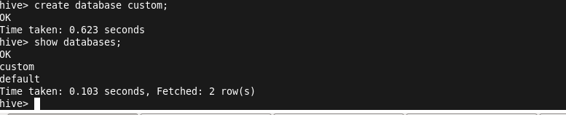

To access the table inside the custom database,we use the following command:

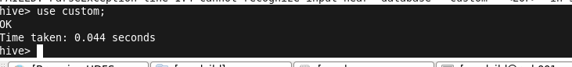

Create a table named temperature_data inside custom database with the following fields (delimited by comma - ‘,’ ) :

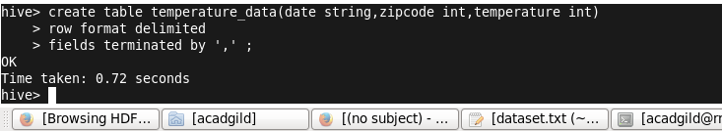

Load the data into temperature_data and then display the content which is inside the table:

