**ASSIGNMENTS-10.3**

1. **Fetch date and temperature from temperature_data where zip code is greater than 300000 and less than 399999**

creation of table and data load into hive:

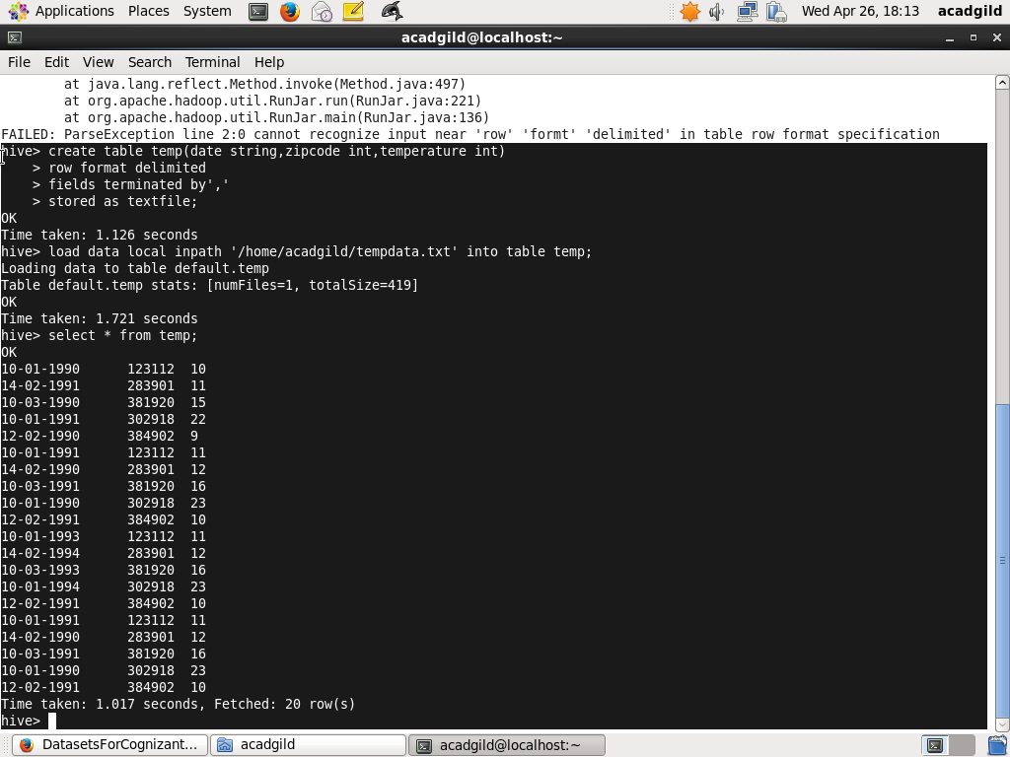

To fetch date and temperature from temperature_data where zip code is greater than 300000 and less than 399999

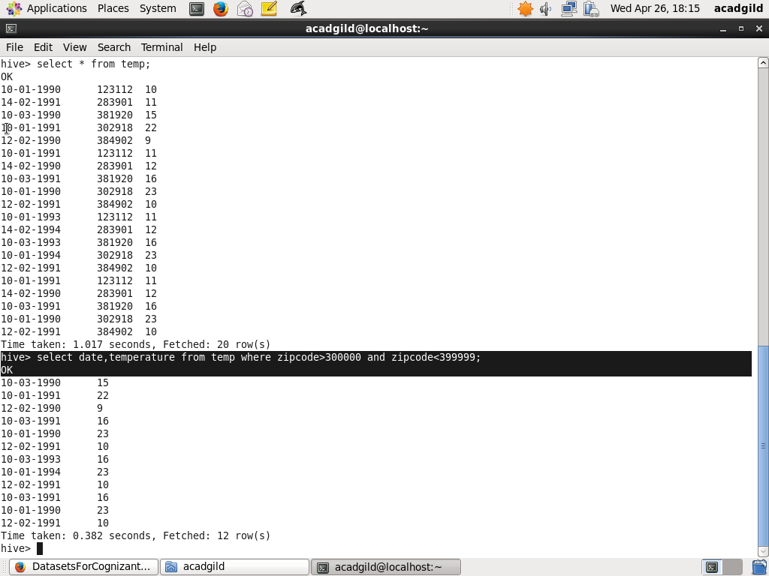

Result for above query:

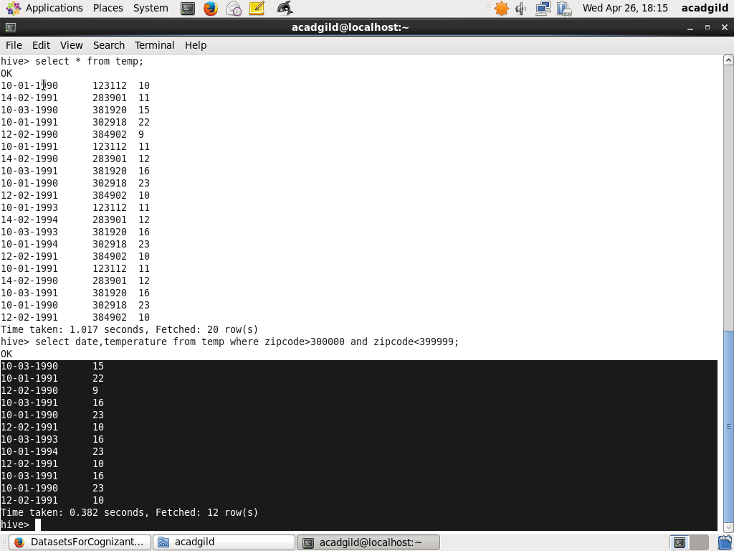

1. **Calculate maximum temperature corresponding to every year from temperature_data table.**

creation of table and data load into hive:



To calculate maximum temperature corresponding to every year from temperature_data table:

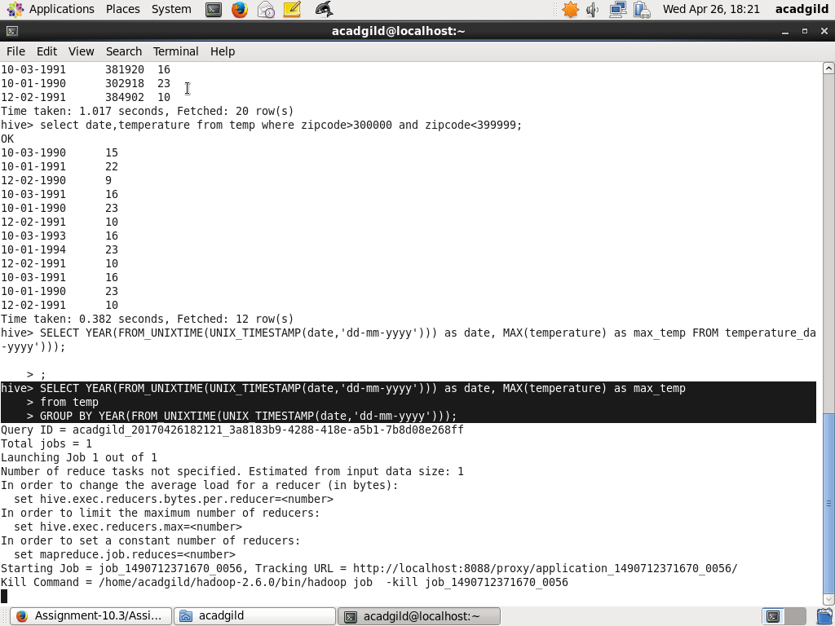

Result for above query:

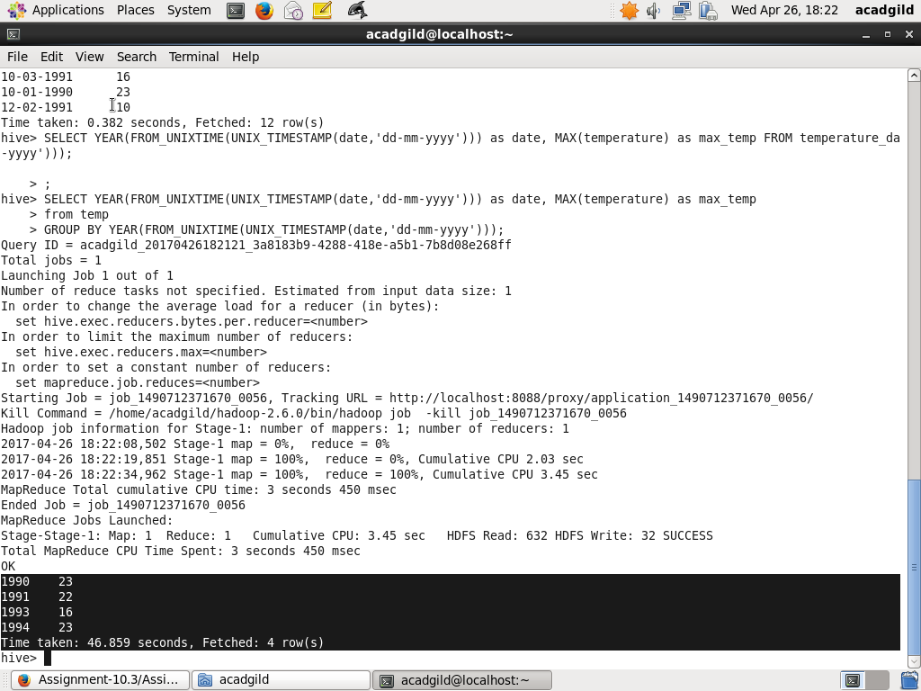

**3.Calculate maximum temperature from temperature_data table corresponding to those years which have at least 2 entries in the table.**

creation of table and data load into hive:



To calculate maximum temperature from temperature_data table corresponding to those years which have at least 2 entries in the table:

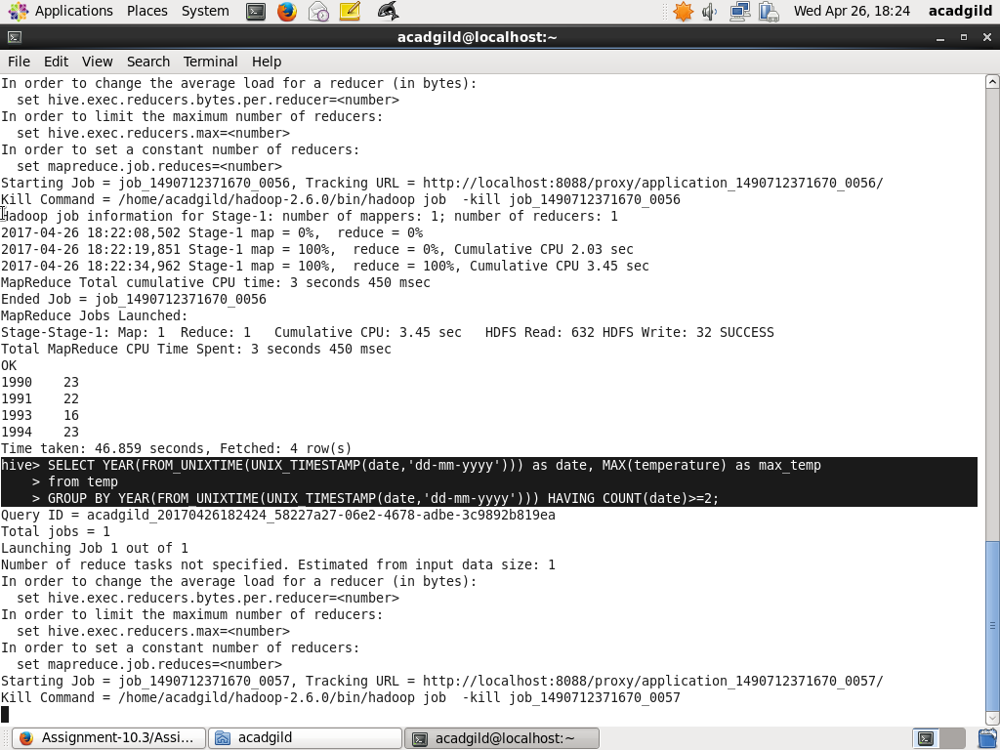

Result for the above query:

