**ASSIGNMENT-10.4**

**Write a hive query find the average age of male and female persons died in the titanic tragedy**

Creation of table:

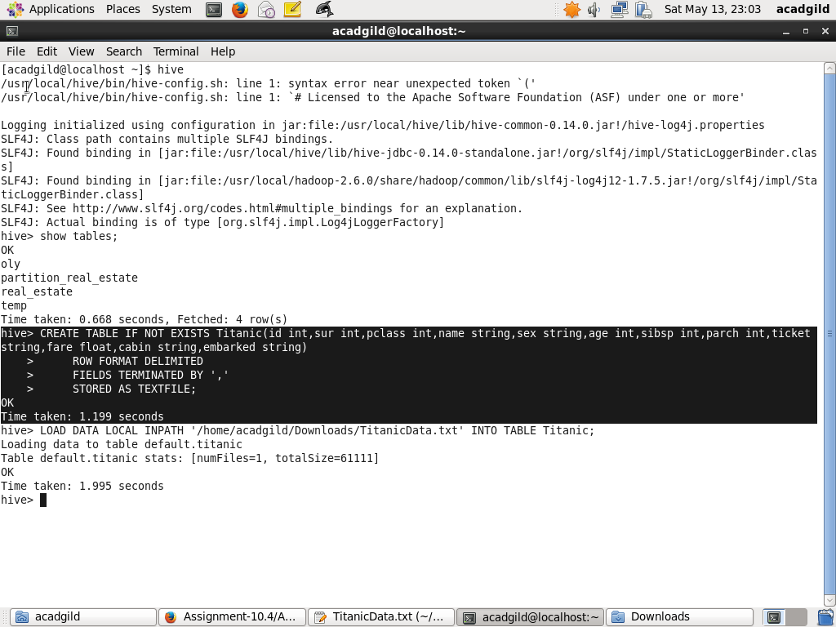

Load the data:

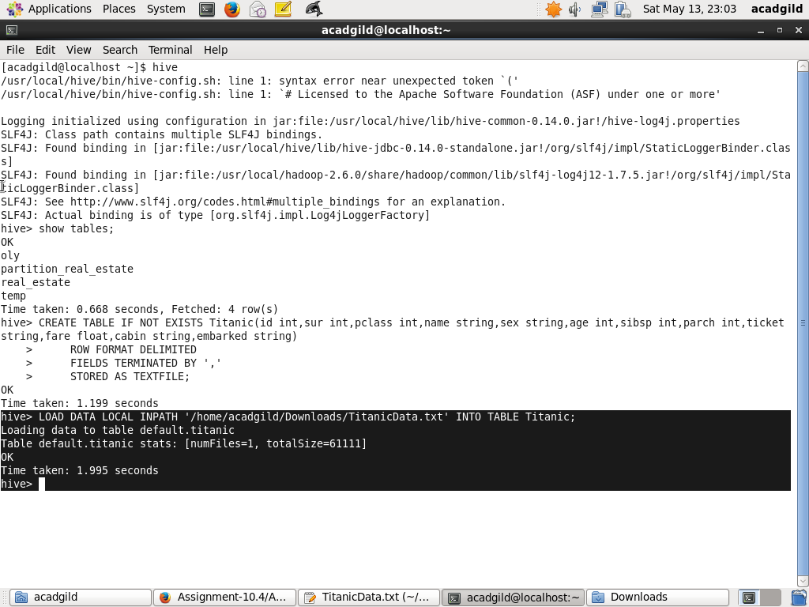

Query for find the average age of male and female persons died in the titanic tragedy:

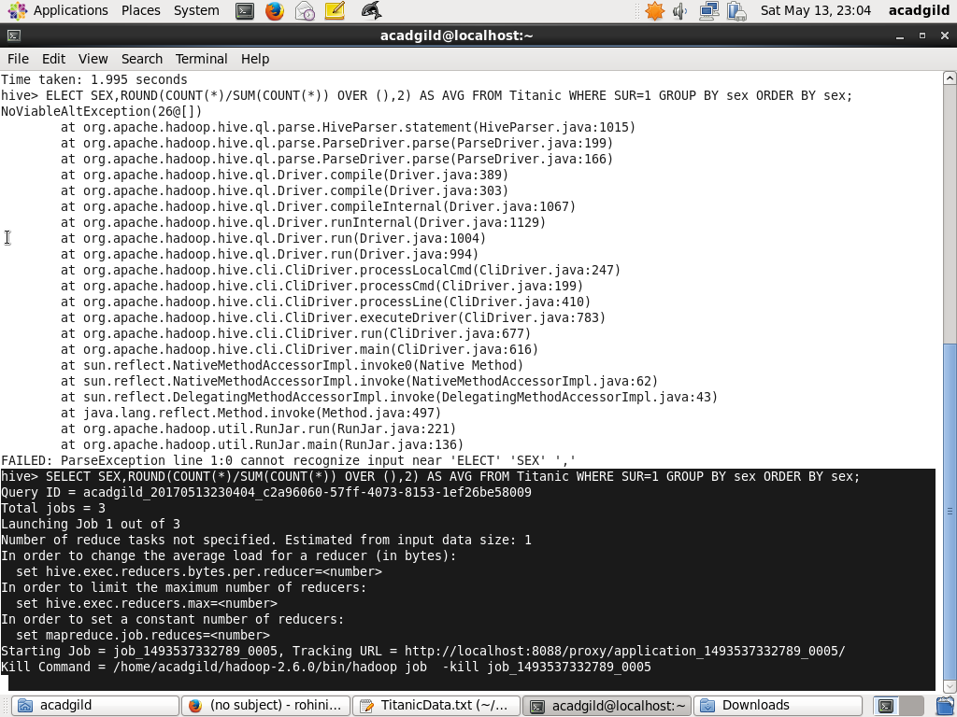

Result for the above query:

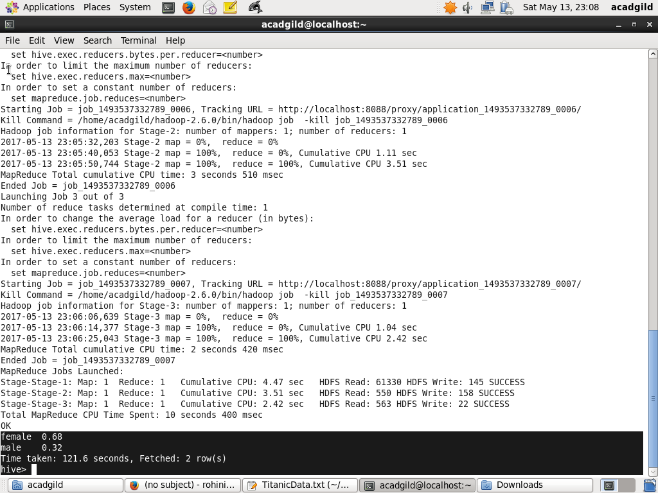

**Write a hive query to find the number of people died and survived in each class**

Creation of table:



Load the data:



Query to find the number of people survived in each class:

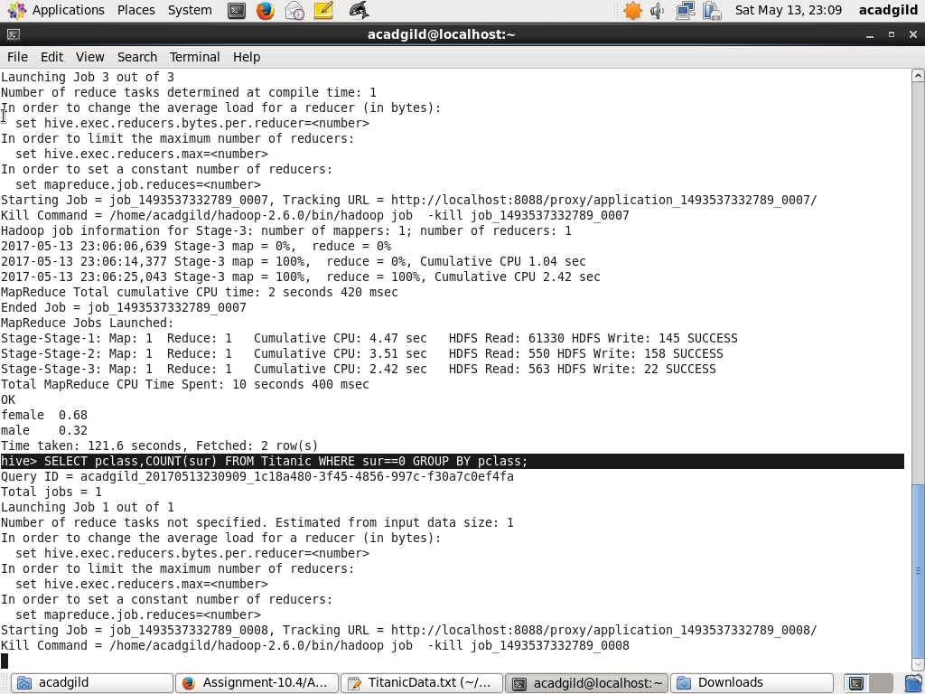

Result for the above query:

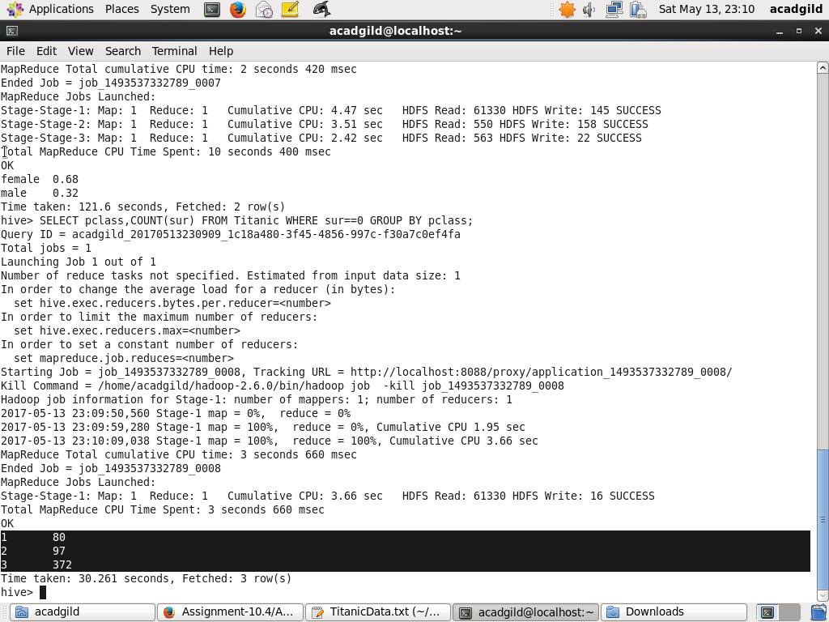

Query to find the number of people died in each class:

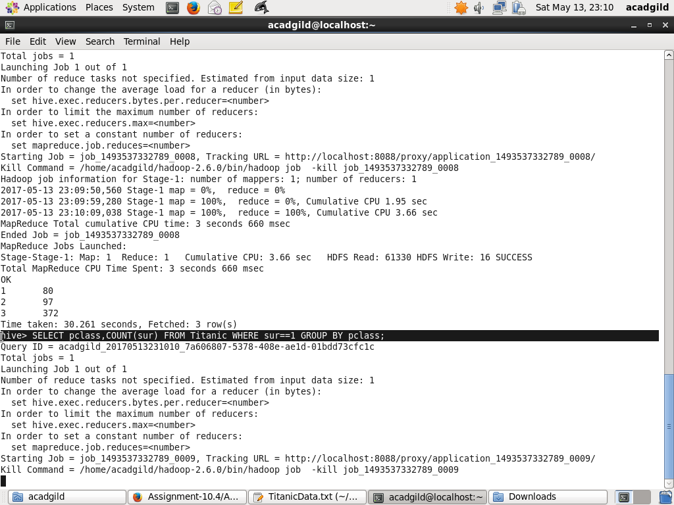

Result for the above query:

