**ASSIGNMENT-10.5**

**Write a hive query to find the top 20 destination people travel the most**

Create the table called travel_data:

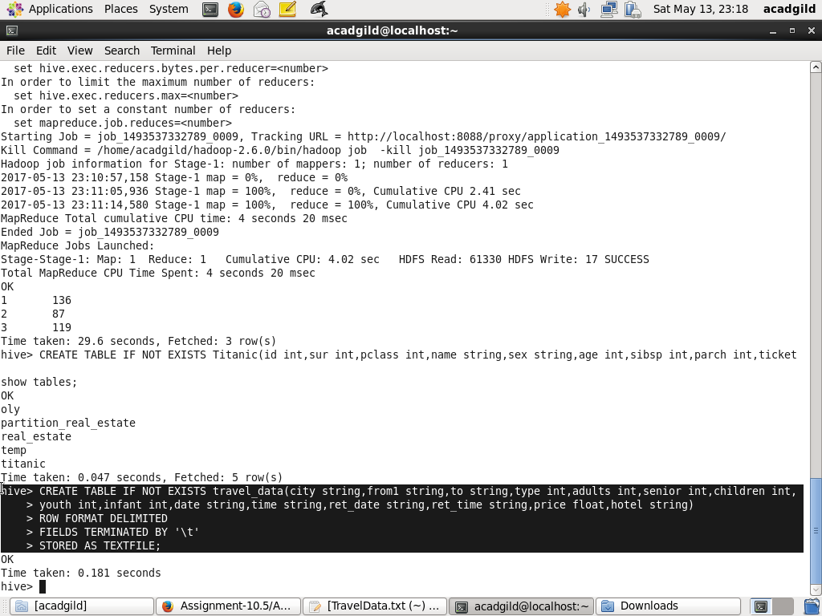

Loading the data from TravelData.txt:

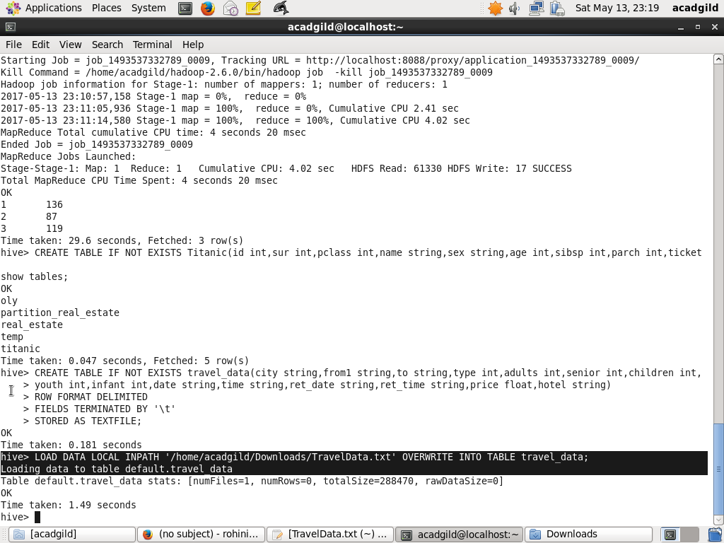

Query to find the top 20 destination people travel the most:

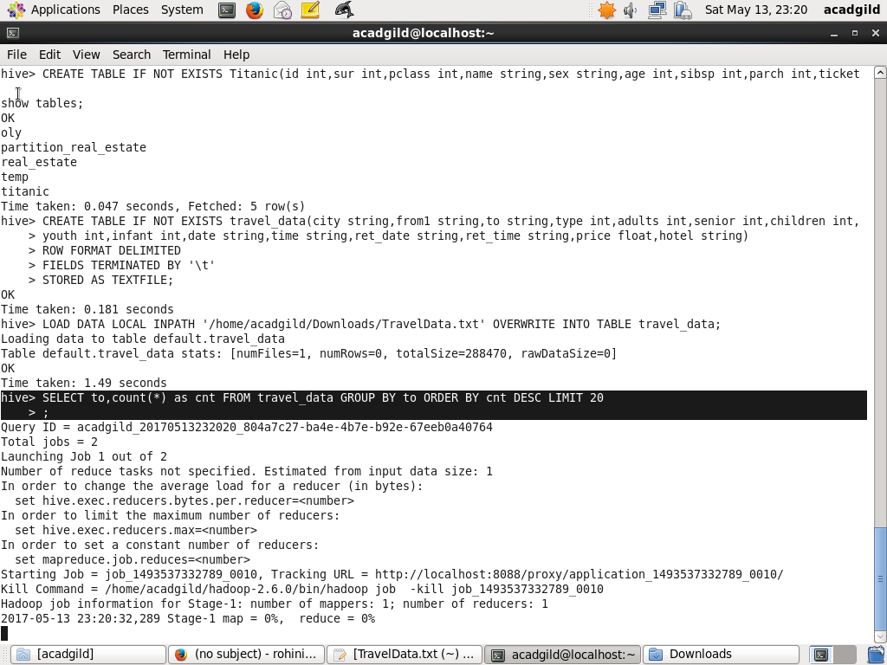

Result for the above query:

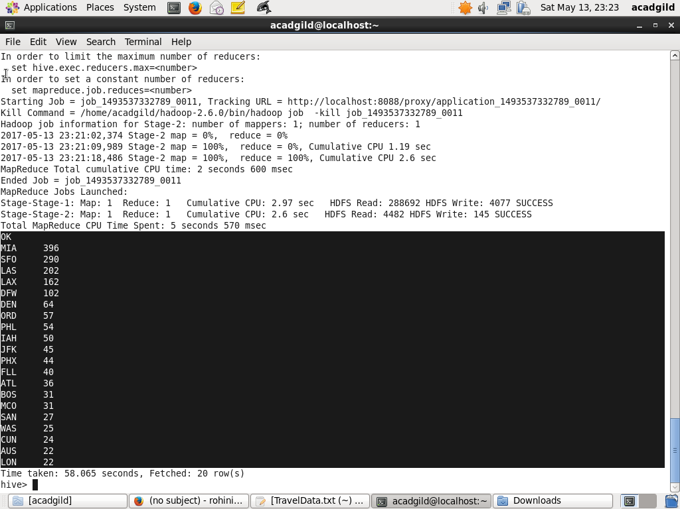

**Write a hive query to find the top 20 locations from where people travel the most**

Create the table called travel_data:



Loading the data from TravelData.txt:



Query to find the top 20 locations from where people travel the most:

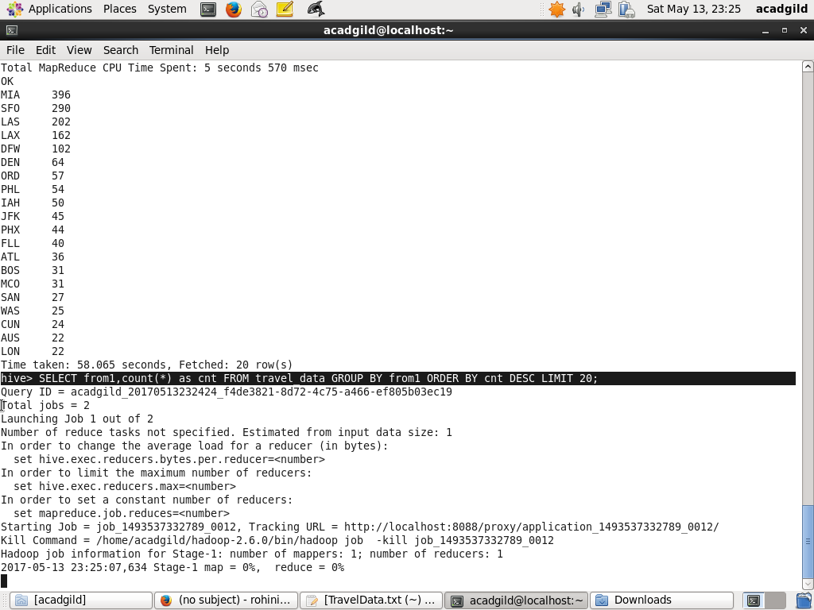

Result for the above query:

